Supporting Information for: Caching in: A seed dispersal mutualism portends the decline of an imperiled songbird-pine system
Author List: Ana Miller-ter Kuile^{1,2}, Andreas P. Wion³, Kyle C. Rodman⁴, Jamie S. Sanderlin², Kiona Ogle¹
Author Affiliations:
¹ Northern Arizona University School of Informatics, Computing, and Cyber Systems, Flagstaff, Arizona, USA
² USDA Forest Service Rocky Mountain Research Station, Flagstaff, Arizona, USA
³ Forest Stewards Guild, Santa Fe, New Mexico, USA
⁴ Ecological Restoration Institute, Northern Arizona University, Flagstaff, Arizona, USA
Corresponding author: Ana Miller-ter Kuile, ana.miller-ter-kuile@nau.edu, Northern Arizona University School of Informatics, Computing, and Cyber Systems, 1295 Knoles Drive, Flagstaff, Arizona 86011

SI Methods
We implemented the above model in the Bayesian software JAGS (Plummer, 2003, version 4.3.0) using R (R Core Team, 2020, version 4.5.1) and the jagsUI wrapper package (Kellner, 2021, version 1.6.2). We prepared data using the here (Muller, 2020, version 1.0.1), tidyverse (Wickham et al., 2019, version 2.0.0), sf (Pebesma & Bivand, 2023, version 1.0.21), terra (Hijmans, 2020, version 1.8.54), readxl (Wickham & Bryan, 2015, version 1.4.5), exactextractr (Daniel Baston, 2019, version 0.10.0), spatialEco (Evans & Murphy, 2023, version 2.0-2), nngeo (Dorman, 2018, version 0.4.8), auk (Strimas-Mackey et al., 2017, version 0.8.2), lubridate (Grolemund & Wickham, 2011, version 1.9.4), prism (Hart & Bell, 2015, version 0.0.6), FNN (Beygelzimer et al., 2010, version 1.1.4.1), and data.table (Barrett et al., 2006, version 1.17.6) packages.

SI Results
Model performance and goodness-of-fit
All stochastic model parameters converged with an $\hat{R}≤$ 1.1 (SI Figure 3). Regression of observed data versus predicted data (based on the posterior mean of 1000 samples of replicated data) had a mean R² of 0.74 (s.e. 0.0003). In general, the model under-estimated the highest pinyon jay counts but performed well for most other values (SI Figure 4). The RMSE for our in-sample dataset had an average value of 3.25 (s.e.: 0.001) and the out-of-sample dataset had a value of 5.10 (s.e.: 0.0002; SI Figure 5). Thus, our model predicted our in-sample data slightly better than the out-of-sample data, but neither RMSE values are large considering the scale of the count data (counts per checklist ranged from 0 to 350), suggesting good model fit and predictive capacity. We observed no evidence for strong or consistent spatial autocorrelation in model residuals (SI Figure 6).
Covariates influencing detection
Pinyon jay detection probability was most influenced by the number of observers, with fewer birds observed on checklists with more observers (-1.01 [-1.10, -1.04]). Checklists where observers walked at faster speeds had more detections (0.43 [0.40, 0.46]). Speed incorporated the distance (“effort”) and duration variables from the original checklists and this effect is likely influenced by checklists where observers went further in a traveling checklist. Fewer birds were observed at later start times (-0.19 [-0.25, -0.14]) and there was a weak effect in which longer surveys had fewer detections (-0.03 [-0.07, -0.003]).

SI Figures
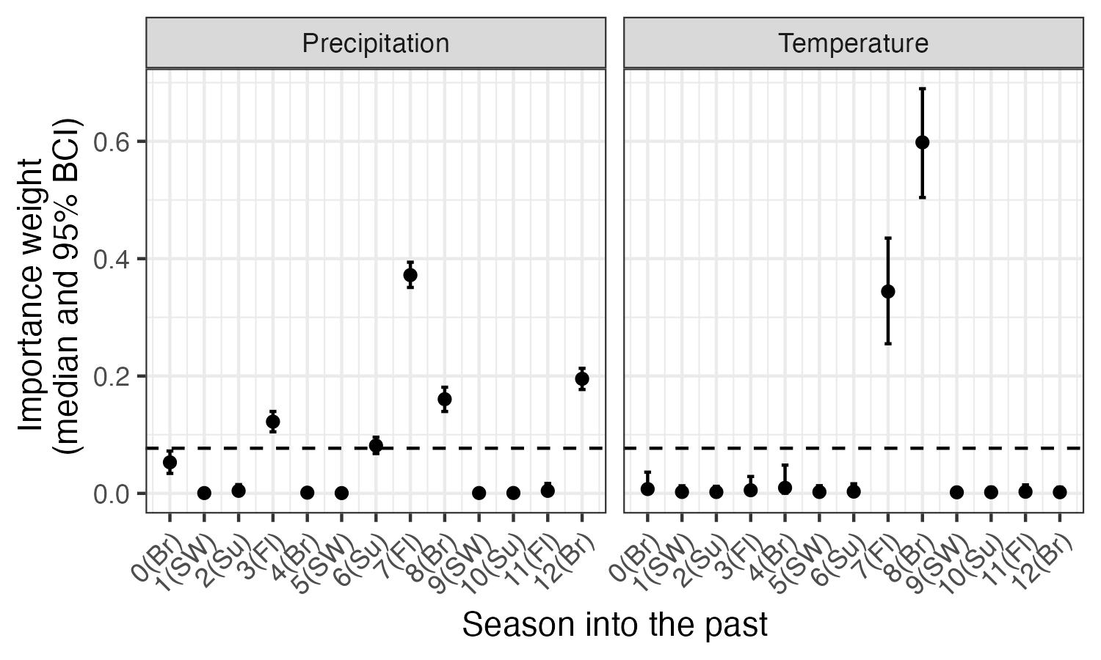
SI Figure 1. Posterior estimates (median and 95% CI) for the seasonal importance weights for climate (precipitation and maximum temperature; w terms, see equation 5). The dashed horizontal line indicates the ‘null’ weight in which all time periods would have equal weights. Any weights that extend clearly above this line suggest significant importance of the corresponding climate variable during that season to pinyon jay abundance. Seasons are based on pinyon jay biology and include: Br (breeding; February - May), Fl (fledging; May - June), Su (summer localized foraging; July), and SW (summer and winter dispersed foraging or ‘irruption’ period; August - January).

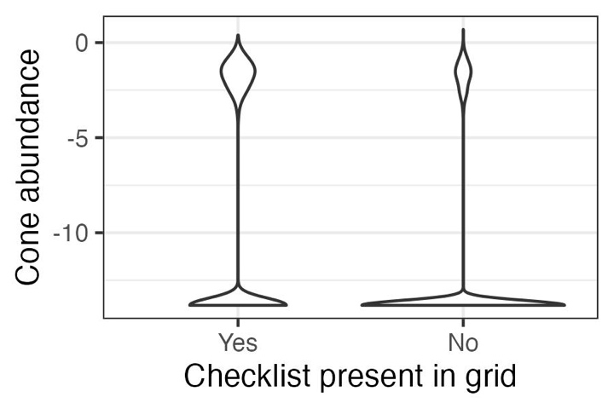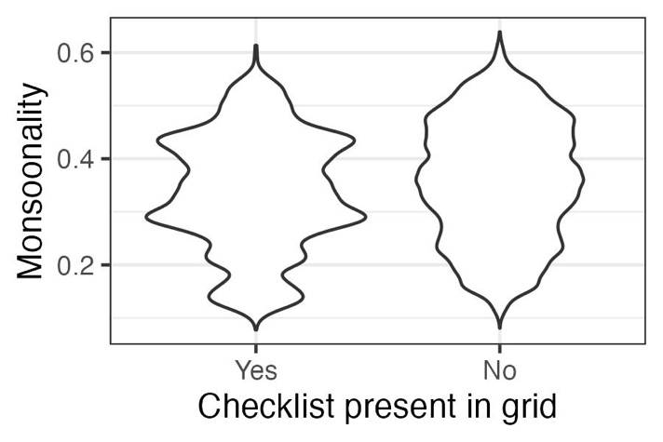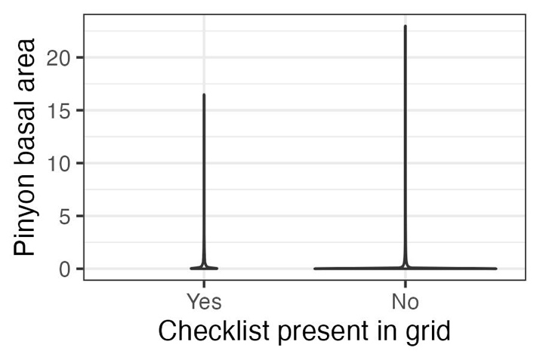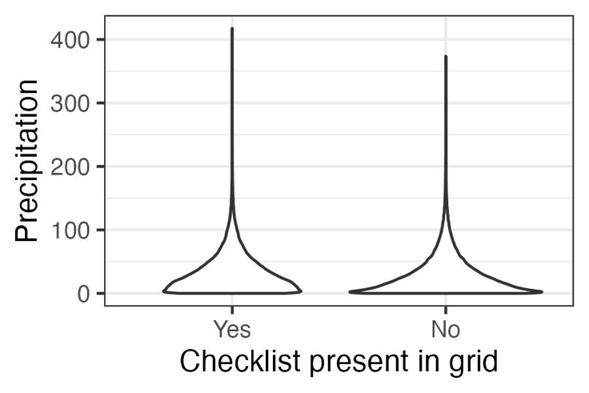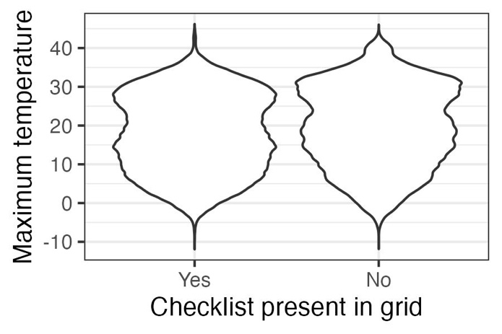
SI Figure 2. Validation results supporting the use of space-for-time substitution of replicate checklists within sampling polygons. To use replicate eBird surveys within a year at a location in models such as N-mixture or occupancy models, checklists need to represent sites that display the full range of values for covariates of interest. In general, checklists in our dataset meet these criteria. Data represented here are values for all raster grid cells for all years (~1 million grid cells, depending on covariate). Thus, for the two covariates for which we are missing the upper tails, (a) cone availability and (e) pinyon basal area, these represent extreme outliers (<1% of total values in the dataset; ~20-200 raster grid cells, depending on covariate).

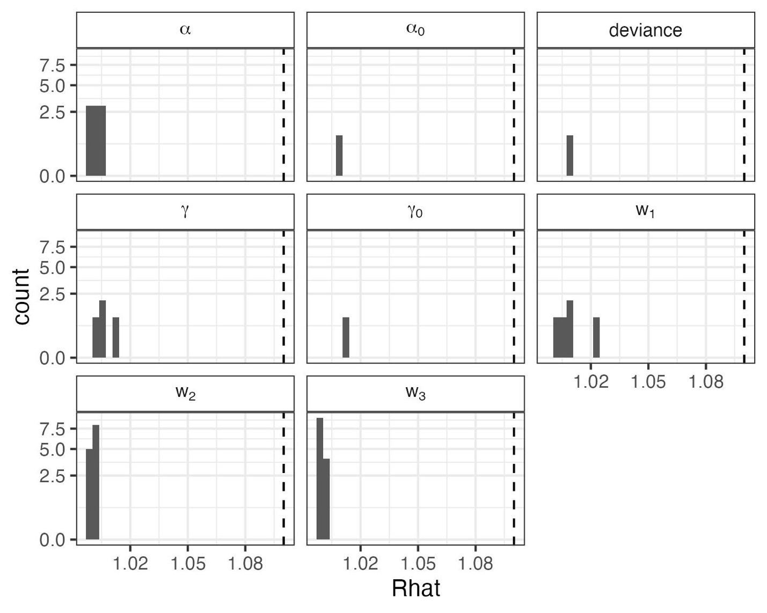
SI Figure 3. Convergence statistics for stochastic parameters in the N-mixture for representing biological ($α$ and $α_{0}$) and detection ($γ$ and $γ_{0}$) covariate effects, deviance (an overall index of model fit), and the cone and climate weights (w₁, w₂, and w₃). All parameters converged with potential scale reduction ($\hat{R}$) values < 1.1 (dashed line).
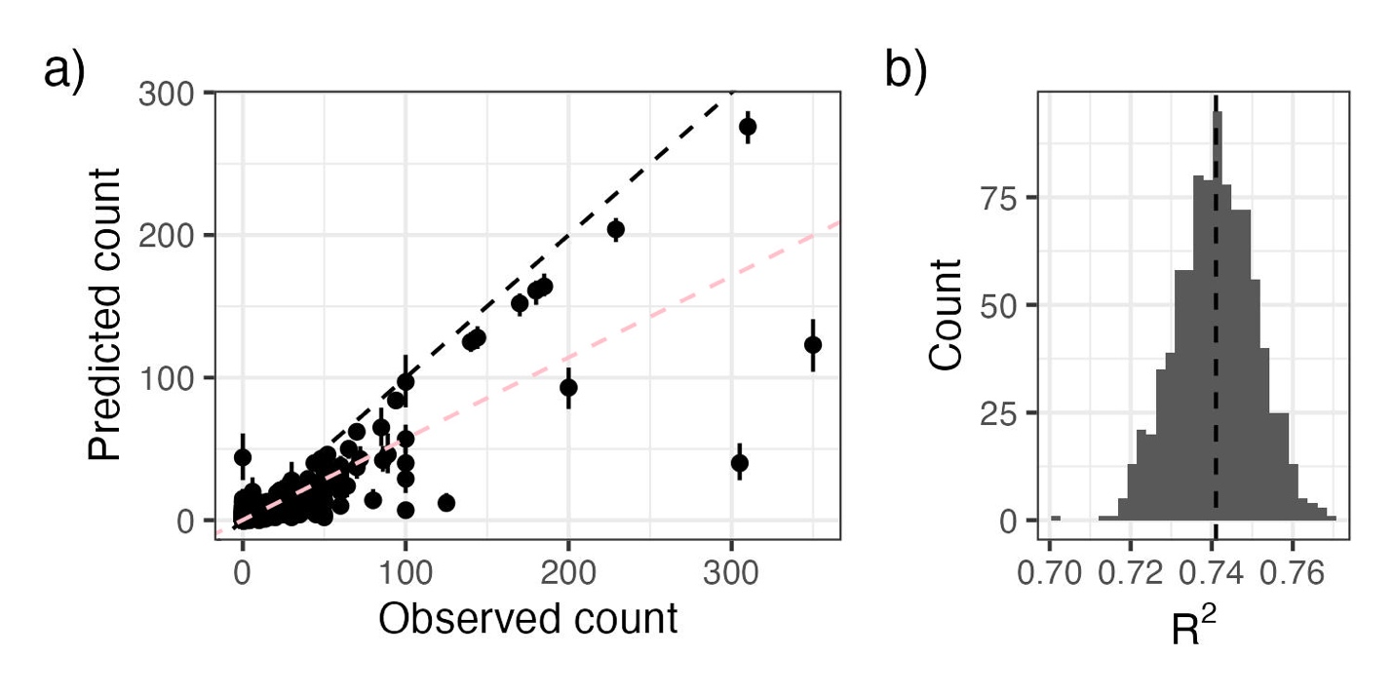
SI Figure 4. As an evaluation of goodness-of-fit, we examined a) the relationship between observed pinyon jay counts and counts predicted from the model (median and 95% Bayesian Credible Interval) and b) the R² of this relationship from ~1000 posterior samples. In a), the black dashed line represents the 1:1 line; the pink line corresponds to the relationship between predicted and observed bird count values. In b) the dashed vertical line represents the mean R².

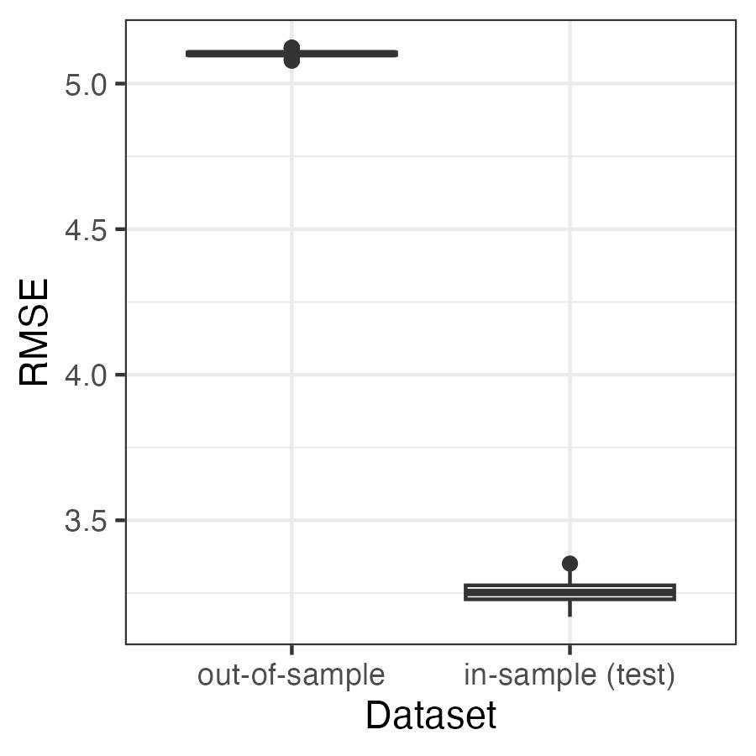
SI Figure 5. Root mean squared error (RMSE) to evaluate the predictive ability of the model applied to the in-sample (“test”) and out-of-sample datasets. Values for RMSE are on the scale of the data (counts of pinyon jays per square kilometer). The RMSE values are relatively small compared to the range of possible counts in a checklist (0 to 350 birds per hectare in our test dataset).

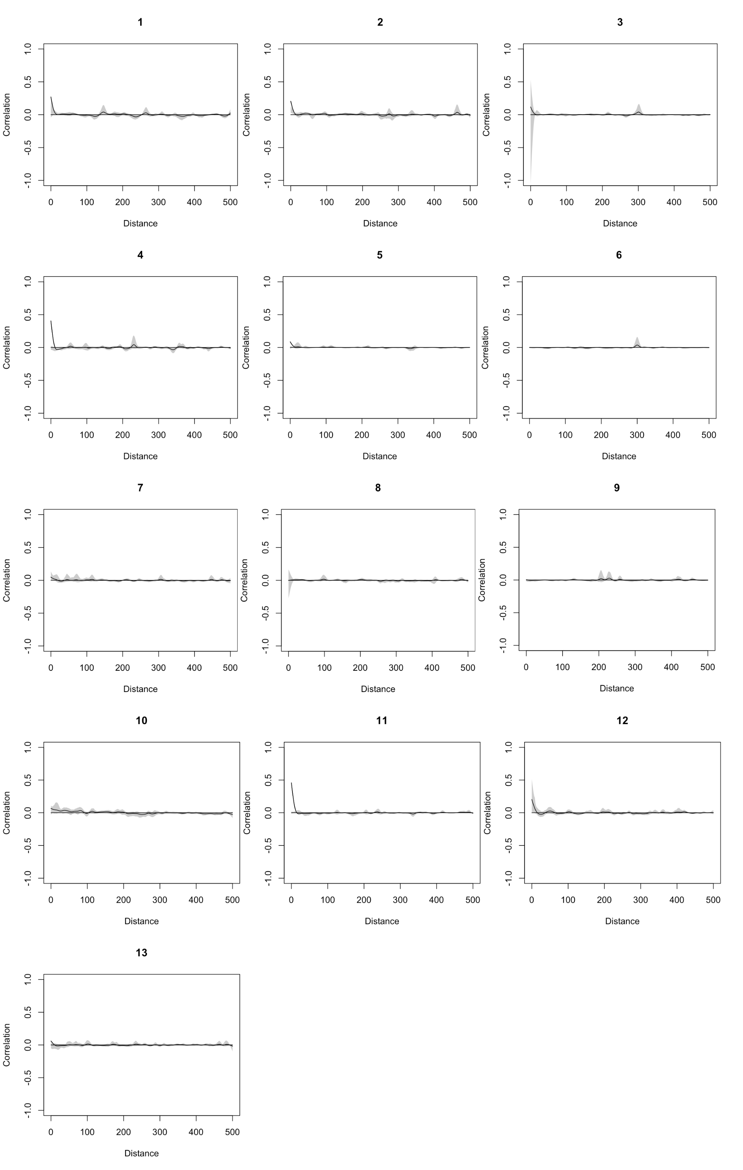


SI Figure 6. Evaluation of spatial autocorrelation (Pearson correlation on the y-axis) for residuals in each year (year indices are indicated above each figure panel, where 1 = 2010, 2 = 2011, …, 13 = 2022). Distance values are in kilometers. There was no consistent evidence of spatial autocorrelation of residuals.

