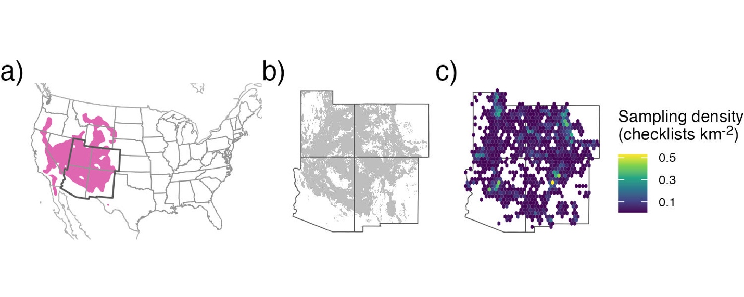
Figure 1. The full species range for (a) pinyon jays (pink region; data from eBird Status and Trends), with our study region delineated by the darker borders (southwestern USA, including Arizona, Colorado, New Mexico, and Utah). The (b) range of two-needled pinyon in our study region, along with the (c) sampling density (in checklists km⁻²) across all years for pinyon jay based on eBird data (2010-2022) after spatial and temporal subsampling and filtering checklists to areas with two-needle pinyon basal area as shown in (b).

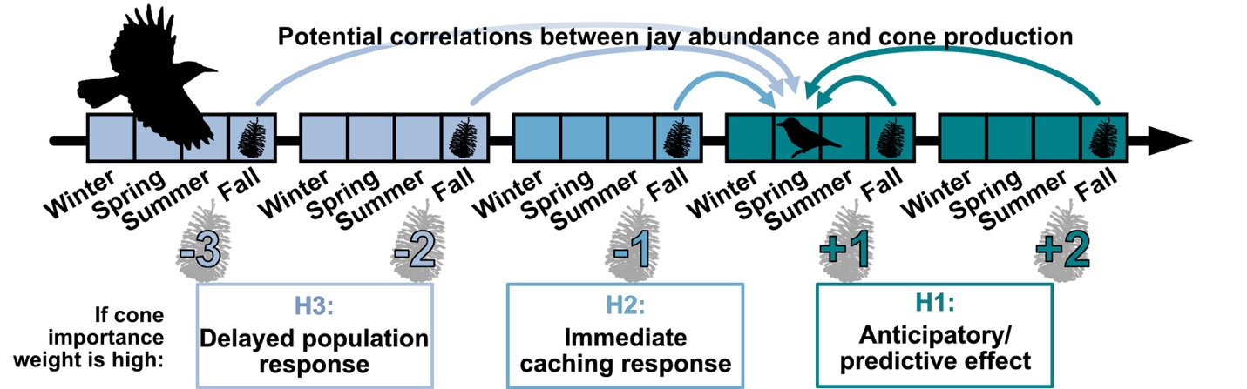

Figure 2. A timeline of hypothesized temporal relationships between pinyon jay abundance and pinyon cone availability. Three hypotheses describe how jay abundance in a given focal year (e.g., bird icon in timeline) is related to pinyon cone (seed) production in past and future time periods (cone icons along timeline), including H1: jays “anticipate” seed availability through utilization of other food resources (e.g., acorns, juniper berries) that mature more quickly than pinyon seeds or because they see pinyon cones developing in an area; H2: jays respond “immediately” to pinyon seeds produced in the previous fall and winter by nesting near cache sites the following spring nesting season; H3: jays have a “delayed” response to seed availability as the young produced during the caching year enter the breeding population 1.5-2 years later. The numerical values along the bottom of the timeline (-3, -2, …, +2) indicate potential temporal coupling (past, concurrent, future years) between jays and pinyon seeds.

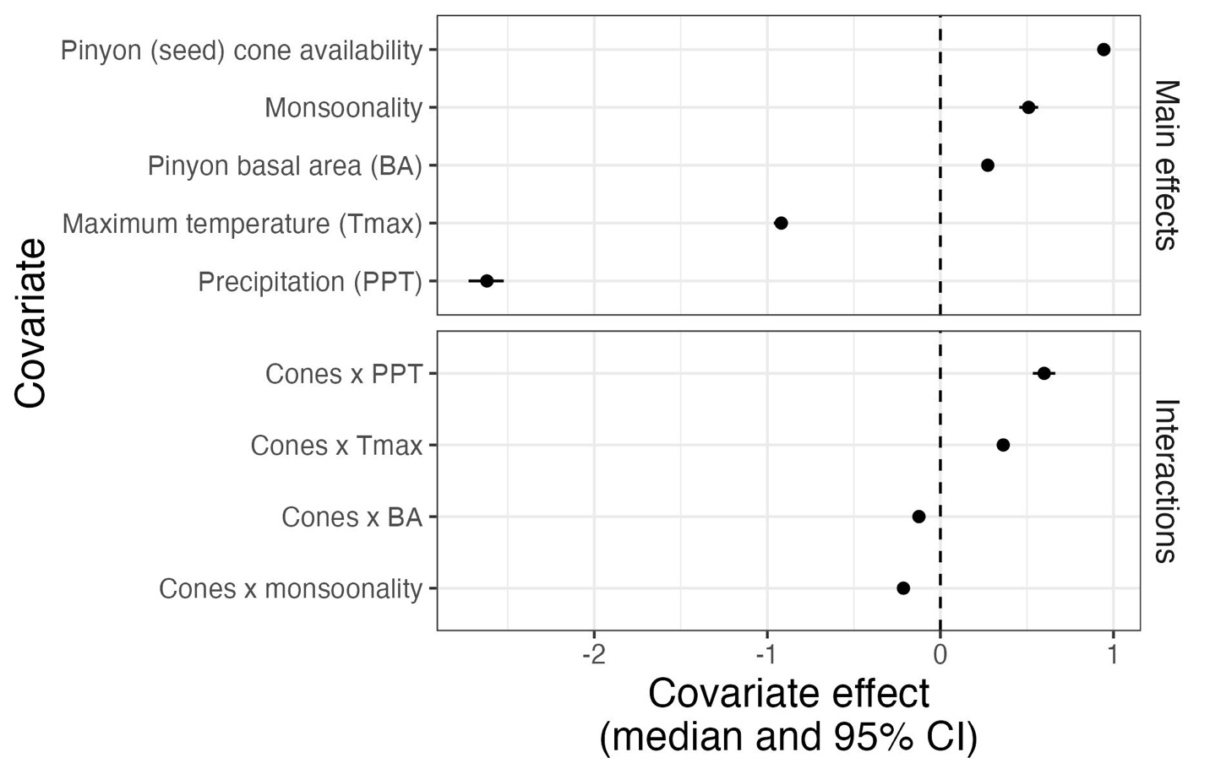
Figure 3. Covariate effects for all main effects and all 2-way interactions involving pinyon cone production (“Cones”). All covariates were standardized, allowing for comparison of the effect sizes of the main effects across covariates. Covariate effects are shown as the posterior median (filled symbols) and 95% credible interval (CI, whiskers); any covariate effect with a 95% CI that crosses the dashed line at zero indicates that the corresponding covariate or interaction have no clear effect on pinyon jay abundance.

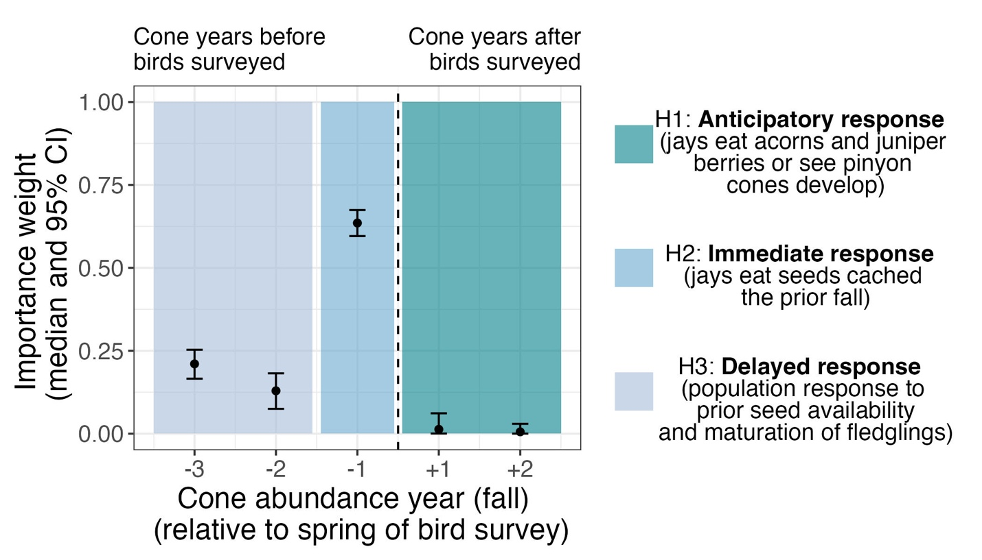
Figure 4. Posterior estimates (median and 95% CI) of the importance weights (w terms, see equation 5) describing the temporal coupling between pinyon jay abundance and pinyon cone (seed) availability (see Figure 2). Colored boxes indicate time periods that align with the three ecological hypotheses describing an anticipatory (H1), immediate (H2), and delayed (H3) response of jays to pinyon seed availability. The dotted vertical line separates periods that align with birds responding to past cone availability (left of the dotted line; H2 and H3) versus periods associated with birds responding to future seed availability (right of dotted line; H1).

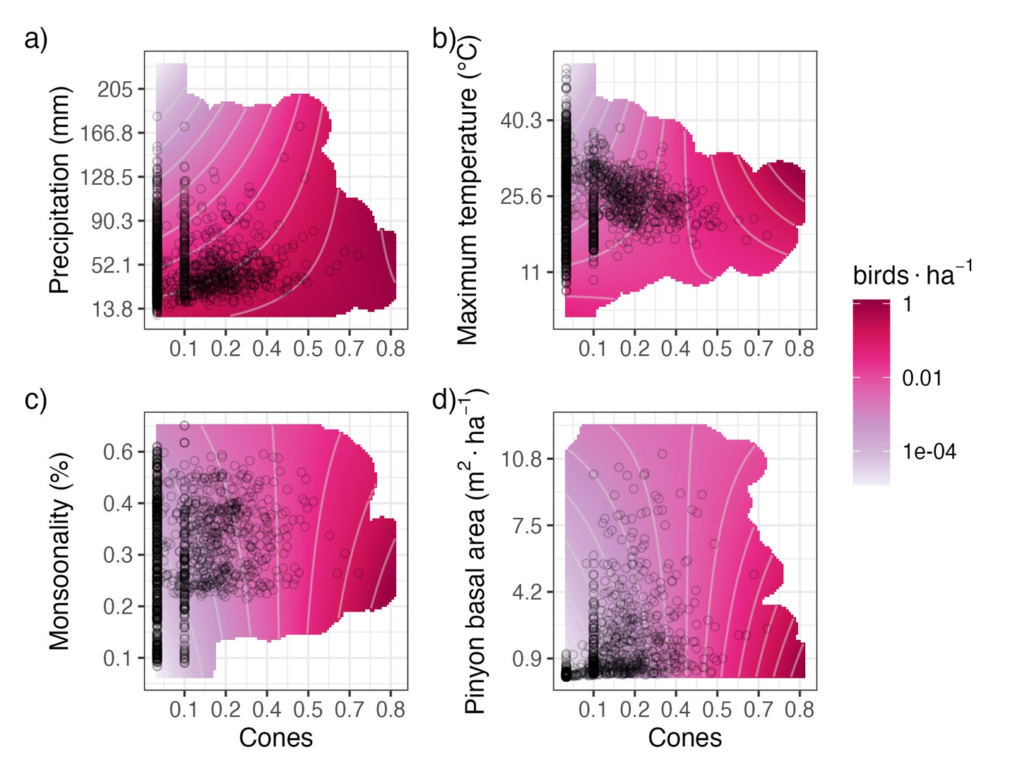

Figure 5. Interaction plots for the four covariates that significantly interacted with pinyon cone (seed) availability to influence pinyon jay abundance (see Figure 3), including: a) precipitation, b) maximum temperature, c) monsoonality, and d) pinyon basal area. The contour lines and color (pink) intensity denote the predicted number of birds per hectare, where darker pink/magenta colors correspond to a greater number of birds associated with that combination of covariates. Black circles represent a random sample of the observed covariate data, and the pink shading is trimmed to exclude covariate values that were not represented in the data.

