**Title:** Caching in: Tree masting influences populations of a declining avian species

**Author List**: Ana Miller-ter Kuile1,2, Andreas P. Wion3, Kyle C. Rodman4, Kiona Ogle1, Jamie S. Sanderlin2

**Author Affiliations**:

1 Northern Arizona University School of Informatics, Computing, and Cyber Systems, Flagstaff, Arizona, USA

2 USDA Forest Service Rocky Mountain Research Station, Flagstaff, Arizona, USA

3 Forest Stewards Guild, Santa Fe, New Mexico, USA

4 Ecological Restoration Institute, Northern Arizona University, Flagstaff, Arizona, USA

**Corresponding author:** Ana Miller-ter Kuile, ana.miller-ter-kuile@nau.edu, Northern Arizona University School of Informatics, Computing, and Cyber Systems, 1295 Knoles Drive, Flagstaff, Arizona 86011

# Conflict of Interest

The authors declare no conflicts of interest.

# Author Contributions

AM-tK, APW, and KCR conceived the ideas; AM-tK, KO, and JSS developed statistical methods; AM-tK and KCR developed novel data layers and ran statistical models; AM-tK led the writing of the manuscript with support from APW and KCR. All authors contributed to the drafts and gave final approval for publication.

**Statement on Inclusion**

The authors reside within the study area. We shared preliminary results with wildlife biology land managers in the region and intend to provide a 1-page report to managers and others aimed at conserving two-needle pinyon pine and pinyon jay.

# Data Availability

Data and code for this paper are available on Zenodo (get up there!)

# Abstract

1. [Big picture and gaps]
2. [Methods]
3. [Results]
4. [Synthesis]

# Keywords

seed production, interannual climate variability, mutualism, *Pinus edulis*, *Gymnorhinus cyanocephalus*, resource availability, species interactions

# 1 Introduction

Species interactions, including predation, herbivory, competition, and mutualisms, shape the functioning of every ecosystem (Tylianakis et al., 2008). Mutualist relationships, in particular, are threatened by environmental change across the globe - the loss of one interaction partner often leads to the co-extinction or functional extinction of the other and the loss of ecological functions maintained by mutualist interactions (Bascompte et al., 2019; Donoso et al., 2020; Valiente‐Banuet et al., 2015). For example, the loss of large-bodied seed dispersers changes ecosystem functions such as carbon storage (Brodie et al., 2025) and the global pollinator decline is likely to influence not only crop production (Burkle et al., 2013; Reilly et al., 2024), but also the structure and diversity of plant communities (Artamendi et al., 2024; Potts et al., 2010).

Interactions between plants and their seed dispersers (“synzoochrony”; (Gómez et al., 2019) are an important subset of mutualistic interactions that shape plant and animal communities (Pearse et al., 2016; Qiu et al., 2023). In seed dispersal interactions, plants often benefit by being dispersed further from conspecifics and pathogens (Comita et al., 2014; Connell, 1971; Janzen, 1970) or by being buried by seed dispersers (“scatterhoarding”, (Elwood et al., 2018). Animals benefit by eating many of the seeds they disperse, and in the case of scatterhoarders, stashing seeds for later away from predation by other seed eaters (Vander Wall, 2003). However, such interactions can also become negative for plants when limited seeds are available, with seed dispersers instead becoming seed predators (Bogdziewicz et al., 2020).

Many plant species whose seeds are readily eaten by seed predators (e.g., insects, rodents, birds) exhibit “masting” patterns in which, at the population level, plants produce a synchronous and abundant seed crop in particular years - animals will still eat many seeds but at least a few seeds will be dispersed to areas favorable for germination (Vander Wall, 2002). Masting occurs for a variety of reasons, including climate favorability and seed predator avoidance (Qiu et al., 2023) For seed dispersers, masting means that seed availability is unreliable across space and time, and thus, interactions between masting plants and seed dispersers are also likely to differ based on the availability of seeds, frequency of masting, alternative food resources, interannual climate variability, and habitat characteristics (Chamberlain et al., 2014; Elwood et al., 2018; McKinnon et al., 2017; Pearse et al., 2016; Sawaya et al., 2018; Simon et al., 2023). Further, these relationships are likely to have complex temporal patterns (e.g., lags between seed availability and seed disperser population increases; (Moore & Dittel, 2020). Understanding the relationships in space and time between seed production in masting species and seed dispersers, generally, is an important first step in understanding the ecology and evolution of the complex species interaction of seed dispersal, as well as the conservation and management of ecosystems relying on this ecosystem function (Moore & Dittel, 2020).

In temperate conifer forests, birds are primary seed dispersers that interact with masting species (Pesendorfer et al., 2016; Vander Wall, 2023). A notable example is the relationship between the two-needle pinyon pine *(Pinus edulis*) and the pinyon jay (*Gymnorhinus cyanocephalus*) in the western US (United States). In this close mutualism, jayscache seeds as a food resource throughout the landscape, which, in turn, can help to promote new regeneration of the pinyon pine (Floyd, 1982; Ligon, 1978; Wiggins, 2005). Piñon pine is a masting species, so jays have adapted to taking advantage of the pulse of resources through the evolution of morphological traits such as seed-storing esophageal pouches and behavioral traits such as long-range foraging dispersal (“irruption”) and flock-based social structures that help birds find, disperse, and store large numbers of seeds (Bednekoff & Balda, 1996; Ligon, 1978; Marzluff, 1988; Marzluff & Balda, 1988; Stotz & Balda, 1995). Pinyon jays have been declining over the last several decades, but the cause of their decline is a complex and unknown set of drivers, which could include climate, habitat change, and food resource availability (Boone et al., 2018; Van Lanen et al., 2023). Concurrently, large-scale mortality events of two-needle pinyon have occurred since the early 2000s, driven by extreme drought and insect outbreaks (Breshears et al., 2005; Meddens et al., 2015), with only limited tree regeneration to support the next generation of forests (Redmond et al., 2018). Thus, the number of living pinyon pine on the landscape has declined (Shaw et al., 2005), coinciding with a decline in the seed production of the remaining live trees (Redmond et al., 2012; Wion et al., 2025). The close mutualism between pinyon jays and pinyon pine suggests that these tree mortality events and declines in seed production may be linked to declines in populations of pinyon jays.

In this study, we aimed to determine the temporal dynamics and context dependence of the relationship between piñon pine and its key seed disperser, the pinyon jay, in the Southwest US. To leverage the broadest spatial and temporal availability of data on pinyon jay abundance, we used eBird (Sullivan et al., 2009) data (13 years; 2010 - 2022) to evaluate how pinyon jay abundance related to piñon pine seed availability (e.g., Wion et al., 2025) and potential mediating factors such as climate and habitat structure. Specifically, in this study, we evaluate: 1) what is the magnitude and time scales of the relationship between birds and piñon pine seed availability? and 2) how is this relationship mediated by habitat and climate variables that vary by site and/or year? Understanding these patterns is not only crucial for the conservation of pinyon jays but also builds a general framework for evaluating the context dependence of seed dispersal interactions and how ongoing habitat and climate changes may shape these interactions in the future (e.g., temporal mismatches in birds and resources (Belitz et al., 2025).

# 2 Materials and Methods

### 2.1 Study region and pinyon jay and pine relationship

Pinyon jays are a widespread species that occurs across the western US (California, Nevada, Utah, Arizona, Colorado, New Mexico). In this study, we focused on the intermountain and southwest regions of the US where broad-scale information on two-needle pinyon cone production (as a proxy for seed production) was available (Wion et al., 2025). It is likely that pinyon jays rely on other species of pinyon pine (e.g., *P. cembroides, P. monophyla*) and other masting species (e.g., oaks) across their range, but these species lack wide-scale estimates of seed production. Previous studies have suggested that pinyon jays may “predict” cone availability with visual cues to cone maturation (Ligon, 1978); while other work has documented nesting birds near cache sites from the previous year (Stotz & Balda, 1995). Thus, we developed our model with a temporal component that incorporated both potential “predictive” effects of cones and “response” effects (e.g., spending time near cache sites, delayed population responses). These predicted temporal relationships between pinyon jays and two-needle pine cone production can be found in Figure 1.

### 2.2 Covariate data

To investigate relationships between pinyon jays and piñon pine seed production, we developed a statistical model that included cone production and other mediating factors related to habitat structure and interannual climate.

Annual cone production data for two-needle pinyon were developed at a 4-km resolution by Wion et al (2025) as follows. Because cone production for this species is highly sensitive to climate during two discrete periods of phenological development (Forcella, 1981), counts of cone production were regressed against these weather conditions, and the resulting slope coefficients were used to extrapolate across the study area. Cone production was then modeled using 4-km monthly PRISM (Parameter-elevation Regressions on Independent Slopes Model; (PRISM Climate Group, 2025) climate data from 1900-2024, masked to the distribution of this species (Wilson et al., 2013). While this model predicts cone availability, not seeds, the two are highly correlated in co-occurring pine species (e.g., *P. ponderosa* (Shepperd et al., 2006). We used the cone production dataset both as a direct measure of pinyon seed availability and a proxy for the availability of other seeds eaten by pinyon jay (e.g., acorns, juniper berries) that respond to the same climate signals as pinyon pine, but with different temporal lags (1-year lag for acorns and juniper berries, 2-year lag for pinyon pine; (Parmenter et al., 2018).

As an indicator of habitat structure, we derived yearly basal area of two-needle pinyon from 2010 to 2022 by combining basal area (BA) maps for this species from the 2000s decade (Wilson et al. 2013) and annual maps of tree cover from v.3.0 of the Rangelands Analysis Platform (RAP) (Allred et al., 2021). We used these canopy cover maps to annualize the species BA maps, and to project them forward in time using several steps. First, we aggregated RAP canopy cover in each year from a 30-m to a 250-m resolution (using the mean value) to align with BA maps. Next, for each 250-m pixel, we divided pinyon basal area by percent canopy cover in that same location (i.e., the mean canopy cover from 2000 to 2009) to calculate the amount of pinyon BA represented by each unit of canopy cover (i.e., an expansion factor). Finally, we used these pixel-specific expansion factors and differences between 2000-2009 cover and the cover of a focal year (e.g., 2010) to adjust pinyon BA up or down in each pixel and year from 2010 to 2022 based on remotely sensed estimates of canopy cover. This approach allowed for both increases or decreases in pinyon BA throughout our study period based on patterns of ingrowth or mortality, respectively, and qualitatively aligned with patterns of forest change in different locations throughout the US Southwest. For this study, we aggregated these 250-m grids to a 4-km resolution to align with other covariates.

In addition to these covariates, we also gathered gridded climate data relevant to bird biology (physiology and relative food availability) (Ligon, 1978; McDermott & DeGroote, 2016; Skagen & Adams, 2012; Stotz & Balda, 1995) from PRISM (PRISM Climate Group, 2024). As time-varying covariates, we obtained monthly maximum temperature and monthly total precipitation, which we then compiled into seasonal variables based on important periods in the jay life cycle (Wiggins, 2005). To represent spatial gradients in precipitation seasonality, which affects plant communities and resource availability, we also calculated the percentage of the 30-year monthly normal precipitation falling in the months of July-September (i.e., the North American monsoon, referred to as “monsoonality” (Adams & Comrie, 1997).

### 2.3 eBird filtering and subsampling

To estimate pinyon jay abundance in relation to recent (2010-2022) seed abundance, we used data from eBird (Sullivan et al., 2009) from the four states of interest (Arizona, Colorado, New Mexico, and Utah) and further filtered pinyon jay observations to areas with pinyon pine vegetation cover in the 2000s (Wilson et al., 2013). We chose to use eBird data because it has broad spatial and temporal coverage within the region of interest and equivalent spatial scale to compare bird abundance and our covariates (4x4 km grid cells). This covariate resolution is too fine for many long-term, broad-scale standardized monitoring protocols, such as Breeding Bird Survey (ca. 40-km transects; (Sauer et al., 2020).

eBird is participatory science data, meaning that members from the public collect bird observation data and contribute to the eBird database. Thus, these data often require subsetting to ensure spatial and temporal consistency. We followed filtering methods from the eBird database curators and similar studies (Robinson et al., 2018; Strimas-Mackey et al., 2023). Specifically, we selected data that represented only complete checklists (e.g., observers recorded all birds of all species observed, not just individuals of species of interest). We selected checklists from the nesting season (late February to early May; (Wiggins, 2005) and included only observations of “stationary” and “traveling” protocols. We considered only the nesting season because this is a time of year in which birds are more stationary, so drivers of local bird abundance are easier to evaluate (Ligon, 1978; Wiggins, 2005). We only included checklists that were collected in under five hours, 0-5 km in distance, and with ten or fewer observers.

eBird collates participatory science data which are not collected under standardized protocols with systematic sampling designs. As such, they do not explicitly control for sampling location, effort, or survey methods, so we also performed data cleaning and subsampling steps following standard practices (Robinson et al., 2018). To do this, we divided the landscape into 4x4 km grid cells to match the spatial scale of the covariates. We spatially sub-sampled eBird observations to include a set of checklists in each grid cell that represented relatively equal sampling effort across time and space. First, to remove spatial bias, we subsampled the number of checklists per 4x4 km grid cell based on the year with the fewest checklists per grid cell (2010; 4 checklists per cell). After filtering to this level, we still had fewer checklists overall in early years. Thus, we further reduced temporal bias by subsampling checklists again so that we had equal sample sizes across years based on the year with the fewest checklists (*n* = 1715 checklists in 2010). We performed this temporal sampling randomly (e.g., not by 4x4 km grid cell). We also removed all checklists within 10 km of the exterior edges of the four states for which we had data (Arizona, Colorado, New Mexico, and Utah) since we had masked some other covariate layers to these states and observations near edges may have misrepresented values for pinyon basal area and cone production. Of 833,834 checklists for the region in the nesting seasons between 2010-2022, we ran our model on 22,295 checklists (average: 1.4 (SE: 0.01) checklists per grid cell in a specific year). We downloaded eBird data in May (Colorado and New Mexico) and June (Arizona and Utah) 2024 (Cornell Lab of Ornithology, 2024a, 2024b). In our final dataset, pinyon jays were observed in 600 (2.7%). The maximum number of birds observed in one survey in this dataset was 350 (mean: 0.42; SE: 0.04).

### 2.4 Modeling relationships between cones and birds with eBird

To explore relationships between pinyon jay abundance and covariates related to seed availability, habitat, and climate, we used an N-mixture model which included an observation process for eBird data and a biological process model that estimates latent “abundance” values (Royle, 2004). The observation process models include covariates that describe variation in detection probabilities (e.g., survey conditions). The biological process includes a likelihood that describes the biological drivers of latent abundance and included the primary variables of interest. Because we were interested in both the effects of current covariate values and past values (e.g., seed availability and climate conditions in previous years and seasons), these biological covariates include a stochastic antecedent modeling structure that allows seed abundance to have both lead and lagged effects (e.g., bird abundance can respond before or after cone and seed maturation) and other yearly climate variables to have lagged effects (Ogle et al., 2015).

Replicate surveys within a closed time and location are a requirement of these types of models that incorporate an observation process (e.g., occupancy and N-mixture models; (Royle et al., 2005). To use unstructured or semi-structured eBird data in this way (e.g., as a space-for-time substitution), checklists must be collected at locations that describe the range of potential covariate values (e.g., are not biased toward certain values of covariates of interest, (Hochachka et al., 2023). We verified that checklists within our filtered dataset (Section 2.3) met this assumption by comparing values for all covariates at locations with checklists to all gridded data available for those covariates (described more in Section 2.2). Thus, we verified that we could use multiple checklists within a location and year as replicate “surveys” with which to estimate detection probability.

### 2.4.1 Observation process for eBird

In our model, observed count data from eBird checklists were used to estimate a “true” latent abundance, , which is dependent on space and time. eBird data were provided in an observation process model that incorporates covariates that impact bird detection. Observed count data were binomially distributed based on a detection probability for birds in a year and the “true” latent abundance for the space and time in which those checklists occurred, , being the total possible “trials”.

eBird checklists are recorded with a geographical point location and also often include information about travel distance of the observer (< 5km in our dataset after filtering). Thus, there is spatial uncertainty arising from two sources: 1) uncertainty in the location in which the survey was conducted (e.g., was the location recorded at the beginning, middle, or end of a survey and at what level of precision) and 2) uncertainty in the location along a survey at which pinyon jays were observed (e.g., were birds observed at the beginning, middle, or end of a walking survey). To account for this spatial uncertainty, we created buffers around each eBird checklist location based on the sampling distance for that checklist (i.e., 1/2 of distance traveled for “traveling” checklists; 0.5 km for “stationary” checklists). Then, we created a merged polygon (“blob”) of all the checklists within a 4x4 grid cell in a given year by merging the buffers of all checklists within a grid cell. Thus, the “blob” and not the underlying 4x4 km grid cell, is the spatial unit at which we estimated abundance, *N*.

eBird observed count data for checklist, , in blob, , and year, , were binomially distributed based on a detection probability, *p*, and the latent true abundance of birds in the checklist:

The detection probability for eBird data included a regression with the detection covariates of start time, duration of survey, speed, and the number of observers for each checklist. See above (Section 2.3) for how we filtered these variables initially based on best practices so that checklists represented similar effort. These covariates all depended on checklist, blob, and year. Thus, the detection component of the model has a likelihood of the form:

where is the underlying detection probability (intercept) and each is the slope of the relationship between detection probability (on the logit scale) and a set of *J* covariates (j = 1, 2, … 5).

### 2.4.2 Biological process of latent pinyon jay abundance with covariates with lead and lagged effects

Latent true abundance of jays in a checklist in a year, was Poisson distributed around an expected rate parameter, , for the blob in which the checklist was located multiplied by the area of the checklist, as follows:

Furthermore, was dependent on a regression of environmental covariates:

In this formulation, covariates include only concurrent effects. These variables in the model included monsoonality and pinyon pine basal area (yearly). Conversely, values for each comprised a stochastic antecedent structure (Ogle et al., 2015) dependent on the covariate, where each was the weighted average value of a set of seasonal or yearly values for that covariate across a defined set of seasons or years. The weights for each covariate across all seasons or years, *l*, , had a Dirichlet prior and sum to 1. The weight, or importance weight, for each season or year indicated how important that value was to the overall effect (larger values of the weight mean more importance of that season or year to that covariate effect). The covariates for which we calculated antecedent weights were seed (cone) production, maximum temperature, and precipitation. Seed (cone) production was considered on a yearly scale (cones are only produced up to one time in a year) and included both lead and lagged effects (e.g., jays “predict” seed years or “respond” to good seed years), and included one prior year and the current year (both “predictive” time periods), and three years after the current year (“lagged” time periods). Lead (“predictive”) years represented years in which “quicker” resources are available (e.g., acorns, juniper berries) and/or birds observe cones developing on trees (Parmenter, “Predict” paper for jays). Lag years represented both the year in which birds cached seeds and years following in which individuals that hatched during the caching year nesting season enter the breeding population (~1.5-2 years; (Marzluff & Balda, 1988); Figure 1). Both temperature and precipitation were at a seasonal scale and only consider lagged effects. The seasons were based on important seasonal biology for pinyon jays, including: breeding (February-April), feeding dependent young (May-June), summer (July), fall and winter foraging, potentially with irruption (August - January) (Wiggins 2005). For seasonal covariates, we considered 12 seasons into the past. We also considered interactions between seed (cone) abundance and all other covariates (pinyon basal area, monsoonality, maximum temperature, and precipitation) to determine how the relationship between cones and birds is mediated by other covariates related to piñon seed reliability and alternative food resources (e.g., juniper berries, acorns, insects).

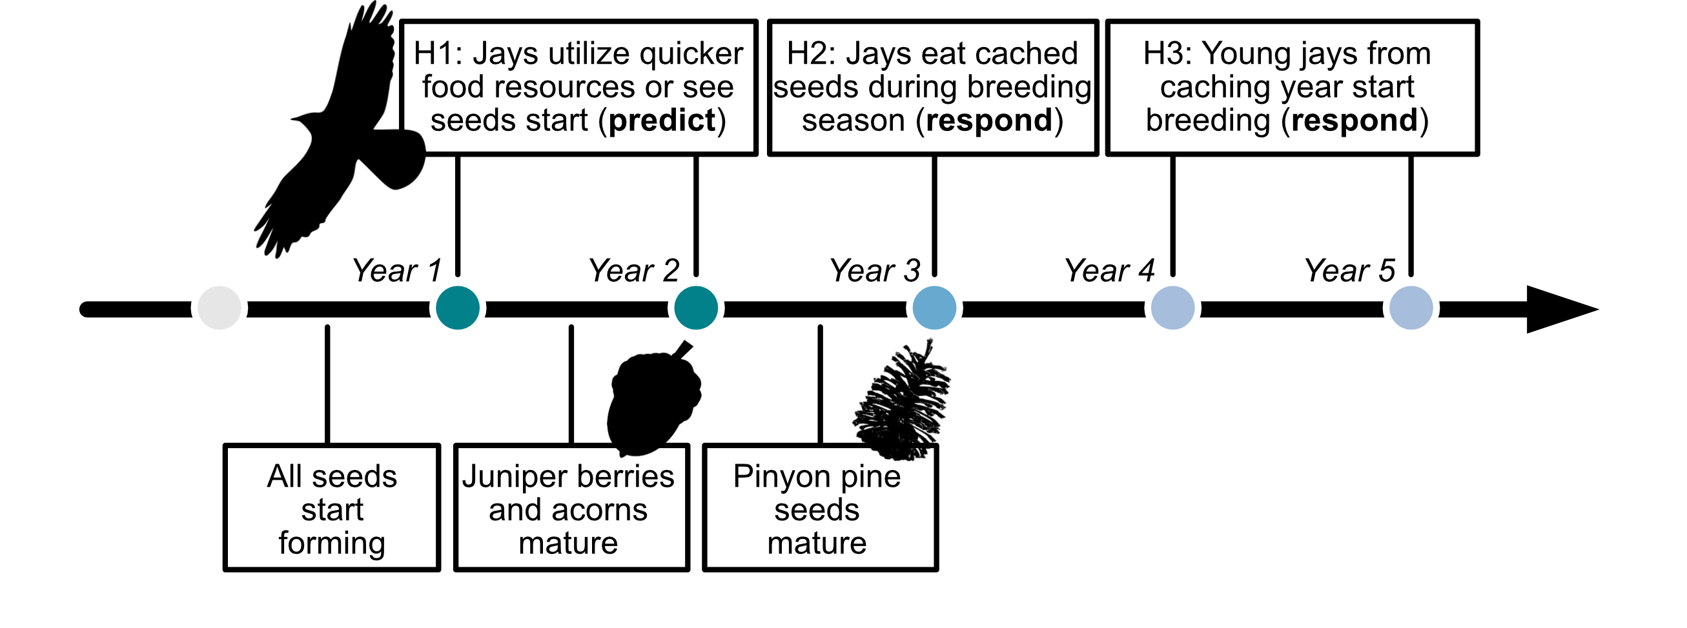

Figure 1: A timeline of hypothesized pinyon jay responses (top) and the progression of seed and cone development (bottom) following a favorable climate year for cone development. We outline three hypotheses driving the temporal relationships between pinyon jay and seed availability, including H1: jays ‘predict’ seed availability through utilization of other foods (e.g., acorns, juniper berries) or because they see cones developing in an area; H2: jays ‘respond’ to seed availability in the nesting season after they cache seeds and H3: jays ‘respond’ to seed availability with a delay as the young from the caching year enter the breeding population 1.5-2 years later.

Because blobs sometimes covered more than one 4x4 km grid cell, we determined the percent of a blob covering each grid cell and then calculated weighted average covariate values based on the covariate values of all overlapped cells times the percent of the blob overlapping that cell. On average, blobs covered 2.13 [SE = 0.01] 4x 4 km grid cells, with a minimum of one grid and a maximum of nine for a single blob.

### 2.5 Model implementation, convergence, and diagnostics

We implemented models in the Bayesian software JAGS (Plummer, 2003, version 4.3.0) using R (R Core Team, 2020, version 4.5.1) and the jagsUI wrapper package (Kellner, 2021, version 1.6.2). We prepared data using the here (Muller, 2020, version 1.0.1), tidyverse (Wickham et al., 2019, version 2.0.0), sf (Pebesma & Bivand, 2023, version 1.0.21), terra (Hijmans, 2020, version 1.8.54), readxl (Wickham & Bryan, 2015, version 1.4.5), exactextractr (Daniel Baston, 2019, version 0.10.0), spatialEco (Evans & Murphy, 2023, version 2.0-2), nngeo (Dorman, 2018, version 0.4.8), auk (Strimas-Mackey et al., 2017, version 0.8.2), lubridate (Grolemund & Wickham, 2011, version 1.9.4), prism (Hart & Bell, 2015, version 0.0.6), FNN (Beygelzimer et al., 2010, version 1.1.4.1), and data.table (Barrett et al., 2006, version 1.17.6) packages.

We initially ran models to generate 4000 MCMC samples with which to determine how many iterations would be needed to reach convergence on each parameter’s posterior distribution. We then used the Raftery diagnostic (Raftery & Lewis, 1995) to determine the necessary number of iterations for each model and re-ran models with more iterations and initial values sufficient to reach convergence based on the raftery.diag() function in the coda package (Plummer et al., 1999, version 0.19.4.1). We assessed model convergence by evaluating trace, history, and autocorrelation plots generated with the mcmcplots package (Curtis, 2010, version 0.4.3). We quantified model convergence by evaluating whether Gelman-Ruman statistics, , for all root nodes in the model were < 1.1 (Gelman & Rubin, 1992). We assessed model goodness-of-fit by comparing observed count data from eBird to predicted count data based on the model mean value for number of birds per checklist. We verified the lack of spatial autocorrelation in observed data by examining the residual variation from the model and its lack of spatial correlation within a year based on spline correlogram using the R package ncf (Bjornstad, 2008, version 1.3-2).

### 2.6 Out of sample model validation

To evaluate predictions outside of data used to train the model, we performed the same set of steps for spatially and temporally stratifying available checklists from eBird (section 2.3 above), ensuring that we selected checklists that were not used in model fitting. We had 20,380 checklists that represented “out of sample” data. We predicted out of sample model fit using ~1000 posterior samples for covariate effects and intercepts from the test dataset and model. We then compared model fit (RMSE and R2 between observed and predicted bird counts) of the test and out-of-sample datasets.

# Results

*Modeled Effects of Seed Availability*

Based on our fitted model, pinyon jay abundance was positively correlated with cone availability ( = 0.95 [0.92, 0.98]). The importance weights of the years considered (two years before cones; three years after cones) indicate the greatest weight the year after cones ( = 0.64 [0.60, 0.67]) and some weight to two and three years after cones ( = 0.13 [0.07, 0.18] and 0.21 [0.17, 0.25], for two and three years after cones, respectively), though negligible weight for the years before cones ( = 0.01 [0, 0.03] and 0.01 [0, 0.06] for two and one years before cones, respectively). In other words, jay abundance in the spring breeding season had a strong, positive relationship with cone production in the prior fall. Abundances also remained higher in these same areas for up to three years after cone production.

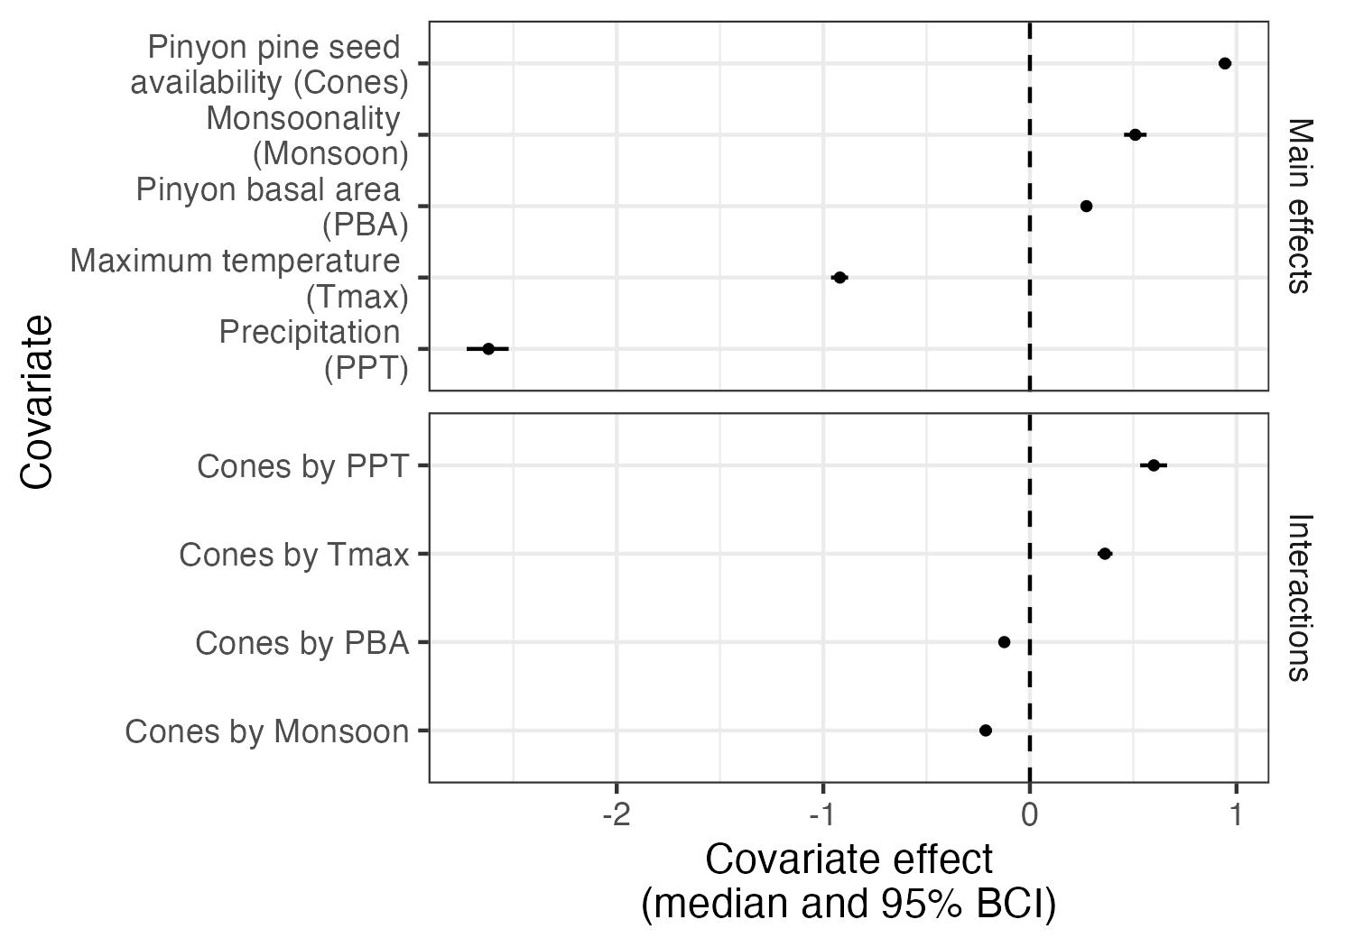

Figure 2: Covariate effects for all main covariates and their interactions with cones. All covariates were scaled and so their relative magnitudes of effect can be compared. All values represent posterior median and 95% Bayesian Credible Intervals and any covariate ranges that cross the dashed line at zero have no clear effect on pinyon jay abundance.

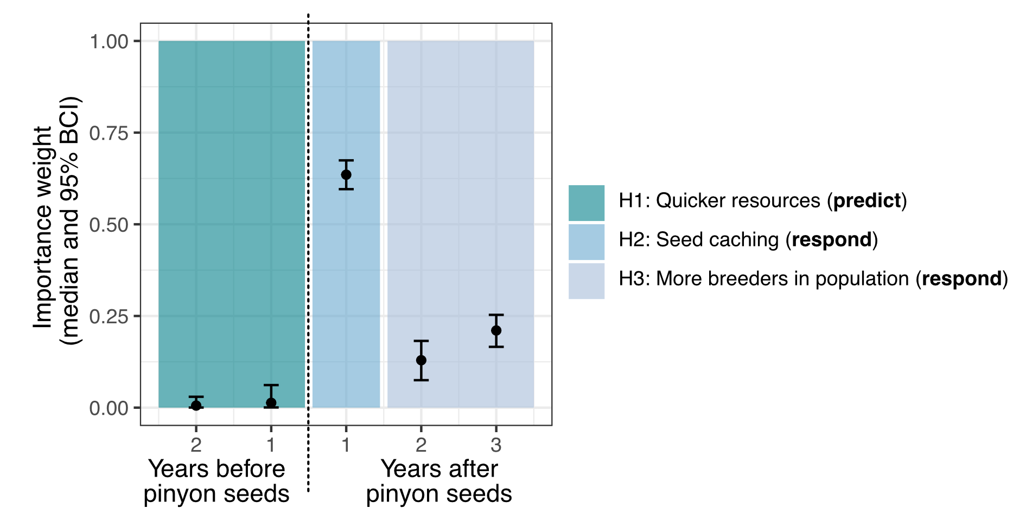

Figure 3: Importance weights for the years considered for the relationship between pinyon jays and pinyon cone (seed) availability. Colored boxes indicate the three ecological hypotheses about the time period(s) of the relationship between jays and cones. The dashed line indicates the distinction between the years before cones (left) and years after cones (right).

*Mediating Effects of Habitat and Climate*

Based on the interactions between cone availability and other covariates in our fitted model, the relationship between pinyon jay abundance and cone availability was stronger at higher values of precipitation ( = 0.60 [0.56, 0.66]) and maximum temperature ( = 0.37 [0.33, 0.40]). Conversely, the relationship between pinyon jay abundance and cone availability was weaker at higher values of pinyon basal area ( = -0.12 [-0.14, -0.11]) and monsoonality ( = -0.21 [-0.25, -0.19]).

*Other Model Effects*

All other covariates in the model had non-zero effects on pinyon jay abundance. Pinyon jay abundance was negatively related to precipitation ( = -2.62 [-2.72, -2.53]) and maximum temperature ( = -0.92 [-0.96, -0.88]). Pinyon jay abundance was positively associated with monsoonality ( = 0.51 [0.46, 0.56]) and pinyon basal area ( = 0.27 [0.25, 0.29]). All covariates were scaled in the model, so the relative magnitudes of these effects can be compared.

Important seasons for precipitation based on importance weights from the SAM model included, in order of importance weights: two years ago during fledging, three years ago during breeding, two years ago during breeding, and one year ago during fledging ( = 0.37 [0.35, 0.39]; 0.20 [0.18, 0.21]; 0.16 [0.14, 0.18]; 0.12 [0.10, 0.14], for each of those seasons, respectively). All other weights were not important (SI Figure 2). In other words, precipitation had a negative relationship with precipitation two breeding and fledging seasons ago, with some negative input from the fledging season last year and the breeding season three years ago. Important seasons for maximum temperature based on the importance weights from the SAM model included: the breeding and fledging seasons two years ago ( = 0.60 [0.50, 0.69] and 0.34 [0.25, 0.44], for the breeding and fledging seasons, respectively). All other weights were not important (SI Figure 2). In other words, high temperatures during the breeding and fledging season two years ago had a negative effect on pinyon jay abundance.

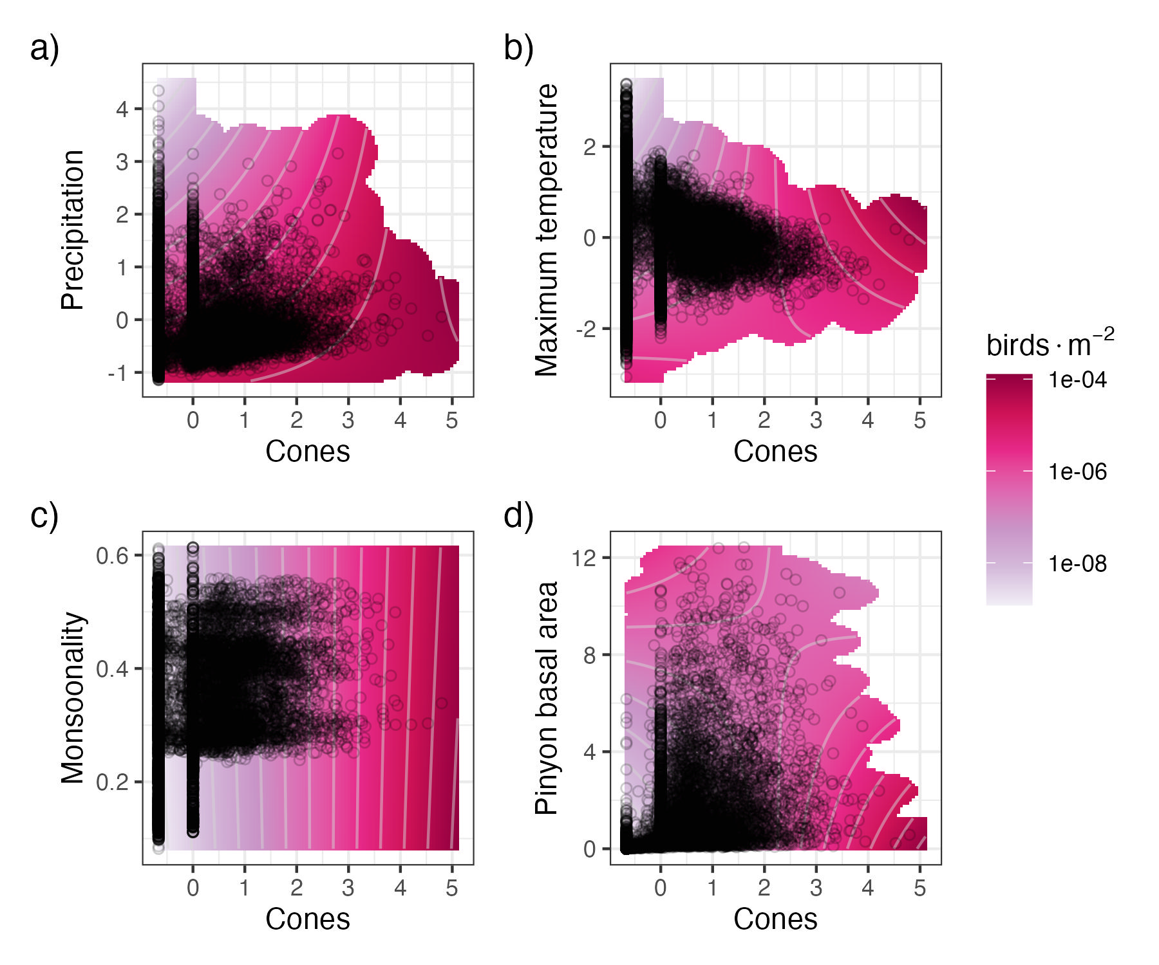

Figure 4: Interaction plots for the four covariates with significant interactive effects with cone (seed) availability, including: a) precipitation, b) maximum temperature, c) monsoonality, and d) pinyon basal area. Darker pink/red color corresponds to a greater number of birds in that combination of covariates. Black circles represent the distribution of the observed data. The predicted number of birds, lambda, is presented on the log scale to better highlight differences.

*Model Goodness-of-Fit*

All parameters in the model converged with an 1.1 (SI Figure 1). The relationship between our observed data and replicated data produced by the model had a mean of 0.74 (SE: 0.0003). In general, the model under-estimated the highest counts but performed well on most other values (SI Figure 3). The RMSE for our in-sample (“test”) dataset had an average value of 3.25 (SE: 0.001) and the out-of-sample dataset had a value of 5.10 (SE: 0.0002; SI Figure 4). Thus, our model predicts slightly better to our in-sample (“test”) data than out-of-sample data, but neither are large on the scale of the count data (counts per checklist ranged from 0 - 350), suggesting good model fit and predictive capacity. We observed no strong spatial autocorrelation in residuals (SI Figure 5).

# 4 Discussion

Here, we demonstrated that pinyon jays have a strong, positive relationship with pinyon pine seed production across the US Southwest, indicating that food resource availability plays a critical role in the abundance and spatiotemporal trends of a declining avian species. Specifically, birds occurred in greater abundance near cache sites the year after high seed production years, with lagged effects that occur over at least two subsequent years. We also found that the relationship between pinyon jay abundance and seed availability is mediated by a suite of habitat and climate variables, including maximum temperature, precipitation, pinyon basal area, and the relative importance of the North American Monsoon (July-September). These interactive relationships suggest a combination of ecological effects, including a stronger relationship with seed availability following “stressful” climatic conditions during the nesting season and a weaker relationship with seed availability in more “suitable” habitat. Determining the relationship between pinyon jays and pinyon pine seed availability and how this relationship is shaped by climate and habitat context is an important step in recognizing potential mechanisms for pinyon jay population changes. We can build on these observations to understand how this important mutualism changes in magnitude or direction through space and time and build an approach for understanding seed dispersal mutualisms in general (Moore & Dittel, 2020).

In many systems with masting tree species, populations of seed predators are known to boom in synchrony with or following large masting events (e.g., (Boutin et al., 2006; Schnurr et al., 2002). This population growth has implications not only for seed predation and dispersal, but also other ecosystem functions and services (e.g., food web responses and disease dynamics (Bogdziewicz et al., 2016; Bregnard et al., 2021; Ostfeld & Keesing, 2000). While we did not observe a “predictive” or synchronous abundance response in pinyon jays (postulated in Ligon, 1978), we did observe that the effects of masting years in two-needle pinyon pine have lasting effects on population dynamics for at least three years (Figure 2). Further, we expect that these lagged responses are due to multiple mechanisms. The first, and stronger, mechanism (~63% of covariate importance weight) is that birds nest in the spring near cache sites from the previous fall (Stotz & Balda, 1995). The second, weaker, mechanism (13-21% of covariate importance weight), is likely a delayed population response from mast-year fledglings maturing to the breeding population (1.5-2 years after fledging; (Marzluff & Balda, 1988). Temporal delays are common in trophic interactions, including seed dispersal, though they are often discounted in food web and interaction network models (Yang et al., 2023). In any system, understanding these delayed responses and their mechanisms will aid in building better predictive models of species interactions (Poisot et al., 2015). Delayed effects may be particularly important to understand in systems with resource pulses (like masting), since they can link population fluctuations to proximal causes amidst the dynamics of systems with intrinsic boom and bust cycles (Clark et al., 2019).

Understanding the context dependence of species interactions helps predict current and future ecosystem states given ongoing anthropogenic changes (e.g., (Liu & Gaines, 2022; Polazzo et al., 2022). However, context dependent results are most useful if variation can be explained by consistent patterns or mechanisms (Catford et al., 2022). We found two predictable patterns in the context dependence of the relationship between pinyon jays and pinyon pine seeds. First, jays rely more on cones following climatic conditions that may be unfavorable for reproduction and population growth (lagged effects of temperature and precipitation, Figure 4 a and b; (Ligon, 1978; Marzluff, 1988). Second, jays rely less on cones in areas with more favorable habitat (higher pinyon pine basal area and higher North American Monsoon influence; Figure 4 c and d; (Boone et al., 2018; Johnson et al., 2016; Ligon, 1978; Neilson & Wullstein, 1983; Van Lanen et al., 2023). These patterns have implications for understanding the seed dispersal interaction between these two species and when it might change in direction or magnitude (Chamberlain et al., 2014). For example, jays may eat more seeds that they cache more quickly following stressful climatic conditions (weakening or shifting the mutualistic interaction); or they may eat fewer cached seeds in habitats with more food resources (strengthening the mutualistic interaction). The mediating effects of climate and habitat on seed dispersal in masting species may be more pronounced since seed dispersers have to be adaptable to pulses of resources when they become available (Clark et al., 2019).

This study highlights how seed dispersal mutualisms likely vary across space and time, especially in ecosystems where plant species mast. For one, climate and food availability interact over multiple years to impact the population dynamics of seed dispersers (Lira et al., 2019). Especially for declining species of dispersers, this temporal component can provide an evidence-based moving window with which to evaluate population trends (e.g., (Rouyer et al., 2011). Further, seed dispersers in masting systems have likely adapted unique strategies for surviving the boom and bust nature of these ecosystems, including wider diets and behaviors that support population persistence (e.g., sociality, irruptive movement (Strong et al., 2015)). This study demonstrates the importance of long-term and broad scale studies for understanding patterns shaping species interactions and how they shape ecosystems (Hughes et al., 2017; Liu & Gaines, 2022; Magurran et al., 2010). To understand the consequences of the temporal and spatial patterns shaping this mutualism, further studies can evaluate this system “from the plant’s perspective”. Specifically, under what climate and habitat conditions do pinyon jays serve as effective seed dispersers? Like many mutualisms, the benefit to pinyon pine may depend on context (Chamberlain et al., 2014; Moore & Dittel, 2020). [Understanding the context dependence of this mutualism is crucial giving the ongoing and future changes, including increased tree mortality and declining seed abundance, which will make it harder for pinyon jays to find seeds. Cite the stuff here from intro.]

Masting systems are defined by dynamic nutrient fluxes (CITE). These effects ripple out to impact whole food webs over the course of years (CITE). While seed dispersers that depend on masting species likely adapted to take advantage of seed resource pulses when they became available, many systems where masting is regulated by climate may face increased variability with climate change as seed production declines or as seed availability becomes more patchy with plant mortality events (CITE). Patterns in seed disperser populations and masting species rely on important feedbacks between interaction partners, with mutualistic interactions becoming predation when there are fewer seed resources (CITE). Like all mutualistic interactions, seed dispersal interactions are at great risk of disappearing with ongoing change across the globe due to processes such as co-extinction (Colwell et al., 2012; Dunn et al., 2009) and phenological mismatches. Building our understanding about the temporal dynamics and context dependence of seed dispersal interactions in masting systems is an important first step in understanding and curbing biodiversity loss in ecosystems across the planet.

**References**

Adams, D. K., & Comrie, A. C. (1997). The North American Monsoon. *Bulletin of the American Meteorological Society*, *78*(10), 2197–2213. https://doi.org/10.1175/1520-0477(1997)078%253C2197:TNAM%253E2.0.CO;2

Allred, B. W., Bestelmeyer, B. T., Boyd, C. S., Brown, C., Davies, K. W., Duniway, M. C., Ellsworth, L. M., Erickson, T. A., Fuhlendorf, S. D., Griffiths, T. V., Jansen, V., Jones, M. O., Karl, J., Knight, A., Maestas, J. D., Maynard, J. J., McCord, S. E., Naugle, D. E., Starns, H. D., … Uden, D. R. (2021). Improving Landsat predictions of rangeland fractional cover with multitask learning and uncertainty. *Methods in Ecology and Evolution*, *12*(5), 841–849. https://doi.org/10.1111/2041-210X.13564

Artamendi, M., Martin, P. A., Bartomeus, I., & Magrach, A. (2024). Loss of pollinator diversity consistently reduces reproductive success for wild and cultivated plants. *Nature Ecology & Evolution*, *9*(2), 296–313. https://doi.org/10.1038/s41559-024-02595-2

Barrett, T., Dowle, M., Srinivasan, A., Gorecki, J., Chirico, M., Hocking, T., Schwendinger, B., & Krylov, I. (2006). *data.table: Extension of `data.frame`* [Dataset]. The R Foundation. https://doi.org/10.32614/cran.package.data.table

Bascompte, J., García, M. B., Ortega, R., Rezende, E. L., & Pironon, S. (2019). Mutualistic interactions reshuffle the effects of climate change on plants across the tree of life. *Science Advances*, *5*(5). https://doi.org/10.1126/sciadv.aav2539

Bednekoff, P. A., & Balda, R. P. (1996). Social caching and observational spatial memory in pinyon jays. *Behaviour*, *133*(11/12), 807–826.

Belitz, M. W., Larsen, E. A., Hurlbert, A. H., Di Cecco, G. J., Neupane, N., Ries, L., Tingley, M. W., Guralnick, R. P., & Youngflesh, C. (2025). Potential for bird–insect phenological mismatch in a tri‐trophic system. *Journal of Animal Ecology*, *94*(4), 717–728. https://doi.org/10.1111/1365-2656.70007

Beygelzimer, A., Kakadet, S., Langford, J., Arya, S., Mount, D., & Li, S. (2010). *FNN: Fast Nearest Neighbor Search Algorithms and Applications* [Dataset]. The R Foundation. https://doi.org/10.32614/cran.package.fnn

Bjornstad, O. N. (2008). *ncf: Spatial Covariance Functions* [Dataset]. The R Foundation. https://doi.org/10.32614/cran.package.ncf

Bogdziewicz, M., Crone, E. E., & Zwolak, R. (2020). Do benefits of seed dispersal and caching by scatterhoarders outweigh the costs of predation? An example with oaks and yellow‐necked mice. *Journal of Ecology*, *108*(3), 1009–1018. https://doi.org/10.1111/1365-2745.13307

Bogdziewicz, M., Zwolak, R., & Crone, E. E. (2016). How do vertebrates respond to mast seeding? *Oikos*, *125*(3), 300–307. https://doi.org/10.1111/oik.03012

Boone, J. D., Ammon, E., & Johnson, K. (2018). Long-term declines in the Pinyon Jay and management implications for piñon–juniper woodlands. In W. D. Shuford, R. E. Gill, & C. M. Handel, *Trends and Traditions: Avifaunal Change in Western North America* (pp. 190–197). Western Field Ornithologists. https://doi.org/10.21199/SWB3.10

Boutin, S., Wauters, L. A., McAdam, A. G., Humphries, M. M., Tosi, G., & Dhondt, A. A. (2006). Anticipatory Reproduction and Population Growth in Seed Predators. *Science*, *314*(5807), 1928–1930. https://doi.org/10.1126/science.1135520

Bregnard, C., Rais, O., & Voordouw, M. J. (2021). Masting by beech trees predicts the risk of Lyme disease. *Parasites & Vectors*, *14*(1), 168. https://doi.org/10.1186/s13071-021-04646-0

Breshears, D. D., Cobb, N. S., Rich, P. M., Price, K. P., Allen, C. D., Balice, R. G., Romme, W. H., Kastens, J. H., Floyd, M. L., Belnap, J., Anderson, J. J., Myers, O. B., & Meyer, C. W. (2005). Regional vegetation die-off in response to global-change-type drought. *Proceedings of the National Academy of Sciences*, *102*(42), 15144–15148. https://doi.org/10.1073/pnas.0505734102

Brodie, J. F., Bello, C., Emer, C., Galetti, M., Luskin, M. S., Osuri, A., Peres, C. A., Stoll, A., Villar, N., & López, A. (2025). Defaunation impacts on the carbon balance of tropical forests. *Conservation Biology*, *39*(1), e14414. https://doi.org/10.1111/cobi.14414

Burkle, L. A., Marlin, J. C., & Knight, T. M. (2013). Plant-Pollinator Interactions over 120 Years: Loss of Species, Co-Occurrence, and Function. *Science*, *339*(6127), 1611–1615. https://doi.org/10.1126/science.1232728

Catford, J. A., Wilson, J. R. U., Pyšek, P., Hulme, P. E., & Duncan, R. P. (2022). Addressing context dependence in ecology. *Trends in Ecology & Evolution*, *37*(2), 158–170. https://doi.org/10.1016/j.tree.2021.09.007

Chamberlain, S. A., Bronstein, J. L., & Rudgers, J. A. (2014). How context dependent are species interactions? *Ecology Letters*, *17*(7), 881–890. https://doi.org/10.1111/ele.12279

Clark, J. S., Nuñez, C. L., & Tomasek, B. (2019). Foodwebs based on unreliable foundations: Spatiotemporal masting merged with consumer movement, storage, and diet. *Ecological Monographs*, *89*(4), e01381. https://doi.org/10.1002/ecm.1381

Colwell, R. K., Dunn, R. R., & Harris, N. C. (2012). Coextinction and Persistence of Dependent Species in a Changing World. *Annual Review of Ecology, Evolution, and Systematics*, *43*(1), 183–203. https://doi.org/10.1146/annurev-ecolsys-110411-160304

Comita, L. S., Queenborough, S. A., Murphy, S. J., Eck, J. L., Xu, K., Krishnadas, M., Beckman, N., & Zhu, Y. (2014). Testing predictions of the Janzen–Connell hypothesis: A meta‐analysis of experimental evidence for distance‐ and density‐dependent seed and seedling survival. *Journal of Ecology*, *102*(4), 845–856. https://doi.org/10.1111/1365-2745.12232

Connell, J. H. (1971). On the role of natural enemies in preventing competitive exclusion in some marine animals and in rain forest trees. In *Dynamics of Populations*. Centre for Agricultural Publishing and Documentation.

Cornell Lab of Ornithology. (2024a). *eBird Basic Dataset* (Version EBD_relJun-2024) [Dataset].

Cornell Lab of Ornithology. (2024b). *eBird Basic Dataset* (Version EBD_relMay-2024) [Dataset].

Curtis, S. M. (2010). *mcmcplots: Create Plots from MCMC Output* (p. 0.4.3) [Dataset]. https://doi.org/10.32614/CRAN.package.mcmcplots

Daniel Baston. (2019). *exactextractr: Fast Extraction from Raster Datasets using Polygons* [Dataset]. The R Foundation. https://doi.org/10.32614/cran.package.exactextractr

Donoso, I., Sorensen, M. C., Blendinger, P. G., Kissling, W. D., Neuschulz, E. L., Mueller, T., & Schleuning, M. (2020). Downsizing of animal communities triggers stronger functional than structural decay in seed-dispersal networks. *Nature Communications*, *11*(1), 1582. https://doi.org/10.1038/s41467-020-15438-y

Dorman, M. (2018). *nngeo: K-Nearest Neighbor Join for Spatial Data* [Dataset]. The R Foundation. https://doi.org/10.32614/cran.package.nngeo

Dunn, R. R., Harris, N. C., Colwell, R. K., Koh, L. P., & Sodhi, N. S. (2009). The sixth mass coextinction: Are most endangered species parasites and mutualists? *Proceedings of the Royal Society B: Biological Sciences*, *276*(1670), 3037–3045. https://doi.org/10.1098/rspb.2009.0413

Elwood, E. C., Lichti, N. I., Fitzsimmons, S. F., & Dalgleish, H. J. (2018). Scatterhoarders drive long‐ and short‐term population dynamics of a nut‐producing tree, while pre‐dispersal seed predators and herbivores have little effect. *Journal of Ecology*, *106*(3), 1191–1203. https://doi.org/10.1111/1365-2745.12902

Evans, J. S., & Murphy, M. A. (2023). *spatialEco* (Version 2.0-2) [Computer software].

Floyd, M. E. (1982). The Interaction of Pinon Pine and Gambel Oak in Plant Succession near Dolores, Colorado. *The Southwestern Naturalist*, *27*(2), 143. https://doi.org/10.2307/3671138

Forcella, F. (1981). Ovulate Cone Production in Pinyon: Negative Exponential Relationship with Late Summer Temperature. *Ecology*, *62*(2), 488–491. https://doi.org/10.2307/1936722

Gelman, A., & Rubin, D. B. (1992). Inference from Iterative Simulation Using Multiple Sequences. *Statistical Science*, *7*(4). https://doi.org/10.1214/ss/1177011136

Gómez, J. M., Schupp, E. W., & Jordano, P. (2019). Synzoochory: The ecological and evolutionary relevance of a dual interaction. *Biological Reviews*, *94*(3), 874–902. https://doi.org/10.1111/brv.12481

Grolemund, G., & Wickham, H. (2011). Dates and Times Made Easy with**lubridate**. *Journal of Statistical Software*, *40*(3). https://doi.org/10.18637/jss.v040.i03

Hart, E., & Bell, K. (2015). *prism: Access data from the Oregon State Prism climate project* [Computer software]. Zenodo. https://doi.org/10.5281/ZENODO.33663

Hijmans, R. J. (2020). *terra: Spatial Data Analysis* [Dataset]. The R Foundation. https://doi.org/10.32614/cran.package.terra

Hochachka, W. M., Ruiz-Gutierrez, V., & Johnston, A. (2023). Considerations for fitting occupancy models to data from eBird and similar volunteer-collected data. *Ornithology*, *140*(4). https://doi.org/10.1093/ornithology/ukad035

Hughes, B. B., Beas-Luna, R., Barner, A. K., Brewitt, K., Brumbaugh, D. R., Cerny-Chipman, E. B., Close, S. L., Coblentz, K. E., de Nesnera, K. L., Drobnitch, S. T., Figurski, J. D., Focht, B., Friedman, M., Freiwald, J., Heady, K. K., Heady, W. N., Hettinger, A., Johnson, A., Karr, K. A., … Carr, M. H. (2017). Long-Term Studies Contribute Disproportionately to Ecology and Policy. *BioScience*, *67*(3), 271–281. https://doi.org/10.1093/biosci/biw185

Janzen, D. (1970). Herbivores and the number of tree species in tropical forests. *The American Naturalist*, *104*(940), 501–528.

Johnson, K., Neville, T. B., Smith, J. W., & Horner, M. W. (2016). Home range- and colony-scale habitat models for Pinyon Jays in piñon-juniper woodlands of New Mexico, USA. *Avian Conservation and Ecology*, *11*(2). https://doi.org/10.5751/ace-00890-110206

Kellner, K. (2021). *jagsUI: a wrapper around “rjags” to streamline JAGS analyses* (Version 1.5.2) [R]. https://CRAN.R-project.org/package=jagsUI

Ligon, J. D. (1978). Reproductive Interdependence of Pinon Jays and Pinon Pines. *Ecological Monographs*, *48*(2), 111–126. https://doi.org/10.2307/2937295

Lira, P. K., De Souza Leite, M., & Metzger, J. P. (2019). Temporal Lag in Ecological Responses to Landscape Change: Where Are We Now? *Current Landscape Ecology Reports*, *4*(3), 70–82. https://doi.org/10.1007/s40823-019-00040-w

Liu, O. R., & Gaines, S. D. (2022). Environmental context dependency in species interactions. *Proceedings of the National Academy of Sciences*, *119*(36), e2118539119. https://doi.org/10.1073/pnas.2118539119

Magurran, A. E., Baillie, S. R., Buckland, S. T., Dick, J. McP., Elston, D. A., Scott, E. M., Smith, R. I., Somerfield, P. J., & Watt, A. D. (2010). Long-term datasets in biodiversity research and monitoring: Assessing change in ecological communities through time. *Trends in Ecology & Evolution*, *25*(10), 574–582. https://doi.org/10.1016/j.tree.2010.06.016

Marzluff, J. M. (1988). Do pinyon jays alter nest placement based on prior experience? *Animal Behaviour*, *36*(1), 1–10. https://doi.org/10.1016/s0003-3472(88)80244-6

Marzluff, J. M., & Balda, R. P. (1988). The Advantages of, and Constraints Forcing, Mate Fidelity in Pinyon Jays. *The Auk*, *105*(2), 286–295. https://doi.org/10.2307/4087492

McDermott, M. E., & DeGroote, L. W. (2016). Long‐term climate impacts on breeding bird phenology in Pennsylvania, USA. *Global Change Biology*, *22*(10), 3304–3319. https://doi.org/10.1111/gcb.13363

McKinnon, E. A., Kurt Kyser, T., & Stutchbury, B. J. M. (2017). Does the proportion of arthropods versus fruit in the diet influence overwintering condition of an omnivorous songbird? *Journal of Field Ornithology*, *88*(1), 65–79. https://doi.org/10.1111/jofo.12187

Meddens, A. J. H., Hicke, J. A., Macalady, A. K., Buotte, P. C., Cowles, T. R., & Allen, C. D. (2015). Patterns and causes of observed piñon pine mortality in the southwestern United States. *New Phytologist*, *206*(1), 91–97. https://doi.org/10.1111/nph.13193

Miller-ter Kuile, A., Apigo, A., Bui, A., Butner, K., Childress, J. N., Copeland, S., DiFiore, B. P., Forbes, E. S., Klope, M., Motta, C. I., Orr, D., Plummer, K. A., Preston, D. L., & Young, H. S. (2022). Changes in invertebrate food web structure between high- and low-productivity environments are driven by intermediate but not top-predator diet shifts. *Biology Letters*, *18*(10). https://doi.org/10.1098/rsbl.2022.0364

Moore, C. M., & Dittel, J. W. (2020). On mutualism, models, and masting: The effects of seed‐dispersing animals on the plants they disperse. *Journal of Ecology*, *108*(5), 1775–1783. https://doi.org/10.1111/1365-2745.13414

Muller, K. (2020). *here: A simpler way to find your files* (Version 1.0.1) [R]. https://CRAN.R-project.org/package=here

Neilson, R. P., & Wullstein, L. H. (1983). Biogeography of Two Southwest American Oaks in Relation to Atmospheric Dynamics. *Journal of Biogeography*, *10*(4), 275. https://doi.org/10.2307/2844738

Ogle, K., Barber, J. J., Barron‐Gafford, G. A., Bentley, L. P., Young, J. M., Huxman, T. E., Loik, M. E., & Tissue, D. T. (2015). Quantifying ecological memory in plant and ecosystem processes. *Ecology Letters*, *18*(3), 221–235. https://doi.org/10.1111/ele.12399

Ostfeld, R. S., & Keesing, F. (2000). Pulsed resources and community dynamics of consumers in terrestrial ecosystems. *Trends in Ecology & Evolution*, *15*(6), 232–237. https://doi.org/10.1016/S0169-5347(00)01862-0

Parmenter, R. R., Zlotin, R. I., Moore, D. I., & Myers, O. B. (2018). Environmental and endogenous drivers of tree mast production and synchrony in piñon–juniper–oak woodlands of New Mexico. *Ecosphere*, *9*(8), e02360. https://doi.org/10.1002/ecs2.2360

Pearse, I. S., Koenig, W. D., & Kelly, D. (2016). Mechanisms of mast seeding: Resources, weather, cues, and selection. *New Phytologist*, *212*(3), 546–562. https://doi.org/10.1111/nph.14114

Pebesma, E., & Bivand, R. (2023). *Spatial Data Science: With Applications in R* (1st ed.). Chapman and Hall/CRC. https://doi.org/10.1201/9780429459016

Pesendorfer, M. B., Sillett, T. S., Koenig, W. D., & Morrison, S. A. (2016). Scatter-hoarding corvids as seed dispersers for oaks and pines: A review of a widely distributed mutualism and its utility to habitat restoration. *The Condor*, *118*(2), 215–237. https://doi.org/10.1650/condor-15-125.1

Plummer, M. (2003). JAGS: A program for analysis of Bayesian graphical models using Gibbs sampling. *Proceedings of the 3rd International Workshop on Distributed Statistical Computing*, *124*(125.10).

Plummer, M., Best, N., Cowles, K., Vines, K., Sarkar, D., Bates, D., Almond, R., & Magnusson, A. (1999). *coda: Output Analysis and Diagnostics for MCMC* (p. 0.19-4.1) [Dataset]. https://doi.org/10.32614/CRAN.package.coda

Poisot, T., Stouffer, D. B., & Gravel, D. (2015). Beyond species: Why ecological interaction networks vary through space and time. *Oikos*, *124*(3), 243–251. https://doi.org/10.1111/oik.01719

Polazzo, F., Marina, T. I., Crettaz-Minaglia, M., & Rico, A. (2022). Food web rewiring drives long-term compositional differences and late-disturbance interactions at the community level. *Proceedings of the National Academy of Sciences*, *119*(17), e2117364119. https://doi.org/10.1073/pnas.2117364119

Potts, S. G., Biesmeijer, J. C., Kremen, C., Neumann, P., Schweiger, O., & Kunin, W. E. (2010). Global pollinator declines: Trends, impacts and drivers. *Trends in Ecology & Evolution*, *25*(6), 345–353. https://doi.org/10.1016/j.tree.2010.01.007

PRISM Climate Group. (2024). *PRISM* [Computer software]. https://prism.oregonstate.edu

PRISM Climate Group. (2025). *PRISM* [Computer software]. https://prism.oregonstate.edu

Qiu, T., Aravena, M.-C., Ascoli, D., Bergeron, Y., Bogdziewicz, M., Boivin, T., Bonal, R., Caignard, T., Cailleret, M., Calama, R., Calderon, S. D., Camarero, J. J., Chang-Yang, C.-H., Chave, J., Chianucci, F., Courbaud, B., Cutini, A., Das, A. J., Delpierre, N., … Clark, J. S. (2023). Masting is uncommon in trees that depend on mutualist dispersers in the context of global climate and fertility gradients. *Nature Plants*, *9*(7), 1044–1056. https://doi.org/10.1038/s41477-023-01446-5

R Core Team. (2020). *R: A language and environment for statistical computing* [Computer software]. R Foundation for Statistical Computing. https://www.R-project.org/

Rafferty, N. E., CaraDonna, P. J., & Bronstein, J. L. (2015). Phenological shifts and the fate of mutualisms. *Oikos*, *124*(1), 14–21. https://doi.org/10.1111/oik.01523

Raftery, A. E., & Lewis, S. M. (1995). The number of iterations, convergence diagnostics and generic Netropolis algorithms. In *Practical Markov Chain Monte Carlo*. Chapman and Hall.

Redmond, M. D., Forcella, F., & Barger, N. N. (2012). Declines in pinyon pine cone production associated with regional warming. *Ecosphere*, *3*(12), 1–14. https://doi.org/10.1890/ES12-00306.1

Redmond, M. D., Weisberg, P. J., Cobb, N. S., & Clifford, M. J. (2018). Woodland resilience to regional drought: Dominant controls on tree regeneration following overstorey mortality. *Journal of Ecology*, *106*(2), 625–639. https://doi.org/10.1111/1365-2745.12880

Reilly, J., Bartomeus, I., Simpson, D., Allen‐Perkins, A., Garibaldi, L., & Winfree, R. (2024). Wild insects and honey bees are equally important to crop yields in a global analysis. *Global Ecology and Biogeography*, *33*(7), e13843. https://doi.org/10.1111/geb.13843

Robinson, O. J., Ruiz-Gutierrez, V., Fink, D., Meese, R. J., Holyoak, M., & Cooch, E. G. (2018). Using citizen science data in integrated population models to inform conservation. *Biological Conservation*, *227*, 361–368. https://doi.org/10.1016/j.biocon.2018.10.002

Rouyer, T., Ottersen, G., Durant, J. M., Hidalgo, M., Hjermann, D. Ø., Persson, J., Stige, L. Chr., & Stenseth, N. Chr. (2011). Shifting dynamic forces in fish stock fluctuations triggered by age truncation? *Global Change Biology*, *17*(10), 3046–3057. https://doi.org/10.1111/j.1365-2486.2011.02443.x

Royle, J. A. (2004). *N*‐Mixture Models for Estimating Population Size from Spatially Replicated Counts. *Biometrics*, *60*(1), 108–115. https://doi.org/10.1111/j.0006-341x.2004.00142.x

Royle, J. A., Nichols, J. D., & Kéry, M. (2005). Modelling occurrence and abundance of species when detection is imperfect. *Oikos*, *110*(2), 353–359. https://doi.org/10.1111/j.0030-1299.2005.13534.x

Sauer, J., Link, W., & Hines, J. (2020). *The North American breeding bird survey, analysis results 1966-2019: US Geological Survey data release* [Dataset]. US Geological Survey: Patuxent, MD, USA.

Sawaya, G. M., Goldberg, A. S., Steele, M. A., & Dalgleish, H. J. (2018). Environmental variation shifts the relationship between trees and scatterhoarders along the continuum from mutualism to antagonism. *Integrative Zoology*, *13*(3), 319–330. https://doi.org/10.1111/1749-4877.12311

Schnurr, J. L., Ostfeld, R. S., & Canham, C. D. (2002). Direct and indirect effects of masting on rodent populations and tree seed survival. *Oikos*, *96*(3), 402–410. https://doi.org/10.1034/j.1600-0706.2002.960302.x

Shaw, J. D., Steed, B. E., & DeBlander, L. T. (2005). Forest Inventory and Analysis (FIA) Annual Inventory Answers the Question: What Is Happening to Pinyon-Juniper Woodlands? *Journal of Forestry*, *103*(6), 280–285. https://doi.org/10.1093/jof/103.6.280

Shepperd, W. D., Edminster, C. B., & Mata, S. A. (2006). Long-Term Seedfall, Establishment, Survival, and Growth of Natural and Planted Ponderosa Pine in the Colorado Front Range. *Western Journal of Applied Forestry*, *21*(1), 19–26. https://doi.org/10.1093/wjaf/21.1.19

Simon, O. G., Manu, S. A., Nwaogu, C. J., & Omotoriogun, T. C. (2023). Supplementing a grain diet with insects instead of fruits sustains the body condition of an omnivorous bird. *Ecology and Evolution*, *13*(5). https://doi.org/10.1002/ece3.10141

Skagen, S. K., & Adams, A. A. Y. (2012). Weather effects on avian breeding performance and implications of climate change. *Ecological Applications*, *22*(4), 1131–1145. https://doi.org/10.1890/11-0291.1

Stotz, N. G., & Balda, R. P. (1995). Cache and recovery behavior of wild pinyon jays in northern Arizona. *The Southwestern Naturalist*, *40*(2), 180–184.

Strimas-Mackey, M., Hochachka, W. M., Ruiz-Gutierrez, V., Robinson, O. J., Miller, E. T., Auer, T., Kelling, S., Fink, D., & Johnston, A. (2023). *Best Practices for Using eBird Data: Vol. Version 2.0*. Cornell Lab of Ornithology. https://doi.org/10.5281/zenodo.3620739

Strimas-Mackey, M., Miller, E., & Hochachka, W. (2017). *auk: eBird Data Extraction and Processing in R* [Dataset]. The R Foundation. https://doi.org/10.32614/cran.package.auk

Strong, C., Zuckerberg, B., Betancourt, J. L., & Koenig, W. D. (2015). Climatic dipoles drive two principal modes of North American boreal bird irruption. *Proceedings of the National Academy of Sciences*, *112*(21). https://doi.org/10.1073/pnas.1418414112

Sullivan, B. L., Wood, C. L., Iliff, M. J., Bonney, R. E., Fink, D., & Kelling, S. (2009). eBird: A citizen-based bird observation network in the biological sciences. *Biological Conservation*, *142*(10), 2282–2292. https://doi.org/10.1016/j.biocon.2009.05.006

Tylianakis, J. M., Didham, R. K., Bascompte, J., & Wardle, D. A. (2008). Global change and species interactions in terrestrial ecosystems. *Ecology Letters*, *11*(12), 1351–1363. https://doi.org/10.1111/j.1461-0248.2008.01250.x

Valiente‐Banuet, A., Aizen, M. A., Alcántara, J. M., Arroyo, J., Cocucci, A., Galetti, M., García, M. B., García, D., Gómez, J. M., Jordano, P., Medel, R., Navarro, L., Obeso, J. R., Oviedo, R., Ramírez, N., Rey, P. J., Traveset, A., Verdú, M., & Zamora, R. (2015). Beyond species loss: The extinction of ecological interactions in a changing world. *Functional Ecology*, *29*(3), 299–307. https://doi.org/10.1111/1365-2435.12356

Van Lanen, N. J., Monroe, A. P., & Aldridge, C. L. (2023). A hidden cost of single species management: Habitat-relationships reveal potential negative effects of conifer removal on a non-target species. *Biological Conservation*, *280*, 109959. https://doi.org/10.1016/j.biocon.2023.109959

Vander Wall, S. B. (2002). MASTING IN ANIMAL-DISPERSED PINES FACILITATES SEED DISPERSAL. *Ecology*, *83*(12), 3508–3516. https://doi.org/10.1890/0012-9658(2002)083%255B3508:miadpf%255D2.0.co;2

Vander Wall, S. B. (2003). Reciprocal pilferage and the evolution of food-hoarding behavior. *Behavioral Ecology*, *14*(5), 656–667. https://doi.org/10.1093/beheco/arg064

Vander Wall, S. B. (2023). Seed Dispersal in Pines (Pinus). *The Botanical Review*, *89*(3), 275–307. https://doi.org/10.1007/s12229-023-09288-8

Wickham, H., Averick, M., Bryan, J., Chang, W., McGowan, L., François, R., Grolemund, G., Hayes, A., Henry, L., Hester, J., Kuhn, M., Pedersen, T., Miller, E., Bache, S., Müller, K., Ooms, J., Robinson, D., Seidel, D., Spinu, V., … Yutani, H. (2019). Welcome to the Tidyverse. *Journal of Open Source Software*, *4*(43), 1686. https://doi.org/10.21105/joss.01686

Wickham, H., & Bryan, J. (2015). *readxl: Read Excel Files* (p. 1.4.3) [Dataset]. https://doi.org/10.32614/CRAN.package.readxl

Wiggins, D. A. (2005). *Pinyon Jay (Gymnorhinus cyanocephalus): A technical conservation assessment.* USDA Forest Service, Rocky Mountain Region. http://www.fs.fed.us/r2/projects/scp/assessments/pinyonjay.pdf

Wilson, B. T., Lister, A. J., Riemann, R. I., & Griffith, D. M. (2013). *Live tree species basal area of the contiguous United States (2000-2009)* [Dataset]. Forest Service Research Data Archive. https://doi.org/10.2737/RDS-2013-0013

Wion, A. P., Pearse, I. S., Broxson, M., & Redmond, M. D. (2025). Mast hindcasts reveal pervasive effects of extreme drought on a foundational conifer species. *New Phytologist*, *246*(2), 450–460. https://doi.org/10.1111/nph.20321

Yang, Y., Foster, K. R., Coyte, K. Z., & Li, A. (2023). Time delays modulate the stability of complex ecosystems. *Nature Ecology & Evolution*, *7*(10), 1610–1619. https://doi.org/10.1038/s41559-023-02158-x