**Title:** The relationship between an avian seed disperser and seed availability in the Southwest USA is lagged and dependent on climate and habitat context

**Author list**: Ana Miller-ter Kuile1,2, Andreas Wion3, Kyle Rodman4, Kiona Ogle1, Jamie S. Sanderlin2

**Author affiliations**:

1 Northern Arizona University School of Informatics, Computing, and Cyber Systems, Flagstaff, Arizona, USA

2 USDA Forest Service Rocky Mountain Research Station, Flagstaff, Arizona, USA

3 USGS Santa Fe, New Mexico, USA

4 Ecological Restoration Institute, Northern Arizona University, Flagstaff, Arizona, USA

**Corresponding author:** Ana Miller-ter Kuile, ana.miller-ter-kuile@nau.edu, Northern Arizona University School of Informatics, Computing, and Cyber Systems, 1295 Knoles Drive, Flagstaff, Arizona 86011

# Conflict of Interest

The authors declare no conflicts of interest.

# Author Contributions

Ana Miller-ter Kuile, Andreas Wion, and Kyle Rodman conceived the ideas; Ana Miller-ter Kuile, Kiona Ogle, and Jamie Sanderlin developed statistical methods; Ana Miller-ter Kuile and Kyle Rodman developed novel data layers and ran statistical models; Ana Miller-ter Kuile led the writing of the manuscript with main support from Andreas Wion and Kyle Rodman. All authors contributed to the drafts and gave final approval for publication. **Statement on inclusion**: The authors reside within the study area. We shared preliminary results with wildlife biology land managers in the region and intend to provide a 1-page report to managers and others aimed at conserving piñon pine and pinyon jay.

# Data availability

Data and code for this paper are available on Zenodo (get up there!)

# Abstract

1. [Big picture and gaps]
2. [Methods]
3. [Results]
4. [Synthesis]

# Keywords

masting, monsoon, mutualism, pinyon pine, pinyon jay, precipitation, species interactions, temperature

# 1 Introduction

Species interactions, including predation, herbivory, competition, and mutualisms, shape the functioning of every ecosystem (Tylianakis et al., 2008). These relationships vary across space, time, and environmental context. In particular, mutualisms often change in magnitude and even direction depending on other factors (Chamberlain et al., 2014; Gómez et al., 2019; Sawaya et al., 2018). Mutualist relationships are also threatened by environmental change across the globe - the loss of one interaction partner often leads to the co-extinction or functional extinction of the other and the loss of ecological functions maintained by mutualist interactions (Bascompte et al., 2019; Donoso et al., 2020; Valiente‐Banuet et al., 2015).

Interactions between plants and their seed dispersers (“synzoochrony”; (Gómez et al., 2019) are an important subset of mutualistic interactions that shape plant and animal populations and communities. In seed dispersal interactions, plants often benefit by being dispersed further from conspecifics and pathogens (Comita et al., 2014; Connell, 1971; Janzen, 1970) or by being buried by seed dispersers (“scatterhoarding”, (Elwood et al., 2018). Animals benefit by eating many of the seeds they disperse, and in the case of scatterhoarders, stashing seeds for later away from predation by other seed eaters (Vander Wall, 2003). However, the mutual benefit of seed dispersal can become a negative interaction for plants, with seed dispersers becoming seed predators when fewer seeds are available (Bogdziewicz et al., 2020). Thus, many plant species that rely on animal seed dispersal exhibit “masting” patterns in which, at the population level, plants produce a large abundance of seeds in some years - animals will still eat many seeds but at least a few seeds will be dispersed to areas favorable for germination (Vander Wall, 2002). This masting pattern, especially in regions where plants do not mast every year, means that seeds are an unreliable resource and many animal seed dispersers (especially mammals and birds) are adapted to take advantage of other foods, including the seeds of other plants and other animals (e.g., insects; (McKinnon et al., 2017; Simon et al., 2023).

In temperate conifer forests, many important seed dispersers are birds (Pesendorfer et al., 2016; Vander Wall, 2023). For example, in the western USA, piñon pine forests benefit from pinyon jays caching seeds across the landscape (Floyd, 1982; Ligon, 1978; Wiggins, 2005). Piñon pine is a masting species, so jays have adapted to taking advantage of the pulse of resources through the evolution of morphological traits such as esophageal pouches and behavioral traits such as long-range foraging dispersal (“irruption”) and flock-based social structures that help birds find and store large numbers of seeds (Bednekoff & Balda, 1996; Ligon, 1978). Pinyon jays have been declining over the last several decades, but the cause of their decline is a complex and unknown set of drivers which could include habitat change and climate (Boone et al., 2018; Van Lanen et al., 2023). Pinyon pines have also seen large shifts in demography, range (expansions and die offs), and reproduction due to climate change and climate variability (CITE - also make sure I didn’t mispeak above, (Shriver et al., 2025; Wion et al., 2025), some things about expansions/dieoff). Because of their mutual relationship, it is likely that the trends of these two species are linked in important ways for the conservation of both pinyon jays and the piñon pine ecosystem.

While the dependence of seed dispersers on seeds may vary across space and time and with the availability of seed, these relationships are likely to have complex temporal patterns (e.g., lags between seed availability and seed disperser population increases; (Moore & Dittel, 2020) and to be shaped by abiotic and biotic context (Chamberlain et al., 2014; Elwood et al., 2018; Sawaya et al., 2018). Studying these relationships with time and context require long-term data, which is often lacking in studies across many seed disperser systems (Moore & Dittel, 2020). For example, for pinyon jay and piñon seeds, the study of these relationships has mostly been short-term studies (2-3 years); the few longer-term studies (~8 years) are of populations in one or a few locations (e.g, regions of Arizona and New Mexico; (Johnson et al., 2016; Ligon, 1978; Stotz & Balda, 1995). Further, these studies did not consider temporal or context-dependent responses across large portions of the pinyon jay range. Previous studies have suggested that pinyon jays may “predict” cone availability with visual cues to cone maturation (Ligon, 1978); while other work has documented nesting birds near cache sites from the previous year (Stotz & Balda, 1995). The relative effects of these temporal patterns are important to explore for understanding how the population patterns of piñon pine and pinyon jay are linked. Additionally, across space and time, the context of species interactions is likely to change with changes in biotic and abiotic context, such as how underlying climate context changes the relative frequency at which masting occurs (Pearse et al., 2016), the presence of other competing seed dispersers (Chamberlain et al., 2014), or the combination of other resources or stressors in a given space and time (Sawaya et al., 2018). For pinyon jays, this may mean they rely on piñon seeds to different degrees across space and time based on the reliability of seeds (e.g., how often masting occurs in a location) or when other climate conditions are creating population boons or bottlenecks (McDermott & DeGroote, 2016). Understanding the timescales of relationships between seed production in masting species and seed dispersers, generally, is an important first step in understanding the ecology and evolution of the complex species interaction of seed dispersal, as well as the conservation and management of ecosystems relying on this ecosystem function (Moore & Dittel, 2020).

In this study, we aimed to determine the temporal dynamics and context dependence of the relationship between piñon pine and one of its seed dispersers, the pinyon jay, in the Southwest USA. To leverage the broadest spatial and temporal availability of data on pinyon jay abundance, we used eBird (Sullivan et al., 2009) data (13 years; 2010 - 2022) to evaluate how pinyon jay abundance is related to piñon pine seed availability (Wion et al., 2025). We explored the mediating effects of: habitat (piñon pine basal area), yearly climate (maximum temperature, precipitation), and average climate (contribution of monsoon moisture, which shapes piñon seed frequency) on the dependence of pinyon jays on seed availability in a given site and a given year. We allowed seed availability to have lead (jays “predict” seed years), and lag (jays “respond to” seed years) effects on jay abundance using a stochastic antecedent modeling approach (Ogle et al., 2015). Relatedly, we allowed maximum temperature and precipitation to have lagged and immediate effects on jay abundance. Specifically, in this study, we evaluate: 1) what is the magnitude and time scales of the relationship between birds and piñon pine seed availability? and 2) how is this relationship mediated by habitat and climate variables that vary by site and/or year? Understanding these patterns is not only crucial for the conservation of pinyon jays but also builds a general framework for evaluating the context dependence of seed dispersal interactions and how ongoing habitat and climate changes may shape these interactions in the future (e.g., temporal mismatches in birds and resources; (Belitz et al., 2025).

# 2 Materials and Methods

### 2.1 Pinyon jay biology and study site

Pinyon jays are a widespread species that occurs across the western US (California, Nevada, Utah, Arizona, Colorado, New Mexico). Pinyon jays are generalist seed- and insect-eaters and are part of an important mutualistic relationship with piñon pines (Balda, 2020; Ligon, 1978). Birds cache large amounts of piñon pine seeds when they are available and by burying seeds they increase the potential for seedlings to germinate (Floyd, 1982). Pinyon jays often flock and nest in large numbers and are highly social (Bednekoff & Balda, 1996; Marzluff, 1988; Marzluff & Balda, 1988; Stotz & Balda, 1995). Pinyon jays are in decline across much of their range for a variety of potential reasons, including changes in habitat quality and food availability (Boone et al., 2018; Van Lanen et al., 2023). Piñon pine is a masting species [Andreas can you fill in some cool ecology mirroring above for piñon?] Concurrently, piñon pines have seen shifts in their range, age and size structure, and reproduction [Andreas - provide some details here about decline/change for pinyon pine, matching above for the bird side].

Although pinyon jays occur across the western US, in this study, we focused on the intermountain and southwest regions of the US because of available information on cone production (as a proxy for seed production) for single-needle pinyon (e.g., data from Utah, Colorado, New Mexico, and Arizona; Wion et al., 2025). [Any other justifications for including only data from this region WRT climate/habitat? Please add tree guys]. Pinyon jays occur in piñon ecosystems of other subspecies of piñon pine (CITE), but no masting information is available at a broad scale for these species (Andreas - TRUE?)

### 2.2 Covariate data

Because we were interested in relationships between pinyon jays and piñon pine seed production, we built a model that included cone production (as a proxy for piñon seed production; Wion et al., 2025) and other mediating factors. We used the cone production dataset both as a direct measure of piñon seed availability and a proxy for the availability of other seeds eaten by pinyon jay (e.g., acorns, juniper berries) that respond to the same climate signals as piñon pine, but with different temporal lags (1-year lag for acorns and juniper berries, 2-year lag for piñon pine; (Parmenter et al., 2018). The covariates we included as mediating factors included site-level yearly climate and pinyon basal area data as well as site level average monsoonal moisture (precipitation occurring in July-September). We compiled all covariates at a 4x4 km raster grid scale since this is a scale at which these data are available (e.g., PRISM). Cone production data came from published models estimating yearly cone production across the region [Andreas, please fill in here]. [Andreas, can you provide citations linking cone to seed availability?]. We derived yearly basal area by [Kyle please fill in here]. In addition to these covariates, we also gathered gridded climate data relevant to bird biology (physiology and relative food availability; (Ligon, 1978; McDermott & DeGroote, 2016; Skagen & Adams, 2012; Stotz & Balda, 1995) from PRISM, including monthly maximum temperature, monthly cumulative precipitation, and the percent of the 30-year monthly normal precipitation falling in the months of July-September to quantify the proportion of moisture experienced in a grid during the monsoon season (Wion et al. 2025 OTHER “monsoon” citations?).

### 2.3 eBird filtering and subsampling

To estimate pinyon jay abundance in relation to recent (2010-2022) seed abundance, we used data from eBird (Sullivan et al., 2009) from the four states of interest (Arizona, Colorado, New Mexico, and Utah) and further filtered pinyon jay observations to areas with pinyon pine vegetation cover (CITE where Kyle got his pinyon pine layers from). We chose to use eBird data because it has broad spatial and temporal coverage within the region of interest and equivalent spatial scale to compare bird abundance and our covariates (4x4 km grid cells). This covariate scale is too fine for many long-term, broad-scale standardized monitoring protocols, such as Breeding Bird Survey (25-mile transects; (Sauer et al., 2020).

eBird is participatory science data, meaning that members from the public collect bird observation data and contribute to the eBird database. Thus, these data often require subsetting based on data completeness. We followed filtering methods from the eBird database curators and similar studies (Robinson et al., 2018; Strimas-Mackey et al., 2023). Specifically, we selected data that represented only complete checklists (e.g., observers recorded all birds of all species observed, not just individuals of species of interest). We selected checklists from the nesting season (late February to early May; (Wiggins, 2005) and included only observations of “stationary” and “traveling” protocols. We considered only the nesting season because this is a time of year in which the mechanisms for local bird abundance are easy to evaluate because of communal nesting behavior and because nesting often occurs near areas where birds have cached seeds from the previous year (Ligon, 1978; Wiggins, 2005). We only included checklists that were collected in under five hours, 0-5 km in distance, and with ten or fewer observers.

eBird data are unstructured data not collected under standardized protocols with systematic sampling designs for sampling location, effort, and sampling methods, so we also performed spatial and temporal sub-sampling (Robinson et al., 2018). To do this, we divided the landscape into 4x4 km grid cells to match the spatial scale of the covariates. We spatially sub-sampled eBird observations to include a set of checklists in each grid cell that represented relatively equal sampling effort across time and space. Given that we observed the fewest number of checklists per year in 2010 (average 4.2 checklists per grid cell), we subsampled to this level ( 4 checklists per cell). After filtering to this level, we still had fewer checklists in early years due to fewer cells having checklists in them. Thus, we further reduced temporal bias by subsampling checklists again so that we had equal sample sizes across years based on the year with the fewest checklists (*n* = 1715 checklists in 2010). We performed this temporal sampling randomly (e.g., not by 4x4 km grid cell). We also removed all checklists within 10 km of the exterior edges of the four states for which we had data (Arizona, Colorado, New Mexico, and Utah) since we had masked some other covariate layers to these states and observations near edges may have misrepresented values for pinyon basal area and cone production. Of 833,834 checklists for the region in the nesting seasons between 2010-2022, we ran our model on 22,295 checklists (average: 1.4 (SE: 0.01) checklists per grid cell in a specific year). We downloaded eBird data in May (Colorado and New Mexico) and June (Arizona and Utah) 2024 (Cornell Lab of Ornithology, 2024a, 2024b).

### 2.4 Modeling relationships between cones and birds with eBird

To explore relationships between pinyon jay abundance and environmental covariates, we used a two-part model with an observation process for eBird and a biological process model that estimates latent “abundance” values (Royle, 2004). The observation process models include covariates that describe variation in detection probabilities (e.g., survey conditions). The biological process includes a likelihood that describes the biological drivers of latent abundance. These biological covariates include a stochastic antecedent modeling structure that allows seed abundance to have both lead and lagged effects (e.g., bird abundance can respond before or after cone and seed maturation) and other yearly climate variables to have lagged effects (Ogle et al., 2015).

Replicate surveys within a closed time and location are a requirement of these types of models that incorporate an observation process (e.g., occupancy and N-mixture models; (Royle et al., 2005). To use unstructured or semi-structured eBird data in this way (e.g., as a space-for-time substitution), checklists must be collected at locations that describe the range of potential covariate values (e.g., are not biased toward certain values of covariates of interest, (Hochachka et al., 2023). We verified that checklists within our filtered dataset (Section 2.3) met this assumption by comparing values for all covariates at locations with checklists to all gridded data available for those covariates (described more in Section 2.2). Thus, we verified that we could use multiple checklists within a location and year as replicate “surveys” with which to estimate detection probability.

### 2.4.1 Observation process for eBird

In our model, observed count data from eBird checklists were used to estimate a “true” latent abundance, , which is dependent on space and time. eBird data were provided in an observation process model that incorporates covariates that impact bird detection. Observed count data were binomially distributed based on a detection probability for for birds in a year and the “true” latent abundance for the space and time in which those checklists occured, , being the total possible “trials”.

eBird checklists are recorded with a geographical point location and also often include observers walking some distance (< 5km in our dataset after filtering). Thus, there is spatial uncertainty arising from two sources: 1) uncertainty in the location in which the survey was conducted (e.g., was the location recorded at the beginning, middle, or end of a survey and at what level of precision) and 2) uncertainty in the location along a survey at which pinyon jays were observed (e.g., were birds observed at the beginning, middle, or end of a walking survey). To account for this spatial uncertainty, we created buffers around each eBird checklist based on the sampling distance for that checklist (1/2 of distance traveled for “traveling” checklists; 0.5 km for “stationary” checklists). Then, we created a merged polygon (“blob”) of all the checklists within a 4x4 grid cell in a given year by merging the buffers of all checklists within a grid cell. Thus, the “blob” and not the underlying 4x4 km grid cell, is the spatial unit at which we estimated abundance, *N*.

eBird observed count data for checklist, , in blob, , and year, , were binomially distributed based on a detection probability, *p*, and the latent true abundance of birds in the checklist:

The detection probability for eBird data included a regression with the detection covariates of start time, duration of survey, speed, and the number of observers for each checklist. See above (Section 2.3) for how we filtered these variables initially based on best practices so that checklists represented similar effort. These covariates all depended on checklist, blob, and year. Thus, the detection component of the model has a likelihood of the form:

where is the underlying detection probability (intercept) and each is the slope of the relationship between detection probability (on the logit scale) and a set of *J* covariates (j = 1, 2, … 5).

### 2.4.2 Biological process of latent pinyon jay abundance with covariates with lead and lagged effects

Latent true abundance of jays in a checklist in a year, was Poisson distributed around an expected rate parameter, , for the blob in which the checklist was located multiplied by the area of the checklist, as follows:

Furthermore, was dependent on a regression of environmental covariates:

In this formulation, covariates include only concurrent effects. These variables in the model included monsoonality and pinyon pine basal area (yearly). Conversely, values for each comprised a stochastic antecedent structure (Ogle et al., 2015) dependent on the covariate, where each was the weighted average value of a set of seasonal or yearly values for that covariate across a defined set of seasons or years. The weights for each covariate across all seasons or years, *l*, , had a Dirichlet prior and sum to 1. The weight, or importance weight, for each season or year indicated how important that value was to the overall effect (larger values of the weight mean more importance of that season or year to that covariate effect). The covariates for which we calculated antecedent weights were seed (cone) production, maximum temperature, and precipitation. Seed (cone) production was considered on a yearly scale (cones are only produced up to one time in a year) and included both lead and lagged effects (e.g., jays “predict” seed years or “respond” to good seed years), and included one prior year and the current year (both “predictive” time periods), and three years after the current year (“lagged” time periods). Lead (“predictive”) years represented years in which “quicker” resources are available (e.g., acorns, juniper berries) and/or birds observe cones developing on trees (Parmenter, “Predict” paper for jays). Lag years represented both the year in which birds cached seeds and years following in which individuals that hatched during the caching year nesting season enter the breeding population (~1.5-2 years; (Marzluff & Balda, 1988); Figure 1). Both temperature and precipitation were at a seasonal scale and only consider lagged effects. The seasons were based on important seasonal biology for pinyon jays, including: breeding (February-April), feeding dependent young (May-June), summer (July), fall and winter foraging, potentially with irruption (August - January) (Wiggins 2005). For seasonal covariates, we considered 12 seasons into the past. We also considered interactions between seed (cone) abundance and all other covariates (pinyon basal area, monsoonality, maximum temperature, and precipitation) to determine how the relationship between cones and birds is mediated by other covariates related to piñon seed reliability and alternative food resources (e.g., juniper berries, acorns, insects).

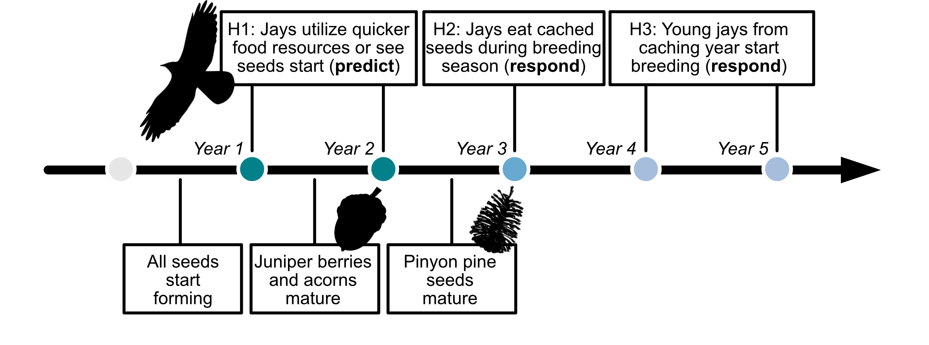

Figure 1: A timeline of hypothesized pinyon jay responses (top) and the progression of seed and cone development (bottom) following a favorable climate year for cone development. We outline three hypotheses driving the temporal relationships between pinyon jay and seed availability, including H1: jays ‘predict’ seed availability through utilization of other foods (e.g., acorns, juniper berries) or because they see cones developing in an area; H2: jays ‘respond’ to seed availability in the nesting season after they cache seeds and H3: jays ‘respond’ to seed availability with a delay as the young from the caching year enter the breeding population 1.5-2 years later.

Because blobs sometimes covered more than one 4x4 km grid cell, we determined the percent of a blob covering each grid cell and then calculated weighted average covariate values based on the covariate values of all overlapped cells times the percent of the blob overlapping that cell. On average, blobs covered 2.13 [SE = 0.01] 4x 4 km grid cells, with a minimum of one grid and a maximum of nine for a single blob.

### 2.5 Model implementation, convergence, and diagnostics

We implemented models in the Bayesian software JAGS (Plummer, 2003, version 4.3.0) using R (R Core Team, 2020, version 4.5.1) and the jagsUI wrapper package (Kellner, 2021, version 1.6.2). We prepared data using the here (Muller, 2020, version 1.0.1), tidyverse (Wickham et al., 2019, version 2.0.0), sf (Pebesma & Bivand, 2023, version 1.0.21), terra (Hijmans, 2020, version 1.8.54), readxl (Wickham & Bryan, 2015, version 1.4.5), exactextractr (Daniel Baston, 2019, version 0.10.0), spatialEco (Evans & Murphy, 2023, version 2.0-2), nngeo (Dorman, 2018, version 0.4.8), auk (Strimas-Mackey et al., 2017, version 0.8.2), lubridate (Grolemund & Wickham, 2011, version 1.9.4), prism (Hart & Bell, 2015, version 0.0.6), FNN (Beygelzimer et al., 2010, version 1.1.4.1), and data.table (Barrett et al., 2006, version 1.17.6) packages.

We initially ran models to generate 4000 MCMC samples with which to determine how many iterations would be needed to reach convergence on each parameter’s posterior distribution. We then used the Raftery diagnostic (Raftery & Lewis, 1995) to determine the necessary number of iterations for each model and re-ran models with more iterations and initial values sufficient to reach convergence based on the raftery.diag() function in the coda package (Plummer et al., 1999, version 0.19.4.1). We assessed model convergence by evaluating trace, history, and autocorrelation plots generated with the mcmcplots package (Curtis, 2010, version 0.4.3). We quantified model convergence by evaluating whether Gelman-Ruman statistics, , for all root nodes in the model were < 1.1 (Gelman & Rubin, 1992). We assessed model goodness-of-fit by comparing observed count data from eBird to predicted count data based on the model mean value. We verified the lack of spatial autocorrelation in observed data by examining the residual variation from the model and its lack of spatial correlation within a year based on the spline correlogram using the R package ncf (Bjornstad, 2008, version 1.3-2).

### 2.6 Out of sample model validation

To evaluate model fit, we performed the same set of steps for spatially and temporally stratifying available checklists from eBird (section 2.3 above), ensuring that we selected checklists that were not used in model fitting. We had 20,380 checklists that represented “out of sample” data. We predicted out of sample model fit using ~1000 posterior samples for covariate effects and intercepts from the test dataset and model. We used RMSE to compare the test and out-of-sample datasets for model fit.

# Results

Of the total number of available eBird checklists in the years of interest (2010-2022), pinyon jays were observed in 5,658 of them (0.7%). In our in-sample dataset (n = 22,295 checklists), pinyon jays were observed in 600 (2.7%). The maximum number of birds observed in one survey in this dataset was 350 (mean: 0.42; SE: 0.04). All parameters in the model converged with an 1.1 (SI Figure 1).

Pinyon jay abundance was positively correlated with cone availability ( = 0.95 [0.92, 0.98]). The importance weights of the years considered (two years before cones; three years after cones) indicate the greatest weight the year after cones ( = 0.64 [0.60, 0.67]) and some weight to two and three years after cones ( = 0.13 [0.07, 0.18] and 0.21 [0.17, 0.25], for two and three years after cones, respectively), though negligible weight for the years before cones ( = 0.01 [0, 0.03] and 0.01 [0, 0.06] for two and one years before cones, respectively).

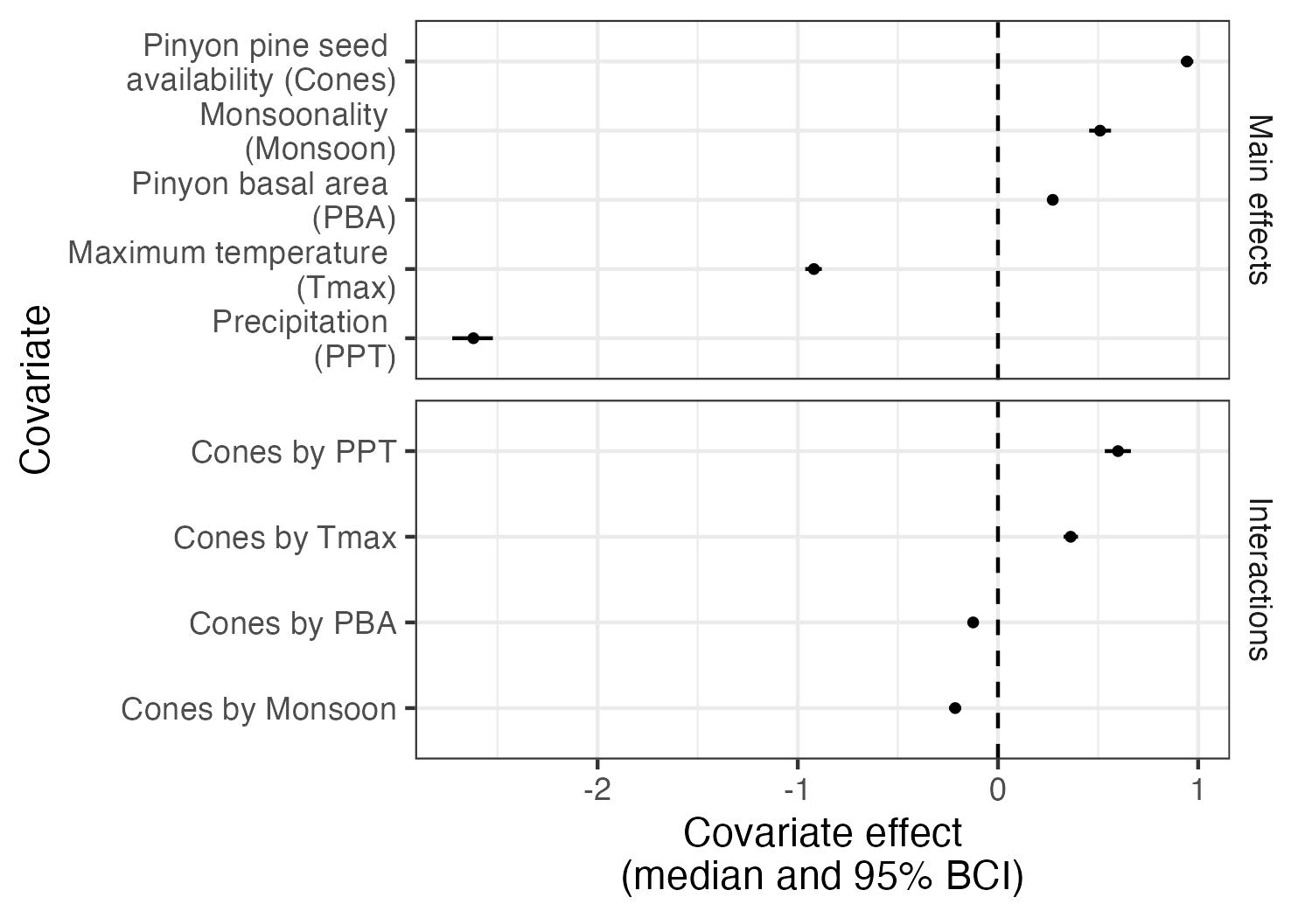

Figure 2: Covariate effects for all main covariates and their interactions with cones. All covariates were scaled and so their relative magnitudes of effect can be compared. All values represent posterior median and 95% Bayesian Credible Intervals and any covariate ranges that cross the dashed line at zero have no clear effect on pinyon jay abundance.

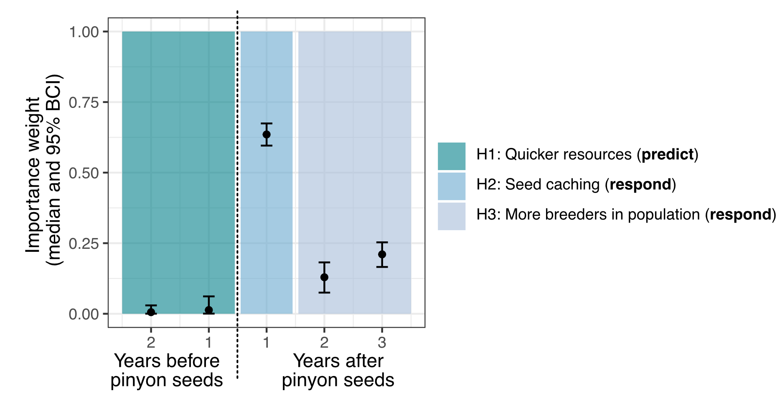

Figure 3: Importance weights for the years considered for the relationship between pinyon jays and pinyon cone (seed) availability. Colored boxes indicate the three ecological hypotheses about the time period(s) of the relationship between jays and cones. The dashed line indicates the distinction between the years before cones (left) and years after cones (right).

All other covariates and interactions in the model had non-zero effects on pinyon jayabundance. Those main effects that were negatively related to pinyon jay abundance were: precipitation ( = -2.62 [-2.72, -2.53]) and maximum temperature ( = -0.92 [-0.96, -0.88]). Main effects that were positively related to pinyon jay abundance were: Monsoonality ( = 0.51 [0.46, 0.56]) and pinyon basal area ( = 0.27 [0.25, 0.29]). Positive interactions included the interactions between cones and: precipitation ( = 0.60 [0.56, 0.66]) and maximum temperature ( = 0.37 [0.33, 0.40]). Negative interactions included the interactions between cones and: pinyon basal area ( = -0.12 [-0.14, -0.11]) and monsoonality ( = -0.21 [-0.25, -0.19]). All covariates were scaled in the model, so the relative magnitudes of these effects can be compared.

Important seasons for precipitation based on importance weights from the SAM model included, in order of importance weights: two years ago during fledging, three years ago during breeding, two years ago during breeding, and one year ago during fledging ( = 0.37 [0.35, 0.39]; 0.20 [0.18, 0.21]; 0.16 [0.14, 0.18]; 0.12 [0.10, 0.14], for each of those seasons, respectively). All other weights were not important (SI Figure 2). Important seasons for maximum temperature based on the importance weights from the SAM model included: the breeding and fledging seasons two years ago ( = 0.60 [0.50, 0.69] and 0.34 [0.25, 0.44], for the breeding and fledging seasons, respectively). All other weights were not important (SI Figure 2).

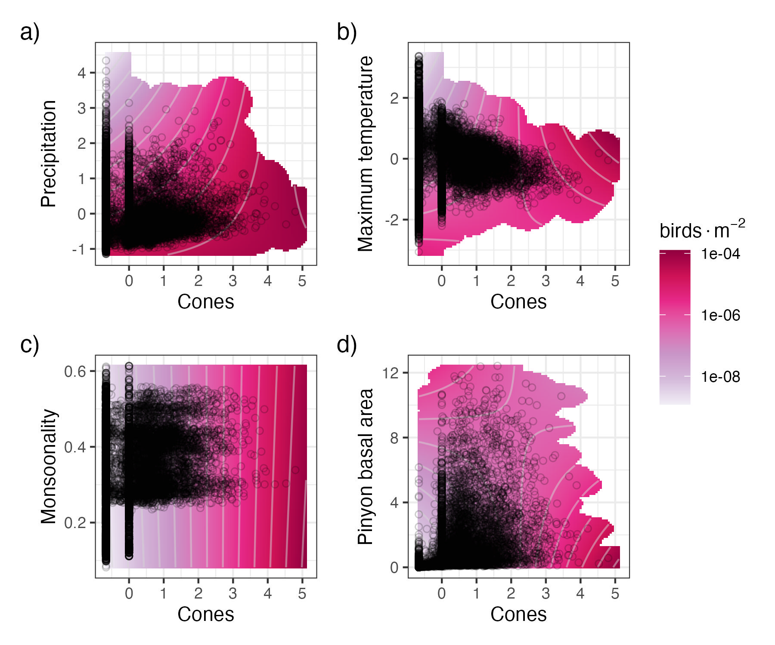

Figure 4: Interaction plots for the four covariates with significant interactive effects with cone (seed) availability, including: a) precipitation, b) maximum temperature, c) monsoonality, and d) pinyon basal area. Darker pink/red color corresponds to a greater number of birds in that combination of covariates. Black circles represent the distribution of the observed data. The predicted number of birds, lambda, is presented on the log scale to better highlight differences.

As a goodness-of-fit metric, the relationship between our observed data and replicated data produced by the model had a mean = 0.74 (SE: 0.0003). In general, the model under-estimates higher counts (SI Figure 3). The RMSE for our in-sample (“test”) dataset had an average value of 5.10 (SE: 0.0002) and the out-of-sample dataset had a value of 3.25 (SE: 0.001; SI Figure 4). Thus, our model predicts slightly better to our in-sample (“test”) data than out-of-sample data, but neither are large on the scale of the count data (counts per checklist ranged from 0 - 350), suggesting good model fit and predictive capacity. We observed no strong spatial autocorrelation in residuals (SI Figure 5).

# 4 Discussion

In this study, we found that the relationship between pinyon jay abundance and piñon pine seed availability has a multi-year signal and is mediated by habitat and climate context. Birds nest in greater abundance near cache sites the year after high seed production years and population boons from these high seed years propagate to influence nesting bird abundance at those sites for three years following high seed years. Further, the relationship between pinyon jay abundance and seed availability is mediated by a suite of habitat and climate variables, including maximum temperature, precipitation, pinyon basal area, and the relative contribution of monsoon (July-September) precipitation to overall precipitation in a location. These mediating effects suggest a combination of ecological effects, including a stronger relationship with seed availability following “stressful” climatic conditions during the nesting season and a weaker relationship with seed availability in more “suitable” habitat. Determining the relationship between pinyon jays and pinyon pine seed availability and how this relationship is shaped by climate and habitat context is an important step in recognizing potential mechanisms for pinyon jay population changes. We can build on these observations to understand how this important mutualism changes in magnitude or direction through space and time and build an approach for understanding seed dispersal mutualisms in general (Moore & Dittel, 2020).

Pinyon jay abundance responded positively to cone abundance (Figure 2). Despite previous studies suggesting that jays “predict” masting years (either because they see cones maturing or because other food sources become available first, e.g., (Ligon, 1978; Parmenter et al., 2018), we did not observe this predictive response (e.g., H1 in Figures 1 and 3). Rather, jay populations increased following high piñon pine seed years (‘lagged’ response). This lagged effect was strongest the year following cone availability (~63% of covariate weight in first year after seeds; Figure 3), likely since birds nest in the late winter and early spring near sites where they cached seeds the previous fall (Stotz & Balda, 1995). While the second and third years following seed availability had a weaker contribution to the overall seed availability effect (13-21% of covariate weight), they still seem to contribute to the relationship between pinyon jay and seed availability. Seeds are likely not viable following the first year in which they are cached (Floyd, 1982), though it is unknown what timeframes seeds that do not germinate in that first year are still sought out by pinyon jays. Jays have an incredible spatial memory for their cache sites and those of their flock (Bednekoff & Balda, 1996), so if seeds are still available in years following the first cache year, birds are likely to remember and revisit these cache sites. This delayed signal may also be delayed population dynamics. Pinyon jays become reproductively mature 1.5-2 years following fledging (Marzluff & Balda, 1988). Thus, the two- and three-year delayed pinyon jay abundance response to seeds may be related to fledged young from the year following cones maturing and entering the breeding population. Pinyon jays often nest in similar places year to year (Marzluff & Balda, 1988), so they may nest near places with previous year caches year after year and get counted in that location years following a population boom after a seed year.

Pinyon pine and pinyon jays occur across a broad range of habitat and climate conditions across the Southwest USA. Across this range, pinyon jays display variable responses to pinyon pine seed availability (Figures 2 and 4). For example, the relationship between pinyon jay abundance and climate variables suggested that jays rely more on cones following unfavorable climatic conditions. When temperatures are hot or when late winter/early spring precipitation is high, there are fewer pinyon jays observed during the nesting season, likely due to nest failure from high temperatures and/or late winter and early spring snowstorms that are one of the leading cause of nest failure for pinyon jays (Ligon, 1978; Marzluff, 1988). In addition, pinyon jays rely heavily on invertebrate prey during the spring nesting season (Ligon, 1978) and the emergence of these invertebrates is likely regulated by temperature and/or precipitation in the early season. Interestingly, during unfavorable climatic conditions, pinyon jays have stronger relationships with pine seed availability (Figures 2 and 4). The temperature and precipitation relationships both also have lags, with the greatest effects being the breeding and/or fledging season two years ago (SI Figure 2). Thus, nesting jays are more abundant following a warm and/or wet nestling/fledgling season two years ago and a high seed production year last year. Pinyon jays adapt their nesting based on previous experience (e.g., nesting in different locations based on “learned” experiences from past nest failures, (Marzluff, 1988). Thus, the birds may have adaptive or learned nesting behaviors in response to nest failures two years ago, relying more on a predictable resource following these stressful nesting years. It is clear that seed availability and climate have legacies on pinyon jay populations over several years (~3 years); thus, providing an evidence-based moving window with which to evaluate population trends (e.g., (Rouyer et al., 2011).

The interactive effects of other habitat and climatic conditions (e.g., pinyon basal area and monsoonality) and pinyon pine seed availability suggest that in locations with suitable habitat and/or other reliable food sources, there is a weaker relationship between jay abundance and pinyon pine seed availability (Figures 2 and 4). Pinyon jays are known to prefer habitat with high pinyon basal area (Boone et al., 2018; Van Lanen et al., 2023), thus, it may be that birds generally spend more time in these habitats for reasons other than seed availability (e.g., preferred nesting habitat locations), thus weakening the relationship between seeds and birds (Johnson et al., 2016). In places with higher monsoon moisture, there are likely other food sources (e.g., invertebrates) that are preferred during the nesting season (e.g., grasshoppers; (Ligon, 1978).

Beyond the pinyon pine ecosystem and pinyon jays, this study highlights the context dependence of seed dispersal mutualisms across space and time. We build on growing literature highlighting how mutualisms are shaped by their environmental and climate context (Elwood et al., 2018; Sawaya et al., 2018; Vander Wall, 2010). Understanding the context of mutualisms will be important in a world with ever changing climate and habitat (Chamberlain et al., 2014). Further, this study demonstrates that mutualisms can play out to shape ecosystem states across multiple years – climate and food availability interact over multiple consecutive years to impact the population dynamics of seed dispersers (Lira et al., 2019). Thus, a complete understanding of seed dispersal systems may require evaluations over multiple years with models such as those used in this study to illuminate the often-multiple timeframes over which mutualisms shape interaction partners (Ogle et al., 2015). These temporal effects demonstrate the importance of long-term and broad scale studies for understanding patterns shaping ecosystems across the globe (Hughes et al., 2017; Magurran et al., 2010). These observations can help build mechanistic studies at smaller scales (in both space and time). As one example, we did not evaluate this system “from the plant’s perspective”. Specifically, we did not evaluate under which climate or habitat conditions pinyon jays serve as effective seed dispersers. However, a next step would be to examine pinyon seed germination across space and time to determine the strength and direction (e.g., seed predation or dispersal) of the interaction between these two species across a range of habitat and climate conditions (Chamberlain et al., 2014; Elwood et al., 2018).

Species interactions that shape ecosystems across the globe are shaped by environmental context (Chamberlain et al., 2014; Miller-ter Kuile et al., 2022; Sawaya et al., 2018). In particular, species participating in mutualistic interactions are at a great risk of disappearing with ongoing change across the globe due to processes such as co-extinction (Colwell et al., 2012; Dunn et al., 2009) and phenological mismatches. As population dynamics of mutualist partners in plant-animal interactions continue to change with habitat and climate change, mutualisms may continue to change or disappear (Rafferty et al., 2015). Building our understanding about the temporal dynamics and context dependence of mutualisms is an important first step in understanding and curbing biodiversity loss in ecosystems across the planet.

**References**

Balda, R. P. (2020). Pinyon Jay (Gymnorhinus cyanocephalus). In S. M. Billerman, B. K. Keeney, P. G. Rodewald, & T. S. Schulenberg (Eds.), *Birds of the World*. Cornell Lab of Ornithology. https://doi.org/10.2173/bow.pinjay.01

Barrett, T., Dowle, M., Srinivasan, A., Gorecki, J., Chirico, M., Hocking, T., Schwendinger, B., & Krylov, I. (2006). *data.table: Extension of `data.frame`* [Dataset]. The R Foundation. https://doi.org/10.32614/cran.package.data.table

Bascompte, J., García, M. B., Ortega, R., Rezende, E. L., & Pironon, S. (2019). Mutualistic interactions reshuffle the effects of climate change on plants across the tree of life. *Science Advances*, *5*(5). https://doi.org/10.1126/sciadv.aav2539

Bednekoff, P. A., & Balda, R. P. (1996). Social caching and observational spatial memory in pinyon jays. *Behaviour*, *133*(11/12), 807–826.

Belitz, M. W., Larsen, E. A., Hurlbert, A. H., Di Cecco, G. J., Neupane, N., Ries, L., Tingley, M. W., Guralnick, R. P., & Youngflesh, C. (2025). Potential for bird–insect phenological mismatch in a tri‐trophic system. *Journal of Animal Ecology*, *94*(4), 717–728. https://doi.org/10.1111/1365-2656.70007

Beygelzimer, A., Kakadet, S., Langford, J., Arya, S., Mount, D., & Li, S. (2010). *FNN: Fast Nearest Neighbor Search Algorithms and Applications* [Dataset]. The R Foundation. https://doi.org/10.32614/cran.package.fnn

Bjornstad, O. N. (2008). *ncf: Spatial Covariance Functions* [Dataset]. The R Foundation. https://doi.org/10.32614/cran.package.ncf

Bogdziewicz, M., Crone, E. E., & Zwolak, R. (2020). Do benefits of seed dispersal and caching by scatterhoarders outweigh the costs of predation? An example with oaks and yellow‐necked mice. *Journal of Ecology*, *108*(3), 1009–1018. https://doi.org/10.1111/1365-2745.13307

Boone, J. D., Ammon, E., & Johnson, K. (2018). Long-term declines in the Pinyon Jay and management implications for piñon–juniper woodlands. In W. D. Shuford, R. E. Gill, & C. M. Handel, *Trends and Traditions: Avifaunal Change in Western North America* (pp. 190–197). Western Field Ornithologists. https://doi.org/10.21199/SWB3.10

Chamberlain, S. A., Bronstein, J. L., & Rudgers, J. A. (2014). How context dependent are species interactions? *Ecology Letters*, *17*(7), 881–890. https://doi.org/10.1111/ele.12279

Colwell, R. K., Dunn, R. R., & Harris, N. C. (2012). Coextinction and Persistence of Dependent Species in a Changing World. *Annual Review of Ecology, Evolution, and Systematics*, *43*(1), 183–203. https://doi.org/10.1146/annurev-ecolsys-110411-160304

Comita, L. S., Queenborough, S. A., Murphy, S. J., Eck, J. L., Xu, K., Krishnadas, M., Beckman, N., & Zhu, Y. (2014). Testing predictions of the Janzen–Connell hypothesis: A meta‐analysis of experimental evidence for distance‐ and density‐dependent seed and seedling survival. *Journal of Ecology*, *102*(4), 845–856. https://doi.org/10.1111/1365-2745.12232

Connell, J. H. (1971). On the role of natural enemies in preventing competitive exclusion in some marine animals and in rain forest trees. In *Dynamics of Populations*. Centre for Agricultural Publishing and Documentation.

Cornell Lab of Ornithology. (2024a). *eBird Basic Dataset* (Version EBD_relJun-2024) [Dataset].

Cornell Lab of Ornithology. (2024b). *eBird Basic Dataset* (Version EBD_relMay-2024) [Dataset].

Curtis, S. M. (2010). *mcmcplots: Create Plots from MCMC Output* (p. 0.4.3) [Dataset]. https://doi.org/10.32614/CRAN.package.mcmcplots

Daniel Baston. (2019). *exactextractr: Fast Extraction from Raster Datasets using Polygons* [Dataset]. The R Foundation. https://doi.org/10.32614/cran.package.exactextractr

Donoso, I., Sorensen, M. C., Blendinger, P. G., Kissling, W. D., Neuschulz, E. L., Mueller, T., & Schleuning, M. (2020). Downsizing of animal communities triggers stronger functional than structural decay in seed-dispersal networks. *Nature Communications*, *11*(1), 1582. https://doi.org/10.1038/s41467-020-15438-y

Dorman, M. (2018). *nngeo: K-Nearest Neighbor Join for Spatial Data* [Dataset]. The R Foundation. https://doi.org/10.32614/cran.package.nngeo

Dunn, R. R., Harris, N. C., Colwell, R. K., Koh, L. P., & Sodhi, N. S. (2009). The sixth mass coextinction: Are most endangered species parasites and mutualists? *Proceedings of the Royal Society B: Biological Sciences*, *276*(1670), 3037–3045. https://doi.org/10.1098/rspb.2009.0413

Elwood, E. C., Lichti, N. I., Fitzsimmons, S. F., & Dalgleish, H. J. (2018). Scatterhoarders drive long‐ and short‐term population dynamics of a nut‐producing tree, while pre‐dispersal seed predators and herbivores have little effect. *Journal of Ecology*, *106*(3), 1191–1203. https://doi.org/10.1111/1365-2745.12902

Evans, J. S., & Murphy, M. A. (2023). *spatialEco* (Version 2.0-2) [Computer software].

Floyd, M. E. (1982). The Interaction of Pinon Pine and Gambel Oak in Plant Succession near Dolores, Colorado. *The Southwestern Naturalist*, *27*(2), 143. https://doi.org/10.2307/3671138

Gelman, A., & Rubin, D. B. (1992). Inference from Iterative Simulation Using Multiple Sequences. *Statistical Science*, *7*(4). https://doi.org/10.1214/ss/1177011136

Gómez, J. M., Schupp, E. W., & Jordano, P. (2019). Synzoochory: The ecological and evolutionary relevance of a dual interaction. *Biological Reviews*, *94*(3), 874–902. https://doi.org/10.1111/brv.12481

Grolemund, G., & Wickham, H. (2011). Dates and Times Made Easy with**lubridate**. *Journal of Statistical Software*, *40*(3). https://doi.org/10.18637/jss.v040.i03

Hart, E., & Bell, K. (2015). *prism: Access data from the Oregon State Prism climate project* [Computer software]. Zenodo. https://doi.org/10.5281/ZENODO.33663

Hijmans, R. J. (2020). *terra: Spatial Data Analysis* [Dataset]. The R Foundation. https://doi.org/10.32614/cran.package.terra

Hochachka, W. M., Ruiz-Gutierrez, V., & Johnston, A. (2023). Considerations for fitting occupancy models to data from eBird and similar volunteer-collected data. *Ornithology*, *140*(4). https://doi.org/10.1093/ornithology/ukad035

Hughes, B. B., Beas-Luna, R., Barner, A. K., Brewitt, K., Brumbaugh, D. R., Cerny-Chipman, E. B., Close, S. L., Coblentz, K. E., de Nesnera, K. L., Drobnitch, S. T., Figurski, J. D., Focht, B., Friedman, M., Freiwald, J., Heady, K. K., Heady, W. N., Hettinger, A., Johnson, A., Karr, K. A., … Carr, M. H. (2017). Long-Term Studies Contribute Disproportionately to Ecology and Policy. *BioScience*, *67*(3), 271–281. https://doi.org/10.1093/biosci/biw185

Janzen, D. (1970). Herbivores and the number of tree species in tropical forests. *The American Naturalist*, *104*(940), 501–528.

Johnson, K., Neville, T. B., Smith, J. W., & Horner, M. W. (2016). Home range- and colony-scale habitat models for Pinyon Jays in piñon-juniper woodlands of New Mexico, USA. *Avian Conservation and Ecology*, *11*(2). https://doi.org/10.5751/ace-00890-110206

Kellner, K. (2021). *jagsUI: a wrapper around “rjags” to streamline JAGS analyses* (Version 1.5.2) [R]. https://CRAN.R-project.org/package=jagsUI

Ligon, J. D. (1978). Reproductive Interdependence of Pinon Jays and Pinon Pines. *Ecological Monographs*, *48*(2), 111–126. https://doi.org/10.2307/2937295

Lira, P. K., De Souza Leite, M., & Metzger, J. P. (2019). Temporal Lag in Ecological Responses to Landscape Change: Where Are We Now? *Current Landscape Ecology Reports*, *4*(3), 70–82. https://doi.org/10.1007/s40823-019-00040-w

Magurran, A. E., Baillie, S. R., Buckland, S. T., Dick, J. McP., Elston, D. A., Scott, E. M., Smith, R. I., Somerfield, P. J., & Watt, A. D. (2010). Long-term datasets in biodiversity research and monitoring: Assessing change in ecological communities through time. *Trends in Ecology & Evolution*, *25*(10), 574–582. https://doi.org/10.1016/j.tree.2010.06.016

Marzluff, J. M. (1988). Do pinyon jays alter nest placement based on prior experience? *Animal Behaviour*, *36*(1), 1–10. https://doi.org/10.1016/s0003-3472(88)80244-6

Marzluff, J. M., & Balda, R. P. (1988). The Advantages of, and Constraints Forcing, Mate Fidelity in Pinyon Jays. *The Auk*, *105*(2), 286–295. https://doi.org/10.2307/4087492

McDermott, M. E., & DeGroote, L. W. (2016). Long‐term climate impacts on breeding bird phenology in Pennsylvania, USA. *Global Change Biology*, *22*(10), 3304–3319. https://doi.org/10.1111/gcb.13363

McKinnon, E. A., Kurt Kyser, T., & Stutchbury, B. J. M. (2017). Does the proportion of arthropods versus fruit in the diet influence overwintering condition of an omnivorous songbird? *Journal of Field Ornithology*, *88*(1), 65–79. https://doi.org/10.1111/jofo.12187

Miller-ter Kuile, A., Apigo, A., Bui, A., Butner, K., Childress, J. N., Copeland, S., DiFiore, B. P., Forbes, E. S., Klope, M., Motta, C. I., Orr, D., Plummer, K. A., Preston, D. L., & Young, H. S. (2022). Changes in invertebrate food web structure between high- and low-productivity environments are driven by intermediate but not top-predator diet shifts. *Biology Letters*, *18*(10). https://doi.org/10.1098/rsbl.2022.0364

Moore, C. M., & Dittel, J. W. (2020). On mutualism, models, and masting: The effects of seed‐dispersing animals on the plants they disperse. *Journal of Ecology*, *108*(5), 1775–1783. https://doi.org/10.1111/1365-2745.13414

Muller, K. (2020). *here: A simpler way to find your files* (Version 1.0.1) [R]. https://CRAN.R-project.org/package=here

Ogle, K., Barber, J. J., Barron‐Gafford, G. A., Bentley, L. P., Young, J. M., Huxman, T. E., Loik, M. E., & Tissue, D. T. (2015). Quantifying ecological memory in plant and ecosystem processes. *Ecology Letters*, *18*(3), 221–235. https://doi.org/10.1111/ele.12399

Parmenter, R. R., Zlotin, R. I., Moore, D. I., & Myers, O. B. (2018). Environmental and endogenous drivers of tree mast production and synchrony in piñon–juniper–oak woodlands of New Mexico. *Ecosphere*, *9*(8), e02360. https://doi.org/10.1002/ecs2.2360

Pearse, I. S., Koenig, W. D., & Kelly, D. (2016). Mechanisms of mast seeding: Resources, weather, cues, and selection. *New Phytologist*, *212*(3), 546–562. https://doi.org/10.1111/nph.14114

Pebesma, E., & Bivand, R. (2023). *Spatial Data Science: With Applications in R* (1st ed.). Chapman and Hall/CRC. https://doi.org/10.1201/9780429459016

Pesendorfer, M. B., Sillett, T. S., Koenig, W. D., & Morrison, S. A. (2016). Scatter-hoarding corvids as seed dispersers for oaks and pines: A review of a widely distributed mutualism and its utility to habitat restoration. *The Condor*, *118*(2), 215–237. https://doi.org/10.1650/condor-15-125.1

Plummer, M. (2003). JAGS: A program for analysis of Bayesian graphical models using Gibbs sampling. *Proceedings of the 3rd International Workshop on Distributed Statistical Computing*, *124*(125.10).

Plummer, M., Best, N., Cowles, K., Vines, K., Sarkar, D., Bates, D., Almond, R., & Magnusson, A. (1999). *coda: Output Analysis and Diagnostics for MCMC* (p. 0.19-4.1) [Dataset]. https://doi.org/10.32614/CRAN.package.coda

R Core Team. (2020). *R: A language and environment for statistical computing* [Computer software]. R Foundation for Statistical Computing. https://www.R-project.org/

Rafferty, N. E., CaraDonna, P. J., & Bronstein, J. L. (2015). Phenological shifts and the fate of mutualisms. *Oikos*, *124*(1), 14–21. https://doi.org/10.1111/oik.01523

Raftery, A. E., & Lewis, S. M. (1995). The number of iterations, convergence diagnostics and generic Netropolis algorithms. In *Practical Markov Chain Monte Carlo*. Chapman and Hall.

Robinson, O. J., Ruiz-Gutierrez, V., Fink, D., Meese, R. J., Holyoak, M., & Cooch, E. G. (2018). Using citizen science data in integrated population models to inform conservation. *Biological Conservation*, *227*, 361–368. https://doi.org/10.1016/j.biocon.2018.10.002

Rouyer, T., Ottersen, G., Durant, J. M., Hidalgo, M., Hjermann, D. Ø., Persson, J., Stige, L. Chr., & Stenseth, N. Chr. (2011). Shifting dynamic forces in fish stock fluctuations triggered by age truncation? *Global Change Biology*, *17*(10), 3046–3057. https://doi.org/10.1111/j.1365-2486.2011.02443.x

Royle, J. A. (2004). *N*‐Mixture Models for Estimating Population Size from Spatially Replicated Counts. *Biometrics*, *60*(1), 108–115. https://doi.org/10.1111/j.0006-341x.2004.00142.x

Royle, J. A., Nichols, J. D., & Kéry, M. (2005). Modelling occurrence and abundance of species when detection is imperfect. *Oikos*, *110*(2), 353–359. https://doi.org/10.1111/j.0030-1299.2005.13534.x

Sauer, J., Link, W., & Hines, J. (2020). *The North American breeding bird survey, analysis results 1966-2019: US Geological Survey data release* [Dataset]. US Geological Survey: Patuxent, MD, USA.

Sawaya, G. M., Goldberg, A. S., Steele, M. A., & Dalgleish, H. J. (2018). Environmental variation shifts the relationship between trees and scatterhoarders along the continuum from mutualism to antagonism. *Integrative Zoology*, *13*(3), 319–330. https://doi.org/10.1111/1749-4877.12311

Shriver, R. K., Pletcher, E., Biondi, F., Urza, A. K., & Weisberg, P. J. (2025). Long-term tree population growth can predict woody encroachment patterns. *Proceedings of the National Academy of Sciences*, *122*(18). https://doi.org/10.1073/pnas.2424096122

Simon, O. G., Manu, S. A., Nwaogu, C. J., & Omotoriogun, T. C. (2023). Supplementing a grain diet with insects instead of fruits sustains the body condition of an omnivorous bird. *Ecology and Evolution*, *13*(5). https://doi.org/10.1002/ece3.10141

Skagen, S. K., & Adams, A. A. Y. (2012). Weather effects on avian breeding performance and implications of climate change. *Ecological Applications*, *22*(4), 1131–1145. https://doi.org/10.1890/11-0291.1

Stotz, N. G., & Balda, R. P. (1995). Cache and recovery behavior of wild pinyon jays in northern Arizona. *The Southwestern Naturalist*, *40*(2), 180–184.

Strimas-Mackey, M., Hochachka, W. M., Ruiz-Gutierrez, V., Robinson, O. J., Miller, E. T., Auer, T., Kelling, S., Fink, D., & Johnston, A. (2023). *Best Practices for Using eBird Data: Vol. Version 2.0*. Cornell Lab of Ornithology. https://doi.org/10.5281/zenodo.3620739

Strimas-Mackey, M., Miller, E., & Hochachka, W. (2017). *auk: eBird Data Extraction and Processing in R* [Dataset]. The R Foundation. https://doi.org/10.32614/cran.package.auk

Sullivan, B. L., Wood, C. L., Iliff, M. J., Bonney, R. E., Fink, D., & Kelling, S. (2009). eBird: A citizen-based bird observation network in the biological sciences. *Biological Conservation*, *142*(10), 2282–2292. https://doi.org/10.1016/j.biocon.2009.05.006

Tylianakis, J. M., Didham, R. K., Bascompte, J., & Wardle, D. A. (2008). Global change and species interactions in terrestrial ecosystems. *Ecology Letters*, *11*(12), 1351–1363. https://doi.org/10.1111/j.1461-0248.2008.01250.x

Valiente‐Banuet, A., Aizen, M. A., Alcántara, J. M., Arroyo, J., Cocucci, A., Galetti, M., García, M. B., García, D., Gómez, J. M., Jordano, P., Medel, R., Navarro, L., Obeso, J. R., Oviedo, R., Ramírez, N., Rey, P. J., Traveset, A., Verdú, M., & Zamora, R. (2015). Beyond species loss: The extinction of ecological interactions in a changing world. *Functional Ecology*, *29*(3), 299–307. https://doi.org/10.1111/1365-2435.12356

Van Lanen, N. J., Monroe, A. P., & Aldridge, C. L. (2023). A hidden cost of single species management: Habitat-relationships reveal potential negative effects of conifer removal on a non-target species. *Biological Conservation*, *280*, 109959. https://doi.org/10.1016/j.biocon.2023.109959

Vander Wall, S. B. (2002). MASTING IN ANIMAL-DISPERSED PINES FACILITATES SEED DISPERSAL. *Ecology*, *83*(12), 3508–3516. https://doi.org/10.1890/0012-9658(2002)083[3508:miadpf]2.0.co;2

Vander Wall, S. B. (2003). Reciprocal pilferage and the evolution of food-hoarding behavior. *Behavioral Ecology*, *14*(5), 656–667. https://doi.org/10.1093/beheco/arg064

Vander Wall, S. B. (2010). How plants manipulate the scatter-hoarding behaviour of seed-dispersing animals. *Philosophical Transactions of the Royal Society B: Biological Sciences*, *365*(1542), 989–997. https://doi.org/10.1098/rstb.2009.0205

Vander Wall, S. B. (2023). Seed Dispersal in Pines (Pinus). *The Botanical Review*, *89*(3), 275–307. https://doi.org/10.1007/s12229-023-09288-8

Wickham, H., Averick, M., Bryan, J., Chang, W., McGowan, L., François, R., Grolemund, G., Hayes, A., Henry, L., Hester, J., Kuhn, M., Pedersen, T., Miller, E., Bache, S., Müller, K., Ooms, J., Robinson, D., Seidel, D., Spinu, V., … Yutani, H. (2019). Welcome to the Tidyverse. *Journal of Open Source Software*, *4*(43), 1686. https://doi.org/10.21105/joss.01686

Wickham, H., & Bryan, J. (2015). *readxl: Read Excel Files* (p. 1.4.3) [Dataset]. https://doi.org/10.32614/CRAN.package.readxl

Wiggins, D. A. (2005). *Pinyon Jay (Gymnorhinus cyanocephalus): A technical conservation assessment.* USDA Forest Service, Rocky Mountain Region. http://www.fs.fed.us/r2/projects/scp/assessments/pinyonjay.pdf

Wion, A. P., Pearse, I. S., Broxson, M., & Redmond, M. D. (2025). Mast hindcasts reveal pervasive effects of extreme drought on a foundational conifer species. *New Phytologist*, *246*(2), 450–460. https://doi.org/10.1111/nph.20321