**Group-06**



Course Title : Multimedia and Animation techniques laboratory

Course code : 456

**SUBMITTED TO:**

**Dr.Mohammad Zahidur Rahman Sabrina Sharmin**

Professor Lecturer

Department of Computer Science & Department of Computer Science & Engineering Engineering

Jahangirnagar University Jahangirnagar University

**SUBMITTED BY:**

|  |  |  |
| --- | --- | --- |
| **Sl** | Class Roll | Name |
| 1 | 47 | Anamul Haque |
| 2 | 42 | Bikash Halder |
| 3 | 24 | Hemal Rahman |
| 4 | 31 | Enamul Haque |
| 5 | 51 | Raton roy |
| 6 | 257 | Afsana anni |

Date of submission: 25 February, 2019

|  |  |
| --- | --- |
| **Members** | **Roles** |
| **1.Dr. Mohammad Zahidur Rahman** | **Producer** |
| **2.Raton Kumar Ray** | **Coordinator** |
| **3.Anamul Haque** | **Environment Compiler ,Content Expert** |
| **4.Afsana Anne** | **Art Director,Designer** |
| **5.Md. Enamul Haque** | **Team Leader,Scale and evaluation expert** |
| **6.Bikash Halder** | **Education technologist and phychologist** |
| **7.SM. Waliur Rahman Hemal** | **Art Director,Designer** |

**Multimedia and Animation Technique**

**Project Name**: Programming in C

1. **Educational Goals:**

* Student can be easily understood this course
* They are very interested to reading this book
* Flow chart represented by multimedia
* All course topics are represented by easily

**Course Topics:**

•The C language

•The C pre processor

•The Standard C library

•C Programming accuracy and style

•Sample solutions to the exercise

**Explanation of Topics:**

•The C language

* + Constant and variables
  + Input output explanation
  + Array
  + Conditional statement
  + Function statement

•The C pre Processor

•The standard C library

* Introduction to C library
* String function
* Character function
* Mathematical function

•C Programming accuracy and style

* Run time error
* Sample solutions to the exercise
* Exercise some question

1. **The Coverage and Flow Required:**

* Programming language C
* Array
* String
* Function
* Condition
* Flow chart
* Mathematical equation
* File

**Flow chart:**

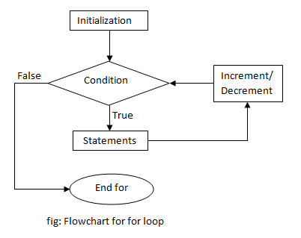

For loop statement:

for (initializationStatement; testExpression; updateStatement)

{

// codes

}

1. **Evaluation scales:**

* understand for beginner student
* Understand for medium student
* Understand for good at student

1. **Using content of multimedia**

* JPEG image
* GIF image
* Graphics
* Audio
* Video
* Animation

1. **Building the materials in order to produce educational results**

* We provide theory respect to the topics
* We Provide header file
* We provide function
* We provide condition
* We provide mathematically equation

1. **Making changes according to the feedback on a trial version of the E-Content**

* We will option to changes our project in term of user requirement