51单片音乐机简谱编程示例

一、音符变量对应表(F大调)
变量 as c1 d1 e1 f1 g1 a1 a1s c2 d2 e2 f2 g2 a2
二、根据乐谱确定变量
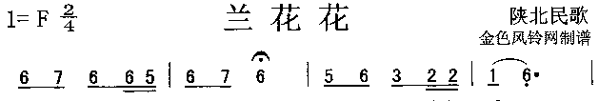
d2 e2 d2 d2 c2 d2 e2 d2 c2 d2 a1 g1 g1 f1 d1
T/2 T/2 T/2 T/4 T/4 T/2 T/2 T T/2 T/2 T/2 T/4 T/4 T/2 T+T/2
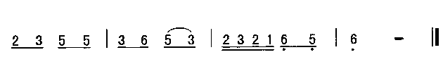
g1 a1 c2 c2 a1 d2 c2 a1 g1 a1 g1 f1 d1 c1 d1
T/2 T/2 T/2 T/2 T/2 T/2 T/2 T/2 T/4 T/4 T/4 T/4 T/2 T/2 T*2
三、程序数组：
//《兰花花》
code CNote MusicTab[] =
{ // {音名,时值}
{d2,T/2},{e2,T/2},{d2,T/2},{d2,T/4},{c2,T/4},{d2,T/2},{e2,T/2},{d2,T},
{c2,T/2},{d2,T/2},{a1,T/2},{g1,T/4},{g1,T/4},{f1,T/2},{d1,T+T/2},
{g1,T/2},{a1,T/2},{c2,T/2},{c2,T/2},{a1,T/2},{d2,T/2},{c2,T/2},{a1,T/2},
{g1,T/4},{a1,T/4},{g1,T/4},{f1,T/4},{d1,T/2},{c1,T/2},{d1,T*2},
{0,T}, {0,T},
{0,0} //结束标志
};

51单片音乐机五线谱编程示例
一、音符变量对应表（E大调）
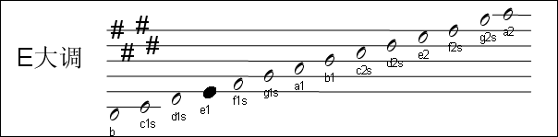
二、根据乐谱确定变量
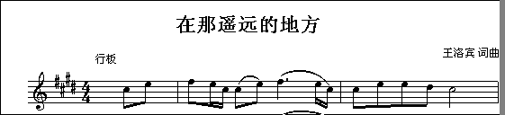
c2s e2 f2s e2 c2s c2s e2 f2s e2 c2s c2s e2 e2 d2s c2s
T/2 T/2 T/2 T/4 T/4 T/2 T/2 T+T/2 T/4 T/4 T/2 T/2 T/2 T/2 T*2
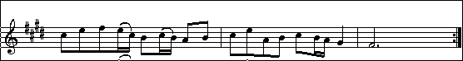
c2s e2 f2s e2 c2s b1 c2s b1 a1 b1 c2s e2 a1 b1 c2s b1 a1 g1s f1s
T/2 T/2 T/2 T/4 T/4 T/2T/4T/4 T/2T/2 T/2T/2T/2T/2 T/2T/4T/4 T T*2+T
三、程序数组
//《在那遥远的地方》
code CNote MusicTab[] ={ // {音名,时值}
{c2s,T/2},{e2,T/2},{f2s,T/2},{e2,T/4},{c2s,T/2},{c2s,T/2},{e2,T/2},
{f2s,T+T/2},{e2,T/4},{c2s,T/4},{c2s,T/2},{e2,T/2},{e2,T/2},{d2s,T/2},{c2s,T*2},
{c2s,T/2},{e2,T/2},{f2s,T/2},{e2,T/4},{c2s,T/4},{b1,T/2},{c2s,T/4},{b1,T/4},
{a1,T/2},{b1,T/2},{c2s,T/2},{e2,T/2},{a1,T/2},{b1,T/2},
{c2s,T/2},{b1,T/4},{a1,T/4},{g1s,T},{f1s,T*2+T},
{0,0} //结束标志
};

