

Inspection Management App
Build prompt and business workflows
Version 3.2 · 21 October 2026
Prepared for Anas, ARAL Property Inspection Service, Dubai
Phase 1 approved · Phase 2 delivered · Phase 3 next

Contents
About this document 3
Part A: How the business runs 4
Our services and prices 5
The journey at a glance 7
Workflow 1: Lead management 8
Workflow 2: Quotation and agreement 9
Workflow 3: Operations, scheduling and dispatch 10
Workflow 4: Job execution, inspection and report 11
Workflow 5: Invoicing, payment and commission 12
Job status reference 13
Part B: The build prompt 14
1. Role and working rules 15
2. Brand and theme 15
3. Regulatory scope guard 16
4. Technology 16
5. Roles and permissions 16
6. Clients and commercial terms 17
7. Lead management 17
8. Service catalogue and pricing 18
9. Requests and quotations 18
10. Payments 19
11. Scheduling and the inspection app 19
12. Reports and technical review 20
13. PDF documents 21
14. Invoicing and VAT 21
15. Inspector commission and subcontractors 22
16. Email 22
17. Admin controls 22
18. Dashboard, KPIs and Excel 23
19. Quality, security and hosting 23
20. Delivery phases 23
21. Acceptance criteria 24
Appendix: decisions approved in Phase 1 24

About this document
This document describes the app ARAL will use to run its inspection business, from the first enquiry to the paid invoice. It has two parts.
Part A, How the business runs, starts with the seven services ARAL offers and their prices, then shows the five workflows in plain language: lead management, quotation, operations, job execution and invoicing. Each one has a diagram, a step-by-step table showing who does what and what the app does, what happens when things go wrong, and what we measure. Use it to train staff and to check that the app matches how you want to work.
Part B, The build prompt, is the full specification given to the developer (Claude) who builds the app. It is detailed on purpose: every rule written here is a rule the app will enforce. If you change how you want to work, change it here first.
Where things stand
Phase 1 (design) approved on 21 October 2026. Database, report field mapping and screen layouts.
Phase 2 (foundation) delivered. Sign-in with two-step codes, roles, users, company settings, terms and wording with versions, service catalogue and prices, inspectors, equipment, checklists, comment library, English and Arabic screens. Code in GitHub: ananader1977/aral-inspection.
Phase 3 is next: leads, client requests, the pricing engine, quotations and the PDF engine.

Who is who
Role | Who it is | What they do in the app
Super Admin | Anas (owner / General Manager) | Everything, including users, prices, terms and settings
Admin coordinator | Office staff on payroll | Leads, quotations, scheduling, client contact
Inspector | Outsourced engineers, paid 42% commission | Their own jobs on the phone: findings, photos, videos
Technical Manager | Outsourced chartered engineer on retainer | Reviews and approves every report before it is issued
Accountant | Outsourced accounting | Invoices, payments, credit notes, commission payouts
Client | Owners, buyers, tenants, banks, developers | Accept quotes, sign, pay, download reports and invoices

PART A
How the business runs
What we offer and what it costs, then the lead, quotation, operations, job execution and invoicing workflows

Our services and prices
ARAL is an independent, engineer-led inspection company. We document the condition of a property with photos, videos and thermal imaging, and deliver a clear report within 24 to 48 hours of the visit. We never sell repairs, so our findings are never influenced by repair work.
We offer seven services: three for residential clients (owners, buyers and tenants), two for banks and lenders, and two for developers and owners associations, plus one add-on, thermal imaging.

Included in every inspection
- Visit by a qualified inspector, with the report reviewed and signed off by our Technical Manager.
- Room-by-room findings marked Critical, Attention or Informational, each with photos and, where useful, video.
- Air conditioning, electrical (socket and RCD testing), plumbing, drainage, water heater, finishes, doors and windows.
- Moisture meter checks in wet areas.
- PDF report with a summary of the findings, a QR code to verify it, and an online version with the videos.
- A follow-up call to go through the report.

Residential services
Service | For | What the client gets | Report within
Resale (pre-purchase) inspection | Buyers of ready properties | Full condition report before signing the MOU or transfer, with findings to negotiate with the seller. Includes one re-inspection. | 24 h
Snagging and handover inspection | Buyers of new off-plan units | 200+ point check before accepting the keys, with a defect list in the developer’s format. Includes one re-inspection after the developer’s repairs. | 48 h
Move-in / move-out report | Tenants and landlords | Signed, dated, photo-backed condition record that protects the security deposit. | 24 h

Residential prices (AED, before VAT)
Property | Resale inspection | Snagging and handover | Move-in / move-out
Studio apartment | 1,200 | 1,200 | 900
1-bedroom apartment | 1,500 | 1,400 | 900
2-bedroom apartment | 1,700 | 1,800 | 1,300
3-bedroom apartment | 1,860 | 2,400 | 1,300
4-bedroom apartment or larger | 2,300 | 2,400 | 1,300
Townhouse | 2,500 | 3,000 | 1,800
Villa, up to 4 bedrooms | 3,000 | 4,500 | 2,200
Villa, 5 bedrooms or more | 3,500 | 6,000 | 2,200

For comparison, published 2026 snagging prices in Dubai run from about AED 800 to 1,500 for a studio, AED 1,600 to 3,500 for a 3-bedroom apartment and AED 3,000 to 6,000 or more for a large villa (Real Estate Club Dubai, 2026). ARAL sits in the middle of that range and competes on report quality, turnaround and thermal imaging rather than on price.

Commercial services

Banks and lenders
Bulk rates per unit, agreed in each bank’s rate card. Turnaround is counted from access to the property.
Service | What the bank receives | Price (AED) | Turnaround
Repossessed or distressed asset inspection | Condition, vacancy, keys and an indication of repair costs, for default, auction or resale decisions | 1,300 per unit | 48 h
Buyer handover programme | White-label snagging offered to the bank’s new-home mortgage customers, with a re-inspection after the developer’s repairs | 2,000 per unit | 3 days

Developers and owners associations
Service | What the client receives | Price (AED)
Pre-handover quality check | Unit-by-unit snagging for a developer before handover to buyers, with every defect tracked until it is closed | Per proposal, bulk rate per unit
Defect-period tracking | Re-inspection of open defects before the developer’s defect liability period ends, with a status report per unit | Per proposal

Add-on
Item | Price (AED, before VAT)
Thermal imaging (infrared scan for hidden leaks, moisture, air leaks and overheating electrics) | 500

About these prices
All prices are in AED and exclude VAT. 5% VAT is added once ARAL registers with the FTA (required when taxable sales pass AED 375,000).
These are the prices loaded in the app (Settings → Prices) and shown on the website. They can be changed there at any time.
Bank prices are bulk rates confirmed in each bank’s rate card. Developer services are quoted per project.
There are no surcharges. Valuations are not offered: valuation requests are referred to a RERA-registered valuation partner.
Source for the market comparison: Real Estate Club Dubai, "Best Snagging & Property Inspection Companies in Dubai (2026)", realestateclubdubai.com.

The journey at a glance
Every job follows the same path. A lead becomes a quotation, the quotation becomes a paid and scheduled job, the inspector inspects, the Technical Manager approves the report, and the Accountant closes the money side. The app moves the job from one person to the next and records who did what and when.
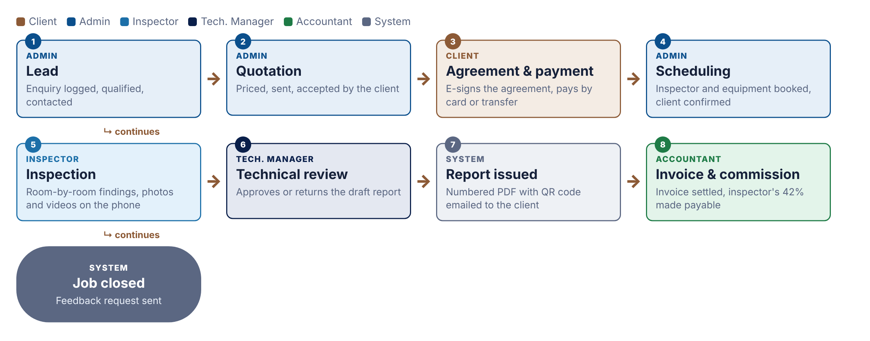
Stage | Owner | What the client receives | Document number
Lead | Admin coordinator | A call or WhatsApp reply and a price estimate | -
Quotation | Admin coordinator | Quotation PDF with a secure link to accept | QT-2026-00001
Agreement and payment | Client | Service agreement to sign, card checkout, receipt | -
Scheduling | Admin coordinator | Confirmation with date, time and inspector; reminder the day before | JOB-2026-00001
Inspection | Inspector | An inspector on site at the agreed time | -
Technical review | Technical Manager | - | -
Report issued | System | Report PDF with photos, QR code and online videos | RPT-2026-00001
Invoice and commission | Accountant | Invoice (Tax Invoice once VAT-registered) | INV-2026-00001
Closed | System | A short feedback request | -

Two rules that run through every workflow
The SLA clock starts when the inspector gets into the property, not when the client books. Bank contracts measure turnaround this way.
Nothing issued is ever edited. Quotations get revisions (R1, R2), reports get new versions, and invoices are corrected with credit notes. The client and ARAL always see the same document.

Workflow 1: Lead management
A lead is anyone who asks about an inspection. The goal is to answer quickly, check the request is something ARAL can do, and turn it into a job without typing anything twice.
Starts when | Ends when
An enquiry arrives by website, WhatsApp, phone, a broker, a bank or a repeat client. | The lead is converted into a job request, or closed as Lost with a reason.
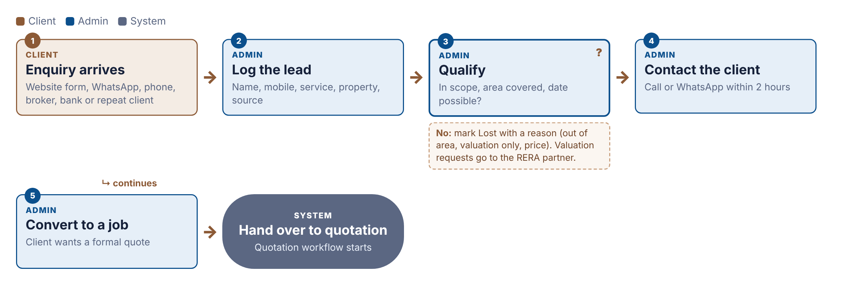

Step by step
# | Step | Who | What the app does | Status after
1 | Enquiry arrives | Client | Web enquiries create a lead automatically; calls and WhatsApp are typed in by the Admin. | New lead
2 | Log the lead | Admin | Checks for the same mobile or unit in the last 90 days and warns about duplicates. Records the referral source. | New lead
3 | Qualify | Admin | Shows whether the service is in our licence scope and whether an inspector covers the area. | Qualified / Lost
4 | Contact the client | Admin | Gives an instant price estimate from the price list (property type and bedrooms). Logs each contact. | Contacted
5 | Convert to a job | Admin | Creates the client, the property and the job (JOB-2026-00001). Copies all lead details so nothing is typed twice. | New request

When things don’t go to plan | What we measure
• No reply after 2 follow-ups in 7 days: the lead is marked Lost (no response), so the pipeline stays clean.  • Bank and developer leads follow a longer route: pilot jobs, vendor onboarding and a rate card. Track them as a lead with the stage 'Onboarding'.  • Valuation-only requests are referred to the RERA-registered partner. ARAL does not issue valuations. | • Response time to new leads (target: under 2 hours)  • Lead-to-job conversion by source  • Lost reasons (price, area, timing, valuation only)

Workflow 2: Quotation and agreement
The quotation fixes the scope, the price and the terms. The client accepts online, signs the service agreement and pays, so the job reaches scheduling with no paperwork left.
Starts when | Ends when
A job request exists (from a lead, the website or a bank upload). | The client has signed and paid, or is a company on credit terms.
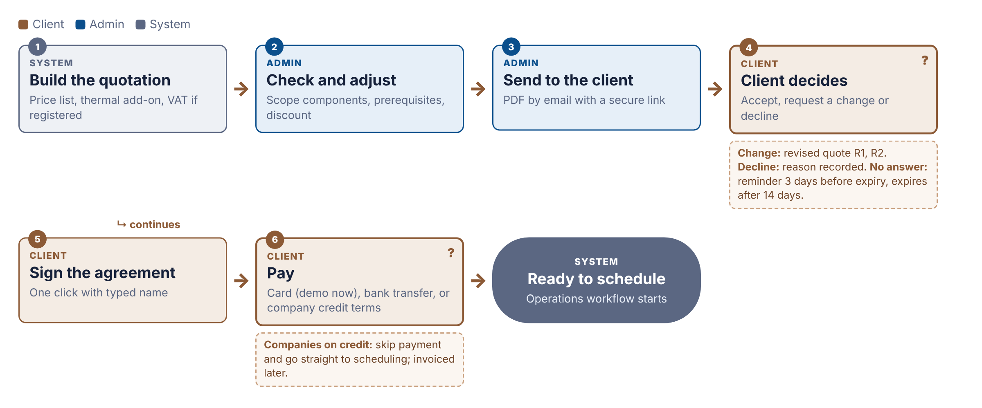

Step by step
# | Step | Who | What the app does | Status after
1 | Build the quotation | System | Fills the price from the service, property type and bedrooms, or the bank's rate card. Adds thermal imaging if chosen. Developer services are quoted per project. | Quote draft
2 | Check and adjust | Admin | Blocks discounts above the Admin's limit. Prints only the scope blocks that apply (e.g. no pool section for apartments). | Quote draft
3 | Send to the client | Admin | Numbers the quote (QT-2026-00001), emails the PDF from Gmail, and logs it under Messages. | Quoted
4 | Client decides | Client | Records the decision with name, time and IP address. Reminds automatically before expiry. | Quote accepted / rejected / expired
5 | Sign the agreement | Client | Emails the service agreement with the current terms version. Stores the signature, time and IP. | Agreement signed
6 | Pay | Client | Opens the card checkout or records a bank transfer with proof. Emails a receipt. | Paid

When things don’t go to plan | What we measure
• The demo card checkout (4242 4242 4242 4242) is used until a real gateway is switched on. Demo payment links are never sent to real clients.  • A quote can only be edited as a new revision once it has been sent, so the client and ARAL always see the same version.  • If prices change, quotes already sent keep their original price until they expire. | • Quote-to-acceptance rate  • Average time from enquiry to accepted quote  • Average discount given

Workflow 3: Operations, scheduling and dispatch
Operations puts the right inspector and the right equipment at the property at the agreed time, with access arranged and AC and DEWA connected.
Starts when | Ends when
The job is paid (or approved on credit). | The inspector has checked in at the property and the inspection starts.
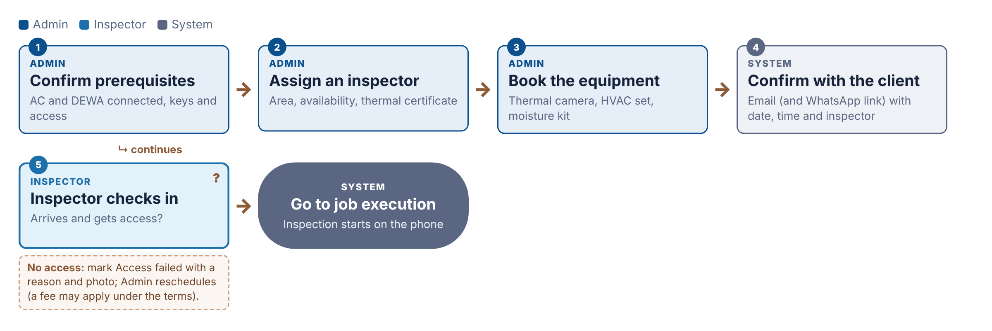

Step by step
# | Step | Who | What the app does | Status after
1 | Confirm prerequisites | Admin | Shows the checklist from the quote. A job cannot be confirmed until access details are filled in. | Paid
2 | Assign an inspector | Admin | Suggests inspectors who cover the area and are free. Blocks anyone whose licence, insurance or agreement has expired. | Scheduled
3 | Book the equipment | Admin | Reserves a free toolset for the slot. Blocks equipment that is past its calibration date. | Scheduled
4 | Confirm with the client | System | Sends the confirmation, then a reminder the day before with the prerequisites again. | Scheduled
5 | Inspector checks in | Inspector | Records arrival time and GPS. This is when the SLA clock starts. | In progress / Access failed

When things don’t go to plan | What we measure
• Rescheduling by the client with less than 24 hours' notice is recorded, so the fee in the terms can be charged.  • If no inspector is available within the SLA, the Admin sees a warning before confirming the date with the client.  • Bank jobs uploaded in bulk are scheduled from one screen, grouped by area. | • Jobs scheduled within 24 hours of payment  • Access-failed rate  • Inspector utilisation per week

Workflow 4: Job execution, inspection and report
This is the core of the service. The inspector records each room on the phone, the Technical Manager checks the work, and the client receives a numbered report that cannot be changed afterwards.
Starts when | Ends when
The inspector checks in at the property. | The report is issued to the client, and any re-inspection is booked.
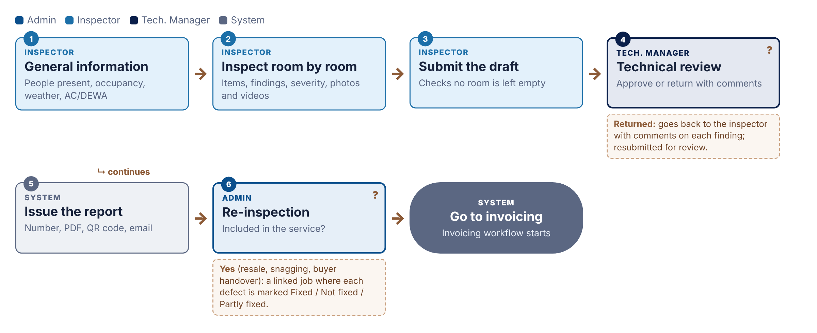

Step by step
# | Step | Who | What the app does | Status after
1 | General information | Inspector | Pre-fills the inspector, property and date. Takes the cover photo. | In progress
2 | Inspect room by room | Inspector | Offers ready-made findings for each item. Saves everything on the phone and syncs when there is signal. | In progress
3 | Submit the draft | Inspector | Warns about rooms with no entry and photos not linked to a finding. Locks the draft for the inspector. | Under review
4 | Technical review | Technical Manager | Shows every finding with its photos; the reviewer can change severity or wording, with each change logged. | Approved / Returned
5 | Issue the report | System | Gives the report number (RPT-2026-00001), builds the PDF with contents and summary, saves it to Google Drive and emails the client a link. | Report issued
6 | Re-inspection | Admin | Creates the linked re-inspection job with the original findings ready to tick off. | Report issued / Re-inspection due

When things don’t go to plan | What we measure
• An issued report can never be edited. A correction creates version 2, and the QR page shows version 1 as replaced.  • If the SLA is at risk (for example 6 hours left), the job is highlighted on the dashboard for the Admin and the Technical Manager.  • Videos are shown in the PDF as a thumbnail with a QR code that opens them on the online report. | • Reports issued within SLA (from property access)  • Reports returned by the reviewer  • Average findings and photos per report

Workflow 5: Invoicing, payment and commission
Invoicing makes sure every issued report is billed and paid, refunds are handled properly, and inspectors are paid their commission on time.
Starts when | Ends when
The report is issued. | The invoice is paid, the inspector’s commission is paid and the job is closed.
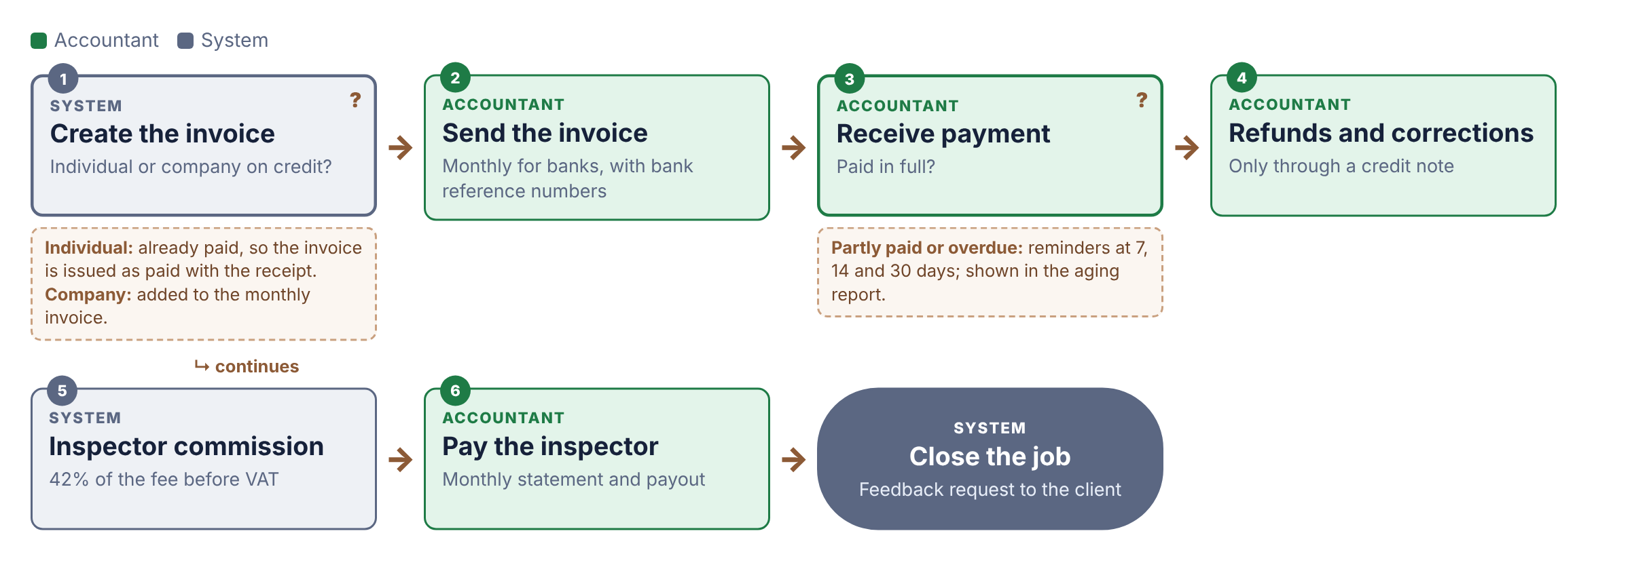

Step by step
# | Step | Who | What the app does | Status after
1 | Create the invoice | System | Numbers the invoice (INV-2026-00001). Shows 'Tax Invoice' with 5% VAT once VAT registration is switched on. | Invoiced
2 | Send the invoice | Accountant | Emails the PDF with a card payment link (live gateway only) and bank details. | Invoiced
3 | Receive payment | Accountant | Matches card payments automatically. Bank transfers and cheques are recorded with proof. | Paid / Part paid
4 | Refunds and corrections | Accountant | Issues a credit note (CN-2026-00001). Issued invoices are never edited or deleted. | Paid / Refunded
5 | Inspector commission | System | Becomes payable when the report is issued and (for individuals) the job is paid. Goes on the monthly commission statement. | Commission payable
6 | Pay the inspector | Accountant | Produces the statement PDF and an Excel payout list. Marks commissions as paid. | Commission paid

When things don’t go to plan | What we measure
• Before VAT registration, invoices carry no VAT. Turning VAT on changes new invoices only.  • A cancelled job after payment is refunded through a credit note; the inspector's commission is cancelled if no visit took place.  • Data is kept in a structured form so it can be exported for the UAE e-invoicing system when ARAL is required to join. | • Days sales outstanding (bank clients)  • Overdue amount by aging band  • Commission paid on time

Job status reference
These are the statuses a job moves through. The app only allows the moves shown in the workflows and records every change with the person, the time and a note.
Status | Meaning | Who moves it on
New request | Converted from a lead or received online; not yet quoted | Admin coordinator
Quoted | Quotation sent, waiting for the client | Client
Quote accepted | Client accepted; agreement sent | Client
Agreement signed | Agreement signed; waiting for payment | Client or Accountant
Paid | Paid in full or the deposit (or on credit terms) | Admin coordinator
Scheduled | Inspector, equipment and time confirmed | Inspector
In progress | Inspector on site; SLA clock running | Inspector
Under review | Draft submitted to the Technical Manager | Technical Manager
Report issued | PDF sent to the client; locked | Accountant
Invoiced | Invoice issued (or added to the monthly invoice) | Accountant
Closed | Paid, commission handled, feedback requested | -
Quote rejected / expired | Client declined or did not answer in time | Admin (may revise)
On hold / Access failed | Paused by the client, or no access on the day | Admin coordinator
Re-inspection due | A follow-up visit is included and not yet done | Admin coordinator
Cancelled / Refunded | Job stopped; any payment returned by credit note | Accountant

PART B
The build prompt
The full specification for the developer

1. Role and working rules
You are a senior full-stack engineer. Build a production-ready web application for ARAL Property Inspection Service in Dubai. It runs the business end to end, following the workflows in Part A:
lead → quotation → agreement → payment → scheduling → field inspection → technical review → report issue → invoice → inspector commission → closure

- Screens are in English and Arabic. All PDFs and emails are in English.
- Work in the phases in section 20. After each phase, stop, summarise what was built, list your assumptions and wait for approval.
- Ask before guessing. Do not invent business rules, fees or legal wording.
- Amounts in AED. Time zone Asia/Dubai. Dates shown as DD/MM/YYYY.

2. Brand and theme
Item | Value
Trade name | ARAL Property Inspection Service
Arabic name (screens; confirm against the trade licence) | آرال لخدمات فحص العقارات
Tagline | Smarter Inspections | Safer Properties
Navy | #0A1F4A: text, top bar, headings
Royal blue | #0B4F8C: buttons, links, "Attention" findings
Sky blue | #2283C8: accents and focus
Copper | #8C5A36: secondary accent, dividers, active tab
Copper tint | #F4ECE4: soft backgrounds
Critical red | #C62828: critical findings
Page and text | Background #F5F7FA, cards #FFFFFF, text #16213A

- Style: clean white layout, navy top bar with a thin copper line (as in the logo’s "— SERVICE —"), 8 px rounded corners.
- Logo files needed: the full logo and the icon-only mark as SVG or transparent PNG, plus a white version for dark backgrounds. The favicon and phone app icon come from the mark.
- PDFs use the built-in Helvetica font in the brand colours.
- All brand values live in Settings so they can change without code.

3. Regulatory scope guard
Non-negotiable
ARAL holds a DET licence for property inspection services (activity 6820007), registered with DLD/RERA through Trakheesi. It is not a licensed valuation firm.
The app must never produce a market value, valuation figure or "valuation report" under ARAL’s name.
Clients who need a valuation are referred to a RERA-registered valuation partner. ARAL does not offer valuation-support inspections.
Build a switch VALUATION_MODULE_ENABLED (off by default) so full valuation reports can be added later, once ARAL and a registered valuer hold RERA authorisation.
Every report carries scope and limitation wording that the Super Admin can edit.

4. Technology
Use the same architecture as the Dar Al Bunyan app (GitHub ananader1977/dar-al-bunyan). Copy and adapt its modules; do not import across repositories.
Part | Choice
Runtime | Node.js 22.13 or later, JavaScript ES modules. No npm packages.
Screens | Plain HTML, CSS and JavaScript in public/. No framework, no build step.
Database | Node’s built-in SQLite, one file at DB_PATH. Schema in src/schema.sql.
PDF | Dar Al Bunyan’s dependency-free pdf.js, extended with JPEG photos, automatic page breaks, a repeating header and footer ("Page X of Y"), "(continued)" headings, a 2-photo grid with captions, coloured findings and a table of contents. Target: a 60 to 70 page report with 200+ photos in under 30 seconds and under 20 MB.
Excel | Dar Al Bunyan’s xlsx.js. Exports in English; Arabic names still display correctly.
Email | Gmail SMTP with an app password for ananader1@gmail.com. Every message logged under Messages.
Payments | PAYMENT_PROVIDER=mock demo checkout first; Stripe ready behind settings (section 10).
Photos and files | Google Drive, one folder per job: ARAL/Jobs/{job no.} – {building} {unit}/photos | videos | pdf. The server disk holds only the database and a temporary cache.
Languages | English and Arabic screen dictionaries, a language switch, right-to-left layout for Arabic.
Sign-in | Sessions with hashed passwords; authenticator-app codes (2FA) for Super Admin, Admin, Technical Manager and Accountant.
Hosting | Private GitHub repo ananader1977/aral-inspection, deployed on Render with render.yaml and a persistent disk.

5. Roles and permissions
Permissions are checked on the server for every request. Hiding a button is not enough.
Role | Equivalent in the business plan | Can do
Super Admin | Founder / General Manager | Everything: users, settings, terms, addresses, prices, templates, numbering, tax, audit log
Admin coordinator | Admin and report coordinator | Leads, requests, quotes, scheduling, clients, inspectors and equipment, exports. No system settings.
Inspector | Outsourced inspection network | Only their assigned jobs: inspection, photos, draft report; their own commission statement
Technical Manager | Outsourced chartered engineer | Review, return or approve reports; checklists, comment library and glossary
Accountant | Outsourced accounting | Invoices, payments, refunds, credit notes, commission payouts, financial exports
Company client | Bank, developer, owners association | Portal: bulk requests, SLA tracking, reports, invoices, statement of account
Individual client | Owner, buyer, tenant | Portal: book, accept quote, sign, pay, download own documents

6. Clients and commercial terms
- Client groups: banks and lenders; owners, buyers and tenants; developers and owners associations; brokers and referrers.
- Company clients have a contract or panel record, a rate card (bulk prices per unit), an SLA per service, credit terms (for example 30 days with a monthly invoice), and several users and branches.
- Individual clients pay in advance (in full, or the deposit set in Settings) before the inspection.
- Referral source is recorded on every lead and job, with an optional referral fee.

7. Lead management
New in this version. Follows Workflow 1.
- Sources: website form (creates a lead automatically), WhatsApp, phone, email, broker, bank, repeat client.
- Fields: name, mobile, email, client type, service wanted, property type, bedrooms, community, preferred date, source, notes, assigned Admin.
- Statuses: New → Contacted → Qualified → Converted, plus Onboarding (banks and developers) and Lost.
- Lost reasons (picklist): price, out of area, timing, valuation only (referred to partner), no response, chose a competitor.
- Follow-up: reminder to the Admin if a new lead is not contacted within 2 hours; marked Lost (no response) after 2 follow-ups in 7 days.
- Instant estimate from the price list while on the phone.
- Convert creates the client, the property and the job in one step, with nothing typed twice.
- Duplicate check: same mobile or same unit within 90 days.
- Dashboard: response time, conversion by source, lost reasons.

8. Service catalogue and pricing
Loaded on first start and editable in Settings. Prices are AED before VAT.
Code | Service | Client group | Price range | Turnaround
OWN-PPI | Resale (pre-purchase) inspection (incl. 1 re-inspection) | Owner / buyer | 1,200 – 3,500 | 24 h
OWN-SNG | Snagging and handover (incl. 1 re-inspection) | Owner | 1,200 – 6,000 | 48 h
OWN-MIO | Move-in / move-out condition report | Owner / tenant | 900 – 2,200 | 24 h
BNK-REP | Repossessed / distressed asset inspection | Bank | 1,300 per unit | 48 h
BNK-HND | Buyer handover programme (white-label snagging) | Bank | 2,000 per unit | 3 days
DEV-PHQ | Pre-handover quality check | Developer | Per proposal | Per proposal
DEV-DPT | Defect-period tracking | Developer / owners association | Per proposal | Per proposal
ADD-THM | Add-on: thermal imaging | Any | 500 | With the job

Pricing rule: price for the service, property type and bedrooms + thermal imaging if chosen − discount (limited by role). There are no surcharges. A bank’s rate card replaces the list price; developer services are quoted per project. The public booking page shows an instant estimate.

9. Requests and quotations

9.1 Requests
- Channels: converted lead, public booking form, client portal, bulk upload (Excel) for banks, entry by the Admin.
- Fields: client details (with an English name for PDFs), service, purpose, property type, emirate, community, building, unit, plot, title deed no., developer, handover date, built-up and plot area (sq ft and sq m), bedrooms, maid’s room, occupancy, access contact and keys, preferred dates, documents (title deed, affection plan, Oqood, SPA, handover letter), bank reference no.
- On submit: job number JOB-2026-00001 and an acknowledgement email.

9.2 Quotation
- Built from the pricing rule; lines can be edited. VAT is shown only once ARAL is VAT-registered.
- Number QT-2026-00001, revisions R1, R2. Valid for 14 days (editable); reminder 3 days before expiry; expires automatically.
- Emailed as a PDF with a secure link: Accept, Request a change, Decline, Pay. Acceptance records the name, time and IP address.
- Acceptance triggers the service agreement, which the client signs online (typed name) before paying.

9.3 Quotation layout
Block | Contents
Document details | Quotation no., issue date on every page, valid until, revision
Client | Attention name, company, email, mobile
Property | Type, bedrooms, community, building, unit, area. Title written automatically, e.g. "2 Bedroom Apartment – IMPZ".
Service and scope | Service type, re-inspection included, components in scope (exterior, interior, structure, MEP, HVAC, water leak and moisture, pool, life safety). Villa-only items hidden for apartments.
Before we come | AC connected, DEWA connected, keys and access arranged, unit empty and clean
Report and delivery | Delivery time (24 hours by default), photos and videos, findings by severity, follow-up call
Wording blocks | Cover letter, introduction, component descriptions, equipment, standards, exclusions, why choose us. Only blocks for the selected scope are printed.
Fees | Lines, discount, subtotal, VAT (if registered), total, amount in words, payment terms, bank details, card payment link and QR
Optional extra | Thermal imaging add-on
Sign-off and footer | Signatory, credentials, signature; address, phones, email, website, DET licence no., RERA no., Page X of Y

10. Payments
- Demo first. PAYMENT_PROVIDER=mock gives a built-in checkout that accepts the test card 4242 4242 4242 4242 (any future expiry, any CVC) and records a demo_pi_… reference.
- The demo page shows a clear "DEMO – no real payment" banner. In demo mode, payment links are never sent to real clients; admins test with "Test online payment".
- Switching to Stripe later (STRIPE_SECRET_KEY, STRIPE_WEBHOOK_SECRET) or adding N-Genius or Telr must not change any other code.
- Full amount or deposit; receipt PDF emailed on payment.
- Bank transfer, cheque and cash recorded by the Accountant with proof of payment.
- Partial payments, refunds through credit notes, and a payment ledger per job and per client.
- Live gateway: verify webhook signatures and process each payment once only. Never store card details.

11. Scheduling and the inspection app

11.1 Scheduling
- Assign by area, availability and qualification (for example thermal-certified). One calendar per inspector; no double-booking.
- Inspectors with an expired licence, insurance or agreement cannot be assigned.
- Equipment is booked with the job; a thermal job needs a free thermal camera within its calibration date.
- Confirmation email (with a WhatsApp link) with date, time and inspector, and a reminder the day before.

11.2 Inspection app on the phone
- Installed from the browser to the home screen on iPhone and Android. No App Store release.
- Works offline: everything is saved on the phone and synced when there is signal. Nothing is lost if the app closes.
- Check-in records arrival time and GPS and starts the SLA clock. "No access" records the reason with a photo.
- Rooms are built from the checklist and the bedroom count; the inspector can add, rename or remove rooms.
- For each item: ready-made finding or free text, severity, recommended trade, photos, videos and thermal images.
- Take photo, Add from gallery, Record video (up to 60 seconds) on every finding; mark-up with red arrows, circles and text.
- Photos are reduced on the phone (about 1,600 px) so 200+ photos upload over mobile data.
- Quick mode: take all the photos room by room first, then link them to findings.
- Client or tenant signature on site for move-in and move-out reports.

12. Reports and technical review
- Report types: resale, snagging and handover (also used for the bank buyer handover programme and the developer pre-handover quality check), move-in / move-out, repossessed or distressed asset, and defect-period tracking (a re-inspection report).
- Two-step review: the inspector submits, the Technical Manager approves or returns it with comments. Once issued, the report is locked; a correction creates a new version.
- Report number RPT-2026-00001 and a QR code that opens a verification page (number, date, property, valid or replaced).
- Re-inspection: a linked job where each original finding is marked Fixed, Not fixed or Partly fixed, with before and after photos.
- Sign-off: inspector and Technical Manager names, credentials and signatures, and ARAL’s RERA registration number.

12.1 Report structure
Follows the structure of the sample resale report. All fixed wording is ARAL’s own. Every page has the ARAL logo at the top and "ARAL | {building}, Unit {unit}, {community} · Page X of Y" at the bottom.
# | Part | Contents | Source
1 | Cover | Title, cover photo, property, client, inspection date, report no., inspector, QR code | Job data
2 | Introduction | How to read the report; properties do not pass or fail; snapshot in time | Wording
3 | What we inspect | Visual, non-invasive scope; what a material defect is | Wording
4 | Standards followed | DM, DEWA, Civil Defence, Trakhees, InterNACHI, ASHRAE, NFPA | Wording
5 | Contents | Sections with page ranges | Automatic
6 | General information | Inspector, people present, occupancy, property note, levels, age, weather and °C, AC and DEWA, time in and out | Inspector
7 | Understanding the report | Colour legend: red Critical, blue Attention, dark Informational | Wording
8 | Systems | Air conditioning, electrical, water heater (plus plumbing, life safety, structure when in scope) | Inspector
9 | Rooms and areas | Kitchen, laundry, living room, balconies, maid’s room and bath, powder room, bedrooms, bathrooms | Inspector
10 | Glossary | Only the terms used in this report | Automatic
11 | Report summary | Red and blue findings with page and item number | Automatic
12 | Conclusion | Limitations; not a warranty | Wording
13 | Terms and conditions | The version the client signed | Wording
14 | Thermal addendum | Only when the thermal camera was used | Wording
15 | Sign-off | Inspector and Technical Manager | Review
16 | Back page | Thank you, contact details, tagline | Settings

12.2 Findings, photos and videos
- Each room holds numbered items (e.g. "4. Shower Faucet Condition") with a Type, Materials or Location detail (e.g. "Cultured marble").
- Each item holds findings: the text, the severity, the trade to call (e.g. "licensed plumber"), whether it appears in the summary, and an optional glossary term.
- Severity (approved): red Critical for safety or value, blue Attention for repair or replacement, dark Informational for items tested and working.
- Repair cost estimates are kept internal for resale reports and optional on snagging reports (approved).
- Photos print 2 per row under their finding with a caption; thermal images sit next to the normal photo with the temperature range.
- Videos print as a thumbnail with a QR code that opens them on the online report (approved).
- A room with no findings prints "No defects observed at the time of inspection".

13. PDF documents
- Quotation, service agreement, inspection report (all types), invoice, receipt, credit note, statement of account, inspector commission statement.
- A4 and English only. Clients have an English name field for PDFs.
- Header: ARAL logo, company name, branch address, TRN once VAT-registered, DET licence no., RERA no. Footer: contact details and Page X of Y.
- Terms, addresses and wording are taken from Settings when the document is issued and frozen into it.
- Bank buyer-handover reports can carry the bank’s logo (white label).

14. Invoicing and VAT
- VAT switch: ARAL registers for VAT once taxable sales pass AED 375,000. Before then invoices carry no VAT. After the switch, new documents say "Tax Invoice" with 5% VAT and every field the FTA requires.
- Number INV-2026-00001; supplier and client details, supply date, lines, subtotal, VAT, total, amount in words.
- One invoice per job for individuals; one monthly invoice for companies, listing each job and bank reference.
- Corrections only by credit note (CN-2026-00001). Issued invoices are never edited or deleted.
- Data kept ready for export to the UAE e-invoicing system.
- Statement of account and receivables aging (0–30, 31–60, 61–90, 90+ days); reminders at 7, 14 and 30 days overdue.

15. Inspector commission and subcontractors
- Inspectors are outsourced: their own licence or manpower supplier, agreement and insurance, each with an expiry date.
- Commission is 42% of the job fee before VAT by default, with a rate per inspector or service if needed and an optional bonus.
- Commission becomes payable when the report is issued and, for individuals, the job is paid. It is cancelled if a job is refunded with no visit.
- Monthly commission statement PDF per inspector and an Excel payout list for the Accountant.
- Specialist subcontractors (concrete testing, pool, waterproofing, drone) recorded as job costs.

16. Email
- Sent from Gmail with an app password, as "ARAL Property Inspection Service". Settings has a "send me a test email" button.
- English templates the Super Admin can edit, with fields such as {{client_name}}, {{job_no}}, {{quote_link}}, {{pay_link}}, {{inspection_date}}, {{report_link}}.
- Templates: lead follow-up, request received, quotation, quotation reminder, agreement, payment receipt, inspection confirmation and reminder, no access, report issued, invoice, payment reminder, re-inspection due, feedback request.
- The relevant PDF is attached; every email is logged and retried on failure. A warning shows near Gmail’s limit of about 500 emails a day.

17. Admin controls
- Users: add, deactivate, set roles, reset passwords and two-step codes.
- Company: name, branch addresses, DET licence no., RERA no., TRN, logo, bank details, signatures, insurance details.
- Terms and wording: one version-controlled text per document and report page, with a start date. Each issued document records the version it used.
- Catalogue: services, prices, the thermal add-on, discount limits, bank rate cards.
- Checklists, comment library and glossary (Super Admin and Technical Manager).
- Numbering, VAT switch, quote validity, deposit, reminders and SLA targets.
- Picklists: property types, communities, developers, purposes, banks, materials, trades, lost reasons.
- Audit log: who, what, when, before and after, from where; searchable and exportable.

18. Dashboard, KPIs and Excel
- Dashboard: new leads and response time, jobs by status, jobs this month against the target (100 a month by month 12), revenue by client group, money owed, SLA compliance, average turnaround, inspector workload, equipment use, review score (target 4.8), quote conversion, bookings by source.
- Every list has filters, search and Export to Excel of exactly what is shown.
- Ready-made exports: lead register, job register, SLA report per bank, quotations, invoices with VAT summary, payments, aging, commissions, equipment calibration.

19. Quality, security and hosting
- Screens fully in English and Arabic with right-to-left layout; no fixed text outside the dictionaries.
- Security: OWASP Top 10, validation on the server for every request, rate limits, protection against cross-site requests, secrets only in environment settings, HTTPS, signed expiring links for files.
- UAE data protection (PDPL): retention rules per record type, consent, export or deletion of a client’s data on request, access logs. Write it up so bank security questionnaires can be answered from it.
- Daily backups with a tested restore. Master data is deactivated rather than deleted.
- Automated tests (node --test) for pricing, VAT, commission and job statuses, plus one full run from lead to commission statement. GitHub Actions runs them on every push.
- README in the Dar Al Bunyan style: features, roles, quick start, Render, Gmail, Google Drive, payments, backups.

20. Delivery phases
Stop for approval at the end of each phase.
Phase | Scope | Status
1 | Database design, report field mapping, screen layouts | Approved 21 Oct 2026
2 | Sign-in and 2FA, roles, users, settings, wording, catalogue, libraries, English/Arabic screens | Delivered
3 | Leads, requests, pricing engine, quotations, PDF engine | Next
4 | Agreement, demo card payments, email templates
5 | Scheduling, equipment, phone inspection app, reports, review, QR verification
6 | Invoices, VAT switch, credit notes, commissions, client and partner portals
7 | Dashboard, KPIs, Excel exports
8 | Tests, security review, deployment, user guide

21. Acceptance criteria
- An individual job runs from a website lead to card payment, inspection, review, issued report and receipt with no manual database changes.
- A bank job runs from bulk upload to an inspection within SLA, an issued report and a monthly invoice.
- No market value or valuation figure is shown anywhere while the valuation switch is off.
- All PDFs print correctly in English; every screen works in Arabic and English.
- The inspection report follows the sample report part by part.
- Switching VAT on changes new documents to Tax Invoices with 5% VAT and leaves issued ones unchanged.
- A change to a user, the terms or an address appears on the next PDF produced.
- The commission statement equals 42% (or the inspector’s own rate) of eligible jobs.
- Every list exports correctly to Excel.

Appendix: decisions approved in Phase 1
# | Decision | Approved answer
1 | Severity scale | Red Critical, blue Attention, dark Informational
2 | Repair cost estimates | Internal for resale; optional on snagging reports
3 | Videos in the PDF | Thumbnail with a QR code to the online report
4 | Report summary | Red and blue findings, ticked per finding
5 | Agreement step | Client e-signs after accepting the quote and before paying
6 | Terms and conditions | Draft placeholders now; final text from ARAL’s lawyer

