Software Design Document
Online Complaint Management System with Admin Dashboard



Submitted by
Anan Ahmad (S23BINFT1M01141)

Submitted to
Miss Sara Fareed

Department of Information Technology
Faculty of Computing
The Islamia University of Bahawalpur

Summery
The Online Complaint Management System with Admin Dashboard is a web-based application built on Django and MySQL, following the Model-View-Template (MVT) architectural pattern. The system is designed to digitize complaint handling for educational institutions, service organizations, and businesses. Users can register, submit complaints with attachments, track statuses in real time, and submit resolution feedback. Administrators operate through a centralized dashboard to manage, categorize, assign, and resolve complaints. The design is structured around three layers: a responsive HTML/CSS/JavaScript frontend, Django-powered business logic and API layer, and a MySQL relational database for persistent data storage. The document covers the full application architecture with controller descriptions, data model schema with entity relationships, and the complete user interface design including screen layouts and input controls.

Table of Contents
1. Application Architecture 4
2. Data Model Schema 8
2.1 Users 8
2.2 Complaints 8
2.3 Departments 9
2.4 staff 9
ER Diagram: 10
3. User Interface 11
3.1 Design Philosophy: 11
3.2 Screens / Pages and Their Data: 11

- Application Architecture
The system follows Django's MVT (Model-View-Template) pattern, which is a variation of the standard MVC pattern adapted for web frameworks.
Architecture Components:
The Model layer handles all database interactions and business data. The View layer contains the application's business logic, processes HTTP requests, communicates with models, and returns responses to templates. The Template layer is the presentation layer rendering HTML to the browser.
Proposed Models (Data Entities):
User, Complaint, ComplaintCategory, ComplaintAssignment, ComplaintStatus, Feedback, Notification, Department, Staff
Proposed Views (Controllers):
UserAuthView, ComplaintView, AdminDashboardView, StaffView, NotificationView, ReportView, FeedbackView
Proposed Templates (UI Screens):
register.html, login.html, dashboard.html, submit_complaint.html, track_complaint.html, admin_dashboard.html, manage_complaints.html, complaint_detail.html, feedback.html
Controller Descriptions with Functions:
- UserAuthView Handles all authentication-related operations. Functions: register_user(), login_user(), logout_user(), validate_credentials(), hash_password(), check_role()
- ComplaintView Manages complaint lifecycle from submission to resolution. Functions: submit_complaint(), get_complaint_by_id(), list_user_complaints(), update_complaint_status(), attach_file(), generate_complaint_id(), search_complaints(), filter_complaints()
- AdminDashboardView Central controller for the administrative interface. Functions: get_all_complaints(), assign_complaint_to_staff(), get_dashboard_stats(), filter_by_status(), filter_by_category(), manage_users(), generate_report()
- StaffView Handles operations available to assigned staff members. Functions: get_assigned_complaints(), update_resolution_notes(), mark_complaint_resolved(), view_complaint_detail()
- NotificationView Manages all system-generated notifications. Functions: send_notification(), get_user_notifications(), mark_notification_read(), notify_on_status_change()
- FeedbackView Handles post-resolution feedback submission. Functions: submit_feedback(), get_feedback_by_complaint(), list_all_feedback()
- ReportView Administrative reporting and data analysis. Functions: generate_summary_report(), export_complaint_data(), get_complaint_statistics()
External APIs and Libraries Used:
Django REST Framework is used to expose structured API endpoints for complaint submission, status updates, and user management. Django's built-in authentication system handles session management, password hashing (PBKDF2), and permission checks. Crispy Forms library handles form rendering with Bootstrap integration. Django Storages is used for file attachment handling. Git and GitHub are used for version control throughout the project lifecycle.
Coding Conventions:
All Python files follow PEP 8 naming and formatting standards. Views are class-based where possible for reusability. Functions use snake_case naming. Models use PascalCase. HTML templates follow Bootstrap 5 grid conventions. JavaScript uses camelCase naming. All sensitive configurations (database credentials, secret keys) are stored in environment variables and not hardcoded.
Class Diagram:
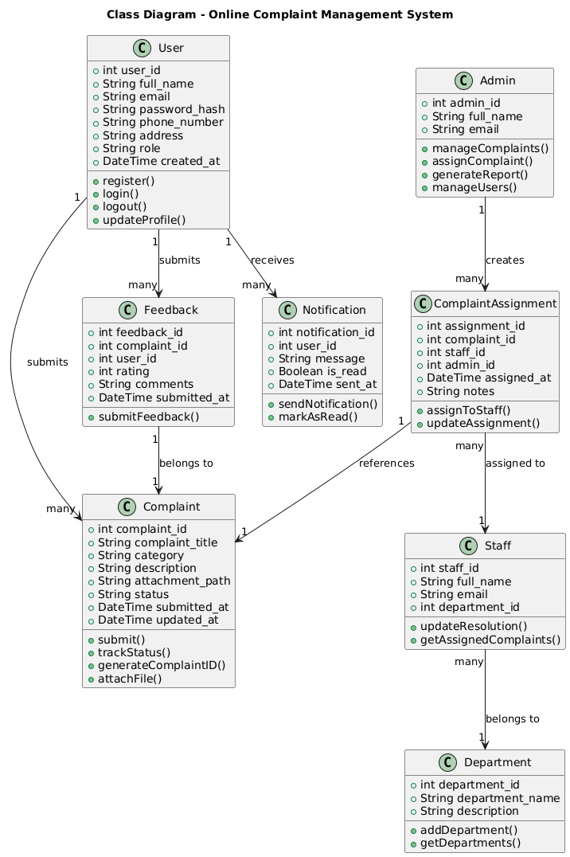
Sequence Diagram Complaint Submission:
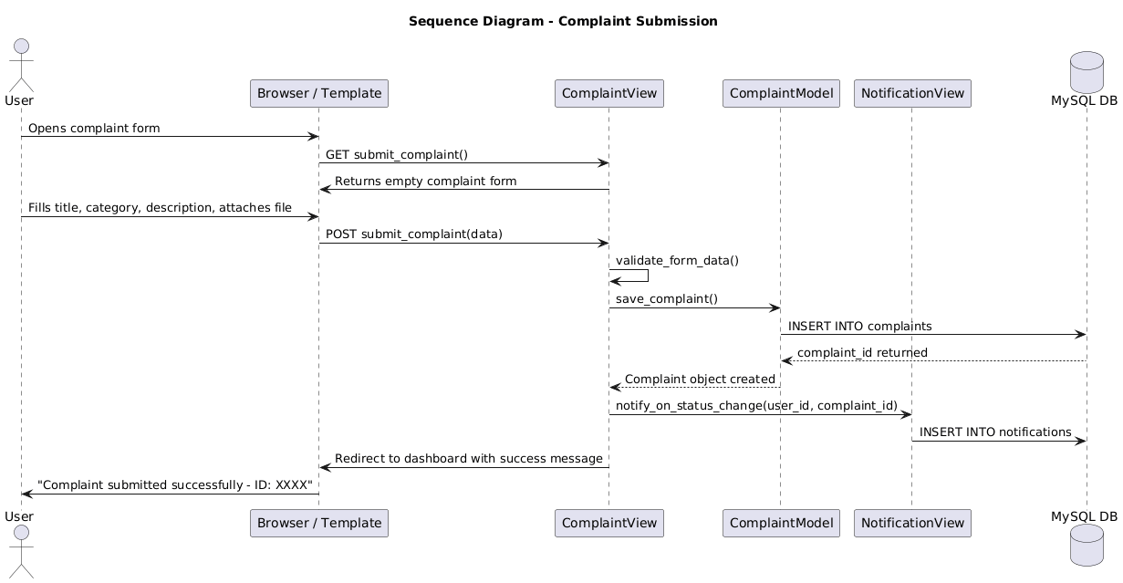

Sequence Diagram Admin Complaint Assignment:
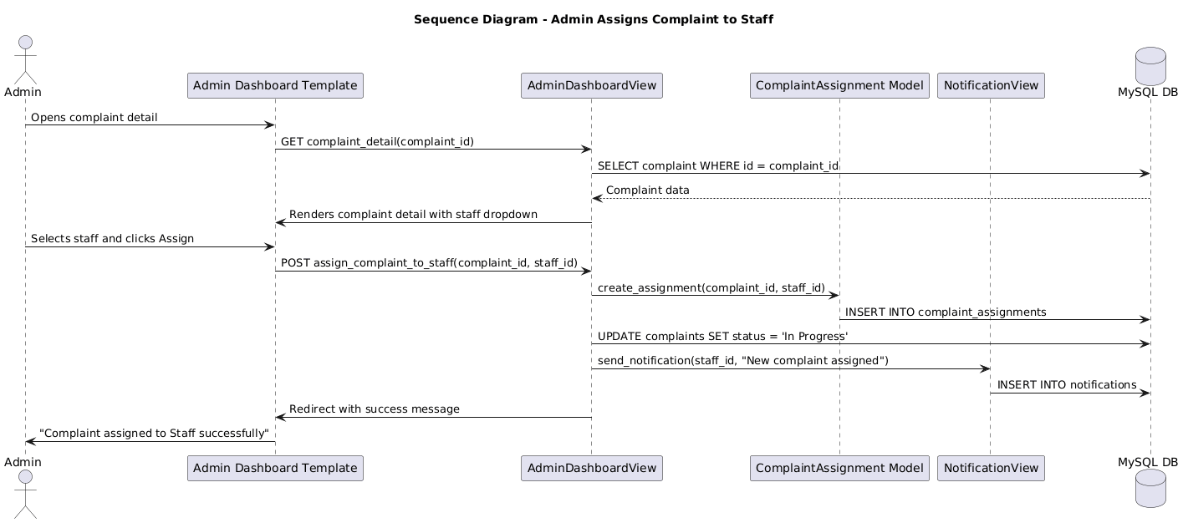

- Data Model Schema
The system database is hosted on MySQL and contains the following entities with their full field definitions and relationships.
  - Users
Field Name | Data Type | Constraints | Description
user_id | INT | PRIMARY KEY, AUTO_INCREMENT | Unique user identifier
full_name | VARCHAR(100) | NOT NULL | Legal full name of user
email | VARCHAR(150) | NOT NULL, UNIQUE | Login email address
password_hash | VARCHAR(255) | NOT NULL | Encrypted password (PBKDF2)
phone_number | VARCHAR(20) | NOT NULL | Active contact number
address | TEXT | NOT NULL | Residential or organizational address
role | ENUM('user','admin','staff') | NOT NULL, DEFAULT 'user' | Access control role
created_at | DATETIME | DEFAULT CURRENT_TIMESTAMP | Account creation timestamp

  - Complaints
Field Name | Data Type | Constraints | Description
complaint_id | INT | PRIMARY KEY, AUTO_INCREMENT | Unique complaint identifier
user_id | INT | FOREIGN KEY → users(user_id) | Complaint submitter
complaint_title | VARCHAR(200) | NOT NULL | Short title of the complaint
category | VARCHAR(100) | NOT NULL | Complaint category/type
description | TEXT | NOT NULL | Full detailed complaint description
attachment_path | VARCHAR(300) | NULLABLE | File system path to uploaded attachment
status | ENUM('Pending','In Progress','Resolved') | DEFAULT 'Pending' | Current status of complaint
submitted_at | DATETIME | DEFAULT CURRENT_TIMESTAMP | Time complaint was submitted
updated_at | DATETIME | ON UPDATE CURRENT_TIMESTAMP | Time of last status change

  - Departments
Field Name | Data Type | Constraints | Description
department_id | INT | PRIMARY KEY, AUTO_INCREMENT | Unique department identifier
department_name | VARCHAR(100) | NOT NULL, UNIQUE | Name of the department
description | TEXT | NULLABLE | Brief description of department scope

  - staff
Field Name | Data Type | Constraints | Description
staff_id | INT | PRIMARY KEY, AUTO_INCREMENT | Unique staff identifier
user_id | INT | FOREIGN KEY → users(user_id) | Links to user account
department_id | INT | FOREIGN KEY → departments(department_id) | Department this staff belongs to
full_name | VARCHAR(100) | NOT NULL | Staff full name
email | VARCHAR(150) | NOT NULL | Staff email address

ER Diagram:
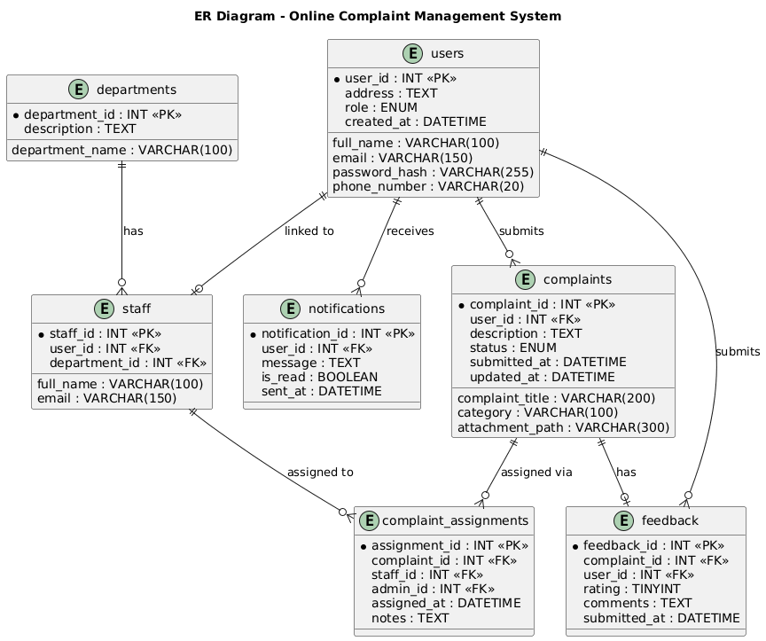

- User Interface

3.1 Design Philosophy:
The UI is designed for clarity, simplicity, and professional appearance suitable for institutional and organizational use. The design follows a clean and minimal style with clear visual hierarchy, making it usable by users with basic web browsing skills.
Color Scheme: Primary color is deep blue (#1E3A5F) representing trust and professionalism. Accent color is orange (#F57C00) used for action buttons and status badges. Background is light grey (#F4F6F9). Text is dark charcoal (#2C3E50). Success states use green (#27AE60) and error/pending states use red (#E74C3C).
Font: The system uses Roboto (Google Fonts) for all body text at 14px–16px with Inter as the heading font at weights 600 and 700.
Screen Constraints: The interface is fully responsive. Desktop layout targets 1280px width with a sidebar navigation. Tablet targets 768px. Mobile targets 375px with stacked layout and hamburger menu.

3.2 Screens / Pages and Their Data:
Screen 1: Registration Page (register.html)
Purpose: Allows new users to create an account.
Data displayed: Registration form with field labels and validation messages.
Controls and their working: Full Name textbox accepts alphabetic characters only, minimum 3 characters. Email textbox validates RFC 5321 email format. Password textbox enforces minimum 8 characters including one number and one special character, input is masked. Phone Number textbox accepts numeric input only, 10 to 13 digits. Address textarea accepts any text, minimum 10 characters. Register button submits the form via POST to UserAuthView.register_user(). All fields are required. On success, user is redirected to login page. On failure, inline error messages appear under each invalid field.
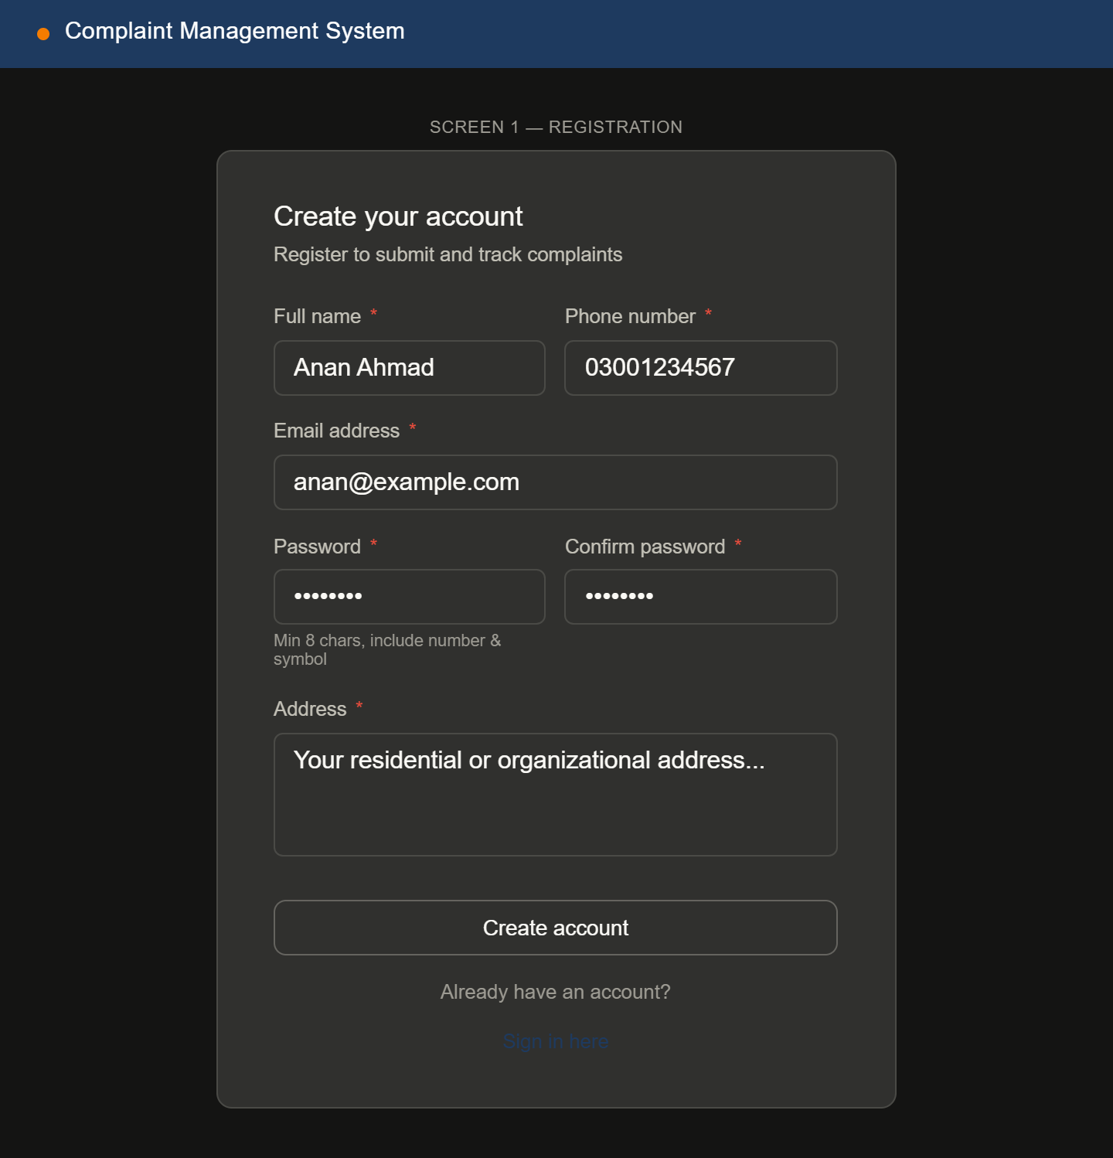
Screen 2: Login Page (login.html)
Purpose: Authenticates registered users and admins.
Data displayed: Login form, forgot password link.
Controls and their working: Email textbox accepts valid email format. Password textbox accepts masked input. Login button submits credentials to UserAuthView.login_user(). System checks role field and redirects users to user dashboard and admins to admin dashboard. Invalid credentials display a toast error. Forgot Password link navigates to password reset flow (future enhancement placeholder).
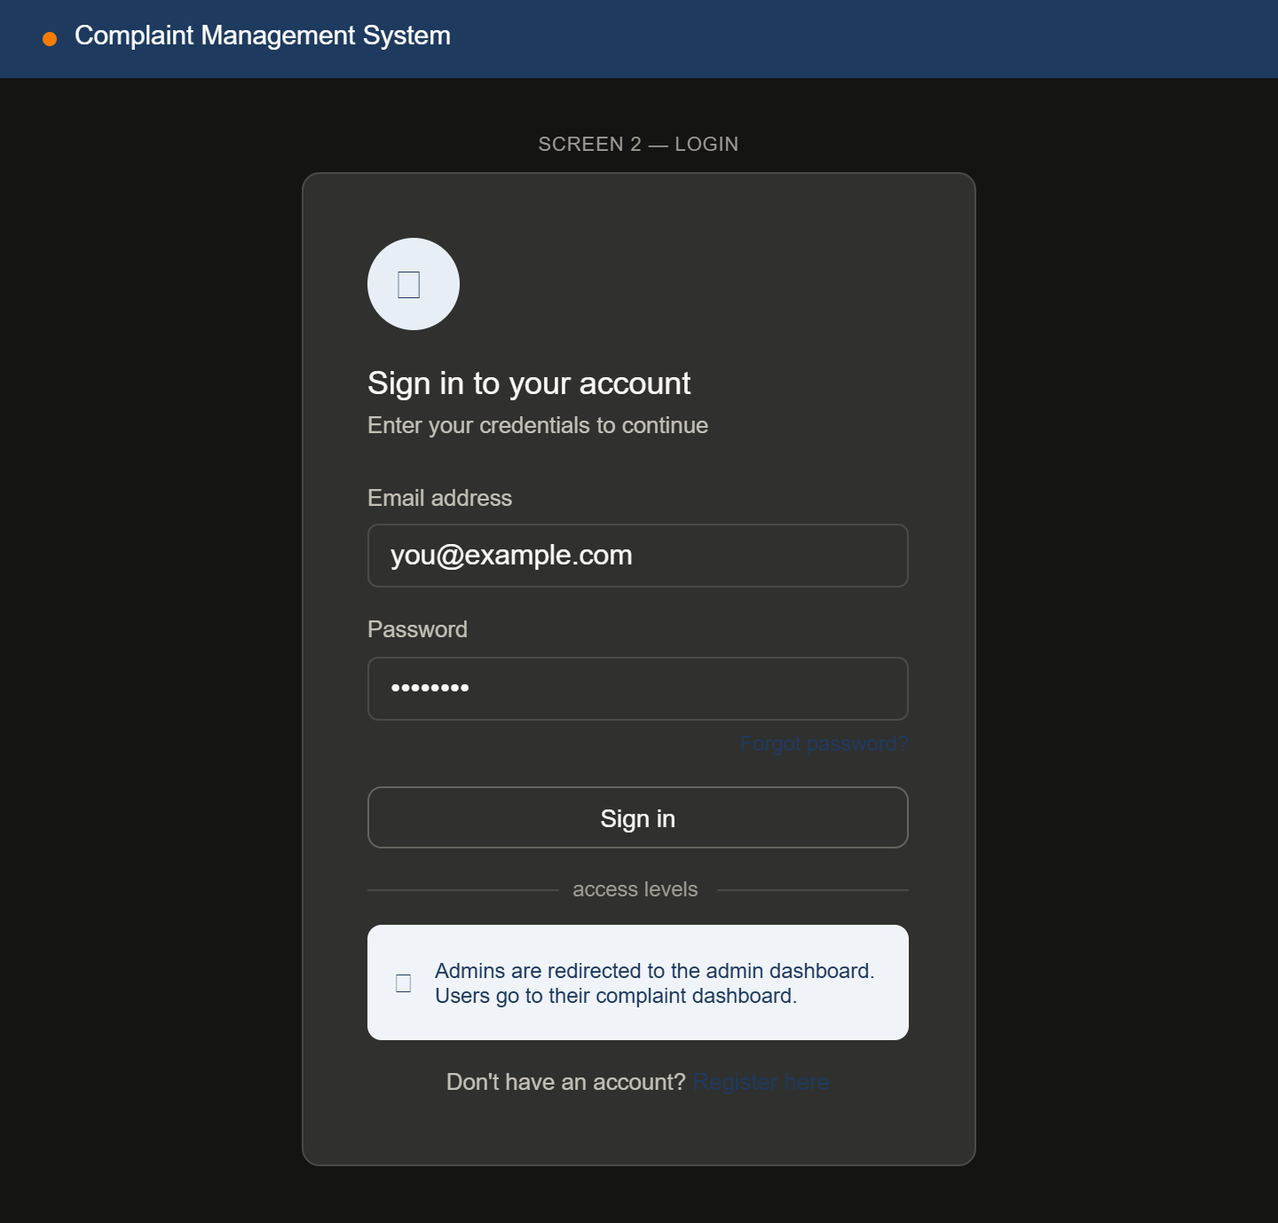
Screen 3: User Dashboard (dashboard.html)
Purpose: Central hub for logged-in users to view and manage their complaints.
Data displayed: Summary statistics (total complaints submitted, pending count, resolved count), list of recent complaints with complaint ID, title, category, date, and status badge.
Controls and their working: Submit New Complaint button navigates to submit_complaint.html. Each complaint row is clickable and opens the complaint detail view. Status badges are color-coded: Pending is red, In Progress is orange, Resolved is green. Search bar at the top accepts keyword input and filters the complaint list in real time using JavaScript. Filter dropdown allows filtering by status: All, Pending, In Progress, Resolved. Notification bell icon shows unread notification count and opens a dropdown list of recent notifications.
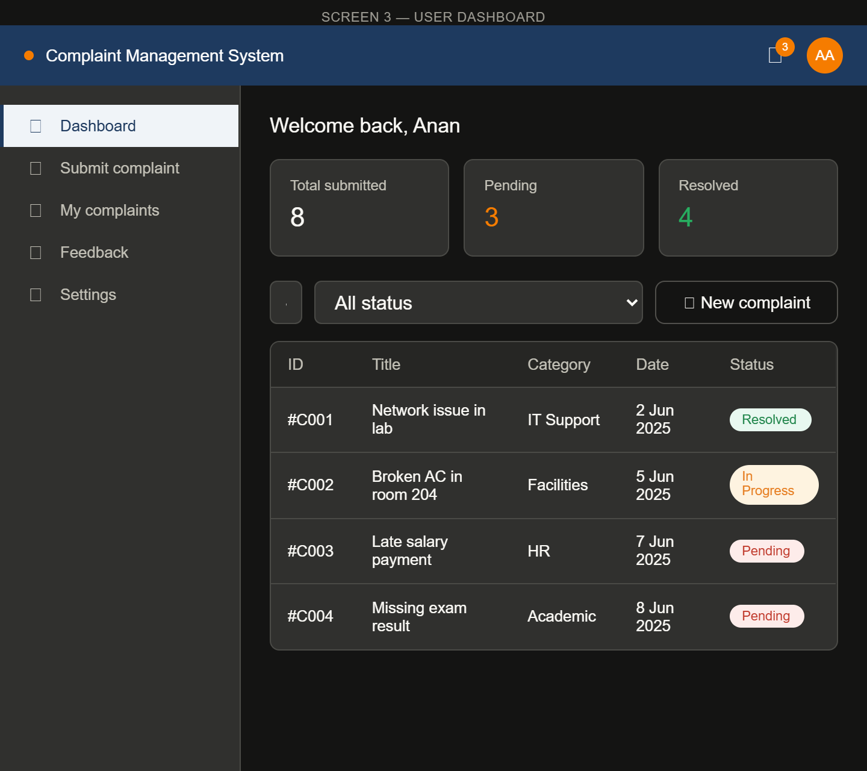
Screen 4: Submit Complaint Page (submit_complaint.html)
Purpose: Allows users to fill and submit a new complaint.
Data displayed: Empty form with labeled input fields.
Controls and their working: Complaint Title textbox accepts plain text, maximum 200 characters, required. Category dropdown shows predefined categories pulled from the database. Description textarea accepts multi-line text, minimum 50 characters, required. Attachment upload control accepts PDF, JPG, and PNG files only, maximum file size 5MB, optional. Submit button validates all required fields client-side using JavaScript before sending POST request to ComplaintView.submit_complaint(). On success, confirmation message is shown with the generated complaint ID. On failure, validation errors appear inline.
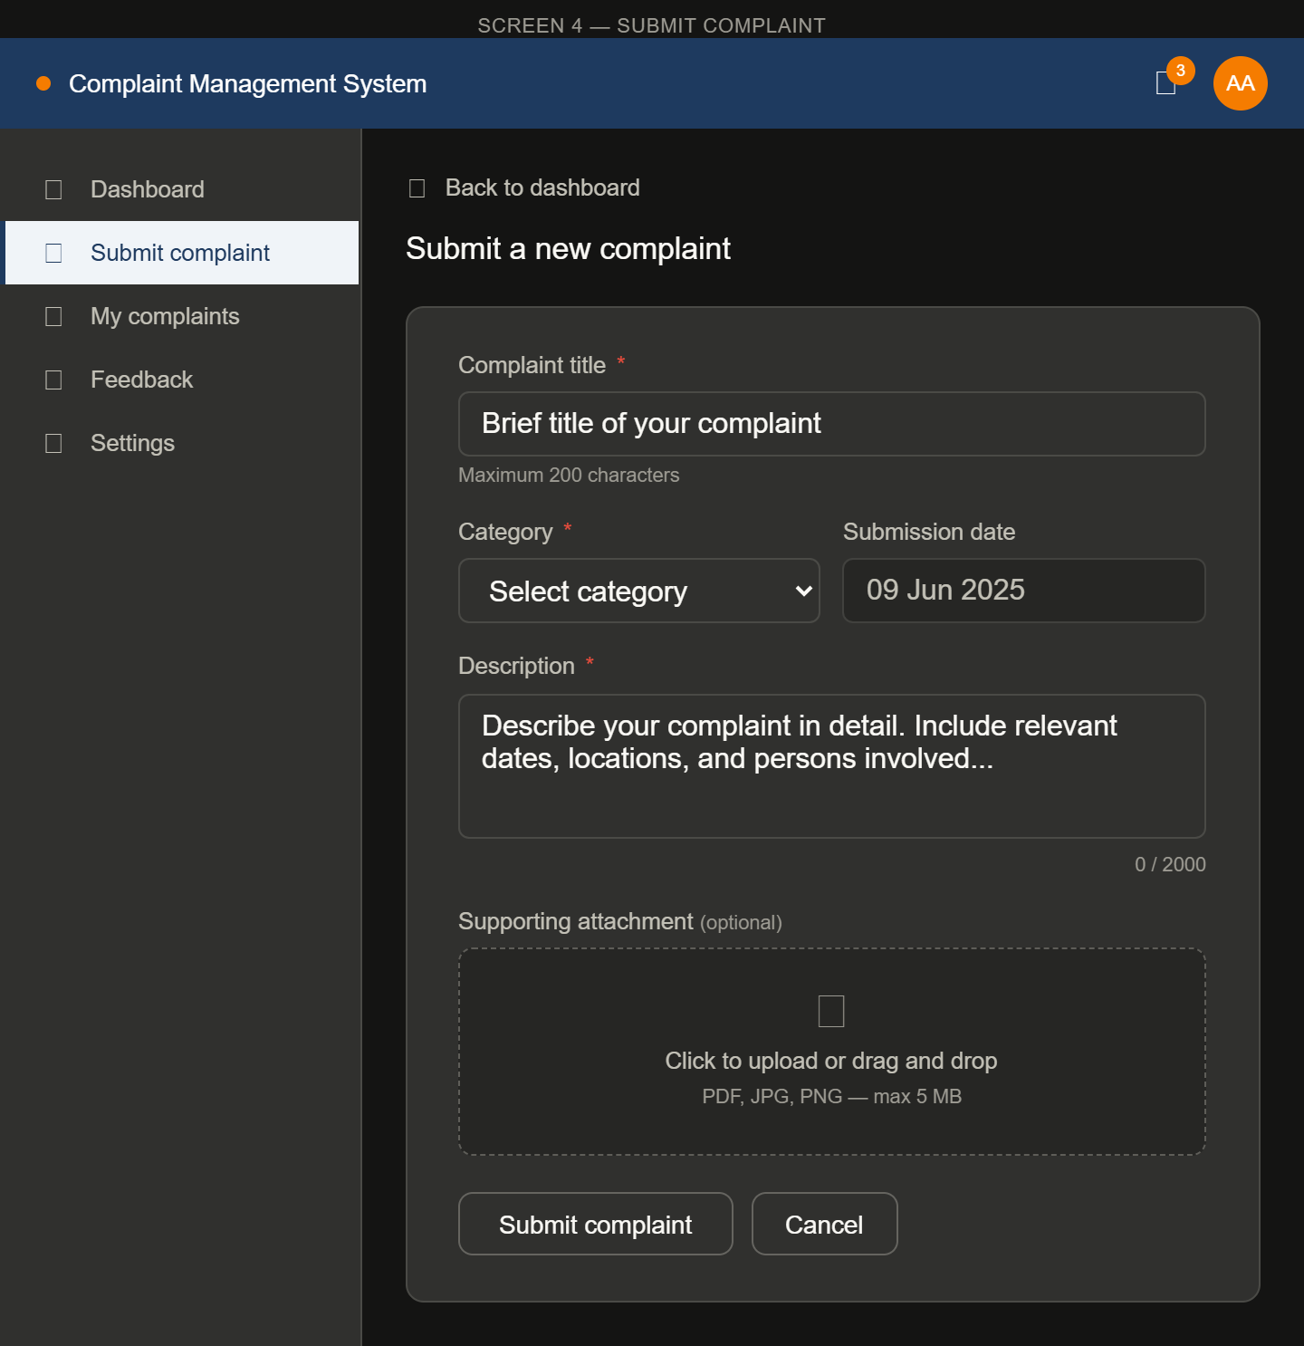
Screen 5: Complaint Tracking Page (track_complaint.html)
Purpose: Displays detailed status and timeline of a specific complaint.
Data displayed: Complaint ID, title, category, description, attachment link, submission date, current status, assignment information, timeline of status changes.
Controls and their working: Status timeline displays chronological events with timestamps. If status is Resolved, a Submit Feedback button appears which navigates to the feedback form. Print button opens browser print dialog for the complaint detail. Back to Dashboard button navigates back to dashboard.html.
