Software Requirement Specifications
Online Complaint Management System with Admin Dashboard



Submitted by
Anan Ahmad (S23BINFT1M01141)

Submitted to
Miss Sara Fareed

Department of Information Technology
Faculty of Computing
The Islamia University of Bahawalpur

Meeting Details
Sr No | Details | Date | Supervisor Signature
Summary
The Online Complaint Management System with Admin Dashboard is designed to modernize traditional complaint handling processes by providing a secure, efficient, and user-friendly digital platform. The system enables users to register, log in, submit complaints, track complaint progress, and provide feedback, while administrators can manage complaints through a centralized dashboard, assign issues to relevant staff, monitor complaint statuses, and ensure timely resolutions.
This project addresses major problems associated with manual complaint systems, such as delayed responses, poor record management, and lack of transparency. By integrating modern web technologies, structured workflows, and automated complaint tracking, the proposed system significantly improves communication between users and administrators while reducing operational workload.
The Software Requirement Specification (SRS) defines the complete system structure, including project scope, functional and non-functional requirements, use cases, process flows, UML diagrams, and technological frameworks. It serves as a foundational blueprint for developing a scalable and maintainable solution.
Overall, this project offers an effective and professional complaint management solution that enhances service quality, organizational efficiency, and customer satisfaction.

Table of Contents
1. Introduction 5
1.1. Scope 5
1.2. Product Perspective 6
1.3. User Characteristics 7
1.4. Similar apps and systems/Literature Review 8
1.5. Proposed Technologies 8
2. Requirements 10
2.1. Function Requirements 10
2.1.1. Sign Up 10
2.1.2 Login 11
2.1.3. Complaint Submission 11
2.1.4 Complaint Tracking 12
2.2. Non-Functional Requirements 12
2.2.1 Security 12
2.2.2 Performance 12
2.2.3 Usability 13
2.2.4 Reliability 13
2.2.5 Scalability 13
2.2.6 Maintainability 13
2.2.7 Compatibility 13
3. Use Cases and Flow of Processes 14
3.1. Use Case 1 16
3.2 Use Case 2 17
3.3 Use Case 3 18
4. References 20

- Introduction
In today’s era, organizations are increasingly shifting from manual operations to automated systems in order to improve efficiency, transparency, and user satisfaction. Complaint handling is one of the critical areas where many institutions, businesses, universities, and service providers still rely on outdated manual procedures such as paper forms, phone calls, or in-person submissions.
The proposed Online Complaint Management System with Admin Dashboard is designed to modernize and simplify the complaint registration, tracking, and management process. This system will provide users with an online platform where they can securely register, log in, submit complaints, attach supporting documents, and monitor complaint progress in real-time.
On the administrative side, the system will include a powerful dashboard that enables administrators to efficiently manage incoming complaints, assign them to relevant staff or departments, categorize issues, update complaint statuses, and monitor system performance.
By integrating automation, real-time tracking, secure authentication, and organized complaint management, this system aims to reduce manual workload while significantly enhancing operational efficiency and customer satisfaction.
Purpose
The primary purpose of this project is to develop a web-based complaint management platform that digitizes the complaint handling process for organizations and institutions.
The main goals are:
- To provide users with an easy and secure online complaint submission platform
- To enable real-time complaint status tracking
- To reduce delays caused by manual complaint handling methods
- To improve communication between complainants and administrators
- To centralize complaint data for better management and reporting
- To create an efficient admin dashboard for complaint monitoring and assignment
- To ensure transparency, accountability, and timely resolution of complaints
Overall, the system is intended to provide a professional, organized, and user-friendly solution that enhances service quality and operational productivity.
  - Scope
The scope of the Online Complaint Management System covers all essential functionalities required for digital complaint management.
Included Features:
User Side:
- User registration and secure login
- Complaint submission with category and detailed description
- File attachment support
- Complaint history management
- Real-time status tracking
- Search and filter functionality
- Notification alerts regarding complaint updates
- Feedback submission after complaint resolution
Admin Side:
- Secure admin login
- Complaint dashboard
- Complaint categorization and filtering
- Complaint assignment to departments or staff
- Status management (Pending, In Progress, Resolved)
- User management
- System monitoring and reporting
Excluded Features:
- Mobile application development (initial version)
- Third-party payment integration
- AI-based complaint analysis
- Multi-language support (future enhancement)
This project mainly focuses on creating a complete web-based solution for educational institutions, service organizations, and businesses.
  - Product Perspective
The Online Complaint Management System is a standalone web application that can also be integrated into existing organizational workflows.
System Structure:
- Frontend: User-friendly web interface for users and admins
- Middle-End: Business logic for complaint processing and workflow management
- Backend: Secure authentication, complaint management, and database handling
- Database: Centralized complaint and user information storage
The system replaces conventional complaint procedures with an automated digital platform, offering greater speed, accessibility, and record management.
Key Advantages:
- 24/7 complaint submission access
- Centralized digital records
- Faster processing and resolution
- Improved transparency
- Better decision-making through organized data
  - User Characteristics
The system is designed for multiple user roles:
1. Users/Complainants:
- General public, customers, students, or employees
- Basic computer and internet knowledge required
- Can submit, monitor, and review complaints
2. Administrators:
- System managers or complaint officers
- Responsible for complaint oversight
- Can manage users, complaints, assignments, and reporting
3. Staff/Departments:
- Assigned personnel responsible for resolving complaints
- Update complaint progress and final resolutions
User Skill Requirements:
- Basic web browsing knowledge
- Ability to upload documents
- Familiarity with digital forms
The system interface will be designed to remain simple, responsive, and accessible for users of varying technical backgrounds.

  - Similar apps and systems/Literature Review
Several existing systems offer complaint management functionalities, but many lack customization, efficient dashboards, or user-friendly designs.
Existing Systems:
- University complaint portals
- Customer service ticketing systems
- Helpdesk management software
- Government complaint systems
Common Features:
- Complaint registration
- Status tracking
- Admin complaint handling
Limitations Found:
- Complex interfaces
- Limited user transparency
- Slow complaint assignment
- Weak reporting features
- Poor mobile responsiveness
Proposed System Improvements:
- Modern admin dashboard
- Better user experience
- Real-time notifications
- Enhanced search and filter options
- User feedback system
- Simplified complaint workflow
This project improves upon previous systems by offering a more practical, scalable, and efficient solution.
  - Proposed Technologies
To ensure reliability, scalability, and maintainability, the following technologies are proposed:
Component | Technology
Frontend | HTML, CSS, JavaScript
Backend | Django
Business Logic / APIs | Django Framework
Database | MySQL
Version Control | Git & GitHub
UI/UX Design | Figma
Hosting | Localhost / cPanel

- Requirements
The Online Complaint Management System is designed to provide a complete digital platform for complaint submission, complaint management, status tracking, and communication between users and administrators. The system will streamline complaint processes by allowing users to register securely, submit complaints, attach relevant documents, monitor complaint progress, and provide feedback after resolution.
On the administrative side, the system will offer centralized complaint handling through a dashboard where administrators can manage complaints, assign tasks to departments or staff, update statuses, categorize issues, and generate organized records. Notifications and search functionality will further improve user experience and operational performance.
The requirements are divided into two major categories:
- Functional Requirements
- Non-Functional Requirements
  - Function Requirements
    - Sign Up
- Name: FR001
- Purpose:
The sign-up process allows new users to register themselves in the system to gain access to complaint submission and tracking features.
- User(s):
  - General User
  - Customer
  - Student
  - Employee
- Input:
  - Full Name: User’s legal name
  - Email Address: Valid and active email
  - Password: Minimum 8 characters with numbers and special characters
  - Phone Number: Active contact number
  - Address: Current residential or organizational address
- Output:
  - User account successfully created
  - User can log in securely
  - Other requirements will be provided in similar way.

2.1.2 Login
- Name: FR002
- Purpose:
Allows registered users and administrators to securely access the system.
- User(s):
  - Registered Users
  - Admin
  - Staff Members
- Input:
  - Email
  - Password
- Output:
  - Successful login to dashboard
  - Access denied for invalid credentials

2.1.3. Complaint Submission
- Name: Name: FR003
- Purpose:
Allows users to submit complaints digitally for proper management.
- User(s):
  - Registered Users
- Input:
  - Complaint Title
  - Complaint Category
  - Complaint Description
  - Supporting Documents / Attachments
  - Submission Date
- Output:
  - Complaint registered successfully
  - Unique complaint ID generated
  - Complaint visible in user dashboard

2.1.4 Complaint Tracking
- Name: FR004
- Purpose:
Enables users to monitor complaint progress.
- User(s):
  - Registered Users
- Input:
  - Complaint ID
  - User Dashboard Request
- Output:
  - Status shown as Pending / In Progress / Resolved
  - Complaint timeline displayed

  - Non-Functional Requirements

2.2.1 Security
- Secure user authentication
- Password encryption
- Role-based access control
- Protection against unauthorized access
- Secure complaint data storage

2.2.2 Performance
- Fast complaint submission and retrieval
- Efficient dashboard performance
- Real-time updates
- Support for multiple simultaneous users

2.2.3 Usability
- User-friendly interface
- Responsive design for desktop and mobile browsers
- Easy navigation
- Clear complaint tracking system

2.2.4 Reliability
- Consistent complaint data management
- Minimal downtime
- Secure backup and recovery options

2.2.5 Scalability
- Capable of handling increasing complaint volumes
- Expandable for future modules
- Multi-department support

2.2.6 Maintainability
- Structured codebase
- Easy debugging and updates
- Future enhancement support

2.2.7 Compatibility
- Works on modern web browsers
- Supports different screen sizes
- Compatible with hosting platforms like Localhost and cPanel

- Use Cases and Flow of Processes
Use cases are the formal representation of process flows defined by the functional requirements of the Online Complaint Management System. These use cases describe how different actors interact with the system to perform major operations such as registration, login, complaint submission, complaint tracking, and complaint management.
The system-level use case diagram includes the following primary actors:
- User / Complainant
- Admin
- Staff / Department
These actors interact with the system according to their assigned roles and permissions.
Major System Use Cases:
- User Sign Up
- User Login
- Submit Complaint
- Track Complaint Status
- Manage Complaints
- Assign Complaints
- Update Complaint Status
- Search and Filter Complaints
- Provide Feedback

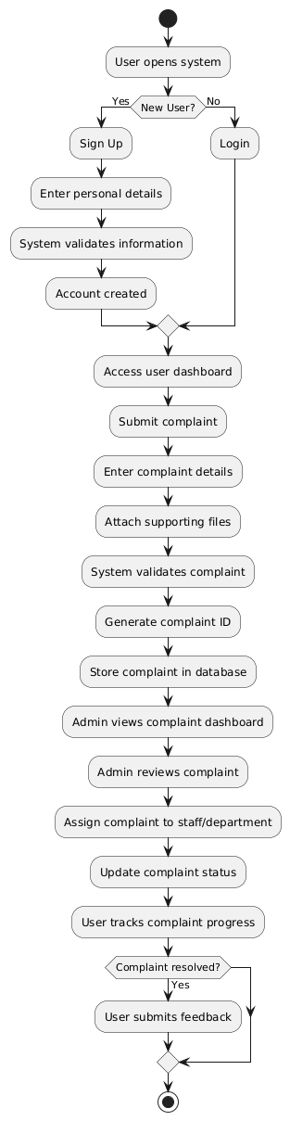
  - Use Case 1
ID | UC001
Name | Sign Up
Description | This use case describes the process flow of user registration in the system
Requirement(s) | FR001
Actor(s) | User
Precondition | User must not already have an account
Postcondition | User account created successfully
Basic Flow | - User opens registration page  - User enters required credentials  - System validates all inputs  - Required fields include:  - Full Name  - Email  - Password  - Address  - Phone Number  - System verifies:  - Email format  - Password strength  - Phone number validity  - System stores user information  - User account is created successfully
Diagrams
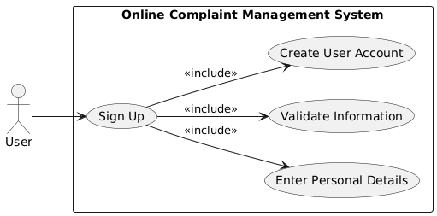

3.2 Use Case 2
ID | UC002
Name | Login
Description | This use case describes user/admin login process
Requirement(s) | FR002
Actor(s) | User, Admin
Precondition | Registered account exists
Postcondition | User successfully logged into dashboard
Basic Flow | Basic Flow  - User opens login page  - User enters email and password  - System validates credentials  - System authenticates role  - Dashboard access granted  Alternative Flow  - Forgot password option available  Exceptions  - Invalid credentials  - Unauthorized access  - System authentication failure
Diagram
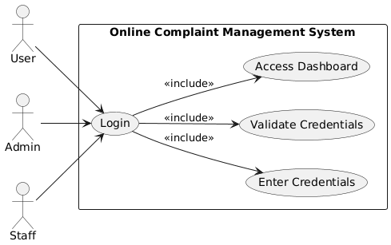

3.3 Use Case 3
ID | UC003
Name | Submit Complaint
Description | This use case describes complaint submission by users
Requirement(s) | FR003
Actor(s) | User
Precondition | User must be logged in
Postcondition | Complaint successfully submitted
Basic Flow | Basic Flow  - User opens complaint form  - User enters:  - Complaint Title  - Category  - Description  - Attachment  - System validates details  - Complaint is submitted  - Unique complaint ID generated  - User receives confirmation
Diagram
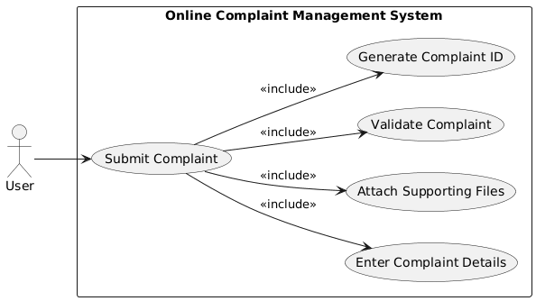
- References
[1] I. Sommerville, Software Engineering, 10th ed. Boston, MA, USA: Pearson, 2015.
[2] R. S. Pressman and B. R. Maxim, Software Engineering: A Practitioner’s Approach, 8th ed. New York, NY, USA: McGraw-Hill Education, 2019.
[3] M. Fowler, Patterns of Enterprise Application Architecture. Boston, MA, USA: Addison-Wesley Professional, 2002.
[4] Django Software Foundation, “Django Documentation,” [Online]. Available: https://docs.djangoproject.com/
[5] Oracle Corporation, “MySQL Documentation,” [Online]. Available: https://dev.mysql.com/doc/
[6] GitHub, “GitHub Documentation,” [Online]. Available: https://docs.github.com/
[7] L. Bass, P. Clements, and R. Kazman, Software Architecture in Practice, 4th ed. Boston, MA, USA: Addison-Wesley, 2021.
[8] Object Management Group (OMG), Unified Modeling Language (UML) Specification, Version 2.5.1, 2017.
[9] A. Dennis, B. H. Wixom, and D. Tegarden, Systems Analysis and Design: An Object-Oriented Approach with UML, 5th ed. Hoboken, NJ, USA: Wiley, 2015.
[10] S. Bennett, J. Skelton, and K. Lunn, Schaum’s Outline of UML, New York, NY, USA: McGraw-Hill, 2001.

