AI RECRUITMENT GUARDIAN
An Explainable Machine Learning Framework for Fake Job Detection and Risk Assessment
Project Report
Team: Ananaya Arora, Vanshika
B.Tech Artificial Intelligence & Machine Learning, IGDTUW

Abstract
Online recruitment fraud undermines trust in job platforms and causes direct financial and emotional harm to job seekers. This project presents AI Recruitment Guardian, an explainable machine learning framework that classifies job postings as genuine or fraudulent, and — unlike typical black-box classifiers — accompanies every prediction with a human-readable justification. The system compares five supervised learning algorithms on the EMSCAD dataset, selects the best performer through tuned hyperparameters and imbalance-aware evaluation, and layers SHAP-based explainability on top to produce a 0-100 Job Trust Score, ranked reasons for each verdict, and suspicious-phrase highlighting. The framework is deployed as an interactive web application that accepts a job posting by text or URL and returns a verification report in real time.

1. Introduction
Fraudulent job postings are used to harvest personal data, extract upfront “registration” or “processing” fees, or recruit victims into unwitting financial schemes. Manual screening does not scale against the volume of postings on modern job boards, and existing automated filters are largely opaque, offering a binary verdict with no justification a user can independently check. This project addresses both problems: detection accuracy and explainability of the decision.

1.1 Problem Statement
Given a job posting's textual content (title, description, requirements, benefits, company profile) and structured metadata (employment type, required experience/education, industry, function, and posting-quality signals such as presence of a company logo or salary range), classify the posting as genuine or fraudulent, and explain the classification in terms a non-technical user can act on.

1.2 Objectives
- Detect fraudulent job postings using supervised machine learning.
- Compare multiple ML algorithms on a common, imbalance-aware evaluation protocol.
- Generate an interpretable Job Trust Score (0-100) for each posting.
- Explain every prediction using SHAP, at both global and per-instance level.
- Deploy the framework as an interactive web application for real-time verification.

2. Literature Review
A review of twelve papers on automated job-fraud and related text-classification detection informed the design of this project (full review in Literature_Review_Papers_1-12.docx). Across the reviewed literature, two recurring gaps motivated this work's direction: first, most prior systems report only a single model's accuracy without a controlled comparison against alternative algorithms on the same split and metrics; second, very few expose the reasoning behind a fraud verdict, which limits user trust and makes the systems difficult to audit. AI Recruitment Guardian is designed to directly close both gaps: Section 4 compares five algorithms under an identical protocol, and Section 5 attaches a SHAP-based explanation to every prediction.

3. Methodology

3.1 Dataset
The EMSCAD (Employment Scam Aegean Dataset) dataset was used, consisting of real-world job postings labelled genuine or fraudulent. The dataset is heavily imbalanced, with fraudulent postings forming a small minority of the total — a characteristic that shaped both the modelling and evaluation strategy described below.

3.2 Preprocessing and Feature Engineering
Text fields (title, company profile, description, requirements, benefits) were lowercased, stripped of HTML tags, URLs, email addresses, punctuation and digits, then combined into a single document per posting for vectorisation. Missing categorical fields were imputed as "Not Specified"; missing salary and department fields were converted into binary presence indicators. In addition to these standard steps, eleven fraud-indicator phrases (e.g. “registration fee”, “wire transfer”, “no interview”) were flagged as binary features by direct string match against the raw (uncleaned) text, giving the model an explicit signal for known scam vocabulary alongside the statistical TF-IDF signal.
Feature block | Count | Description
TF-IDF text features | 3000 | Unigrams + bigrams from title, company profile, description, requirements, benefits
One-hot categorical | 198 | employment_type, required_experience, required_education, industry, function
Engineered numeric/flags | 19 | telecommuting, has_company_logo, has_questions, has_salary, has_department, description_length, suspicious_phrase_count, has_email_gmail, and 11 fraud-phrase flags
Table 1. Feature blocks assembled for model input (3217 features total).

3.3 Model Development
Five supervised classifiers were trained and hyperparameter-tuned on an identical train/test split: Logistic Regression, Naive Bayes, Support Vector Machine, Random Forest, and XGBoost. Because fraudulent postings are a small minority of the dataset, accuracy alone was treated as an unreliable metric; models were instead compared on precision, recall, F1-score and ROC-AUC for the fraud (minority) class, and XGBoost's class-imbalance weighting (scale_pos_weight) was tuned to the training set's class ratio.

3.4 Explainable AI
SHAP (SHapley Additive exPlanations) was applied to the selected XGBoost model using its TreeExplainer, which computes exact Shapley values efficiently for tree ensembles. Two levels of explanation were produced: a global view ranking which features most influence the model's decisions overall, and a local, per-posting view showing exactly which words, categories, and engineered flags pushed an individual prediction toward “fake” or “genuine”, and by how much.

3.5 Job Trust Score
The model's fraud probability is converted into a Job Trust Score on a 0-100 scale (100 = most trustworthy) via trust_score = (1 - P(fake)) × 100, and mapped to three risk bands: Low Risk (≥70), Medium Risk (40-69), and High Risk (<40). Each score is accompanied by the top SHAP-ranked reasons supporting and opposing the verdict, translated into plain-language labels (e.g. “suspicious phrase: wire transfer”).

3.6 Web Application
The framework is deployed as a Flask web application with a custom interface. A user can either paste a job posting's details directly or supply a URL for automatic extraction; the application returns the Job Trust Score, risk classification, ranked reasons, matched fraud-indicator phrases, and an annotated version of the posting text with SHAP-driven highlighting.

4. Results

4.1 Model Comparison
All five tuned models were evaluated on the same held-out test set. Results are summarised in Table 2.
Model | Accuracy | Precision | Recall | F1-score | ROC-AUC
XGBoost (selected) | 0.987 | 0.920 | 0.798 | 0.854 | 0.993
SVM | 0.986 | 0.949 | 0.751 | 0.839 | 0.985
Random Forest | 0.983 | 0.925 | 0.711 | 0.804 | 0.994
Logistic Regression | 0.978 | 0.720 | 0.879 | 0.792 | 0.982
Naive Bayes | 0.967 | 0.665 | 0.630 | 0.647 | 0.955
Table 2. Test-set performance of all five tuned models. XGBoost was selected for its highest F1-score on the minority (fraud) class, balancing precision and recall better than the alternatives despite Random Forest's marginally higher ROC-AUC.

4.2 Global Feature Importance (SHAP)
Figure 1 ranks the features with the greatest overall influence on the model's fraud predictions, averaged across a sample of the test set. Figure 2 shows the same features with direction: red points indicate a high value of that feature pushing the prediction toward “fake”, blue points toward “genuine”.
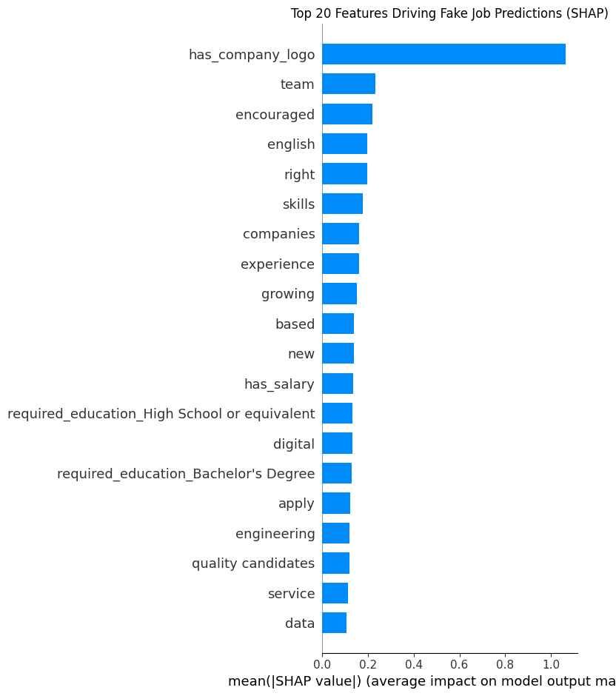
Figure 1. Top 20 features by mean absolute SHAP value.
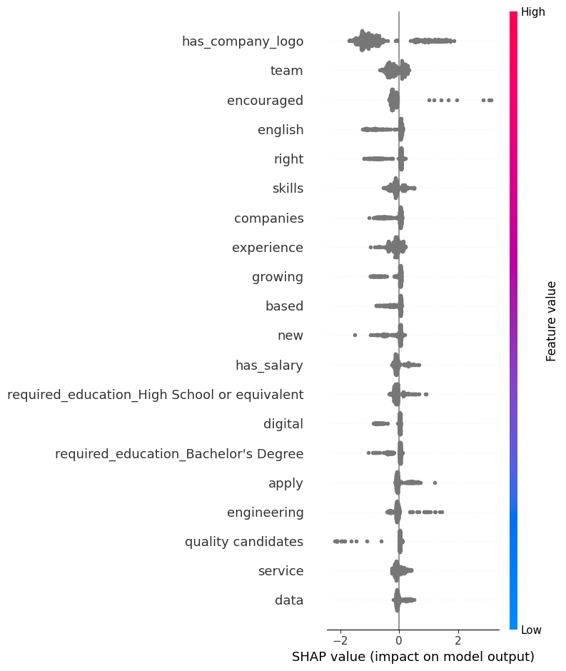
Figure 2. SHAP summary (beeswarm) plot showing feature value and direction of impact.

4.3 Local Explanation and Job Trust Score
For an individual fraudulent posting in the test set, the model correctly assigned a fraud probability of 0.999, translating to a Job Trust Score of 0.1 (High Risk). The leading SHAP reasons for this verdict included the absence of a company logo and wording strongly associated with scam postings, consistent with the global feature ranking in Section 4.2. This confirms that the explanation layer surfaces reasoning consistent with the model's overall learned behaviour, rather than arbitrary per-instance noise.

5. Discussion
The comparison in Table 2 shows all five models perform strongly on ROC-AUC, reflecting the fact that most postings are easy to classify; the meaningful differences appear on the minority-class F1-score, where XGBoost's balance of precision (0.920) and recall (0.798) outperforms the alternatives. Class-imbalance weighting via scale_pos_weight was sufficient to achieve strong recall without resorting to synthetic oversampling (e.g. SMOTE), which was considered and deliberately avoided: generating synthetic samples in the 3217-dimensional sparse TF-IDF space risks producing unrealistic postings that would not correspond to any real job listing, undermining the SHAP explanations built on top of the model.
The suspicious-phrase flags proved to be a valuable complement to the purely statistical TF-IDF signal: they encode known scam vocabulary explicitly rather than relying on the model to rediscover it from word frequency alone, and they map directly onto human-readable explanations in the Job Trust Score output.

6. Conclusion and Future Scope
AI Recruitment Guardian demonstrates that fraud detection and explainability are not competing goals: the same SHAP values that justify a model's decision can be repackaged into a trust score and plain-language reasons that a non-technical user can act on. The completed system spans the full pipeline from raw data to a deployed, interactive verification tool.
Future extensions identified for this project include:
- Incorporating LIME as a second explanation method and comparing its output against SHAP.
- Expanding the fraud-phrase list using patterns mined from newly reported scam postings.
- Adding structured extraction for URL-scraped postings on JavaScript-rendered sites.
- Periodic retraining as new labelled postings become available, to guard against concept drift.

7. Tools and Technologies
- Python — pandas, NumPy, scikit-learn, XGBoost, SHAP
- Flask — web application backend
- Jupyter Notebook — data understanding, preprocessing, model development, explainability
- Dataset: EMSCAD (Employment Scam Aegean Dataset)

