**Experiment No 1**

**Apply Assembly Language Programing to enter and display 8 bit & 16 bits number**

**Program 1: Enter and display 8 bit no**

.model small

.data

msg1 db 10,13,"Enter 8 bit nos :$"

msg2 db 10,13,"8 bit nos is :$"

.code

.startup

mov ah,09h

lea dx,msg1

int 21h

mov ah,01h

int 21h

sub al,30h

mov cl,04h

shl al,cl

mov bl,al

mov ah,01h

int 21h

sub al,30h

add al,bl

mov bh,al

mov ah,09h

lea dx,msg2

int 21h

mov bl,bh

and bl,0f0h

shr bl,cl

add bl,30h

mov dl,bl

mov ah,02h

int 21h

mov bl,bh

and bl,0fh

add bl,30h

mov dl,bl

mov ah,02h

int 21h

.exit

end

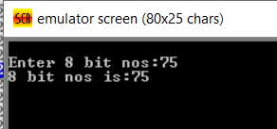

**Program 2: Enter and display 16 bit no**

.model small

.data

msg1 dw 10,13,"Enter 16 bit nos :$"

msg2 dw 10,13,"16 bit nos is :$"

.code

.startup

mov ah,09h

lea dx,msg1

int 21h

mov ah,01h     ;input 1st digit

int 21h

sub al,30h

mov cl,04h

shl al,cl

mov bh,al

mov ah,01h    ;input 2nd digit

int 21h

sub al,30h

add bh,al

mov ah,01h  ;input 3rd digit

int 21h

sub al,30h

mov cl,04h

shl al,cl

mov bl,al

mov ah,01h   ;input 4th digit

int 21h

sub al,30h

add bl,al

**;Display 16 bit no**

mov ah,09h

lea dx,msg2

int 21h

mov ch,bh

and ch,0f0h

mov cl,04h

shr ch,cl

add ch,30h

mov dl,ch

mov ah,02h

int 21h

mov ch,bh

and ch,0fh

add ch,30h

mov dl,ch

mov ah,02h

int 21h

mov dh,bl

and dh,0f0h

mov cl,04h

shr dh,cl

add dh,30h

mov dl,dh

mov ah,02h

int 21h

mov dh,bl

and dh,0fh

add dh,30h

mov dl,dh

mov ah,02h

int 21h

.exit

end

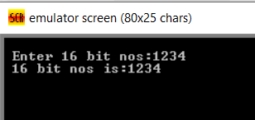

**Experiment No 2**

**Apply Assembly Language Programing to perform addition and subtraction of two 16 bits numbers using macros and procedure.**

**Addition of two 16 bit nos using procedure**

.model small

.data

num1 dw 1234H

num2 dw 1000H

res dw ?

.code

mov ax,@data

mov ds,ax

call addproc

mov ah,4ch

int 21H

proc addproc

mov ax,num1

add ax,num2

mov res,ax

ret

endp

ends

End

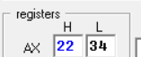

**Subtraction of two 16 bit nos using procedure**

.model small

.data

num1 dw 1234H

num2 dw 1000H

res dw ?

.code

mov ax,@data

mov ds,ax

call subproc

mov ah,4ch

int 21H

proc subproc

mov ax,num1

sub ax,num2

mov res,ax

ret

endp

ends

End

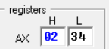

**Addition of two 16 bit nos using Macro**

addm macro num1,num2

mov ax,num1

add ax,num2

mov res,ax

endm

.model small

.data

num1 dw 1234H

num2 dw 1000H

res dw ?

.code

mov ax,@data

mov ds,ax

addm num1,num2

mov ah,4ch

int 21H

ends

End



**Subtraction of two 16 bit nos using Macro**

subm macro num1,num2

mov ax,num1

sub ax,num2

mov res,ax

endm

.model small

.data

num1 dw 1234H

num2 dw 1000H

res dw ?

.code

mov ax,@data

mov ds,ax

subm num1,num2

mov ah,4ch

int 21H

ends

End



**Experiment No 3**

**Apply Assembly Language Programing to covert HEX to BCD and BCD to HEX.**

1. **BCD to Hex Conversion**

;bcd to hex

.model small

.data

Var DW 0172d

.code

;Initlize Data Segment

mov ax,@DATA

mov DS,ax

mov bx,Var

mov al,bh

mov ah,00h

mov cl,10h

div cl

mov dh,ah

mov cl,al

CALL PRINT

mov dl,dh

mov cl,dl

CALL PRINT

mov al,bl

mov ah,00h

mov cl,10h

div cl

mov dh,ah

mov cl,al

CALL PRINT

mov cl,dh

CALL PRINT

;to terminate program

mov ah, 4ch

int 21h

ret

PRINT PROC ;print procedure to print

;number

cmp cl,09

jle ad

add cl,07h ;if less than 9 ,add 30h

ad: add cl,30h ;if greater than 9,add 37h

mov dl,cl

mov ah,02h

int 21h

ret

PRINT ENDP

Ends

End

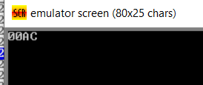

1. **HEX to BCD Conversion**

;hex to bcd

.model small

.data

hex dw 0ACH

counter db 0

.code

;initialize Data Segment

mov ax,@DATA

mov DS,ax

mov ax,hex

mov bx,000Ah

L:

inc counter

div bx

push dx

cmp ax,0

mov dx,00h

je exit

jmp L

exit:

mov cl,counter

mov ch,00h

L1:

pop dx

add dl,30h

mov ah,02h

int 21h

LOOP L1

;to terminate program

mov ah,4ch

int 21h

ret

ends

end

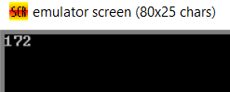

**Experiment No 4**

**Finding Negative Numbers from given array**

print macro m

**mov** ah,09h

**mov** dx,**offset** m

**int** 21h

endm

.model small

.data

list db 10,20,80h,86h,23,26,12,57,89h ;array of numbers

count db (0) ;count variable(to store answer)

msg db 10,13, "The number of negative numbers is: $" ;output message

.code

start: **mov** ax,@data

**mov** ds,ax

**mov** ch,00 ; temp storage of ans

**mov** si,**offset** list ;point to start of array

**mov** cl,09 ;count of numbers in the array

again: **mov** al,[si] ;copy num in al

**and** al,80h ;AND with 80H

**jz** next ; jump to next statement if result is zero

; i.e. positive number. Else increase count

**inc** ch ;increment count if negative number if ANDing

; gives non zero value

next:

**inc** si ;inc si to point to next location in array

**dec** cl ;decrement count of the array to check

**jnz** again ;if all numbers aare not covered do again

**mov** bl,ch ;store the answer in bl

;printing the result

print msg ;print the string

**mov** cl,04 ;count for shifting to display a number

**mov** al,bl ;copy ans in "AL" register

**and** al,0f0h ;Mask the LSB and take only MSB

**shr** al,cl ;shift the numberto bring MSB to LSB

**cmp** al,09 ;if it is number 0-9 just add 30H

**jbe** alpha ; if character A-F add additional 7

**add** al,07 ; for correct ASCII value to display

alpha: **add** al,30h ; add 30H to make the number ASCII

**mov** ah,02 ; display function

**mov** dl,al ; content to be displyed needs to be in DL

; for 02 function

**int** 21h

;printing LSB digit

**mov** ah,02 ;02 function for single digit display

**mov** al,bl ;copy ans in Al register

**and** al,00fh ; Mask the MSB. Since number is in LSB no need to

; shift

**cmp** al,09 ; check if number in 0-9

**jbe** alpha2 ; if alphabet add additional 7 to make correct

**add** al,07 ; ASCII value

alpha2: **add** al,30h ; add 30H for ASCII value

**mov** dl,al ; display content in DL for 02 function

**int** 21h

**mov** ah,4ch ; 4ch function to terminate program and return

**int** 21h ; to DOS prompt

end start

end ; end of file

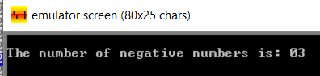

**Experiment No 5**

**Student should be able to apply string operations (i) Accept, (ii) Display, (iii) Concatenate and (iv) Compare in ALP.**

.model small

.stack

.data

m1 db 10,13,"Enter 1st string:$"

m2 db 10,13,"Length of 1st string:$"

m3 db 10,13,"Display 1st string:$"

m4 db 10,13,"Enter 2nd string:$"

m5 db 10,13,"Length of 2nd string:$"

m6 db 10,13,"Display 2nd string:$"

m7 db 10,13,"Comparison : $ "

m8 db 10,13,"Strings are Equal$"

m9 db 10,13," Strings are not Equal$"

m10 db 10,13,"Concatenatd String is : $"

str1 db 80,?,80 DUP(?)

str2 db 80,?,80 DUP(?)

str3 db 80,?,80 DUP(?)

.code

Disp macro xx

mov ah,09h

lea dx,xx

int 21h

endm

.startup

Disp m1 ;Enter 1st string

mov ah,0Ah ;Read a string from the keyboard into buffer addressed by DX

lea dx,str1

int 21h

Disp m2 ;Length of 1st string

lea si,str1+1

mov dl,[si]

mov cl,dl

add dl,30h

mov ah,02h

int 21h

Disp m3 ;Display 1st string

lea si,str1+2

Back:

mov dl,[si]

mov ah,02h

int 21h

inc si

dec cl

jnz Back

Disp m4 ;Enter 2nd string

mov ah,0Ah

lea dx,str2

int 21h

Disp m5 ;Length of 2nd string

lea si,str2+1

mov dl,[si]

mov cl,dl

add dl,30h

mov ah,02h

int 21h

Disp m6 ;Display 2nd string

lea si,str2+2

Back1:

mov dl,[si]

mov ah,02h

int 21h

inc si

dec cl

jnz Back1

Disp m7 ; Comparison

lea si,str1+1

mov cl,[si]

lea di,str2+1

mov ch,[di]

cmp cl,ch

jnz AA

lea si,str1+2

lea di,str2+2

Back2:

mov dl,[si]

mov dh,[di]

cmp dl,dh

jnz AA

inc si

inc di

dec cl

jnz Back2

Disp m8 ;Strings are Equal

jmp con

AA:

Disp m9 ; Strings are not Equal

con:

Disp m10 ;Concatenatd String is

lea si,str1+1

mov cl,[si]

mov bl,cl

lea di,str2+1

mov ch,[di]

mov bh,ch

add bl,bh

lea si,str1+2

lea di,str3+2

Back3:

mov dl,[si]

mov [di],dl

inc si

inc di

dec cl

jnz back3

lea si,str2+2

Back4:

mov dl,[si]

mov [di],dl

inc si

inc di

dec ch

jnz Back4

lea di,str3+2

Back5:

mov dl,[di]

mov ah,02h

int 21h

inc di

dec bl

jnz Back5

Exit:

.exit

end

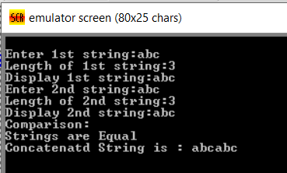

**Experiment No 6**

**Write a mixed language code for designing calculator**

#include <stdio.h>

void main() {

int a, b, c;

printf("\n\n");

printf(" Enter first number a: ");

scanf("%d",&a);

printf(" Enter second number b: ");

scanf("%d",&b);

printf("\n a=%d",a);

printf("\n b=%d",b);

asm {

mov ax,a

mov bx,b

add ax,bx

mov c,ax

}

printf("\n\n The addition of a and b is

%d",c);

asm {

mov ax,a

mov bx,b

sub ax,bx

mov c,ax

}

printf("\n\n The subtraction of a and b

is %d",c);

asm {

mov ax,a

mov bx,b

mul bx

mov c,ax

}

printf("\n\n The multiplication of a and

b is %d",c);

asm {

mov ax,a

mov bx,b

div bx

mov c,ax

}

printf("\n\n The division of a and b is

%d",c);

printf("\n\n");

}

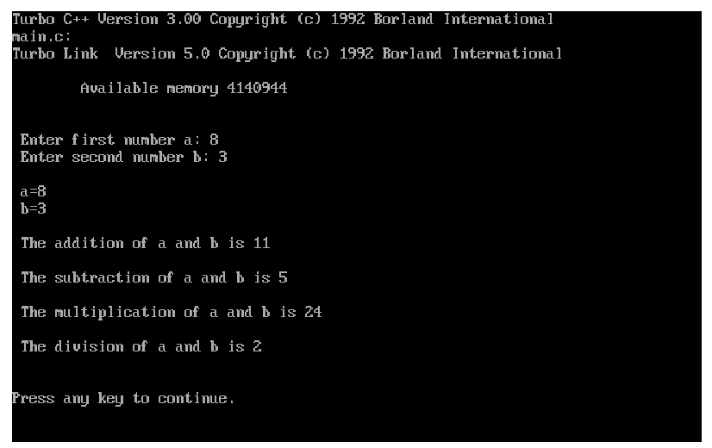

#include <iostream.h>

#include <conio.h>

int main()

{

clrscr();

int a, b, c, d;

cout << "Enter Your Number : - " << endl;

cin >> a;

cout << "Enter No to shift: - " << endl;

cin >> b;

asm mov ax, a;

asm mov cx, b;

asm shl ax, cl;

asm mov c, ax;

cout << "Shift left :- " << c << endl;

cout << "Enter no to shift: - " << endl;

cin >> d;

asm mov ax, a;

asm mov cx, d;

asm shr ax, cl;

asm mov c, ax;

cout << "Shift Right :- " << c << endl;

getch();

return 0;

}

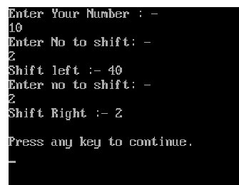

**Experiment No 7 : Interfacing of Mouse Driver**

.model small

.stack

.data

msg1 db 10,13, "Mouse driver present:"

.code

disp macro xx

mov ah,09

lea dx,xx

int 21h

endm

.startup

mov ax,0000   ;mouse driver check

int 33h

cmp ax,00h

je last

disp msg1

mov ax,0004  ;mouse cursor position

mov cx,0

mov dx,0

int 33h

mov ax, 0007 ;set horizontal limit

mov cx,0010

mov dx,055h

int 33h

mov ax, 0008 ;set vertical limit

mov cx,0010

mov dx,055h

int 33h

pixel:

mov ax,0001 ;display mouse cursor

int 33h

mov ax,0003

int 33h

cmp bx,01 ;left button

je left

jmp right

left:

mov bx,0011h   ;set graphics mode

int 10h

mov ah,0ch ;display pixel on screen

int 10h

right:

mov ax,0001

int 33h

cmp bx,02

je last

jmp pixel

last:

mov ax,00 ;set text mode

int 10h

.exit

end

