

Configuration Manual

MSc Research Project

MSc. Data Analytics

Anand Jha

Student ID: x21157251

School of Computing

National College of Ireland

Supervisor: Teerath kumar Menghwar

National College of Ireland

MSc Project Submission Sheet

School of Computing
Student Name: | Anand Jha
Student ID: | X21157251
Programme: | MSc. Data Analytics | Year: | 2023-2024
Module: | MSc. Research Project
Lecturer: | Prof. Teerath Kumar Menghwar
Submission Due Date: | 14/12/2023
Project Title: | Leveraging OpenCV for Precise Yoga Pose Estimation and Reducing Injury Risks
Word Count: | 1271 Page Count: 17

I hereby certify that the information contained in this (my submission) is information pertaining to research I conducted for this project. All information other than my own contribution will be fully referenced and listed in the relevant bibliography section at the rear of the project.
ALL internet material must be referenced in the bibliography section. Students are required to use the Referencing Standard specified in the report template. To use other author's written or electronic work is illegal (plagiarism) and may result in disciplinary action.
Signature: | Anand Jha
Date: | 14/12/2023

PLEASE READ THE FOLLOWING INSTRUCTIONS AND CHECKLIST

Attach a completed copy of this sheet to each project (including multiple copies) | □
Attach a Moodle submission receipt of the online project submission, to each project (including multiple copies). | □
You must ensure that you retain a HARD COPY of the project, both for your own reference and in case a project is lost or mislaid. It is not sufficient to keep a copy on computer. | □

Assignments that are submitted to the Programme Coordinator Office must be placed into the assignment box located outside the office.

Office Use Only
Signature:
Date:
Penalty Applied (if applicable):

Configuration Manual

Anand Jha
x21157251

Introduction

This Configuration Manual outlines the comprehensive process involved in realizing the project “Leveraging OpenCV for Precise Yoga Pose Estimation and Reducing Injury Risks “. It details the specific aspects of data sources, system prerequisites, utilized libraries, and the code involved in the implementation and evaluation of the research models.

System Prerequisites

The hardware and software version for this project used are given below.

Hardware Prerequisites

Operating System | Windows 11
Processor | 12th Gen Intel® core™ i9-12900Mhz, 14 core(s) 20 Logical Processor
Ram | 16.0 GB
System type | X64-based PC
Table 1: Hardware Prerequisites

Software Prerequisites
Programming Language used in this project is Python and Jupiter Notebook is used as a programming tool to run the Python code.

- Python 3.9.13
- Jupiter Notebook 6.4.12

All the libraries used in the research to complete the project from start to end is shown in the Figure 1 and Figure 2.

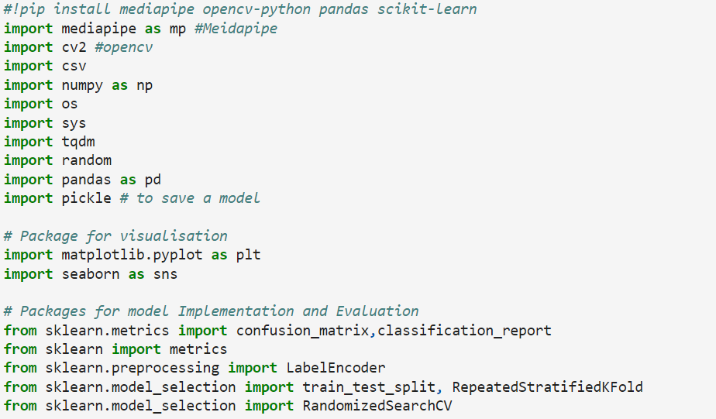
Figure 1: Python Libraries used in this Python Project- Part 1

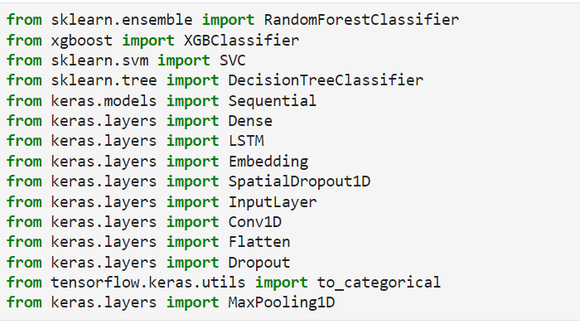
Figure 2: Python Libraries used in this Python Project- Part 2

Data Collection

This project draws upon a curated yoga image dataset sourced from Kaggle, consisting of diverse yoga poses to classify and detect in real-time. The dataset encompasses five prevalent yoga poses: Asho Mukha Scanasana (320 images), Balasana (261 images), Utkata Konasana (180 images), Virabhadrasana (209 images), and Vrikshasana (334 images). In total, 1304 yoga pose images were meticulously compiled, featuring individuals with varying backgrounds and body types. These poses were systematically organized into distinct folders, each named after the corresponding yoga pose, facilitating structured data management and analysis.

Data Preprocessing

In order to transform the yoga image dataset into a CSV file format containing 99 landmark features (33 landmark points * 3 dimensions), several crucial steps were undertaken in research project code. Before proceeding with the data preprocessing phase, it was imperative to install essential libraries such as Mediapipe and OpenCV. Additionally, all the requisite packages, as outlined in Figure 1 and Figure 2 of the project documentation, were imported to facilitate the dataset conversion process. These preparatory steps ensured the seamless execution of the subsequent data preprocessing procedures.

Feature Extraction
In this part all the images are extracted from the yoga pose folder name and with the help of Mediapipe library all the 33 landmarks in three different direction is extracted. This landmark is then stored in the csv file format.
So, there will be in total 99 features in this csv file format. Refer Figure 3and Figure 4.

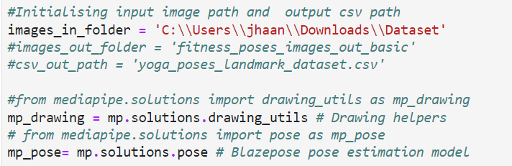
Figure 3: Initialize Path and Load Blazepose model

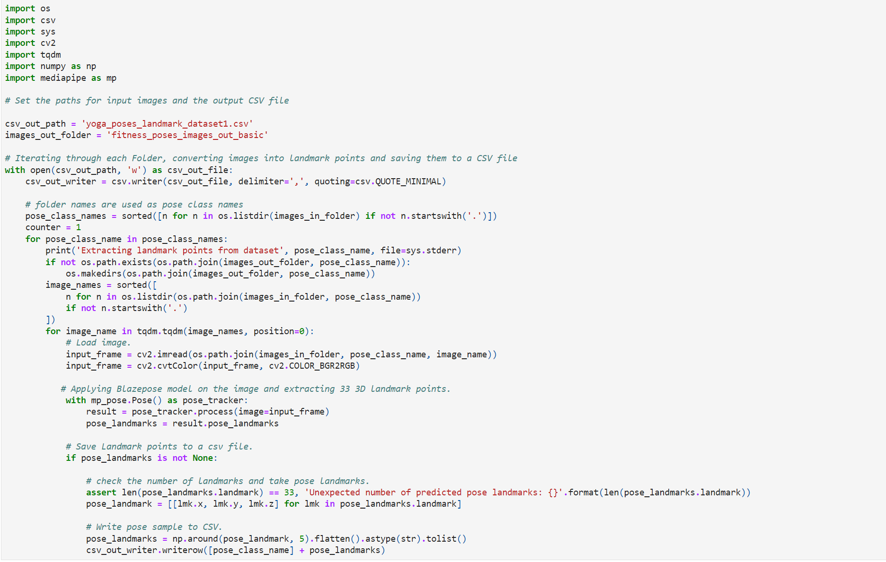
Figure 4: Creating CSV file for landmarks in x,y,z direction

Heading to each column is give as x1, y1, z1, x2, y2, z2 and so on. Refer Figure 5.

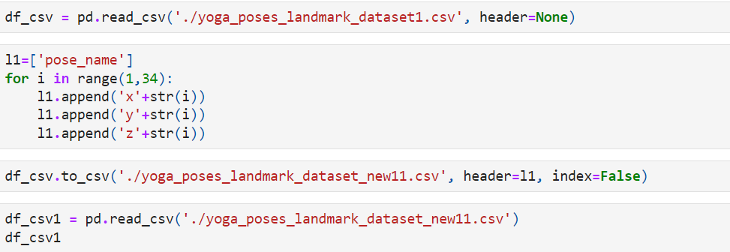

Figure 5: Adding Header to the Dataset

Data Transformation

As all the data in sequence order of yoga below code is used to shuffle the dataset, so that there will be no bias in the model. Refer Figure 6.

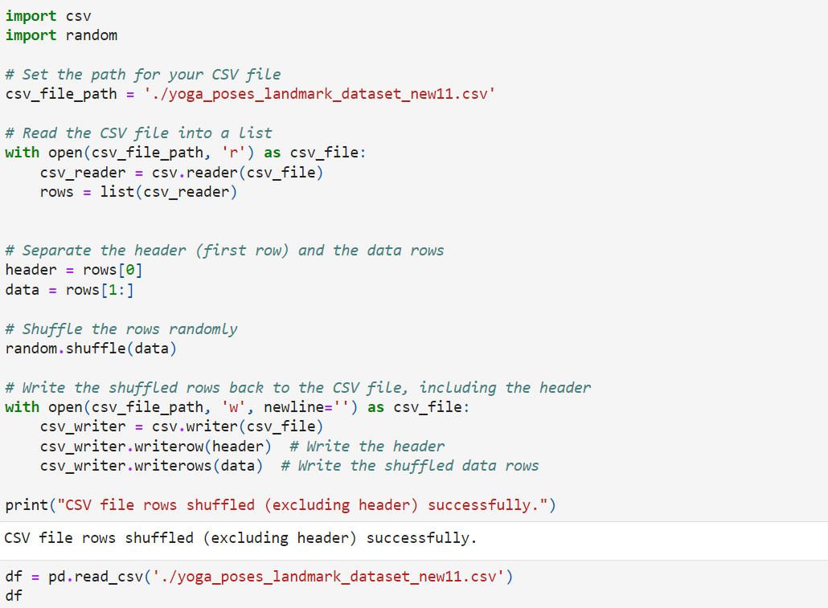
Figure 6: Shuffling the Dataset

To visualize the distribution of the class Following code is used below, refer to the Figure 7. And Later Label encoding is done in Figure 8.
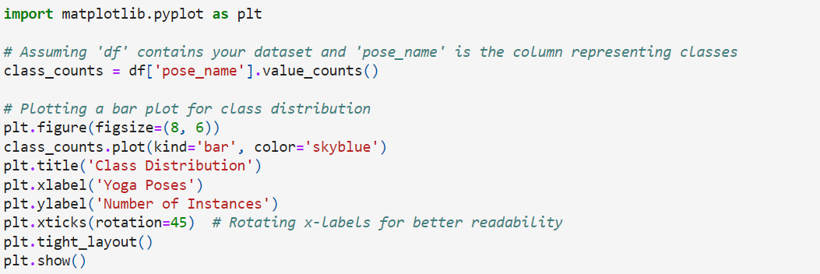
Figure 7: Class Distribution Graph

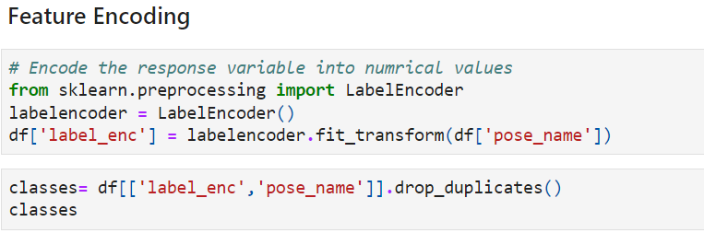
Figure 8: Feature Encoding
After Feature encoding, to add the pose name to encoded classes use the below code, refer Figure 9.

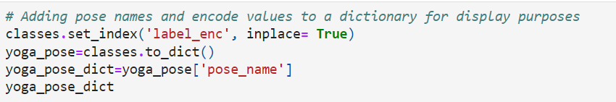

Figure 9: Labelling the Class

Before Training the model, dataset must split into training and test in 70:30. Refer Figure 10

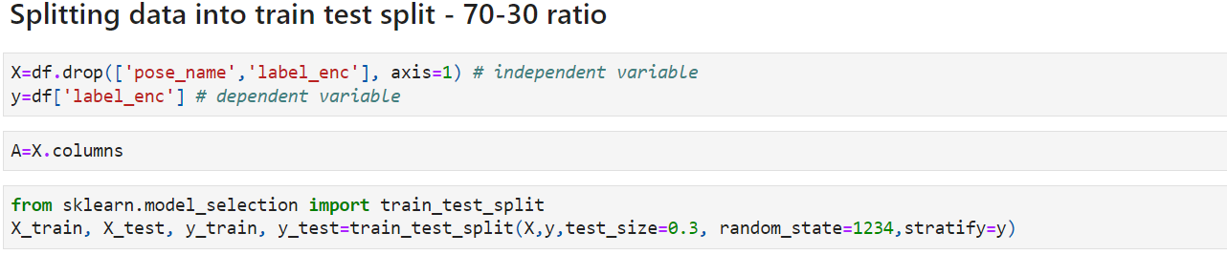
Figure 10: Splitting the data

Model Implementation and Evaluation
Both deep learning and Machine learning algorithm are used to train the model, to evaluate deep learning Figure 11 and 15) mode accuracy and loss function is used, and graph is drawn for the same (Figure 12,13 and 14). In the case of machine learning evaluation matrix like accuracy, precision, recall and f2 score is used to find the best model. And model is further optimising by using the Hyper parameter.

Deep learning

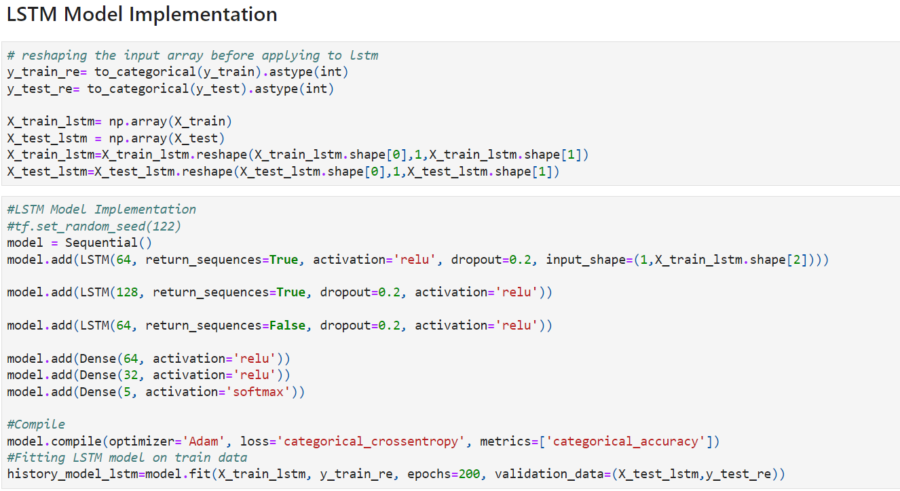
Figure 11: LSTM model

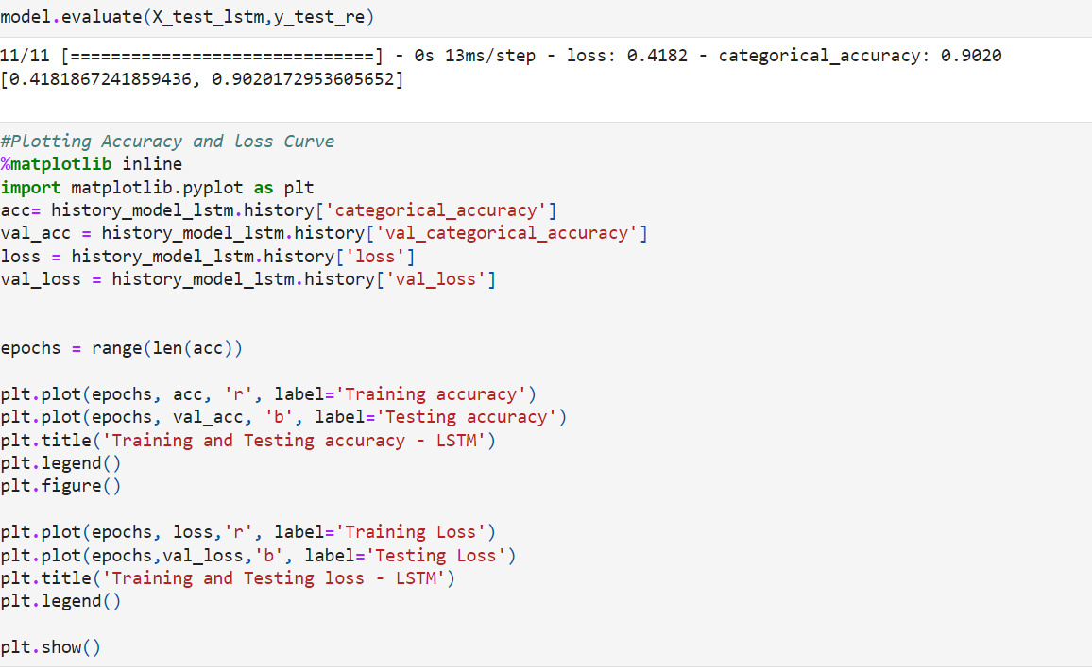
Figure 12: Accuracy and Loss Graph

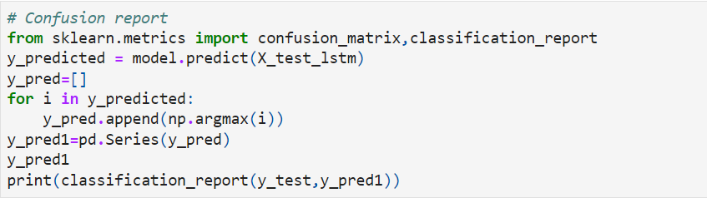
Figure 13: Confusion Report For LSTM

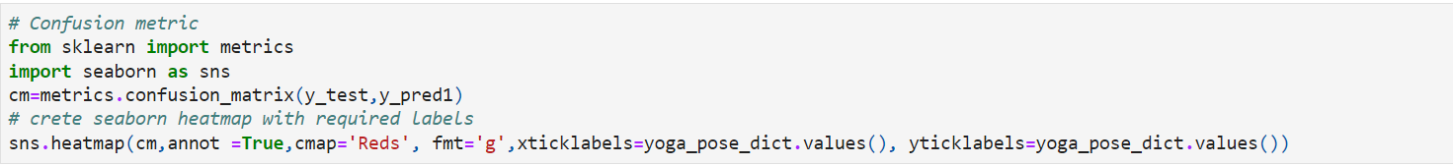
Figure 14: Confusion Matrix for LSTM
To implement and evaluate CNN use below Figure 15.

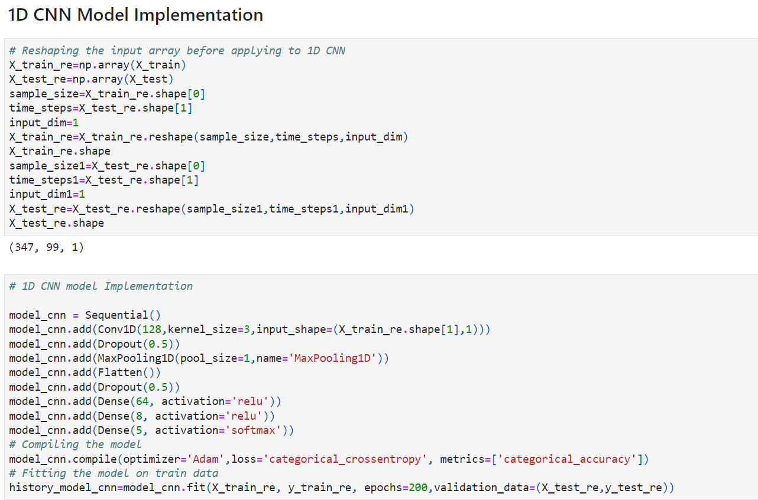
Figure 15: CNN Model

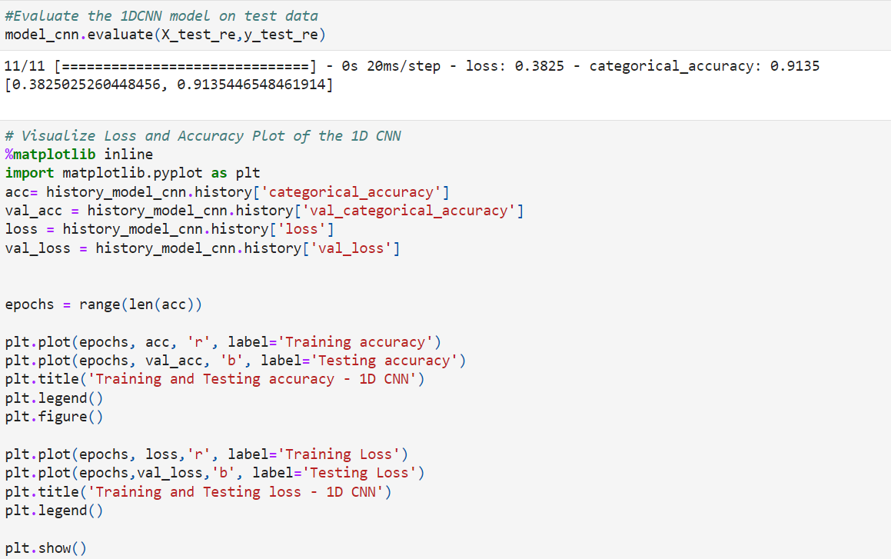
Figure 16: CNN Model Evaluation Graph

Machine learning
To Implement Machine learning model, refer below codes. Figure 17 is implementation for Random Forest Model.

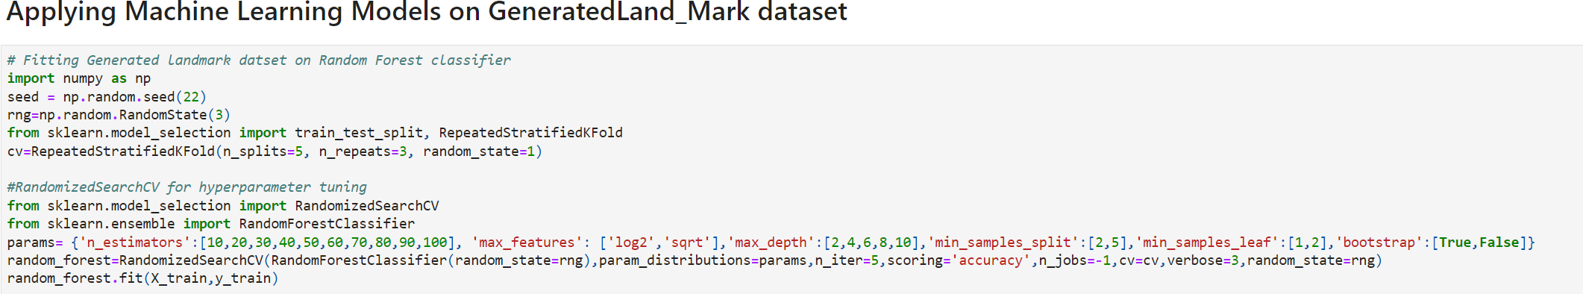
Figure 17: Random Forest Model

Refer Figure 18, 19 for the evaluation matrix.

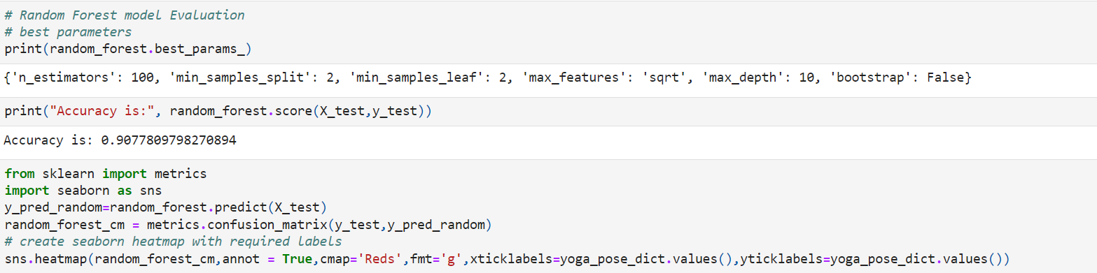
Figure 18: Evaluation Matrix for Random Forest Model- Part 1

Figure 19: Evaluation Matrix for Random Forest Model- Part 2

To implement Xgboost Classifier refer Figure 20,21,22.

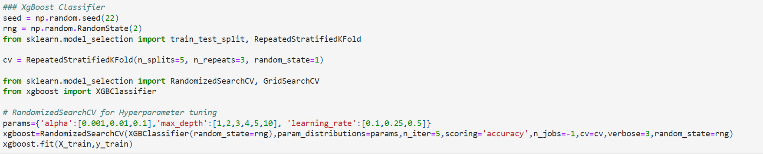
Figure 20: XGBoost Classifier Model
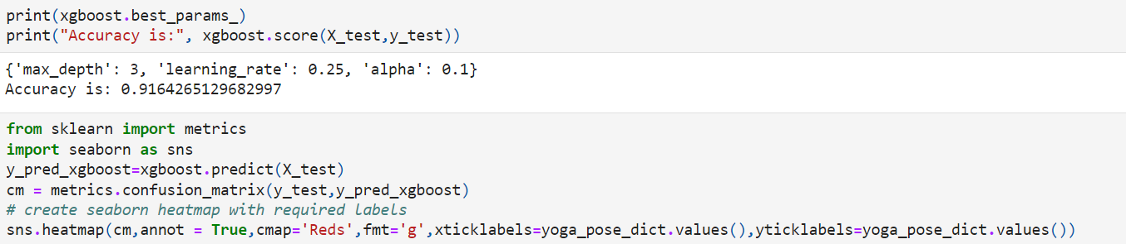
Figure 21: XGBoost Classifier Evaluation Matrix Part 1
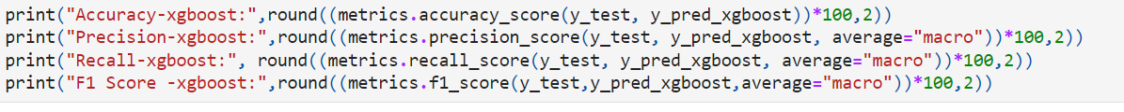
Figure 22: XGBoost Classifier Evaluation Matrix Part 2
To implement SVM refer Figure 22,23,24.

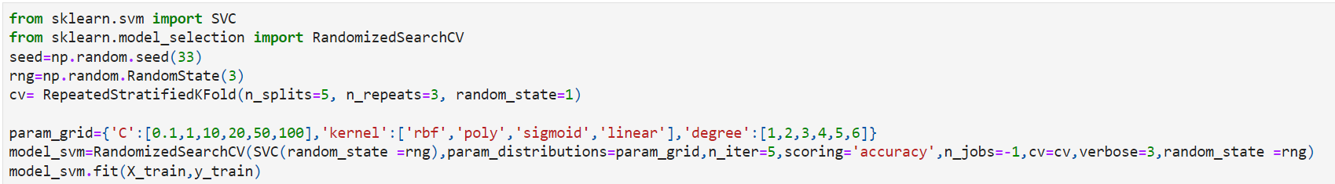
Figure 23: SVM Model
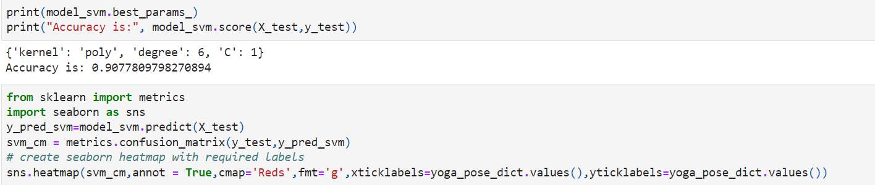
Figure 24: SVM Model Evaluation Matrix Part 1

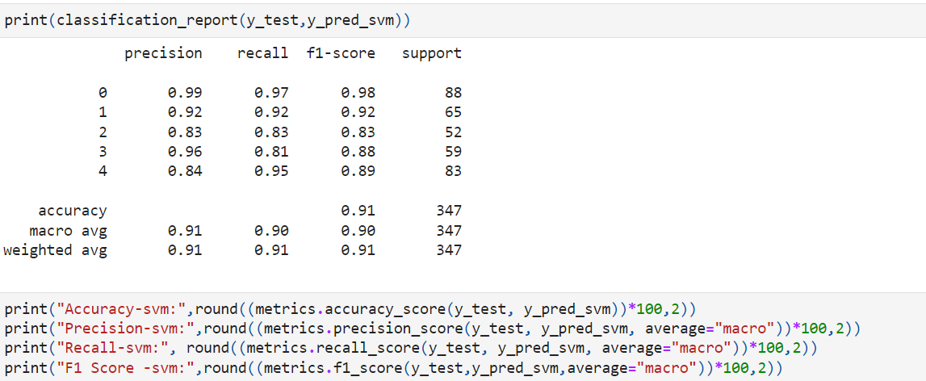
Figure 25: SVM Model Evaluation Matrix Part 2
To implement decision model, refer following Figure 26,27,28.

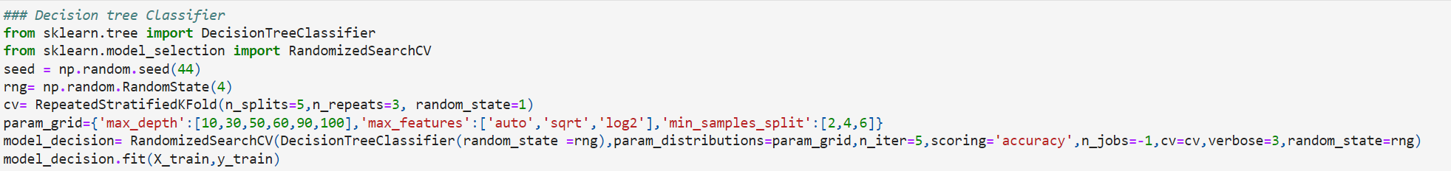
Figure 26: Decision Tree Classifier
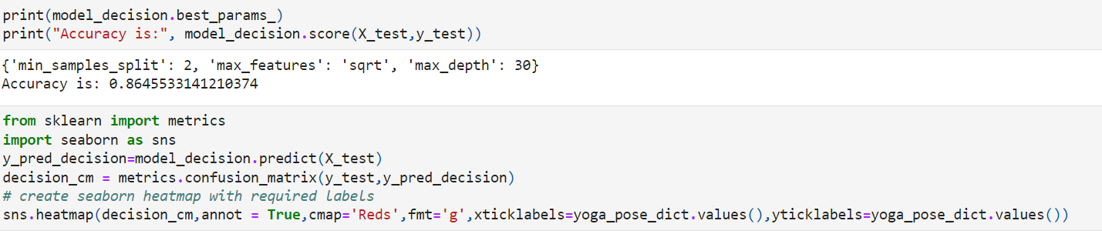
Figure 27: Decision Tree Classifier Evaluation Matrix Part 1
Figure 28: Decision Tree Classifier Evaluation Matrix Part2

To Implement KNN Model, refer Figure 29,30.

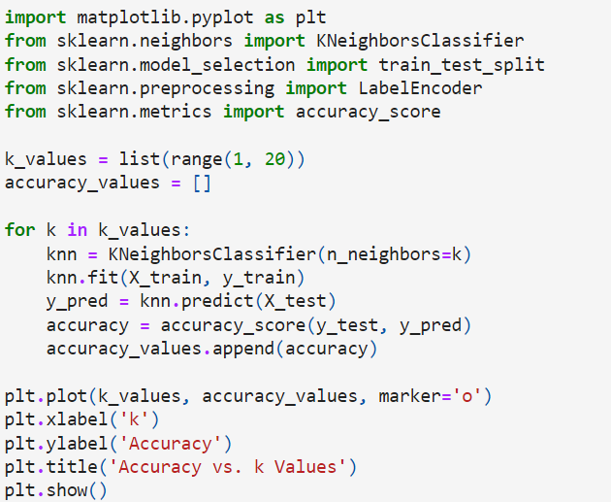
Figure 29: KNN Model
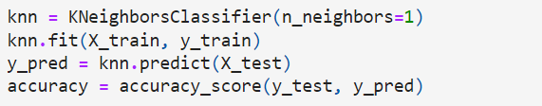
Figure 30: KNN Evaluation Matrix

Saving the Optimal Model

Evaluate and save the model with highest accuracy and dump it in pickle file and load it when the system is built for future use.

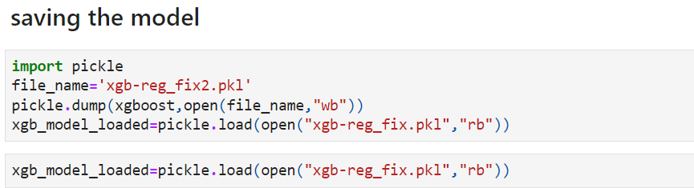
Figure 31: Saving the Model

Building Yoga Pose Image Detection System

Refer Below Figure 32 to build the system to identify pose in the given image .

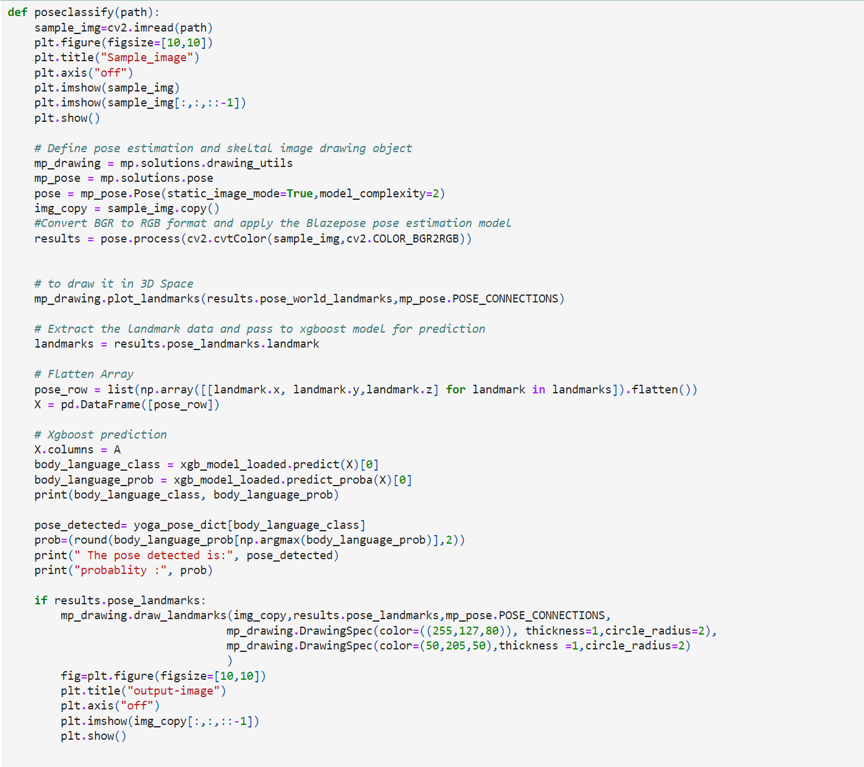
Figure 32: Yoga Pose Image Detection
To call the system use the code in Figure 33.

Figure 33: Identify the Yoga Pose

Building the Real Time Yoga Pose Detector

To build the final real time yoga pose detector refer the Figure 34, 35, 36. In this Figure 34 has code to add yoga pose benefit and Figure 35 has Audio feedback Function.

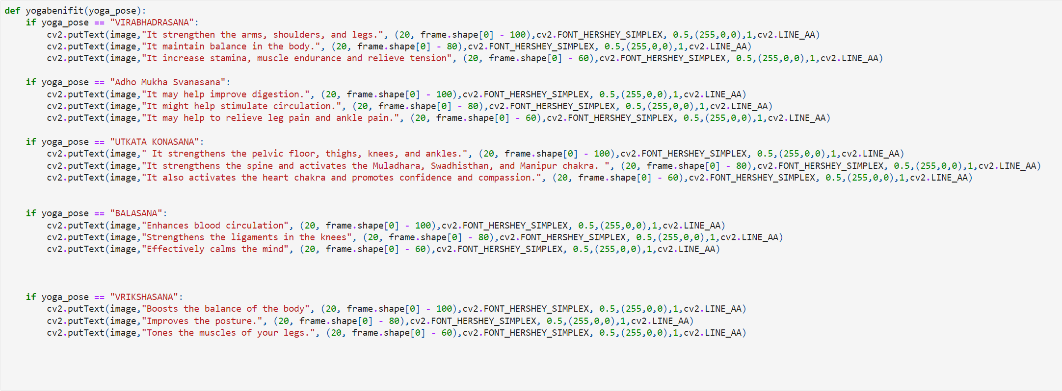
Figure 34: Building Yoga Pose Benefit Function
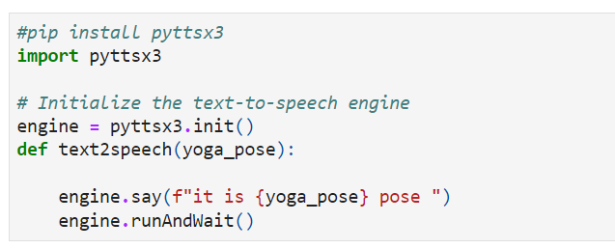
Figure 35: Adding Audio Feature In The Sytem
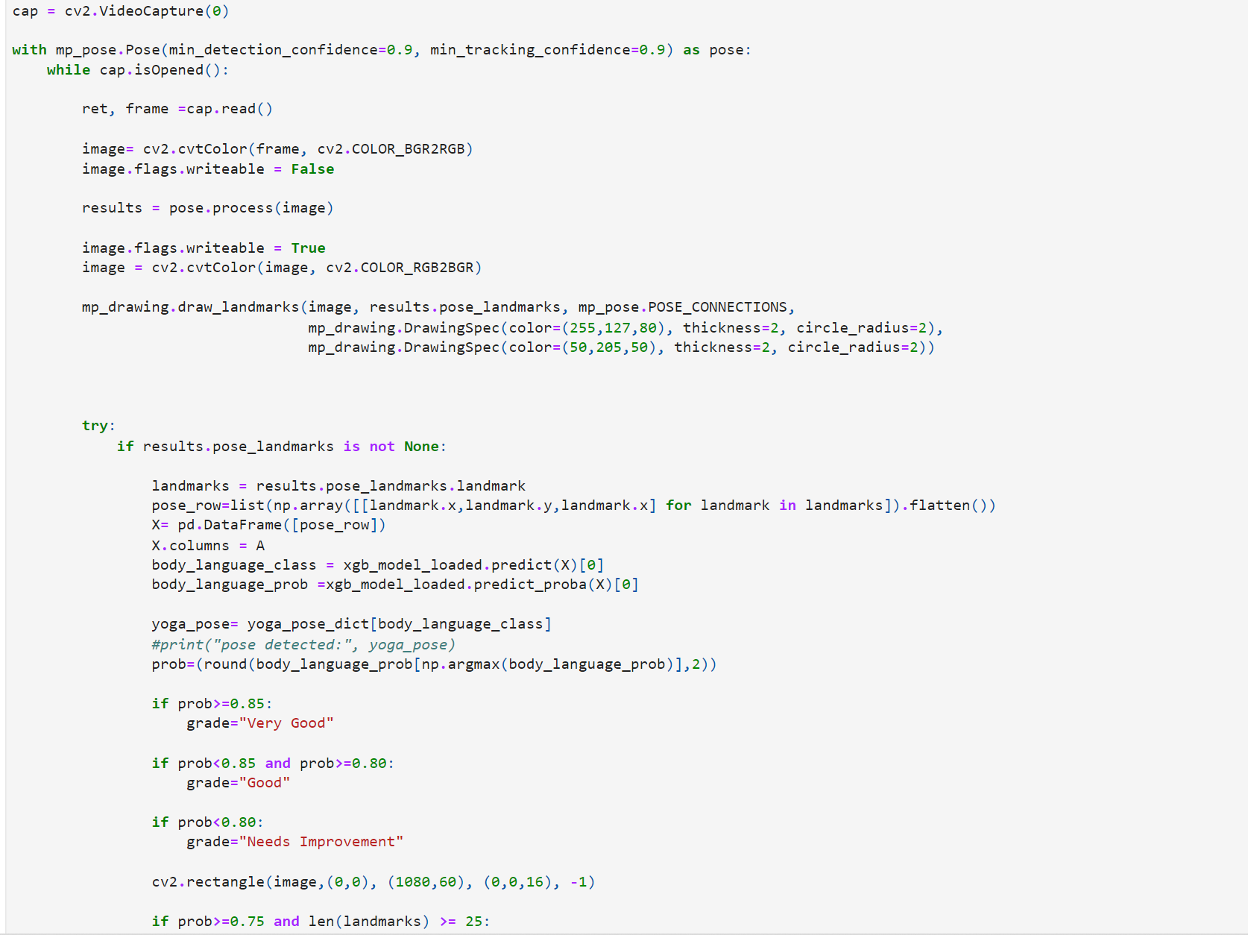
Figure 36: Yoga Pose Detector System- Part 1

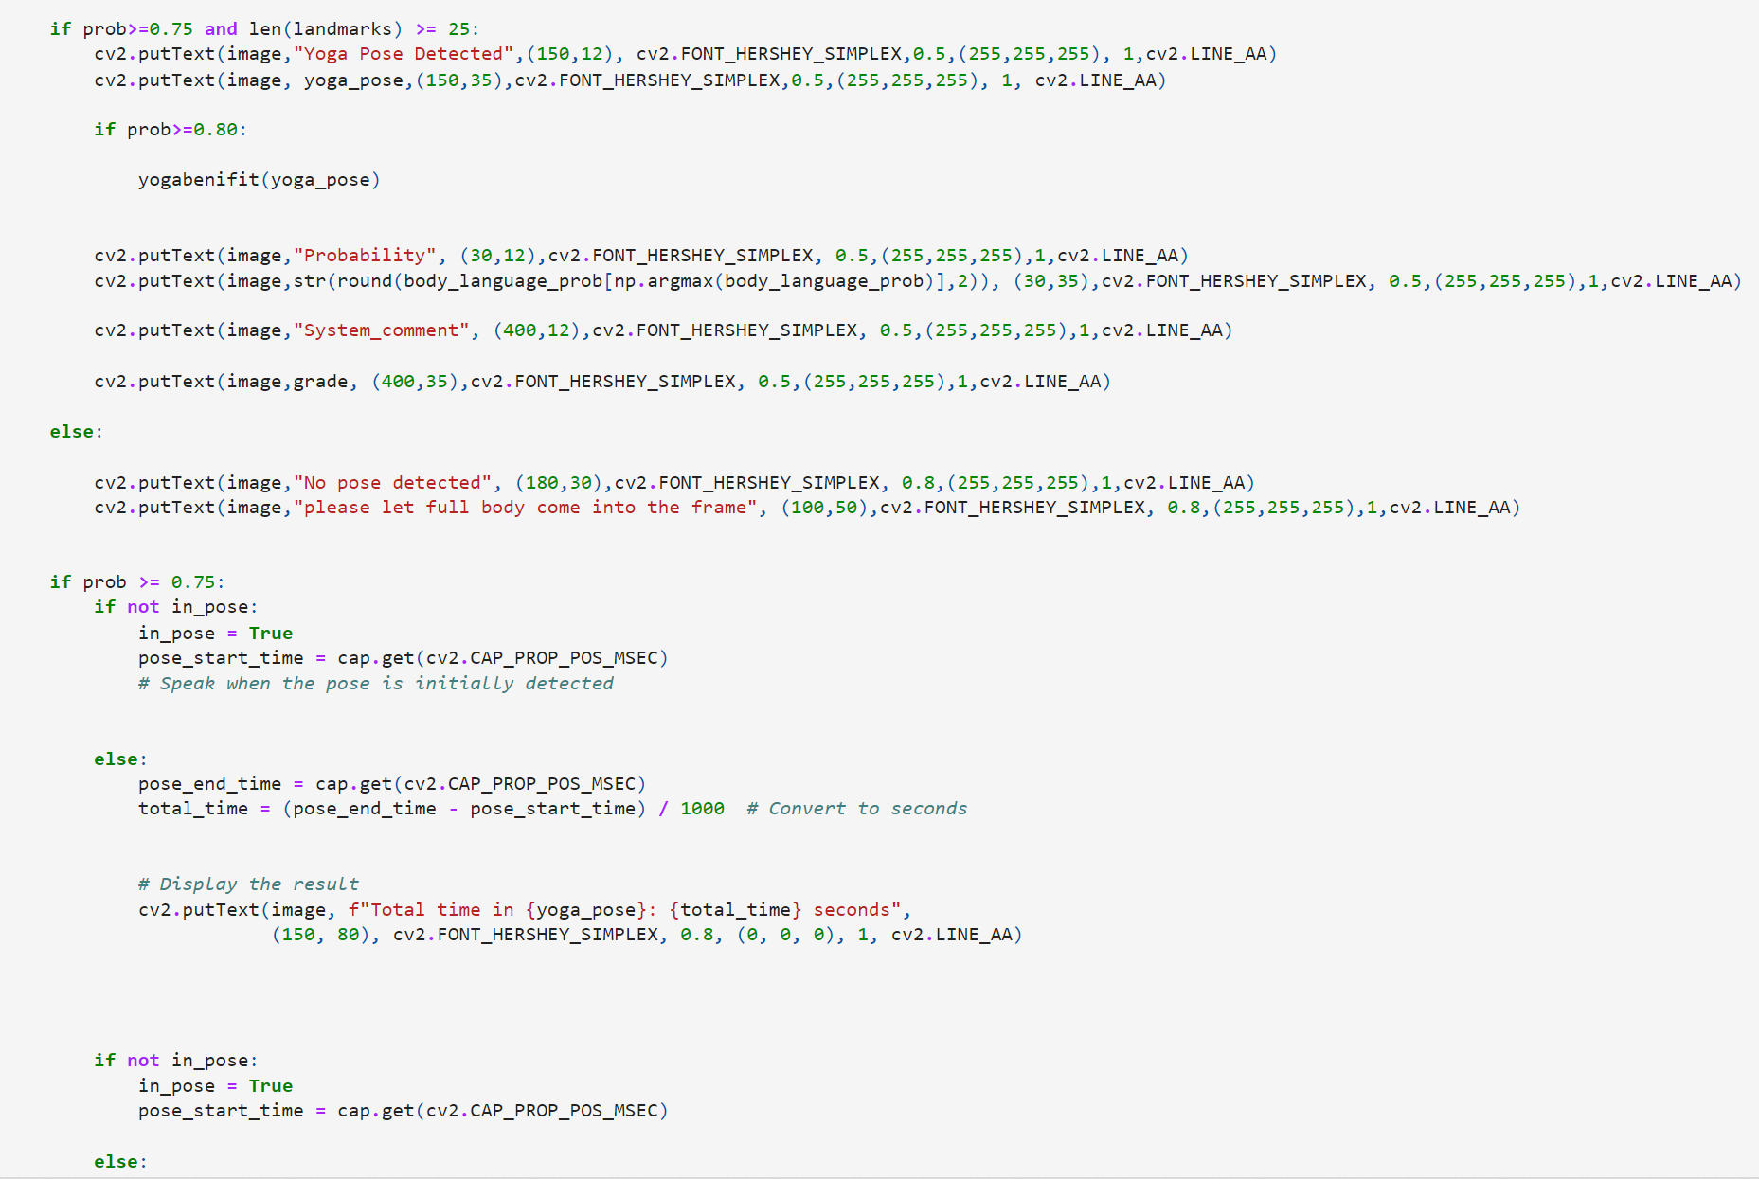
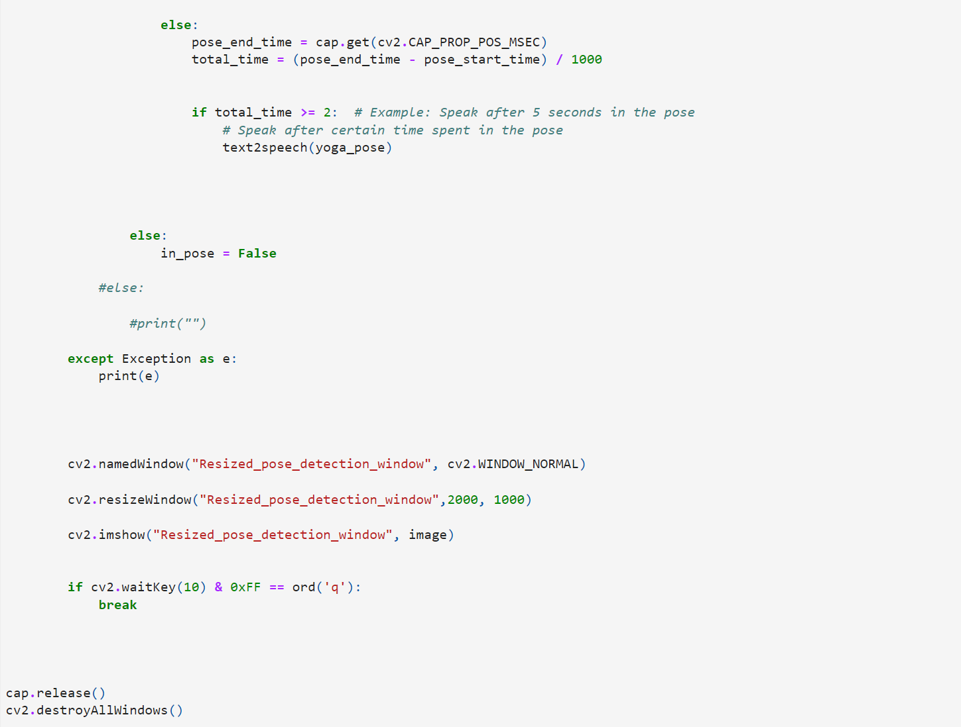
Figure 37: Yoga Pose Detector System- Part 2

References

Link for the dataset used in this Project.

