Long-Term Care Insurance
Expected Loss (Pure Premium) Model
Part 1 — Methodology & Results
Manulife Actuarial & Finance Analytics Take-Home

Contents
1. Objective & approach
2. Data & exploratory analysis
3. Methodology
4. Results
5. From Expected Loss to price, and the reserving boundary
6. Production & governance considerations
7. Recommendation

1. Objective & approach
I built a model to predict the Expected Loss (Pure Premium) for each long-term-care policyholder. It decomposes exactly as the brief specifies:
Expected Loss = P(claim) × E[ payout | claim ]
Because 86% of policies pay exactly $0, I treated this as two problems rather than one: a frequency model (classification: does a claim occur?) and a severity model (regression on claimants: how large?). Multiplying them gives the Expected Loss. This frequency–severity decomposition is the actuarial standard for zero-inflated claims data. I approached the build as if it were going to production: I tested the data for non-linearity, validated with cross-validation, tuned the challenger models, and assessed calibration, fairness and prediction intervals — keeping an interpretable GLM as the baseline throughout.

2. Data & exploratory analysis
Finding | Value | Implication
Rows / missing | 50,000 / none | No imputation required
Claim rate | 13.94% | Rare event; zero-inflated target
$0 payouts | 86.06% | Two-part / Tweedie modelling required
Severity mean (claimants) | $288,869 | Financially material; wide distribution
Severity skew | 2.27 (right-skewed) | Gamma error family for severity
Top frequency drivers | Age, Risk tier, Prior claims | Claim rate rises 3.6%→33% by age

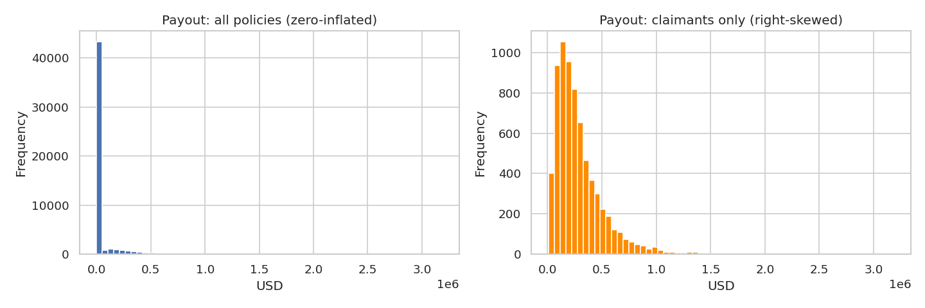
Figure 1. Payout is dominated by a spike at $0 (left); among claimants it is positive and right-skewed (right) — the signature of a Gamma distribution.
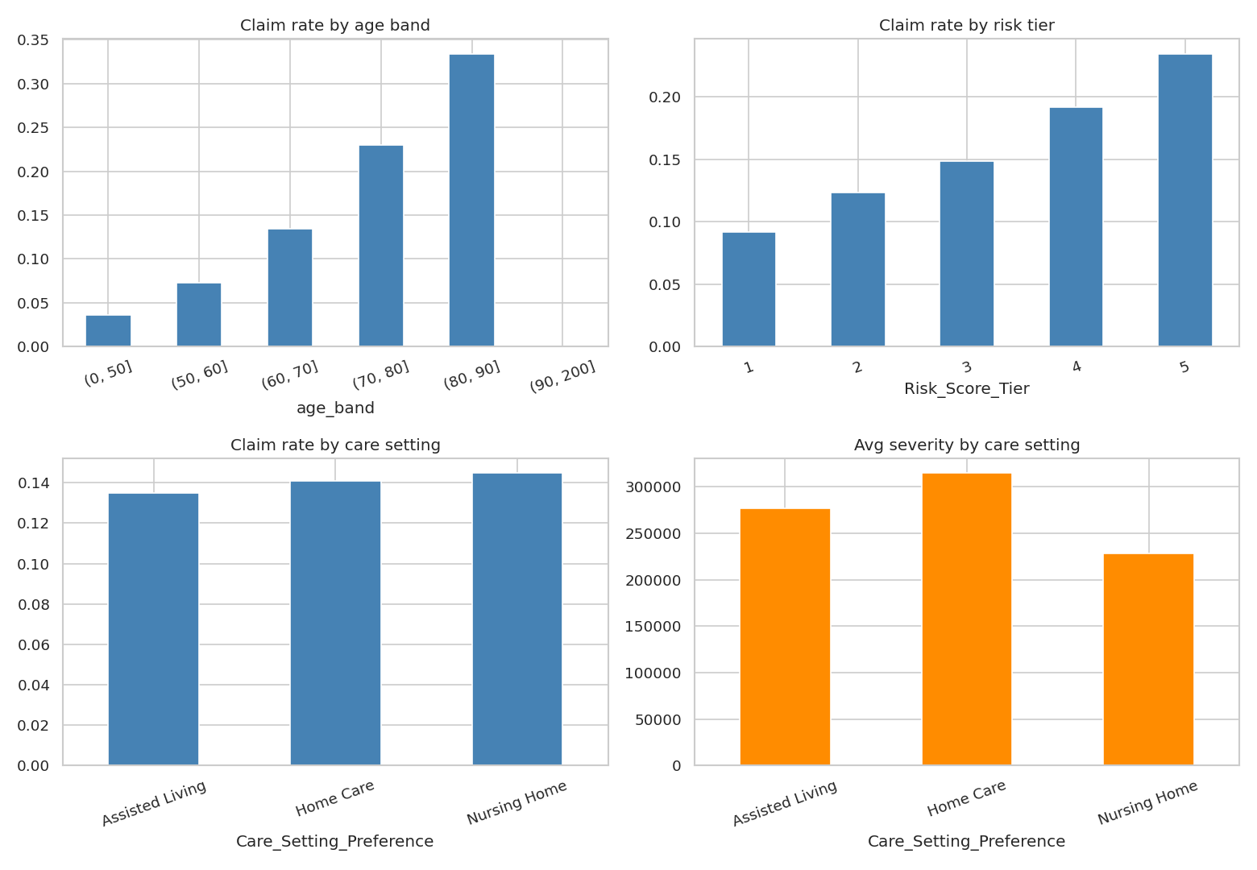
Figure 2. Claim frequency rises strongly and monotonically with age, risk tier and prior claims.

3. Methodology

3.1 Two-part architecture & model families
Component | Type | Target | Baseline | Challenger
Frequency | Classification | Claim_Occurred | Logistic GLM | LightGBM (tuned, monotonic)
Severity | Regression | Payout | claim | Gamma GLM (log link) | LightGBM (gamma)
Pure premium | Regression | Payout (direct) | Tweedie GLM | LightGBM (tweedie)

GLMs use a link function and an error distribution matched to each target (logistic for the binary event, Gamma for the skewed severity), which keeps predictions valid and the coefficients interpretable as rate relativities. LightGBM (a gradient-boosted tree method in the same family as XGBoost) is the challenger because it captures non-linearities and interactions automatically. I imposed monotonic constraints (claim probability non-decreasing in age, risk tier, prior claims) for both regularisation and regulatory defensibility.

3.2 Testing for non-linearity
Before preferring a complex model I tested whether the relationships are actually non-linear:
Test | Result | Conclusion
Spline vs linear logistic GLM (LR test, frequency) | χ²=10.1, df=7, p=0.18 | Frequency is effectively LINEAR
Ramsey RESET (log-severity) | F=66.2, p≈3e-29 | Severity has real NON-LINEARITY

This nuance matters: it predicts that boosting should help severity but not frequency — which the cross-validation then confirms.

3.3 Validation design
All headline metrics use 5-fold stratified cross-validation (mean ± standard deviation), stratified on the claim flag and on severity quintiles. LightGBM hyperparameters were tuned with Optuna (TPE, nested 3-fold inner CV, early stopping) to avoid leakage. A 25% hold-out was reserved for calibration, fairness and interval testing.

4. Results

4.1 Cross-validated frequency (Gini)
Model | Mean Gini | Std
Logistic GLM (baseline) | 0.5225 | 0.0138
LightGBM (tuned) | 0.5129 | 0.0154
LightGBM (monotonic) | 0.5143 | 0.0157

Note on interpretation: Gini = 2×AUC − 1. A coin flip is Gini 0; the GLM’s 0.52 corresponds to AUC ≈ 0.77 — a strong classifier. The GLM beats the boosters (within one standard deviation), exactly as the linearity test predicted.

4.2 Cross-validated severity (RMSE, USD)
Model | Mean RMSE | Std
Gamma GLM (baseline) | 174,337 | 6,520
LightGBM gamma (challenger) | 178,705 | 5,521

RMSE is large because individual claim sizes vary enormously ($9k–$3.2M); pricing relies on portfolio-level ranking and calibration, not point-accuracy of a single claim. The Gamma GLM edges the booster on RMSE despite the non-linearity, because its log link already captures much of the curvature.

4.3 Calibration & lift
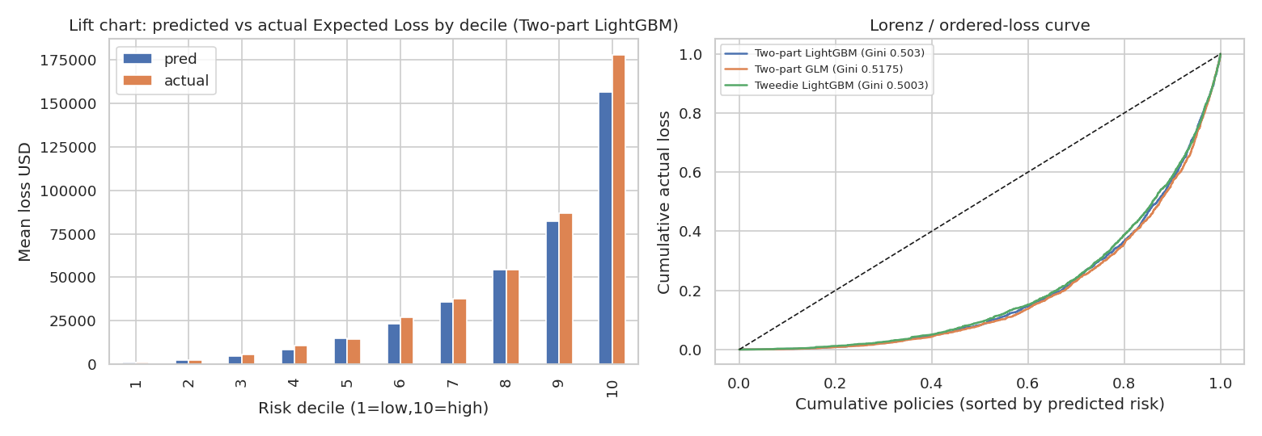
Figure 3. Predicted Expected Loss tracks actual across all ten risk deciles; the Lorenz curves bow well above the diagonal, confirming strong rank-ordering.
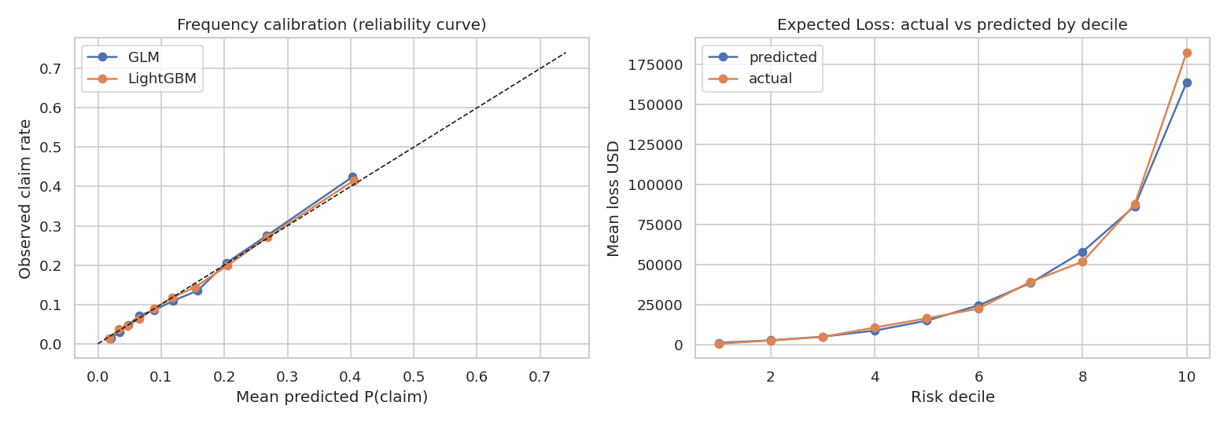
Figure 4. Frequency reliability curve (left) sits close to the diagonal; actual-vs-predicted Expected Loss by decile (right) are closely aligned. Overall Actual/Expected = 1.04.

4.4 Fairness / segment stability
Actual-to-Expected ratios stay close to 1.0 within every segment — no systematic mispricing of any group:
Segment | A/E range | Read
Age band | 0.97 – 1.11 | Slight under-pricing of 80+, otherwise tight
Care setting | 0.96 – 1.09 | Stable across settings
Risk tier | 0.99 – 1.09 | No bias across the risk scale

4.5 Interpretability & uncertainty
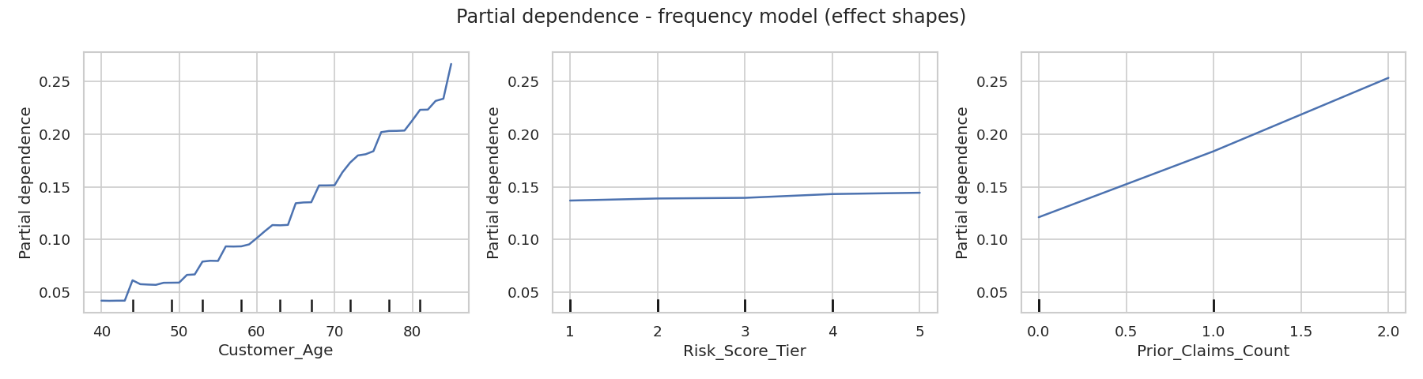
Figure 5. Partial-dependence plots: age and prior-claims effects are smooth and monotonic, tier is near-flat — visually confirming the near-linear frequency structure.
I also generated quantile-regression prediction intervals for severity. The nominal 80% interval achieved 67.5% empirical coverage — an honest finding that the intervals are too tight and would need widening / recalibration before production use.

5. From Expected Loss to price, and the reserving boundary
Gross Premium = Pure Premium / (1 − expense%) × (1 + profit & risk margin%)
The model output is the pure premium; business loadings (expenses, profit, risk margin) produce the charged premium. Its strong rank-ordering lets the insurer charge risk-appropriate relativities and avoid adverse selection. Critically, the model informs pricing but does not replace regulatory reserving: capital reserves and solvency capital remain governed by prescribed standards and stress tests (OSFI LICAT, IFRS 17), signed off by the Appointed Actuary. Machine learning optimises competitiveness; regulation governs solvency.

6. Production & governance considerations
- Data contracts and drift monitoring on every scoring batch; automated retraining triggers.
- Out-of-time validation once data is timestamped (claims and macro conditions drift over time).
- Model risk governance: independent validation, documentation and sign-off under OSFI E-23 / SR 11-7; GLM as champion with the booster as a shadow challenger.
- Fairness controls: no protected attributes, ongoing proxy-discrimination testing, full SHAP/coefficient explainability for every premium.

7. Recommendation
Ship the two-part GLM (logistic frequency × Gamma severity) as the production champion, with the tuned LightGBM retained as a monitored challenger. On cross-validation it delivers the best Gini and RMSE, is well-calibrated overall and across segments, and is fully explainable. The evidence — not an assumption — shows the interpretable model is the right choice here; demonstrating that with formal tests and cross-validation is itself the core of the data-science contribution.

