GenAI Architecture for Automated
Actuarial Valuation & Solvency Reporting
Part 2 — System Design (local working tool + Azure productionisation)
Manulife Actuarial & Finance Analytics Take-Home

Contents
1. Objective & guiding principle
2. The working tool — local architecture
3. The data inputs
4. How the tool works, step by step
5. Financial accuracy, privacy & guardrails
6. Productionising on Azure
7. Why this is the right design

1. Objective & guiding principle
The Finance and Actuarial functions need to produce a Standard Actuarial Valuation & Solvency Report for executive leadership on a recurring cycle. Today this is a slow, manual assembly of model outputs, ledger figures and macroeconomic context into a regulator-grade narrative. The objective is an AI-driven workflow that drafts this report automatically while meeting the accuracy, privacy and governance bar of a regulated insurer.
The whole design rests on one principle: the LLM composes the narrative, but it never invents a number. Every figure is read from a verified source and reconciled before publication; the model only writes prose around numbers it is given. I have implemented this as a runnable tool, and below I show both how it runs locally and how it would be productionised on Azure.

2. The working tool — local architecture
I built a runnable Python implementation that executes the full workflow on a laptop using a standard OpenAI API key. The offline test suite uses a deterministic mock model so it can run with no key and no token spend.
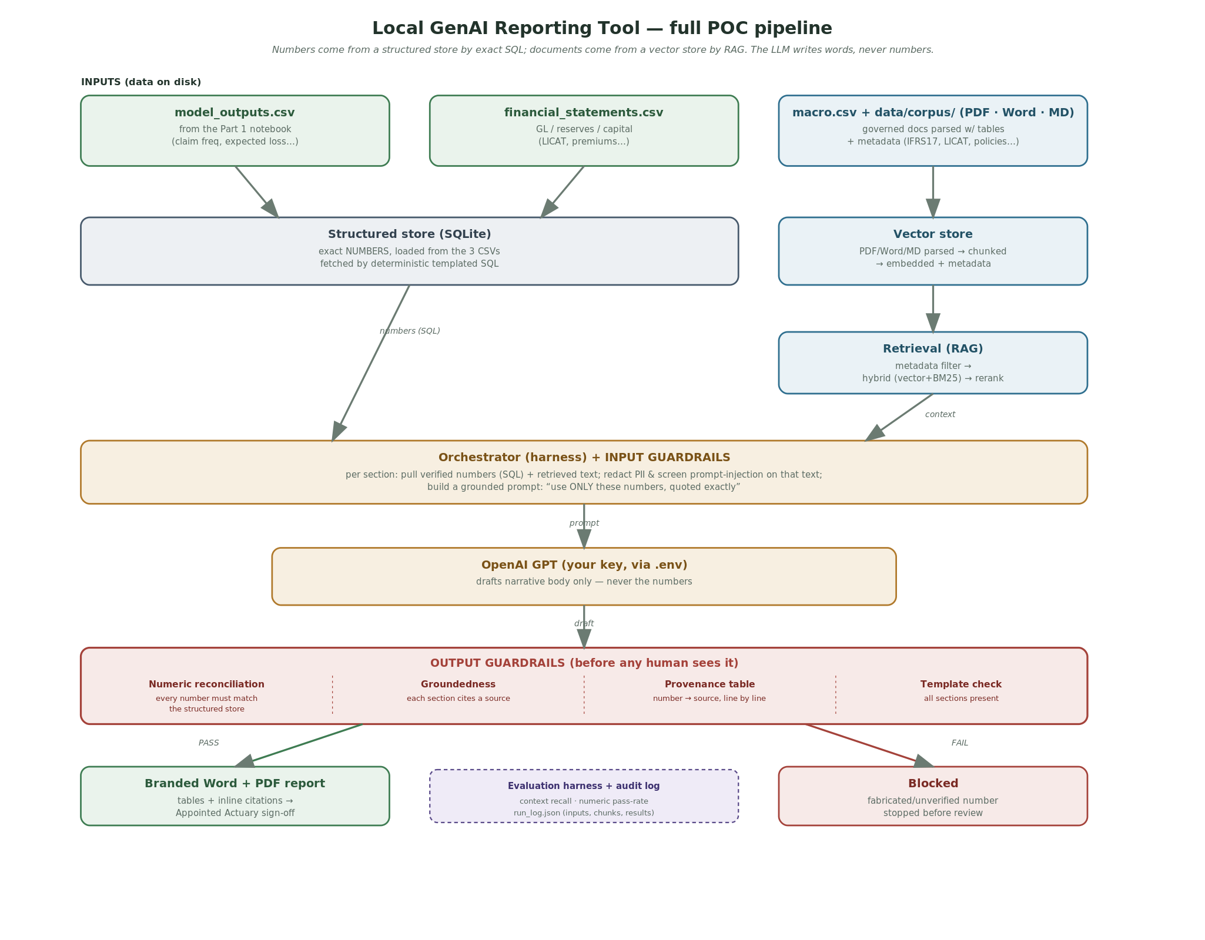
Figure 1. Local tool architecture. Verified numbers and governed documents on disk feed a KnowledgeBase and a RAG retriever; the orchestrator builds a grounded prompt; OpenAI drafts the narrative; guardrails validate every figure before a human reviews it.

3. The data inputs
Three data families feed the report — they map directly onto the brief's “model outputs, financial statements, and macroeconomic data”:
File / source | What it is | Maps to brief
data/inputs/model_outputs.csv | The Part 1 model outputs: policy count, claim frequency, mean expected loss, mean severity, total expected claims. Exported by the Part 1 notebook. | Model outputs
data/inputs/financial_statements.csv | The GL / capital figures: gross written premium, policy reserves, available & required capital, LICAT ratio, supervisory target, period, currency. | Financial statements
data/inputs/macro.csv | Macroeconomic assumptions: inflation rate, discount rate, wage inflation. | Macroeconomic data
data/corpus/ (.md, .pdf, .docx) | Governed DOCUMENTS for RAG in multiple real formats — regulatory PDFs (with tables), Word policies, markdown — each tagged with metadata (source, doc_type, topic, date) via front-matter or a manifest catalogue. | Regulatory / policy context

Why the split matters: numbers live in the structured CSV and are fetched by exact lookup; documents live in the corpus and are fetched by semantic search (RAG). Numbers are never embedded or reconstructed by the model — that separation is what makes the output trustworthy. In production the CSV becomes a database and the corpus becomes a managed search index, but the roles are identical.

4. How the tool works, step by step
- Ingestion (multi-format) loads the three input CSVs into a SQLite structured store, and parses the corpus across PDF (text + tables), Word and markdown — chunking + embedding each into a vector store with per-chunk metadata.
- Structured store (numbers) returns each figure by exact, templated SQL — never by similarity. It also exposes the full set of allowed numbers used by the reconciliation guardrail.
- Retrieval (RAG) for each section: metadata filter → hybrid search (vector + BM25 keyword) → cross-encoder rerank, returning the most relevant governed text.
- Input guardrails run on every retrieved chunk before it reaches the model: PII redaction and prompt-injection screening (untrusted document text is neutralised).
- Orchestrator + LLM assemble the verified figures + sanitised context into a grounded prompt (“use ONLY these numbers, quoted exactly”); OpenAI drafts the narrative body — never a figure.
- Output guardrails validate the draft: numeric reconciliation against the structured store, groundedness/citations, template completeness, plus a provenance table mapping every number to its source.
- Evaluation + audit an offline harness scores retrieval (context recall) and numeric pass-rate; every run writes an audit log (inputs, retrieved chunks, guardrail results).
- Output rendering the approved content is rendered into a branded Word document and PDF — cover page, formatted tables built from the verified numbers, inline [n] citations, references and a sign-off block. The LLM writes prose; this layer owns all formatting.
- Human-in-the-loop only a draft passing every guardrail goes to the Appointed Actuary for sign-off; a failing draft is blocked.

5. Financial accuracy, privacy & guardrails
Accuracy is enforced by design, not hoped for: numbers are retrieved, never generated; narrative is grounded in retrieved documents with citations; a numeric-reconciliation guardrail blocks any figure that does not match the source of truth; and a human signs off. In the live demo, the guardrail correctly blocks a fabricated LICAT figure even when it comes from the real model. Privacy: PII is redacted before the model sees any text, and in production the model runs in a private deployment with no training on company data, role-based access, encryption and Canada data residency.

6. Productionising on Azure
The local tool is intentionally a faithful, scaled-down version of a cloud system: every component has a managed Azure equivalent, and the interfaces are the same so the move is a swap, not a rewrite. To productionise it I would: replace the CSV source of truth with Azure SQL / Synapse / Microsoft Fabric; replace the TF-IDF retriever with Azure AI Search (hybrid vector + keyword) populated by text-embedding-3 embeddings; replace the direct OpenAI call with Azure OpenAI deployed inside a private VNet (no training on data); run the orchestration as an Azure Prompt Flow / Semantic Kernel workflow triggered by Azure Data Factory and Functions / Logic Apps on the reporting cycle; implement the guardrails with Azure AI Content Safety (groundedness) and Azure AI Language (PII) alongside the custom numeric reconciliation; and wrap everything in security and governance — Entra ID RBAC, Key Vault encryption, Microsoft Purview lineage, Canada data residency, audit logging and OSFI E-23 model-risk governance — with an offline evaluation harness (Azure AI Evaluation SDK) and online monitoring (Azure Monitor / App Insights). The same human actuary sign-off remains the final gate.
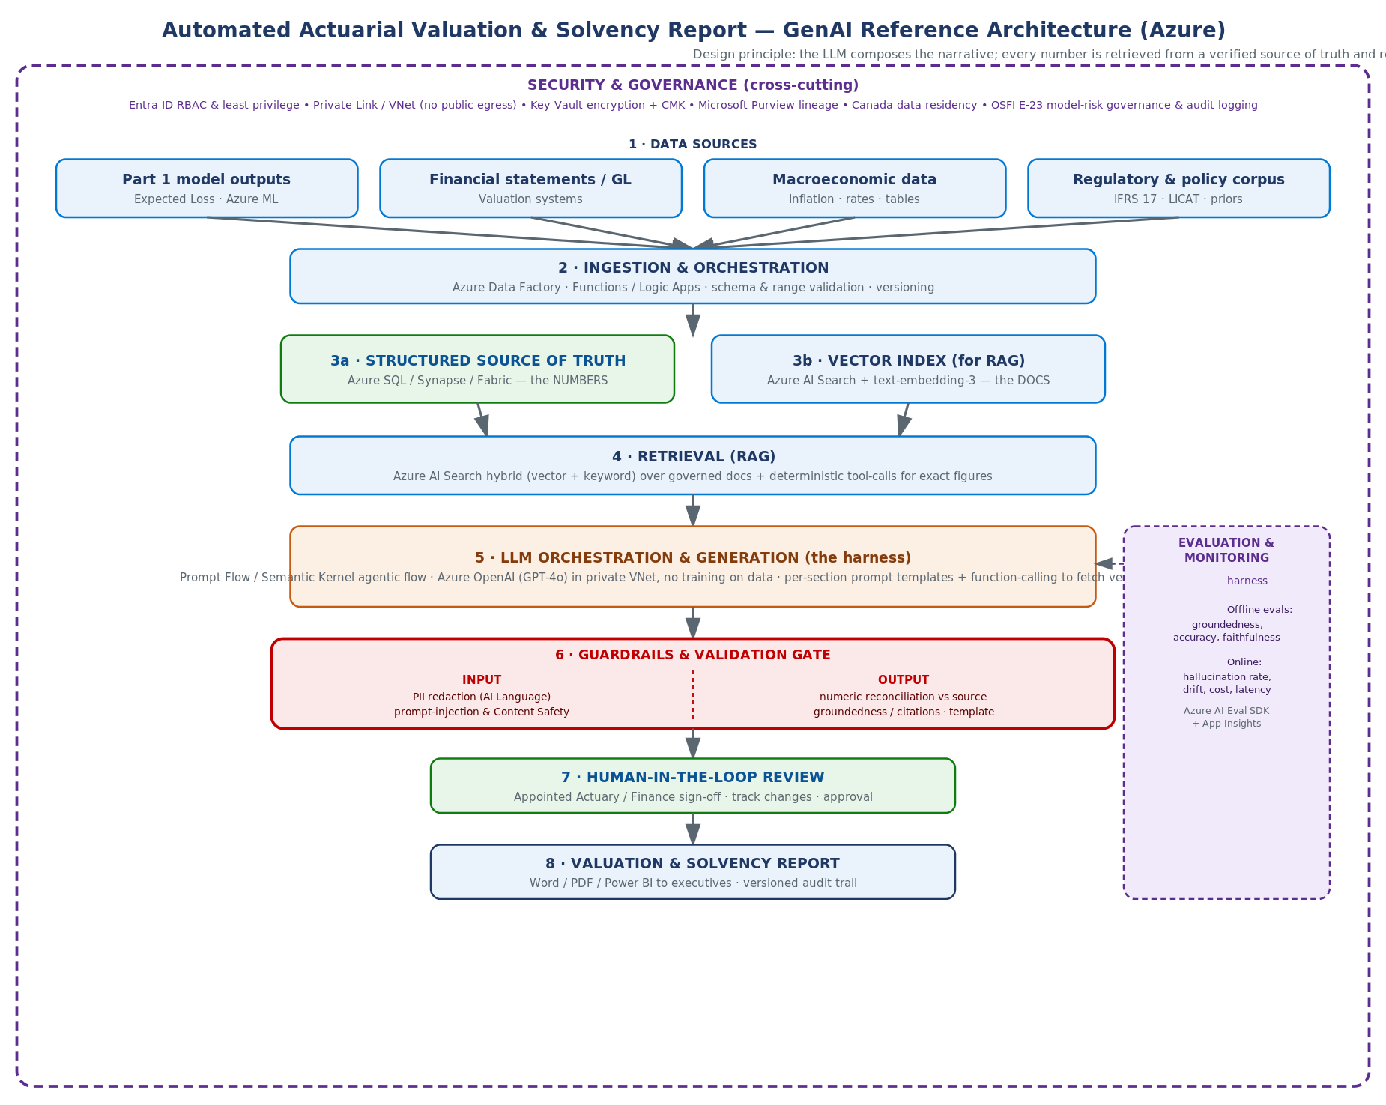
Figure 2. The same workflow productionised on Azure. Each local component is replaced by a managed service; the data flow, guardrails gate, evaluation harness and human sign-off are unchanged.

7. Why this is the right design
It uses the LLM only for what it is reliably good at — composing fluent narrative — and removes it from what it is unreliable at — being the source of numbers. RAG plus numeric reconciliation make the output verifiable; private deployment, PII redaction and data residency make it compliant; the evaluation harness makes quality measurable; and human sign-off keeps accountability where regulators require it. Building it as a working local tool first proves the design end-to-end before any cloud spend.

