**VALET FITNESS Questions   
User Side**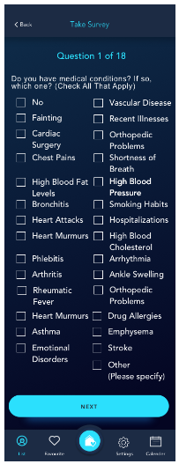

1- Is it mandatory for users to answer all questions and where to redirect after completing profile? Yes, it is mandatory to answer all. User cannot go to next question without answering current screen.  
2- Can Users upload his/her profile image and where it should be? Yes, in Settings  
3- Can Users view personal trainer skills and certificates? Good question. That is what the PT and Nutritionist’s profiles are for. Users do not see the certificate but may see skills that the professionals put up. Could we actually put up a verified blue check sign on the profiles that have uploaded a certificate and is approved (by us)?  
4- Can Users change his/her current location while booking? Yes.   
5- After Booking can users change his/her session location? If scheduled on the same day, no. If booked in advance, yes.  
6- When user pay booking amount at booking time or after session? User pays upfront, at booking time.  
7- If personal trainer cancels user booking can user get his/her amount back? User gets their credit back (shown on their homepage).  
8- If User cancel booking before booking time can his/her amount detect? If the client is unable to attend a session, Valet Fitness does implement a fee of $25 if the session is cancelled later than 12 hours. Before the 12-hour grace period, he or she will be given a courtesy to reschedule with no additional fee.  
9- Age limit is required for sign up? 18 years+  
  
  
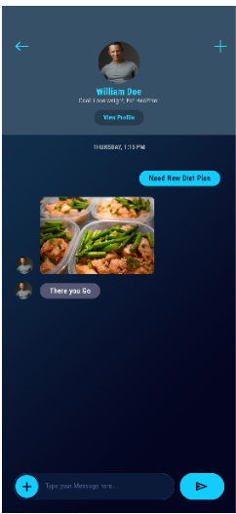  
  
  
10- Can users block personal trainer/nutritionist from chat? Great question. Yes could we add on the upper right side of this chat the three vertical dots icon and have “Report” and “Block”? The “X” icon isn’t supposed to be there.  
11- Can user edit and change name, email and password from settings? Yes.  
  
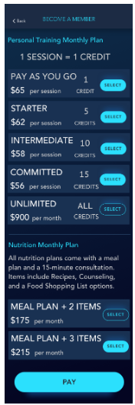  
12- Please describe the personal training Monthly Plan? Firstly, let’s change UNLIMITED PRICING to $1320. (Sending you an updated screen for this). User pays upfront. If user wants to pay for 5 credits, they will be getting 5 sessions to work with a personal trainer. Users may cancel their monthly subscription at any time. Their credits will still remain until their month period (30 days) is over.   
13- Please describe the nutrition Monthly Plan? There are three selections: (1) Recipes (2) Counseling (3) Food Shopping List displayed on the nutritionist’s profile. User can select a plan where user can select two of the three, or select all three. The notice is shown on this screen above. On the nutritionist’s profile, the client can select which of the two they can pick if they picked the *Select Two* option.

Also, to avoid confusion, on the screen above, user can SELECT and DESELECT each button. This way, if user changes their mind of getting PT and Nut packages, they could just deselect (pressing the same button) to opt out of it.  
  
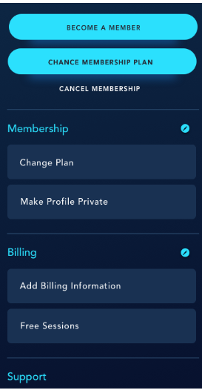  
14- When click on Become a Member which screen would be open? The pricing list would open.   
15- What does it do with chance membership plan? I am actually sending you an updated screen that has this part out on the top. It will be under “Membership”, rather.   
16- What is purpose of change plan? The purpose of this is to change the membership plan. Sending you an updated screen that says “Change Membership Plan”  
17- What is purpose of Profile Private? This allows users to hide their Track Your Progress Profiles from their health professionals for BOTH parties. The PT/N either see it, or they don’t.  
18- Add Billing information screen is missing. Okay, sending!  
19- How user can get free sessions? Users can get free sessions by referring friends.  
  
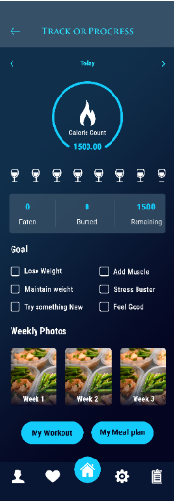  
20- In previous Documents you have told to disregard the Goal Section so why we have it in finalized screen? The Goal Section will be on this screen and not editable. This information may be changed by retaking the survey. Could we change the cup icons on this screen?   
  
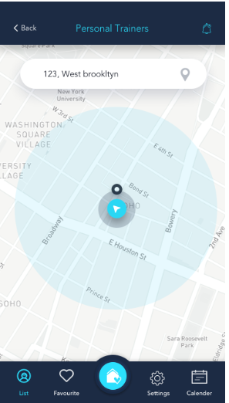  
21- Is it current location of personal trainer or location of session availability? Location of current and active personal trainers ready to train within the hour. I also updated the Filter page that connects with this map. If a user wants to workout with a trainer *Now*, they could take a peek at the map. Let me know if you have questions about this.  
  
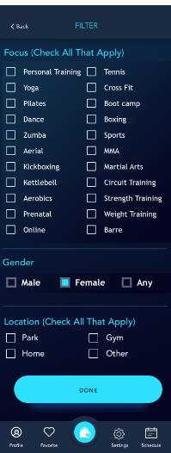  
22- How gender filter work because no gender in sign up? Just added the “M or F” question on PT App Q8. Sending it over to you.  
23- Track Nutritionist Screens Missing. Like a Filters screen for the nutritionist? Okay, sending!

**Personal Trainer Side**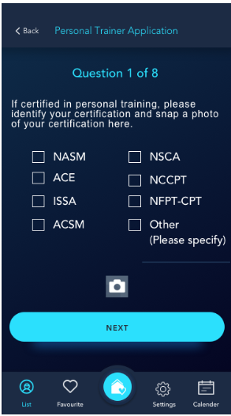  
1- Is it mandatory to personal trainers to answer all questions? Yes, it is mandatory. Personal trainer must be certified which is why it is the first question.  
2- Can personal trainers upload multi photos of certificates? Good question. Yes!

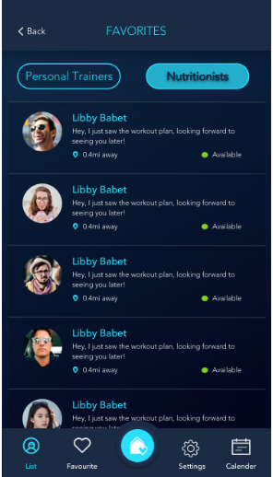  
3- What is purpose of Favorites screen in personal trainer? PT can save clients they have worked with. This is only for them to see.

In my client screen Personal Trainer view clients, they have worked. So what is purpose of this screen?  
4- How many times personal trainer offer free 15 min consultations to one user and what will happen after 15 min consultations, if their conversation have not ended yet? PT/N could offer this as many times as they want under their discretion. Sending you a popup indicating that.  
5- Can personal trainer change his/her name, email, and password? Yes, on their Settings screen.  
6- Can personal trainer search/or book another personal trainer? Good question. No.  
7- Age limit for sign up? 21 years+  
8- Can personal trainer change the time or date after booking and also cancel the booking, if yes then how much time before booking? PT can cancel and change date any time but if cancelled within 2 hours of session period, a pop-up will indicate that if they cancel more than 3 times in a 6-month period, their profile will be deactivated for 90 days.

For clients, they pay a $25 cancellation fee if they cancel within 12 hours to their session. They must cancel before the 12-hour-period mark to avoid a cancellation fee.  
9- Where we are getting information about has gym, equipment’s, available at home, park or other? Sending you an updated a screen including all the survey questions. This will be under PT App Q6.  
  
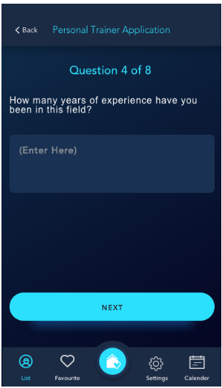  
10- It would be better if we take career started date from personal trainer. Okay, that works!  
11- Is All personal trainers have same charges per session? Yes, Trainers get paid $50/session/client.  
if there is high paid/experience personal trainer?  
  
  
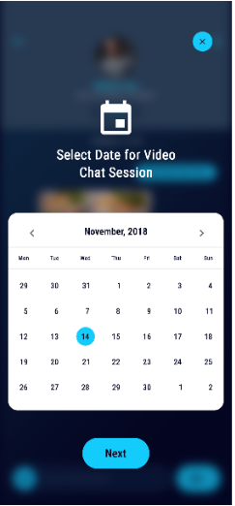  
12- Blue one is booked or available?

Available.

Available is highlighted in blue (like above), and *Unavailable* should show in gray TEXT. SELECTED should appear slightly different with the blue, like in the other screen below.  
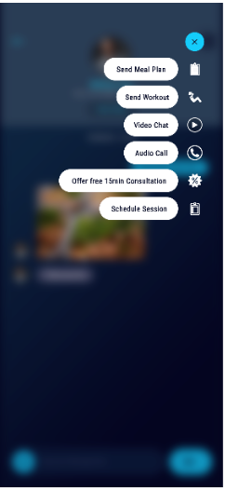  
13- How can user know that which time should do the workout and how much days he should do it?

PT/N can view his schedule for that information. On the schedule, there is a list of upcoming sessions with clients or he can view the calendar as a whole.

For this screen however, if a client and PT/N have already been chatting and trying to schedule a date, a PT/N could offer any time they’re available. User could ACCEPT or DECLINE the offer. PT/N could do it at any time. (PT does not have access in sending Meal Plan, and N does not have access to sending Workouts).

User can have this on his/her notification that PT/N wants to offer a 15-minute consultation.  
  
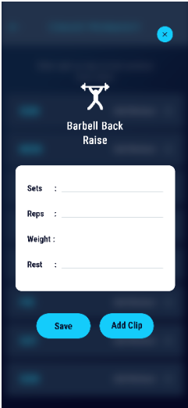  
14- Workout Title Field is required  
“Barbell Back Raise” is the title of this exercise. Could we add an *edit icon* so we can edit the title of the exercises?  
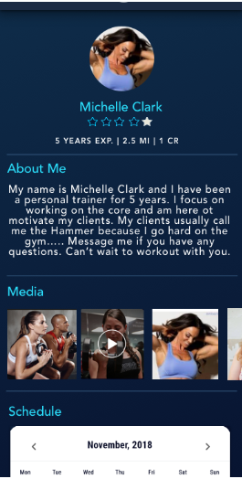  
15- From where personal trainer add media? They can add media by clicking on the photo there itself. This whole page is editable for the PT. I think we should add an edit icon on each media shown in the upper right corner so PT/N could know.  
  
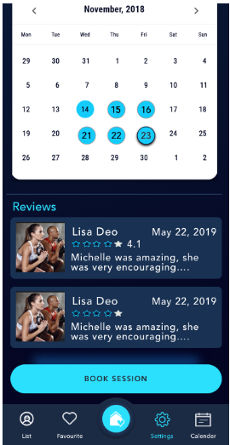  
16- What is purpose of Book Session in personal Trainer Edit profile?  
I am sending you an updated screen of the “Book Session” in place right underneath the calendar so it makes more sense, and with a message on the top saying, You are viewing this page as a client would. You may edit this page.”  
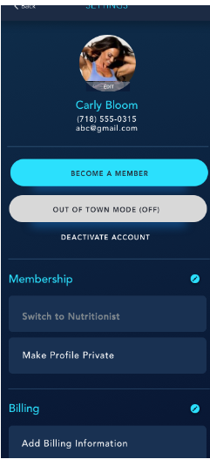  
17- How Personal Trainer Become a member? Sending you updated version without “Become A Member.”   
18- What is Purpose of out of Town mode? PT/N could put that sign on when they won’t be in town or available to work with clients. This indicates that they won’t be available until they turn that mode *off*. If this mode has reached 30 days, it will automatically be deactivated.  
19- Is possible for personal trainer to become nutritionist? That is “coming soon”. Disregard this feature.  
20- What is Purpose of make profile private? Making the profile private means PT/N don’t want any clients seeing their profile. They can still be active working with clients, but they don’t want clients seeing their profiles. Their profile is hidden from every one, even clients they work with. Let’s say, if a client has *“favorited”* a PT or N who has made their profile private, the client could still see the PT/N names on their “Favorites,” but cannot see the profile when is clicked on.  
  
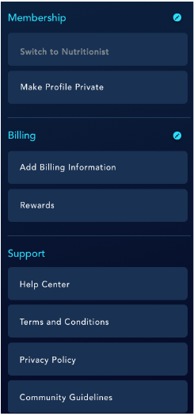  
21- What is purpose of Rewards? PTs get rewards when they refer new clients. They get $5 per new client.  
Rewards screen is missing and how personal trainer refer new clients?

**Nutritionist View**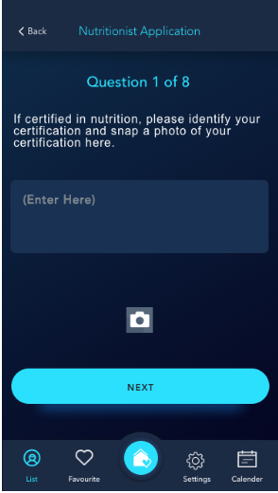1-Can Nutritionist Upload multiple photos of certificates? Yes.  
2- Age limit for Sign up? 21 years+  
  
  
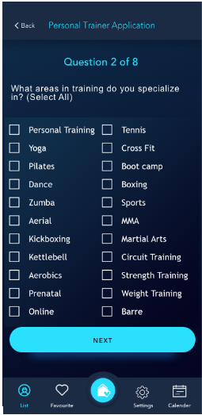  
3- Nutritionist questions 2 to 8 are missing It is the same questions as the PT, just the text on the top would say “Nutritionist Application”. I am sending you a few updated screens that shows some revised questions and an added question. Thanks for pointing this out.  
  
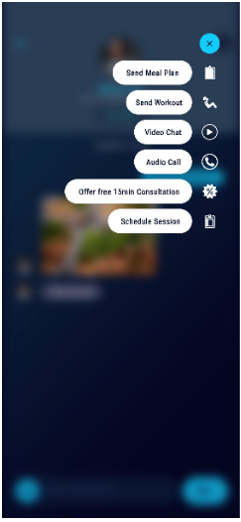  
4- In Nutritionist what is purpose of workout here? Disregard that. Nut should only see Send Meal Plan as the Trainer should only see Send Workout Plan  
5- Price is missing in Nutritionist side. Nutritionists get paid $35/week/client.  
  
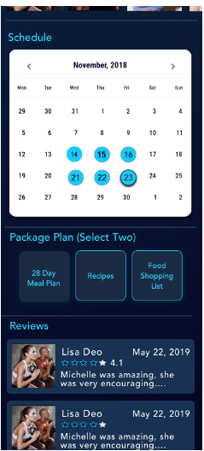  
6- Describe Package Plan in detail. Client may change their package plan in settings (Package Plan *select two* or Package Plan *select three*). If client has *select two*, their options display on this page and they may select their preferred two here.7-Is it mandatory to answer all questions? Questions from the application/survey? Yes. All questions are required. However, the survey may be taken at any time.  
8- How many time Nutritionist offer free 15 min consultations to one user? Many times as they want. It is on their discretion. This is their own time and won’t be getting paid extra for it. Nut may want to use this as a time to sell themselves to the client or to talk to their existing client..  
By the way, PT/N cannot reach out to clientele. Only clients can reach out to the health professionals.  
  
**Questions**1- Location is missing in sign up of personal trainer and user than how distance   
calculate? In the very beginning of the app, there is a screen that allows you to plug in your zip code. That is best suitable for anyone at the very beginning of the app. I will resend it to you.  
  
then how location change work?   
  
  
2- Distance validation for personal trainer/Users for booking? The Personal Trainer/ Nutritionist could be anywhere and far. But the closest ones could show up on the top first, and of course depending on the filter clients put in.  
3- How many types of notifications?

-Messages to and from client/PT/N

-when PT/N adds workout/meal plan

-reminding PT/N to check in with their client if they haven’t viewed their client’s profile more than 2 days.

-reminding client to post their meals for their nutritionists to see  
reminding client to see their meals post that was send by nutritionists?

-reminding clients to drink water  
4- When will user become a member? Good question! FYI: I am sending you an updated screen for PT App Q4 so PT/N could put down their cost for each session.

When users sign up, they are able to use the app without limitations. They can track PT/N, upload photos of their meals, weekly progress, add how much water their drinking, take the survey, view PT/N profiles, their schedules, and view their original prices BUT cannot schedule session with PT/N or write to them. They must be a member to do that. Users become members when they pay for PT sessions or Nut sessions. (Members pay on a monthly basis and may cancel at anytime. If they wish to cancel, must be before their month cycle is up. They may use the rest of their credits (if they have any) before their month cycle ends).  
5- Describe Payments Details Personal Training sessions and Nutritionist sessions are bought separately. User can buy either personal training sessions, nutritionist sessions, or BOTH. When they buy *either* sessions, they become a member. That means they agree to pay on a monthly basis.   
6- How to withdraw amount from app? On PT App Q8, PT/N put in their routing and account number so they can connect their commission to their bank accounts. They may cash-out at any time. To withdraw amount from the app, PT/N must click on their balance on the homepage. I will send you a screen to demonstrate that.

Additional information:

Font/s:

Trebuchet MS

HEX color:

Light blue color- 14CCFB (please use)

-red check boxes are a one-time notification. When user clicks on it, it disappears.

-chats are monitored. They are not allowed to speak to each other outside of the app.

-background should be the same on all screens ex: bookings in PT/N.