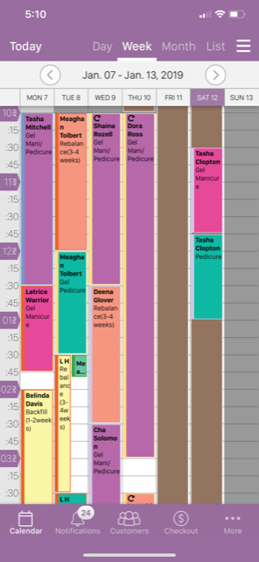“Appointment book”

View the breakdown at the top (Day, Week, Month, List)

The view from the mobile and website should be color coded. Any service set should have the option of color coding by the professional during set up as well as min or hours. This way at glace the know what the appointment is and how long it will take. The thin lines on the side of the side of the appointments have meanings as well (confirmed, Standing, need approval.)

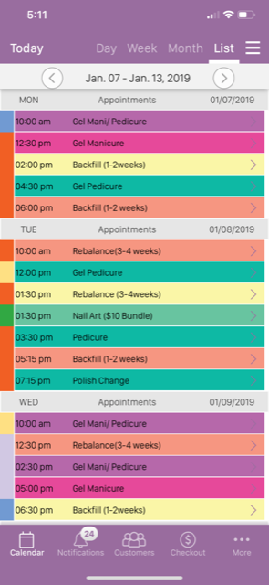“Appointment book Continued”

The List view... Still color coded just in a simple listed form.

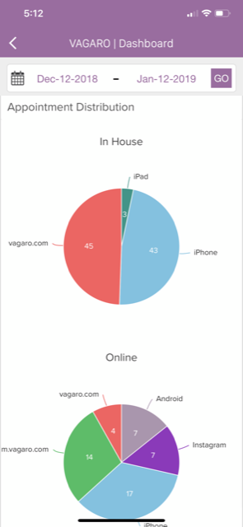

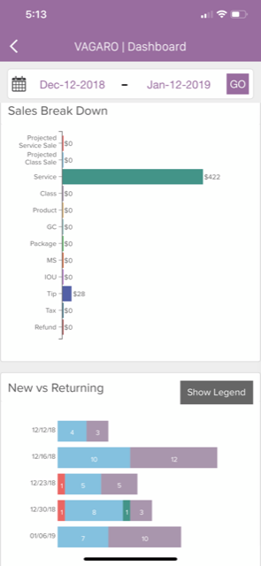 GS= Gift certificates …MS will become Coupons… No IOU…

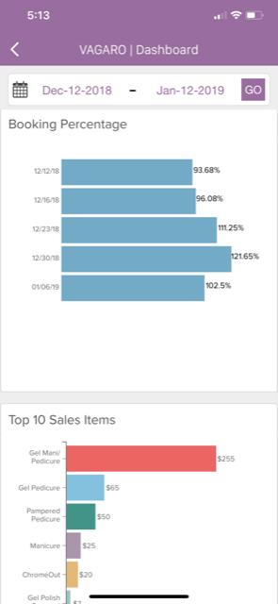

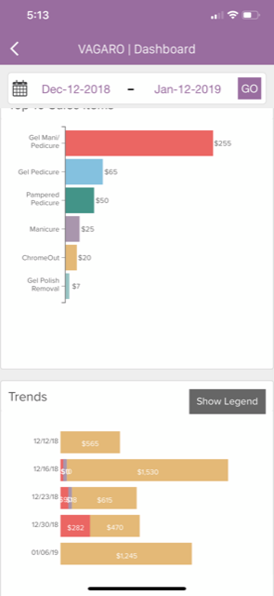

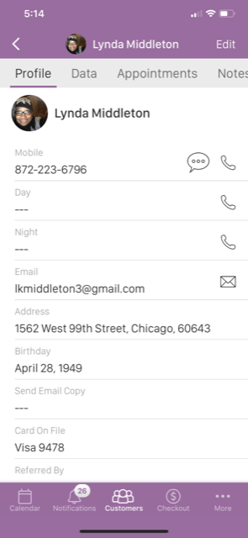Clients profile

when the clients picture is touched with upcoming appointments their Profile should show

At the top of the page

(Profile, Data, Appointments, Notes)

You can see the profile and the ability to call from a phone link.

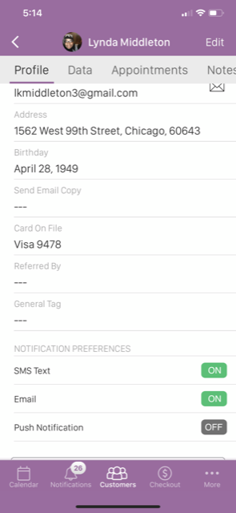We NEED Notification preferences

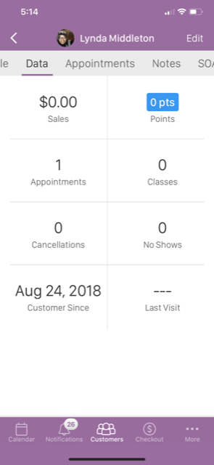 Make sure they can change the customer start date if need be.

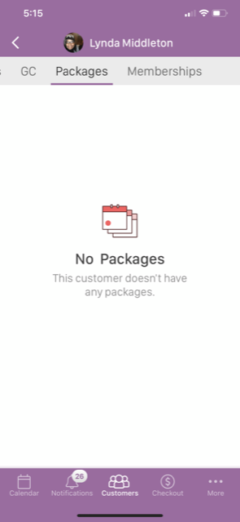You also see checkout. So below this pic you will see there is an option that the professional has to push Arrived. Once that is pushed they will be able to “cash out” the client for the service. If they received extra services they can add them on at the time b4 checkout.

There is also a “no show” button. If that button is pushed after a time frame chosen by the professional a fee will be charged to the card.

Needs a clear terms link on the page. Also each email sent to the clients when making the appointment should say PLEASE READ THE TERMS AND CONDITIONS OF THIS PROFESSIONAL as they may have changed.

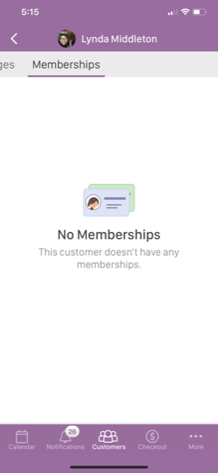

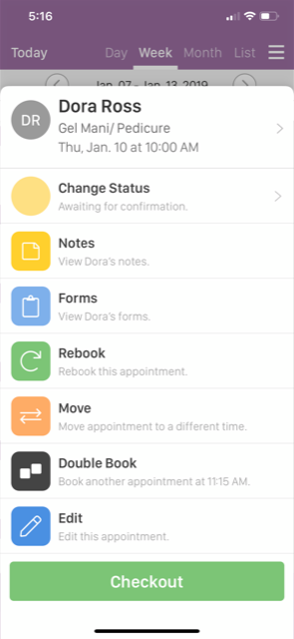

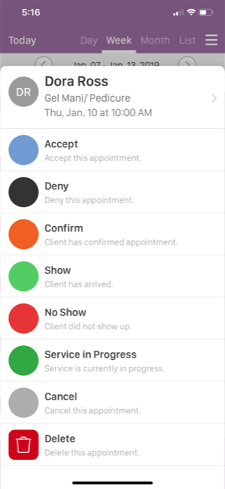 Approval on dashboard… All of these buttons should attach to an email informing the client of what has occurred. It should also tell them to refer to the professional’s page for terms.

1. Directions to location (Bus, Car, Walking)
2. A Service provider list that can only be viewed by other professionals only called “The Providers”. Same Profile Page Just can be seen by the professional and rated by the professional. The will not have the store, classes or jobs links. They will be able to schedule appointments and have the option to get paid for services through the site.
3. “Become a part of my network” At the bottom of the page profiles pictures/ links will be of other professionals. All they have to do is request the other Professional by clicking “Become a part of my network and the professional has to approve it. On the bottom of the picture it will say “The Professional (Whatever profession they are in) in (Whatever state they work).
4. Multiple staff booking for businesses