*Certification Name:*

Jenkins, From Zero To Hero: Become a DevOps Jenkins Master

*Tools*:

1. Jenkins
2. Docker
3. GIT
4. AWS
5. Ansible
6. Maven

*Learning outcomes:*

1. Learnt what is Jenkins and how it works in depth.
2. Learnt how to integrate Jenkins with Docker, Ansible, AWS, GIT, Email, Maven and more.
3. Learnt how to create docker images and run them as containers.
4. Learnt how to design and build your own Jobs with a bunch of tools.
5. Learnt Continuous Integration and Continuous Deployment.

As part of POC implemented following:

1. Installed CentOS on virtual machine. Installed docker & docker compose inside a VM.

Pulled latest Jenkins image from docker hub and create a custom image using docker compose. Created a Jenkins container. Configured Jenkins.

1. Created a first freestyle job. Executed a bash script from Jenkins. Modified job using parameterized project.

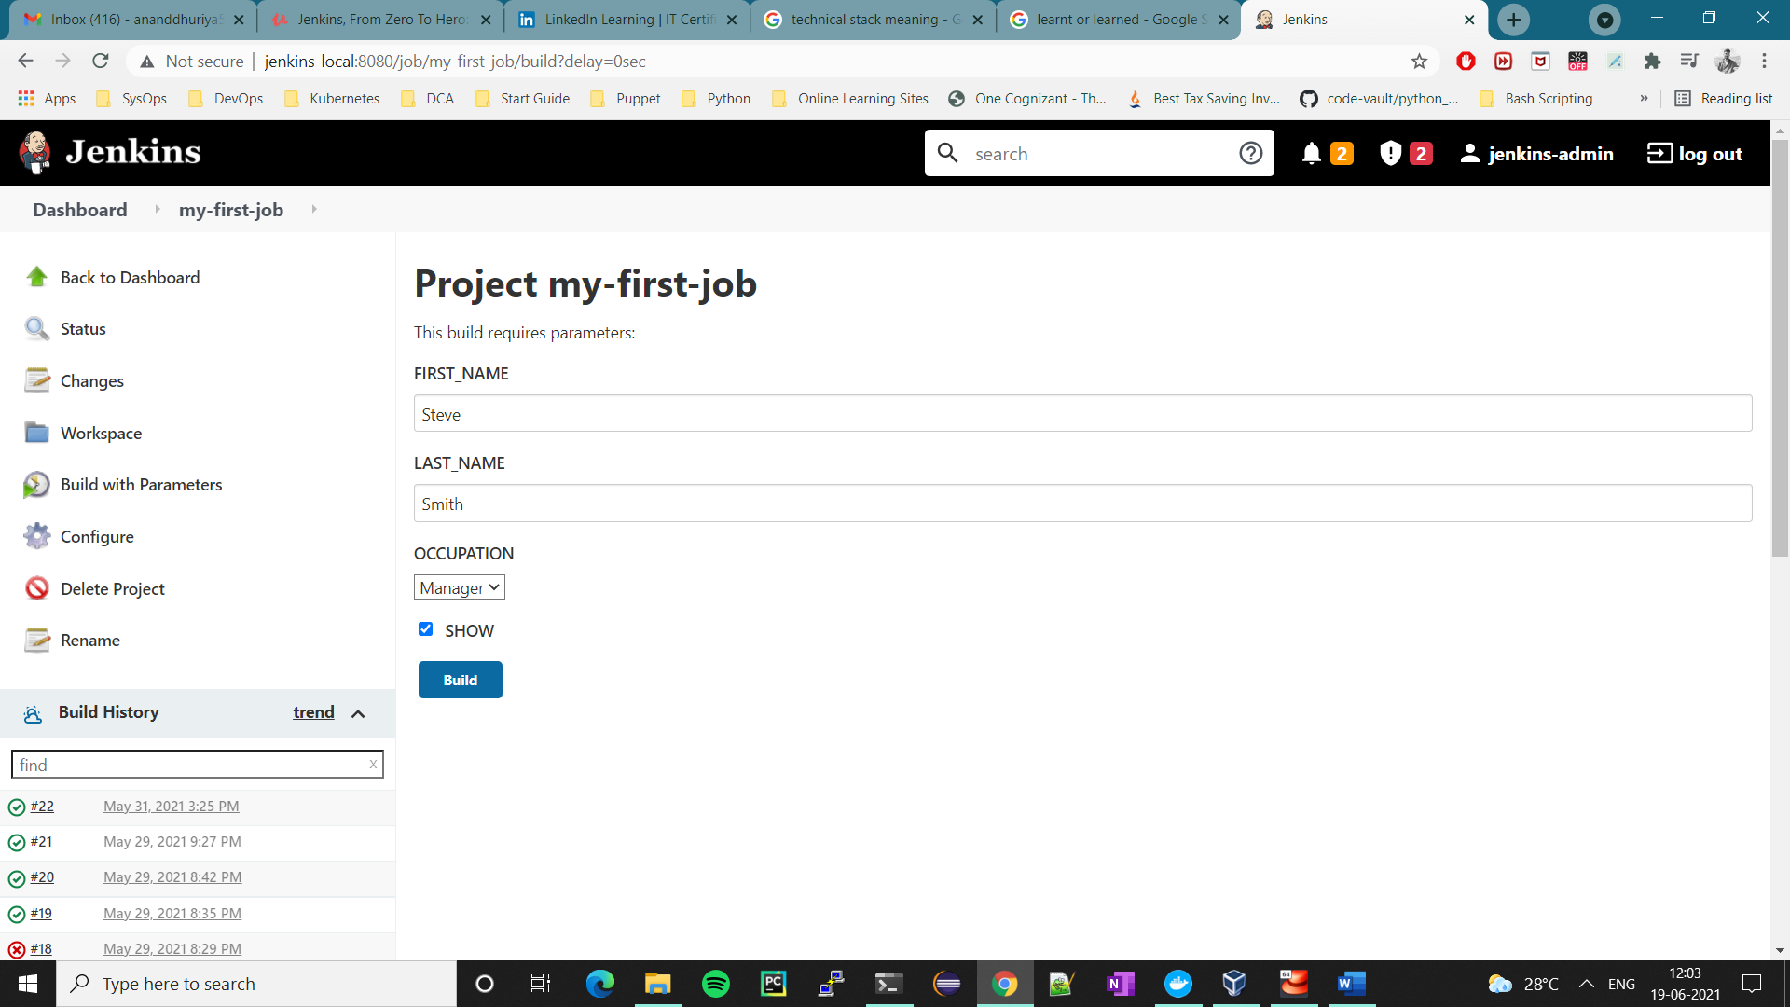

1. Created a CentOS7 based remote host to execute scripts from Jenkins using Docker.

Executed Jenkins jobs on remote host using SSH plugin.

1. Created a database backup shell script and integrated it with Jenkins parameterized project. Based on input parameters job will be connected to specified host then it creates a backup file of specified database and pushed it to specific AWS S3 bucket.

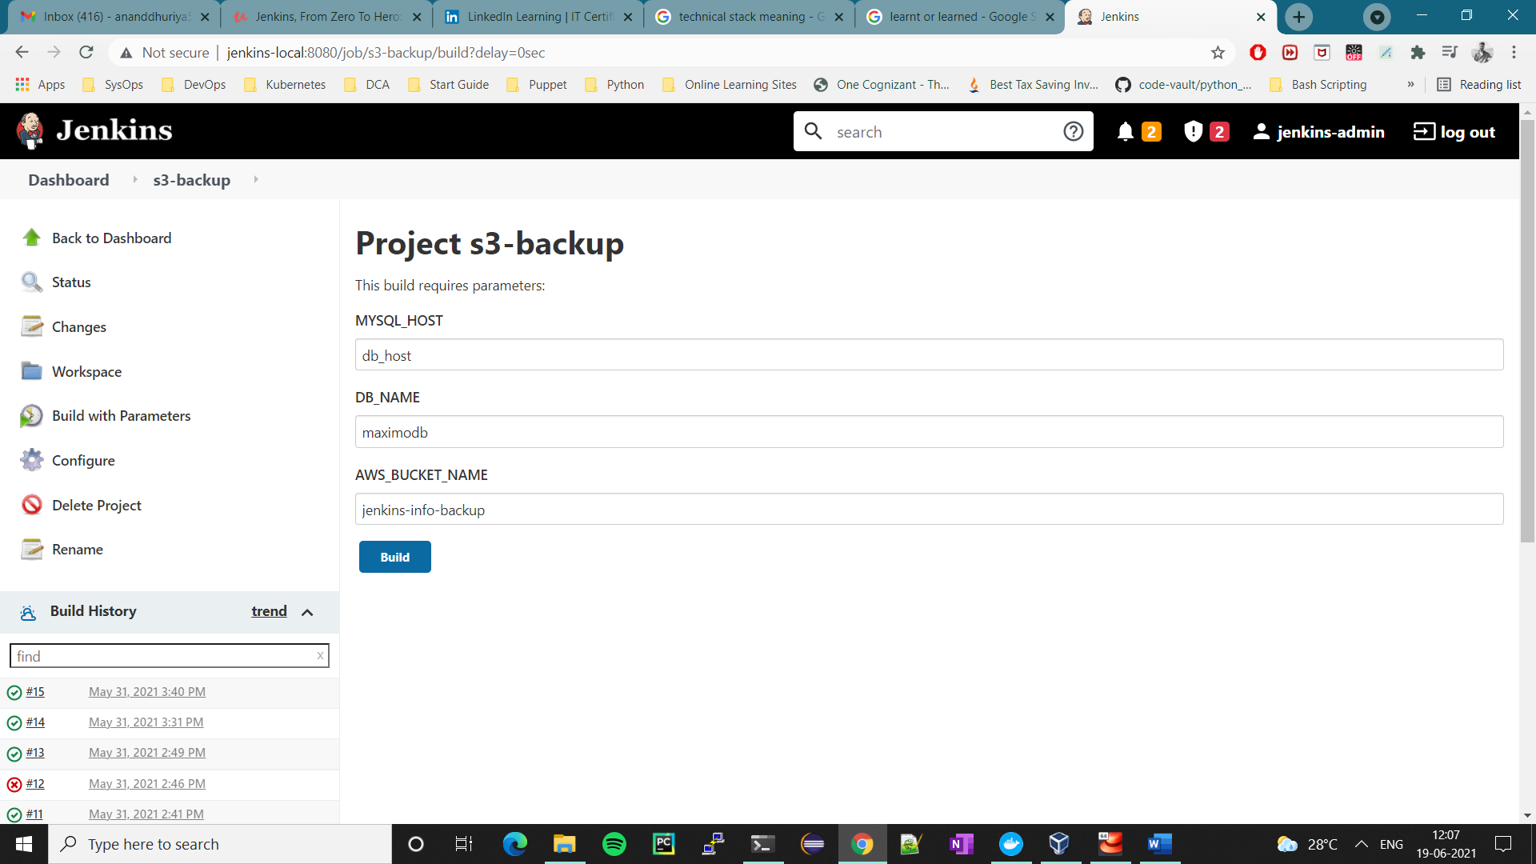

1. Created a simple Jenkins Inventory & playbook. Integrated Jenkins with Ansible. Executed playbooks from Jenkins using parameterized project.
2. Created a Jenkins age based parameterized job using Ansible, MySQL, PHP, NGINX and shell scripting. On successful job build, PHP based web application displays filtered user information based on age parameter. In backend Shell script will query MySQL database using “where age = $age” clause and feeds list of users to PHP based web application.

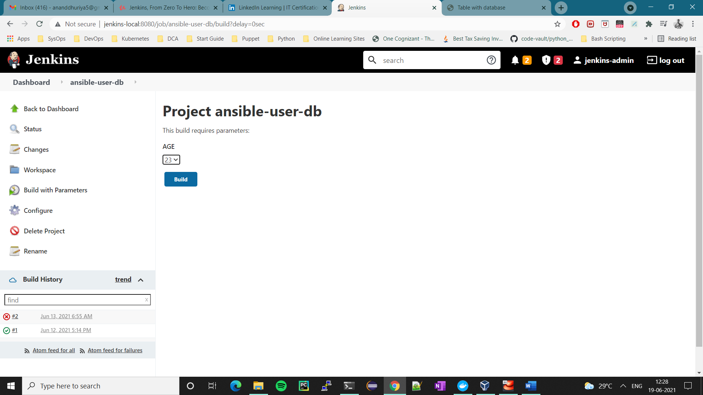

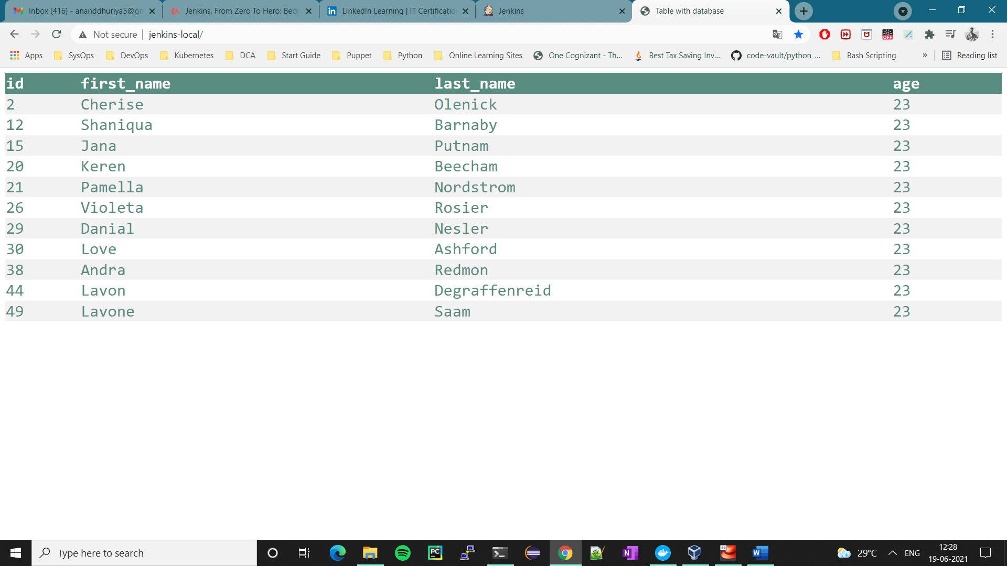

1. Created RBAC (Role Based Access Control) in Jenkins.
2. Scheduled job execution using crons.