# **Automotive: Technology and Trends:**

Table of Contents

Table of Contents 1

Introduction 2

Telematics 3

Infotainment 4

Power-train management 5

Vehicle diagnostics 6

Data security and functional safety 7

Road safety 7

Passenger comfort 8

Lighting 8

Body electronics 9

Instrument clusters 9

Types of Cars 9

By body styles: 9

By length size (from smallest to largest) : 13

By class: 16

Others: 16

What is heads-up display (HUD) for Cars? Learn about the embedded software, device drivers and stacks 18

What are the basic embedded software stacks and drivers of the Car HUD system? 18

Receiving and Making Calls/Messages through HUD system of the car: 18

Instrumentation cluster/Virtual Gauges on Heads-up display 20

Maps and Navigation for driver assistance 20

Texas Instruments (TI) Pico Projector for HUD display 20

12 Design Strategies to develop an ‘In-Vehicle Infotainment’ System 20

Principles of in vehicle sensors in case of emergency 21

# Introduction

#### [Electronics is being used in vehicles for safety and security, infotainment, networking, power train and engine management, and more. Rapid advancements in sensor technology, microcontrollers, wireless communications, embedded systems, etc. are opening up a gamut of new challenges and opportunities in this space](http://electronicsforu.com/technology-trends/st-releases-embedded-developing-tools-osx).

Today’s cars are becoming more fuel-efficient and safe, and have more stability because of electronics systems. Features like multi-camera surround-view parking assistance, blind spot detection, RADAR systems that support adaptive cruise control, pre-crash protection and collision warning systems with and without automatic steering and brake intervention, lane-departure warning system and people-detection camera are becoming common. Lately, some of these features have become a must-have for many high-end cars not only globally but also in India. A lot of cutting-edge electronics goes into auto infotainment (navigation, music systems etc), electronic control such as anti-lock system, stability, transmission, fuel injection, emission control, air bags, emergency-brake-assist system, driver assistance systems and passenger comfort. Processors such as ARM’s Cortex family are used for such applications.

# 

# Telematics

[NXP sees two major trends that are currently dominating developments in automotive space—connected mobility and carbon dioxide emission reduction. Electronics is the key enabler for both the trends. Connected mobility will improve safety, increase convenience and facilitate customised entertainment while on road. Various high-performance, automotive-qualified technologies will be required in the connected vehicle of the future.](http://electronicsforu.com/technology-trends/st-releases-embedded-developing-tools-osx)Many of the car electronics technologies such as immobilisers (anti-theft devices) are expected to be used in light commercial vehicles and two-wheelers in the near future in India alsoHere is a quick overview of the key electronics systems used in today’s vehicles.TelematicsTelematics is nothing but integrated use of information and communications technologies in vehicles. [The primary applications for in-car and car-to-car communications are location-based services and assisted driving. A combination of technologies such as the global positioning system (GPS), IEEE 802.11p based wireless access for vehicular environment (WAVE) and mobile mesh networking is used to achieve these goals.](http://electronicsforu.com/technology-trends/st-releases-embedded-developing-tools-osx)

Of late, car-to-infrastructure networks such as vehicle-to-toll gates and car-to-traffic lights are also gaining ground. Hence there is a great need for telematics chips that are automotive-qualified and can cater to various functions like GPS, GSM, CAN, NFC, USB and security.

Location-based services include on-demand dynamic navigation and notifications in case of accidents, emergency or stolen car situations. Such systems are based on GPS technology. Assisted driving services include avoidance of accidents, detection of lane violations, traffic signal detection and improvement of traffic flow. In the future, this is expected to extend to driverless driving and unmanned vehicle applications where the destination and the GPS-based roadmap will allow automatic navigation of the car without requiring a driver.

The primary approach for car-to-car communications is to use dedicated short-range radio communication to allow cars to signal one another and receive messages from traffic equipment in concert with the GPS system as appropriate. Scanners and radio receivers are also key components for such applications. The technology preferred for car-to-car communications is IEEE 802.11p—a version of the popular IEEE 802.11 standard. IEEE 1609 (previously IEEE P1556) is the standard for higher-level protocol layers since IEEE 802.xx standards are defined only for layers 1 and 2. These include core system, security and privacy, networking services and channel management. This is commonly called WAVE, and operates in the 5.9GHz dedicated short-range communications (DSRC) band. There also have been recent proposals for use of the standard 3G/4G technologies instead of the 802.11p based approach.

Another recent approach being considered for in-car Internet access or for car-to-car communications is mobile mesh networking. Each car or node reconfigures itself automatically and acts like a relay mobile station. A mobile base station is a wireless relay (transceiver) that can send, receive and forward packets of information. The underlying technology along with the fixed base stations can be the standard 3G/4G or WiMAX technologies.

# [Infotainment](http://electronicsforu.com/technology-trends/st-releases-embedded-developing-tools-osx)

# [Infotainment](http://electronicsforu.com/technology-trends/st-releases-embedded-developing-tools-osx)

Widespread adoption of communications technologies in vehicles has led to the growth of information and entertainment applications such as driver assist systems, e-commerce (online shopping, e-toll and insurance), location-based services, fleet management applications, personalised media delivery and so on.

[Vehicle manufacturers are exploring a variety of technologies including advanced displays, touch screens, speech recognition, personal speaker control, noise cancellation, on-board storage, connectivity with other consumer electronic devices and hands-free control. There is also a lot of effort pumped into integrating all the multimedia options in a car onto a common platform, making it easy to upgrade the operating system, drivers, compilers and applications, enhance cost-efficiency and scalability, and ensure greater security and privacy.](http://electronicsforu.com/technology-trends/st-releases-embedded-developing-tools-osx)

[Processors commonly used in automotive infotainment are from Freescale, Renesas, Texas Instruments, NXP, Intel and ARM. Operating systems used are QNX, Vx Works, pSOS, Embedded Linux, Windows CE, Windows Auto and MS Auto. Automotive infotainment being a vibrant and upcoming space, the industry has come together to bring about a bit of standardisation. Open Source development platform GENIVI, AUTOSAR Open architecture and MOST protocol are results of such efforts that are widely used. Similarly, diagnostic protocols such as the UDF and KWP 2000 are also becoming popular.](http://electronicsforu.com/technology-trends/st-releases-embedded-developing-tools-osx)

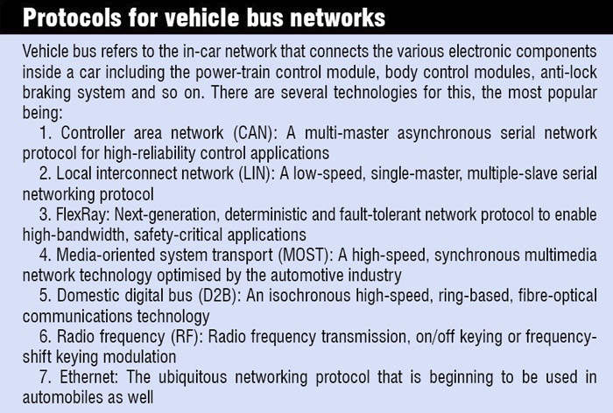

Other common components in an automotive infotainment platform include:

* Hands-free telephony
* Software frameworks
* Connectivity software frameworks
* IEEE 1394 automotive software stacks
* Audio-video decoders and encoders
* Multimedia gateways
* Digital TV technologies like DVB-T/H, ISDB-T
* ATSC/OpenCable
* AV/C General,
* FCP/CMP, IIDC controllers.

Internet applications are set to make a major impact on car drivers and passengers during the next decade as we will undoubtedly witness new and innovative car-centric Internet applications and services. However, there will also be usage restrictions due to driver distraction issues while driving a car. Better interfaces with minimal driver distraction for Internet-based content will emerge in the next few years—some to be enabled by new infotainment systems and architectures. There is also a tremendous impetus coming from the mobile device world, with an explosion of applications related to mobility. Some of these applications will also find their way into cars.

# [Power-train management](http://electronicsforu.com/technology-trends/st-releases-embedded-developing-tools-osx)

# [Power-train management](http://electronicsforu.com/technology-trends/st-releases-embedded-developing-tools-osx)

Power-train of an automobile is concerned with generation, transmission and emission of energy, and includes the engine and transmission, wheels, suspension, drive shaft and exhaust system. It is typically managed using a power-train control module (PCM), which includes engine control and transmission control units. If  [Power-train of an automobile is concerned with generation, transmission and emission of energy, and includes the engine and transmission, wheels, suspension, drive shaft and exhaust system. It is typically managed using a power-train control module (PCM), which includes engine control and transmission control units. If engine is the heart of a car, PCM is the brain. PCM is perhaps one of the oldest applications of electronics in automobiles—although in its early years it was simply called an engine control unit.](http://electronicsforu.com/technology-trends/st-releases-embedded-developing-tools-osx)

Automakers are under increasing pressure from both governments and consumers to improve overall fuel efficiency across their fleet (e.g., the US goal is 54.5 MPG by 2025) and lower polluting emissions. This is achieved by increasingly tight computerised control of the complete engine combustion process.A PCM often includes powerful processors (32-bit), sophisticated control strategies, smart sensors and actuators. It uses various sensors such as oxygen sensor, coolant sensor, mass air-flow sensor, air-intake sensor, crankshaft-angle sensor, throttle-position sensor, camshaft-angle sensor and knock sensor, to monitor the automobile’s working and adjust the air/fuel mixture for maximum efficiency and least pollution.[Making a PCM requires cutting-edge design and development tools for application software development, diagnostics, porting to different platforms, functional testing, re-engineering of legacy code, modelling of sensors, actuators and components, vehicle suspension controls and electronic power steering, calibration engineering, high-level synchronisation and so on. Tool chains like ETAS, INCA Instrumentation, CANAnalyzer, CANDela, CANOe, Pi auto simulator bench and static vehicle simulator, and open-/closed-loop LabCar are used. Protocols like CAN, LIN, J1850, OBD-II, EOBD, UDS and KWP2000 are popular.](http://electronicsforu.com/technology-trends/st-releases-embedded-developing-tools-osx)

# Vehicle diagnostics

A lot of electronics goes into monitoring the health of vehicles. On-board electronics add self-diagnostic and reporting capabilities to modern automobiles. Earlier, diagnostic tools were limited to lighting up relevant indicators to warn the driver, but today’s connected versions provide real-time information to drivers, fleet owners and rescue teams using standardised communication protocols and trouble codes, allowing rapid problem identification and rectification. Most modern tools can relay information to mobile devices.

A combination of on-board diagnostics, handheld scan tools, PC-based scan tools and analysis platforms, data loggers, etc is often used. Apart from the many analysers, scopes and meters installed in the vehicle to monitor engine, battery, air-conditioning, smoke and fluid levels, enthusiastic drivers often go in for additional instrumentation to monitor more parameters. These components are often managed by a diagnostic engine and advanced software controls.

Several standards and tool chains are available for design and development of diagnostic equipment, production testing, remote diagnostic interfaces and application-programming interfaces, etc. On-board diagnostics-II (OBD2) and Open diagnostics exchange (ODX) standards are popular today. These specify a data model to describe diagnostic data, including diagnostic trouble codes, data parameters, identification data, input/output parameters and communication parameters.

# Data security and functional safety

At one point of time, security in a car meant preventing break-ins and more complex locks. But, security has many more dimensions now.

With the tremendous amount of data streaming through today’s vehicles, security has become a necessity for automakers to protect their control systems from software attacks.

Apart from physical intrusion, automakers also need to protect the car from inappropriate manipulation such as car tuning and fake spares. They need to prevent hackers from accessing the various ECUs. New payment methods for parking fees or tolls bring up the need to secure the flow of transactional data. Navigation systems pose a threat to privacy. In short, there are umpteen complex dimensions to automotive security today.

Hence a combination of security solutions including chip cards and identification systems for entry control, hardware and software security modules to prevent unauthorised access to the engine control unit, tamper detection to protect against unauthorised code changes, power modifications and emissions tampering, and advanced network security to protect streaming data is used to protect a vehicle. Crypto and authentication chips, such as those offered by NXP, can bring the credit card or electronic passport level of security to cars.

ISO 26262 standard helps enforce functional safety requirements in today’s automobiles. It not only helps design safe products but also set up appropriate processes for developing such products. It is being increasingly adopted by automotive system developers.

# Road safety

Features such as airbags and stability control systems, adaptive cruise control, anti-lock braking system, lane-departure warning, tyre-pressure sensor systems, panoramic rear-view aids, traffic light recognition, collision detection, electronic steering and chassis domain control are used in various combinations to improve passenger safety.

Such safety mechanisms involve a complex interplay of intelligent sensors, microcontrollers, automotive power standard products, application-specific standard products, highly-integrated customised application-specific ICs (ASICs), cost-effective system-in-package (SiP) solutions and more. Plus, there are protocols such as PSI5 and DSI to be complied with.

The facility of e-call is being adopted by many automakers today. This technology automatically alerts emergency service providers to the location of an accident. With inter-vehicle communication, Ethernet-based parking-assistance solutions, crash-avoidance technologies, intelligent sensors for car battery monitoring, blind-spot detection, night vision and more, the industry is gearing up to the challenges and coming up with solutions that will have an overall impact on the safety of passengers

2012 witnessed all cars having mandatory electronic stability control (ESC). ESC is the most significant safety feature since three-point seat belt. Another feature called intelligent speed adaptation is used to inform the driver about the speed limit for the road he is driving on and automatically reduce the vehicle’s speed. The technology can very well benefit our country where every day one hears cases of high-speed collision with stationary vehicles on expressways

# Passenger comfort

Apart from Internet connectivity and the accompanying infotainment applications, automatic temperature control, personalisation of preferences, high-end displays, individualised media delivery, integrated display panel and electronic control for recliners are some of the features that contribute to passenger comfort in high-end automobiles.

# Lighting

With the growing popularity of light-emitting diodes (LEDs), electronic components are beginning to play a huge role in lights as well. LEDs add an element of intelligence to automotive lighting. High-intensity discharge (HID) lamps provide up to three times more illumination than conventional halogen headlamps while reducing power consumption by roughly 30 per cent. These feature auto-levelling to reduce glare and improve visibility, and brightness or intensity adjustments according to ambient light. They are also more energy-efficient than previous technologies.

# Body electronics

Body electronics addresses a range of applications inside vehicles, including door, window and seat control, entry control, HVAC, lighting and so on. Several electronic components and sensors including a body control module, a central gateway, networking and communications technologies such as CAN, FlexRay, LIN and SAE J2602, 8-, 16- and 32-bit microcontrollers, motor control kits, and a broad range of analogue devices for power management and power switching are used. Special design, development and testing toolkits are used to design body electronics in an integrated and standardised fashion.

# Instrument clusters

Simply put, instrument cluster is the dashboard that the driver sees. The goal of instrument cluster is to provide reliable and real-time information that assists the driver. The in-vehicle network is used to draw information from the various ECUs embedded across the vehicle.

Today’s information clusters are far from the simple mechanical meters of yore. These are completely digital panels built using low-power, automotive-grade embedded systems. They employ high-resolution displays, high-performance 2D/3D image rendering, turn-by-turn navigation, dynamic human-machine interface that can be adapted to day and night conditions, information gateways and in-built security features. Most instrument clusters are reconfigurable, allowing the driver to choose from different preset configurations. For example, the driver can choose to view the data in traditional gauge format or in a trendy new fashion. Some vehicles even allow new formats to be downloaded as applications from the Internet.

# 

# Types of Cars

## By body styles:

**-Sedan** - A type of car in which the cargo area is located behind the rear pillars of the car, often separated from passenger cabin. Compared to hatchbacks, sedans have better protection for the cargo against theft due to the lack of glass window.

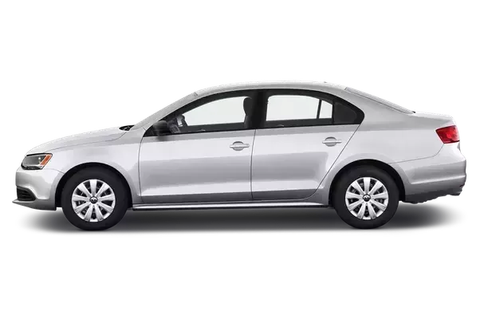

**-Hatchback** - A type of car in which the rear cargo door swings up when opened. The rear window exposes the content of the cargo space, but can be covered up using mat. Traditionally, hatchbacks are usually taller than sedans with taller roof and taller driving position. With the seats folded, the cargo space can be linked with passenger room, creating a larger cargo space. Hatchbacks have shorter cargo length than sedans but in exchange they have superior height.

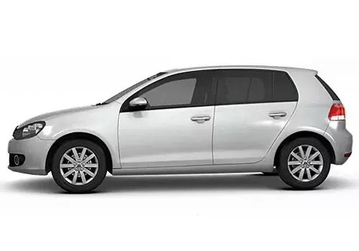

**-MPV/minivan** - Minivans are bigger sized hatchbacks that often come with third row seats (6–8 seats). The main emphasize is on cabin space, which is why it’s often associated with family cars.

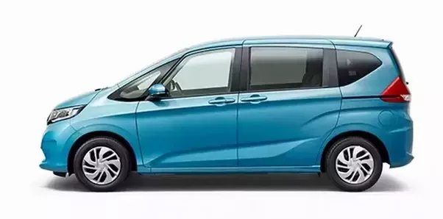

**-SUV/4X4** - SUV is a type of car that emphasize on off-road capability. They are characterized by the tall ride height, boxy body shape (to make it easy to look around), tall bonnet (to see the distance between bonnet and object ahead), and most importantly, they use ladder frame chassis, which is also found in trucks. Ladder frame chassis is heavier than the usual monocoque chassis but has an advantage on off roading.

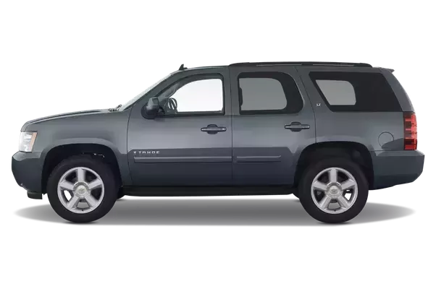

**-CUV/Crossover** - Often mistaken as SUV, CUV/crossover is probably the most confusing type of car. Some CUVs resemble the design of SUVs, but what makes it different is the chassis. SUVs use ladder frame chassis like trucks, while CUVs use the lighter monocoque chassis like sedans and hatchbacks. They are taller than hatchbacks, but not as spacious as minivans.

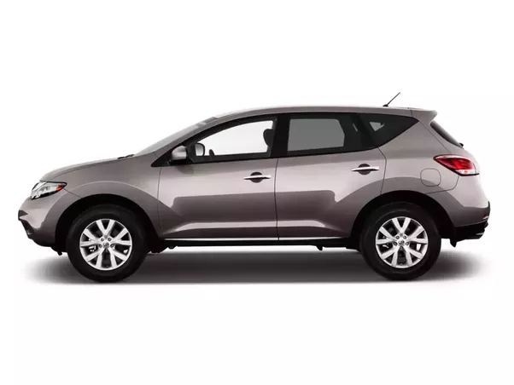

**-Pickup** - Pickup is type of car in which the cargo is separated from the passenger cabin and has an open cargo bed, which can be closed with mat. The open cargo bed allows unlimited vertical space.

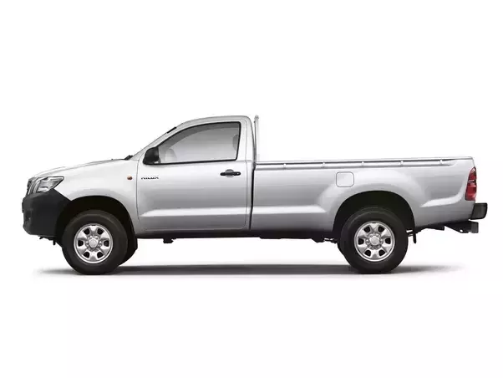

**-Coupe** - Coupes are basically cars with 2 doors. It can be based on sedan or hatchback.

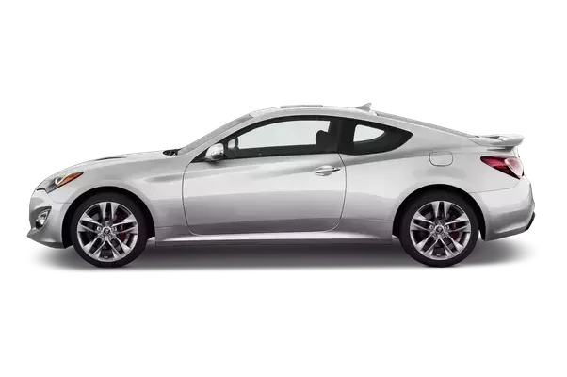

**-Convertible/spyder/cabriolet** - Convertibles are cars that can fold its roof out, allowing passengers to interact with outdoor wind.

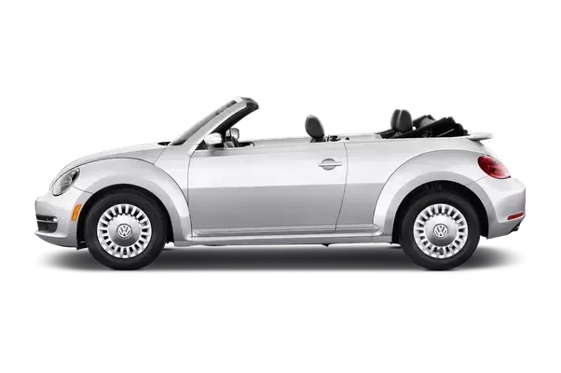

**-Station wagon/estate** - They have longer cargo length than sedan (or equally to sedan) with hatchback style cargo door. Station wagons are often a variation of an existing sedan/hatchback.

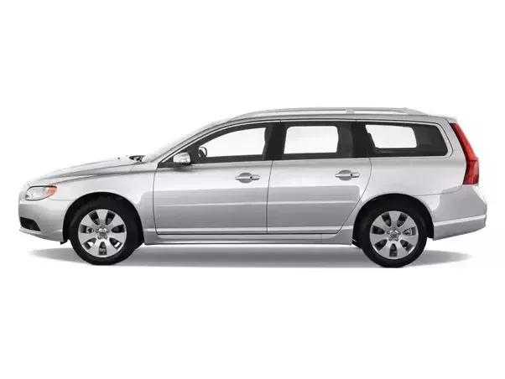

## By length size (from smallest to largest):

**-Micro** - The smallest size category for cars is micro. They are extremely small and can only fit 1 person. They are extremely rare because the size is not practical.Examples : BMW Isetta, Corbin Sparrow, Heinkei Kabine.

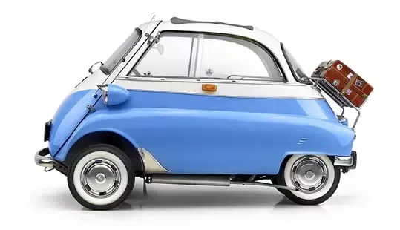

**-City car/kei car/A-segment**- They are considered small in most countries. In exchange for the short length, they often have tall height to maximize space. In Japan, there is a size category called Kei cars. Kei cars are made to avoid size taxes and insurance cost. Examples : Smart fortwo, Suzuki Wagon R, Volkswagen Up, Ford Ka.

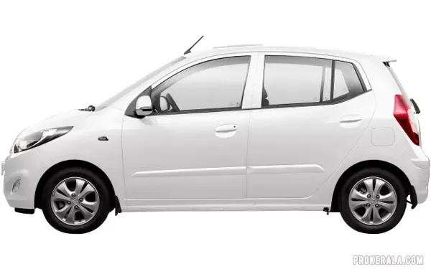

**-Subcompact/super mini/B-segment** - The most common size for cars in developing Asian countries, which is considered a decent size. Examples : Toyota Yaris/Vios, Honda Fit/Jazz/City, Volkswagen Polo, Ford Fiesta.

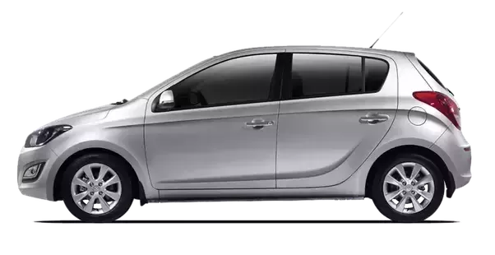

**-Compact/small family car/C-segment** - The most common size for cars in developed countries. They are spacious enough for groceries and family. Examples : Toyota Corolla, Honda Civic, Volkswagen Golf/Jetta, Ford Focus, Mercedes-Benz C-Class, BMW 3 Series.

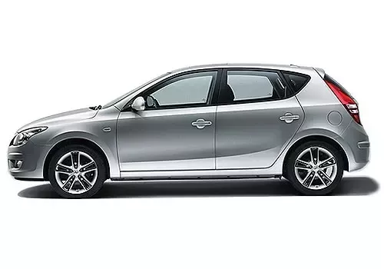

**-Mid size/large family car/D-segment** - Usually for family need, but some benefit from their engine size and cargo space. Examples : Toyota Camry, Honda Accord, Mercedes-Benz E-Class, BMW 5 Series.

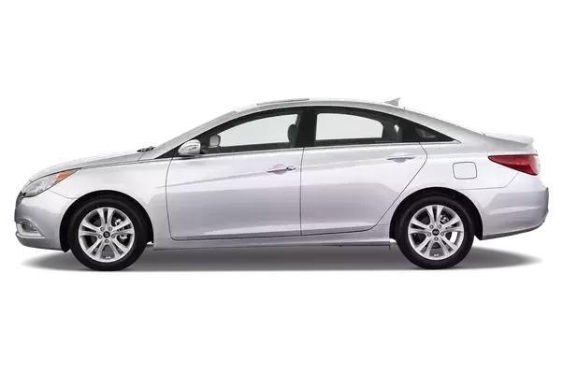

**-Full size** - Considered the longest size for those who need for space or simply want the premium of extra space. Examples: Toyota Crown, Honda Legend, Mercedes-Benz S-Class, BMW 7 Series.

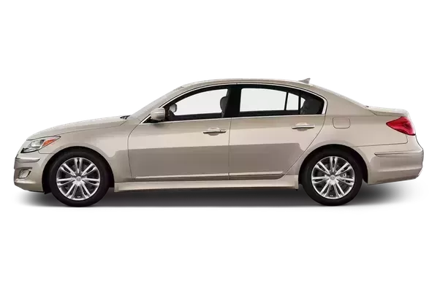

## By class:

**-Economy**- The most basic class for mainstream needs.

**-Executive/luxury**- Have superior features and quality above economy cars.

**-Supercar** - Sportscars that are faster than average sportscars.

**-Hypercar** - Faster than supercar (usually they are some of the fastest production cars of their time), but sometimes hypercars are also called supercars.

## Others:

**-Sportscar** - A type of car that emphasize on performance. Body style is traditionally coupe or convertible, but a sedan or hatchback can also be a sportscar. The requirement to become a sportscar is very subjective. Usually the must exceed certain horsepower depending on the era.

**-Hot hatch** - Hatchbacks that have sportscar performance and handling.

**-Limousine** - Cars that have a stretched length, either to accommodate more passengers or to increase legroom.

**-Ute** - Sedan/coupe/sportscar with pickup bed and sportscar performance.

**-Personal luxury** - Full size coupes.

**-Muscle car** - Mid size sportscar that emphasize on power over handling for saving cost.

**-Pony car** - Like muscle car, but compact size. Sometimes pony cars are also classified as muscle cars.

**-Sports sedan** - Sportscar with 4 door sedan body.

**-Racing car** - Cars that are either designed or modified to go racing ; often sacrifice comfort for the sake of performance and lighter weight.

**-Grand tourer** - 2 door sportscars that are designed to be comfortable for long trip with extra 2 seats at the back and a relatively spacious cargo space.

Modification Styles

**-Hotrod** - A modification style in which the car receive different engine (usually V8). Most hotrods are based on pre-war American cars. Some common features include visible engine from the outside and exposed tires.

**-Ratrod** - Basically hotrod with rusty/old appearance. The body paint is often matte finish.

**-Low Rider** - A modification style using full size American cars from the 60s-80s. Often feature complex details and low ride height. The signature feature is hydraulic suspension system, allowing independent suspensions to adjust the height, creating an impression that the car is dancing. Chrome grille and chrome wheels are very common as well.

**-JDM** - Japanese-inspired modification that focus on performance and handling. They often come with big spoiler and big bumpers.

**-Bosozoku** - Japanese modification that reflects a gangster lifestyle, characterized by the extreme size of exhaust pipes and bumpers.

**-Cal looker**- A modification style with Californian beach theme. Volkswagen Beetle is usually the popular choice.

**-VIP Style** - Japanese style modification that reflects modern luxury lifestyle. The cars are usually full size luxury sedans with large chrome wheels, large bumpers, low ride height, and wheel camber angle that are pop out.

**-Drifter** - Cars modified for drifting stunt.

**-Rally** - Cars modified for rally motorsport, or simply for recreational driving on dirt.

**-Dragster** - Cars modified for drag race (straight line race).

**-Off-road** - To improve off-roading capability.

**-Military** - Same as off road, but more military themed.

## Engine layouts :

**-Front engine layout** - Engine located at the front of/above front axles. Found in most cars.

**-Mid engine layout** - Engine located between the front and rear axles, creating a more balanced weight distribution.

**-Rear engine layout** - Engine located on back of the rear axles. It used to be popular in economy cars, but not anymore. Rear engine layout’s centre of gravity makes it very hard to control. Today, only Porsche 911 use this strange layout and it attracts certain fans.

# What is heads-up display (HUD) for Cars? Learn about the embedded software, device drivers and stacks

According to a report recently released by Credence Research, the automotive head-up display (Car HUD) market is expected to reach US$ 2.09 bn by 2022, expanding at a CAGR of 24.3% from 2015 to 2022.

This report also identifies the HUD market as highly technology-driven where manufacturers are required to make substantial investment in R&D.

Our Embedded Automotive team has developed a proprietary software and hardware design for Car HUD. This being a production-ready design you can launch your HUD display product in 6 months (down from industry average of 2.5 years) and hence reduce the R&D costs and efforts.

We spoke to our automotive embedded software team who has designed this innovative product to understand the basic software components of an HUD for cars.

## What are the basic embedded software stacks and drivers of the Car HUD system?

This embedded HUD system is built on Android Kitkat version 4.4.3., powered by Linux kernel 3.10.53 with Universal Boot Loader.

The Board Support Package (BSP) is developed on Ubuntu 12.04. The HUD embedded system is ported with essential drivers like USB 2.0 OTG drivers, SD and NOR memory drivers, HDMI driver, Keypad driver, Audio Codec drivers and more

## 

## Receiving and Making Calls/Messages through HUD system of the car:

The Phone App in our Car HUD displays call/message info on the head-up display combiner or car windshield. The cell phone’s contact list can also be accessed through In-car HUD.

The driver can make or receive calls and messages by touch-less commands (voice recognition and gesture control features)

The BlueZ stack and essential BT (Bluetooth) drivers have been integrated in this embedded system to support the phone app features.

Android has in-built support for following BT profiles that facilitate device access and data transfer:

* Advanced Audio Distribution Profile (A2DP)
* Device ID Profile (DIP)
* Hands-Free Profile (HFP)
* Message Access Profile (MAP)
* Phone Book Access Profile (PBAP, PBA)
* SIM Access Profile (SAP, SIM, rSAP)

‘Touchless command’ – Voice Recognition and Gesture Control

To ensure driver safety and mitigate driver distraction while driving, our Head-up Display (HUD) design is armed with voice recognition and gesture control features

To enable the gesture control feature, our embedded software team has expertise in integrating either an Infrared (IR) camera or a gesture control sensor as per the requirement

Pocket Sphinx, a third party library for processing voice commands has been integrated for the voice recognition feature

Other third party stacks like Google VR or Nuance can also be integrated as per the application or use-case requirement

Wi-Fi cameras activated with reverse gear and left/right indicators

This heads-up display for cars is integrated with 3 IP-based Wi-Fi cameras. When car activates the reverse gear or turns on left or right indicators, these wifi cameras are switched on.

The cameras capture the rear or left/right view outside the car and display the same on HUD windshield display or the HUD combiner display through projector.

To enable this feature, Wi-Fi 3rd party drivers have been ported and Android Hotspot feature is integrated. Also, camera drivers are ported.

To fetch vehicle data, CAN drivers have been ported and an application to communicate with has been developed.

The turn-by-turn directions feature for the driver assistance in the HUD works in the following way:

* The OBD II application identifies if the reverse gear or left/right indicator has been activated by the driver
* The respective IP-based camera is then activated by parsing the username and password through the url of the corresponding wifi camera
* Images captured by the wifi camera are then sent to the car HUD system with the help of CAN in-vehicle network
* These images are displayed either on the HUD windshield or on the combiner display

## Instrumentation cluster/Virtual Gauges on Heads-up display

Depending on your target audience and use-case requirement, the vehicle data available from the OBD-II port (vehicle speed, battery management, fuel data and more) can be displayed on the virtual instrumentation cluster on the HUD in-car system

The OBD II data is captured by the OBD application interface. This data is then sent to the Car HUD system through CAN drivers

Visual alerts are displayed on the HUD windshield or HUD combiner when the driver exceeds speed of 90kmph (this can be modified as per your requirements)

## Maps and Navigation for driver assistance

This feature also provides assistance to drivers and helps reduce driver distraction. The location map and destination driving navigation are displayed on the HUD system

Sygic Maps stack has been integrated and the required drivers and interfaces have been developed

## Texas Instruments (TI) Pico Projector for HUD display

interface and drivers have been developed to send data from the car HUD to the projector.

platform sends data in RGB format to DLP, which can project the data at a maximum resolution of 864×480

# 12 Design Strategies to develop an ‘In-Vehicle Infotainment’ System

Smart phones loaded with apps, since inception, have changed the way we consume information & stay connected with each other.

This need to stay connected & consume information is felt by users even while driving their vehicles.

OEMs’ and Tier-I suppliers responded to this need with [‘In-Vehicle Infotainment (IVI)’](http://www.embitel.com/product-engineering-2/automotive/infotainment) system. However, soon it has come to their realization that now the rules of Consumer Electronics/Smart-phone experience also apply to the In-Car experience.

A user demands an intuitive HMI/GUI, a responsive touch-screen, over the air updates and seamless integration of apps (installed on his/her phone) in an IVI system. In addition to this, minimizing driver distraction & ensuring maximum driver safety is a top priority for an OEM or a Supplier.

All this makes designing a winning IVI system an interesting challenge! So, here are the 12 design strategies to develop an IVI system that can help you deliver an experience that your consumers deserve:

* In an IVI system it is essential to provide surround view to the driver for driving & parking assist, hence support for multiple (up to 4) cameras is a must. Design middleware and application that support switching between multiple cameras and streaming of data from multiple cameras
* For a super-responsive and an intuitive IVI experience, best practice is to develop a Framework (a library project) which is loaded with all the common functions (API) that can be called by different IVI applications. This makes the entire IVI system very light & highly responsive
* To suit the vehicle environment & in-car user experience, customize the look and feel of the screens to display most important information to the user such as weather, date & time, traffic alerts, and other alerts from the vehicle at all times. Add voice recognition feature and easy way to activate this feature to minimize driver distraction
* Customize the Boot Animation & Boot Images as per the logo & branding requirements of the OEM and/or Supplier
* Depending on the geography of your target Audience, identify the Third Party Apps or deploy apps developed in-house that enhance user experience. For example, apps for navigation, finding nearest fuel station, finding nearest service station, emergency contact service, weather, internet streaming of multimedia and more
* For an intuitive user experience, integrate various sources for multimedia streaming like mass storage devices (USB, CD.), radio sources (AM, FM, WB, XM or DAB), streaming through BT or Wi-Fi, internet streaming and connectivity to Apple devices in a single application
* An Infotainment system also serves users with critical vehicle data. Develop middleware and applications that provide access to vehicle information available on CAN network to the user in the form of graphical interface as well as text based warnings/alerts
* An IVI system also plays a significant role in mitigating driver distraction. With the help of Bluetooth communication driver can respond to or make a call, read message, stream music and more. All necessary Bluetooth profiles along with application must be integrated in IVI system
* To deliver a connected life-style experience the user (and the vehicle/fleet) should be connected to the external world (internet). Include support for connectivity through tethering, Wi-Fi and telematics in the IVI system
* GPS plays an important role in navigation. Include middleware and applications necessary for navigation and other location based services
* Develop and build intelligence in the system to act according to different states of the vehicle such as moving, at rest and parking mode
* Develop and build strategies to help OEMs’ and/or Suppliers with certification and secure installation of the applications in IVI system. This enables individual user or fleet owner(s) to deploy applications of their interests in a safe and secured manner

# 

# Principles of in vehicle sensors in case of emergency

This feature works on the principle that the in vehicle sensors would detect an accident and in turn activate the in-vehicle eCall system which would establish a voice connection directly with the relevant PSAP (Public Safety Answering Point).

The eCall can be generated either manually –by the vehicle occupants- or automatically via activation of in-vehicle sensors when an accident occurs. When activated, the in-vehicle eCall system sends a minimum set of data (MSD) – including key information about the accident such as time, location and vehicle description – is sent to the PSAP operator. It is built on the SST230 Micro-controller core platform and uses the IAR/ CodeSourcery GNU TOOLCHAIN. Furthermore, it is an embedded product engineering solution with in-built network access device(NAD). For connectivity it has in built SIM and In-band data modem solution for sending MSD. For uninterrupted connectivity it comes with its own backup power supply. It has GPS, Bluetooth and CAN integrated.