Diagnostics Services with AUTOSAR and UDS Diagnostics

Contents

Contents 1
Introduction 3
Basic Diagnostics 3
First steps 3
Important Definitions: 3
Important Documents for Diagnostics development: 4
AUTOSAR and Diagnostics Software Modules 8
Diagnostic Communication Manager(DCM) 9
Diagnostic Event Manager(DEM) 16
Function execution time 17
Request Response Format: 17
CDD Integration and Vector tools 17
Important terms: 17
Security Access handling 27
Diagnostics logs: 29
Frame log: 35
CAPL 36
CAPL Program Organization 36
CAPL Variables 36
Expressions in CAPL 37
The Key Word this 37
Event Message Transmission 38
Periodic Message Transmission 38
Conditionally Periodic Message Transmission 38
Handling of Run-Time Errors 38
Declaration of Messages 39
CAPL Event Procedures 39
Diagnostics Panels(Sample panels for understanding purpose only) 40
Sample code(for understanding purpose only) 45
UDS, CANoe, CAPL FAQs 48
What are the different variants of CANoe? 48
What is the difference between Environment and System variables in CAPL? 49
What is J1939/21 Transport Protocol? 49
What is J1939 software stack? 49
How many bytes of data J1939/21 transport protocol support? 49
How Transport Protocol supports Connection Mode – point to point data transfer? 50
How Transport Protocol (J1939-21) supports transfer of Broadcast Announcement Message (BAM)? 52
What is SAE J1939? 53
What is J1939 stack? 53
What is Diagnostic Trouble Code (DTC) in J1939 stack? 54
What are Diagnostic Messages (DM) in J1939 software stack? 55
What does a Diagnostic session describe? 55
What is a default session? 55
What is a Programming session? 55
What is an Extended session? 55
What is Hard Reset? 56
What is Soft reset? 56
Why diagnostics? 56
ECU configuration immediately becomes active, no reset required. 56
What is Functional and Physical addressing? 56
What is Network transport layer in Diagnostics? 56
What is Direct and indirect memory access? 57
What parameters does Diagnostics receive for monitoring and executing diagnostics services and DTC? 57
Write short note on 2F service? 57

Introduction

Diagnostics is used to configure, maintain, support, control and extend an ECU before or after it is installed in a system, e.g. here a vehicle. Diagnostics is usually performed in a request – response scheme: a tester (client) sends a request to an ECU (or even more than one ECU) and the ECU (server) responds by sending a “positive response message” containing the requested information, or a “negative response” indicating the reason for the negative response.

Basic Diagnostics

Using Basic Diagnostics, you can exchange diagnostic information with an ECU also without a Diagnostic Description (CDD/ODX/MDX).
You can describe simple diagnostic services (UDS & KWP) with the Basic Diagnostics Editor and afterwards send/receive the defined requests/responses on CAN, LIN, FlexRay, K-Line and via DoIP using the Diagnostics Console, CAPL and in CAPL test modules/ test case libraries. Additionally, CANoe/CANalyzer supports symbolic interpretation of the Basic Diagnostics services and their parameters in the Trace window. For simple applications, Basic Diagnostics thus represents an extension to the process-oriented approach with CANdela Diagnostic Descriptions. In order to use Basic Diagnostics, you need to add a “Basic Diagnostics ECU” (KWP or UDS) to the CANoe diagnostic configuration. Outside of the measurement, you can now define/modify the diagnostic services in the Basic Diagnostics Editor and commit them to the Diagnostics Console. Saving the CANoe configuration also commits these changes. After the measurement starts, you can call the services in the Diagnostics Console, in CAPL and also in CAPL test modules/ test case libraries. On the same network, you are able to work with ECUs configured using Diagnostic Description files as well as with multiple Basic Diagnostics ECUs at the same time. The TP parameters of these control units must be different though.

First steps

The diagnostic features in CANoe may be used for either tracing diagnostic communication on the bus or for acting as a diagnostic tester (via the Diagnostics Console or via CAPL). Furthermore, they provide capabilities for simulating the diagnostic services of an ECU. All these use cases demand that a Diagnostic Description (a diagnostic database) is used, and it may be necessary to use the ISO TP DLL (or a different TP implementation) to transfer data.

Important Definitions:

Unified Diagnostic Services | Unified Diagnostic Services is an industry standard diagnostic communication framework.
Tester | A system that controls functions such as test, inspection, monitoring, or diagnosis of an on-vehicle electronic control unit and may be dedicated to a specific type of operators (e.g. a scan tool dedicated to garage mechanics or a test tool dedicated to assembly plant agents). The tester is also referenced as the client.
Functional/ Physical Addressing | A device is considered to be physically addressed if the Destination address is the address of the device. It is considered to be functionally addressed if the destination address is the broadcast address.  The diagnostic requests for it will be sent using the transport protocol parameters for functional requests so that all ECUs which react on this functional request will send responses. The responses received from the ECUs will be processed individually in the tester, and the interpretation will be based on the concrete Diagnostic Description for each ECU
Aging | A process whereby certain servers evaluate past results of each internal diagnostic to determine if a confirmed DTC can be cleared from long-term memory, e.g. in the event of a calibrated number of failure free cycles
Monitor Cycle | If ignition changes from OFF to RUN state it will be taken as a new monitor
CDD | CANdela Diagnostic description. CANdela Diagnostic Descriptions (CDD) files are databases for diagnostic data, comparable to the .dbc-file used for CAN messages and signals. The CDD files are created in the Vector tool CANdelaStudio and can be used in CANoe and CANalyzer for symbolic access and interpretation of diagnostic services and parameters.
ODX | Open Diagnostic Data Exchange. ODX files (Open Diagnostic Data Exchange) also carry diagnostic data. This data can be divided into several ODX files and stored in PDX files (ODX archives). The usage of ODX files is similar to the usage of CDD files.
MDX | MDX files (Multiplex Diagnostic Exchange) is an OEM-specific format carrying diagnostic data as well. The usage of MDX files is similar to the usage of ODX archive files.
ISOTP Support | CANoe includes the ISO TP Observer, which interprets messages sent over the CAN bus according to the ISO Transport Protocol ISO/TF2 and displays the results in the Trace window in clear text. It also includes an implementation of the transport protocol that enables easy sending and receiving of diagnostic objects. This implementation is realized by a node layer DLL that comes with every CANoe standard installation and takes care of transport protocol specific functions such as segmentation, flow control etc. To enable transport layer interpretation, it is needed to activate the ISO TP Observer. Please refer to the online help in CANoe on how to activate the observer.
Seed & Key | To access the ECU using an ECU specific DLL. This DLL calculates the Key in dependence of the Seed sent by the ECU. Alternatively for testing purpose on CANoe without DiVa, the DLL can be replaced by a CAPL code.

Important Documents for Diagnostics development:

1 | Generic Global Diagnostic Specification  Part 1 – Diagnostic Implementation Requirements | Customer(OEM)
2 | Subsystem Specific Diagnostic Specification (Part 2)- Includes CDD/MDX files for development | Supplier
3 | Road vehicles — Unified diagnostic services (UDS) — Part 1: Specification and requirements 14229-1 | ISO
4 | Road vehicles — Unified diagnostic services (UDS) — Part-2 Session layer services 14229-2 | ISO
5 | Road vehicles — Unified diagnostic services (UDS) — UDS on CAN 14229-3 | ISO
6 | Diagnostics on controller area network (CAN) ISO 15765-3 | ISO
7 | AUTOSAR_SWS_DiagnosticCommunicationManager | AUTOSAR
8 | AUTOSAR_SWS_DiagnosticEventManager | AUTOSAR
9 | AUTOSAR_SRS_Diagnostic | AUTOSAR

What it contains?

1 | 14229-1 | - Application layer services (diagnostic services).  - Application layer protocol  - Service description conventions  - DCM Functional Unit Services  - Data Transfer Functional Unit Services  - IO Control Functional Unit services  - Routine Functional Unit Services  - Upload Download Functional Unit services
2 | 14229-2
3 | 14229-3
4 | AUTOSAR_SWS_  Diagnostic Communication Manager
5 | AUTOSAR_SWS_  Diagnostic Event Manager
6 | Part 1 – Diagnostic Implementation Requirements
7 | Subsystem Specific Diagnostic Specification (Part 2)

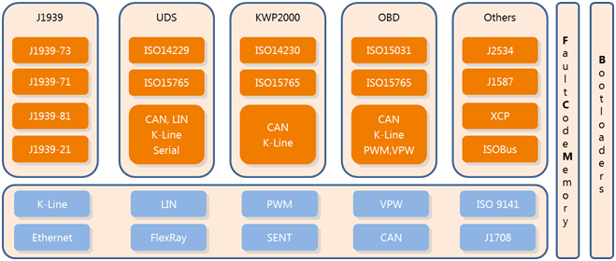



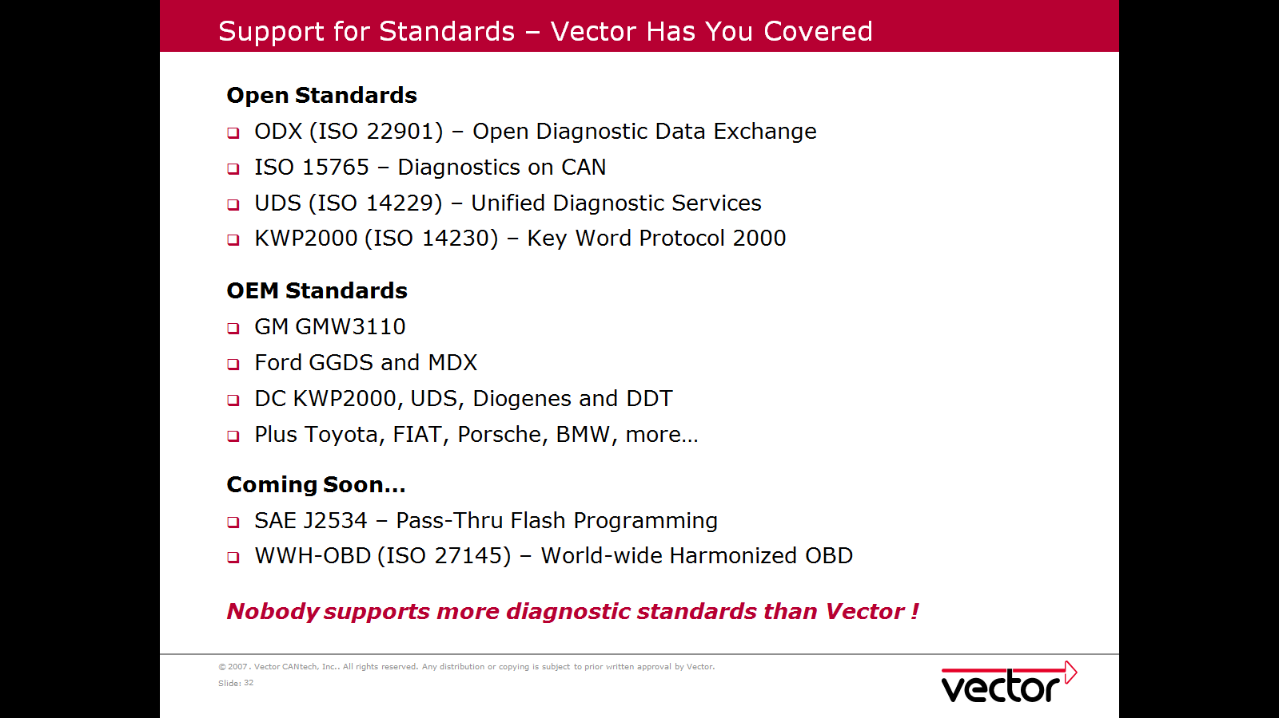

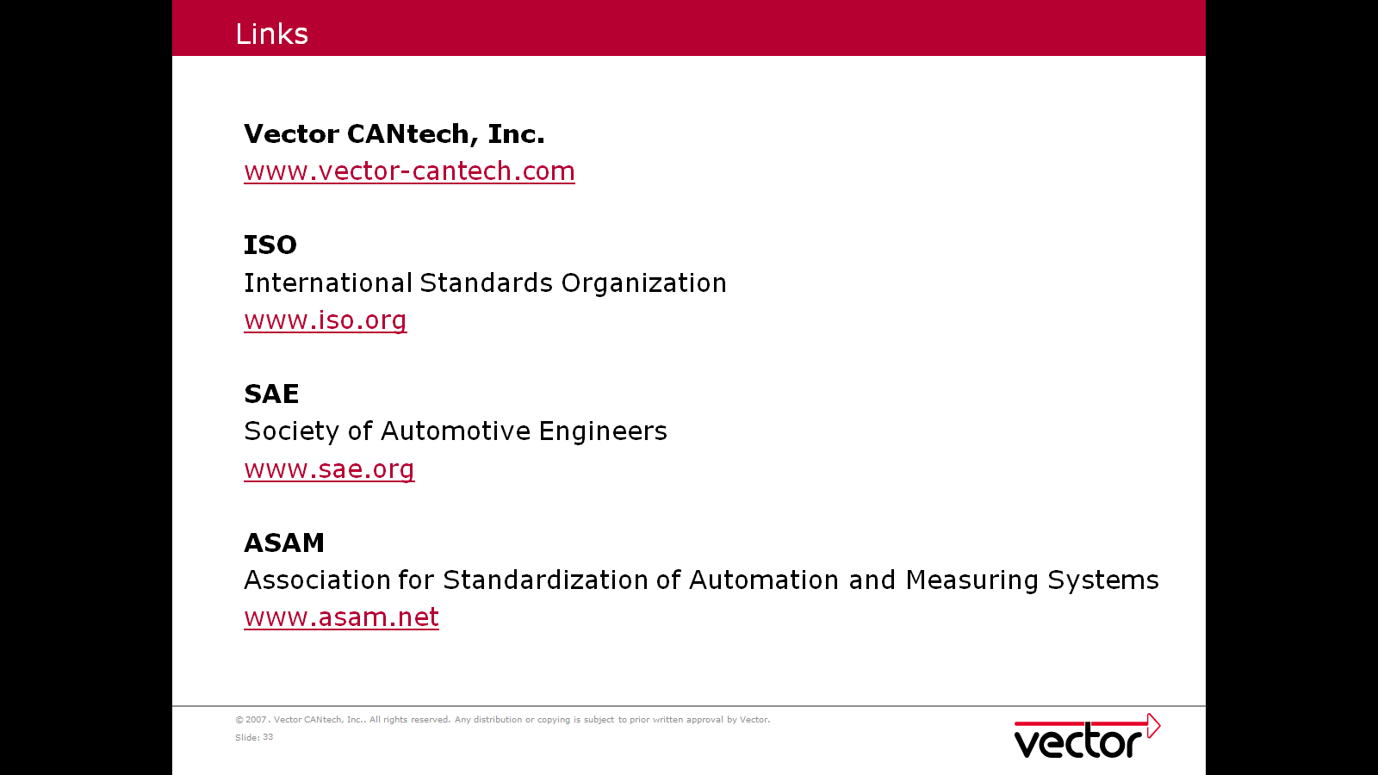

Diagnostics sub system interacts with tester with the help of Network sub system. Network sub system handles CAN communication and related functionalities like transport layer features and network management features. Diagnostics sub system receives protocol data units of diagnostics UDS from network sub system and uses APIs from network sub system to send responses required for diagnostics commands.

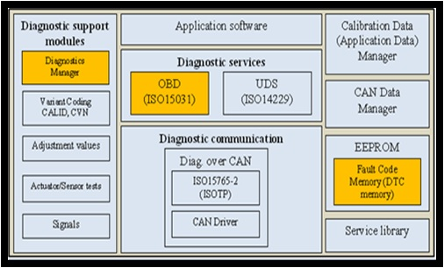

AUTOSAR and Diagnostics Software Modules

In the past, automotive ECU software architectures were not standardized. For the supplier,
this resulted in different, OEM-specific software architectures that required different development processes, development tools and data exchange formats. AUTOSAR (AUTomotive Open System ARchitecture) has the stated goal of standardizing a common, open automotive software architecture

The primary goals of the AUTOSAR architecture are:

>> Hardware abstraction
>> Clearly specified interfaces
>> Standardized behaviour of the basic software
>> Standardized data exchange formats between OEM and suppliers
>> Definition of a harmonized methodology for developing software
>>
Support of model-based functional development
>> Scalability over all ECU and vehicle classes
>> Considers safety requirements per ISO 26262

Today, AUTOSAR (AUTomotive Open System ARchitecture) is the reference architecture for ECU software in the automotive industry. AUTOSAR standardizes the description of individual component or vehicle functions and the description of the overall system.

The diagnostic software in AUTOSAR consists of the two basic software modules DCM, and DEM

AUTOSAR diagnostics is limited to the UDS and OBDII protocols, the layout of diagnostic services of these protocols is implicitly assumed and is not explicitly described in the ECUC data.

The AUTOSAR specifications have been developed for automotive applications only

Diagnostic Communication Manager(DCM)

The DCM (Diagnostic Communication Manager) implements the diagnostic communication per ISO 14229-1 (UDS). All diagnostic requests are first pre-processed by the DCM. One of the tasks of the DCM is comprehensive handling of invalid diagnostic requests. The DCM can already fully process a majority of valid requests; it routes other requests to the functional software.

The DCM is configured based on a ECU Configuration Description. This includes the service identifiers, sub functions, data identifiers (with associated signal structure) and routine identifiers (with parameter lists). In addition, execution of diagnostic requests can be made dependent on the current ECU state (session and security level).

The DCM module provides a common API for diagnostic services. The functionality of the DCM module is used by external diagnostic tools during the development, manufacturing or service.

In the AUTOSAR Architecture the Diagnostic Communication Manager is located in the Communication Services (Service Layer).

The DCM module is network-independent. All network-specific functionality (CAN, LIN, FlexRay or MOST) is handled outside of the DCM module.

The code file structure shall not be defined within the DCM SWS

Limitations:

- The DCM SWS does not cover any SAE J1939 related diagnostic requirements
- The DCM module does not provide any diagnostic multi-channel capabilities

Diagnostic Event Manager(DEM)

The diagnostic sub system component Diagnostic Event Manager (DEM) is responsible for processing and storing diagnostic events (errors) and associated data. Further, the DEM provides fault information to the DCM (e.g. read all stored DTCs from the event memory). The DEM offers interfaces to the application layer and other sub systems.

The DEM (Diagnostic Event Manager) implements an error memory. Up to (and including) AUTOSAR Version 3.x, the DEM is only specified as a facade, because details of error memory behaviour are OEM-specific. Since Version 4, the goal has been to standardize an
OEM-independent error memory, so that its behaviour can be defined in AUTOSAR.

The DEM has the following primary tasks:

>> Administer the DTC status bit
>> Organize error storage, including NVRAM
>> Organize snapshot data (freeze frame)
>> Administer extended data records
>> Provide for unlearning of errors
>> Provide an interface for error readout for the DCM

Event memory defined shall be as per GGDS part 1 specification. DTCs shall be defined as per part2 diagnostics specification for product variant.

Diagnostics Communication Manager | Generally, the DCM module provides a common API and functions for diagnostic services. The functionality of the DCM module is used by external diagnostic tools during the development, manufacturing or service.  Responsibilities of DCM specific to diagnostics sub systems are  - Communication with tester with the help of network sub system excluding transport layer and network management features.  - Identification of Service Ids and sub function Ids  - Identification of diagnostics sessions, Security states and protocol sequence and validity  - Coordinating diagnostics service requests and its execution.  - Sending positive and negative response for diagnostics requests
Diagnostics Event Manager | The diagnostic sub system component Diagnostic Event Manager (DEM) is responsible for processing and storing diagnostic events (errors) and associated data.  Specific responsibilities of DEM with respect to diagnostics sub system are  - Writing DTCs to event memory  - Reading and Clearing DTCs based on diagnostics requests based on UDS  - Updating error status and environment and snapshot data for DTCs  - APIs for all above functionalities which would be used by other sub systems or DCM  - Maintaining diagnostics event memory based on characteristics of event memory defined, error reports received and diagnostics commands.
Test and Calibration Routines | - Functions for each calibration and test routines which would coordinate and call APIs with other sub systems.  - Support Read Data by Identifier, Write Data by Identifier, Routine Control and Input Output Control by Identifier diagnostics requests based on routine identifier and PID.

The following timers are used:

  - Diagnostic communication response timers

  - NVM operations timers – Time out, synchronization, scheduling

  - Test functions timers

Function execution time

All requests sent by the Tester will expect a positive response or a RCRRP (Request Received Response Pending) with in 50ms as mentioned in the table below. The timings which ever are greater than 50ms have to support RCRRP Message.

Service ID | Name | 0x01(ms) | 0x02(ms) | 0x03(ms)
0x10 | Diagnostic Session Control | 50 | 25 | 50
0x11 | ECU Reset | 200 | 200 | 200
0x14 | Clear Diagnostic Information | 1000 |  | 1000
0x18 | Read DTC Information | 50 |  | 50
0x22 | Read Data by Identifier | 50 | 25 | 50
0x27 | Security Access | 50 | 25 | 50
0x2E | Write Data by Identifier | 5000 | 5000 | 5000
0x31 | Routine Control | 200 | 60000 | 200
0x2F | Input Output Control by Identifier | 50 |  | 50
0x34 | Request Download |  | 1000
0x36 | Transfer Data |  | 5000
0x37 | Transfer Exit |  | 5000
0x3E | Tester Present | 50 | 25 | 50
0x85 | Control DTC Setting | 200 |  | 200

Request Response Format:

CDD Integration and Vector tools

Important terms:
CANdesc | CANdesc (desc = diagnostic embedded software component) is the ECU diagnostic software component in the of the CANdela product family. CANdesc enables vehicle and electronic control unit (ECU) manufacturers to implement the diagnostic protocol uniformly across different OEMs and their vehicle lines. CANdesc supports diagnostic communication via CAN, MOST, FlexRay. Any other bus system will be also supported using an optional abstract transport layer interface.
CANdelaStudio | The specification tool CANdelaStudio is a central component of the CANdela solution and supports users in creating and editing a formal ECU diagnostic specification.
vFlash | vFlash is designed for all users at automotive OEMs and suppliers whose tasks include (re-) programming of ECUs. It supports ECU programming  over CAN, FlexRay, LIN, and over Ethernet (DoIP). vFlash allows users to flash ECUs in the laboratory, at programming stations, at a laboratory  vehicle or in the vehicle very efficiently.
Diagnostic Tester | and are the diagnostic testers in Vector's diagnostic tool chain. Paramerization is done via CANdela databases (CDD data from ), and/or via
CANDiVa | DiVa is a CANoe extension for automated testing of diagnostic software implementations in ECUs. Reproducible test cases are generated based on an ECU diagnostic description.

- CDD Imported in CANdela studio
- Edited for new services or PIDS
- Exported as new CDD file
- GENy tool
- Generated CANdesc files(diag_appdesc.c and diag_appdesc.h files)
- Integrated into Network Subsystem
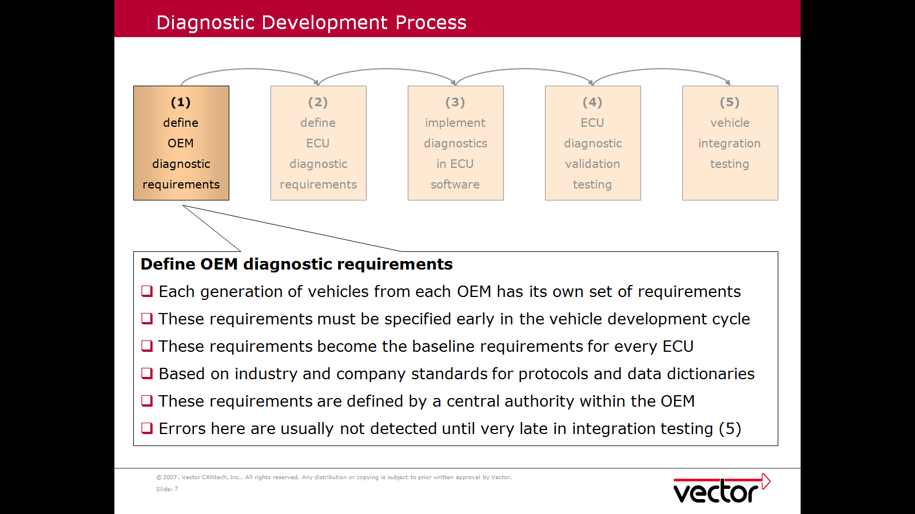

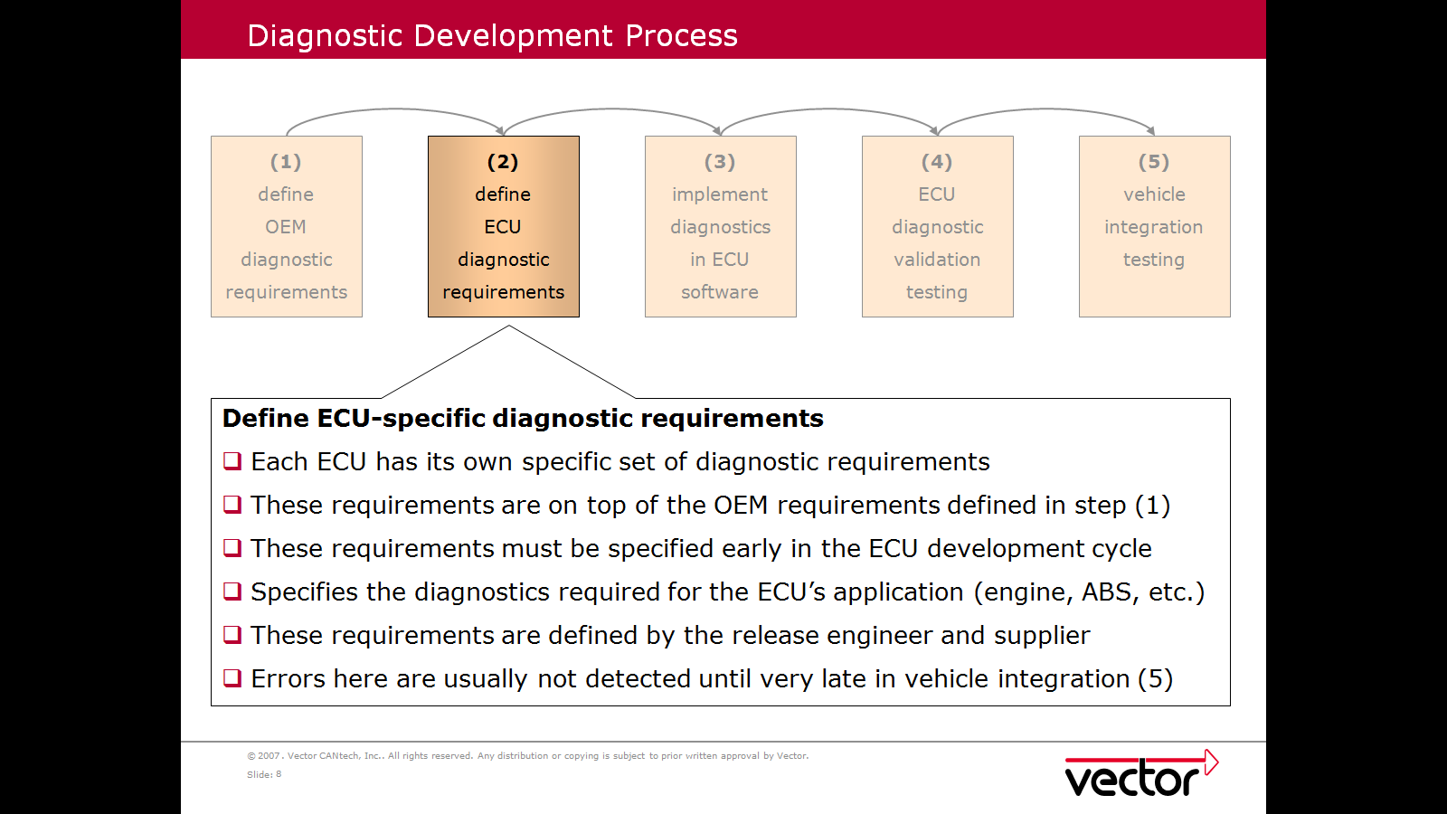

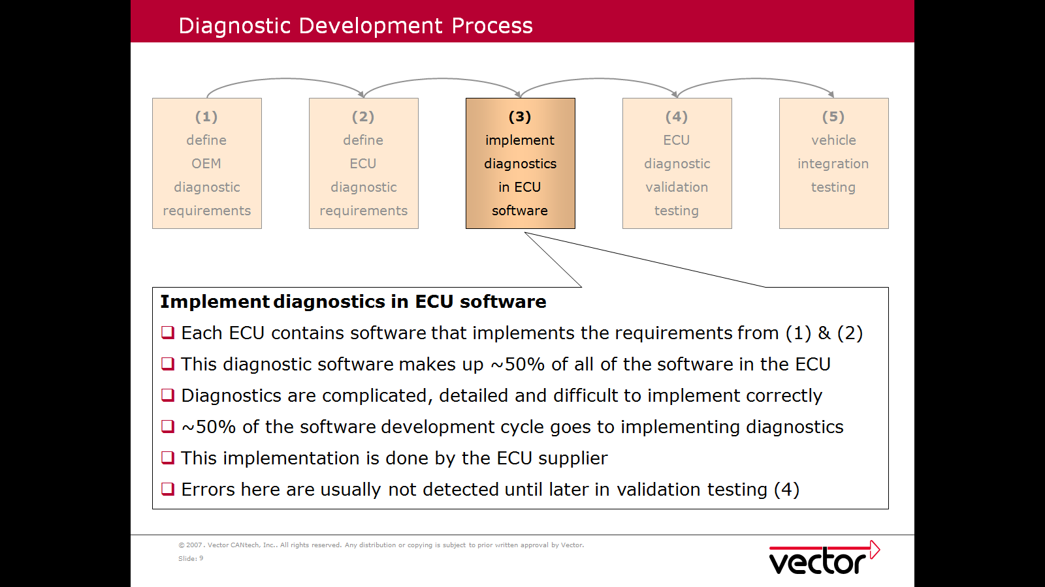

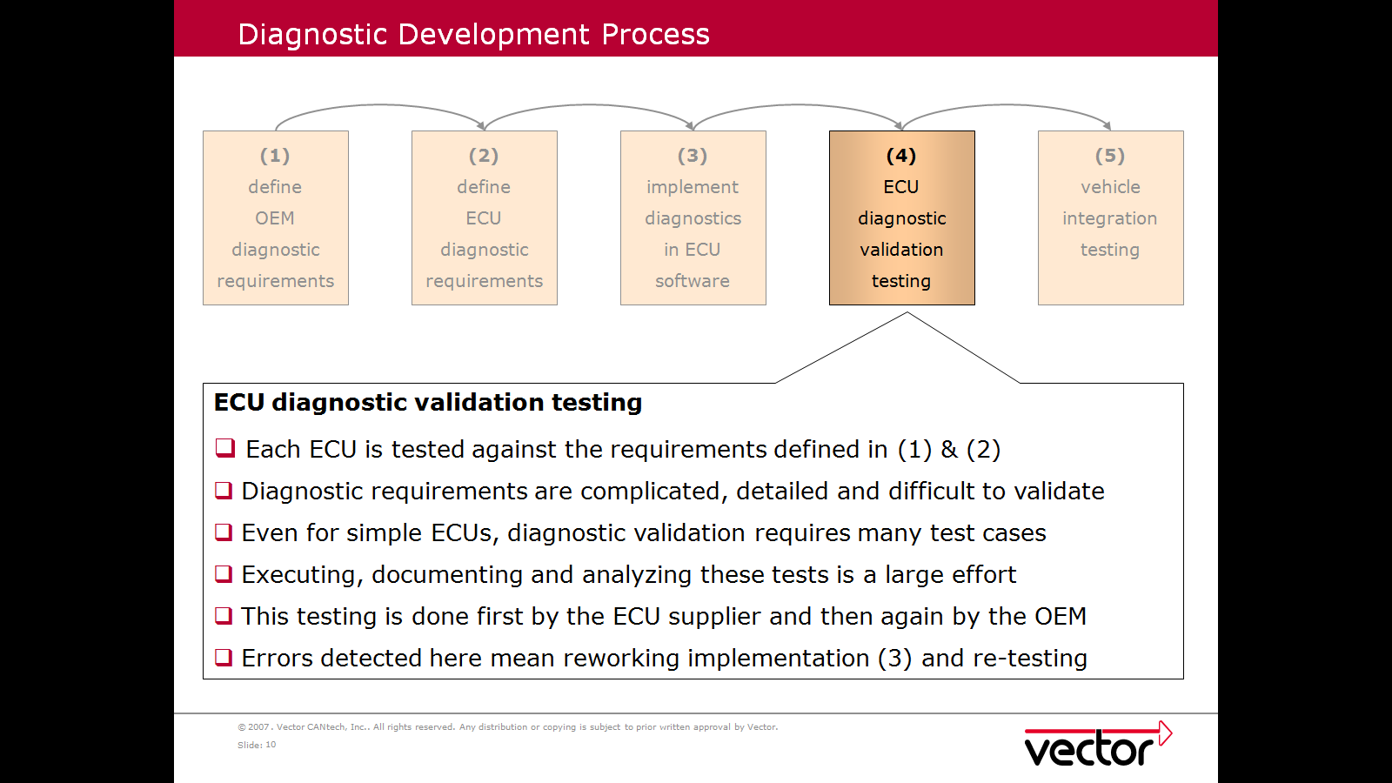

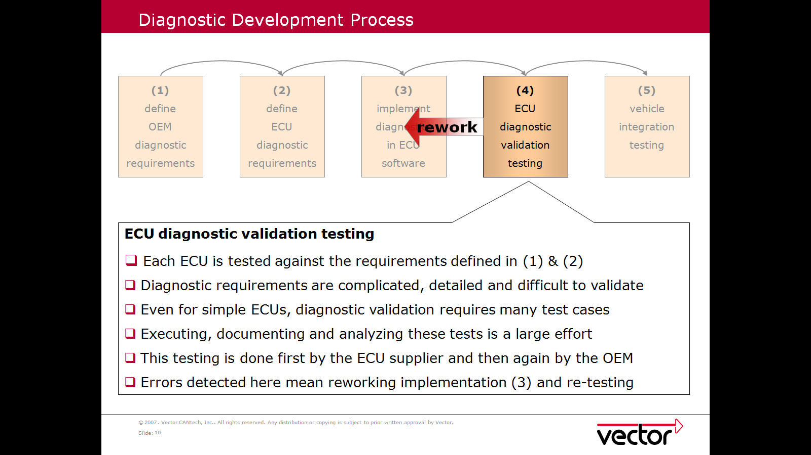

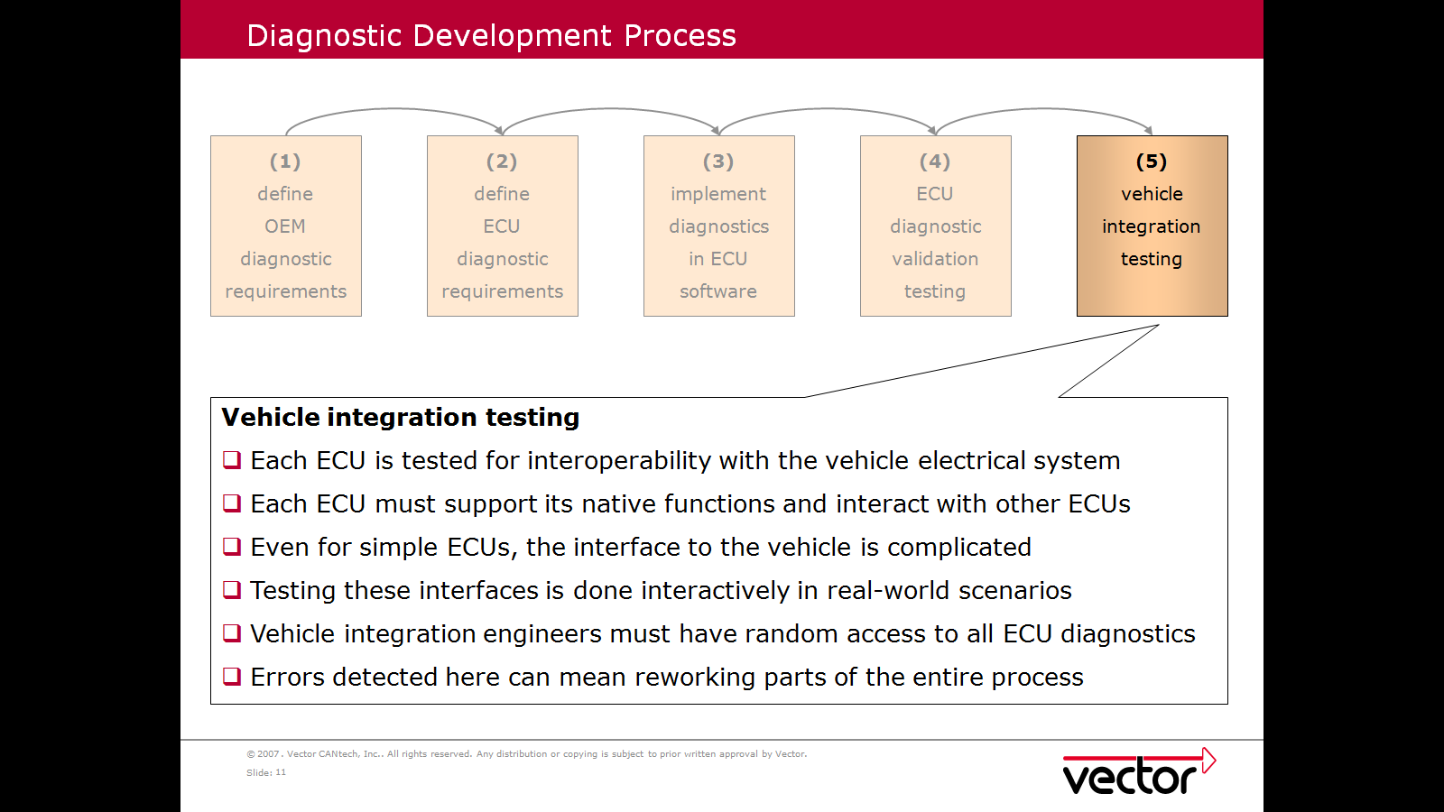

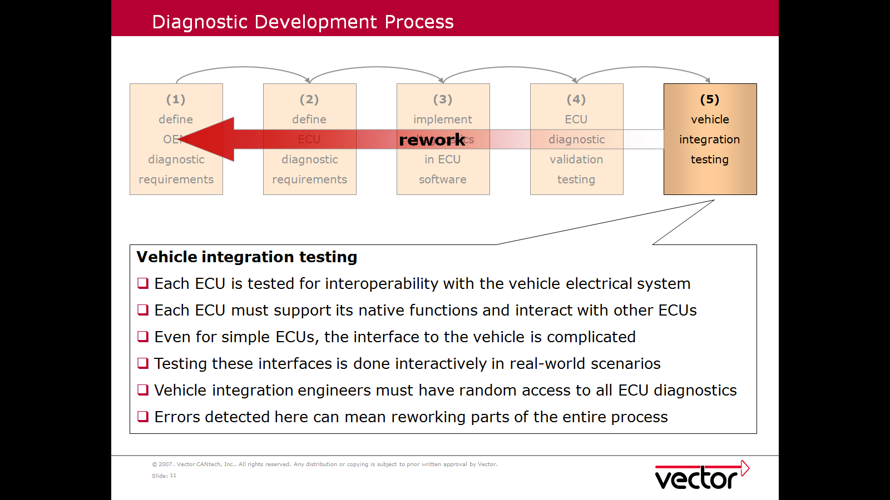

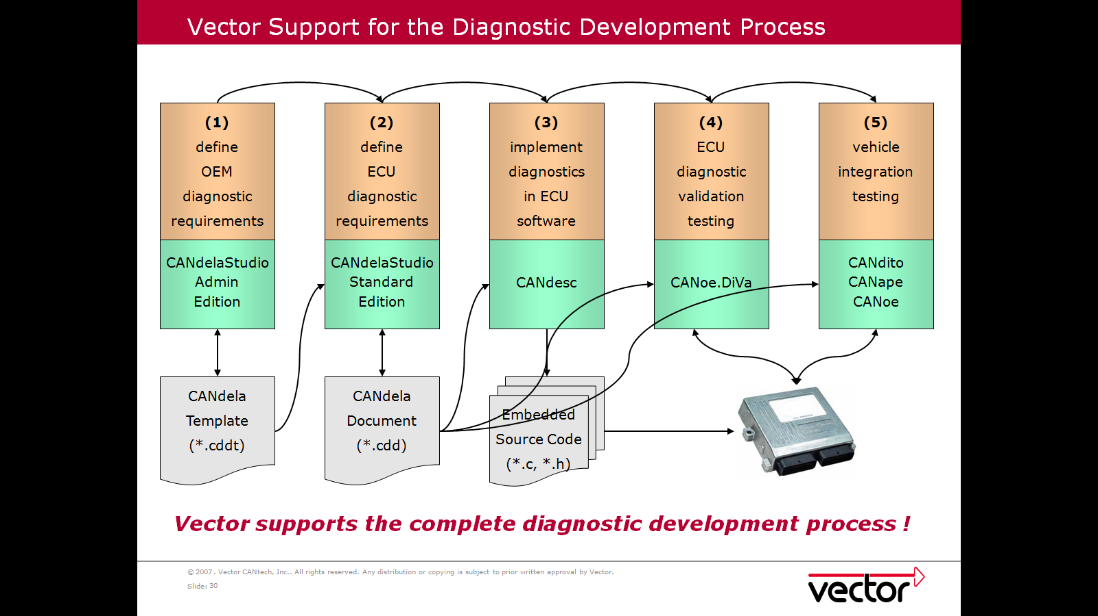

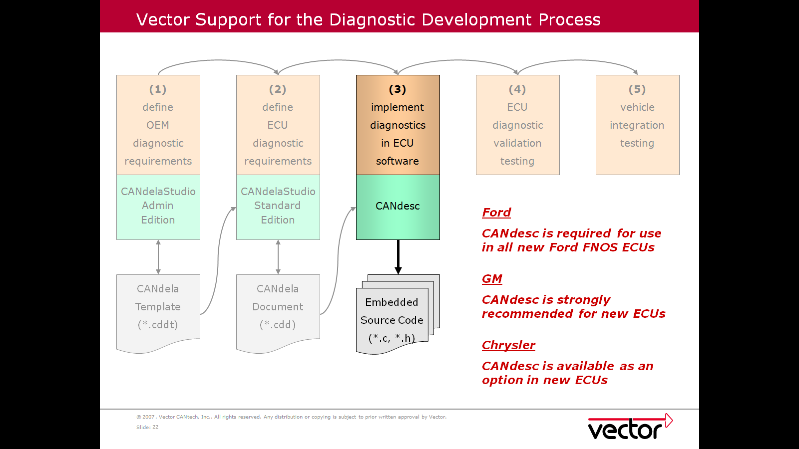

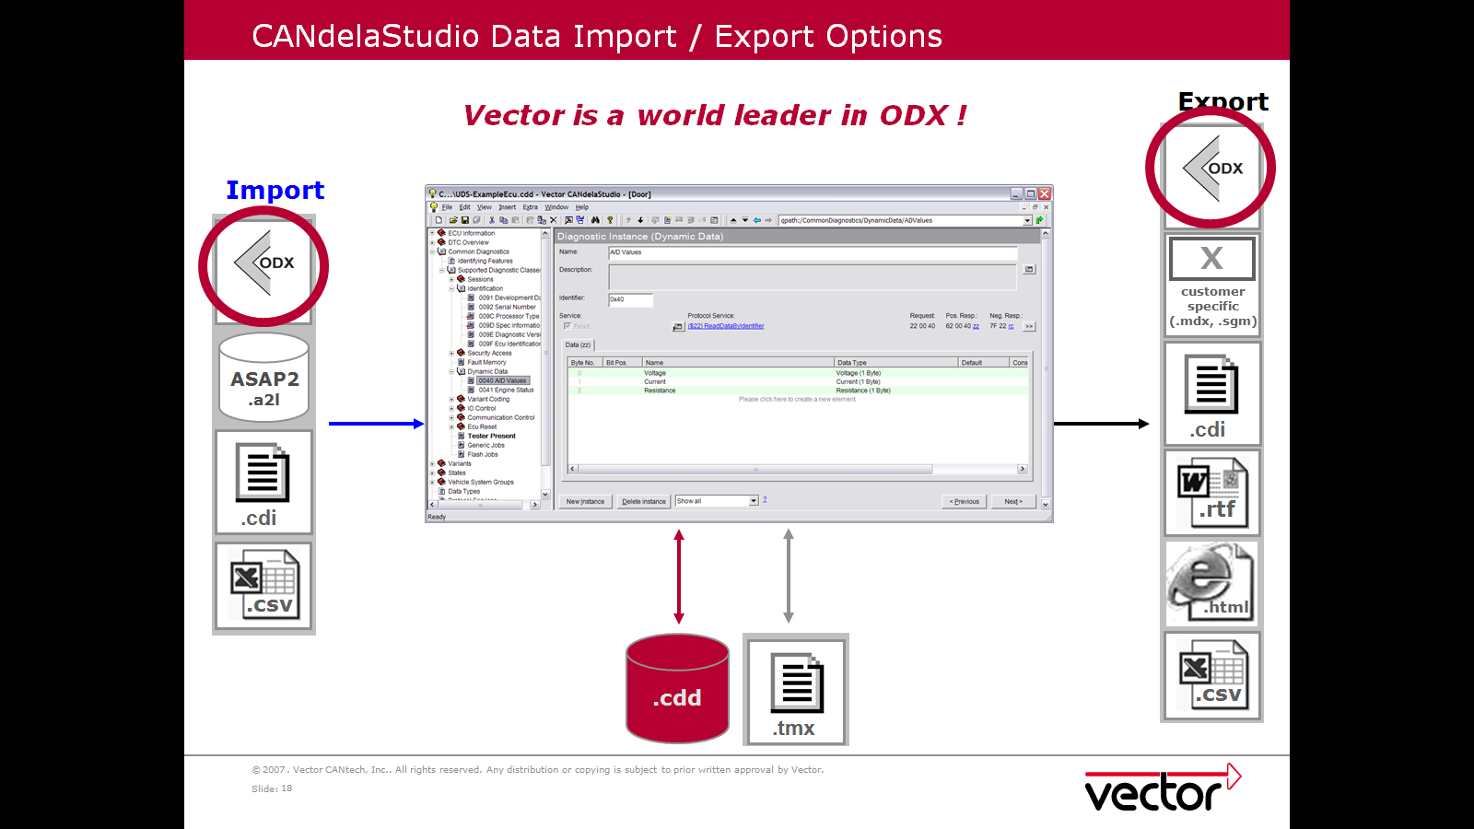

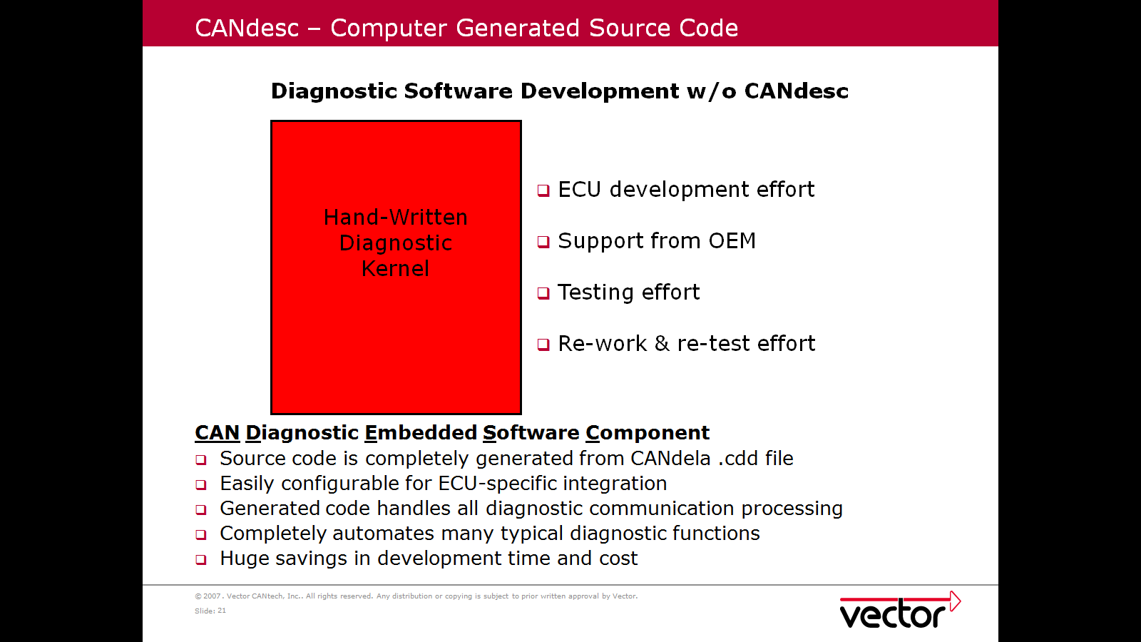

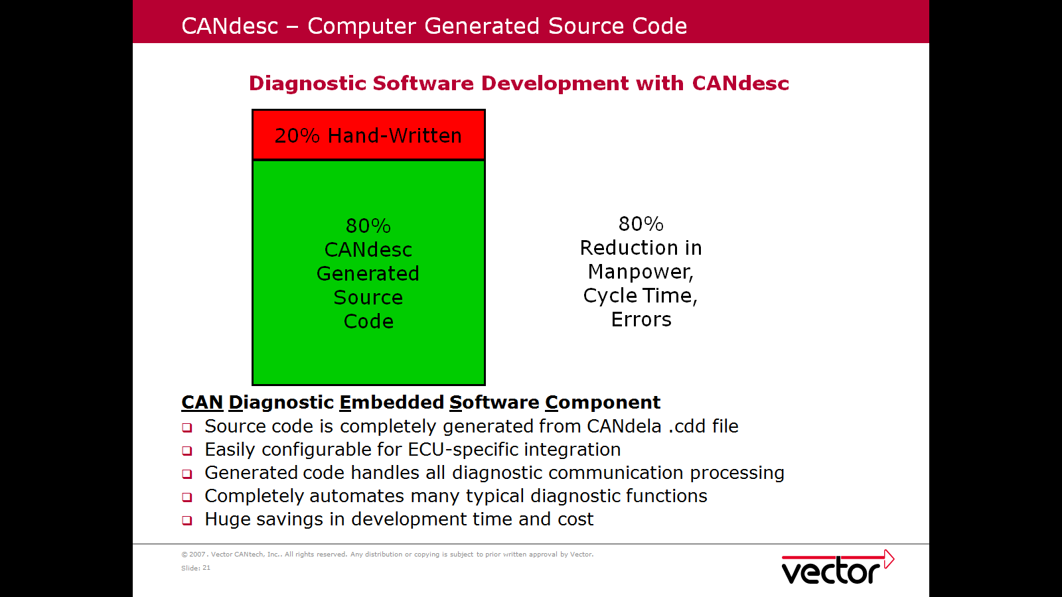

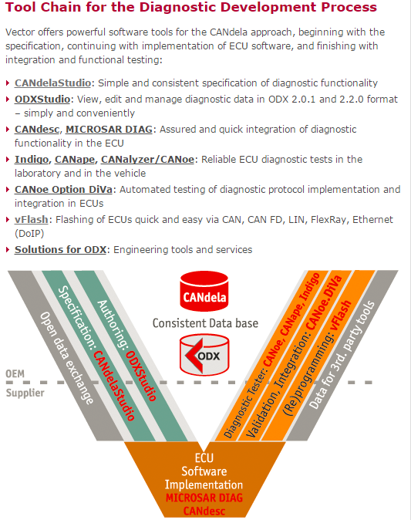

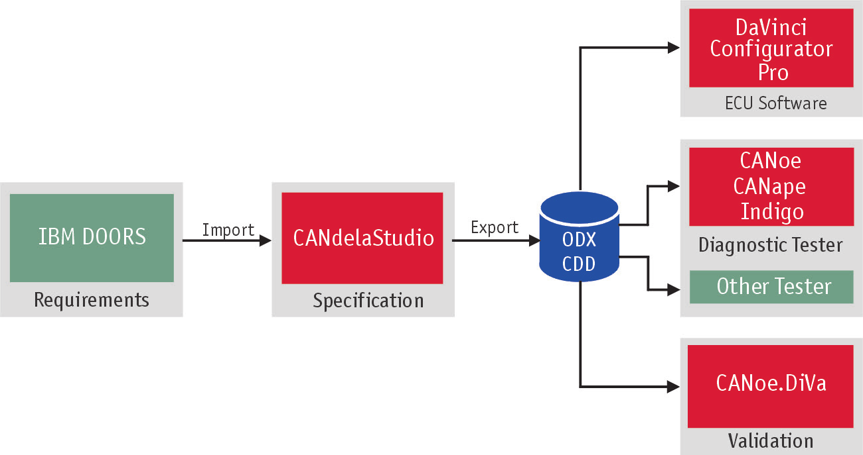

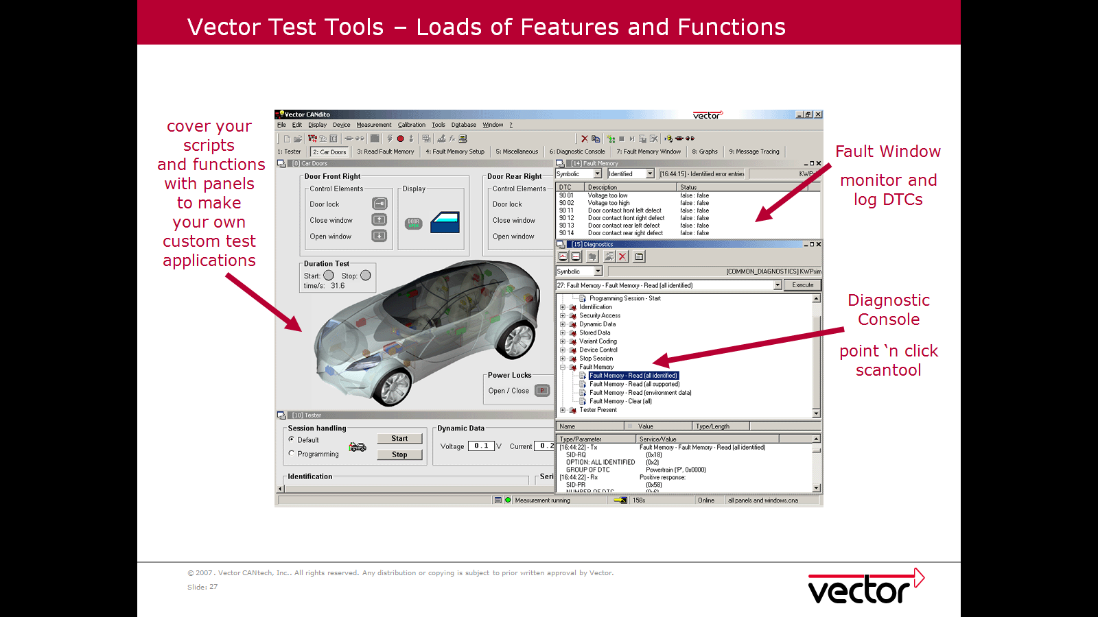

Equivalent changes made in Diagnostics subsystem so request reaches till diagnostics and response returned to Network.

Security Access handling

In order to execute locked diagnostic functions in the control unit (ECU), the tester requires a key to unlock the ECU. The key is calculated from a seed which is received from the ECU in a diagnostic response. The algorithm used to calculate the key can be implemented as a dll (security dll). The DiagGenerateKeyFromSeed function encapsulates the concrete implementation of the key algorithm in the provider-dependent SeedKey DLL. The SeedKey DLL must be configured in the diagnostics configuration dialog (Diagnostics / ISO TP Configuration| | |Security DLL) for each diagnostics description that shall be used with DiagGenerateKeyFromSeed: CANoe and CANalyzer as diagnostic tools.
Depending on the OEM, there are two types of Seed & Key accesses:
- Simple access
- Level based access
Most of the OEMs use a simple Security Access.
Each ECU from a network has its own Security Access. The SeedKey DLL / ECU assignment shall be done in CANoe for each ECU using the “Diagnostic/ISO TP Configuration” menu under “Security DLL”.
In CAPL, the Security DLL of the ECU that has been last set to active using DiagSetTarget is used.
Starting with CANoe7.1 it is possible to use a self-made Security DLL without GenSAKey.dll. The access is assured through new C++ functions that are mandatory in your SeedKey DLL. Please note that if the Security Access is not successful, the Key “0x00” will be transmitted by CANoe. You can observe this in the trace window. In this case you should check your SeedKey DLL. More information on Security Access with SeedKey DLL might be obtained using CANoe Help. There are different functions (APIs) that might be implemented by the SeedKey DLL to integrate the OEM Seed & Key algorithm. We recommend the use of one of the two following:
- GenerateKeyEx
- GenerateKeyExOpt
Both only differ in the parameter ipOptions, which is only part of GeneratekeyExOpt. This parameter enables the access to different Security Levels in case of Level based Security Access (see also 3). However if your OEM uses a Simple Security Access, you might also use the GeneratekeyExOpt API and set the ipOptions parameter to an empty or dummy String. The CAPL-Function DiagGenerateKeyFromSeed automatically adapts itself to the API implemented in the SeedKey DLL. If your SeedKey DLL uses GenerateKeyEx, the CAPL-function DiagGenerateKeyFromSeed shall be used with the ip

The process of Security access is shown as:

Diagnostics logs:
Service 19 and Service 14:

Request for ReadDTCInformation (Service 0x19)
SubFunction: 0x02 (reportDTCByStatusMask) [SPRMIB = False]
DTCStatusMask: 0xFF
Positive Response to ReadDTCInformation (Service 0x19) -- [ECU ID: 0x72F (ACM)]
SubFunction: 0x02 - reportDTCByStatusMask
DTCStatusAvailabilityMask: 0xFF
Number of Returned DTCs: 3
DTC #1: 0xE10000 (U2100-00) [Initial Configuration Not Complete]
Status: 0x2F
Bit 7 - warningIndicatorRequested: 0
Bit 6 - testNotCompletedThisOperationCycle: 0
Bit 5 - testFailedSinceLastClear: 1
Bit 4 - testNotCompletedSinceLastClear: 0
Bit 3 - confirmedDTC: 1
Bit 2 - pendingDTC: 1
Bit 1 - testFailedThisOperationCycle: 1
Bit 0 - testFailed: 1
DTC #2: 0xDA0008 (U1A00-08) [Private Communication Network - Bus Signal / Message Failures]
Status: 0x2E
Bit 7 - warningIndicatorRequested: 0
Bit 6 - testNotCompletedThisOperationCycle: 0
Bit 5 - testFailedSinceLastClear: 1
Bit 4 - testNotCompletedSinceLastClear: 0
Bit 3 - confirmedDTC: 1
Bit 2 - pendingDTC: 1
Bit 1 - testFailedThisOperationCycle: 1
Bit 0 - testFailed: 0
DTC #3: 0xE01A54 (U201A-54) [Control Module Main Calibration Data - missing calibration]
Status: 0x2F
Bit 7 - warningIndicatorRequested: 0
Bit 6 - testNotCompletedThisOperationCycle: 0
Bit 5 - testFailedSinceLastClear: 1
Bit 4 - testNotCompletedSinceLastClear: 0
Bit 3 - confirmedDTC: 1
Bit 2 - pendingDTC: 1
Bit 1 - testFailedThisOperationCycle: 1
Bit 0 - testFailed: 1
Request for ClearDiagnosticInformation (Service 0x14)
GroupOfDTC = 0xFFFFFF (All DTCs)
Positive Response to ClearDiagnosticInformation (Service 0x14)

Service 22:

Request for ReadDataByIdentifier (Service 0x22) -- Single DID
DataIdentifier: 0x1505
Positive Response to ReadDataByIdentifier (Service 0x22) -- [ECU ID: 0x72F (ACM)]
DataIdentifier: 0x1505 Data Size: 2 byte(s)
Data (Hex): 64 00
[0x1505] Vehicle Speed - High Resolution: 200 Kph
Request for ReadDataByIdentifier (Service 0x22) -- Single DID
DataIdentifier: 0x1505
Positive Response to ReadDataByIdentifier (Service 0x22) -- [ECU ID: 0x72F (ACM)]
DataIdentifier: 0x1505 Data Size: 2 byte(s)
Data (Hex): 00 80
[0x1505] Vehicle Speed - High Resolution: 1 Kph
Request for ReadDataByIdentifier (Service 0x22) -- Single DID
DataIdentifier: 0x1505
Positive Response to ReadDataByIdentifier (Service 0x22) -- [ECU ID: 0x72F (ACM)]
DataIdentifier: 0x1505 Data Size: 2 byte(s)
Data (Hex): 01 00
[0x1505] Vehicle Speed - High Resolution: 2 Kph
Request for ReadDataByIdentifier (Service 0x22) -- Single DID
DataIdentifier: 0x1505
Positive Response to ReadDataByIdentifier (Service 0x22) -- [ECU ID: 0x72F (ACM)]
DataIdentifier: 0x1505 Data Size: 2 byte(s)
Data (Hex): 05 00
[0x1505] Vehicle Speed - High Resolution: 10 Kph
Request for ReadDataByIdentifier (Service 0x22) -- Single DID
DataIdentifier: 0x1505
Positive Response to ReadDataByIdentifier (Service 0x22) -- [ECU ID: 0x72F (ACM)]
DataIdentifier: 0x1505 Data Size: 2 byte(s)
Data (Hex): 33 00
[0x1505] Vehicle Speed - High Resolution: 102 Kph

Service 2F

Request for DiagnosticSessionControl (Service 0x10) -- Session: 0x03 (extendedDiagnosticSession) [SPRMIB = False]
Positive Response to DiagnosticSessionControl (Service 0x10) -- [ECU ID: 0x72F (ACM)]
Session: 0x03 (extendedDiagnosticSession) P2can: 50ms P2*can: 5000ms
Request for InputOutputControlByIdentifier (Service 0x2F) -- [ECU ID: 0x727 (ACM)]
DataIdentifier: 0x61A1
InputOutputControlParameter: 0x03 (shortTermAdjustment)
ControlState and ControlMask Total Size: 1 byte(s)
Data (Hex): AB
Positive Response to InputOutputControlByIdentifier (Service 0x2F) -- [ECU ID: 0x72F (ACM)]
DataIdentifier: 0x61A1
InputOutputControlParameter: 0x03 (shortTermAdjustment)
ControlState Total Size: 1 byte(s)
Data (Hex): AB
Request for ReadDataByIdentifier (Service 0x22) -- [ECU ID: 0x727 (ACM)] - Single DID
DataIdentifier: 0x61A1
Positive Response to ReadDataByIdentifier (Service 0x22) -- [ECU ID: 0x72F (ACM)]
DataIdentifier: 0x61A1 Data Size: 1 byte(s)
Data (Hex): AB
[0x61A1] Channel Frequency: 104.6 MHz
Request for InputOutputControlByIdentifier (Service 0x2F) -- [ECU ID: 0x727 (ACM)]
DataIdentifier: 0x61A1
InputOutputControlParameter: 0x00 (returnControlToECU)
ControlState and ControlMask Total Size: 0 byte(s)
Positive Response to InputOutputControlByIdentifier (Service 0x2F) -- [ECU ID: 0x72F (ACM)]
DataIdentifier: 0x61A1
InputOutputControlParameter: 0x00 (returnControlToECU)
ControlState Total Size: 1 byte(s)
Data (Hex): AB
Request for ReadDataByIdentifier (Service 0x22) -- [ECU ID: 0x727 (ACM)] - Single DID
DataIdentifier: 0x61A1
Negative Response to ReadDataByIdentifier (Service 0x22) -- [ECU ID: 0x72F (ACM)]
Response Code: 0x22 (Conditions Not Correct)
SWDL(Sofware Download)

Validating VBF Sequence...
Sequence Name: CHR
VBS Filename:
Use Specific Security Key File: No
Number of Security Levels Loaded: 1
Inhale Associated ECD File: No
Number of Files in VBF Sequence: 4

File #1: H1BT-14G300-AA010.vbf
VBF Version: 2.2, ECU Address: 0x727, Network = CAN_HS
SW Part Type: SBL, SW Part Number: "H1BT-14G300-AA010", Call Info: 0x3F802000, DataFormatIdentifier To Use: 0x00
Number of Erase Blocks: 0
Number of Data Blocks: 1
Data Block #1 --- Start Address: 0x3F802000, Length: 0x214C, Checksum: 0x9DB8
File Checksum: 0x11C03B99

File #2: H1BT-14G298-AA000.vbf
VBF Version: 2.2, ECU Address: 0x727, Network = CAN_HS
SW Part Type: EXE, SW Part Number: "H1BT-14G298-AA000", Call Info: Not Present, DataFormatIdentifier To Use: 0x00
Number of Erase Blocks: 20
Erase Block #1 --- Start Address: 0x20013000, Length: 0x8000
Erase Block #2 --- Start Address: 0x2001B000, Length: 0x3000
Erase Block #3 --- Start Address: 0x2001E000, Length: 0x2000
Erase Block #4 --- Start Address: 0x20020000, Length: 0x20000
Erase Block #5 --- Start Address: 0x20050000, Length: 0xB0000
Erase Block #6 --- Start Address: 0x20100000, Length: 0x100000
Erase Block #7 --- Start Address: 0x20200000, Length: 0x100000
Erase Block #8 --- Start Address: 0x20300000, Length: 0x100000
Erase Block #9 --- Start Address: 0x20400000, Length: 0x100000
Erase Block #10 --- Start Address: 0x20500000, Length: 0x100000
Erase Block #11 --- Start Address: 0x20600000, Length: 0x100000
Erase Block #12 --- Start Address: 0x20700000, Length: 0x100000
Erase Block #13 --- Start Address: 0x20800000, Length: 0x100000
Erase Block #14 --- Start Address: 0x20900000, Length: 0x100000
Erase Block #15 --- Start Address: 0x20A00000, Length: 0x100000
Erase Block #16 --- Start Address: 0x20B00000, Length: 0x100000
Erase Block #17 --- Start Address: 0x20C00000, Length: 0x100000
Erase Block #18 --- Start Address: 0x20D00000, Length: 0x100000
Erase Block #19 --- Start Address: 0x20E00000, Length: 0x100000
Erase Block #20 --- Start Address: 0x20F00000, Length: 0x100000
Number of Data Blocks: 10
Data Block #1 --- Start Address: 0x20013000, Length: 0x4039, Checksum: 0xA05
Data Block #2 --- Start Address: 0x2001B000, Length: 0x10, Checksum: 0x6A0A
Data Block #3 --- Start Address: 0x2001E000, Length: 0x10, Checksum: 0x6A0A
Data Block #4 --- Start Address: 0x20020000, Length: 0xC210, Checksum: 0xF09F
Data Block #5 --- Start Address: 0x20050000, Length: 0xC, Checksum: 0x7E68
Data Block #6 --- Start Address: 0x20050080, Length: 0xAB86B, Checksum: 0xBC98
Data Block #7 --- Start Address: 0x20400000, Length: 0x10, Checksum: 0x6A0A
Data Block #8 --- Start Address: 0x20440000, Length: 0x9170B, Checksum: 0xEE3D
Data Block #9 --- Start Address: 0x20900000, Length: 0x1D6A00, Checksum: 0xD467
Data Block #10 --- Start Address: 0x20B00000, Length: 0x4B5F10, Checksum: 0x6EC2
File Checksum: 0xFB8B59D6

File #3: H1BT-14G548-AA010.vbf
VBF Version: 2.4, ECU Address: 0x727, Network = CAN_HS
SW Part Type: EXE, SW Part Number: "H1BT-14G548-AA010", Call Info: Not Present, DataFormatIdentifier To Use: 0x00
Number of Erase Blocks: 2
Erase Block #1 --- Start Address: 0x40000000, Length: 0x400000
Erase Block #2 --- Start Address: 0x20011000, Length: 0x1000
Number of Data Blocks: 2
Data Block #1 --- Start Address: 0x40000000, Length: 0x94307, Checksum: 0x8A03
Data Block #2 --- Start Address: 0x20011000, Length: 0x18, Checksum: 0x1B4
File Checksum: 0x1E5FA43A

File #4: H1BT-14G299-BA010.vbf
VBF Version: 2.2, ECU Address: 0x727, Network = CAN_HS
SW Part Type: EXE, SW Part Number: "H1BT-14G299-BA010", Call Info: Not Present, DataFormatIdentifier To Use: 0x00
Number of Erase Blocks: 1
Erase Block #1 --- Start Address: 0x20012000, Length: 0x1000
Number of Data Blocks: 1
Data Block #1 --- Start Address: 0x20012000, Length: 0x54, Checksum: 0x5D7B
File Checksum: 0x52458D36

Downloading VBF sequence ...
Note: Not utilizing Fast Download Method.
Note: STmin override not enabled.
Functionally transitioning ECUs to programmingSession - User Initialized Connection ... Ok (Tx Ok, Response Suppressed)

Starting file 1 of 4: H1BT-14G300-AA010.vbf
Attempting to communicate to ECU 0x727 on User Initialized Connection ... ECU Found
Physically transitioning ECU to programmingSession on User Initialized Connection ... Ok
Determining level of SWDL Specification Supported ... Ok
Supported SWDL Specification Version = 006
Reading ECU Core Assembly Part Number 0xF111 ... Ok
DID 0xF111 = Invalid Format (0xFFFFFFFFFFFFFFFFFFFFFFFFFFFFFFFFFFFFFFFFFFFFFFFF)
ASCII DIDs byte values shall be >= 0x2D and <= 0x7D with the exception of NULL 0x00 for ALL pad bytes.
Attempting to Unlock Security Access for Level 0x01 ... Ok
Programming Memory Block 1 of 1 (Address 0x3F802000, Length 0x214C) ... Ok
Transferring data for current block...Ok
Finalizing Memory Block 1 of 1 with transferExit request...Ok
Activating SBL...Ok
Elapsed download time is 3.40 seconds.

Starting file 2 of 4: H1BT-14G298-AA000.vbf
Attempting to Unlock Security Access for Level 0x01 ... Ok
Erasing Memory Block 1 of 20 (Address 0x20013000, Length 0x8000) ... Ok
Erasing Memory Block 2 of 20 (Address 0x2001B000, Length 0x3000) ... Ok
Erasing Memory Block 3 of 20 (Address 0x2001E000, Length 0x2000) ... Ok
Erasing Memory Block 4 of 20 (Address 0x20020000, Length 0x20000) ... Ok
Erasing Memory Block 5 of 20 (Address 0x20050000, Length 0xB0000) ... Ok
Erasing Memory Block 6 of 20 (Address 0x20100000, Length 0x100000) ... Ok
Erasing Memory Block 7 of 20 (Address 0x20200000, Length 0x100000) ... Ok
Erasing Memory Block 8 of 20 (Address 0x20300000, Length 0x100000) ... Ok
Erasing Memory Block 9 of 20 (Address 0x20400000, Length 0x100000) ... Ok
Erasing Memory Block 10 of 20 (Address 0x20500000, Length 0x100000) ... Ok
Erasing Memory Block 11 of 20 (Address 0x20600000, Length 0x100000) ... Ok
Erasing Memory Block 12 of 20 (Address 0x20700000, Length 0x100000) ... Ok
Erasing Memory Block 13 of 20 (Address 0x20800000, Length 0x100000) ... Ok
Erasing Memory Block 14 of 20 (Address 0x20900000, Length 0x100000) ... Ok
Erasing Memory Block 15 of 20 (Address 0x20A00000, Length 0x100000) ... Ok
Erasing Memory Block 16 of 20 (Address 0x20B00000, Length 0x100000) ... Ok
Erasing Memory Block 17 of 20 (Address 0x20C00000, Length 0x100000) ... Ok
Erasing Memory Block 18 of 20 (Address 0x20D00000, Length 0x100000) ... Ok
Erasing Memory Block 19 of 20 (Address 0x20E00000, Length 0x100000) ... Ok
Erasing Memory Block 20 of 20 (Address 0x20F00000, Length 0x100000) ... Ok
Programming Memory Block 1 of 10 (Address 0x20013000, Length 0x4039) ... Ok
Transferring data for current block...Ok
Finalizing Memory Block 1 of 10 with transferExit request...Ok
Programming Memory Block 2 of 10 (Address 0x2001B000, Length 0x10) ... Ok
Transferring data for current block...Ok
Finalizing Memory Block 2 of 10 with transferExit request...Ok
Programming Memory Block 3 of 10 (Address 0x2001E000, Length 0x10) ... Ok
Transferring data for current block...Ok
Finalizing Memory Block 3 of 10 with transferExit request...Ok
Programming Memory Block 4 of 10 (Address 0x20020000, Length 0xC210) ... Ok
Transferring data for current block...Ok
Finalizing Memory Block 4 of 10 with transferExit request...Ok
Programming Memory Block 5 of 10 (Address 0x20050000, Length 0xC) ... Ok
Transferring data for current block...Ok
Finalizing Memory Block 5 of 10 with transferExit request...Ok
Programming Memory Block 6 of 10 (Address 0x20050080, Length 0xAB86B) ... Ok
Transferring data for current block...Ok
Finalizing Memory Block 6 of 10 with transferExit request...Ok
Programming Memory Block 7 of 10 (Address 0x20400000, Length 0x10) ... Ok
Transferring data for current block...Ok
Finalizing Memory Block 7 of 10 with transferExit request...Ok
Programming Memory Block 8 of 10 (Address 0x20440000, Length 0x9170B) ... Ok
Transferring data for current block...Ok
Finalizing Memory Block 8 of 10 with transferExit request...Ok
Programming Memory Block 9 of 10 (Address 0x20900000, Length 0x1D6A00) ... Ok
Transferring data for current block...Ok
Finalizing Memory Block 9 of 10 with transferExit request...Ok
Programming Memory Block 10 of 10 (Address 0x20B00000, Length 0x4B5F10) ... Ok
Transferring data for current block...Ok
Finalizing Memory Block 10 of 10 with transferExit request...Ok
Elapsed download time is 980.39 seconds.

Starting file 3 of 4: H1BT-14G548-AA010.vbf
Attempting to Unlock Security Access for Level 0x01 ... Ok
Extending overall NRC $78 timeout for service $31 temporarily to 300 seconds based upon large erase size of 0x400000.
Erasing Memory Block 1 of 2 (Address 0x40000000, Length 0x400000) ... Ok
Erasing Memory Block 2 of 2 (Address 0x20011000, Length 0x1000) ... Ok
Programming Memory Block 1 of 2 (Address 0x40000000, Length 0x94307) ... Ok
Transferring data for current block...Ok
Finalizing Memory Block 1 of 2 with transferExit request...Ok
Programming Memory Block 2 of 2 (Address 0x20011000, Length 0x18) ... Ok
Transferring data for current block...Ok
Finalizing Memory Block 2 of 2 with transferExit request...Ok
Elapsed download time is 1048.83 seconds.

Starting file 4 of 4: H1BT-14G299-BA010.vbf
Attempting to Unlock Security Access for Level 0x01 ... Ok
Erasing Memory Block 1 of 1 (Address 0x20012000, Length 0x1000) ... Ok
Programming Memory Block 1 of 1 (Address 0x20012000, Length 0x54) ... Ok
Transferring data for current block...Ok
Finalizing Memory Block 1 of 1 with transferExit request...Ok
Checking for valid application ... Ok
Elapsed download time was 1049.00 seconds.
Functionally resetting ECUs - User Initialized Connection ... Ok (Tx Ok, Response Suppressed)
Functionally clearing DTCs - User Initialized Connection ... Ok (Response Received)
Software Download Result: No critical errors occurred during SWDL!

Service 31

Request for DiagnosticSessionControl (Service 0x10) -- [ECU ID: 0x727 (ACM)]
Session: 0x03 (extendedDiagnosticSession) [SPRMIB = False]
Positive Response to DiagnosticSessionControl (Service 0x10) -- [ECU ID: 0x72F (ACM)]
Session: 0x03 (extendedDiagnosticSession) P2can: 50ms P2*can: 5000ms
Request for RoutineControl (Service 0x31) -- [ECU ID: 0x727 (ACM)]
SubFunction: 0x01 (startRoutine) [SPRMIB = False]
RoutineIdentifier: 0x0202
Data Size: 0 byte(s)
Positive Response to RoutineControl (Service 0x31) -- [ECU ID: 0x72F (ACM)]
SubFunction: 0x01 (startRoutine) [SPRMIB = False]
RoutineIdentifier: 0x0202
RoutineType: 2
RoutineStatus: 2 (Routine Is Currently Active)
Data Size: 0 byte(s)
Routine Name: On-Demand Self-Test
Routine Name: On-Demand Self-Test
Request for RoutineControl (Service 0x31) -- [ECU ID: 0x727 (ACM)]
SubFunction: 0x03 (requestRoutineResults) [SPRMIB = False]
RoutineIdentifier: 0x0202
Data Size: 0 byte(s)
Positive Response to RoutineControl (Service 0x31) -- [ECU ID: 0x72F (ACM)]
SubFunction: 0x03 (requestRoutineResults) [SPRMIB = False]
RoutineIdentifier: 0x0202
RoutineType: 2
RoutineStatus: 0 (Routine Completed ALL Functionality)
Data Size: 21 byte(s)
Data (Hex): 9A 02 13 9A 03 13 9A 04 13 9A 06 13 9A 56 15 9D 55 15 E1 00 00
Number of Returned DTCs: 7
DTC #4: 0x9A0613 [Speaker- circuit open]
DTC #5: 0x9A5615 [Antenna - circuit short to battery or open]
DTC #6: 0x9D5515 [Antenna - circuit short to battery or open]
DTC #7: 0xE10000 [Initial Configuration Not Complete]

Service 2E

Request for WriteDataByIdentifier (Service 0x2E) -- [ECU ID: 0x727 (ACM)]
DataIdentifier: 0xFDE3 Data Size: 53 byte(s)
Data (Hex): 03 0C 1A 00 00 00 00 00 00 00 00 00 00 00 00 00 00 00 00 00 00 00 00 00 00 00 00 00 00 00 00 00 00 00 00 00 00 00 00 00 00 00 00 00 00 00 00 00 00 00 00 00 00
[0xFDE3] Supplier DID FDE3: --- (Packeted DID)
Length: 03
Opcode: 0C 1A
Data: 00 00 00 00 00 00 00 00 00 00 00 00 00 00 00 00 00 00 00 00 00 00 00 00 00 00 00 00 00 00 00 00 00 00 00 00 00 00 00 00 00 00 00 00 00 00 00 00 00 00
Positive Response to WriteDataByIdentifier (Service 0x2E) -- [ECU ID: 0x72F (ACM)]
DataIdentifier: 0xFDE3
Service 27:

Request for WriteDataByIdentifier (Service 0x2E) -- [ECU ID: 0x727 (ACM)]
DataIdentifier: 0xEE02 Data Size: 69 byte(s)
Data (Hex): 00 01 00 00 00 00 00 00 00 00 00 00 00 00 00 00 00 00 00 00 00 00 00 00 00 00 00 00 00 00 00 00 00 00 00 00 00 00 00 00 00 00 00 00 00 00 00 00 00 00 00 00 00 00 00 00 00 00 00 00 00 00 00 00 00 00 00 00 00
[0xEE02] ESE/ANC Profile Data: --- (Packeted DID)
Max ESE Profile: 00
Active ESE Profile: 01
ESE Profile Name:
ESE Profile GUID:
ESE Profile Dataset Version: 00 00 00 00
Profile HW Version for ESE: 00
AHU HW Version for ESE: 00
Reserved: 00 00 00 00 00 00 00 00 00
Negative Response to WriteDataByIdentifier (Service 0x2E) -- [ECU ID: 0x72F (ACM)]
Response Code: 0x33 (Security Access Denied)
Request for SecurityAccess (Service 0x27) -- [ECU ID: 0x727 (ACM)]
Seed Request for Security Level: 0x03 [SPRMIB = False]
Positive Response to SecurityAccess (Service 0x27) -- [ECU ID: 0x72F (ACM)]
Seed Request for Security Level: 0x03 [SPRMIB = False]
Seed (Hex): 3C 19 23 92 E1 0D 85 D2 7E 39 9C D8 D7 90 EC 5F
Request for SecurityAccess (Service 0x27) -- [ECU ID: 0x727 (ACM)]
Seed Request for Security Level: 0x03 [SPRMIB = False]
Positive Response to SecurityAccess (Service 0x27) -- [ECU ID: 0x72F (ACM)]
Seed Request for Security Level: 0x03 [SPRMIB = False]
Seed (Hex): 97 4C AA C4 30 02 71 39 A1 B3 23 3B 3E EC 04 89
Request for SecurityAccess (Service 0x27) -- [ECU ID: 0x727 (ACM)]
Key Submittal for Security Level: 0x03 [SPRMIB = False]
Key (Hex): 2A 3B 36 59 31 F7 2F 69 FD 19 F0 8D 63 7A F6 CB
Positive Response to SecurityAccess (Service 0x27) -- [ECU ID: 0x72F (ACM)]
Key Submittal for Security Level: 0x03 [SPRMIB = False]
Request for WriteDataByIdentifier (Service 0x2E) -- [ECU ID: 0x727 (ACM)]
DataIdentifier: 0xEE02 Data Size: 69 byte(s)
Data (Hex): 00 01 00 00 00 00 00 00 00 00 00 00 00 00 00 00 00 00 00 00 00 00 00 00 00 00 00 00 00 00 00 00 00 00 00 00 00 00 00 00 00 00 00 00 00 00 00 00 00 00 00 00 00 00 00 00 00 00 00 00 00 00 00 00 00 00 00 00 00
[0xEE02] ESE/ANC Profile Data: --- (Packeted DID)
Max ESE Profile: 00
Active ESE Profile: 01
ESE Profile Name:
ESE Profile GUID:
ESE Profile Dataset Version: 00 00 00 00
Profile HW Version for ESE: 00
AHU HW Version for ESE: 00
Reserved: 00 00 00 00 00 00 00 00 00
Positive Response to WriteDataByIdentifier (Service 0x2E) -- [ECU ID: 0x72F (ACM)]
DataIdentifier: 0xEE02

Frame log:

00013.561725 (Tx) 0x727 03 22 FD 3E 00 00 00 00 --- Request to Read DataIdentifier 0xFD3E
00013.589455 (Rx) 0x72F 04 62 FD 3E 84 00 00 00 --- Pos Resp to Read DataIdentifier 0xFD3E
00020.096598 (Tx) 0x727 03 22 FD 92 00 00 00 00 --- Request to Read DataIdentifier 0xFD92
00020.108812 (Rx) 0x72F 10 14 62 FD 92 08 C3 D3
00020.109255 (Tx) 0x727 30 00 00 00 00 00 00 00
00020.109500 (Rx) 0x727 30 00 00 00 00 00 00 00
00020.118815 (Rx) 0x72F 21 00 00 00 00 00 00 00
00020.128842 (Rx) 0x72F 22 00 00 00 00 00 00 00 --- Pos Resp to Read DataIdentifier 0xFD92
00136.920285 (Tx) 0x727 03 22 FD 35 00 00 00 00 --- Request to Read DataIdentifier 0xFD35
00136.935899 (Rx) 0x72F 10 1A 62 FD 35 E1 C3 D3
00136.936432 (Tx) 0x727 30 00 00 00 00 00 00 00
00136.936686 (Rx) 0x727 30 00 00 00 00 00 00 00
00136.946123 (Rx) 0x72F 21 47 6F 6C 64 20 2D 42
00136.955896 (Rx) 0x72F 22 69 72 6D 69 6E 67 68
00136.970510 (Rx) 0x72F 23 61 6D 00 00 1A 64 00 --- Pos Resp to Read DataIdentifier 0xFD35
00157.783400 (Tx) 0x727 03 22 FE 35 00 00 00 00 --- Request to Read DataIdentifier 0xFE35
00157.795402 (Rx) 0x72F 10 1A 62 FE 35 E1 C4 33
00157.795779 (Tx) 0x727 30 00 00 00 00 00 00 00
00157.796033 (Rx) 0x727 30 00 00 00 00 00 00 00
00157.806109 (Rx) 0x72F 21 42 42 43 20 52 61 64
00157.815841 (Rx) 0x72F 22 69 6F 20 57 4D 20 20
00157.825868 (Rx) 0x72F 23 20 20 00 00 22 64 00 --- Pos Resp to Read DataIdentifier 0xFE35
00175.853609 (Tx) 0x727 03 22 FD 91 00 00 00 00 --- Request to Read DataIdentifier 0xFD91
00175.869583 (Rx) 0x72F 10 0E 62 FD 91 00 7D 00
00175.870058 (Tx) 0x727 30 00 00 00 00 00 00 00
00175.870312 (Rx) 0x727 30 00 00 00 00 00 00 00
00175.875080 (Rx) 0x72F 21 00 01 43 01 0A 1F 03
00175.885804 (Rx) 0x72F 22 B8 00 00 00 00 00 00 --- Pos Resp to Read DataIdentifier 0xFD91
00196.064518 (Tx) 0x727 03 22 FD 90 00 00 00 00 --- Request to Read DataIdentifier 0xFD90
00196.084515 (Rx) 0x72F 10 0A 62 FD 90 F0 00 00
00196.086153 (Tx) 0x727 30 00 00 00 00 00 00 00
00196.086407 (Rx) 0x727 30 00 00 00 00 00 00 00
00196.094509 (Rx) 0x72F 21 01 01 02 00 00 00 00 --- Pos Resp to Read DataIdentifier 0xFD90

Date: 2016-11-18 Time: 6:34:47 PM (v7.10.0)
Monitoring frames from User Initialized Connection - 500k [VN1610 Channel 1]

Date: 2016-11-18 Time: 6:34:50 PM (v7.10.0)
Monitoring frames from User Initialized Connection - 500k [VN1610 Channel 1]

Date: 2016-11-18 Time: 6:34:53 PM (v7.10.0)
Monitoring frames from User Initialized Connection - 500k [VN1610 Channel 1]

CAPL

CAPL is a procedural programming language similar to C, which was developed by Vector Informatik. The execution of program blocks is controlled by events. CAPL programs are developed and compiled in a dedicated browser called CAPL browser. This makes it possible to access all of the objects contained in the database (messages, signals, environment variables) as well as system variables.

In addition, CAPL provides many predefined functions that support working with the CANoe and CANalyzer development, testing and simulation tools.

The goal of CAPL has always been to solve specific tasks as simply as possible. Typical tasks are reacting to received messages, checking and setting signal values and sending messages.

CAPL programs use specific databases for the concepts of the system under analysis. Messages and signals get their names there,and these names can be used directly in the program code.

CAPL programs do not give the user any pointer types to use. Right from the outset this excludes numerous potential programming errors and causes of program crashes, such as those that frequently happen in C programming. Nonetheless, since pointers – aside from their susceptibility to errors − also represent a very powerful concept, CAPL provides a substitute for some things, e.g. associative arrays as a substitute for dynamic memory. One important property that CAPL shares with C should be mentioned: CAPL is always compiled, i.e. it is converted to efficiently executable and flexible machine code.

A CAPL program consists of two parts:
1. Declare and define global variables
2. Declare and define user-defined functions and event procedures

CAPL Program Organization

CAPL programs have three distinct parts:
1. Global Variable Declarations
2. Event Procedures
3. User-Defined Functions

CAPL Variables
Data types available for variables include integers (dword, long, word, int, byte, char), floating point numbers (float anddouble), CAN messages (message) and timers (timer or msTimer). Except for the timers, all other variables can be initial-ized in their declarations.

variables {
int msgCount; // Is set to 0 at measurement start
message 34 sendMsg = { // Declare message with Id 34
dlc = 1, // Set Data Length Code = 1
byte(0) = 1 // Set 1st data byte = 1
};
}

Variables of the type timer (based on seconds) or msTimer (based on millisec-onds) serve to generate time events. Timer variables are not automatically initialized at the program start, rather they must be "set" explicitly with the function setTimer().

variables {
timer delayTimer; // Declaration of a second timer ...
msTimer cycTimer; // ... and a millisecond timer
}
...
setTimer(delayTimer,3); // Set timer to 3 sec
setTimer(cycTimer,100); // Set timer to 100 msec
...

Messages to be output from the CAPL program are declared with the key word message. The complete declaration includes the message identifier or - when work-ing with symbolic databases - the message name. For example, you might write the following to output messages on the bus that have identifier A (hex) or 100 (dec) or the message EngineDatadefined in the database.

message 0xA m1; // Message declaration (hex)
message 100 m2; // Message declaration (dec)
message EngineData m3; // Symbolic declaration
message * wcrd; // Declaration without Id
...
output(m1); // Transmit message m1
output(m2); // Transmit message m2
output(m3); // Transmit message m3
wcrd.id = 0x1A0; // Define Id...
output(wcrd);

Expressions in CAPL
CAPL syntax is based on the C programming language. The following expressions are permitted as they are in C:

- Instruction blocks: { ... }
- if { ... } and if {...} else { ... }
- switch, case, default
- for.., while.., do..while loops
- continue and break
- return
- ?: expression

The Key Word this
The key word this is used to refer to the the data structure of an object within an event procedure for receiving a CAN object or environment variable. For example, the following accesses the first data byte of message 100 which is just being received:

on message 100 {
byte byte_0;
byte_0 = this.byte(0);
...
}

Event Message Transmission
When information only needs to be transferred on an event basis, the event message is used. This sample program uses the pressing of the ‘b’ key on the PC keyboard to initiate a single CAN message transmission.
variables
{
message 0x555 msg1 = {dlc=1};
}
on key ‘b’
{
msg1.byte(0)=0xAA;
output(msg1);
}

Periodic Message Transmission
When information requires transferring on a repetitive basis, the periodic message is used.
variables
{
message 0x555 msg1 = {dlc=1};
mstimer timer1; // define timer1
}
on start
{
setTimer(timer1,100); // initialize timer to 100 msec
}
on timer timer1
{
setTimer(timer1,100); // reset timer
msg1.byte(0)=msg1.byte(0)+1; // change the data
output(msg1); // output message
}

Conditionally Periodic Message Transmission
When information requires transferring on a repetitive basis only when a certain set of conditions is true, the conditionally periodic message is used.

on timer timerA
{
if(conditionA == 1) // if condition is still true
{
setTimer(timerA,200); // then continue timer
}
msgA.byte(0)=msgA.byte(0)-1; // change the data
output(msgA); // output message
}

Handling of Run-Time Errors
A number of run-time errors are monitored in CAPL:
- Division by zero
- Exceeding upper or lower array limits
- Exceeding upper or lower offsets in the data fields of messages
- Stack overflow when CAPL subroutines are called

If a run-time error is detected, the instrinsic function runError() is called. This outputs a message to the Write window containing the name of the CAPL program, the error type and an error index. The location of the particular CAPL source text which caused the error is found with the help of the error index. The measurement is terminated after output of the message.

The function runError() can also be called directly by the user to generate assertions.

Declaration of Messages

ID | Message identifier
CAN | Chip number
DLC | Data Length Code
DIR | Direction of transmission, possible values: RX, TX, TXREQUEST.
RTR | Remote Transmission Request; possible values: 0 (No RTR), 1 (RTR)
TYPE | Combination of DIR and RTR for efficient evaluation.  (TYPE = (RTR << 8) | DIR )
TIME | Time point, units: 10 microseconds

CAPL Event Procedures

Environment variable change | on envVar{}
Occurrence of an error frame | on errorFrame{}
Elapse of a timer | on timer{}
CAN controller goes to Bus Off | on busOff{}
CAN controller reaches the warning limit | on warningLimit{}
CAN controller goes to ErrorPassive | on errorPassive{}
CAN controller goes to ErrorActive | on errorActive{}
End of measurement | on stopMeasurement{}
Measurement start | on start{}
Initialization of measurement (before meas-urement start) | on preStart{}
Press of a key | on key{}
Receipt of a CAN message | on message{}

Diagnostics Panels(Sample panels for understanding purpose only)

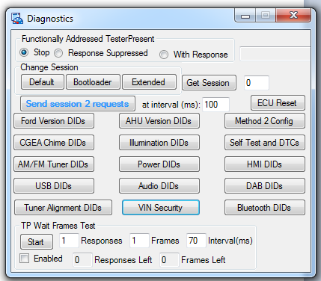

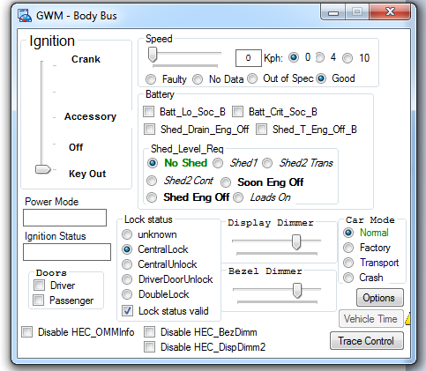

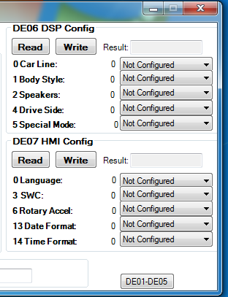

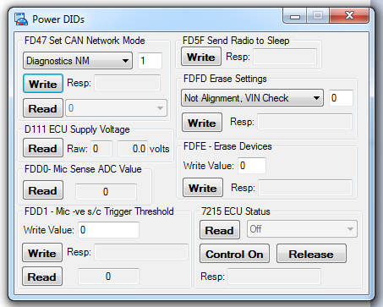

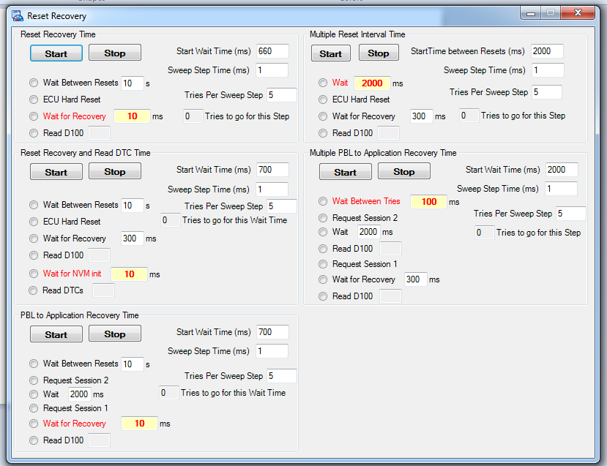
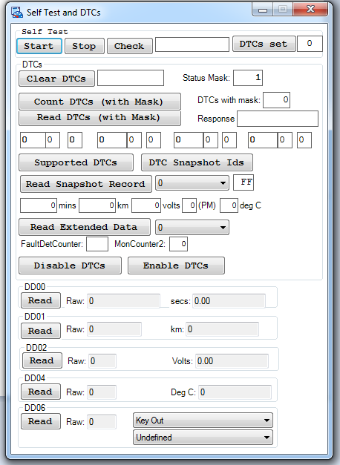

Sample code(for understanding purpose only)

Code to send ECU Diagnostic Message:

SendACUDiagnostic ()
{
SendDiagMessage(ACUDIAGRx);
if ( getValue(diag_TesterPresent) )
{
cancelTimer(TesterPresentTimer);
setTimer(TesterPresentTimer,4000);
}
}

SendDiagMessage(int multiframe_id)
{
int ActualMultiframeId;
int i;
//write("SendDiagMessage(%d)",multiframe_id);
if ( ACUDIAGRx == multiframe_id )
{// maybe functional addressing
if ( getvalue(diag_FunctionalAddressing) )
{
if ( send_len > 7 )
{ // TP messages never sent with FA
ActualMultiframeId = multiframe_id;
}
else
{
switch ( send_buffer[0] )
{
case 0x10:
case 0x11:
case 0x3E:
case 0x22:
case 0x23:
case 0x24:
case 0x2E:
case 0x3D:
case 0x14:
case 0x31:
case 0x85:
{
SendMessage(HECDIAGFA);
break;
}
case 0x19:
{
switch( send_buffer[1] )
{
case 0x01:
case 0x02:
case 0x06:
case 0x0A:
{
SendMessage(HECDIAGFA);
break;
}
default:
{
SendMessage(multiframe_id);
break;
}
}
break;
}
default:
{
SendMessage(multiframe_id);
break;
}
}
}
}
else
{
SendMessage(multiframe_id);
}
}
else
{
SendMessage(multiframe_id);
}
}

TesterPresent checked every 4 seconds
on timer TesterPresentTimer
{
int TesterPresent;

TesterPresent = getValue(diag_TesterPresent);

if ( TesterPresent )
{
send_buffer[0] = 0x3E;
if ( TesterPresent < 2 )
{
send_buffer[1] = 0x00;
}
else
{
send_buffer[1] = 0x80;
}
send_len = 2;
SendDiagMessage(HECDIAGFA);
putvalue(diag_strTesterPresentResponse,"");
settimer(TesterPresentTimer,4000);
}
}

on envVar diag_TesterPresent
{
switch ( getvalue(this) )
{
case 0:
{ //stop
cancelTimer(TesterPresentTimer);
break;
}
case 1:
{ // start response
cancelTimer(TesterPresentTimer);
setTimer(TesterPresentTimer,10);
break;
}
case 2:
{ // start response suppressed
cancelTimer(TesterPresentTimer);
setTimer(TesterPresentTimer,10);
break;
}
default:
{
break;
}
}
}

Change to default session:
on envVar diag_GoToDefault
{
if ( getvalue(this) )
{
send_buffer[0] = 0x10;
send_buffer[1] = 0x01;
send_len = 2;
SendACUDiagnostic();
}
}

Change to programming session:
on envVar diag_GoToBootLoader
{
if ( getvalue(this) )
{
send_buffer[0] = 0x10;
send_buffer[1] = 0x02;
send_len = 2;
SendACUDiagnostic();
}
}

Get current session value:
on envVar diag_GetSession
{
if( getvalue(this) )
{
putvalue(diag_Session,0);
}
else
{
send_buffer[0] = 0x22;
send_buffer[1] = 0xD1;
send_buffer[2] = 0x00;
send_len = 3;
SendACUDiagnostic();
}
}

Change to extended session:
on envVar diag_GoToExtended
{
if ( getvalue(this) )
{
send_buffer[0] = 0x10;
send_buffer[1] = 0x03;
send_len = 2;
SendACUDiagnostic();
}
}

Read PID
ReadPID (word PIDid)
{
send_buffer[0] = 0x22;
send_buffer[1] = (PIDid>>8)&0xFF;
send_buffer[2] = PIDid&0xFF;
send_len = 3;
SendACUDiagnostic();
}

UDS, CANoe, CAPL FAQs

What are the different variants of CANoe?

CANoe is available in different CANoe variants to adapt the software product to the needs of the user.

CANoe CANoe Full Variant CANoe Full - enables the creation and manipulation of the entire feature set of CANoe.

CANoe Run – CANoe Runtime CANoe Run allows the user to execute configurations that were developed using CANoe Full. Users are not able to make any changes or create new objects in the simulation part of CANoe Run (Simulation Setup). A user can think of CANoe Run as a "Read Only" version of CANoe. The analysis part (Measurement Setup) can be adapt to the needs and channels may be added, removed or filtered in CANoe Run.

CANoe Pex – CANoe Panel Executable CANoe Pex allows the user to execute and interact only with the panels developed in CANoe Full. None of the analysis windows are viewable and changes cannot be made to panels.

Logging in CANoe?

Default logging format From version 7.0 on the default logging format can be set in the global option dialog of CANoe/ CANalyzer under Application Settings|Logging. This default format is only used for modules where files have to be written.

What is the difference between Environment and System variables in CAPL?

In CANoe system variables can be used for modelling internal parameters. In contrast to environment variables, system variables describe neither external input/output signals of a node nor they are used for communication of signals between nodes in a real network Instead, system variables are used for development and testing since they provide the opportunity to change and to analyse internal variables and parameters. They are also used to indicate signals in CANoe which are not defined in a database and which were not received via a network (e.g. I/O signals).

What is J1939/21 Transport Protocol?

What is J1939 software stack?
J1939 stack, for automotive ECU and tooling applications in commercial vehicles, is an embedded software code with layered architecture and is compliant with J1939 standard.
J1939 is a standard (set of embedded software specifications) defined by SAE (Society of Automotive Engineers).
The SAE J1939 protocol specifications are defined for CAN bus.
What is J1939/21 – Transport Protocol?
CAN bus, of the in-vehicle network, supports transfer of data of only up to 8 bytes. But SAE J1939 software standard allows messages of more than 8 bytes to be sent between the devices/ECU.
This is facilitated by the Transport Protocol (embedded software specification – J1939/21) of the J1939 software stack.
The CAN based J1939/21 Transport Layer sends messages of more than 8 bytes through multiple packets.
CAN based J1939/21 layer defines the format, sending and reassembling of the packets. It also defines the specifications related to handshake.

How many bytes of data J1939/21 transport protocol support?
A maximum of 1785 bytes can be transferred using Transport Logic/ Transport Layer through CAN based J1939 software stack.
Explanation behind 1785 bytes of data:
- Data frame in CAN based J1939 stack contains 8 bytes. Transport Protocol (J1939/21) utilizes 1st byte of the message frame for number sequencing.
- Remaining 7 bytes/packet are utilized for data transfer.
- And maximum number of packets that can be sent before reset is 255.
- Hence, maximum number of bytes that can be sent before reset is 1785 bytes (255 packets*7 bytes of data/packet).

How Transport Protocol supports Connection Mode – point to point data transfer?
For point to point communication (connection mode), from Source to a specific Destination, transfer of data bytes is facilitated in the following way:
.
.
.
In such a connection mode, from source node to destination node transport of data happens with a handshake between the nodes as shown in above diagram.
Here in the last packet of transmission, there are only five bytes of data, and remaining two bytes are padded with FF (hex) data.

How Transport Protocol (J1939-21) supports transfer of Broadcast Announcement Message (BAM)?
For broadcasting of message, from Source to a several Destinations, transfer of data bytes is facilitated in the following way:
.
.
.
In broadcasting of the message, from source node to destination nodes, transport of data happens without any handshake between the nodes as shown in above diagram.
Here Source node doesn’t wait for confirmation or handshake from destination node(s).
In BAM transfer, in the last packet of transmission there are only five bytes of data, and remaining two bytes are padded with FF(hex) data.
What is J1939 software stack?
Learn about the layered architecture and diagnostic trouble codes (DTC)

What is SAE J1939?
SAE J1939 is a software standard defined by Society of Automotive Engineers (SAE). This software standard has been designed to ensure that Electronic Control Units (ECU) manufactured by different automotive suppliers are able to communicate with each other within an in-vehicle network.
SAE J1939 standard is defined for applications in commercial vehicles for CAN (Controller Area Network) bus.

What is J1939 stack?
J1939 stack is an embedded software stack with layered architecture, compliant with SAE J1939 standard.
This pre-tested software stack, designed by our embedded automotive engineers, can be easily integrated with commercial vehicle applications for diagnostics and communication services.
Our product engineering team has also developed J1939 bootloader for automotive ECU reprogramming services.
J1939 layered architecture specifications – as defined by SAE
The Society of Engineers (SAE) has defined all the functions supported by different layers of the J1939 software stack.
.
.
Following are the details:
- J1939/21 – Data Link/ Transport Layer: This layer defines the Message/Frame Format, Protocol Data Unit (PDU) Formats, Message Type, Message Priority, Bus Access, Arbitration, Error Detection, PGNs and Transport Protocol Functions
- J1939/81 – Network Management Layer: This layer defines Name ECU, Address, Network Management Procedure, Network Error Management, Address Claim and ECU Initialization procedures
- J1939/71 – Vehicle Application Layer: This layer defines Parameter Group Numbers (PGNs), Suspect Parameter Numbers (SPNs) with the Scaling, Limits and Parameter Offset Size.
- J1939/73 – Application Layer for Diagnostics services: This layer defines Diagnostic Trouble Codes (DTC), Diagnostic Parameter Group Definitions and Diagnostic Messages (DM)
(Source: SAE)

What is Diagnostic Trouble Code (DTC) in J1939 stack?
When certain failure occurs in an automotive ECU, it is noted in the form of a Diagnostic Trouble Code (DTC), also known as Fault Code. DTCs’ are defined by SAE J1939 standard.
Diagnostic Trouble Code (DTC) has the following fields:

.
Where:
SPN is Suspect Parameter Number (19 bits)
FMI is Failure Mode Identifier (5 bits)
OC is Occurrence Count (7 bits)
CM is SPN Conversion Method (1 bit).
With help of DTC one can understand failure that has been reported.
For Example:
SPN = 91 Suspect parameter is accelerator pedal position
FMI = 3 Failure mode is identified as voltage above normal
OC = 9 Occurrence count indicates trouble has occurred 9 times
CM = 0 Conversion Method is Intel.

What are Diagnostic Messages (DM) in J1939 software stack?
Diagnostic Messages are messages which give information about the health of the system, intimating about the malfunctions which have currently occurred in the automotive system.
Following are the examples of some of the Diagnostic Messages (DM) in J1939:
- DM1 Message (Active Diagnostic Trouble Codes):
Diagnostic Message 1 (DM1) reports active diagnostic codes that are preceded by the diagnostic lamp status in the message byte. It reports diagnostic condition of the automotive ECU over the In-Vehicle Network with Suspect Parameter Number, Failure Mode Identifier and Occurrence Count.
- DM2 Message (Previously Active Diagnostic Trouble Codes):
Diagnostic Message 2 (DM2) reports previously active diagnostic codes that are preceded by the diagnostic lamp status in the message byte. It reports diagnostic condition of the Automotive ECU over the in-vehicle network with same details.
- DM3 Message (Diagnostics Data Clear):
This message indicates that all the Diagnostic information pertaining to the previously active trouble codes should be cleared or non-active trouble codes should be reset. This ensures that the active trouble codes, which are present in ECU, are not impacted.

What does a Diagnostic session describe?
- Applicable services
- Amount of functionality
- Timing parameter values

What is a default session?
- No tester present required to keep the session active
- Does not support any diagnostic application timeout provision
- Does not require security capability

What is a Programming session?
All diagnostic services required to support memory programming of ECU

What is an Extended session?
Enables all diagnostic services supported by individual ECU. Timer controlled environment for ECU in which all of the supported diagnostic services can be executed. All diagnostic services are supported in extended diagnostic session (some are with security features and must be unlocked before use)

What is Hard Reset?
Simulated power on or start up sequence typically performed after ECU has been previously disconnected from its power supply. All memory (volatile or NV) are initialised.

What is Soft reset?
Like IGN cycle, causes ECU to immediately restart the application program. Saves any data in the NVM before restart.

Why diagnostics?
Robust on-board diagnostics combined with off-board diagnostics procedures for proper identification, isolation, and correction of failed components and systems. Satisfying their objectives contribute to reduction of product life cycle costs and improvements of overall customer satisfaction.

Reprogramming done by diagnostics application layer and so considered a diagnostic function.

Via diagnostics we can do,

- ECU configuration data
- System operation
- Performance
- ECU calibration

ECU configuration immediately becomes active, no reset required.

What is Functional and Physical addressing?
Functional – Requests are sent by means of a global diagnostic address ID. This method is intended to address multiple ECUs
Physical – Requests are sent by means of a diagnostic identifier assigned to a specific ECU

ECU shall support Physical as well as Functional addressing

ECU can handle only one diag request per time.

What is Network transport layer in Diagnostics?
Large blocks of data are transferred between ECU and test tool. This layer transforms data frames received from Data link layer into messages. These messages are mapped to diagnostic protocol services by the application layer.
ECU shall set DLC to 8 when transmitting protocol messages

NW transport protocol controls data segmentation, reconstruction of long messages, timeout handling, and message flow control.

NW transport layer extensively for flash programming and multi frame enhanced protocol messages.
ECU shall not set DTC when tool requests a hard reset.

What is Direct and indirect memory access?

Direct memory access shall be used for engineering development only and protected by mode and security access.
Indirect memory access – Write data to ECU via 2E service.

What parameters does Diagnostics receive for monitoring and executing diagnostics services and DTC?
ECU receives and monitors following parameters –

- Vehicle odometer
- Ignition state
- System voltage

Write short note on 2F service?

Used by external tool to substitute a value

ECU shall re-assume control over the outputs previously under control of the external test tool if one of the following conditions are met:

- A request to Return control to the ECU
- A session transition occurs
- A ECU reset occurs
- Internal disable conditions

What are the Diagnostics Operations required in an ECU?

- Report ECU info
- Report Vehicle Information
- Report IO device information
- Report IO actuation status
- Report or Modify information
- Set/Clear/Age diagnostics fault information
- Secure access to protected information
- Initiate test functions and on board processes
- Set vehicle configuration parameters
- Run calibration tests

What are the different ECU failure groups and failure modes?

- Power faults – Battery High/low, open/Shorted
- Network status – lost communication with ECU
- Signal/Data – Implausible signal received from ECU X
- Network performance – Bus performance
- Network Electrical – CAN Hi/Lo faults/Open/Shorted
- Invalid signal – Circuit High/Low/Open/General electric failure
- Inactive Signal – Stack open/closed/performance
- Signal performance – Circuit erratic/ comparative performance
- Internal faults – ECU internal faults
- Failures of internal components – memory/IC components

Preconditions/enable conditions must be satisfied prior to and during the fault maturation (Active DTCs) or de-maturation process (stored not active DTC).

- IGN status
Network communication failure detection is performed only with IGN in RUN state
- Local/system voltage
- Network configuration status
- Bus physical status
- IO device configuration
- Debounce timer

What is Mature criteria?

Mature criteria defined as failure threshold, monitor internal, declaration rate and time required to set an active DTC

Monitor interval = Min time required to set active DTC

Threshold = boundary once exceeded, failures may be matured. Matured indicates test failed and ‘Test failed’ sets to 1.

What is Monitor interval?

Way a component/system is tested for failure.

Continuously monitored:
Periodically polled for active failure. Condition for both fault maturation and dematuration process.

Non-continuously monitored:
On demand, event driven, one-time instance for active failure condition for fault maturation process

ECU shall provide a mechanism called routine to check non-continuous failures. (ODST, Peripheral test etc.)

What is failure time?

Indicates time interval required to mature an active DTC condition.

