Movie Recommendation System using Big Data Analytics
Minor Project Report · Krishanu Anand · 15 October 2026
GitHub: https://github.com/anand-krishanu/AttractorField

Abstract
This project builds an end-to-end Big Data pipeline on the MovieLens ml-25m dataset (25,000,095 ratings from 162,541 users on 59,047 movies). Data is ingested into Google Cloud Storage and processed with PySpark on Google Cloud Dataproc using a Bronze → Silver → Gold medallion architecture. Spark SQL and window functions produce analysis-ready tables, and a Spark MLlib ALS collaborative-filtering model predicts ratings with a test RMSE of 0.7874 (vs. 1.0578 for a global-mean baseline) and generates a personalised Top-10 list for every user. Results are presented in an interactive Streamlit dashboard, and the workflow is orchestrated with a runner script and an Airflow DAG.

1. Problem Definition
Streaming catalogues contain tens of thousands of titles; users struggle to discover movies they will enjoy, and content teams lack visibility into how tastes evolve. Manually curated lists do not scale to millions of users.

Objectives
- Ingest and store a large real-world ratings dataset in the cloud with full lineage metadata.
- Clean and validate the data (nulls, duplicates, invalid values, orphan keys, inconsistent text).
- Produce analysis-ready Gold tables: popularity, weighted ratings, genre trends, user segments, KPIs.
- Train and evaluate a scalable recommender (ALS) that beats a naive baseline.
- Deliver personalised Top-10 recommendations and an interactive dashboard built on real outputs.

Target users & expected outcomes
- Viewers: personalised, unseen movie recommendations and 'similar movies'.
- Product/content teams: KPIs, genre trends and user segments to guide acquisition and promotion.
- Outcome: an automated, reproducible pipeline from raw data source to end-user dashboard.

2. Dataset
MovieLens 25M is a stable benchmark dataset released by GroupLens Research (University of Minnesota) in 2019. It contains explicit 0.5–5 star ratings collected on movielens.org between 1995 and 2019; each user has rated at least 20 movies. Files: ratings.csv (userId, movieId, rating, timestamp), movies.csv (title with year, pipe-separated genres), tags.csv (free-text user tags) and links.csv (IMDb/TMDb ids). Source: https://grouplens.org/datasets/movielens/25m/ . The smaller ml-latest-small release (100k ratings) was used for local development and testing.
Citation: F. Maxwell Harper and Joseph A. Konstan. 2015. The MovieLens Datasets: History and Context. ACM Transactions on Interactive Intelligent Systems 5, 4, Article 19. https://doi.org/10.1145/2827872

3. Architecture & Technologies
GroupLens → ingest.py → GCS raw/ → Bronze (Parquet) → Silver (clean, partitioned) → Gold (analytics) + MLlib ALS (output/) → Streamlit dashboard. Orchestration: run_pipeline.py (local Docker), scripts/dataproc_run.ps1 (Google Cloud) and an Airflow DAG (dags/movie_reco_dag.py).
Layer | Technology
Storage | Google Cloud Storage (data lake), Parquet (columnar, partitioned)
Processing | Apache Spark 3.5 / PySpark, Spark SQL, window functions
Machine learning | Spark MLlib ALS, RegressionEvaluator, RankingEvaluator
Cloud compute | Google Cloud Dataproc 2.2 (1 × e2-standard-2 master, 2 × e2-highmem-4 workers)
Orchestration | Apache Airflow DAG (Dataproc operators), PowerShell/Python runners
Visualisation | Streamlit + Plotly dashboard
Dev environment | Docker image apache/spark 3.5.3 (Java 17) mirroring Dataproc; GitHub with PR workflow

4. Methodology

4.1 Ingestion & Bronze layer
ingest.py downloads the official zip, writes a manifest (source URL, timestamp, file sizes) and uploads the raw CSVs to GCS — on Dataproc this runs on the cluster so data never passes through the client. bronze.py reads the CSVs with explicit schemas (no inference) and adds ingest_ts, source_file and dataset_version columns before writing Parquet, preserving the raw values for lineage and reprocessing.

4.2 Silver layer – cleaning
silver.py removes null keys, out-of-range ratings and invalid timestamps; resolves duplicate (user, movie) ratings by keeping the latest one with a row_number() window; drops ratings that reference unknown movies (left-semi join); converts epoch seconds to timestamps; extracts the release year from the title with a regex; turns the pipe-separated genres into arrays (mapping '(no genres listed)' to null); lower-cases and de-duplicates tags; and joins IMDb/TMDb links. Ratings are written partitioned by rating_year. Each check is logged:
table | check | rows_before | rows_after | removed
movies | null id/title | 62,423 | 62,423 | 0
movies | duplicate movieId | 62,423 | 62,423 | 0
ratings | null fields | 25,000,095 | 25,000,095 | 0
ratings | invalid rating/timestamp | 25,000,095 | 25,000,095 | 0
ratings | duplicate user-movie | 25,000,095 | 25,000,095 | 0
ratings | orphan movieId | 25,000,095 | 25,000,095 | 0
tags | null/empty tag | 1,093,360 | 1,093,360 | 0
tags | duplicate tag | 1,093,360 | 1,093,359 | 1

4.3 Gold layer – analytics
- movie_stats: count, mean, std-dev and an IMDb-style Bayesian weighted rating WR = v/(v+m)·R + m/(v+m)·C (m = 90th percentile of vote counts) so that low-count movies do not dominate.
- top_movies_by_genre: rank() over a window partitioned by genre (top 20 per genre).
- genre_trends: Spark SQL over a temp view with LAG() to compute year-over-year growth per genre.
- user_activity: per-user volume, average rating, first/last activity and a segment (casual→power).
- user_top_rated, rating_distribution, top_tags and yearly_kpis (with a running cumulative total).

4.4 Recommendation model – Spark MLlib ALS
Alternating Least Squares factorises the sparse user × movie rating matrix into low-rank user and item factor matrices; predicted rating = dot product of the two factor vectors. A first run on all movies showed that titles with only 2–10 ratings received extreme factors and flooded every user's top-10 (precision@10 = 0), so the model is trained only on movies with at least 50 ratings (13,176 movies, still the vast majority of all ratings). Data was split 70/10/20 (train/validation/test, seed 42). A grid over rank ∈ {10, 20} and regParam ∈ {0.05, 0.1} (maxIter 10, non-negative factors, coldStartStrategy=drop) was evaluated on the validation split; the best configuration was refit on train+val and evaluated once on the held-out test split. Ranking quality was measured with precision@10 and NDCG@10 on a sample of 2,000 users, treating test movies rated ≥ 4 as relevant. Recommendations exclude movies the user has already rated. Item-item similarity was computed as cosine similarity between ALS item factors using Spark SQL higher-order functions.

5. Results & Analysis

5.1 Exploratory analytics
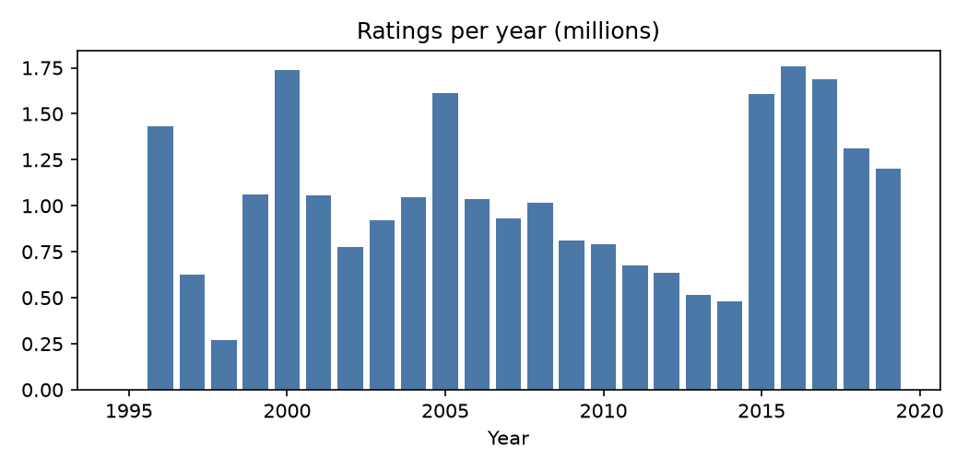
Figure 1 – Rating volume per year
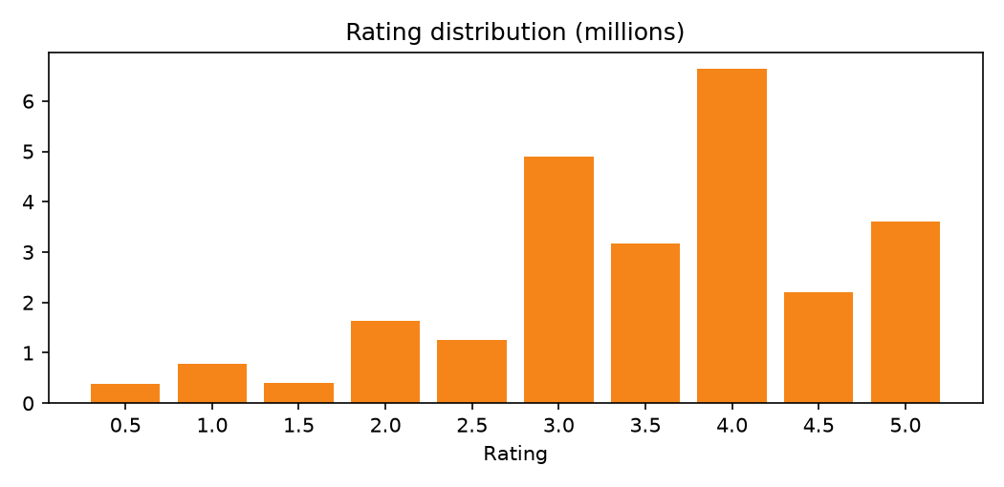
Figure 2 – Distribution of ratings
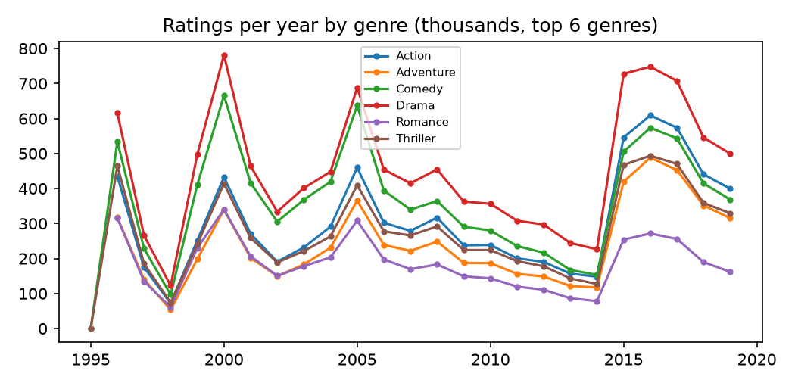
Figure 3 – Genre popularity over time
Ratings are skewed positive: 50% of ratings are 4 stars or more and whole-star ratings dominate half-stars. The busiest year was 2016. Users rated on average 154 movies (median 71), showing a long-tail activity distribution; 6.0% of users are 'power' users with 500+ ratings.

Top-rated movies (Drama, by weighted rating)
rank | clean_title | release_year | num_ratings | avg_rating | weighted_rating
1 | Shawshank Redemption, The | 1,994 | 81,482 | 4.414 | 4.410
2 | Godfather, The | 1,972 | 52,498 | 4.324 | 4.319
3 | Godfather: Part II, The | 1,974 | 34,188 | 4.262 | 4.255
4 | Schindler's List | 1,993 | 60,411 | 4.248 | 4.244
5 | Seven Samurai (Shichinin no samurai) | 1,954 | 13,367 | 4.255 | 4.237
6 | 12 Angry Men | 1,957 | 16,569 | 4.243 | 4.229
7 | Band of Brothers | 2,001 | 1,356 | 4.399 | 4.226
8 | Fight Club | 1,999 | 58,773 | 4.228 | 4.224
9 | One Flew Over the Cuckoo's Nest | 1,975 | 36,058 | 4.219 | 4.213
10 | Casablanca | 1,942 | 26,890 | 4.207 | 4.199

5.2 Model evaluation
rank | regParam | validation RMSE
10 | 0.050 | 0.800
10 | 0.100 | 0.814
20 | 0.050 | 0.791
20 | 0.100 | 0.811

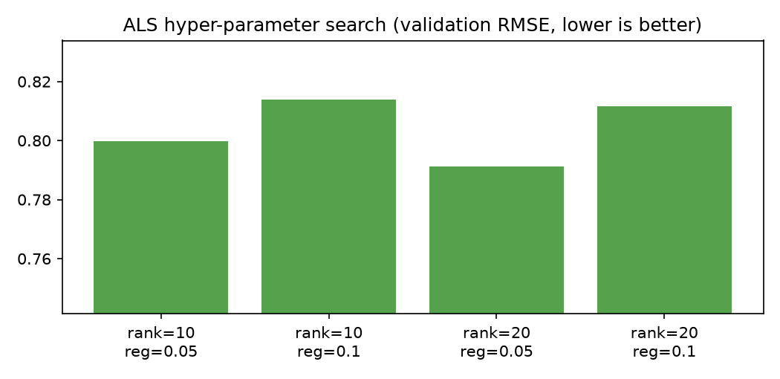
Figure 4 – Hyper-parameter search
Metric | Value
Best parameters | rank=20, regParam=0.05
Train / Val / Test rows | 17,252,352 / 2,462,699 / 4,929,877
Test RMSE (ALS) | 0.787
Test RMSE (global-mean baseline) | 1.058
Test MAE | 0.609
Precision@10 | 0.024
NDCG@10 | 0.031

ALS reduces RMSE by 25.6% relative to always predicting the global mean, i.e. on average its predictions are within ~0.61 stars of the true rating. Ranking metrics are low in absolute terms, which is expected for top-10 retrieval from tens of thousands of movies when only held-out test ratings count as relevant; they serve as a baseline for future improvements.
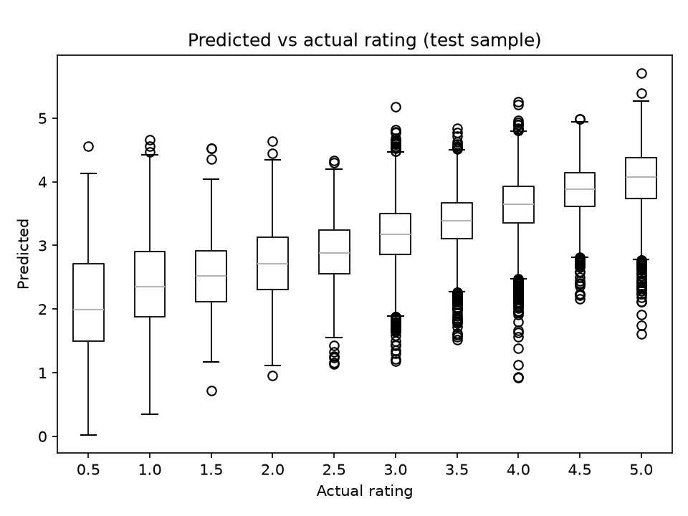
Figure 5 – Predicted vs actual ratings on the test split

5.3 Sample recommendations
User 148 – favourite movies (highest rated):
clean_title | rating
Paths of Glory | 5.000
Good, the Bad and the Ugly, The (Buono, il brutto, il cattivo, Il) | 5.000
Chinatown | 5.000
Life Is Beautiful (La Vita è bella) | 5.000
Seven Samurai (Shichinin no samurai) | 5.000

User 148 – Top-10 recommendations (unseen):
rank | clean_title | release_year | predicted_rating
1 | Planet Earth II | 2016 | 4.540
2 | Planet Earth | 2006 | 4.533
3 | Band of Brothers | 2001 | 4.487
4 | In the blue sea, in the white foam. | 1984 | 4.475
5 | Life | 2009 | 4.437
6 | Cosmos | – | 4.426
7 | The Adventures of Sherlock Holmes and Dr. Watson: Bloody Signature | 1979 | 4.422
8 | Alone in the Wilderness | 2004 | 4.403
9 | Blue Planet II | 2017 | 4.310
10 | Adventures Of Sherlock Holmes And Dr. Watson: The Twentieth Century Approaches | 1986 | 4.298

6. Dashboard
The Streamlit dashboard (dashboard/app.py) reads the Gold and model output Parquet files produced by the Dataproc run. It was designed from business requirements: each page answers the question of one stakeholder group, and every page follows the same reading order of headline numbers, then the main chart, then detail. Chart titles state the finding rather than the metric, one accent colour marks what matters, numbers are abbreviated for readability, and labels use plain language. Run: streamlit run dashboard/app.py
Page | Audience | What it answers
Overview | Leadership | Platform health and recommender impact
Content | Content and acquisition | Top movies per genre, genre volume vs rating, trends, tags, similar movies
Audience | Growth and marketing | Engagement segments, active users over time, rating behaviour
Recommendations | Personalisation | A user's favourites next to their predicted Top-10
Model quality | Data science | RMSE vs baseline, tuning results, error analysis
Data pipeline | Data engineering | Medallion layers, data-quality checks, Dataproc job runtimes

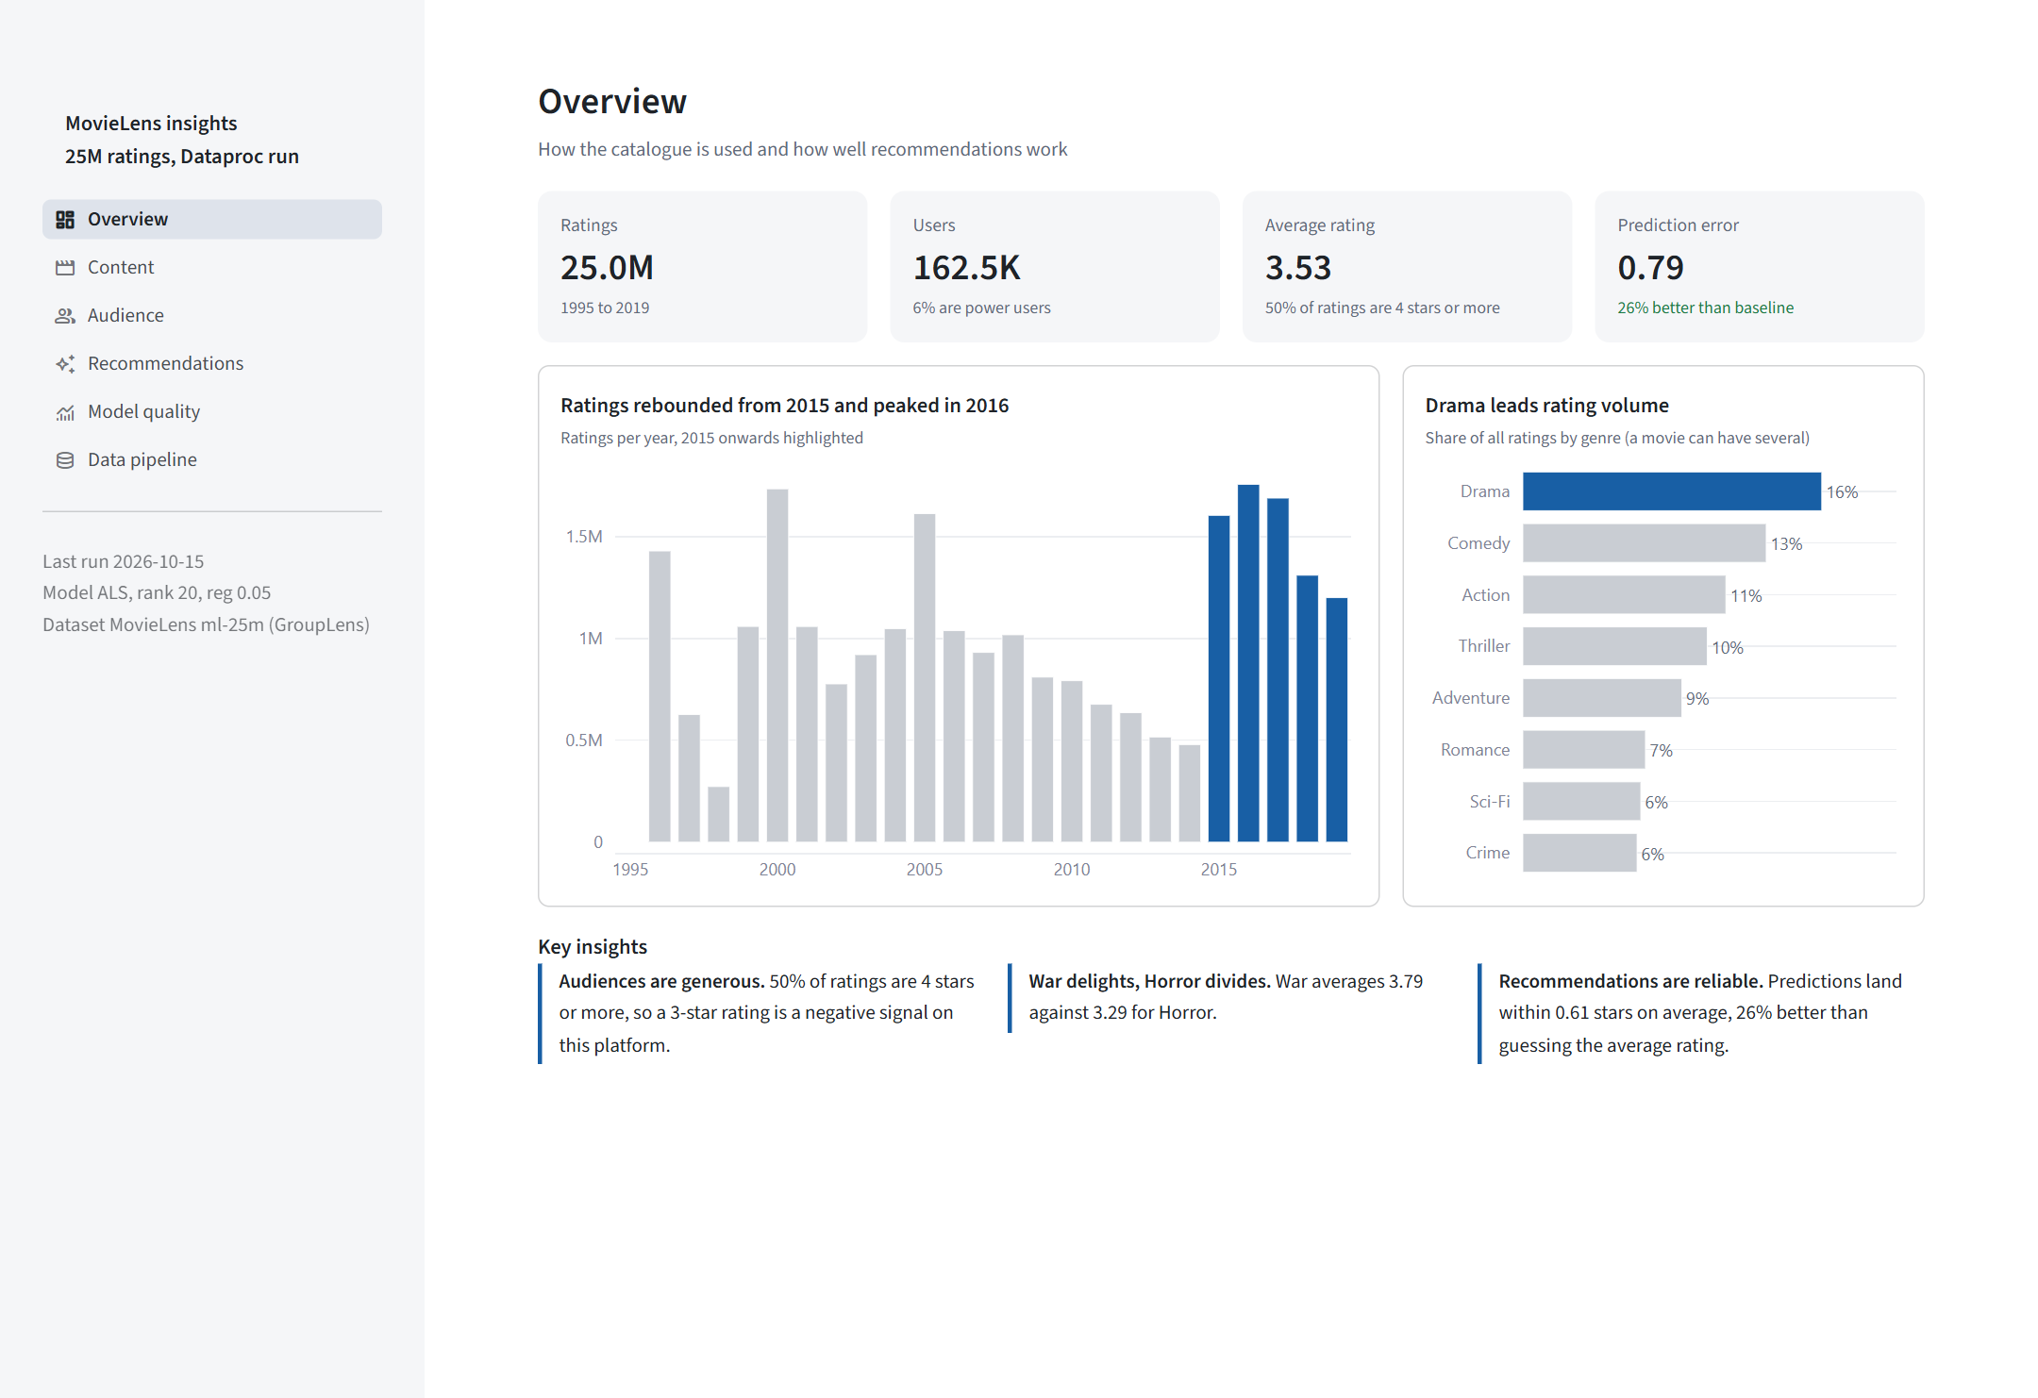
Dashboard 1 – Overview page
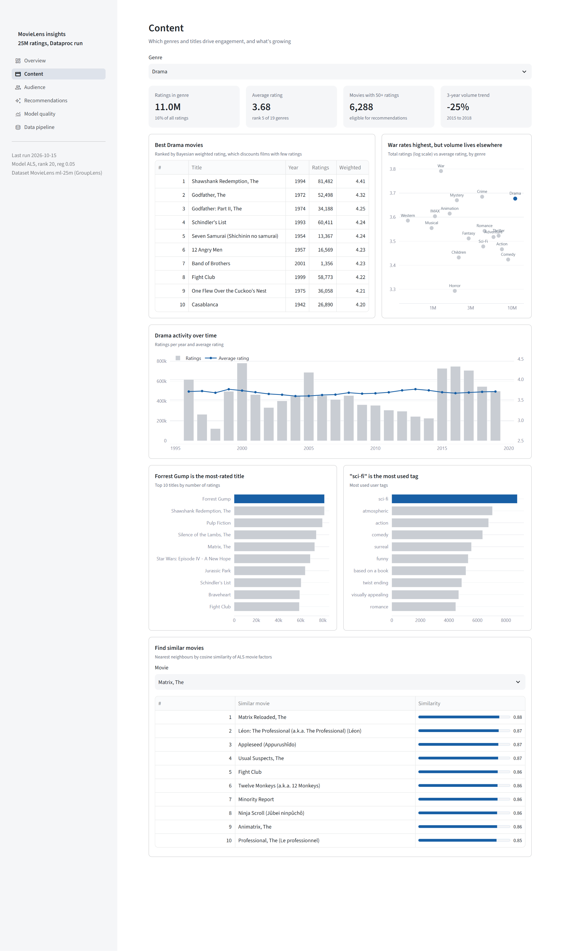
Dashboard 2 – Content page
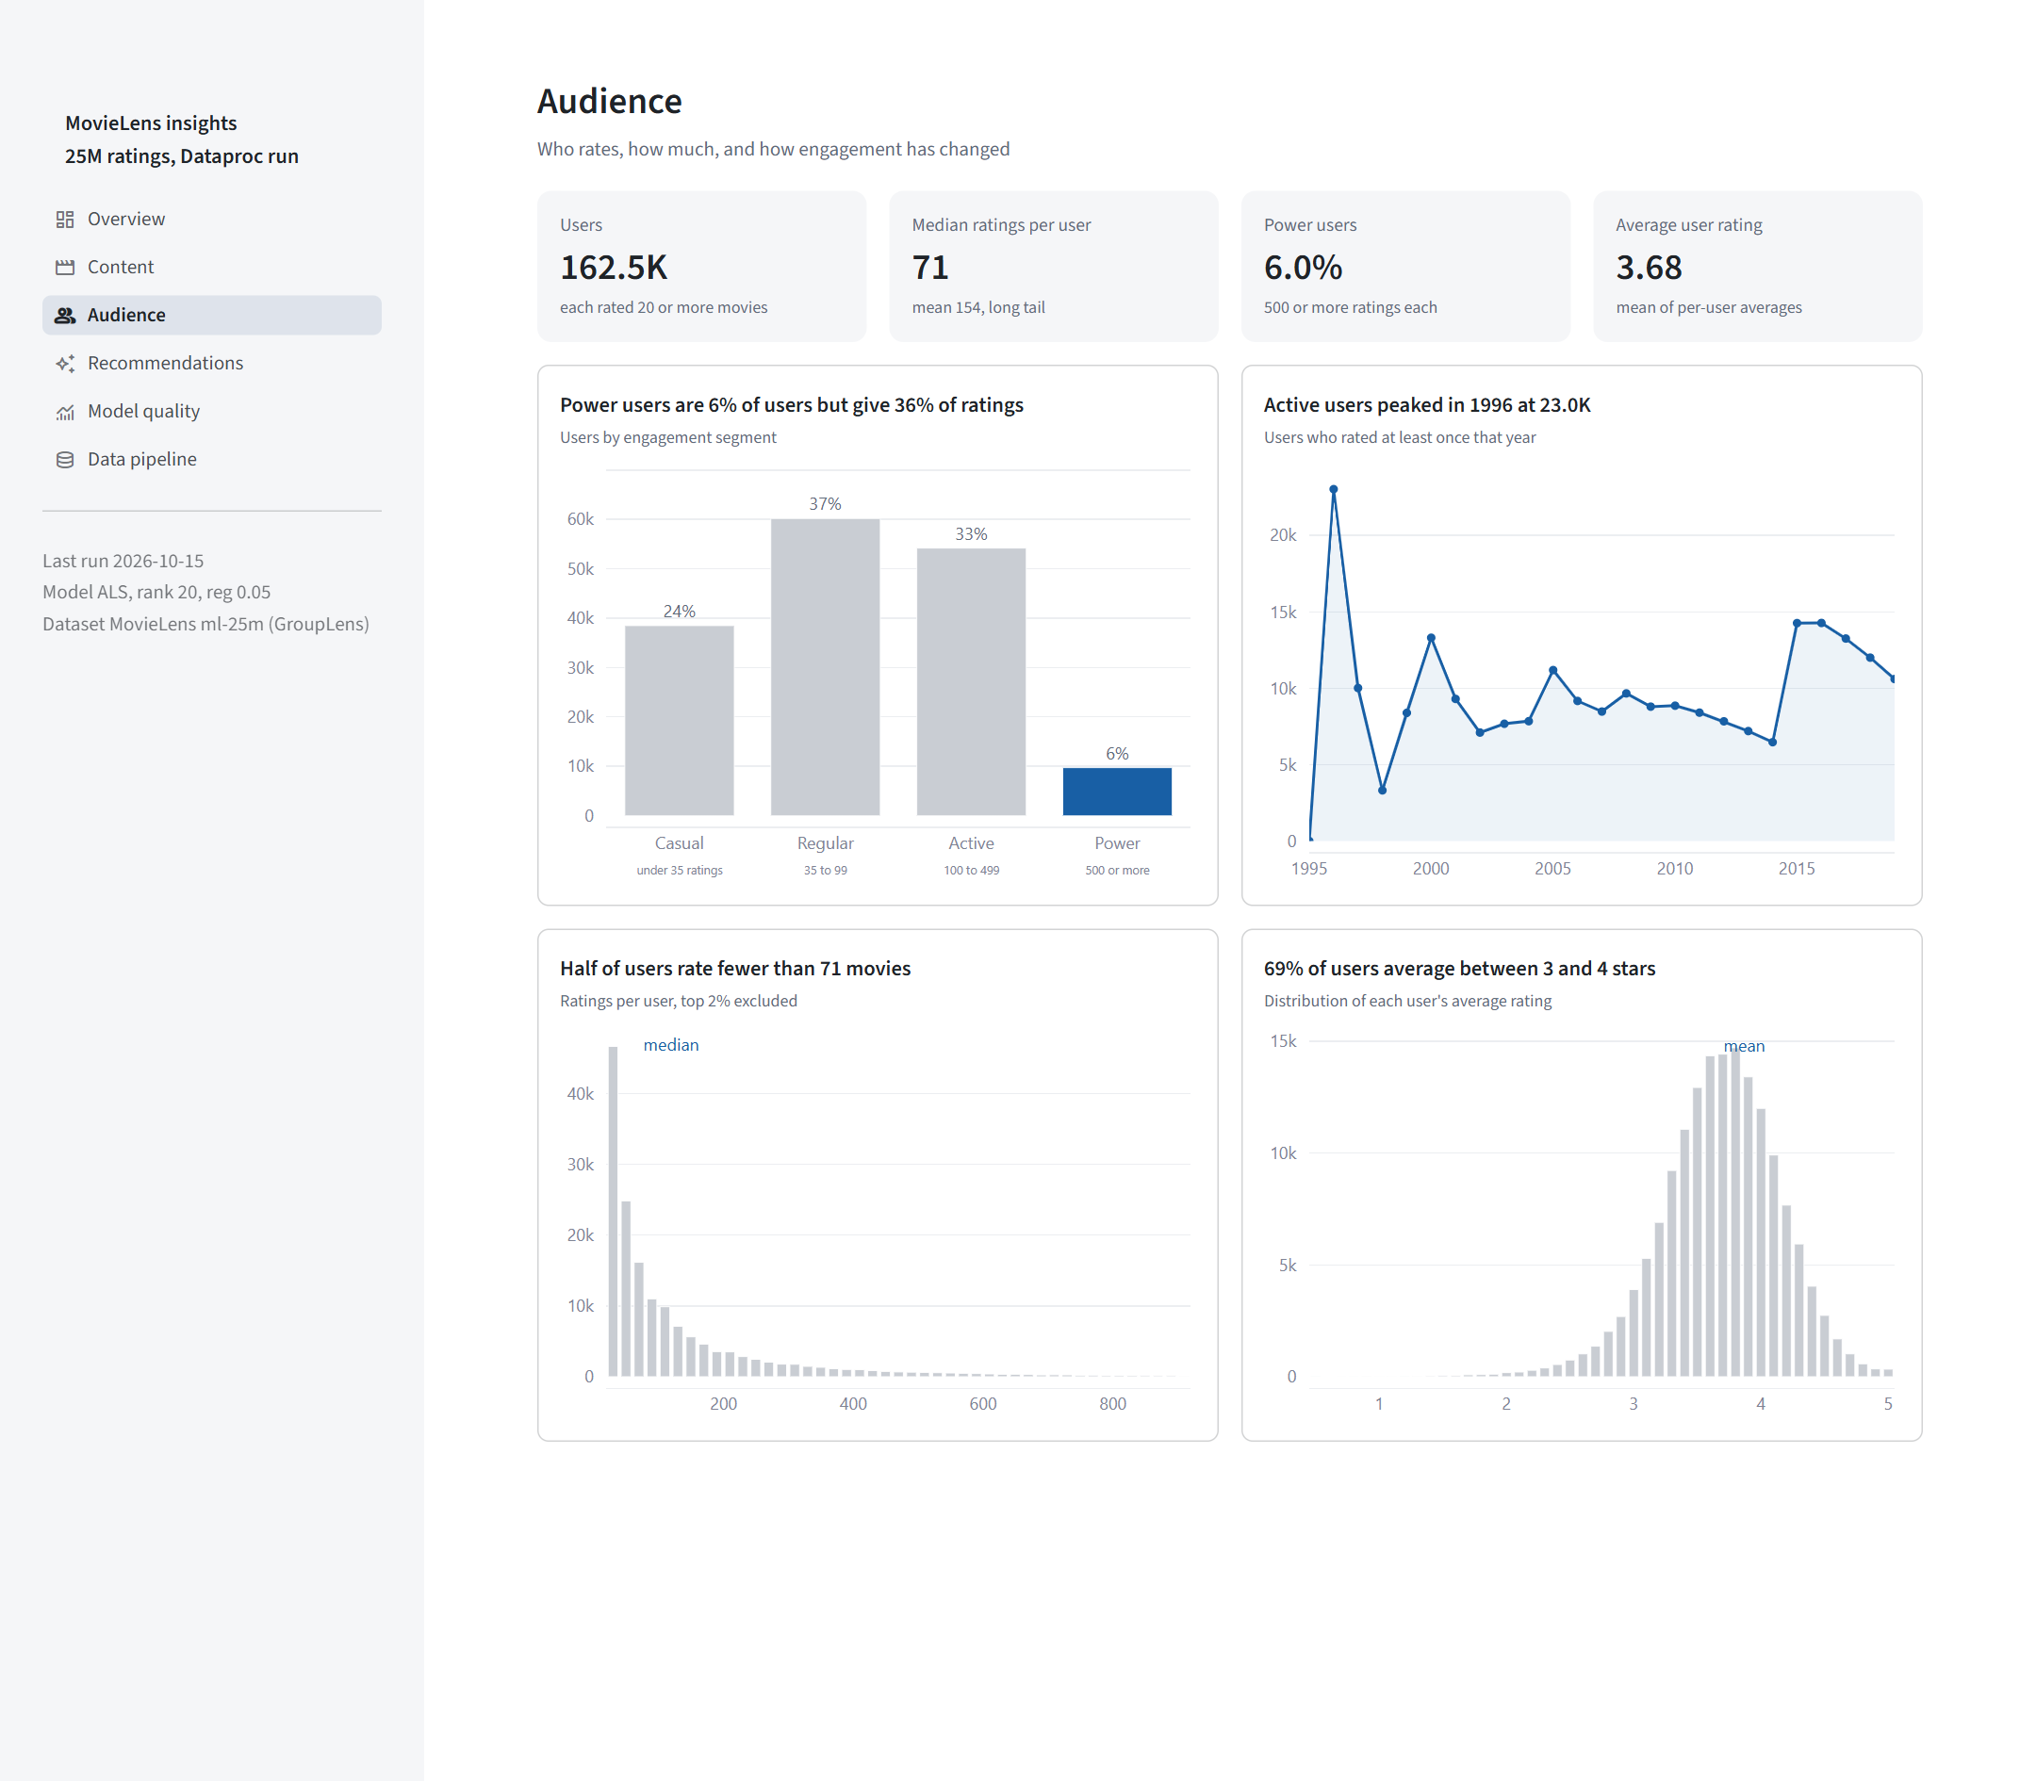
Dashboard 3 – Audience page
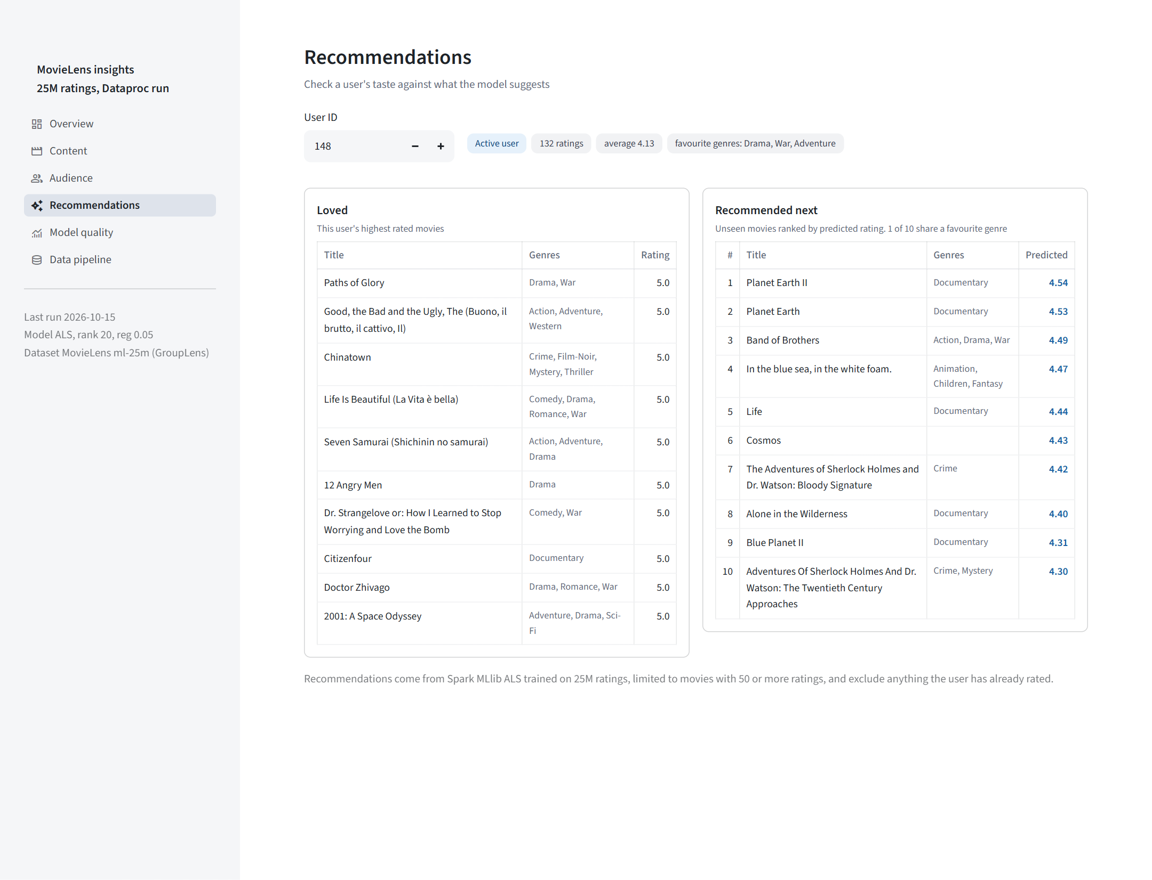
Dashboard 4 – Recommendations page
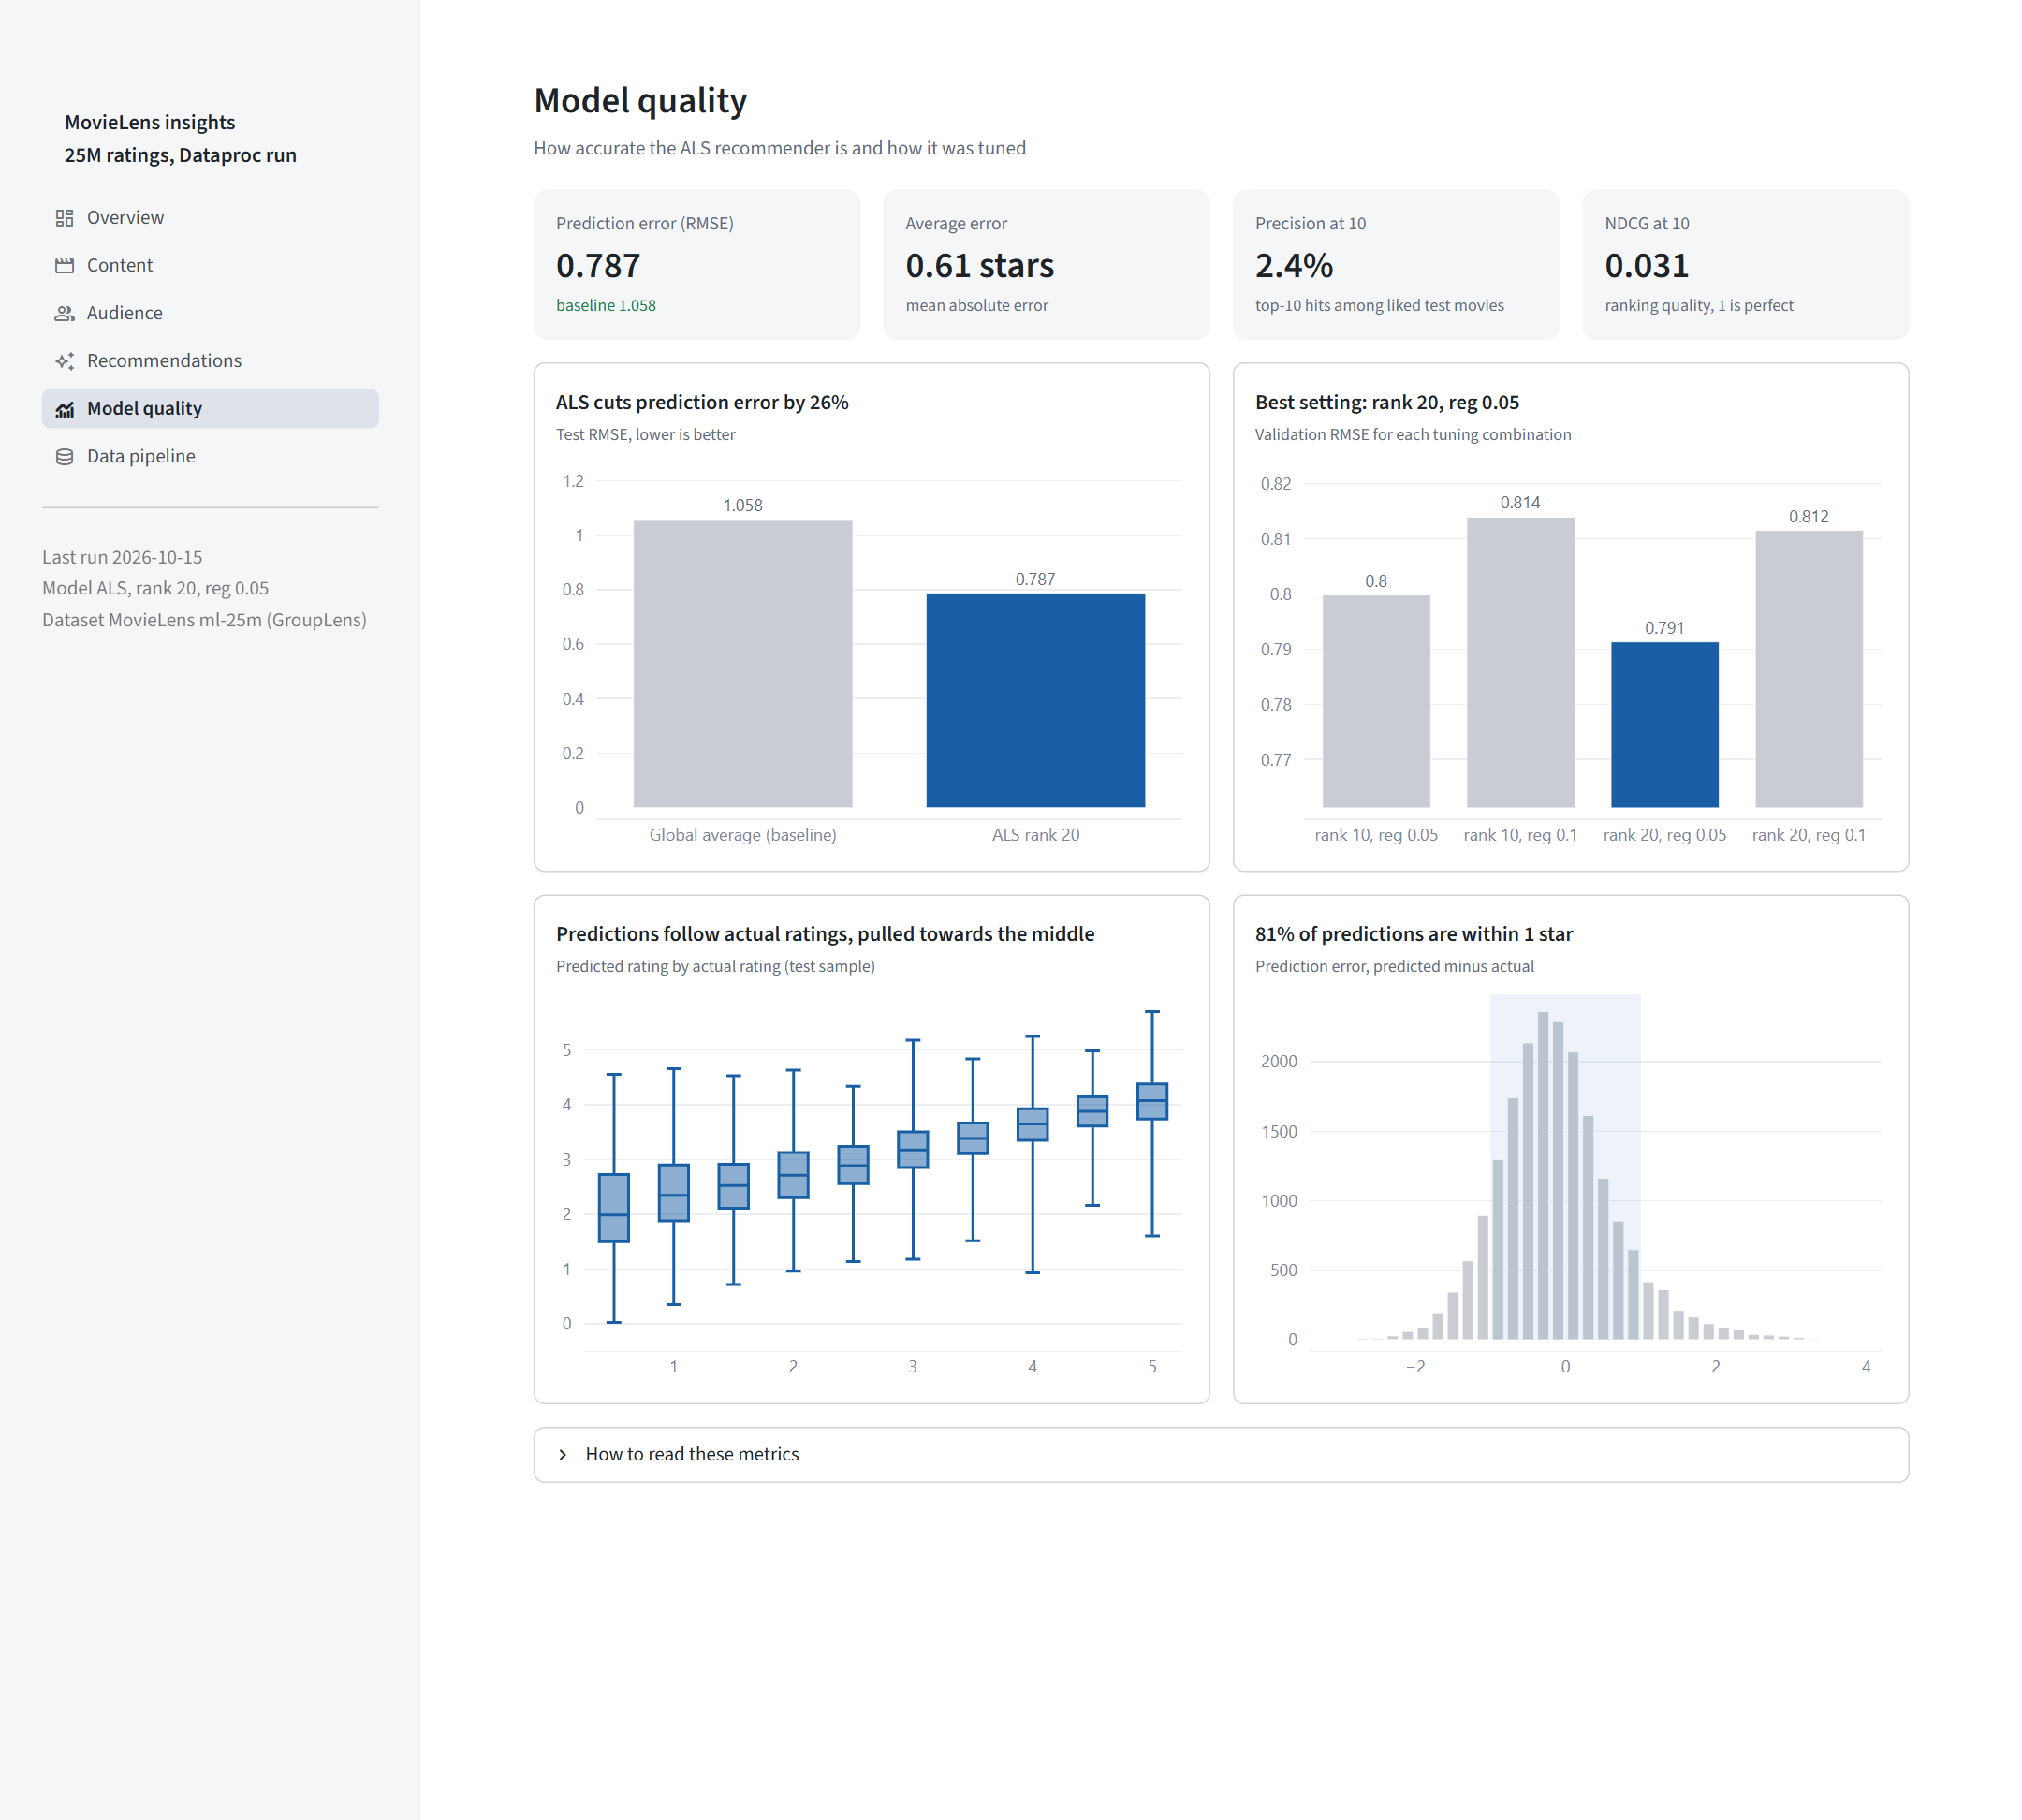
Dashboard 5 – Model quality page
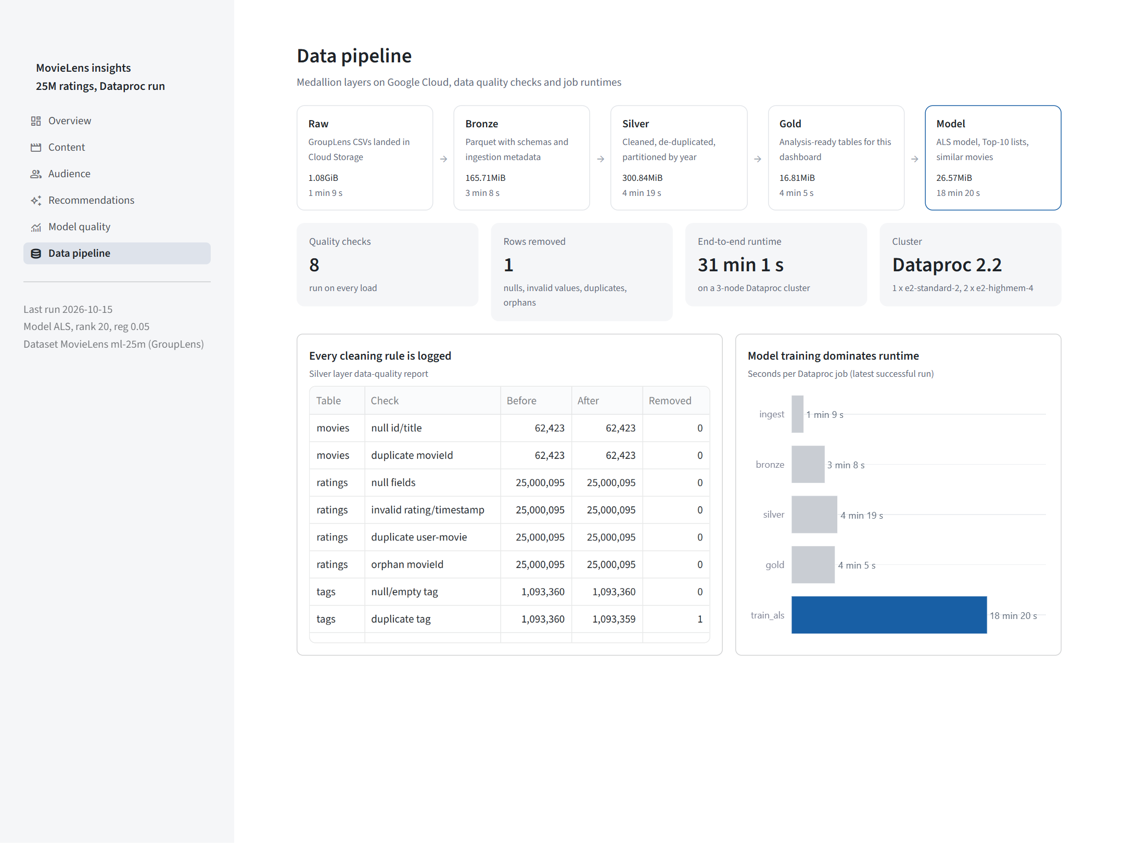
Dashboard 6 – Data pipeline page

7. Cloud execution & orchestration
scripts/dataproc_run.ps1 creates a GCS bucket and a Dataproc 2.2 cluster (auto-deleted after 30 minutes idle), uploads the code, submits ingest, bronze, silver, gold and train_als as PySpark jobs, downloads the outputs for the dashboard and deletes the cluster to minimise cost. The same steps are defined as an Airflow DAG (create_cluster → ingest → bronze → silver → gold → train_als → delete_cluster, weekly schedule, retries, cluster deletion with trigger_rule=ALL_DONE) for deployment on Cloud Composer.

Cloud execution evidence
The repository folder docs/cloud_run_evidence/ contains the Dataproc job history (jobs.txt), the cleaned run logs, the GCS bucket listing per layer (bucket_listing.txt), the Spark driver output of the final ALS job and GCP console screenshots. Job history (project movie-reco-bigdata-2026, region asia-south1):
Job id | Script | State | Start (UTC) | Seconds
d12c51a5 | ingest.py | ERROR | 2026-10-15 13:47:11 | 148
177a1681 | ingest.py | DONE | 2026-10-15 13:50:54 | 69
e02e75a2 | bronze.py | DONE | 2026-10-15 13:52:09 | 188
9cd35a5d | silver.py | DONE | 2026-10-15 13:55:27 | 259
01bdeeb7 | gold.py | DONE | 2026-10-15 13:59:56 | 245
0225b782 | train_als.py | DONE | 2026-10-15 14:04:09 | 1110
8837fca0 | train_als.py | DONE | 2026-10-15 14:30:29 | 1100

GCS layer | Size
raw | 1.08GiB
bronze | 165.71MiB
silver | 300.84MiB
gold | 16.81MiB
output | 26.57MiB
code | 18.56kiB

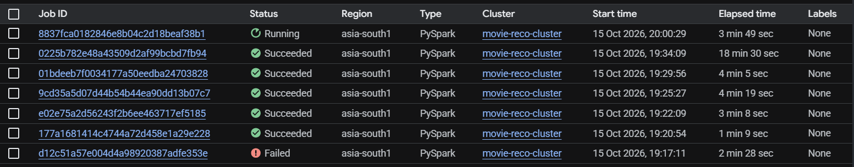
1 Dataproc jobs history
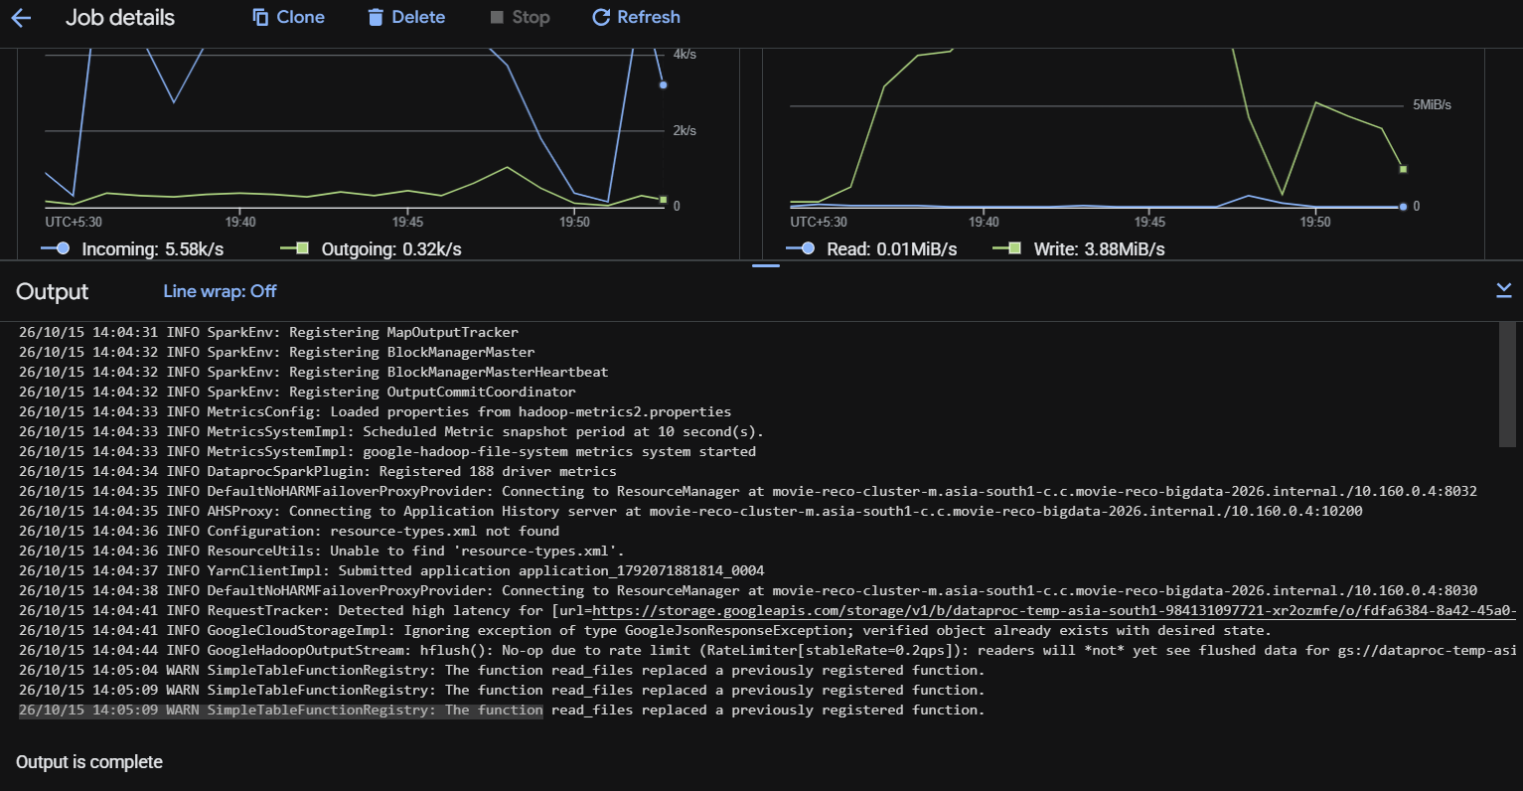
2 Dataproc ALS job details
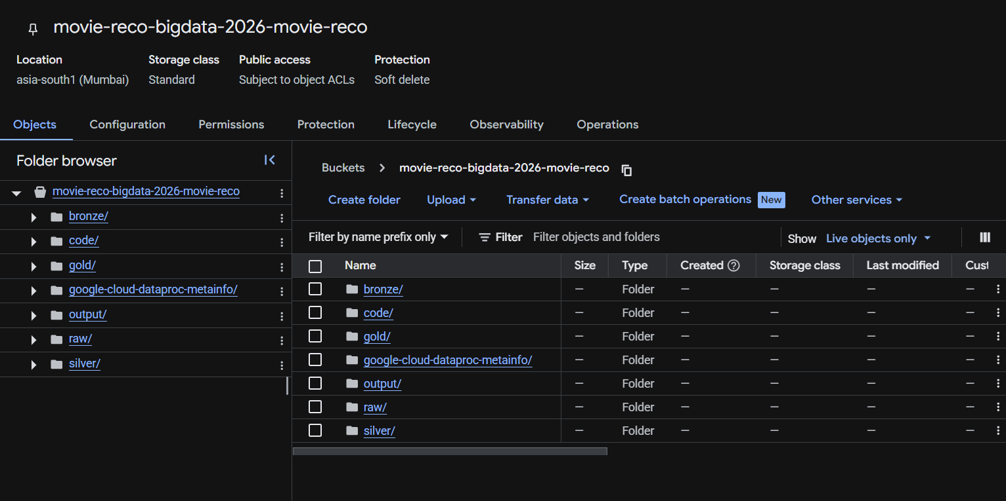
3 GCS bucket medallion layers
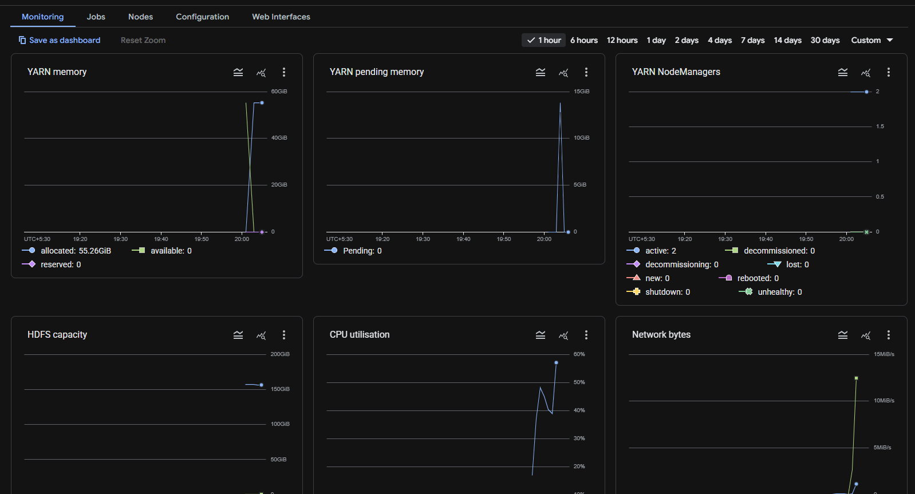
4 Dataproc cluster monitoring
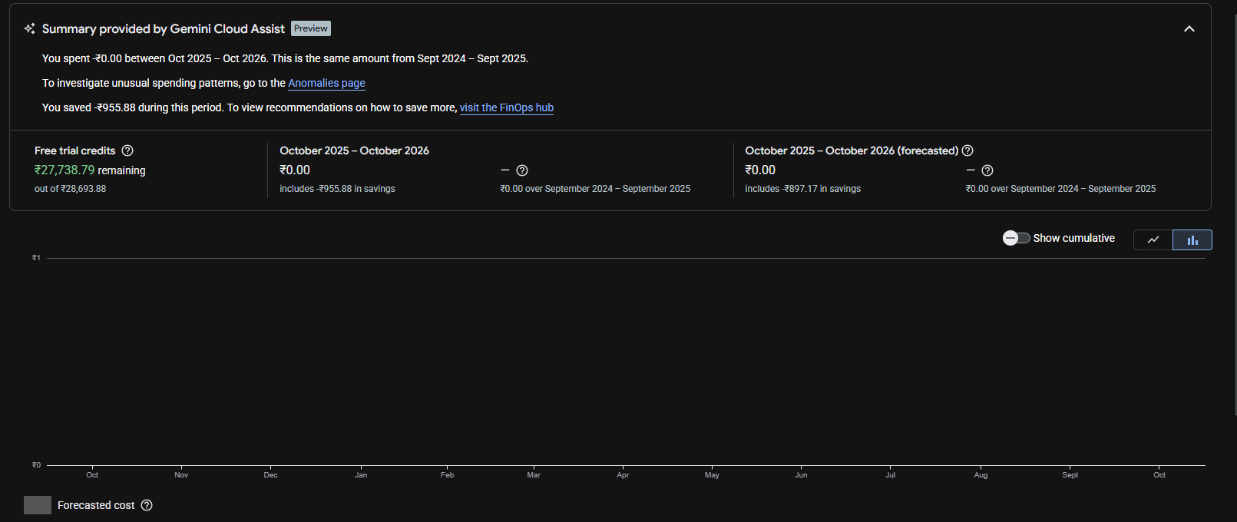
5 Billing free trial credits
Development followed a Git feature-branch workflow: each part (setup/ingest, Bronze/Silver, Gold/ML, cloud orchestration, dashboard/docs) was developed on its own branch and merged through a pull request.

8. Conclusion & Future Work
The project demonstrates scalable Big Data processing of 25,000,095 ratings on Google Cloud: a governed medallion data lake, Spark SQL analytics, a tuned MLlib recommender that clearly beats the baseline, and an interactive dashboard on real outputs. Future work: implicit-feedback ALS and hybrid content features (genres, tags) for cold-start movies, larger hyper-parameter search with CrossValidator, Spark Structured Streaming for real-time rating ingestion, and serving recommendations through an API.

References
- F. M. Harper and J. A. Konstan. The MovieLens Datasets: History and Context. ACM TiiS 5(4), 2015.
- Y. Koren, R. Bell, C. Volinsky. Matrix Factorization Techniques for Recommender Systems. IEEE Computer, 2009.
- Y. Hu, Y. Koren, C. Volinsky. Collaborative Filtering for Implicit Feedback Datasets. ICDM, 2008.
- Apache Spark 3.5 MLlib – Collaborative Filtering: https://spark.apache.org/docs/3.5.3/ml-collaborative-filtering.html
- Google Cloud Dataproc documentation: https://cloud.google.com/dataproc/docs
- GroupLens MovieLens 25M: https://grouplens.org/datasets/movielens/25m/

