Report by: Anand Prashar

NLP Homework 5 – q1

Q:

Please complete cossim sparse(v1,v2) in distsim.py to compute and display

the cosine similarities between each pair of these words. Briefly comment on whether the relative simlarities make sense.

A:

Method has been implemented and uploaded on Vocareum.

Below is the result of executing provided file: testq1.py

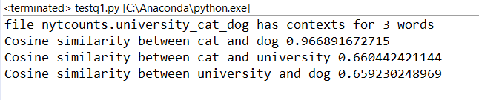

Comment:

Cat and Dog share high cosine similarity here;

University shares a lower similar similiarity( ~= 0.66) with both Cat and Dog.

It makes sense as the vectors used were *context counts*, and we hear Cat and Dog in same context much often than hearing them in context with University.