
MAULANA ABUL KALAM
AZAD UNIVERSITY OF
TECHNOLOGY, WEST
BENGAL

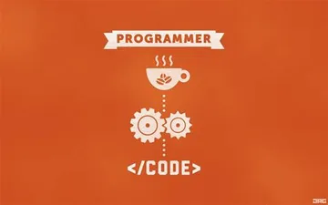

NAME - AMAN ANAND TIWARI
COURSE – BCA (2022 -25)
SEMESTER - I

Practical Assignment for CET I Students

SUBJECT – Programming for Problem Solving
REG. NUMBER - 223001010708
DATE OF ASSIGNMENT – 24 NOV 2022
DATE OF SUBMISSION – 24 NOV 2022

/* 1. Write a program in C to check whether a number is Perfect or not.*/

#include <stdio.h>

int main(void)
{
int n,i,sum;
sum = 0;
printf("enter number\n");
scanf("%d",&n);

for(i=1; i<=n/2; i++)
{
if(n%i == 0)
sum = sum + i;
}
if(sum == n)
printf("%d - perfect number\n",n);
else
printf("%d - not a perfect number \n",n);

return 0;
}
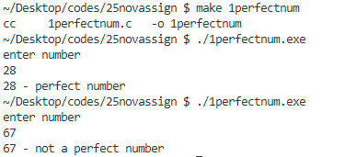
output -

/* 2. Write a program in C to check whether a number is Prime or not.*/

#include <stdio.h>

int main(void)
{
int n,i,divisor,t;
printf("enter number \n");
scanf("%d",&n);

divisor = 0;

for(i=2,t=n/2; i<=t; i++)
{
if(n%i == 0)
{
divisor += 1;
break; /*break as we got atleast one number in set (1,n) so
no need to futhur check it is clear that number is prime*/
}
}

//if total divisors from (2 to n/2) is 0 then prime else composite
if(divisor == 0)
printf("%d is prime \n",n);
else
printf("%d is not prime(composite number) \n",n);

return 0;
}
output -

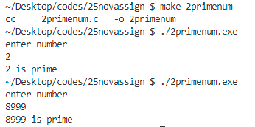

/* 3. Write a program in C to print all prime numbers from 1 to n, n will be taken as user input.*/

#include <stdio.h>

int main(void)
{
int n,i,j,count;
count = 0;
printf("enter number \n");
scanf("%d",&n);

printf("all prime numbers between 1 to %d are : \n",n);

//iterating over numbers from 2 to n as 1 is not prime
for(i = 2; i<=n; i++)
{
count = 0;
//this loop for checking if a number is prime or not
for(j=1; j<=i; j++)
{
if(i%j == 0)
{
count++;
}
}
//printing numbers which are prime
if(count == 2)
printf("%d ",i);
}
printf("\n");

return 0;

}
output -
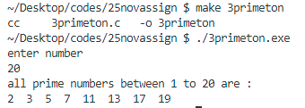

/* 4. Write a program to print all even and odd numbers separately from 1 to n,
n will be taken as user input.*/

#include <stdio.h>

int main(void)
{
int n,i;
printf("enter number \n");
scanf("%d",&n);

printf("even numbers between 1 to %d are --- \n",n);
for(i = 1; i<=n; i++)
{
if(i%2 == 0)
printf("%d ",i);
}
printf("\n");

printf("odd numbers between 1 to %d are --- \n",n);
for(i=1; i<=n; i++)
{
if(i%2 != 0)
printf("%d ",i);
}
printf("\n");

return 0;
}
output -

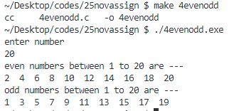

/* 5. Write a program in C to check whether a number is Palindrome or not.*/

#include <stdio.h>

int main(void)
{
int n, rev, temp;
rev = 0;
printf("enter number \n");
scanf("%d",&n);

temp = n; //this temp will be used for looping so n is not changed

while(temp!=0)
{
rev = 10*rev + temp%10;
temp = temp/10;
}

if(rev==n)
printf("pallindrome number \n");
else
printf("not a pallinrome number \n");

return 0;
}
output -
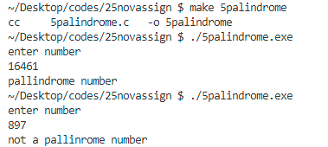

/* 6. Write a program to check whether a number is Armstrong or not. */

#include <stdio.h>
#include <math.h>

int main(void)
{
int n,digit,temp,temp1,sum,r;
digit =0;
r =0;
sum = 0;
printf("enter number \n");
scanf("%d",&n);

temp = n;
temp1 = n;

/*counting number of digit for pow() function
so that we can check armstrong for any number of digits*/
while(temp1!=0)
{
digit++;
temp1 /= 10;
}

//armstrong logic
while(temp != 0)
{
r = temp%10;
sum = sum + pow(r,digit);
temp = temp/10;
}

if(sum == n) //as n is unchanged and temp was changed
printf("number is armstrong \n");
else
printf("number is not armstrong \n");

return 0;
}
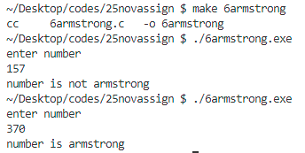
output -

/* 7. Write a program to find the sum of even and odd digits of a number separately.*/

#include <stdio.h>

int main(void)
{
int n,odd_sum,even_sum,r;
odd_sum = 0;
even_sum = 0;
printf("enter number \n");
scanf("%d",&n);
while(n!=0)
{
r = n%10;
if(r%2 == 0)
even_sum = even_sum+r;
else
odd_sum = odd_sum + r;

n = n/10;
}
printf("sum of digits(even by value) = %d \n",even_sum);
printf("sum of digits(odd by value) = %d \n",odd_sum);
return 0;
}
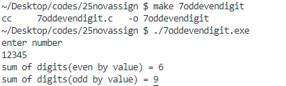
output -

/* 8. Write a program to find the sum of even and odd place digit of a number separately*/

#include <stdio.h>

int main(void)
{
int n,oddsum,evensum,count,rev;
oddsum=0;
evensum=0;
count =1;
printf("enter number \n");
scanf("%d",&n);

//reversing number
rev =0;
while(n!=0)
{
rev = rev*10 + n%10;
n = n/10;
}

while(rev != 0)
{
if(count%2 != 0)
oddsum += rev%10;
else
evensum += rev%10;

count++;
rev = rev/10;
}

printf("sum of digits at odd places is = %d \n",oddsum);
printf("sum of digits at even places is= %d \n",evensum);

return 0;
}
output -
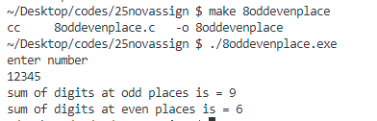

/* 9. Write a program to print Fibonacci series upto nth Term.*/

#include <stdio.h>

int main(void)
{
int n,sum,a,b,i;
a=0, b=1;
printf("enter number(total terms required) \n");
scanf("%d",&n);

//fibonacci printing
printf("%d %d ",a,b);

for(i=2; i<n; i++)
{
sum = a+b;
printf("%d ",sum);
a = b;
b = sum;
}
printf("\n");

return 0;
}
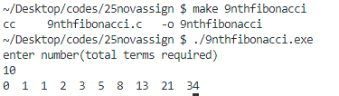
output -

/* 10. Write a program to print the following pattern:
1
2 3
4 5 6
7 8 9 10 */

#include <stdio.h>

int main(void)
{
int n,i,j,c;
printf("enter number of rows in pattern \n");
scanf("%d",&n);

c = 0;

printf("desired pattern is - \n");

//loop for each row
for(i=0; i<n; i++)
{

//loop for each column in the current row
for(j=0; j<=i; j++)
{
c = c+1;
printf("%d ",c);
}

printf("\n");
}

return 0;
}

output -

