**Continuous Integration & Continuous Deployment**

**Best Practices:**

* Maintain Source in a repository
* Write  and run Unit Test cases, better to follow TDD approach
* Merge master branch locally and run all UTs once
* Should be able to branch and merge with master branch through a code review process(pull request)

**Continuous Integration:**

* Once merged with master
  + - Integration server takes a copy of source code
    - Builds the code locally
    - Static code analysis (eg. using Klockworks)
    - Run Unit Test cases
    - Create package or setup
* Dashboard to view check-ins and status of above steps

**Continuous Delivery:**

* Deploy with respect to an environment
* Run Integration tests/smoke test on the installed application
* Dashboard to see status of deployment and tests performed after that.



**Revision control system**

**SVN/GIT**



**Current Development**

Win7

VS2015

**Build server – CI process-**

**Bamboo**

**Get source code from repository:**

**Build solutions:**

**SCA:**

Klocwork

**UT/DIT:**

NUnit

Bamboo



**Deploy setup to VM**



**Continuous Integration & delivery**

**Continuous Deployment**

Virtual Machine

Run Integration Tests

Send Notification

Create Setup

Send Email Notification

Future Goal

Scheduled/Manual

**Stage 0:**

* Create Project in Bamboo
* Get a machine having static IP and should be able to ping acsbamboo.honeywell.com
* Install JRE/JDK and set JAVA_HOME environment variable
* Install Bamboo agent in this machine
* Install required software for the build plan

**Stage 1:**

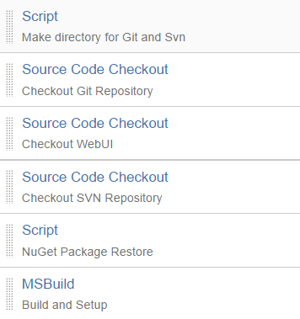

* Email notification once above steps fail or succeed

**Stage 2:**

* Setup Klocworks project for static code analysis and fix issues as regular practice
* Setup NUnit to run unit test cases on all the projects

**Stage 3(future task):**

* Deploy the setup another dedicated machine
* Run Integration/smoke tests on the environment
* Jazzy dashboard with all the steps of CI/CD and details(*Note that Bamboo provides a basic dashboard*)
* Separate builds for different environments(*need to have specific bamboo agents configured for this*)