#===== this application shuffle the playing cards and distribute cards within "n" number of players

#===== prerequisite

1. npm installed on your machine

2. xampp installed on your machine

#===== steps to follow

1. clone this project on your local machine on desktop
2. open application & copy file: "distribute-cards.php" from **SRC** folder and paste @: "xampp/htdocs/ distribute-cards.php” like given in below image

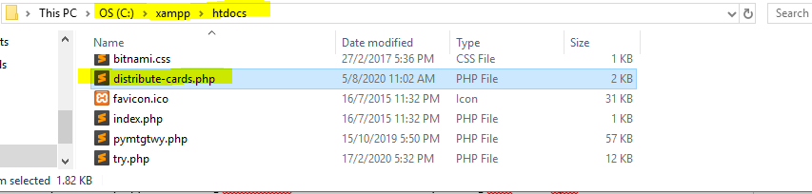

1. Open desktop application using visualstudio IDE and run the server by running cmd ===> "npm start" as mentioned in below image

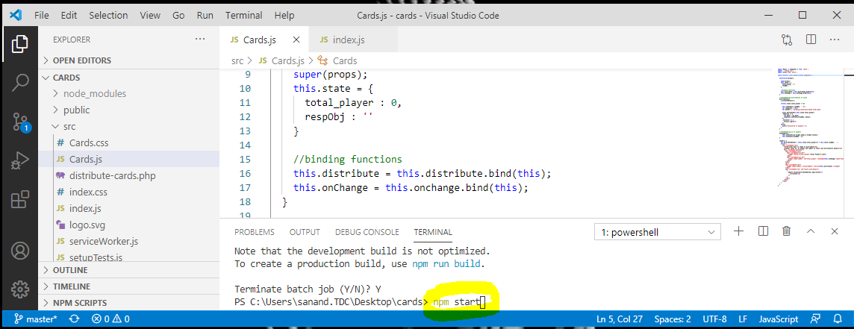

**#==== there is file named SQL-test.php for the explanation for SQL question**