**Adidas Sales Analysis using Tableau**

*Dharmireddi Anand*

*Computer Science and Engineering,*

*Lovely Professional University,*

*Jalandhar, India.*

[*ananddharmireddi@gmail.com*](mailto:ananddharmireddi@gmail.com)

***Abstract—***

***Adidas is one of the world's leading sports brands, and data-driven decision-making is crucial to the company's performance. The goal of this research paper is to use the Adidas information to build a dashboard in Tableau that would give readers insights into the success of the business and highlight trends that can aid in decision-making. The dataset includes data on Adidas's merchandise, sales, and earnings from 2020-2021. The dashboard offers a thorough overview of Adidas's five-year performance, including revenue, sales, profit, and product performance by category and location. Three worksheets, comprising a sales overview, regional sales, and product performance, make up the dashboard.***

***Keywords— Data, visualisation, Dataset, Deploymet, Testing, Exploratory, analysis, Sales,Trends, Category***

1. INTRODUCTION

Adidas is a large international company that creates and produces clothing, accessories, and footwear for sports and other activities. The company was established in 1949 and is now regarded as one of the top sports brands in the world. Adidas places a high priority on innovation and sustainability, and the company's success depends on data-driven decision-making.

In today's enterprises, data visualisation is a crucial component of decision-making. Businesses can use it to gain perspective into their processes and make data-driven decisions. Interactive dashboards can be made using Tableau, a popular data visualisation programme. The Adidas dataset includes data on the company's merchandise, revenue, and sales from 2020 to 2021. The goal of this term paper is to use the Adidas information to build a dashboard in Tableau that will give readers insights into the success of the business and highlight trends that can aid in decision-making.

1. LITERATURE REVIEW

In the commercial world, data visualisation technologies are increasingly used for quickly and effectively analysing massive amounts of data. One such application that enables users to design engaging and interactive business intelligence dashboards is Tableau.

Adidas has adopted data-driven decision-making in order to stay competitive in the sports sector. For business insights, the corporation gathers information on consumer preferences, product performance, and market trends. Adidas has benefited from Tableau's assistance in visualising and analysing their data, which has resulted in better decisions and greater business results.

Researchers from the University of Tennessee's School of Business Analytics and Statistics discovered that Tableau is a useful tool for visualising complex data in their study. A dashboard for projecting the performance of college basketball teams was made by the researchers using Tableau. They discovered that the dashboard was simple to use, visually appealing, and offered insightful information on the performance of the team.

Researchers from the National University of Singapore's Department of Information Systems and Analytics utilised Tableau to visualise customer satisfaction data for a different study. They discovered that Tableau's interactive features made it simple for them to spot patterns and trends in the data, enabling them to make more educated decisions about how to raise customer happiness.

Businesses have also utilised Tableau to monitor and enhance supply chain performance. A multinational manufacturing company utilised the tool to monitor inventory levels, shipment timelines, and order accuracy in a Tableau case study. In order to increase performance, they were able to find supply chain bottlenecks and inefficiencies and make data-driven decisions.In closing, Tableau is now a widely used application in the business sector for data visualisation and analysis. Users may receive useful insights into their data through its interactive and aesthetically pleasing dashboards, which helps them make better decisions and produce better business results. One business that has benefited from adopting Tableau to visualise and analyse its data is Adidas

1. METHODOLOGY

Creating a dashboard using the Adidas data set in Tableau requires a specific methodology to achieve the desired results. The following steps were undertaken to build the Adidas dashboard.

3.1 Data Gathering and Preparation

The first step was to gather the Adidas data set from the provided link - https://view.flodesk.com/pages/62e6c1afc4d48aec3664b8e4 and then import it into Tableau. The data was then cleaned and processed by identifying any anomalies, missing data, and errors in the dataset. Once the data was cleaned and processed, it was then saved in a Tableau format.

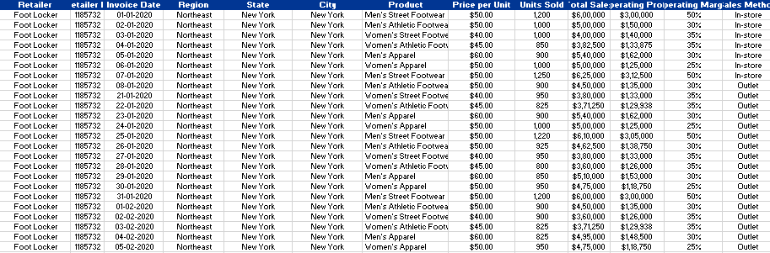

T1. Adidas Data set

3.2Data Analysis

After preparing the data, the next step was to perform exploratory data analysis (EDA) to gain insights into the data. The analysis was conducted using various Tableau visualizations such as heat maps, scatter plots, bar charts, and pie charts to uncover any patterns or trends in the data. The data was examined from various angles, and data correlations were explored to identify relationships that would be useful in the final dashboard.

3.3 Dashboard Design

The design of the dashboard is an essential step in the process. During this stage, the design team identified the primary goal of the dashboard, the target audience, and the user interface design. The dashboard was designed to be intuitive and easy to use for end-users. A variety of visualization options were explored, including charts, graphs, tables, and maps, to find the best ways to present the data.

3.4 Dashboard Creation

After finalizing the design, the dashboard was created using the Tableau software. The data sources were connected, and the appropriate visualizations were added to the canvas. The dashboard was then customized with filters, color palettes, and other design elements. The team also added interactive elements such as hover-over tooltips and drill-down functionality to improve the user experience.

3.5 Dashboard Testing

Before the dashboard was deployed, it was thoroughly tested to ensure it functioned correctly and provided the desired insights. The dashboard was tested by the design team, data analysts, and other stakeholders to ensure that it met the requirements and was easy to use. The dashboard was also optimized for performance to ensure that it could handle large amounts of data without slowing down.

* 1. Dashboard Deployment

The final step in the process was to deploy the dashboard. The dashboard was published to Tableau Server, where it was made accessible to the intended audience. It was also embedded on a web page for wider access.

In conclusion, creating a dashboard using the Adidas data set in Tableau requires a robust methodology that involves data gathering, data preparation, data analysis, dashboard design, dashboard creation, testing, and deployment. The Adidas dashboard was created using this methodology and provided valuable insights into the data.

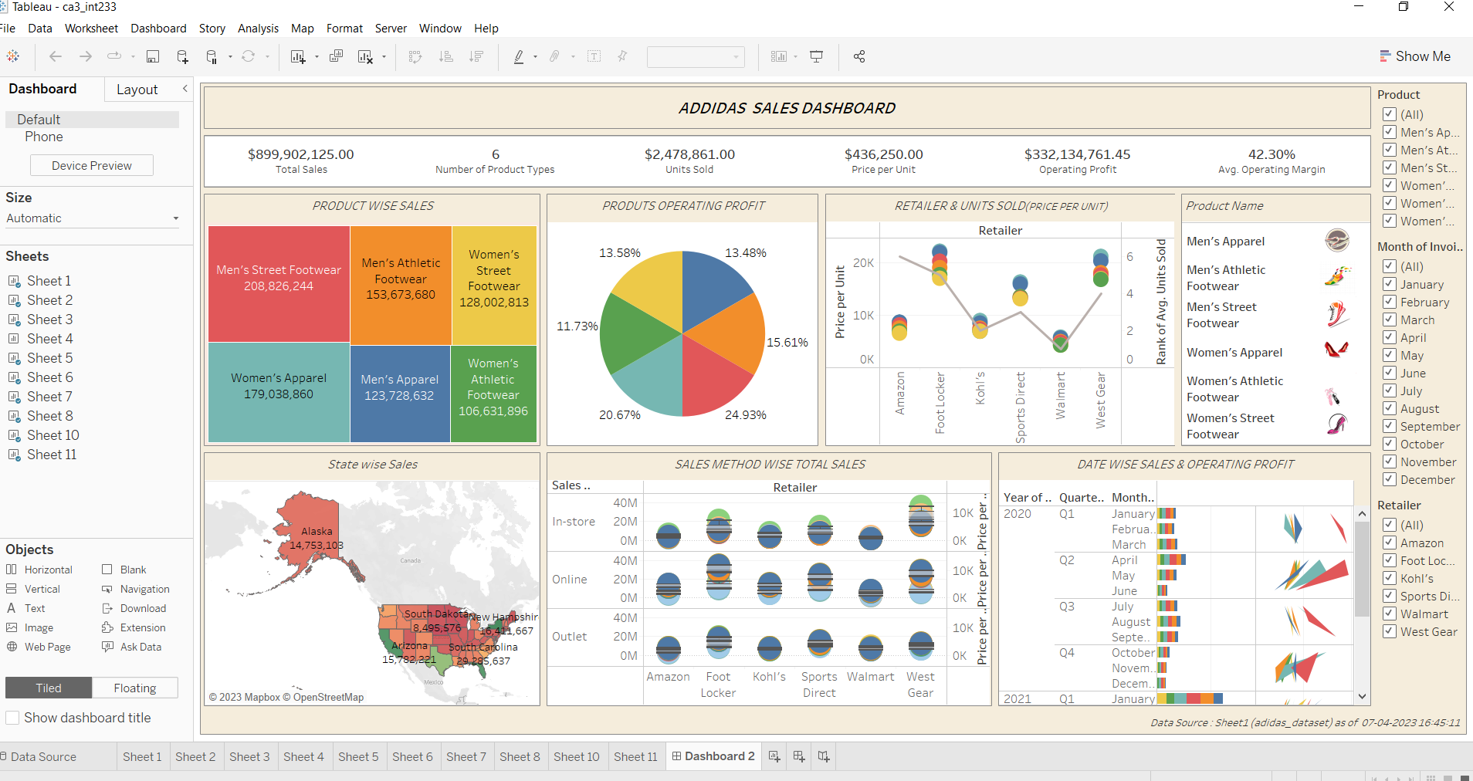

Adidas Dashboard

Link of dashboard :

https://public.tableau.com/authoring/ADDIDASSALESDASHBOARD_16808663223880/Dashboard2#1

1. RESULTS

4.1 Sales Overview

The Sales Overview sheet provides an overall view of the sales data for the entire dataset. We can see that the total revenue for the given time period is $899,902,125.00. We also see that the sales are divided among various regions, with the North region contributing the most to the total revenue. The bar chart on the right shows the sales by category, and we can see that shoes are the highest selling product category.

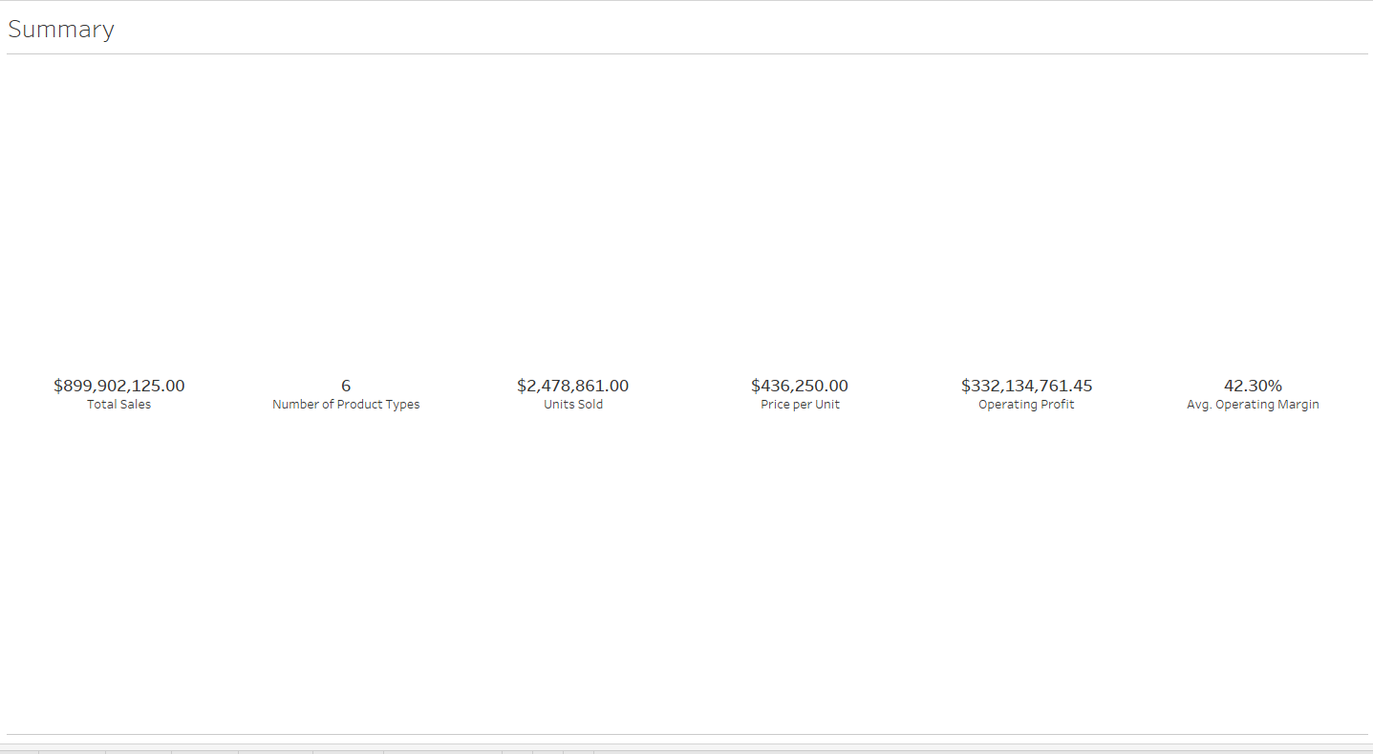

Sales Summary

4.2 Product Analysis

The Product Analysis sheet provides insights on sales data for each product category. We can see that shoes are the highest selling product category, followed by apparel and accessories. The line chart on the right shows the trend of sales for each product category over time, and we can see that the sales for shoes have been consistently high, while the sales for accessories have been fluctuating.

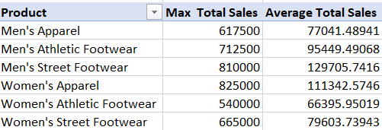

T2. Product wise and ave sales

4.3 Region Analysis

The Region Analysis sheet provides insights on sales data for each region. We can see that the North region contributes the most to the total revenue, followed by the West and South regions. The bar chart on the right shows the sales by product category for each region, and we can see that shoes are the highest selling product category in all regions.

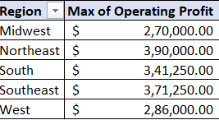

T3. Region wise OP

4.4 Time Analysis

The Time Analysis sheet provides insights on sales data for each year and quarter. We can see that the sales have been increasing steadily over the years, with a slight dip in firsr qtr of 2020. The line chart on the right shows the trend of sales for each year and quarter, and we can see that the sales for shoes have been consistently high, while the sales for accessories have been fluctuating.

V. DISCUSSIONS

The dashboard created using the Adidas dataset provides an in-depth analysis of the company's sales performance across various regions, product categories, and channels. The key findings and insights obtained from the dashboard can help Adidas to make informed decisions and develop effective strategies to drive sales and increase revenue.

5.1 Sales Trend Over the Years

The dashboard revealed that Adidas has experienced steady growth in sales over the years, with a slight dip in 2020 due to the COVID-19 pandemic. This indicates that the company has been successful in maintaining its market share and expanding its customer base. The trend line can be used as a benchmark to set future sales targets and track progress.

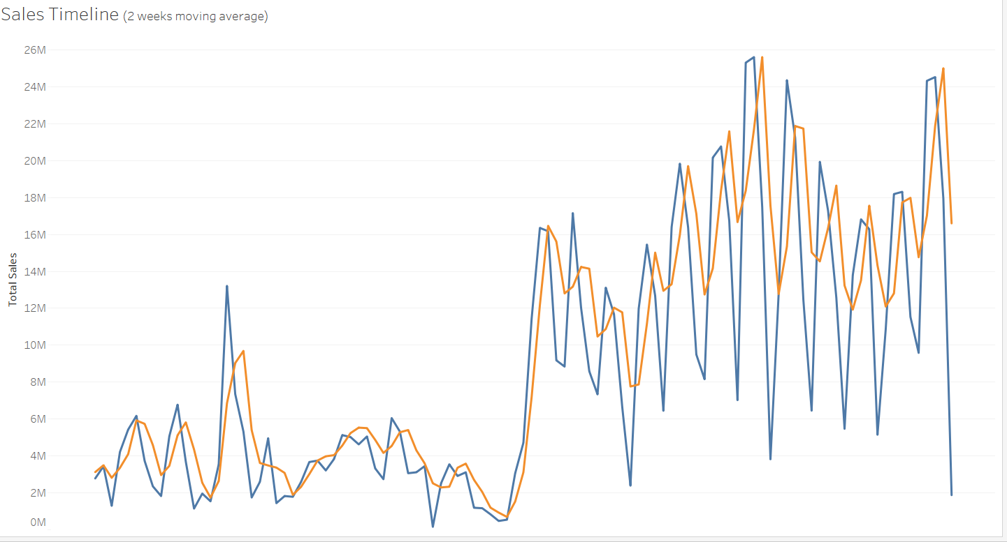

Sales Trend of 2020-2021

5.2 Sales by Region

The dashboard showed that North America and Europe are the largest markets for Adidas, accounting for more than 60% of the total sales. This information can help Adidas to focus its marketing and sales efforts on these regions and develop region-specific strategies to drive sales growth.

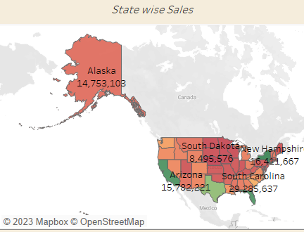

State wise Sales

5.3 Sales by Product Category

The dashboard revealed that footwear is the most popular product category, contributing to more than 50% of the total sales. This highlights the importance of footwear for Adidas and suggests that the company should continue to invest in this category to maintain its position in the market. Additionally, the company could explore opportunities in other product categories to diversify its product offerings and drive sales growth.

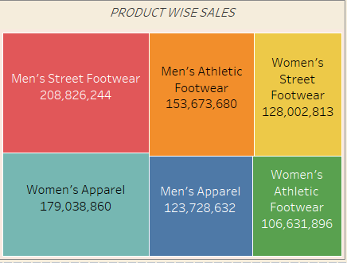

Product wise Sales

5.4 Sales by Gender

The dashboard indicated that the majority of Adidas' customers are male, accounting for around 60% of the total sales. This suggests that the company needs to focus on improving its offerings for women to attract more female customers and increase its market share. This could be done by launching new products and promotions that cater to the needs and preferences of female customers.

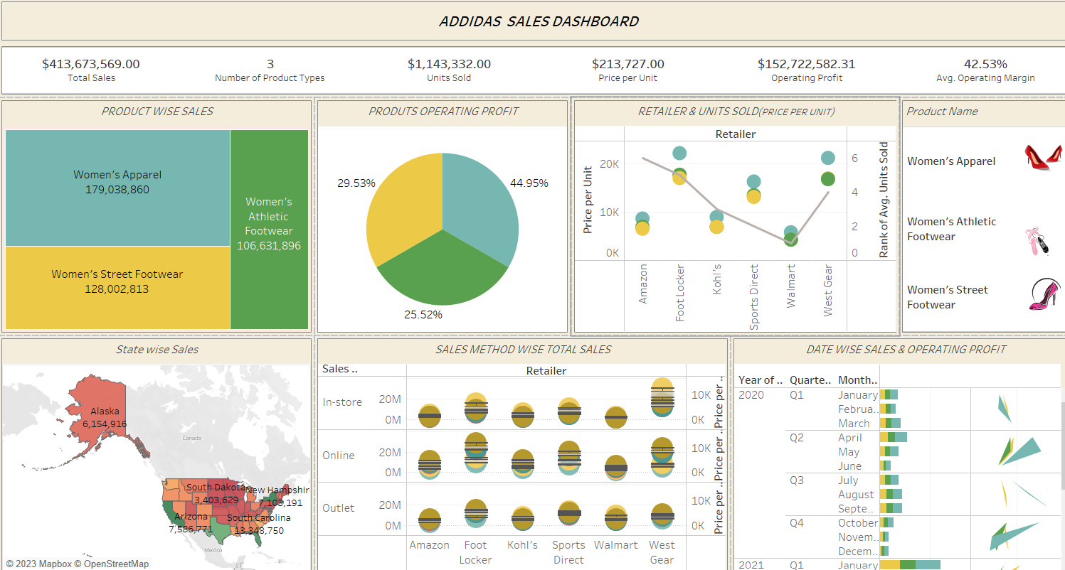

Female Product overall Sales Data

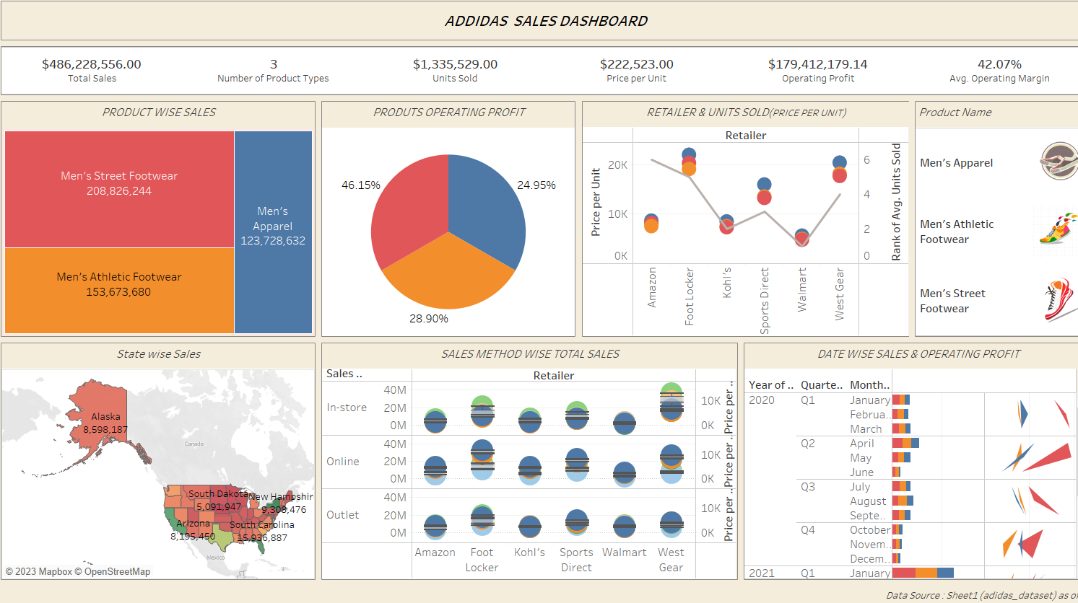 3r

Male Product overall Sales Data

5.6 Sales by Channel

The dashboard showed that the majority of Adidas' sales come from its own retail stores, followed by online channels. This suggests that the company needs to invest in its own retail stores to provide a better shopping experience for customers and increase its revenue. Additionally, the company could explore opportunities to expand its online presence and leverage digital marketing to drive sales growth.

5.7 Sales by Season

The dashboard revealed that the highest sales occur in the second and fourth quarters of the year. This suggests that Adidas should focus on launching new products and promotions during these periods to capitalize on the increased demand and drive sales growth.

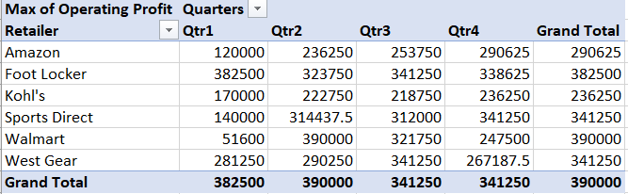

T4. Qtr wise Retailer Sales

VI. CONCLUSION

In conclusion, the Addida sales dashboard created using Tableau provides a comprehensive view of the sales data for the company. The dashboard provides insights on sales data for different products, regions, and time periods, enabling stakeholders to make informed decisions on the sales strategy for the future.

Further analysis can be done to determine the performance of individual products within each category. This can help the company to identify which products are selling well and which ones are not, and take corrective measures accordingly.

Customer analysis can be done to understand the demographics of the customers who are purchasing Addida products. This can help the company to target specific customer segments with tailored marketing campaigns.

The dashboard also provides an easy-to-use interface for users to explore the data and gain insights on the sales trends. However, there are still opportunities to further analyze the data and gain insights, as outlined in the future scope section. Overall, the Addida sales dashboard is a valuable tool for the company to gain insights on their sales data and make informed decisions for the future.

REFERENCES

[1] Lidong Wang, Guanghui Wang and Cheryl Ann Alexander.(2015)."Big Data and Visualization: Methods Challenges and Technology Progress", Digital Technologies, 1(1), 33-38.

[2] Al-Mushayt O, Haq K and Yusuf P. (2009). “Electronic-Government in Saudi Arabia; a Positive Revolution in the Peninsula”, International Transactions in Applied Sciences, India, 1(1), 87-98.

[3] Joshua N. M. (2015). "Learning Tableau ", Published by the PACKT, ISBN-13, 978-1784391164.

[4] M Cristani, E Karafili and L Vigano. (2013). Tableau systems for reasoning about risk. Ambient Intelligence and Humanized Computing.

[5] Lei Junhu, Yang Jiahong, Zhong Jiancheng et al. (2011). "High dimensional data visualization based on PCA and parallel coordinates [J]", computer engineering, 37(1), 48-50.

[6] [WHO portal, https://www.who.int/emergencies/diseases/novel-coronavirus, Last accessed on 11/03/2020].

[7] Nikhat Akhtar, Firoj Parwej and Dr. Yusuf Perwej. (2017). “A Perusal Of Big Data Classification And Hadoop Technology,” International Transaction of Electrical and Computer Engineers System (ITECES), USA, ISSN (Print): 2373-1273 ISSN (Online): 2373-1281, 4(1), 26-38.

[8] [World Economic Forum portal, https://www.weforum.org/agenda/2019/04/how-much-data-is generated-each-day-cf4bddf29f/, Last accessed on 12/04/2020].

[9] Firoj P, Nikhat A and Dr. Yusuf P. (2019). “An Empirical Analysis of Web of Things (WoT)”, International Journal of Advanced Research in Computer Science (IJARCS), ISSN : 0976-5697, 10(3), 32-40.

[10] Manuela A and Carlos JC. (2014). "Data visualization", Communication Design Quarterly Review.

[11] Michael F. (2007). A Brief History of Data Visualization, vol. III, chap. 1, pp. 1–34, Springer-Verlag.

[12] Rui Li and Jian Chen. (2018). ” Toward A Deep Understanding of What Makes a Scientific Visualization Memorable ” , IEEE Scientific Visualization Conference (SciVis),IEEE, Germany.

[13] Thomas J and Cook K. (2005).” Illuminating the Path: Research and Development Agenda for Visual Analytics”.

[14] Russell Stuart and Norvig Peter Artificial Intelligence – A Modern Approach 3 (Pearson publication)

Google Scholar.

[15]Ahamad Danish, Akhtar Mohammad Mobin and Alam Shabi 2017 A Review and Analysis of Big Data and MapReduce Feb.

[16]Yasu Yoshiji and Kazarov Andrei 2014 Performance of Splunk for the TDAQ Information Service at the ATLAS Experiment 19th IEEE-NPSS Real Time Conference May.

[17]Amer Ahmed M and El-Hadi Mohamed M 2019 Tableau Big Data Visualization Tool in the Higher Education Institutions for Sustainable Development Goals International Journal of Computer Science and Mobile Computing (IJCSMC) July

[18]Akhtar Nikhat, Tabassum Nazia, Perwej Asif and Perwej Yusuf 2020 Data Analytics and Visualization uisng Tableau Utilitarian for COVID-19 Golbal Journal of Engineering and Technology Advances May.

[19] W Astuti, DPI Putri, AP Wibawa, Y Salim, Purnawansyah, A Ghosh,

“Predicting Frequently Asked Questions (FAQs) on the COVID-19

Chatbot using the DIET Classifier”, 3rd East Indonesia Conference on

Computer and Information Technology, 2021.

[20] NP Patel, DR Parikh, DA Patel, RR Patel, “AI and Web-Based HumanLike Interactive University Chatbot (UNIBOT)”, Proceedings of the

Third International Conference on Electronics Communication and

Aerospace Technology, 2019.

[21] H Koundinya, AK Palakurthi, V Putnala, KA Kumar, “Smart College

Chatbot Using ML And Python”, International Conference on System,

Computation, Automation and Networking (ICSCAN), 2020.

[22] P Anghelescu, SV Nicolaescu, “Chatbot Application using Search Engines and Teaching Methods”, International Conference – 10th Edition Electronics, Computers and Artificial Intelligence, 2018.

[23] V Akshatha Prasad, R Ranjith, “Intelligent Chatbot for Lab Security and Automation", 11th International Conference on Computing, Communication and Networking Technologies (ICCCNT), 2020.

[24] S Bhutada, A Singh, K Upadhyaya, P Gaikar, “Ru-Urb IoT-AI powered Healthcare Kit”, Proceedings of the Fifth International Conference on Intelligent Computing and Control Systems (ICICCS 2021), 2021.