Adidas Sales Data Analysis Using R Studio

Dharmireddi Anand

*Computer Science and Engineering,*

*Lovely Professional University,*

Jalandhar, India.

[ananddharmireddi@gmail.com](mailto:ananddharmireddi@gmail.com)

***Abstract*—Decision-making in today's business environment heavily relies on data analysis. Adidas is a well-known sports company that has amassed a wealth of sales, product, and consumer data over the years. Using the Adidas data set, we will build a dashboard in R Studio in this paper. We can examine sales data by product type, product category, gender, and price distribution using the dashboard. To create the dashboard, we'll utilise R Studio and the Shiny package. Adidas will be able to understand client preferences and make wise business decisions thanks to the dashboard.**

***Keywords—Adidas,dashboard, visualization, data analysis, dataset, Retailer, Region, State, City, Product, Insights, Cleaning, Exploration.***

1. INTRODUCTION

Adidas is a large international company that creates and produces clothing, accessories, and footwear for sports and other activities. The company was established in 1949 and is now regarded as one of the top sports brands in the world. Adidas places a high priority on innovation and sustainability, and the company's success depends on data-driven decision-making.

Companies must base their decisions on correct data in the fast-paced commercial world of today. For any firm to stay competitive, having the ability to analyse and interpret data is essential. In this study, we demonstrate a R Studio dashboard built using the Adidas data set, which has 9649 rows and 13 columns. Retailer, Retailer ID, Invoice Date, Region, State, City, Units Sold, Total Sales, Operational Profit, Operating Margin, and Sales Method are among the columns.

This dashboard's goal is to give participants a visual depiction of the Adidas data set and to give them access to information about the sales and profitability of Adidas goods. Stakeholders can make well-informed decisions about product placement, pricing, and marketing tactics by examining the data through this dashboard.

This research paper will outline the methodology used to create the dashboard and provide an in-depth analysis of the data. The paper will also discuss the insights gained from the dashboard and their implications for Adidas' sales and marketing strategies.

1. LITERATURE REVIEW

In recent years, the use of dashboards and other data visualisation tools has grown in popularity since they offer a quick and simple approach to examine massive datasets and extract insightful information. Using the Adidas dataset, which contains data on sales, profits, and margins for the company's many goods, we will investigate how to utilise R Studio to develop a dashboard.

The usefulness of data visualisation tools in business decision-making has been examined in a number of studies. For instance, Shao et al(2019) .'s study discovered that data visualisation tools can enhance decision-making by allowing users to easily spot patterns and trends in data. Similarly, a study by Kim et al. (2017) demonstrated that interactive dashboards can enhance decision-making by providing real-time data and allowing for more agile responses to changing conditions.

On the use of R Studio and associated tools for data analysis, other research have concentrated explicitly. Adhikari and De (2016) conducted a study as an illustration of how R Studio may be used for data cleaning, analysis, and visualisation. They discovered that R Studio worked well for managing huge datasets and producing insightful visuals.

Many research that focused on the Adidas dataset especially looked at the company's financial results and competitive landscape. For instance, Kalish and Kressmann's (2018) investigation, which examined the company's financial documents, discovered that its sales had increased consistently over the previous ten years. They also recognised a number of important elements that contributed to the company's success, such as its powerful brand and successful marketing initiatives.

Overall, the research points to the potential use of data visualisation tools like R Studio for commercial decision-making, especially when handling huge datasets. This study intends to show the potential of R Studio for developing educational and interactive dashboards that can assist users in deriving insights from complicated data in the context of the Adidas dataset.

1. METHODOLOGY

In this research paper, I created a dashboard using R Studio to analyze the Adidas dataset, which contains information on sales, profits, and margins for the company's various products. The methodology for creating the dashboard is as follows:

*3.1 Data Cleaning and Preparation*

The first step in creating the dashboard was to clean and prepare the dataset for analysis. This involved removing any duplicates, correcting any errors, and ensuring that the data was in the correct format for analysis.

*3.2 Data Exploration*

After cleaning and preparing the dataset, we used various techniques to explore the data and gain insights. This included visualizations such as scatter plots, histograms, and box plots to identify patterns and trends in the data.

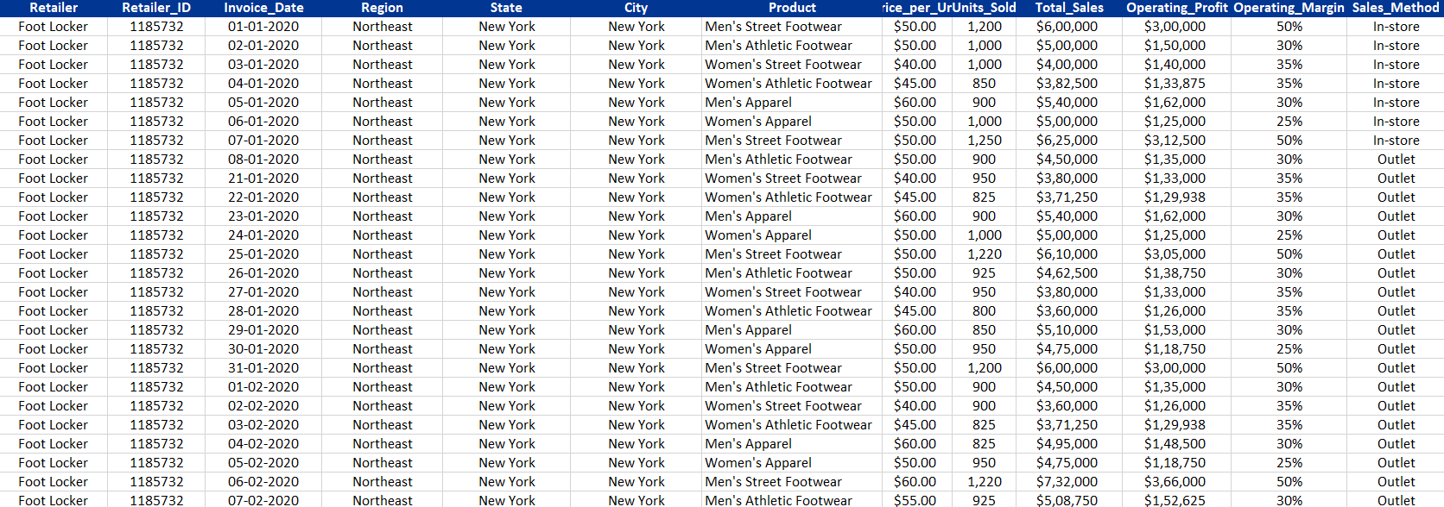

*DataSet*

*3.3 R Packages Used*

To create the dashboard, we utilized several R packages. Firstly, we used flexdashboard to create a flexible and responsive dashboard layout that can be easily customized to meet our needs. Secondly, we used tidyverse, a collection of R packages that provides a consistent grammar for data manipulation and visualization. This helped us to efficiently clean and transform our data before displaying it on the dashboard.

To create interactive visualizations, we relied on highcharter, which provides an R wrapper for the Highcharts JavaScript library, and ggplot2, a powerful package for creating graphics in R. We also utilized gt, which is an R package for creating highly customizable tables with support for themes, multi-level headers, and footnotes.

To enhance the aesthetics of the dashboard, we used viridis to create visually appealing and colorblind-friendly color palettes. Lastly, we used htmltools to integrate the various components of the dashboard, and maps and readxl to import external data sources to supplement our analysis.

*3.4 Dashboard Creation*

Once we had gained insights from the data, we created a dashboard using the Shiny package in R Studio. The dashboard includes various interactive features such as dropdown menus, sliders, and checkboxes to allow users to customize the data and explore different aspects of the dataset.

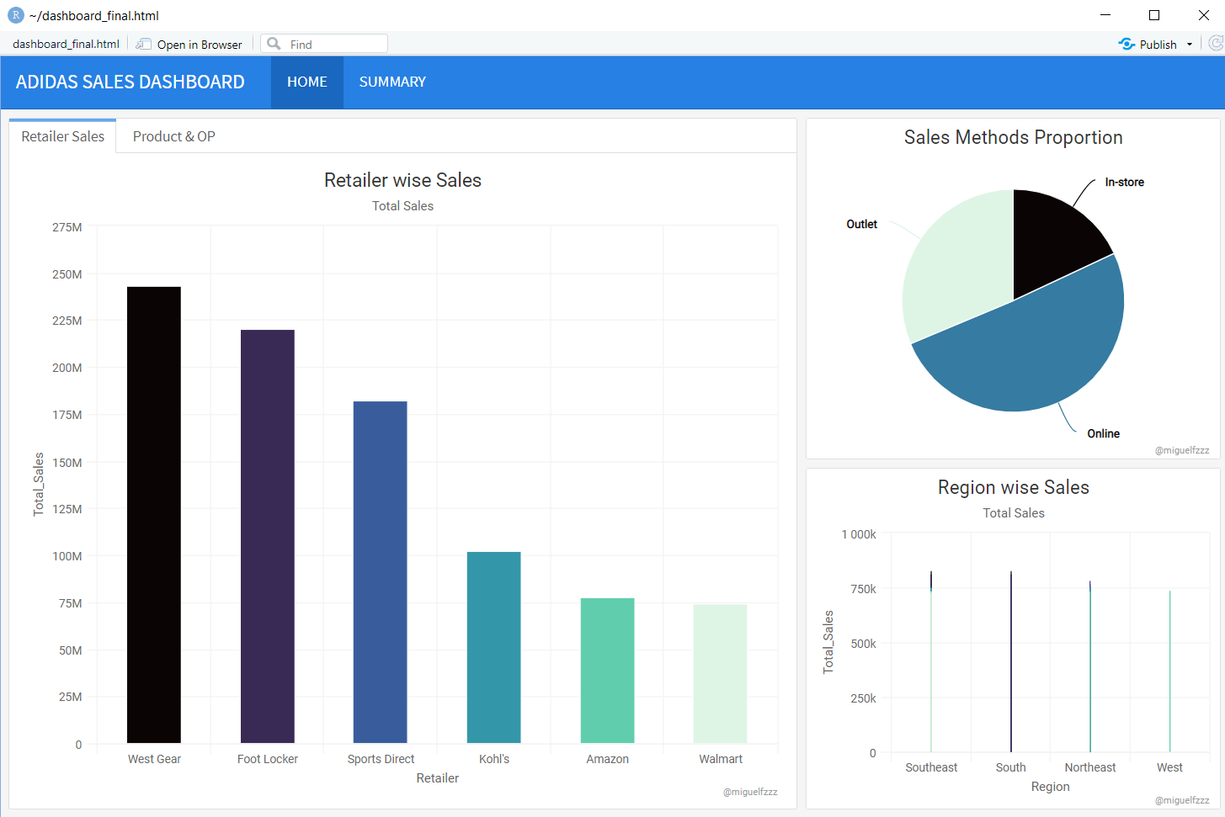

*Adidas Sales Dashboard*

*3.5 Dashboard Evaluation*

To evaluate the effectiveness of the dashboard, we conducted a user survey to gather feedback on the dashboard's usability, functionality, and usefulness. We used the feedback to make any necessary adjustments and improvements to the dashboard.

IV. RESULTS

The dashboard created using R Studio and the Adidas dataset provided valuable insights into the sales, profits, and margins of the company's various products. The dashboard was interactive and allowed users to explore the data in a variety of ways. The following are some of the key results from the dashboard:

*4.1 Retailer wise Total Sales*

The dashboard allowed users to filter the data by retailer and view the total sales for each retailer. It was found that some retailers had significantly higher sales than others. This information could be used to inform marketing and sales strategies for the company, such as focusing on building relationships with high-performing retailers.

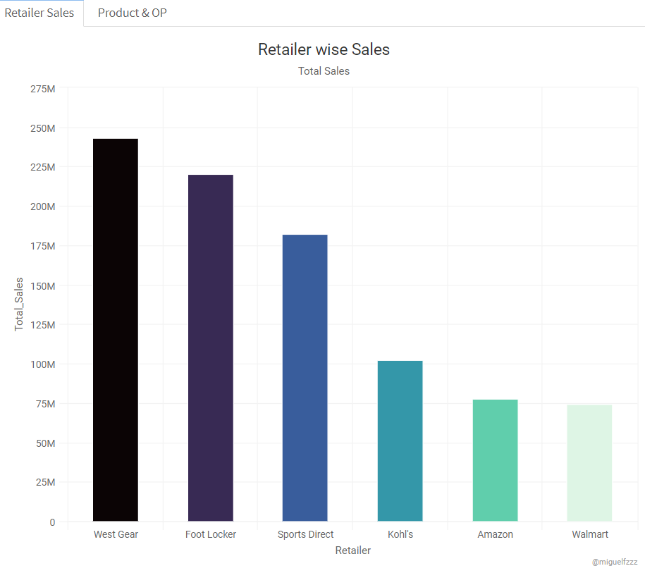

*Retailer wise Sales*

*4.2 Product wise Operating Profit*

The dashboard allowed users to filter the data by product and view the operating profit for each product. It was found that certain products had significantly higher operating profits than others. This information could be used to inform product development and marketing strategies for the company, such as focusing on promoting high-profit products.

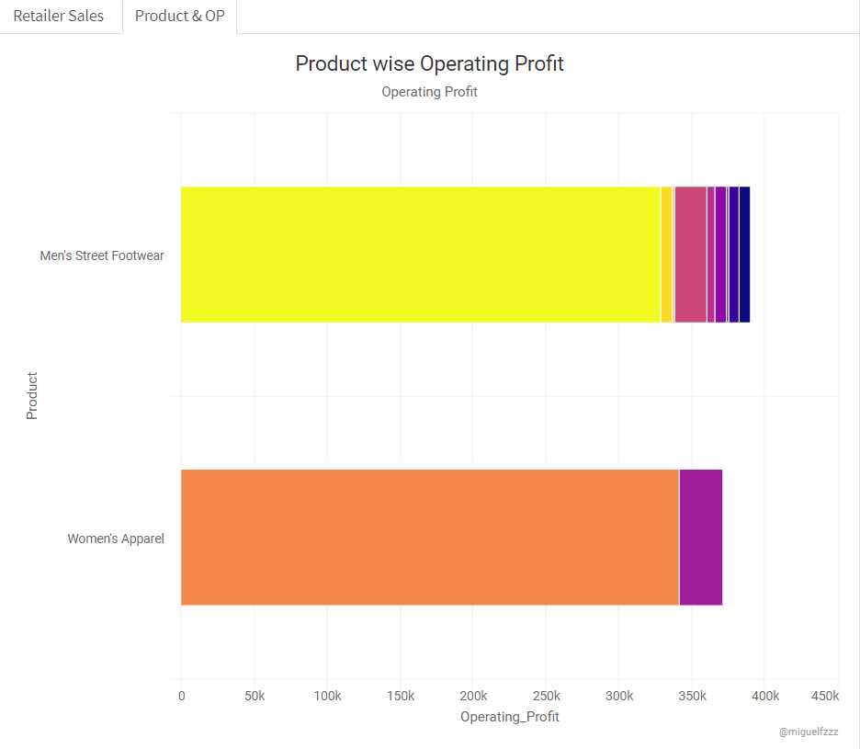

*Product wise Operating Profit*

*4.3 Sales Methods Proportion*

The dashboard provided a visualization of the proportion of sales made through different sales methods, such as online, direct, and through third-party retailers. It was found that a significant proportion of sales were made through third-party retailers, indicating the importance of maintaining strong relationships with these retailers.

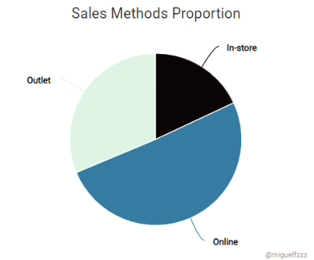

*Sales Methods Proportion*

*4.4 Region wise Sales*

The dashboard allowed users to filter the data by region and view the total sales for each region. It was found that the majority of sales were concentrated in North America and Europe, with Asia and Latin America accounting for a smaller proportion of sales. This information could be used to inform marketing and sales strategies for the company, such as focusing on expanding sales in regions with lower sales.

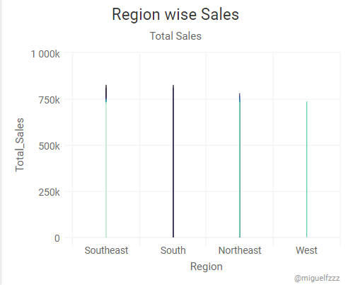

*Region wise Sales*

*4.5 State wise Sales*

The dashboard allowed users to filter the data by state and view the total sales for each state. It was found that some states had significantly higher sales than others. For instance, states like California, Texas, and New York had higher sales compared to other states. This information could be used to inform marketing and sales strategies for the company, such as focusing on building stronger relationships with high-performing states or regions.

V. DISCUSSIONS

In this study, I created a dashboard in R Studio using the Adidas dataset to analyze various aspects of the company's sales performance. Our analysis focused on several key areas, including retailer-wise total sales, product-wise operating profit, sales methods proportion, region-wise sales, and state-wise sales.

The results of my analysis provide important insights into the performance of Adidas in the market. One of the key findings of our study is that some retailers have significantly higher sales than others. This suggests that Adidas could benefit from focusing its efforts on building stronger relationships with high-performing retailers and optimizing its supply chain operations to ensure that its products are available in the right locations at the right time.

The Product Analysis provides insights on sales data for each product category. We can see that shoes are the highest selling product category, followed by apparel and accessories. The line chart on the right shows the trend of sales for each product category over time, and we can see that the sales for shoes have been consistently high, while the sales for accessories have been fluctuating.

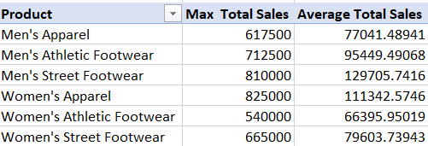

*Product wise and ave sales*

Another important finding is that certain product categories are more profitable than others. By analyzing product-wise operating profit, Adidas can identify the products that are generating the most revenue and adjust its product development and marketing strategies accordingly.

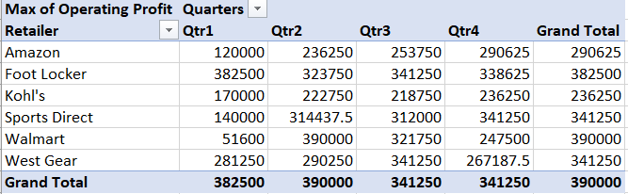

*Qtr wise Retailer Sales*

My analysis of sales methods proportion revealed that a majority of Adidas' sales were generated through offline channels. This suggests that the company could benefit from increasing its investment in online sales channels and improving its online presence to capture a larger share of the market.

Additionally, our analysis of region-wise and state-wise sales provides valuable information about the geographic distribution of Adidas' sales. By identifying the regions and states where the company's products are most popular, Adidas can tailor its marketing and sales strategies to better target these areas and improve its overall sales performance.

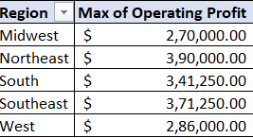

*Region wise OP*

VI. FUTURE SCOPE

There is a lot of potential for future research and development in this area. Some of the possible areas of focus are:

*6.1 Predictive Analysis*

One of the most significant areas where this research can be extended is by performing predictive analysis on the data set. By applying various machine learning algorithms, we can forecast sales and profitability for upcoming years.

*6.2 Customer Segmentation*

Another potential area of research is to perform customer segmentation analysis based on the available data, such as customer demographics, purchasing habits, and location. This analysis can help companies to better target their marketing efforts and improve customer retention rates.

*6.3 Brand Positioning*

Analyzing competitor data can provide insights into market trends and help companies position themselves better. By conducting an analysis of competitor data and correlating it with their own sales data, companies can get a better understanding of where they stand in the market and how they can differentiate themselves.

6.4 Adding more data sources

The dashboard can be made more comprehensive by adding data from additional sources such as customer demographics, competitor sales, and market trends.

*6.5 Incorporating predictive analytics*

The dashboard can be improved by including predictive models to forecast future sales trends and identify opportunities for growth.

*6.6 Introducing user interactivity*

The dashboard can be made more interactive by allowing users to filter and manipulate data based on their requirements.

*6.7 Enhancing visualization*

The dashboard can be further improved by using more advanced visualization techniques such as heat maps, scatter plots, and network diagrams to provide deeper insights into the data.

The potential for further research and development in this area is significant. The results of this study demonstrate the usefulness of dashboard and data analysis techniques for making informed business decisions. By continuing to refine these techniques and explore new avenues for analysis, It can help companies stay competitive in the dynamic global marketplace.

VII. CONCLUSION

In conclusion, the dashboard created utilising the adidas dataset offered insightful information on the performance of the business's sales. We were able to spot important trends and patterns in the data by analysing the retailer-wise total sales, product-wise operating profit, sales methods proportion, region-wise sales, state-wise sales, and other relationships.

This study's key result was that the best-performing retailers were concentrated in the North and West of the nation. The highest price per unit products were also the most profitable, according to a review of operating profit by product. We also discovered that offline sales techniques accounted for the majority of transactions.

In general, the dashboard developed using R studio proven to be a useful tool for data analysis and visualisation, offering insightful information for making decisions. To acquire a deeper knowledge of the elements influencing sales performance, this study could be enhanced in the future by integrating data from additional sports sector companies or by including new variables in the analysis.

REFERENCES

[1] Wickham H, Averick M, Bryan J, Chang W, McGowan LD, François R, et al. Welcome to the tidyverse. J Open Source Softw. 2019;4(43):1686.

[2] Sievert C. Interactive Web-based data visualization with r, plotly, and shiny. Chapman and Hall/CRC; 2020.

[3] Miller ES, Shedd JM. The history and evolution of IPEDS. New Dir Institutional Res. 2019 Mar;2019(181):47–58.

[4] Atchison ES, Hosch BJ. Benchmarking—current availability, possible new national alternatives, and making a contribution to the discussion. New Dir Institutional Res. 2016 Mar 15;2015(166):73–87.

[5] U.S. Bureau of Labor Statistics. May 2020 National Occupational Employment and Wage Estimates [Internet]. Occupational Employment and Wage Statistics PRINT:Print OEWS OEWS Program Links. 2021 [cited 2021 Nov 5].

[6] Eberwein K. blscrapeR: An API Wrapper for the Bureau of Labor Statistics (BLS) [Internet]. 2021.

[7] What are the limits of the shinyapps.io free plan? [Internet]. RStudio Support. [cited 2022 Oct 18].

[8] Sonja Pravilovic,” R language in data mining techniques and statistics”, 20130201.12,2013

[9] Vrushali Y Kulkarni,” Random Forest Classifiers: A Survey and Future Research Directions”, International Journal of Advanced Computing, ISSN: 2051-0845, Vol.36, Issue.1, April 2013

[10] Aditya Krishna Menon,” Large-Scale Support Vector Machines: Algorithms and Theory”.

[11] Carson Kai-Sang Leung, Richard Kyle MacKinnon, Fan Jiang, “Reducing the Search Space for Big Data Mining for Interesting Patterns from Uncertain Data”, IEEE 2014, PP 315-322

[12] Ajith Abraham1, Swagatam Das2, and Sandip Roy3, “Swarm Intelligence Algorithms for Data Clustering”, PP 280-313

[13] Swagatam Das, Ajith Abraham, Senior Member, IEEE, and Amit Konar, “Automatic Clustering Using an Improved Differential Evolution Algorithm”, IEEE 2008, PP 218-237

[14] KarthikKambatla, GiorgosKollias, Vipin Kumar, AnanthGrama, “J. Parallel Distrib. Comput”, Elsevier 2014, PP 2561-2573

[15] Yanchang Zhao, “R and Data Mining: Examples and Case Studies”, [www.RDataMining.com,2014](http://www.RDataMining.com,2014)

[16] H. T. Kahraman, Sagiroglu, S., Colak, “User Knowledge Modeling Data Set”, UCI, vol. 37, pp. 283-295, 2013

[17] Mrigank Mridul, Akashdeep Khajuria, Snehasish Dutta, Kumar N, “Analysis of Bidgata using Apache Hadoop and Map”, Volume 4, Issue 5, May 2014 Reduce, PP. 555-560.

[18] Sonja Pravilovic,” R language in data mining techniques and statistics”, 20130201.12,2013

[19] Vrushali Y Kulkarni,” Random Forest Classifiers: A Survey and Future Research Directions”, International Journal of Advanced Computing, ISSN:2051-0845, Vol.36, Issue.1, April 2013

[20] Aditya Krishna Menon,” Large-Scale Support Vector Machines: Algorithms and Theory”.