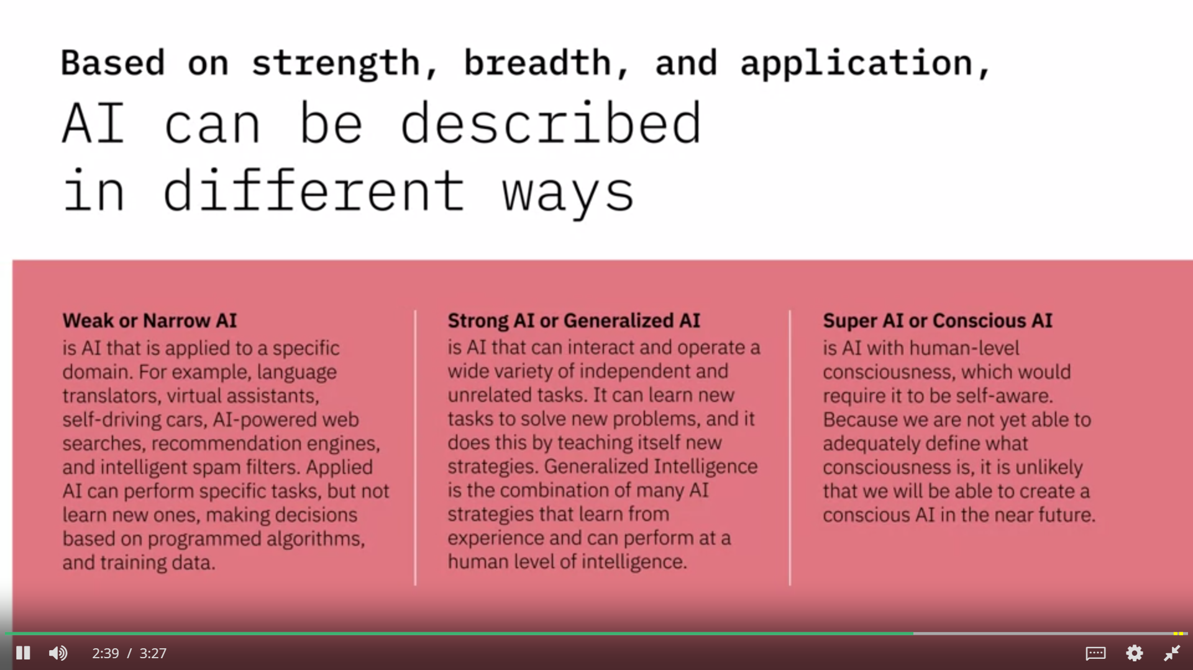

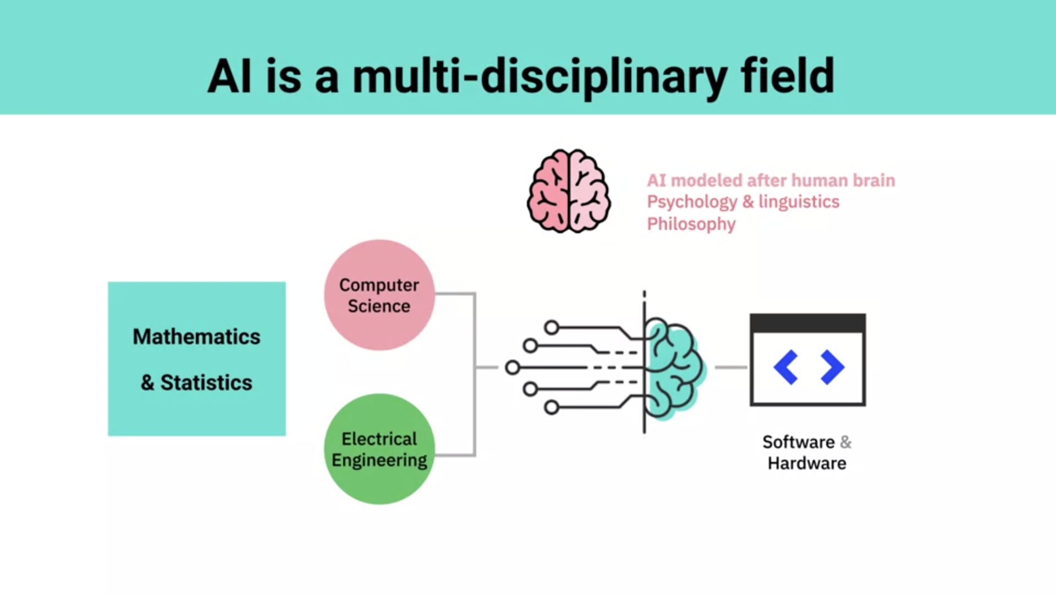

**AI learns by examining examples to create machine learning models based on provided inputs and desired goals. And it does this in three different ways - Supervised, Unsupervised, and Reinforcement Learning.**

**What is the role that philosophy plays in AI?**

**Philosophy provides guidance on intelligence and ethical considerations.**

**WHAT IS AI?**

1.one of them is about teaching the machines to learn, and act, and think as humans would.

2. about how do we get the machines to- how do we impart more of a cognitive capability on the machines and sensory capabilities. So, it's about analyzing images and videos about national language processing and understanding speech. It's about pattern recognition, and so on.

3. creating a technology that's able to, in some cases, replace what humans do.

Definition for artificial intelligence is about imparting the ability to think and learn on the machines.

B) AI is the application of computing to solve problems in an intelligent way using algorithms.

C) AI as a tool that uses computer to complete a task automatically with very little to no human intervention.

D) AI is really a complex series of layers of algorithms that do something with the information that's coming into it.

E) Artificial intelligence is a set of technologies that allows us to extract knowledge from data. So it's any kind of system that learns or understands patterns within that data, and can identify them, and then reproduce them on new information.

F**) Artificial intelligence is, is it's a set of mathematical algorithms that enable us to have computers find, very deep and patterns that we may not have even known exist, without us having to hard code them manually.**

**In which of the following ways can Artificial Intelligence (AI) be defined?**

AI is about augmenting human intelligence by providing information and evidence that subject matter experts need to make informed decisions. AI uses mathematical algorithms to examine examples and create machine learning models based on the inputs and desired outputs.

Which of these statements describes AI accurately from the speakers point of view?

AI can process vast amounts of both structured and unstructured human data to understand patterns.

* IBM Research defines Artificial Intelligence (AI) as Augmented Intelligence, helping experts scale their capabilities as machines do the time-consuming work.
* AI learns by creating machine learning models based on provided inputs and desired outputs.
* AI can be described in different ways based on strength, breadth, and application - Weak or Narrow AI, Strong or Generalized AI, Super or Conscious AI.
* AI is the fusion of many fields of study, such as Computer Science, Electrical Engineering, Mathematics, Statistics, Psychology, Linguistics, and Philosophy.

AI-powered advances in speech synthesis (text-to-speech rather than speech-to-text) have made it possible for machines to re-create a specific human's voice. One of the applications of this technology is to help speech-impaired patients talk in their real voice in place of a computerized voice when they type what they want to say.

Using a machine learning algorithm trained with previous diagnosis data to assist physicians with their findings is a use of AI technology

In Healthcare, while AI is being used to support doctors arrive at more accurate preliminary diagnoses, it is not yet being used to make precise disease diagnoses independently.(legends how gidiyon can cure???)

AI is being used in the recovery of patients who have suffered a neurological trauma by triggering new neural pathways to form in their brain using robotic devices to trigger corresponding movements in the body.

Different movements of the human body correspond to specific parts of the brain that control these movements. By creating massive data sets of information of how people move and how that corresponds to different areas of the brain, AI-powered robots are able to trigger specific movements in the human body which in turn create new neural pathways in the brain.

**Watson** analyzed Grammy nominated song lyrics over the last 60 years to identify the emotional themes in music and categorize them on the basis of emotions such as joy, sadness, and other emotions.

Watson collaborating with ESPN to share insights that help Fantasy App users make better decisions to win their weekly matchups.

Watson playing Jeopardy to win against two of its greatest champions, Ken Jennings and Brad Rutter.

In this lesson, you have learned:

AI-powered applications are creating an impact in diverse areas such as Healthcare, Education, Transcription, Law Enforcement, Customer Service, Mobile and Social Media Apps, Financial Fraud Prevention, Patient Diagnoses, Clinical Trials, and more.

Some of these applications include:

* Robotics and Automation, where AI is making it possible for robots to perceive unpredictable environments around them in order to decide on the next steps.
* Airport Security, where AI is making it possible for X-ray scanners to flag images that may look suspicious.
* Oil and Gas, where AI is helping companies analyze and classify thousands of rock samples to help identify the best locations to drill for oil?

Some famous applications of AI from IBM include:

* Watson playing Jeopardy to win against two of its greatest champions, Ken Jennings and Brad Rutter.
* Watson teaming up with the Academy to deliver an amplified Grammy experience for millions of fans.
* Watson collaborating with ESPN to serve 10 million users of the ESPN Fantasy App sharing insights that help them make better decisions to win their weekly matchups.

**AI is only as good as the robust architecture that supports it. AI requires machine learning, machine learning requires analytics, and analytics requires the right data and information architecture (IA).**