

|  |  |  |
| --- | --- | --- |
| **Guide Name** | | **Panel Head** |
|  | Dr. P. Vigneshwaran | Dr. Annapurani Panaiyappan K |
|  |  |  |
|  | **Faculty Advisor** | **Project Domain** |
|  | Dr. S.Suchitra | Data Mining |
|  |  |  |
|  | **Student(s) Details: Name** | **Passport size photo(s)** |
|  | 1.Anand Kumar Soni  2.Rohit Shrivastava |  |
|  |  |  |

Registration Number(s)

1.RA1711003010481

2 RA1711003010511.

**Email ID(s)& Mobile Number(s)**

|  |  |  |
| --- | --- | --- |
| 1.av1555@srmist.edu.in | 2.rr5921@srmist.edu.in | 3 |
| 7987518937 | 9131632893 |  |

**Abstract Architecture Diagram**

Cardiovascular disease is one of the most life threatening disease all over world and under distributed age groups. Mortality rates of heart disease around the world is high comparing to any other diseases. Thus heart disease prediction gains importance study and improvement in prediction is needed to save human lives. Once the disease is early predicted, with proper medications, the human lives can be saved. The delay in detection leaves to complexity and the rates of mortality increases.

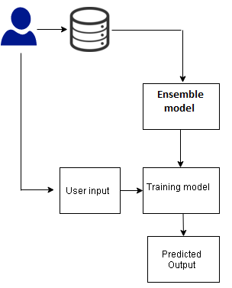

**Significance of the Project Conclusion**

To predict heart disease by an automated medical diagnosis system based on machine learning. We use hybrid model which means it is the best classification algorithm for heart disease prediction. Medical diagnosis industry is gaining pace with the latest technologies such as machine learning, deep learning. Medical treatment industry is already developed with highly effective treatments. Machine learning (ML) is one of the best diagnoses for effective decision making. The proposed system aims to study cardiovascular disease prediction on UCI repository, Cleveland dataset with a novel ensemble learning strategy.

Cardiovascular disease is one of the most life threatening disease under aged group all over world. The change in modern lifestyle, lack of physical exercise, usage of alcohol and tobacco and junk food are the major causes for disease. The medical industry is equipped with highly modernized treatments. However, medical diagnosis industry need much efficient technology for automated detections.optimized the results of decision tree and random forest.

**Conference/Journal Publication Details (If Any)**

9th ICCET 2021/Springer Series Chapters