AI Reel Pipeline
Architecture & Operations
A productized, end-to-end system that converts a single content brief into a publish-ready vertical video reel.

1. What This System Does
Input: a short topic, transcript, or content brief — driven by a client-supplied prompt.
Output: a 60 to 90 second vertical (9:16) video reel with talking-head avatar, motion-graphic b-roll, burned-in captions, ambient audio, thumbnail card, and ready-to-post social copy.

The pipeline is:
- Deterministic — same input + same prompt = same output bundle
- Resumable — every stage writes state; auto-resumes on retry
- Stage-isolated — clean separation of script, media, composition
- Parallel where possible — three media stages run concurrently
- Re-renderable in minutes — visual changes don't trigger a full re-run

2. Functional Architecture
What the system does, viewed as a flow of content artifacts. Every box is an isolated unit. Every arrow is a data hand-off via a versioned JSON contract.
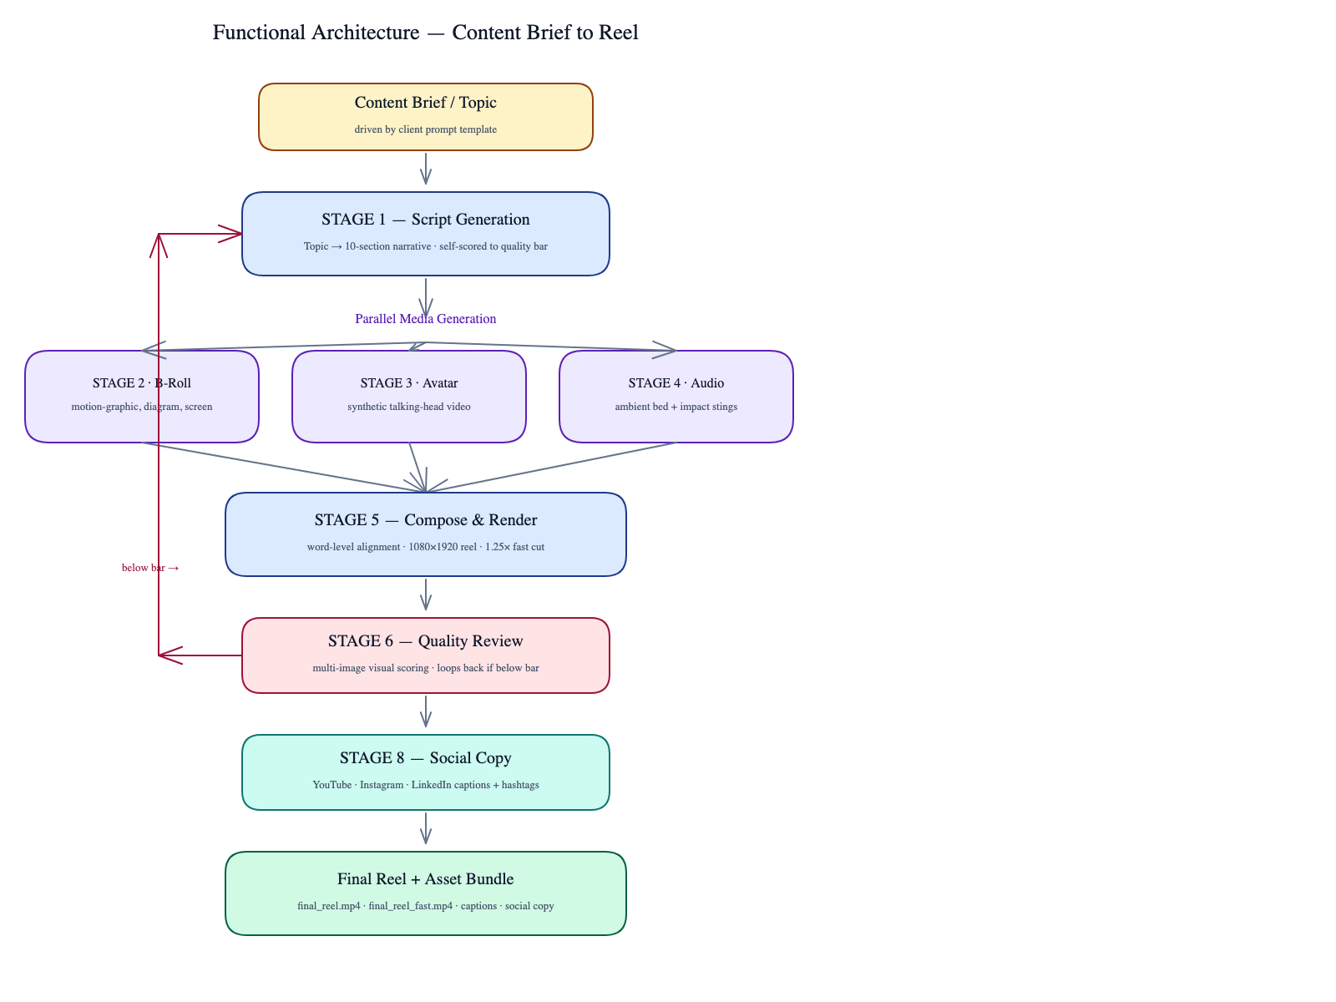

Stages

# | Stage | What It Owns
1 | Script Generation | Topic / brief → structured 10-section script (self-scored)
2 | B-Roll Generation | Per-section motion graphic, screen, diagram, terminal clips
3 | Avatar Generation | Synthetic talking-head video from the spoken script
4 | Audio Generation | Ambient bed tracks + impact stings at trigger moments
5 | Compose & Render | Transcript alignment + 1080x1920 reel + 1.25x fast cut
6 | Quality Review | Multi-image visual evaluation against design rubric
8 | Social Copy | YouTube / Instagram / LinkedIn captions and hashtags

3. Technical Architecture
How the system is built, viewed as runtime components and external services. Component boundaries are firm; external services are interchangeable.
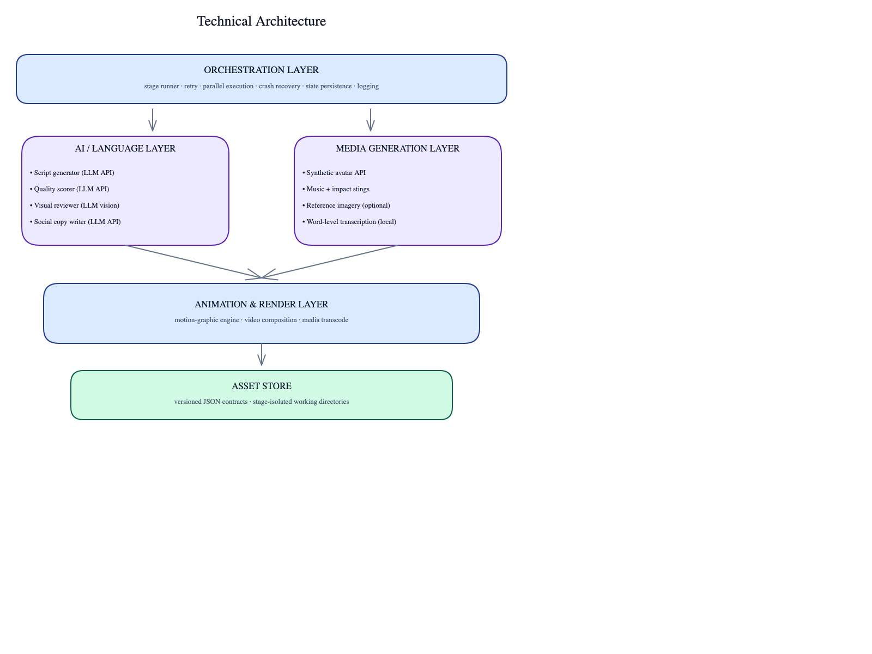

External Services
Each service has at least one drop-in alternative.
Service | Purpose | Replaceable
Anthropic API | Script, scoring, social copy, visual review | No (model-specific)
HeyGen | Synthetic talking-head avatar | Yes (any avatar API)
Kie.ai (ElevenLabs) | Ambient music + impact stings | Yes
Kie.ai (Imagen) | Reference imagery (optional) | Yes
OpenAI Whisper | Word-level transcript alignment | Yes (runs locally)

Internal Components
Component | Technology | Role
Orchestrator | Python | Stage runner, state machine
Animation engine | HyperFrames + GSAP | Motion graphics → MP4
Composition | Remotion + React | Layered timeline → MP4
Transcode | FFmpeg | Codec normalization, speed-up
Asset store | Versioned filesystem | Stage-to-stage hand-off

4. Operational Model — Timing & Cost
Per-reel wall-clock and cost footprint. End-to-end: 15 to 25 minutes per reel on standard developer hardware.

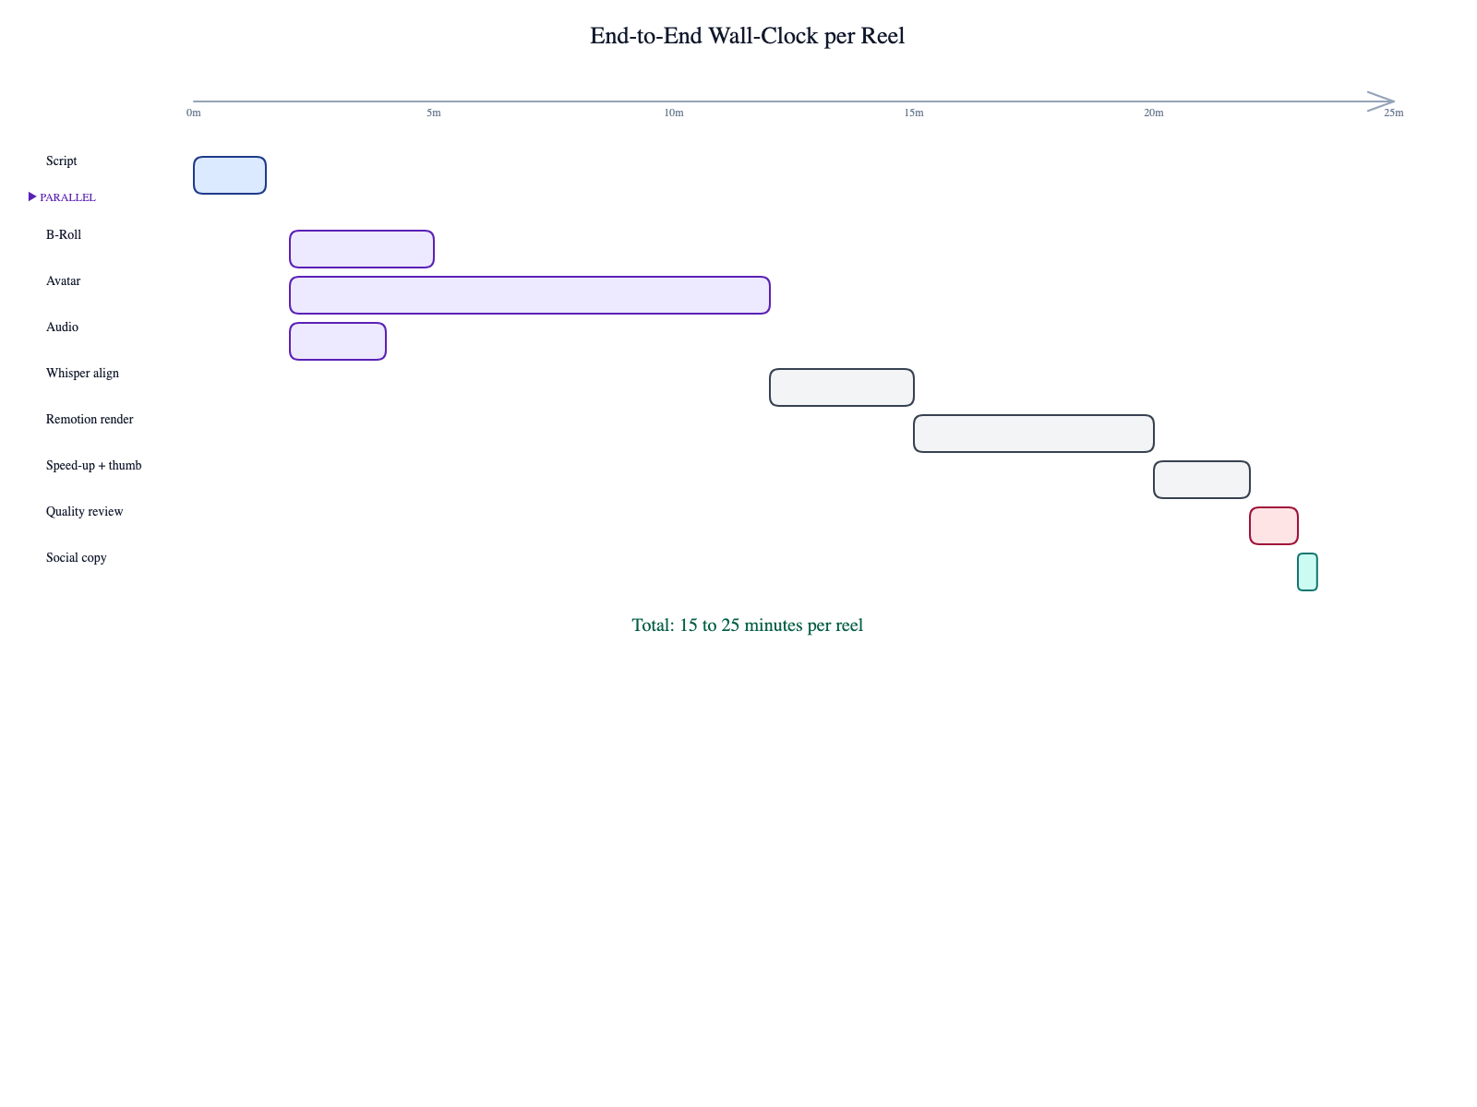

Stage | Typical Duration | Parallel | Cost Driver
Script | ~90 seconds | No | LLM tokens
B-Roll | ~3 minutes | Yes | Browser render, optional media APIs
Avatar | ~5–10 minutes | Yes | Avatar generation credits
Audio | ~2 minutes | Yes | TTS / SFX credits
Compose | ~5–10 minutes | No | Local CPU
Quality Review | ~1 minute | No | LLM tokens (vision)
Social Copy | ~20 seconds | No | LLM tokens

5. Quality Controls
- Script gate — generated scripts are scored against a structured rubric and re-generated until they clear a quality threshold.
- Pre-render check — script is sanity-checked before paying for avatar or media generation.
- Visual review — finished reels are evaluated against a multi-dimensional rubric (hook strength, on-screen text legibility, audio sync, CTA clarity).
- Stale-asset guard — downstream assets are auto-invalidated when their upstream contract changes.

6. Extensibility Surfaces
The pipeline is intentionally modular. Four high-leverage extension points:
- Prompt template — swap scripting style without touching code.
- Visual template library — add new motion-graphic patterns by dropping HTML files.
- Avatar provider — replace via configuration.
- Composition layer — change layout, captions, rhythm via component edits without affecting upstream stages.

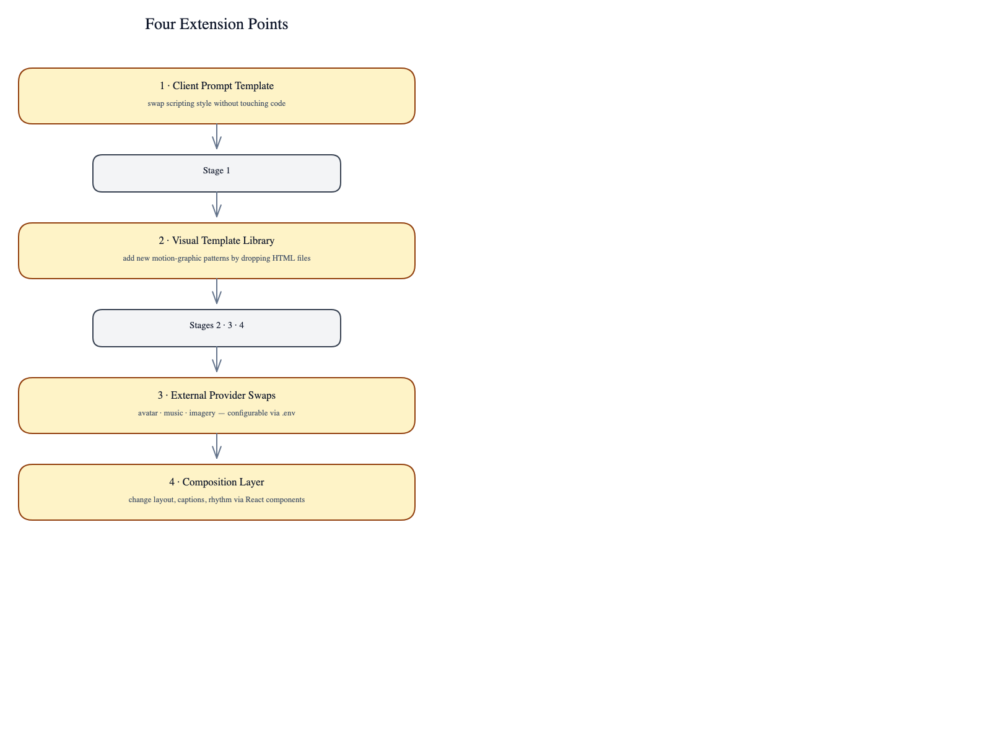

7. Where The Client Prompt Goes
The pipeline accepts a client-supplied prompt template that fully replaces the default Stage 1 generator. The template is the only piece of business logic the client owns. Every downstream stage is template-agnostic.

Required Output Schema
Whatever your prompt produces, the model output must match this JSON shape:
{
"title": "<60 chars max>",
"total_duration_sec": 60–95,
"bgm_transition_sec": <number>,
"bgm_dip_timestamps": [3 numbers],
"full_spoken_script": "<complete narration>",
"grand_takeaway_line": "<quotable line>",
"tool_mentioned": "<product / methodology>",
"sections": [ ...10 section objects... ]
}

Prompt Slot
Paste the client's scripting prompt here. The pipeline injects the input topic / brief into the prompt using {{topic}} or {{brief}} placeholders and calls the language model.

┌──────────────────────────────────────────────────────────────┐
│ [ CLIENT PROMPT — PASTE HERE ] │
│ │
│ The client owns the wording, tone, audience profile, brand │
│ voice, CTA style, and structural constraints. The pipeline │
│ only enforces the output schema. │
│ │
│ Refer to docs/PROMPT_TEMPLATE.md for the canonical slot │
│ used at runtime. │
└──────────────────────────────────────────────────────────────┘

8. What This System Does Not Do
To set expectations crisply:
- Generate scripts longer than ~90 seconds of spoken content
- Mix multiple speakers or styles in a single reel
- Render landscape (16:9) outputs — vertical 9:16 only
- Auto-publish to social platforms — outputs are files; distribution is external
- Process live or streaming inputs — batch only

