Graphs
Contents
Introduction 2
Types 2
Cycles and path 2
Directed and undirected, edge weight 3

Introduction

Types
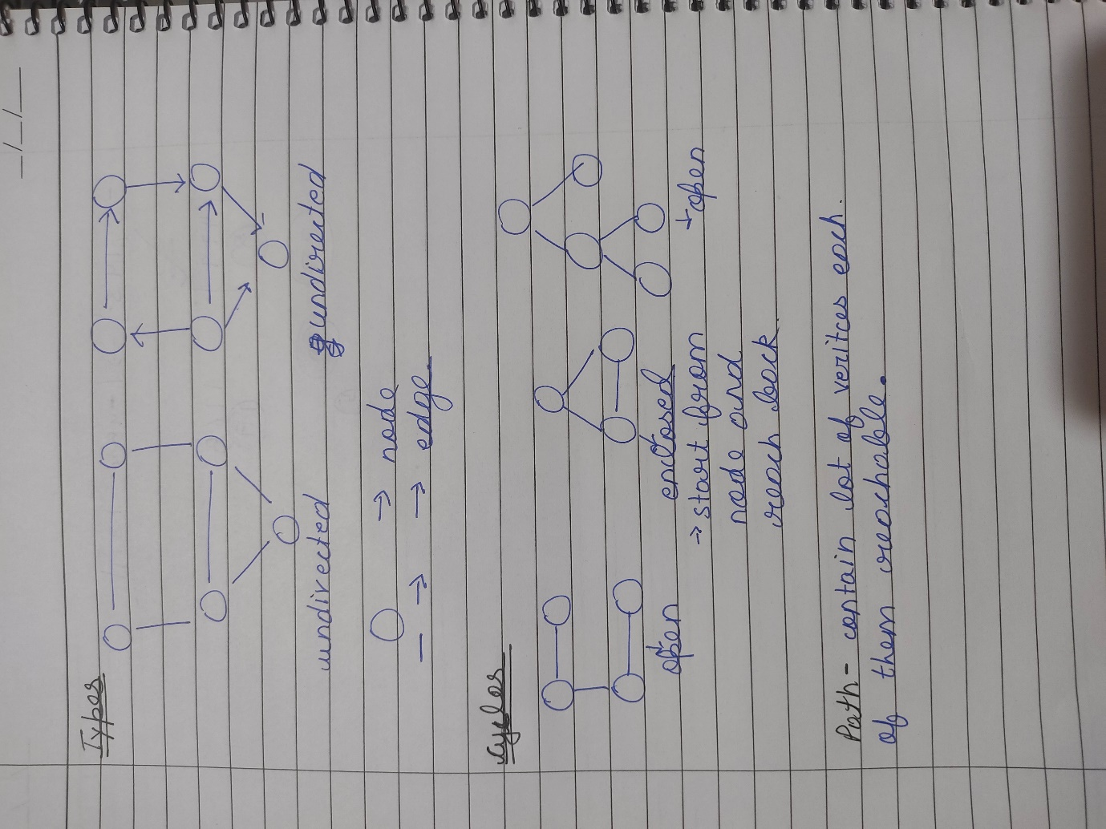

Cycles and path
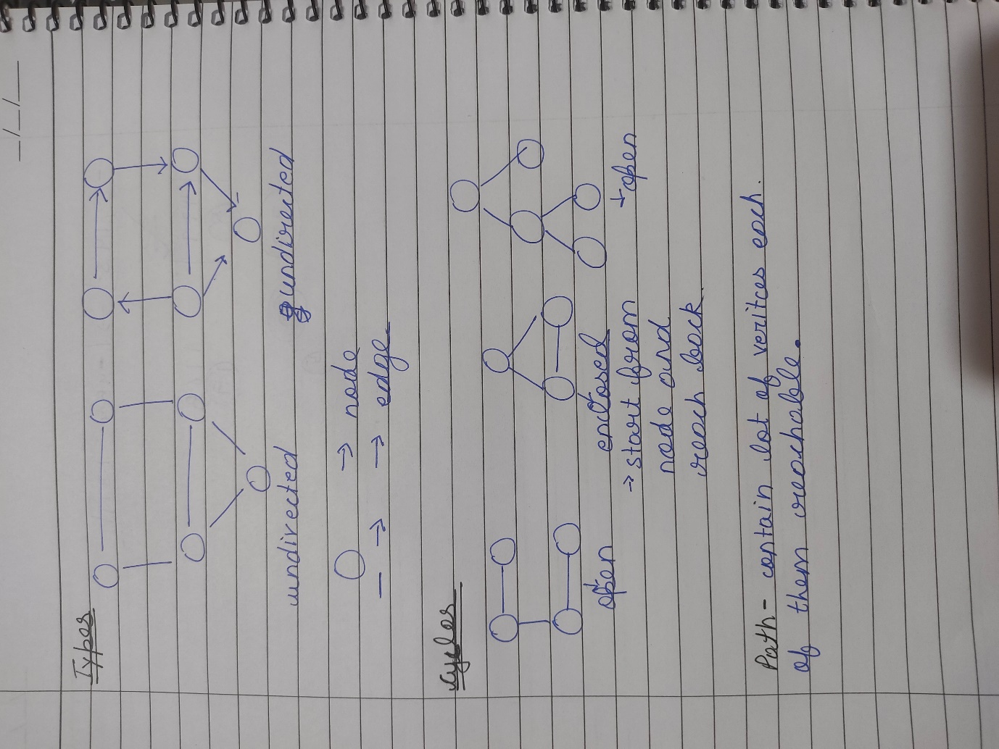

Directed and undirected, edge weight
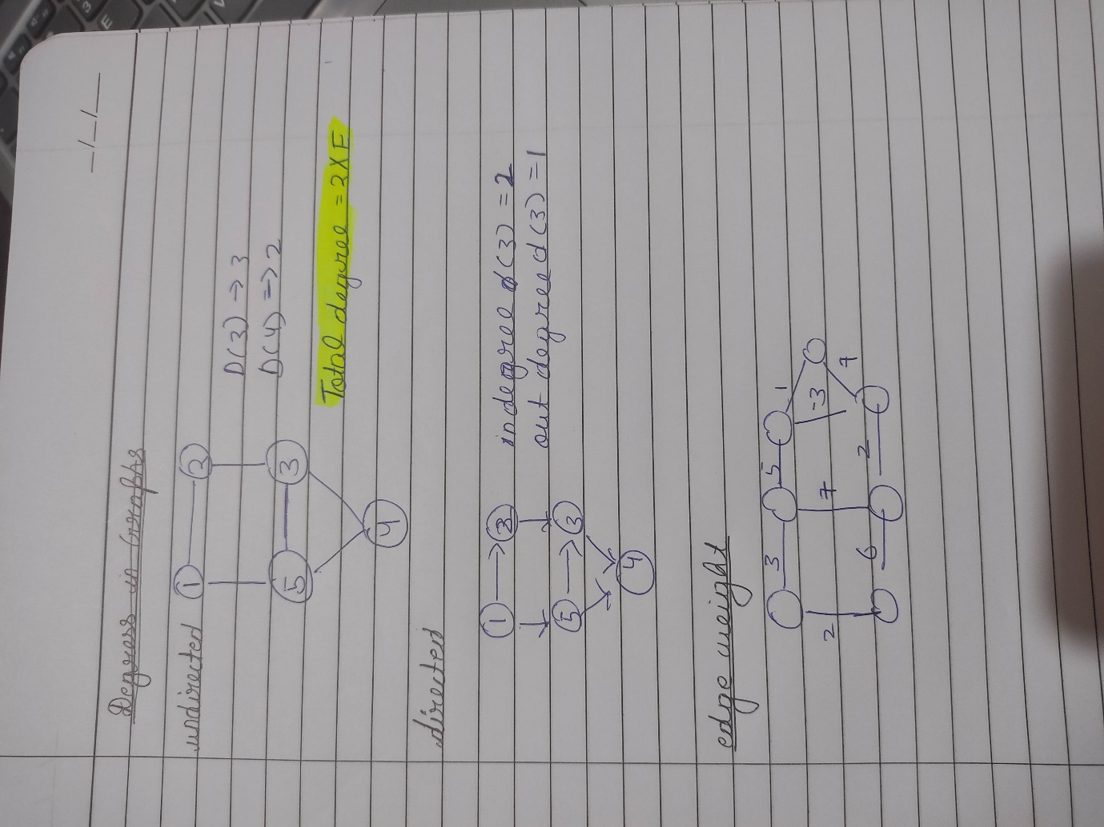

Connected components

BFS
Question – Given a directed graph. The task is to do Breadth First Traversal of this graph starting from 0.
Note: One can move from node u to node v only if there's an edge from u to v and find the BFS traversal of the graph starting from the 0th vertex, from left to right according to the graph. Also, you should only take nodes directly or indirectly connected from Node 0 in consideration.
Answer –
Points to remember –
- Use queue
- Mark visited while pushing to avoid multiple visiting of same element in BFS
Code –
class Solution {
public:
void BFS(int n,vector<bool> &visited,vector<int> adj[],vector<int> &traversal){
if (visited[n]) return;
queue<int> q;
q.push(n);
visited[n] = 1;
while (!q.empty()){
int node = q.front();
q.pop();
traversal.push_back(node);
for (int i : adj[node]){
if (!visited[i]){
q.push(i);
visited[i] = 1;
}
}
}
}
vector<int> bfsOfGraph(int V, vector<int> adj[]) {
vector<int> traversal;
int start = 0;
vector<bool> visited(V+start,0);
BFS(start,visited,adj,traversal);
return traversal;
}
};

DFS

