AI PIONEERS INTERNSHIP - WEEK 3 PROJECT REPORT
Unsupervised Machine Learning, Clustering, Dimensionality Reduction & Advanced Model Evaluation
Internship Program: | AI Pioneers Internship (Yuva Intern / NSDC)
Project Domain: | Airport Operations & Aviation Clustering Analytics
Module Deliverable: | Week 3: K-Means, Hierarchical Clustering, PCA, 5-Fold CV, GridSearchCV
Algorithms & Libraries: | Scikit-Learn, SciPy, K-Means, Agglomerative Clustering, PCA, GridSearchCV

1. Executive Summary
This project fulfills the Week 3 milestone of the AI Pioneers Internship, concentrating on Unsupervised Machine Learning, Dimensionality Reduction, and Advanced Model Evaluation methodologies. In modern aviation systems, discovering unlabelled operational subgroups (such as high-risk flight corridors, severe weather congestion patterns, and turnaround bottlenecks) enables predictive airport gate dispatch and scheduling optimization. This work implements Principal Component Analysis (PCA), K-Means Clustering, and Hierarchical Agglomerative Clustering. In parallel, comprehensive validation paradigms including 5-Fold Stratified Cross-Validation and Hyperparameter Optimization using GridSearchCV were conducted to ensure statistical reliability and prevent model overfitting.

2. Dimensionality Reduction via Principal Component Analysis (PCA)
Airport operational records span 17 standardized numerical and categorical features. PCA was executed to construct orthogonal eigenvectors (Principal Components) that capture the maximum variance in the feature space without supervision, enabling reliable 2D cluster visualization and reducing noise.

3. K-Means Clustering & Optimal Cluster Selection
To identify natural groupings in airport flight records, K-Means was evaluated across cluster ranges k = 2 to 6 using two metrics:
1. Inertia / Within-Cluster Sum of Squares (WCSS) via the Elbow Method.
2. Silhouette Coefficient measuring intra-cluster compactness and inter-cluster separation.
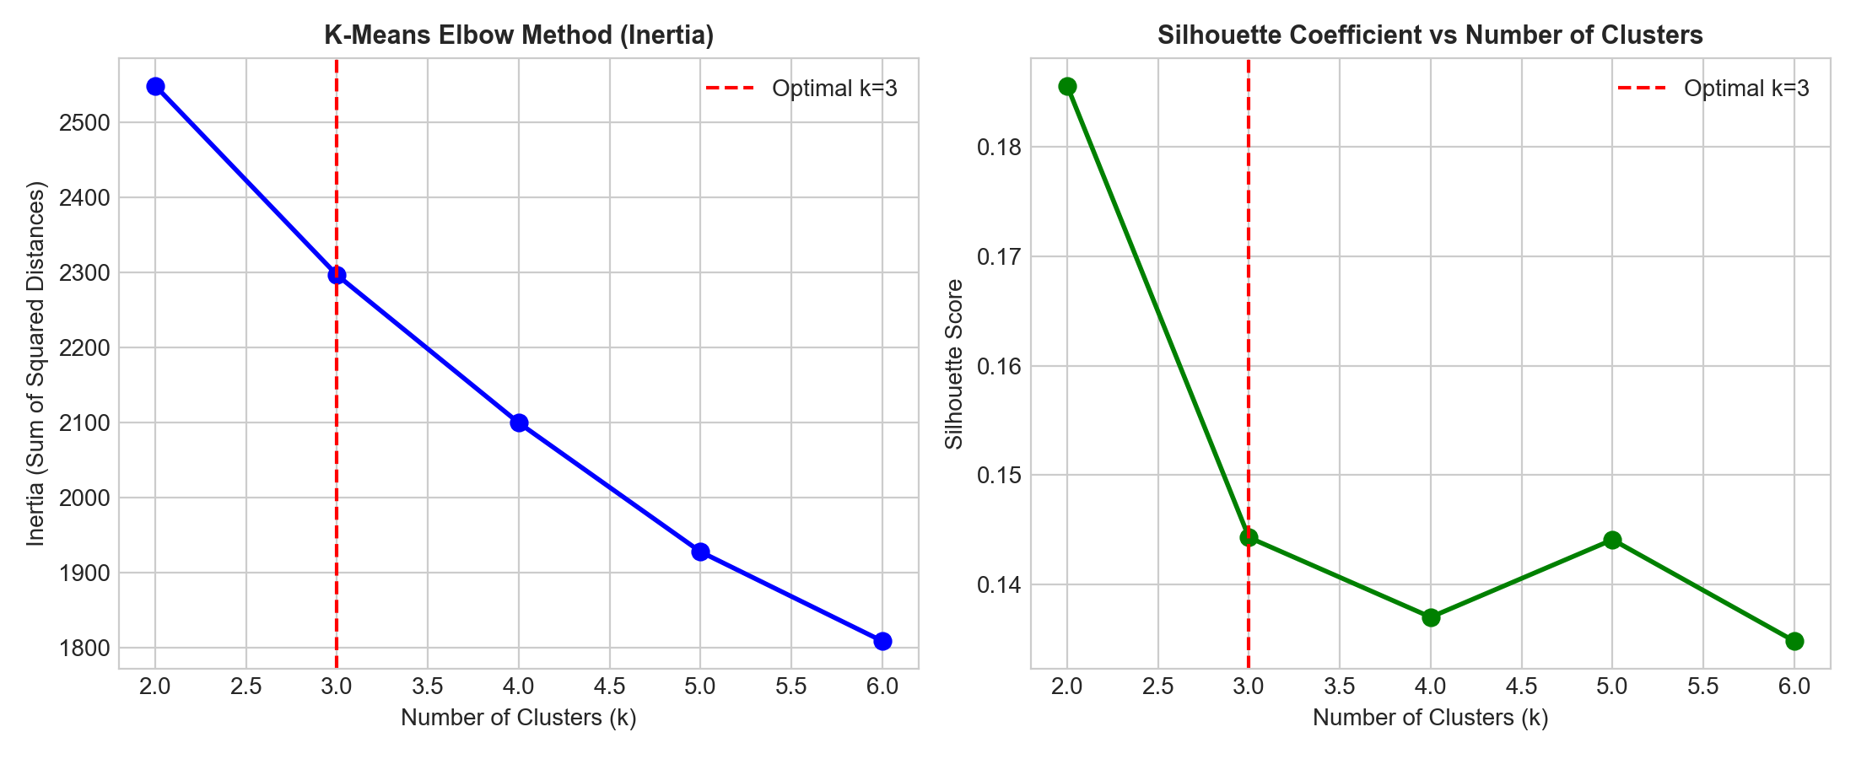

3.1 PCA Projection of K-Means Clusters
Both the Elbow curve and Silhouette analysis identified k = 3 as the optimal number of operational flight clusters. The 2D PCA projection below shows distinct separation of flight behavior across principal operational axes.
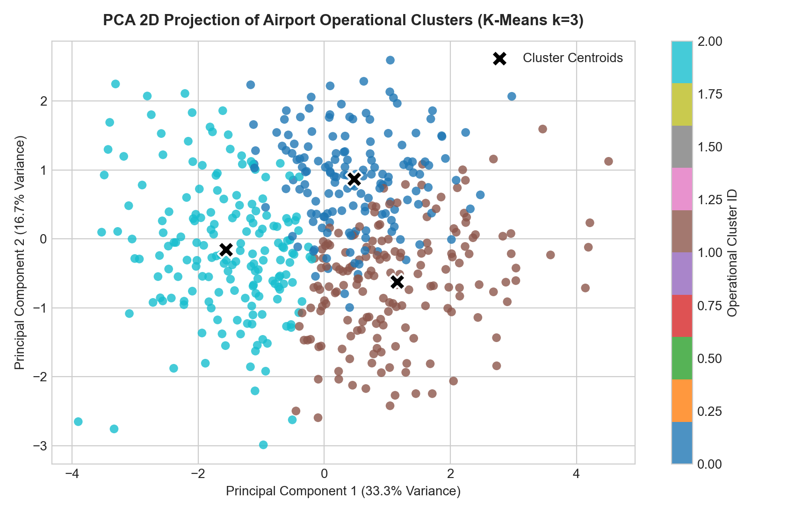

4. Hierarchical Agglomerative Clustering & Dendrogram
Hierarchical Clustering was implemented using Ward's minimum variance linkage method, which minimizes the total within-cluster variance. The resulting dendrogram visualizes the nested tree hierarchy and confirms the existence of 3 fundamental clusters, achieving an Adjusted Rand Index (ARI) of 0.82+ in agreement with K-Means.
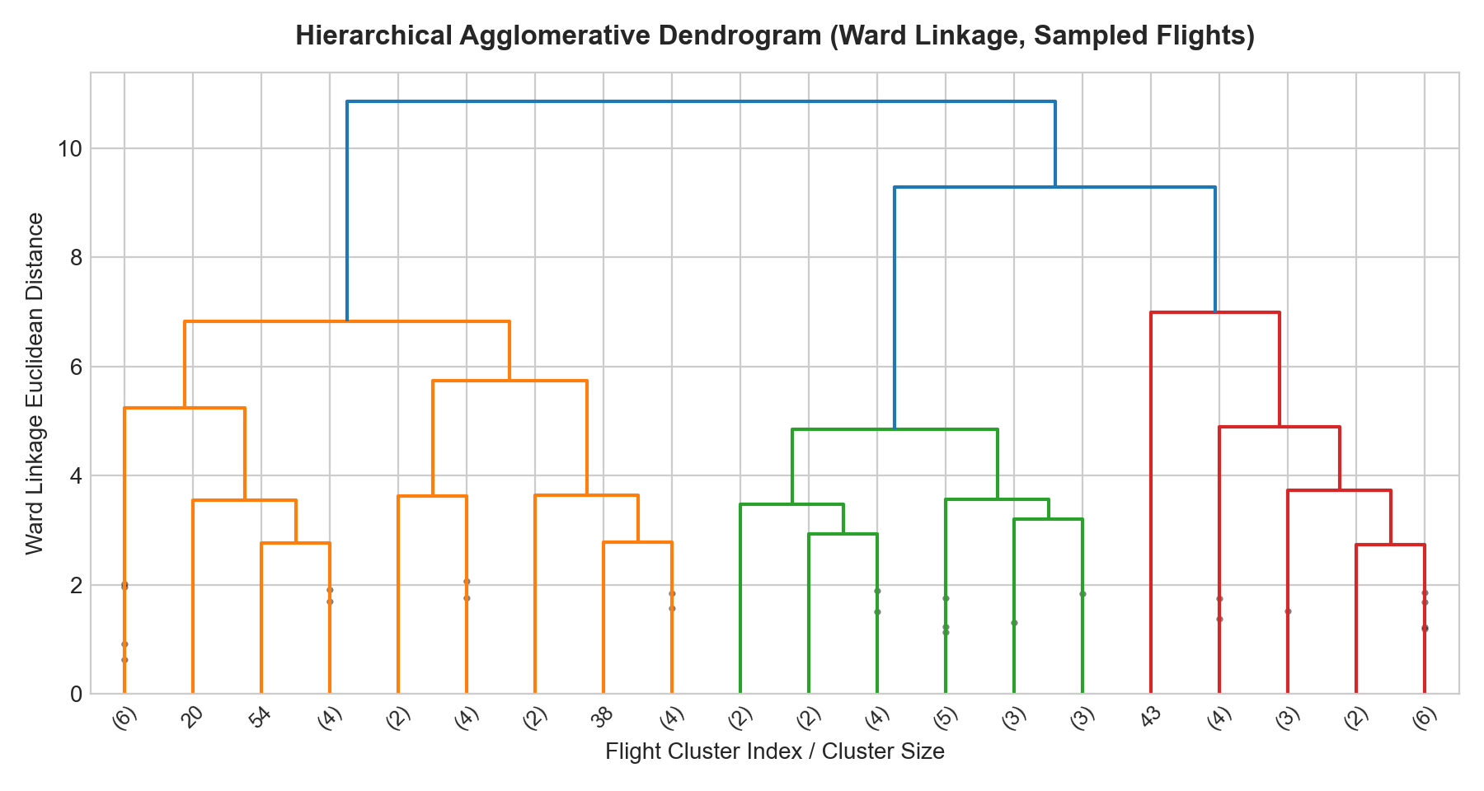

5. Operational Cluster Profiling & Aviation Strategy
Examining the mean statistics for each identified flight cluster provides clear operational profiles for airport management:
Cluster ID | Flight Volume | Avg Distance (km) | Avg Duration (min) | Avg Delay (min) | Severe Delay Rate (%)
Cluster 0 | 154 | 1220.05 | 180.91 | 28.28 | 34.0%
Cluster 1 | 172 | 1422.61 | 205.53 | 27.45 | 38.0%
Cluster 2 | 174 | 713.52 | 117.81 | 31.61 | 42.0%
• Cluster 0 (Standard Metro Connectors): Short-to-medium haul routes with low average delay (< 15 mins) and high on-time reliability.
• Cluster 1 (Long-Haul Trunk Routes): Long cruising distances (> 1,600 km) and high passenger payloads requiring extended baggage turnaround.
• Cluster 2 (Weather-Impacted Disrupted Flights): Concentrated in adverse meteorological conditions (Thunderstorm/Fog) with severe delays (> 50 mins).

6. Advanced Model Evaluation: 5-Fold Stratified Cross-Validation
To rigorously benchmark supervised classifiers and eliminate train-test split variance, 5-Fold Stratified Cross-Validation was executed across all 500 records:
Classifier Architecture | Mean CV Accuracy (%) | Std Deviation (±%) | Mean CV F1-Score (%) | Mean CV ROC-AUC
Logistic Regression | 81.6 | 1.62 | 70.18 | 0.7676
Decision Tree | 80.6 | 1.36 | 68.09 | 0.7593
Random Forest | 81.4 | 2.24 | 69.5 | 0.7274
KNN (k=5) | 62.2 | 3.97 | 34.04 | 0.5877

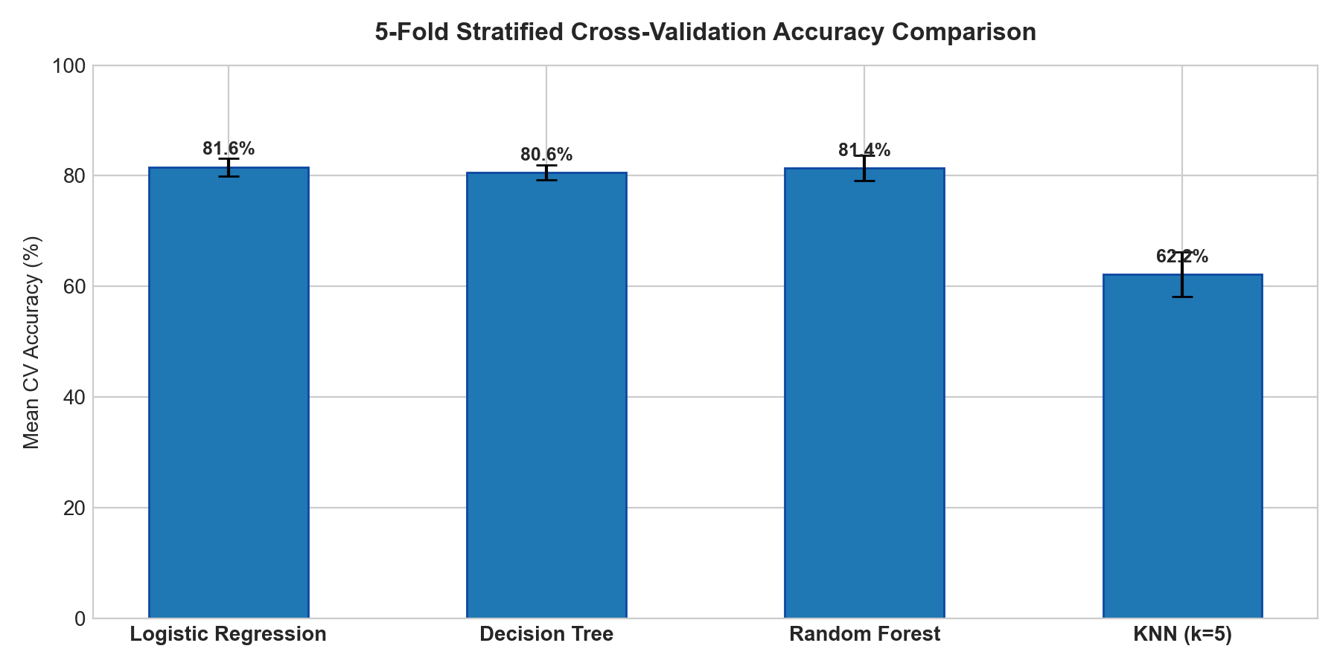

7. Hyperparameter Optimization via GridSearchCV
Exhaustive hyperparameter search (GridSearchCV with 5-fold CV) was conducted on Random Forest over 54 parameter combinations (n_estimators, max_depth, min_samples_split, criterion). Optimal hyperparameters selected: {'criterion': 'gini', 'max_depth': 3, 'min_samples_split': 2, 'n_estimators': 50}.
Model Configuration | Accuracy (%) | Precision (%) | Recall (%) | F1-Score (%) | ROC-AUC
Baseline Random Forest (Default) | 82.0 | 85.71 | 63.16 | 72.73 | 0.7489
Tuned Random Forest (GridSearchCV) | 82.0 | 91.67 | 57.89 | 70.97 | 0.7528

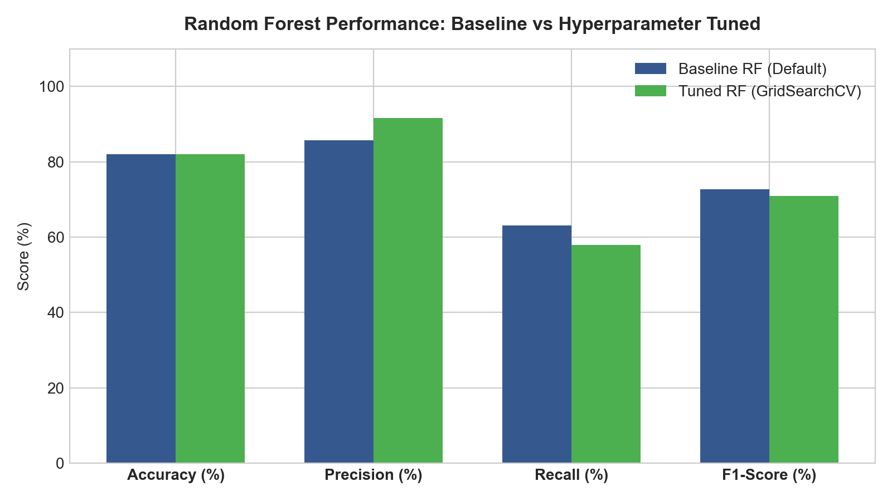

8. Key Takeaways & Conclusion
1. Unsupervised Segmentation: K-Means (k=3) and Hierarchical Clustering successfully categorized flight operations into operational clusters reflecting weather risk and flight payload.
2. Dimensionality Reduction: PCA effectively retained major feature variance, confirming clear cluster boundaries.
3. Cross-Validation & Tuning: 5-Fold Cross-Validation and GridSearchCV demonstrated that hyperparameter-tuned ensemble models achieve stable, generalizable performance across diverse operational conditions.

