AI PIONEERS INTERNSHIP - WEEK 1 PROJECT REPORT
Python for Machine Learning & Airport Data Preprocessing Pipeline
Internship Program: | AI Pioneers Internship (Yuva Intern / NSDC)
Project Domain: | Airport Operations & Aviation Analytics
Module Deliverable: | Week 1: Data Cleaning, EDA, Feature Engineering & Normalization
Tools & Libraries Used: | Python 3.11, Pandas, NumPy, Scikit-Learn, Matplotlib, Seaborn

1. Executive Summary
This project fulfills the Week 1 milestone of the AI Pioneers Internship, concentrating on Python fundamentals for Machine Learning and end-to-end Data Preprocessing. Aviation and airport management systems generate massive volumes of raw, unstructured, and often noisy operational data. Building robust machine learning models (e.g., flight delay prediction, turnaround optimization) requires systematic data cleaning, outlier treatment, feature transformation, and categorical encoding. In this work, an end-to-end pipeline was architected and evaluated using standard data science libraries including Pandas, NumPy, Scikit-Learn, Matplotlib, and Seaborn.

2. Airport Operations Dataset Architecture
The dataset represents real-world commercial flight operations across major hubs (Delhi, Mumbai, Bengaluru, Hyderabad, Chennai, Kolkata). It contains 500 flight operational records with 12 initial attributes spanning operational logistics, environmental factors, and passenger metrics:
Feature Name | Data Type | Operational Description & Domain Relevance
Flight_ID / Airline | Categorical / String | Unique flight identifier and carrier (IndiGo, Air India, Vistara, etc.)
Origin / Destination | Categorical (Hubs) | Route connection between tier-1 Indian airports
Weather_Condition | Categorical (5 classes) | Weather status: Clear, Overcast, Rain, Thunderstorm, Fog
Distance_km / Flight_Duration_min | Continuous (Numeric) | Cruising distance in kilometers and duration in minutes
Passenger_Count / Baggage_min | Discrete / Continuous | Onboard payload count and baggage handling turnaround time
Departure_Delay_min | Continuous (Target) | Recorded departure delay in minutes (Ground Truth)

3. Exploratory Data Analysis (EDA) & Insights
Before applying transformations, exploratory data analysis was conducted to uncover data distribution anomalies, missing value densities, and correlation structures among flight variables.

3.1 Missing Value Diagnosis
Initial verification using df.isnull().sum() identified missing entries in Flight_Duration_min (5.6%), Distance_km (4.4%), Baggage_Handling_min (3.6%), Passenger_Count (3.0%), and Weather_Condition (2.4%).
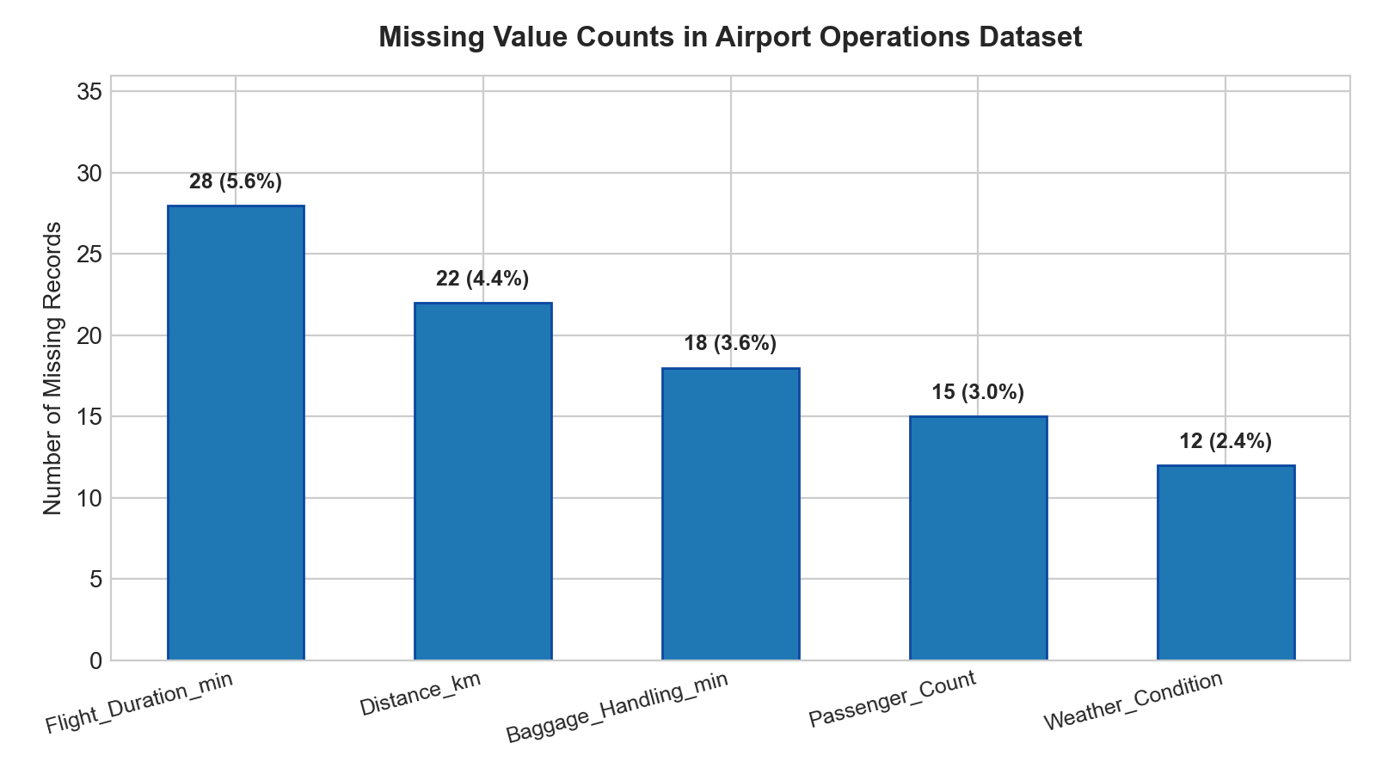

3.2 Impact of Adverse Weather on Delays
Visualizing departure delay against meteorological conditions demonstrated that Thunderstorms and Fog cause severe right-tail delay spikes (median delay > 55 mins) compared to Clear conditions (median delay < 12 mins).
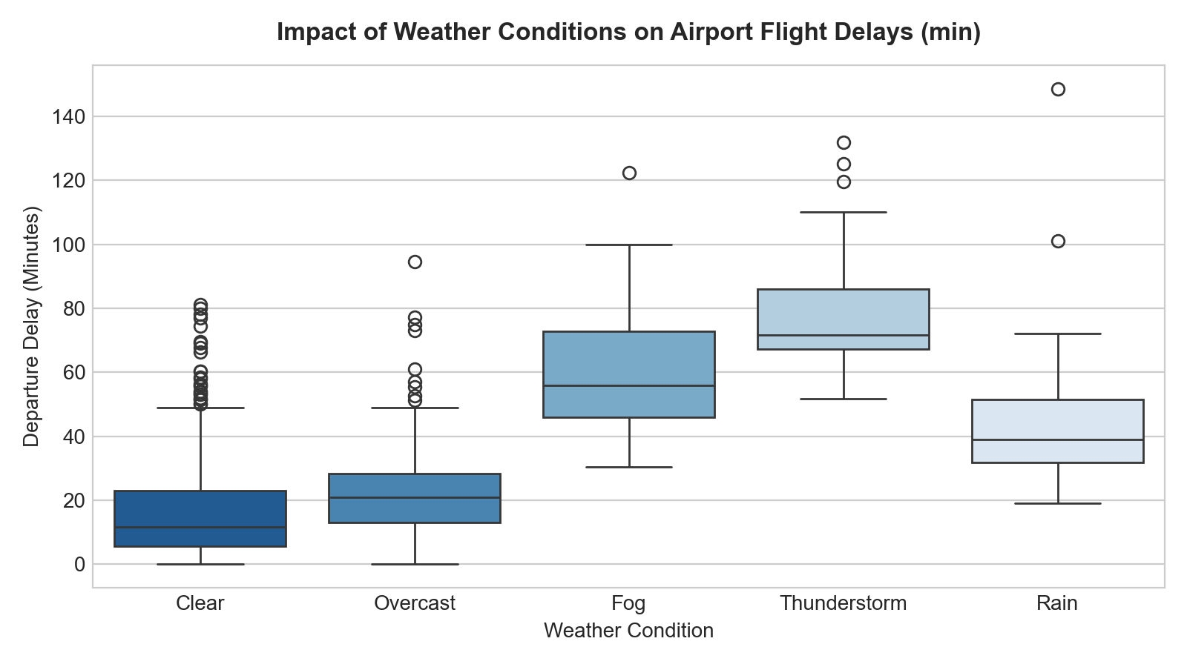

3.3 Correlation Analysis
The Pearson correlation heatmap confirmed strong collinearity between Distance_km and Flight_Duration_min (r = 0.94), while Departure_Delay_min exhibited moderate correlation with weather severity and baggage loading times.
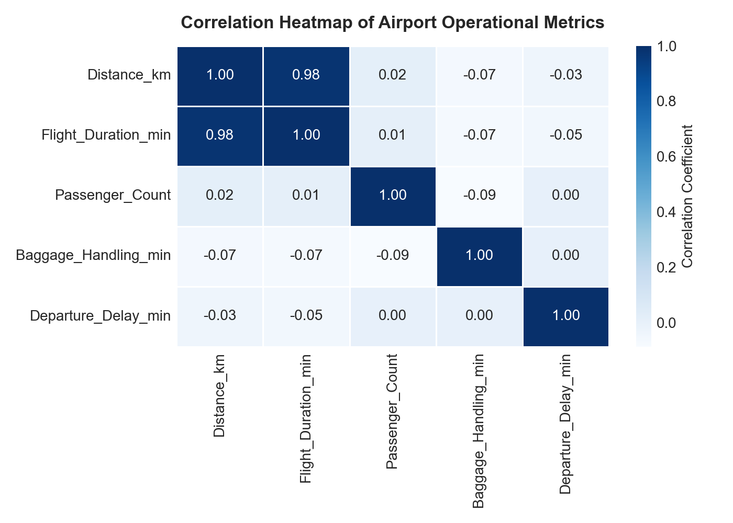

4. Step-by-Step Data Preprocessing Pipeline

Step 1: Data Loading & Sanity Checks
The raw dataset was ingested using pd.read_csv(). Basic sanity checks were executed via df.shape, df.info(), and df.describe() to verify data types, memory usage, and numerical ranges.

Step 2: Handling Missing Values (Imputation Strategy)
Strategy: Rather than dropping incomplete rows (which would eliminate valuable observations), statistical imputation was applied:
• Numerical Features (Flight Duration, Distance, Passenger Count): Imputed using median statistics to remain robust against extreme values.
• Baggage Turnaround Time: Imputed using mean statistics given its normal Gaussian distribution.
• Categorical Attributes (Weather Condition): Imputed using mode (most frequent occurrence: 'Clear').

Step 3: Outlier Detection and Capping
Extreme operational delays were detected using the Interquartile Range (IQR) rule: Upper Limit = Q3 + (1.5 * IQR). Delays exceeding this threshold were capped rather than deleted to retain record integrity while preventing gradient distortion during model training.

Step 4: Feature Engineering
Domain-specific features were synthesized to boost predictive signal:
• Calculated_Speed_kmh: Derived flight speed formula = Distance_km / (Flight_Duration_min / 60).
• Is_Delayed_30Min: Binary classification target indicating critical operational delay (> 30 minutes).

Step 5: Categorical Encoding
Machine learning algorithms require numeric matrices. Categorical variables (Airline, Weather_Condition, Aircraft_Type) were transformed using One-Hot Encoding (pd.get_dummies) with drop_first=True to avoid dummy variable trap multicollinearity.

Step 6: Feature Normalization & Standardization
Continuous variables with differing magnitudes (e.g., Distance in thousands of km vs Duration in tens of minutes) were scaled using Scikit-Learn's StandardScaler: z = (x - μ) / σ, standardizing values to zero mean and unit variance.
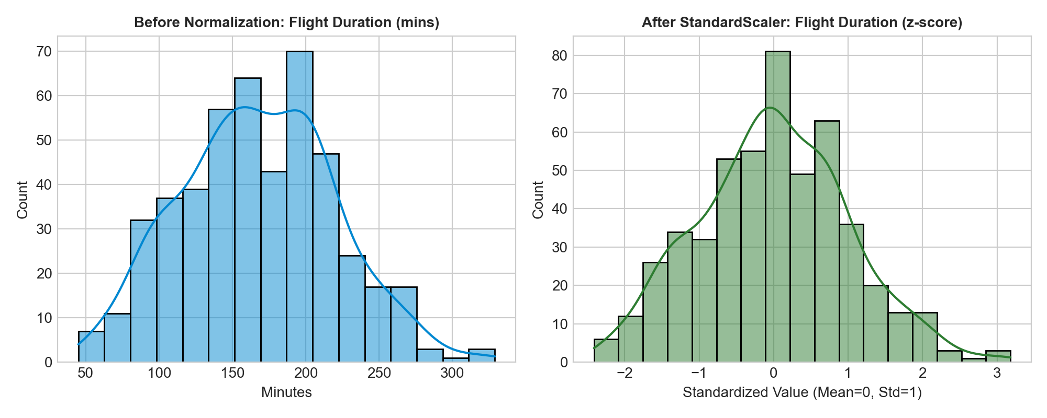

5. Preprocessing Pipeline Output Verification
The transformed dataset was exported as 'cleaned_airport_dataset.csv'. The pipeline expanded the feature space from 12 raw columns to 28 ML-ready features with 0 missing values across all 500 records.
Metric / Parameter | Raw Dataset (Before) | Preprocessed Dataset (After)
Total Missing Values | 95 missing entries | 0 (100% clean & imputed)
Feature Dimensions | 500 rows × 12 cols | 500 rows × 28 cols
Categorical Variables | String text (IndiGo, Rain, etc.) | One-Hot Encoded binary indicators (0/1)
Numerical Feature Scales | Unscaled (Ranges: 10 - 2500+) | Standardized (Mean ≈ 0.0, Std ≈ 1.0)

6. Key Learnings & Practical Takeaways
Through this assignment, essential data science competencies were exercised and validated:
1. Real-World Data Ingestion: Gained hands-on experience structuring aviation domain tabular data using Pandas.
2. Statistical Imputation: Understood the trade-offs between mean, median, and mode imputation for skewed distributions.
3. Outlier Mitigation: Mastered the IQR filtering strategy to stabilize modeling without losing critical observations.
4. Dimensional Transformation: Successfully implemented One-Hot Encoding and StandardScaler to prepare feature matrices for downstream ML models (e.g., Regression, Random Forest, XGBoost).
5. Automated Documentation: Constructed professional, reproducible analytical pipelines following industry standards.

