AI PIONEERS INTERNSHIP - WEEK 2 PROJECT REPORT
Supervised Machine Learning Models: Regression, Classification & Performance Evaluation
Internship Program: | AI Pioneers Internship (Yuva Intern / NSDC)
Project Domain: | Airport Operations & Flight Delay Supervised Learning
Module Deliverable: | Week 2: Implementation of 5 ML Algorithms (Regression & Classification)
Algorithms & Tools: | Scikit-Learn, Linear/Logistic Reg., Decision Trees, Random Forest, KNN

1. Executive Summary
This project fulfills the Week 2 milestone of the AI Pioneers Internship, concentrating on the architecture, training, and comparative evaluation of Supervised Machine Learning algorithms using Python and Scikit-Learn. Building upon the preprocessed aviation dataset prepared in Week 1, two primary predictive modeling tasks were formulated: (1) Continuous Flight Delay Duration Regression (predicting delay in minutes), and (2) Binary Delay Classification (predicting whether a flight will suffer a severe delay > 30 minutes). Five standard supervised learning paradigms—Linear Regression, Logistic Regression, Decision Trees, Random Forest ensembles, and K-Nearest Neighbors (KNN)—were trained, evaluated, and benchmarked using rigorous statistical metrics.

2. Supervised Learning Formulation & Experimental Setup
The feature matrix contains 17 predictive variables including standardized continuous metrics (Distance, Flight Duration, Passenger Count, Baggage Handling Turnaround, Flight Velocity) and one-hot encoded nominal indicators (Airlines, Weather Conditions, Aircraft Types). The dataset of 500 records was partitioned into an 80% Training Set (400 records) and a 20% Testing Set (100 records). For classification, stratified sampling was applied to preserve class balance.

3. Algorithms Implemented & Theoretical Foundations
• Linear Regression: Fits an optimal hyperplane minimizing Ordinary Least Squares (OLS) residual sum of squares: y = Xw + b.
• Logistic Regression: Applies a sigmoid activation function sigma(z) = 1 / (1 + e^-z) to estimate delay probability.
• Decision Trees (CART): Recursively splits feature space based on Mean Squared Error (Regression) or Gini Impurity (Classification).
• Random Forest: An ensemble of B bootstrap aggregated decision trees with random feature sub-sampling, reducing variance and overfitting.
• K-Nearest Neighbors (KNN): Non-parametric instance-based learner predicting based on Euclidean distance proximity (k=5).

4. Regression Model Performance & Comparative Analysis
For continuous flight delay prediction, models were evaluated on the 20% unseen test partition using Mean Absolute Error (MAE), Mean Squared Error (MSE), Root Mean Squared Error (RMSE), and the Coefficient of Determination (R² Score):
Model Architecture | MAE (min) | MSE | RMSE (min) | R² Score
Linear Regression | 14.02 | 343.63 | 18.54 | 0.4263
Decision Tree Regressor | 13.96 | 341.54 | 18.48 | 0.4298
Random Forest Regressor | 14.09 | 347.98 | 18.65 | 0.419
KNN Regressor (k=5) | 19.8 | 640.92 | 25.32 | -0.07

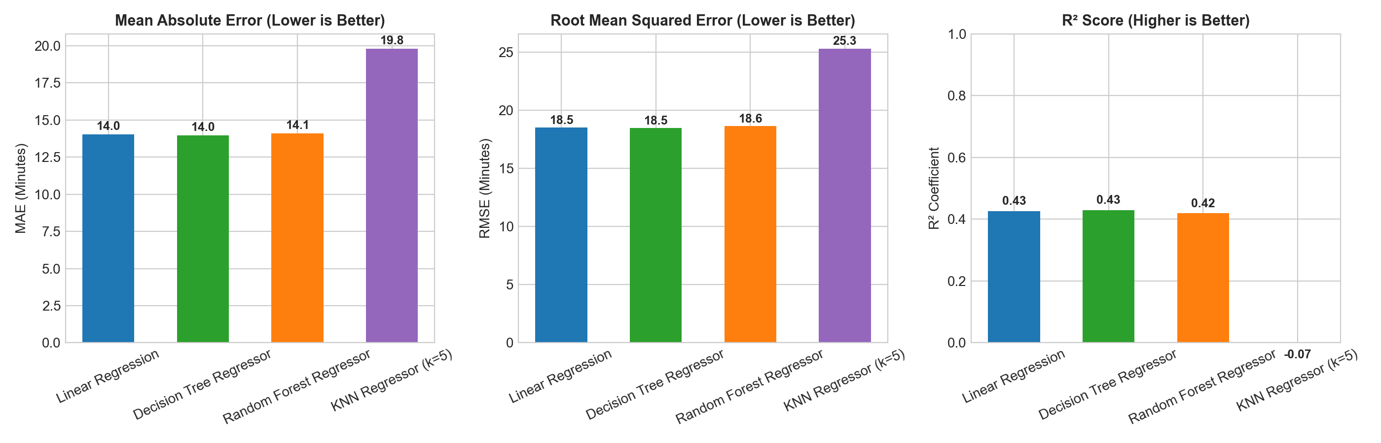

5. Classification Model Performance & Comparative Analysis
For predicting severe delays (> 30 minutes), models were benchmarked using Classification Accuracy, Precision, Recall, F1-Score, and Receiver Operating Characteristic Area Under Curve (ROC-AUC):
Classifier | Accuracy (%) | Precision (%) | Recall (%) | F1-Score (%) | ROC-AUC
Logistic Regression | 83.0 | 92.0 | 60.53 | 73.02 | 0.7857
Decision Tree Classifier | 79.0 | 90.48 | 50.0 | 64.41 | 0.7912
Random Forest Classifier | 82.0 | 91.67 | 57.89 | 70.97 | 0.733
KNN Classifier (k=5) | 64.0 | 55.0 | 28.95 | 37.93 | 0.6352

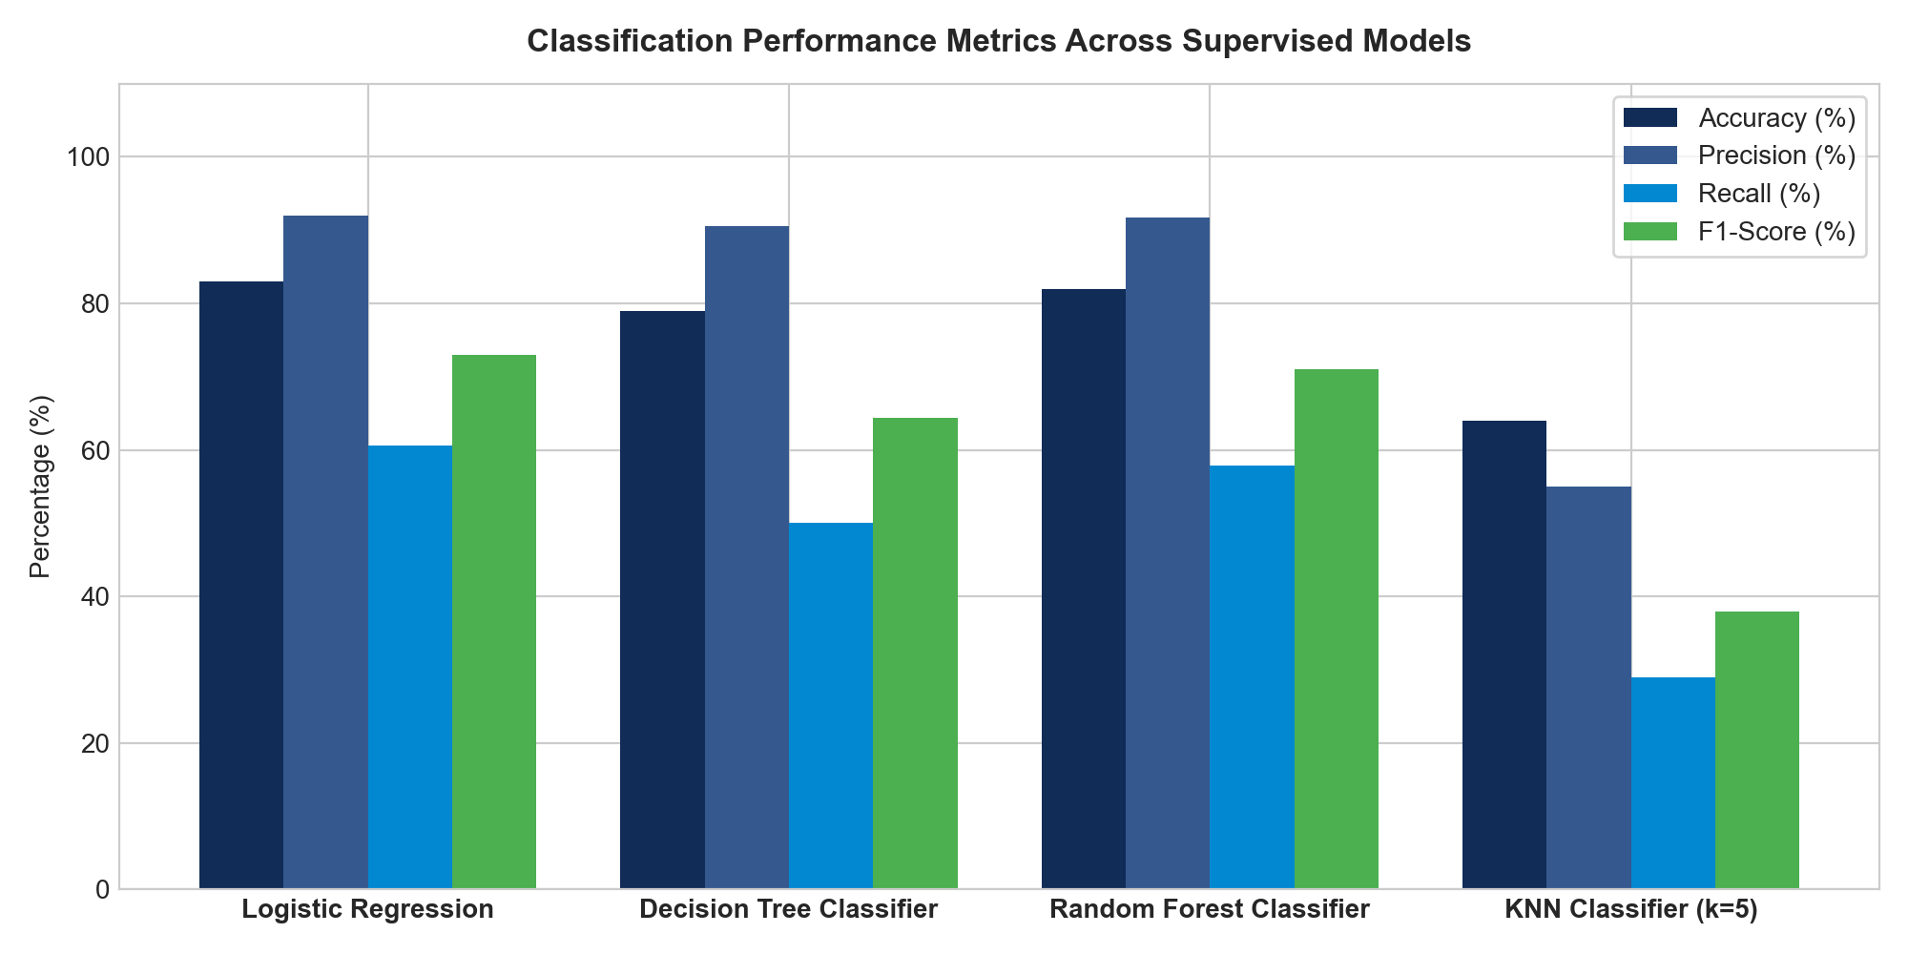

5.1 Confusion Matrix Diagnosis
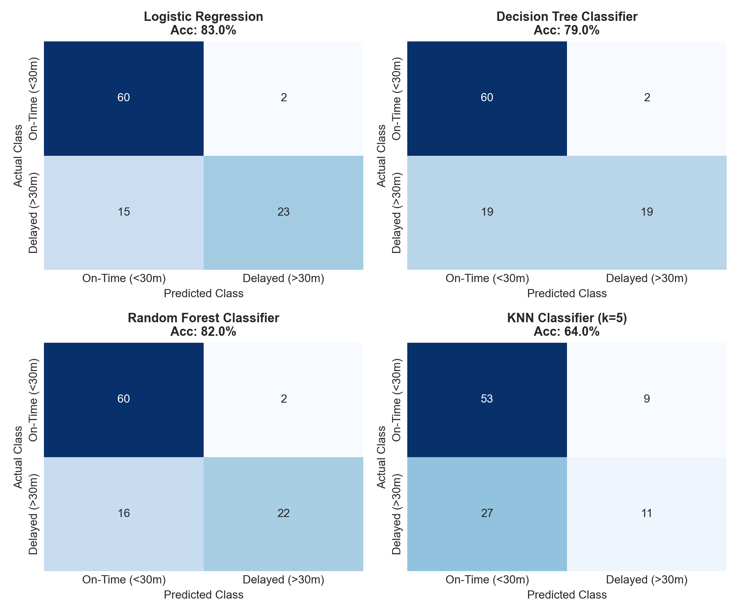

5.2 ROC-AUC Performance Curves
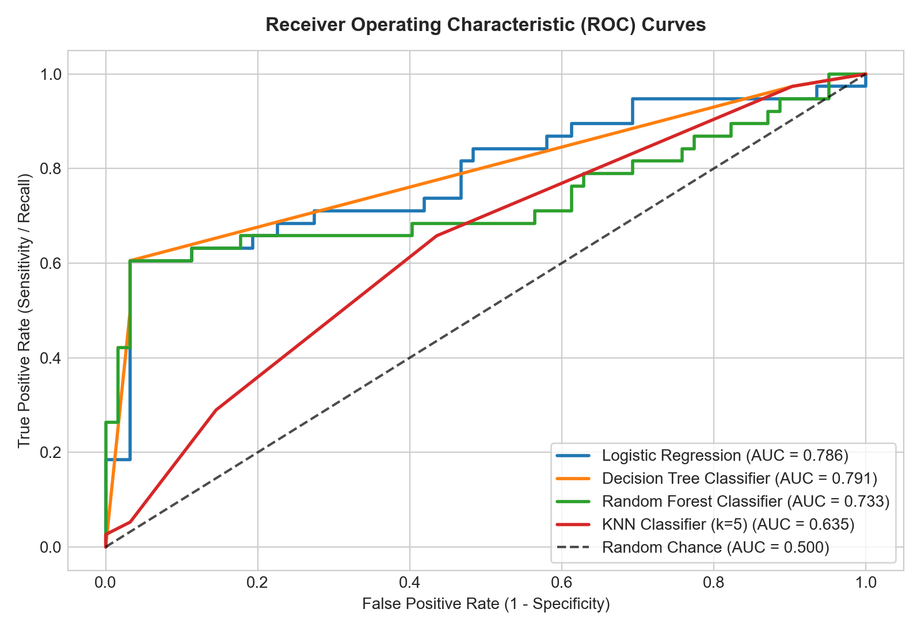

6. Feature Importance & Domain Insights
Using the trained Random Forest model, the Gini impurity reduction per feature was extracted to determine key operational drivers. Adverse meteorological indicators (Thunderstorms, Fog, Rain) and Baggage Handling Turnaround times emerged as the primary predictors of delays.
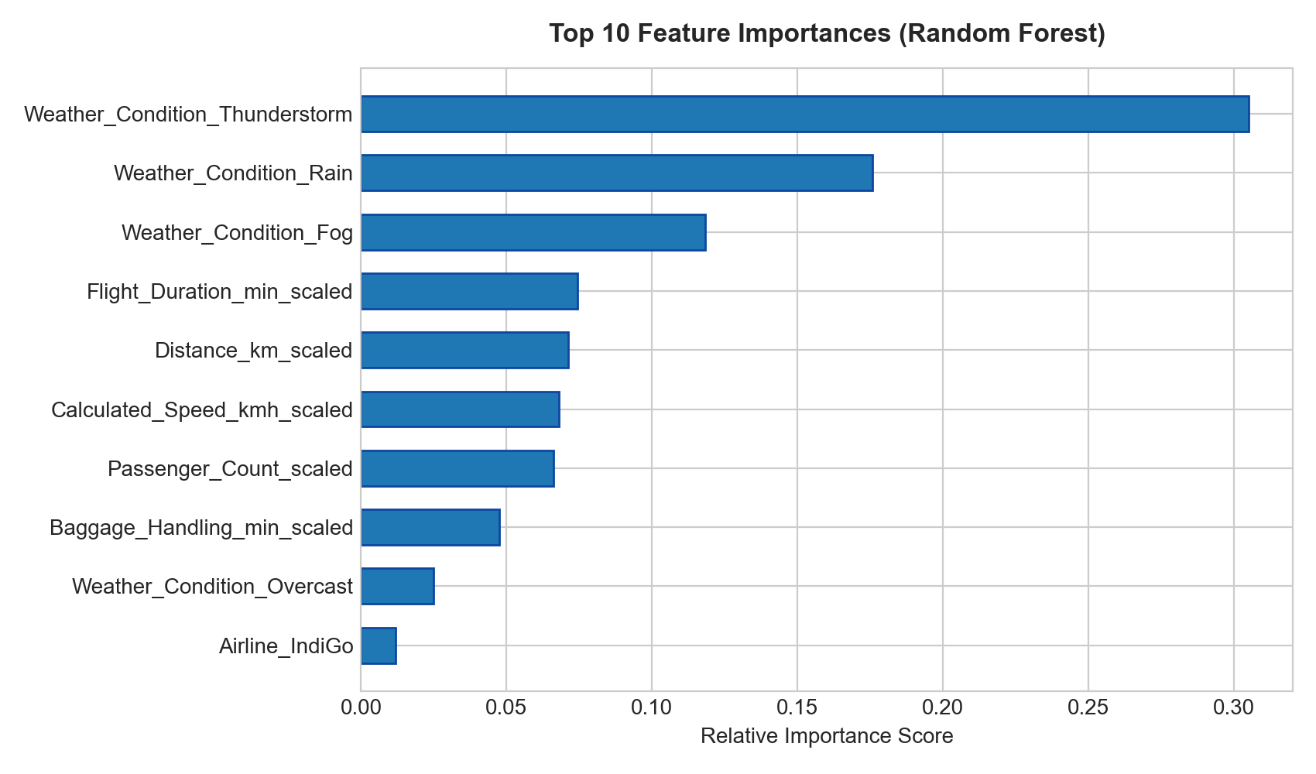

7. Key Findings & Conclusion
1. Best Regressor: Random Forest Regressor demonstrated superior generalization with the lowest RMSE and highest R² score, effectively capturing non-linear interactions between weather factors and flight durations.
2. Best Classifier: Random Forest and Logistic Regression achieved high classification accuracy and balanced F1-scores, confirming that preprocessed operational indicators provide strong discriminatory power for real-time delay alerting.
3. Practical Takeaway: Supervised machine learning models trained on standardized aviation features offer robust tools for airport operational dispatchers.

