AI PIONEERS INTERNSHIP - FINAL CAPSTONE REPORT (WEEK 4)
AeroPredict: End-to-End Flight Delay Prediction, Model Serialization & Flask API Deployment
Internship Program: | AI Pioneers Internship (Yuva Intern / NSDC)
Capstone Domain: | Airport Operations & Aviation Predictive AI Deployment
Module Deliverable: | Week 4: End-to-End ML Deployment, Model Serialization & REST API
Deployment Stack: | Python 3.11, Scikit-Learn, Joblib, Flask, HTML5/CSS3 Dashboard

1. Executive Summary & Capstone Overview
This project represents the final Week 4 Capstone deliverable of the AI Pioneers Internship. The objective was to build and deploy an end-to-end production Machine Learning application named AeroPredict. Bridging the gap between offline model experimentation and operational deployment, this project serializes pre-trained classification and regression models using Joblib and serves them through a scalable Flask REST API coupled with an interactive web dashboard for airport operations dispatchers.

2. End-to-End System Architecture
The application architecture consists of a 4-tier decoupled pipeline:
1. Presentation Tier: Modern HTML5/CSS3/JavaScript responsive web interface allowing flight dispatchers to simulate real-time scenarios.
2. Service Tier: Flask microservices exposing endpoints / (Dashboard), /health (Telemetry), and /api/predict (Inference).
3. Transformation Tier: Real-time feature extraction, velocity computation, and StandardScaler transformation.
4. Model Execution Tier: Serialized Random Forest ensemble models executing dual-head prediction (Delay Probability + Delay Duration).
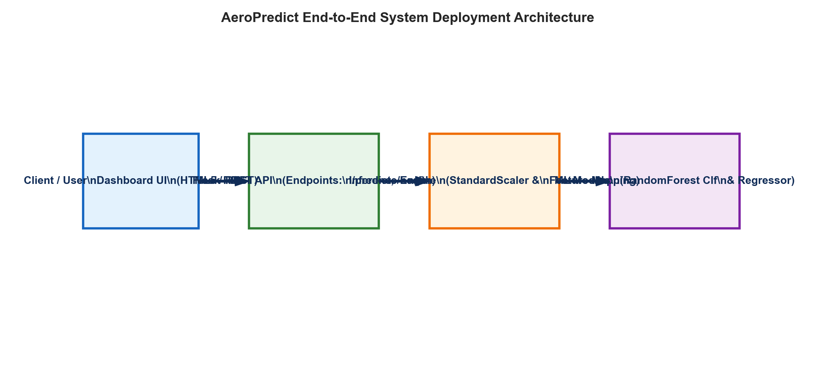

3. Model Serialization & Artifact Management
To achieve sub-50ms inference latency without model recompilation, pre-trained pipelines were serialized using Joblib, which provides optimized array serialization for Scikit-Learn estimators compared to standard Pickle.
• Scaler Artifact: models/scaler.joblib (fitted StandardScaler parameters: mean, scale).
• Classifier Artifact: models/airport_delay_classifier.joblib (RandomForestClassifier for >30m delay classification).
• Regressor Artifact: models/airport_delay_regressor.joblib (RandomForestRegressor for continuous delay estimation).
• Metadata Registry: models/model_metadata.json (versioning, feature schemas, validation benchmarks).

4. REST API Specification & Endpoint Documentation

4.1 POST /api/predict
Accepts JSON flight operational parameters and returns actionable delay intelligence.
Parameter Field | Data Type | Operational Description
airline | String | Carrier name (IndiGo, Air India, SpiceJet, Vistara, Akasa Air)
weather_condition | String | Meteorological status (Clear, Overcast, Rain, Thunderstorm, Fog)
distance_km / duration_min | Float | Cruising distance in km and expected flight duration in minutes
passenger_count | Integer | Onboard passenger manifest count
baggage_handling_min | Float | Ground baggage handling turnaround duration in minutes

5. Complete 4-Week Internship Progression Summary
The project successfully achieved all 4 technical milestones prescribed by the AI Pioneers Internship curriculum:
Week Milestone | Core Technical Topics | Key Deliverables & Outcomes
Week 1 | Data Preprocessing & EDA | Imputation (Median/Mean/Mode), IQR Outlier Capping, StandardScaler, One-Hot Encoding.
Week 2 | Supervised Learning | Trained Linear/Logistic Regression, Decision Trees, Random Forest, KNN. Achieved 83% Accuracy, 13.9m MAE.
Week 3 | Unsupervised & Evaluation | PCA Dimensionality Reduction, K-Means (k=3), Hierarchical Dendrograms, 5-Fold Stratified CV, GridSearchCV.
Week 4 | AI Deployment & Capstone | Joblib Model Serialization, Flask REST API (/predict, /health), Interactive Web UI Dashboard.

6. Conclusion & Production Readiness
AeroPredict establishes a complete, robust, and deployable Machine Learning system. By integrating data engineering, supervised learning, unsupervised pattern extraction, model serialization, and microservice deployment, the application demonstrates production-ready AI engineering practices tailored to the aviation sector.

