Steps by Step process to Resolve SOC7.

- Simple program to add 2 numbers (ACCEPT statement to get the input values A & B)
- Compile the program with PARM option as LIST (also try TEST option along with it)
- Run the program --- (input values as A- X. (bad data ) and B-10)
- You have to see job Abend with SOC7 as below
- Go to SYSOUT/CEEDUMP folder in Spool and get the offset value
- Use the offset value and search in the compiled version of the program (see point 2)
- Just above it you will see what statement SOC7 was raised
- If you need the values you can them too in CEEDUMP at the bottom (this u will see if you use TEST option)

Screen shot are in sequence for above points:

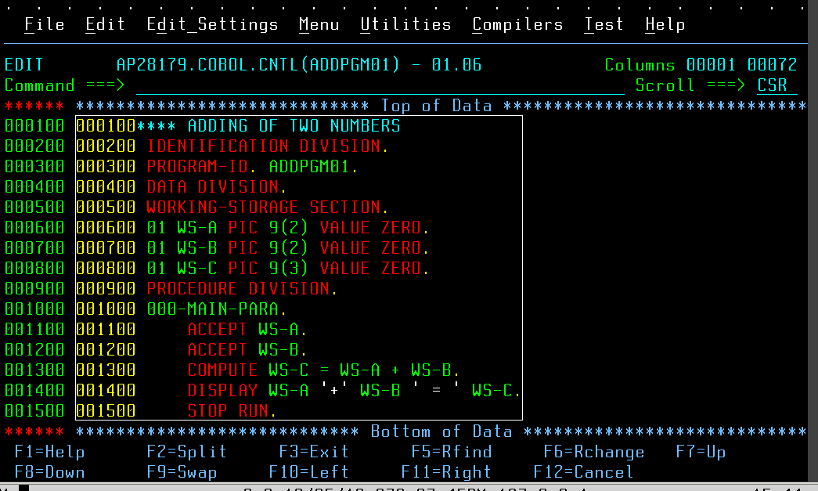
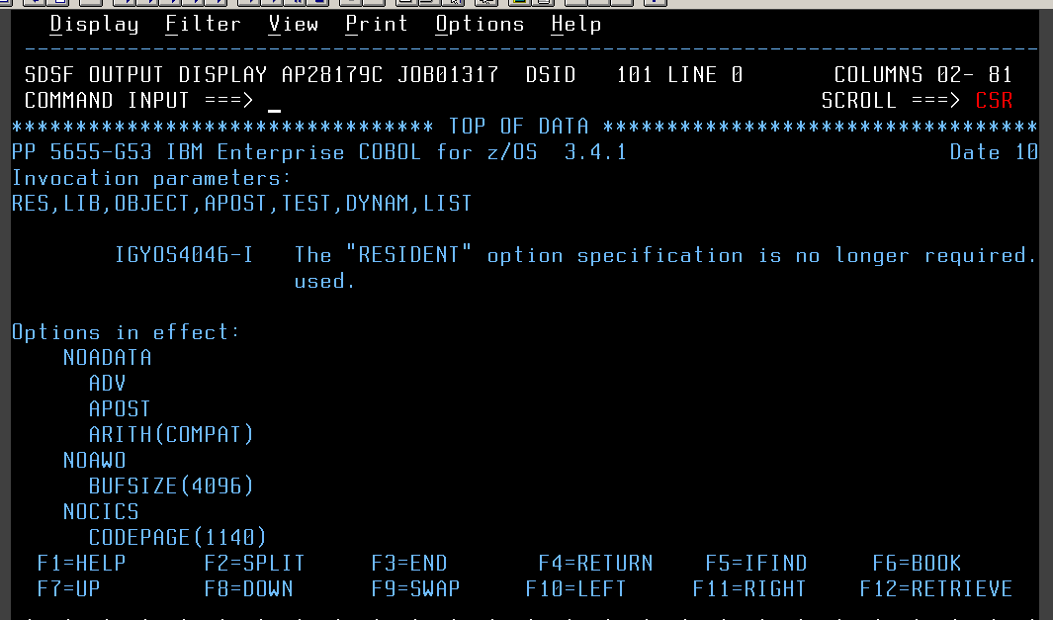

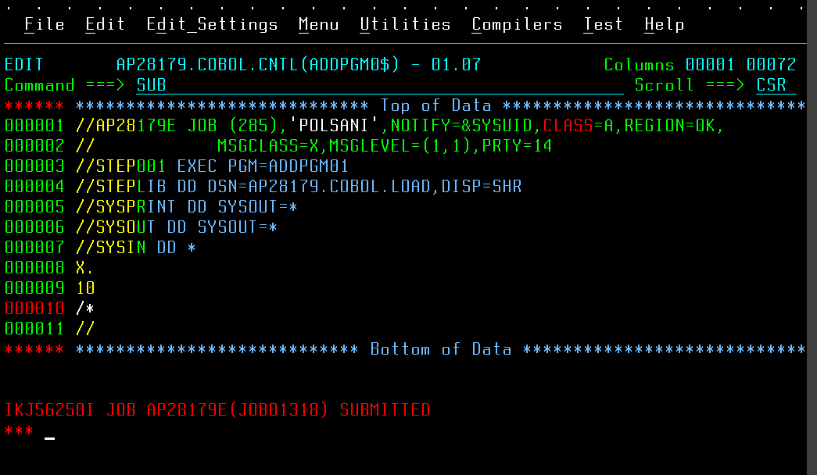

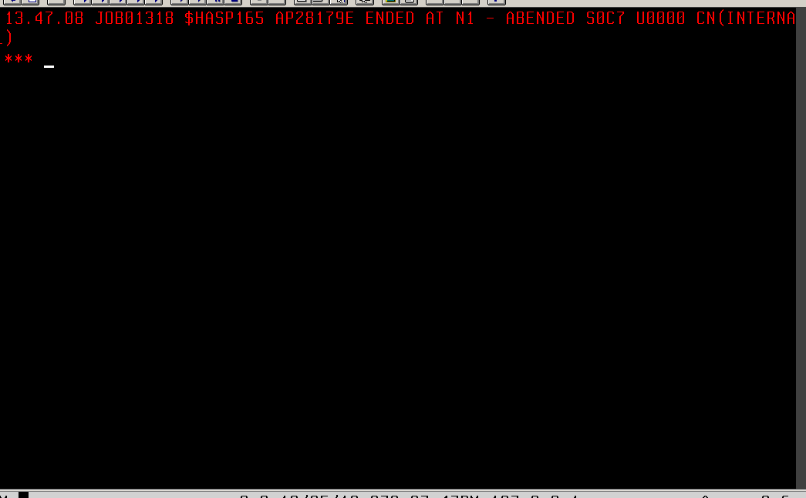

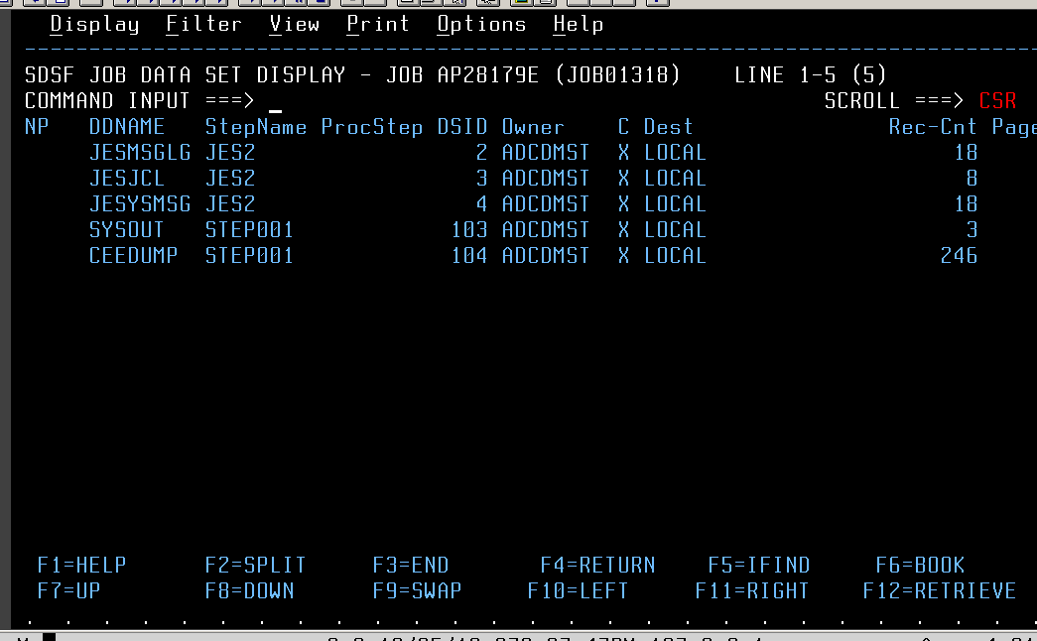

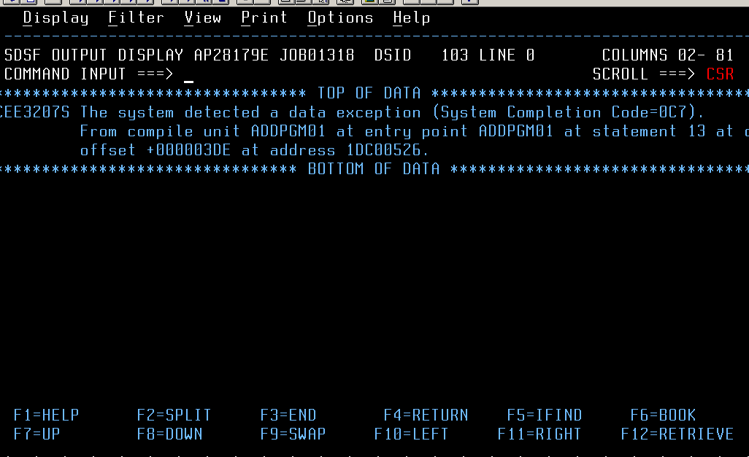

OFFSET VALUE → 000003DE

