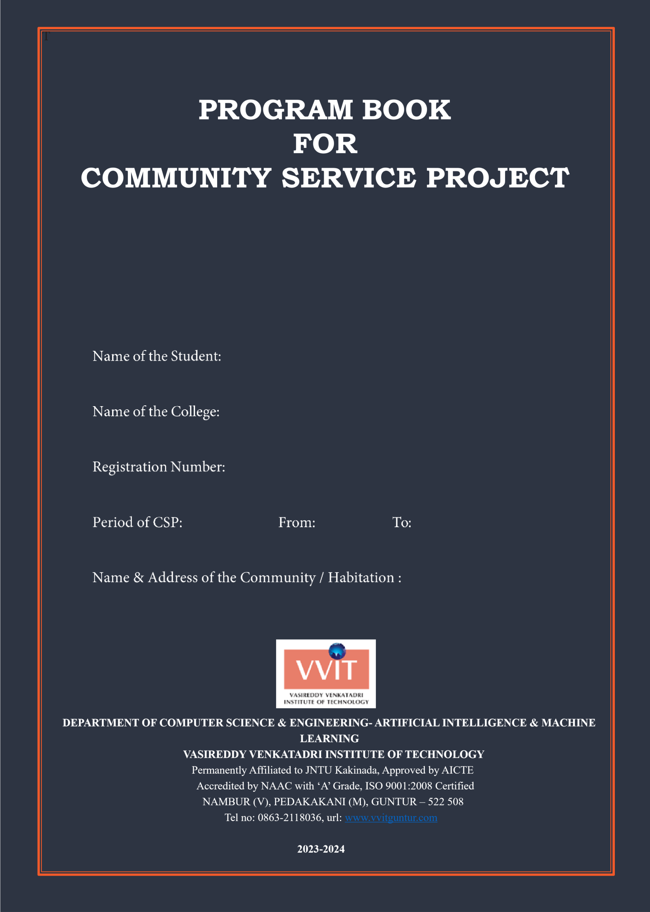






Devarakonda Anand

Vasireddy Venkatadri Institute of Technology

22BQ1A6114

8 Weeks 04/06/2025 30/07/2025

Takkellapadu, Pedakakani Mandal, Guntur District , Andhra Pradesh

2025-2026

Community Service Project Report

Submitted in accordance with the requirement for the degree of Bachelor of Technology Name of the College : Vasireddy Venkatadri Institute of Technology Department :Artificial Intelligence &Machine Learning
Name of the Faculty Guide : Ms.K.Sireesha

Duration of the CSP : 8 Weeks From: 4/06/2025 To:30/07/2025

Name of the Student : Devarakonda Anand

Programmer of Study : B.Tech

Year of Study : IV - II

Register Number : 22BQ1A6114

Date of Submission :

Student’s Declaration

I, Devarakonda Anand, a student of B.Tech Program, Reg. No. 22BQ1A6114 of the Department of Artificial Intelligence & Machine Learning, Vasireddy Venkatadri Institute of Technology College do hereby declare that I have completed the mandatory community 4/06/2025 to 30/07/2025 in Takkellapadu under the Faculty Guideship of Ms.K.Sireesha, Department of Computer Science Engineering – Artificial Intelligence & Machine Learning in Vasireddy Venkatadri Institute of Technology College

(Signature and Date)

Endorsements

Faculty Guide

Head of the Department

Principal

Certificate from Official of the Community

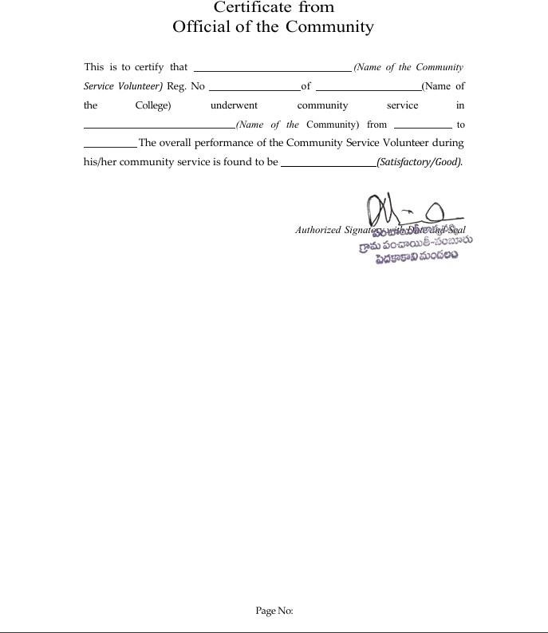

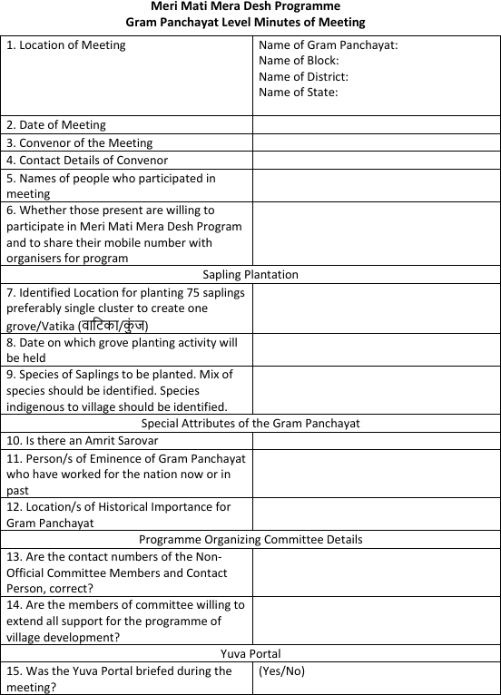

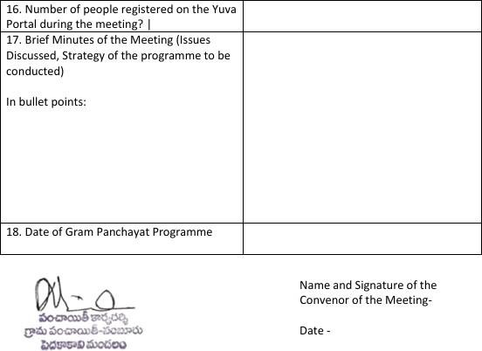

Acknowledgements

We take this opportunity to express my deepest gratitude and appreciation to all those people who made this project work easier with words of encouragement, motivation, discipline, and faith by offering different places to look to expand my ideas and helped me towards the successful completion of this project work.

First and foremost, we express my deep gratitude to Mr. Vasireddy Vidya Sagar, Chairman, Vasireddy Venkatadri Institute of Technology for providing necessary facilities throughout the B.Tech programme.

We express my sincere thanks to Dr. Y. Mallikarjuna Reddy, Principal, Vasireddy Venkatadri Institute of Technology for his constant support and cooperation throughout the B.Tech programme.

We express my sincere gratitude to Dr. G. Sanjay Gandhi, Professor & HOD, Artificial Intelligence and Machine Learning(AI&ML), Vasireddy Venkatadri Institute of Technology for his constant encouragement, motivation and faith by offering different places to look to expand my ideas.

We would like to express my sincere gratefulness to our Guide Ms.K.Shireesha, Assistant Professor, AI&ML for her insightful advice, motivating suggestions, invaluable guidance, help and support in successful completion of this project.

We would like to express our sincere heartfelt thanks to our Project Coordinator B .Pardha Saradhi, Assistant Professor, AI&ML for his valuable advices, motivating suggestions, moral support, help and coordination among us in successful completion of this project.

We would like to take this opportunity to express my thanks to the Teaching and Non-Teaching Staff in the Department of Computer Science & Engineering, VVIT for their invaluable help and support.

Name of Student Devarakonda Anand



Department of Artificial Intelligence and Machine Learning CERTIFICATE
This is to certify that this Project Report is the bonafide work of Devarakonda Anand bearing Reg. No. 22BQ1A6114 respectively who had carried out the project entitled “Water conservation awareness " under our supervision.

Project Guide Head of the Department
(Ms.K.Shireesha,Assistant Professor) (Dr.G.Sanjay Gandhi,Professor)

Submitted for Viva voice Examination held on

Internal Examiner

Contents

CHAPTER 1:ABSTRACT, EXECUTIVE SUMMARY CHAPTER 2: OVERVIEW OF THE COMMUNITY CHAPTER 3: COMMUNITY SERVICE PART CHAPTER 4: OUTCOMES DESCRIPTION
CHAPTER 5: RECOMMENDATIONS AND CONCLUSIONS
OF THE MINI PROJECT

Abstract

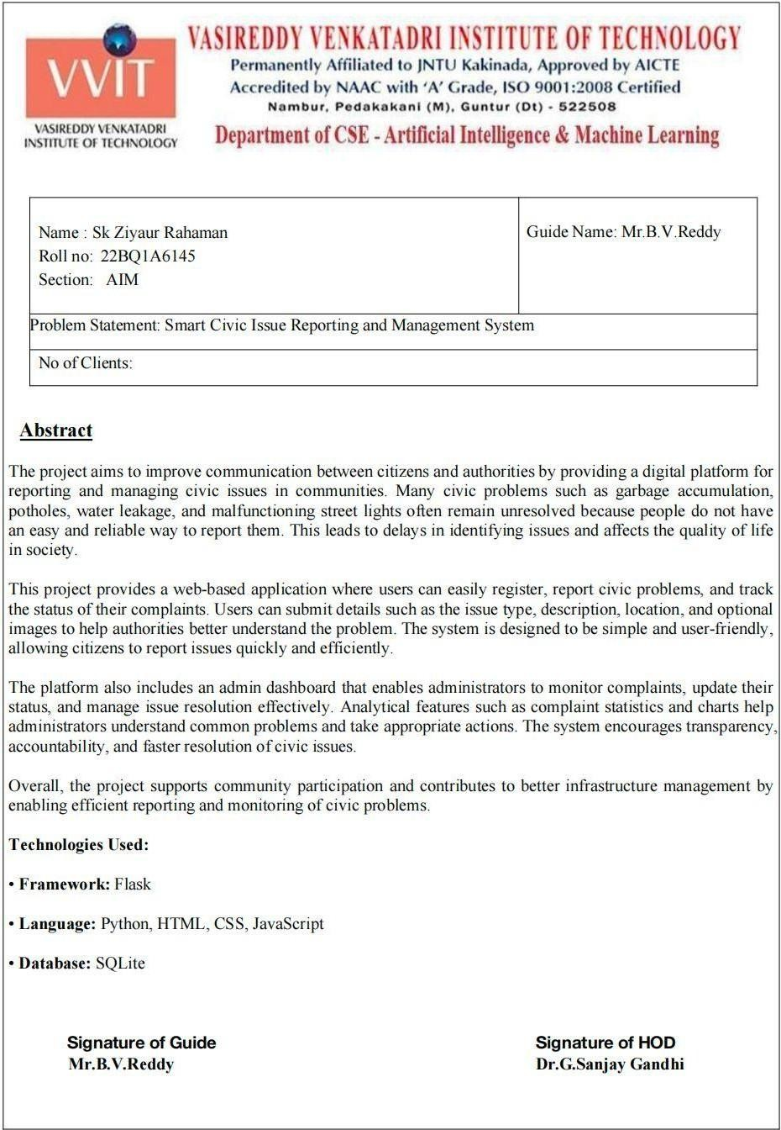
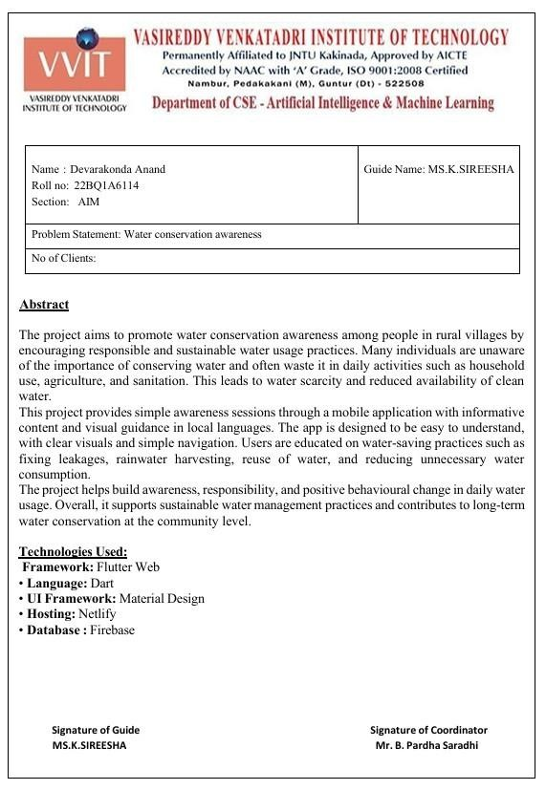

CHAPTER 1: EXECUTIVE SUMMARY

A community service project is an initiative undertaken by individuals or groups to address a specific need or issue within a community. These projects are typically aimed at improving the well-being, quality of life, or circumstances of community members. Community service projects can take various forms and may involve activities such as:

Volunteer Work: Engaging in hands-on activities such as cleaning up parks, serving meals at homeless shelters, tutoring students, or providing companionship to elderly residents.

Fundraising: Organizing events or campaigns to raise funds for local charities, schools, or other community organizations that support important causes.

Awareness Campaigns: Creating and promoting initiatives to raise awareness about social, environmental, or health issues within the community, such as mental health awareness campaigns or recycling drives.

Skill-building Workshops: Offering workshops or training sessions to teach valuable skills to community members, such as financial literacy, job readiness, or computer skills.

Environmental Initiatives: Undertaking projects to protect and improve the environment, such as planting trees, cleaning up litter, or promoting recycling and conservation efforts.

Community Development Projects: Working on projects that aim to enhance the infrastructure or facilities within the community, such as building playgrounds, renovating community centers, or improving access to clean water.

Support Services: Providing support services to vulnerable populations within the community, such as organizing food drives, offering free healthcare clinics, or assisting with disaster relief efforts.

Community service projects can focus upon the following areas:

- Water facilities and drinking water availability
- Health and hygiene
- Stress levels and coping mechanisms
- Health intervention programmes
- Horticulture
- Herbal plants

- Botanical survey
- Zoological survey
- Marine products
- Aqua culture
- Inland fisheries
- Animals and species
- Nutrition
- Traditional health care methods
- Food habits
- Air pollution
- Education
- Water pollution
- Plantation
- Soil protection
- Renewable energy
- Plant diseases
- Yoga awareness and practice
- Health care awareness programmes and their impact
- Use of chemicals on fruits and vegetables
- Organic farming
- Crop rotation
- Floury culture
- Access to safe drinking water
- Geographical survey
- Geological survey
- Sericulture
- Study of species
- Food adulteration
- Incidence of Diabetes and other chronic diseases
- Human genetics
- Blood groups and blood levels
- Animal husbandry
- Mother and child health

CHAPTER 2: OVERVIEW OF THE COMMUNITY

Nambur, situated in the Guntur district of India, is a picturesque village located within the Pedakakani mandal of the Guntur revenue division. Positioned at coordinates 16.18°N latitude and 80.30°E longitude, the village is approximately 6 kilometers from Pedakakani.

One of the notable features of Nambur is its renowned Nature Eco Park. Nambur is known for its peaceful rural surroundings and agricultural landscape, which play an important role in the local economy. The village is surrounded by fertile lands where crops such as paddy, vegetables, and other seasonal crops are cultivated, contributing to the livelihood of many residents..

In terms of governance, Nambur operates under the jurisdiction of its local self-government, the Nambur Gram Panchayat. The village administration is organized into several wards, each represented by a Ward Member, while the overall leadership of the village is provided by the Sarpanch. The Gram Panchayat is responsible for implementing development programs, maintaining infrastructure, and addressing the needs of the local population.

Furthermore, being located in the region surrounding the state capital, Nambur falls under the administrative purview of the Andhra Pradesh Capital Region Development Authority. This authority oversees planning, infrastructure development, and regional growth within the capital region.

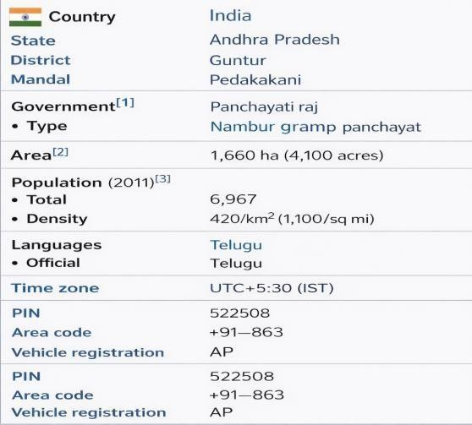

CHAPTER 3: COMMUNITY SERVICE PART

During the Community Service Project, the Water Conservation Awareness Application was developed to educate people in rural villages about the importance of saving water and using it responsibly. Many individuals are unaware of water wastage in daily activities such as household usage, agriculture, and sanitation. This lack of awareness leads to water scarcity and reduces the availability of clean water.
This application helps in spreading awareness through simple and understandable content, encouraging people to adopt water-saving habits and sustainable practices.

System Development and Implementation:

The system was designed with a simple, user-friendly interface to ensure easy accessibility for all users, especially people in rural areas. The application provides educational content in local languages with clear visuals, making it easy for users to understand water conservation methods.

Key Features:

- Informative content about water conservation practices
- Visual guidance on saving water in daily activities
- Awareness about fixing leakages and avoiding water wastage
- Guidance on rainwater harvesting techniques
- Tips for reusing water in household and agriculture
- Simple navigation with local language support
- Mobile-friendly design for easy accessibility

Implementation in Community:

- The application was demonstrated to villagers and community members
- Awareness sessions were conducted to explain water-saving methods
- Users were guided on how to use the application effectively
- Real-time interaction helped clarify doubts and improve understanding

Community Engagement and Feedback Collection:

People showed positive interest in learning about water conservation. Many users understood the importance of saving water and expressed willingness to change their daily habits. Feedback indicated that the application was simple, easy to use, and helpful in increasing awareness.

Infrastructure Support and Technical Assistance:

Guidance and support were provided to help users understand the application. Demonstrations were conducted, and assistance was given to ensure that users could access and use the application independently. Efforts were made to ensure smooth functioning even in low-network areas.

Digital Awareness and Skill Development:

The project helped improve digital awareness among rural users by introducing them to mobile-based applications. Users gained confidence in using technology for learning and adopting better practices. This encouraged responsible behavior and active participation in conserving water at the community level.

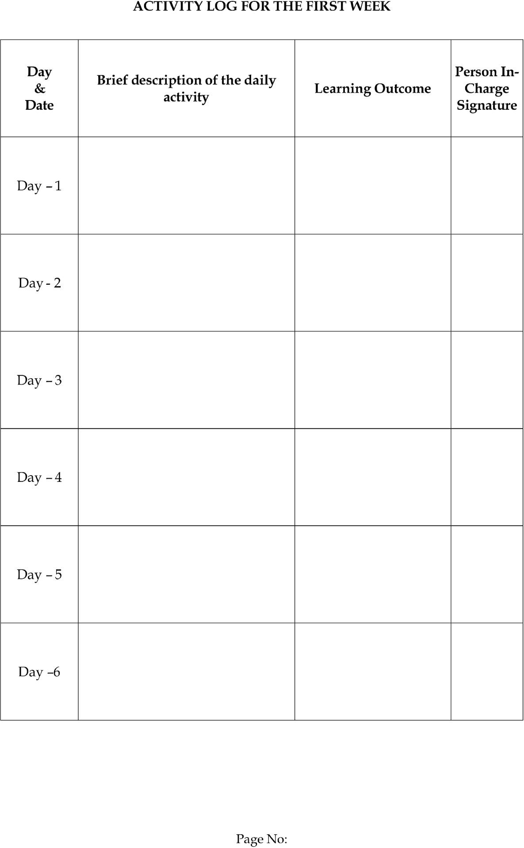



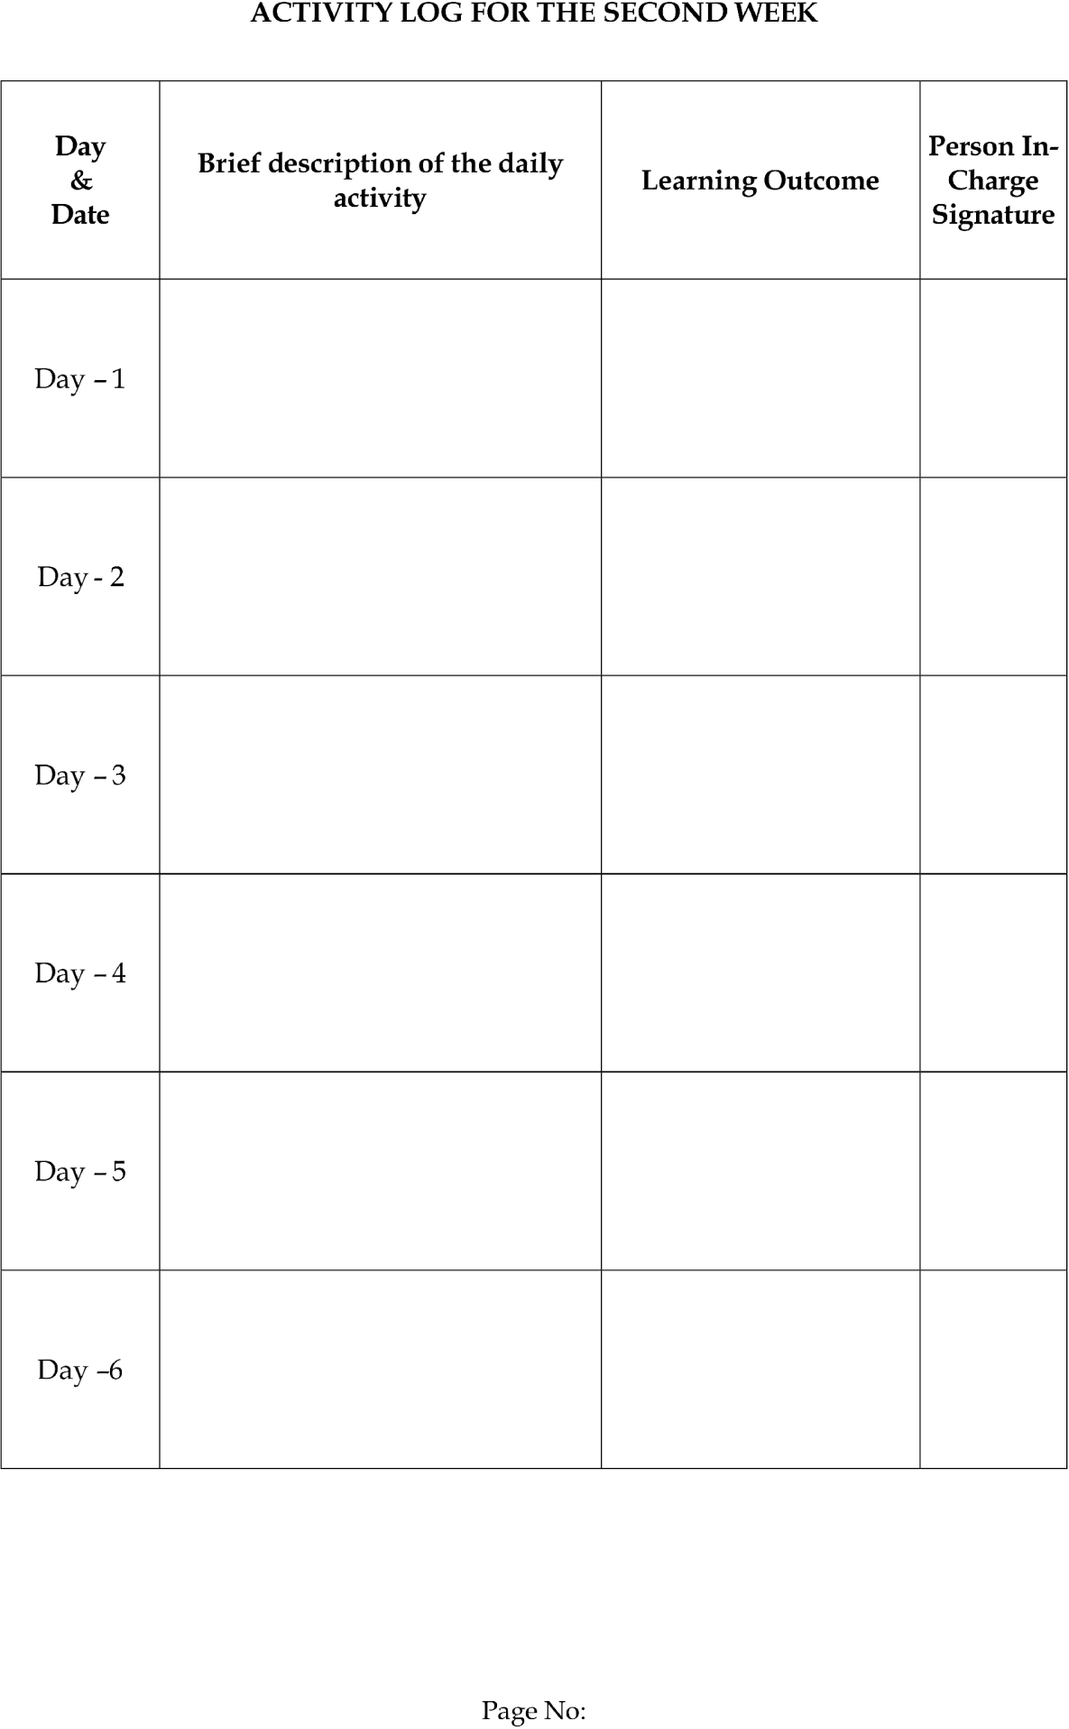



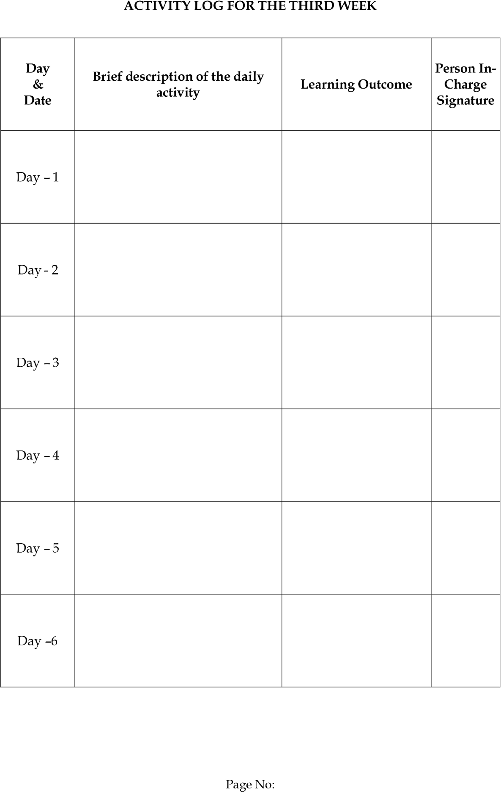



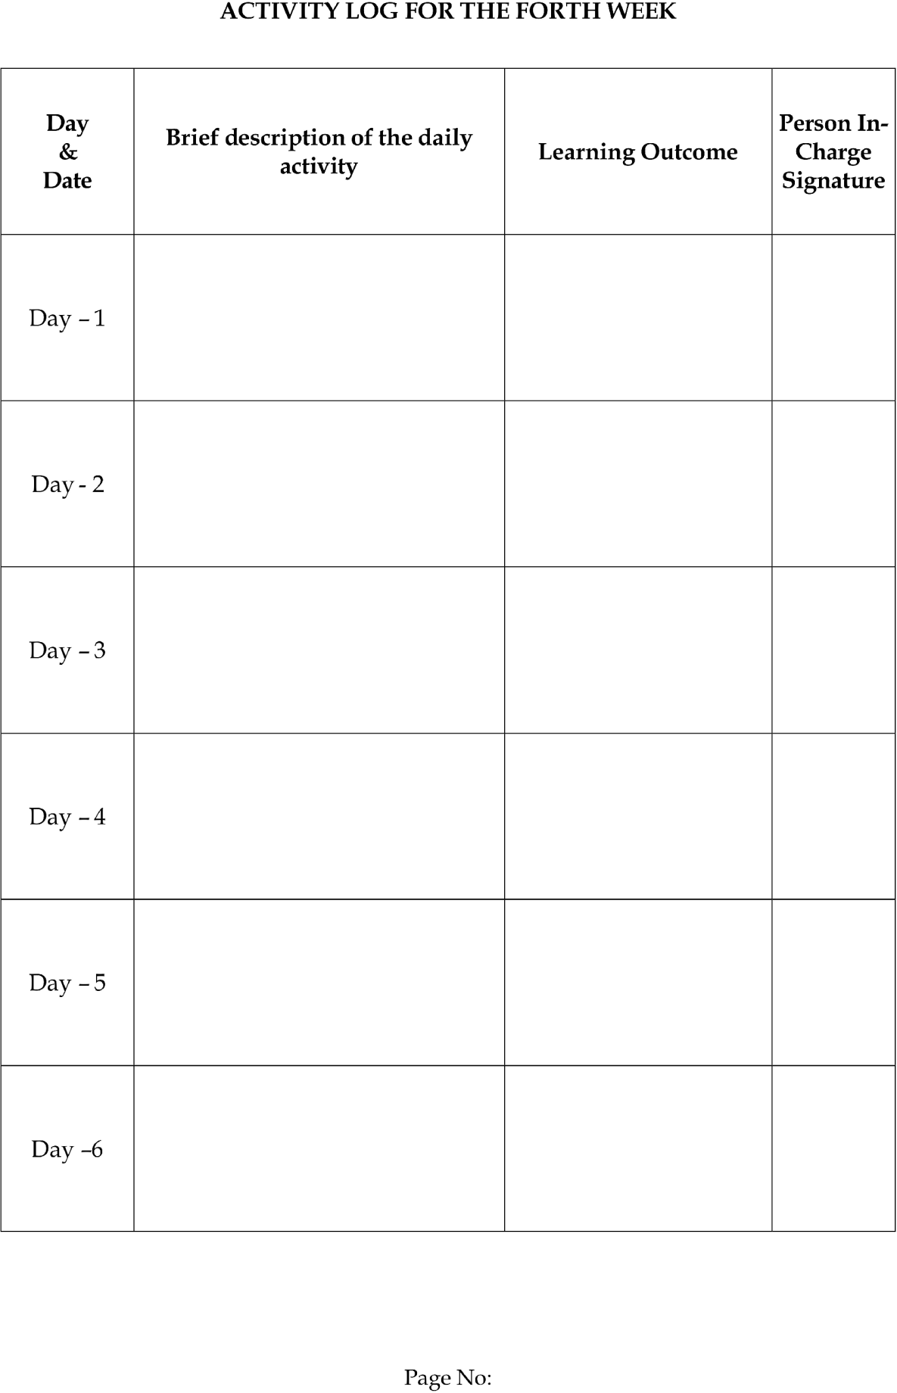



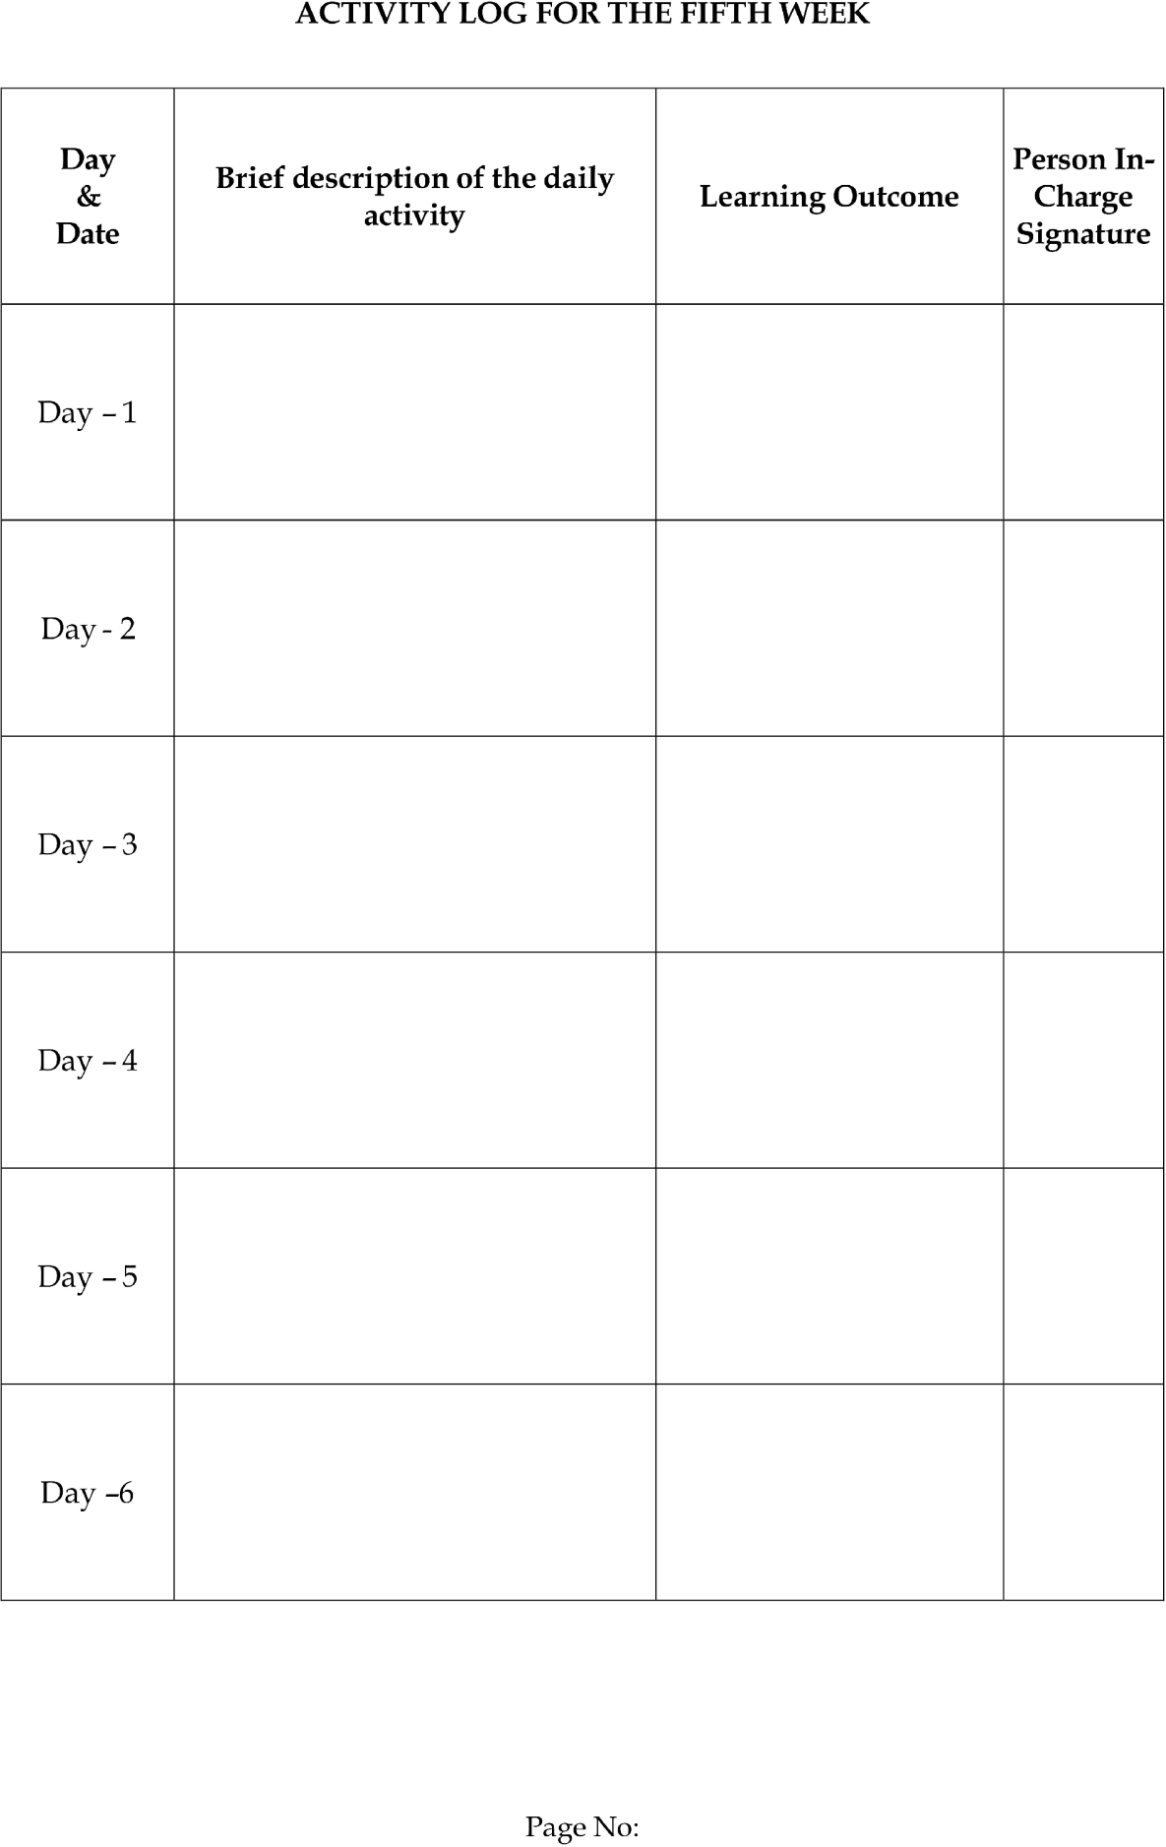



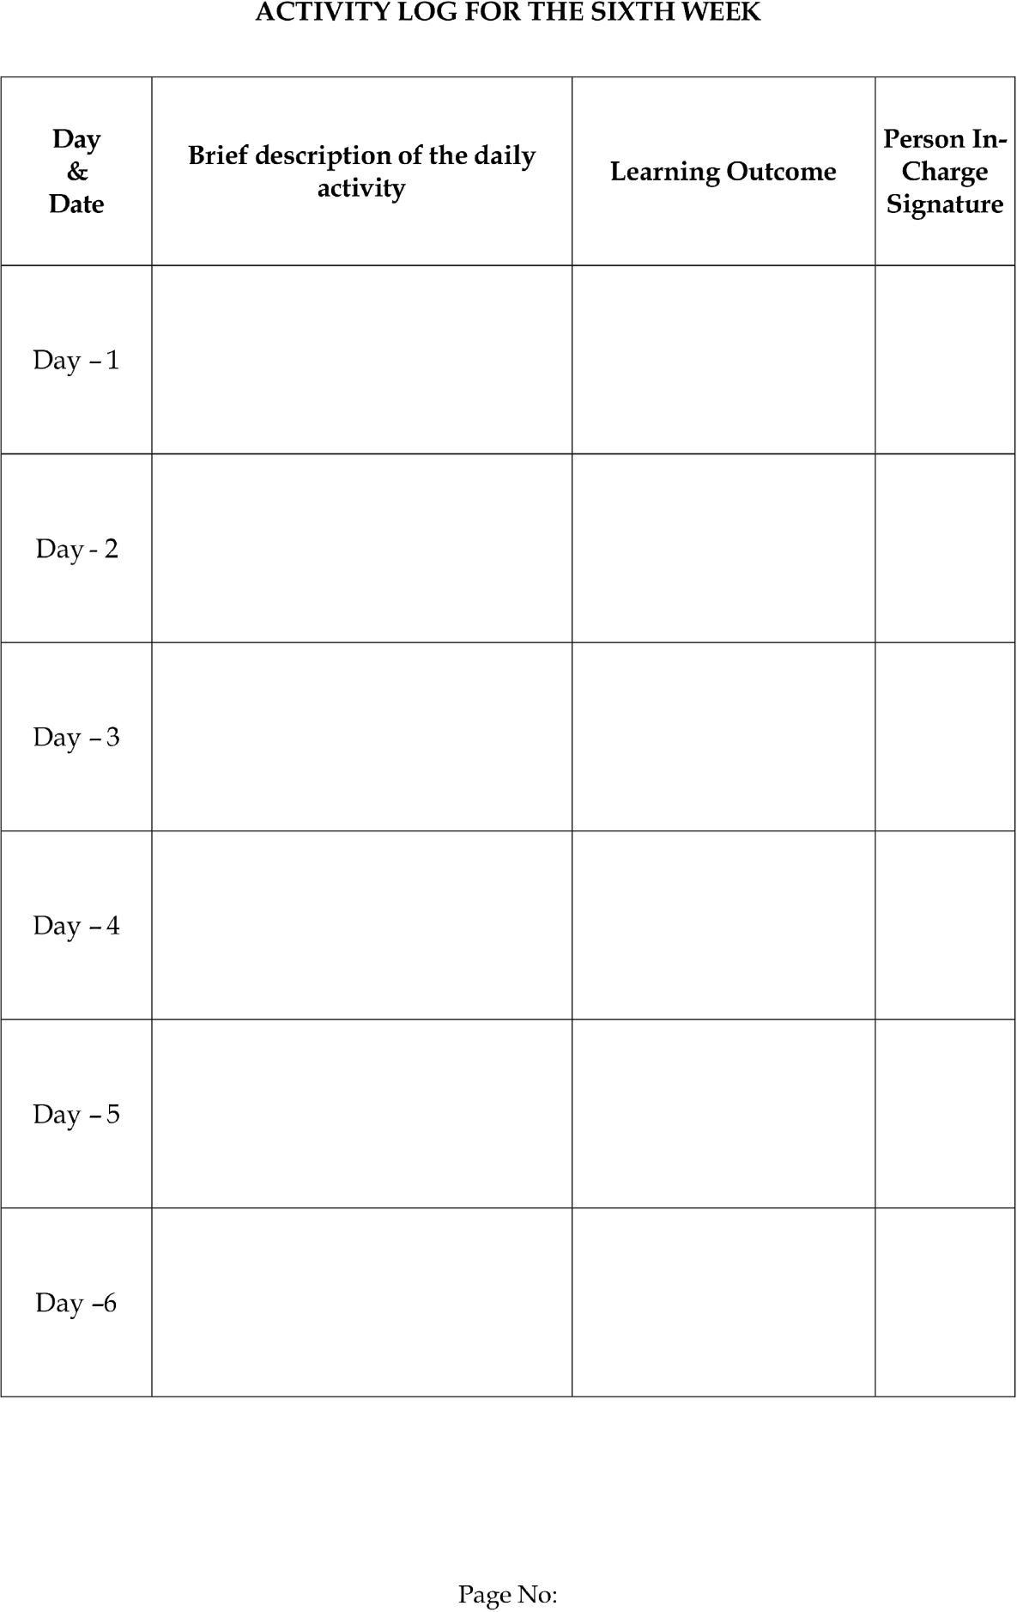



CHAPTER 4: OUTCOMES DESCRIPTION
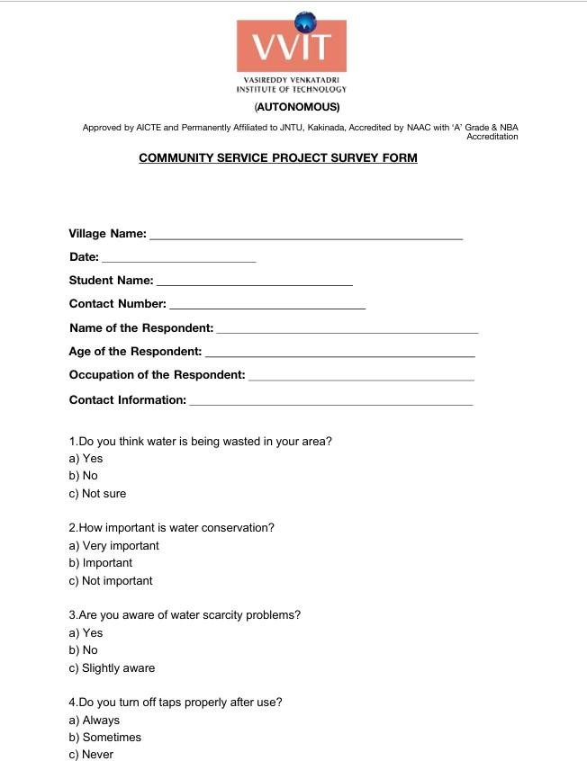

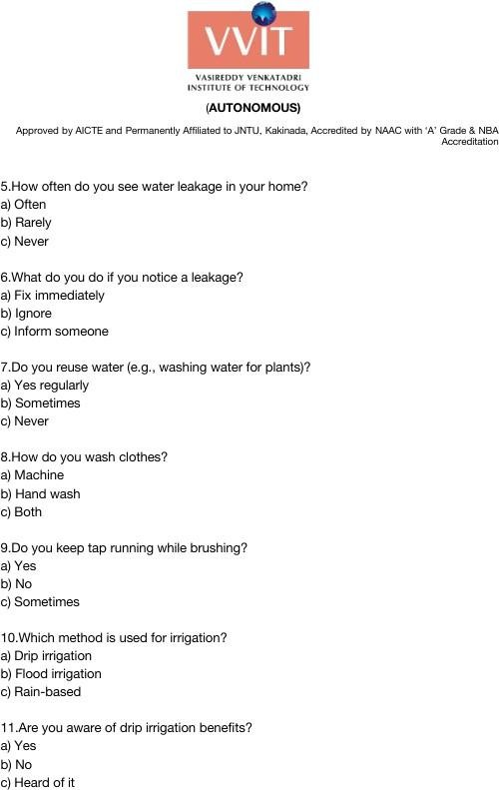

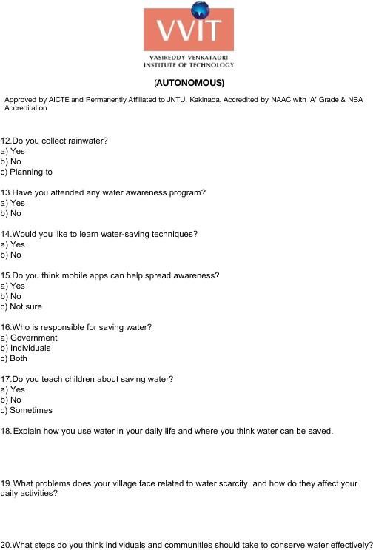







Problem Identified in the Community:
In many rural communities, a major issue is the lack of awareness about water conservation and sustainable water usage. People often use water carelessly in daily activities such as household chores, agriculture, and sanitation due to limited knowledge about its importance.

One of the key problems is excessive water wastage caused by practices like leaving taps open, ignoring leakages, and inefficient irrigation methods. This leads to water scarcity and reduces the availability of clean water for future use.

Additionally, there is a lack of proper educational resources and communication methods to spread awareness about water-saving techniques. Many individuals are not exposed to simple and understandable information about conserving water.

The absence of digital awareness tools further worsens the situation, especially in rural areas where access to easy-to-use applications is limited.

In summary, lack of awareness, improper water usage habits, and limited access to educational tools contribute to water scarcity. Addressing these challenges requires an awareness-driven digital solution.

Workshops on Digital Civic Reporting:
- Conducted sessions explaining the importance of water conservation
- Educated people on daily water-saving habits
- Explained the long-term impact of water wastage

Awareness Campaigns and Outreach Events:

- Organized campaigns in villages to spread awareness
- Promoted responsible water usage practices
- Shared information about sustainable water management

Interactive Demonstrations and User Training:

- Demonstrated the mobile application for awareness
- Showed visual content on water-saving techniques
- Provided guidance on using the app in local languages Outcomes of the Community Awareness Program: Increased Awareness:
- People understood the importance of conserving water
- Awareness about water-saving practices improved Behavioral Change:
- Reduction in careless water usage
- Adoption of practices like fixing leaks and reusing water Community Engagement:
- Active participation in discussions about water conservation
- Increased interest in sustainable living practices

Empowerment and Action:

- Users gained knowledge about efficient water usage
- Communities became more responsible towards water management

Overall, the program helped in promoting digital awareness and improving civic responsibility among people.

Report of the Mini-Project Work Done Project Statement:
Water wastage and lack of awareness in rural areas lead to water scarcity. The Water Conservation Awareness System aims to educate users through a simple mobile application that promotes responsible water usage and sustainable practices.

Why it was selected:

This project was selected because water scarcity is a growing problem, especially in rural areas. By spreading awareness through a digital platform, the project helps promote sustainable water usage and ensures long-term availability of water resources.

Challenges in Water Management:

Awareness Challenges:

- Lack of knowledge about water conservation
- Limited exposure to educational resources

Usage Challenges:

- Excessive water wastage in daily activities
- Ignoring leakages and inefficient usage

Digital Challenges:

- Low digital literacy in rural areas
- Limited access to simple awareness tools

Solution Proposal:

- Awareness Application:
  - Provides educational content on water conservation
- Visual Learning Content:

  - Uses images and simple explanations for better understanding

- Multi-language Support:

  - Content available in local languages

- User-Friendly Interface:

  - Simple navigation for rural users

- Guidelines for Water Saving:

  - Tips like rainwater harvesting, fixing leaks, and reuse of water

Possibilities of Implementation:

Positive Consequences:

  - Increased awareness about water conservation
  - Reduction in water wastage
  - Promotion of sustainable practices

Negative Consequences & Mitigation Strategies:
  - Low digital literacy → Provide simple UI and training
  - Resistance to change → Conduct awareness campaigns
  - Limited internet access → Use lightweight application

Technology/Software Used: Frontend Development:
  - Flutter Web

Programming Language:
  - Dart

UI Framework:
  - Material Design

Hosting:
  - Netlify

Database:
  - Firebase

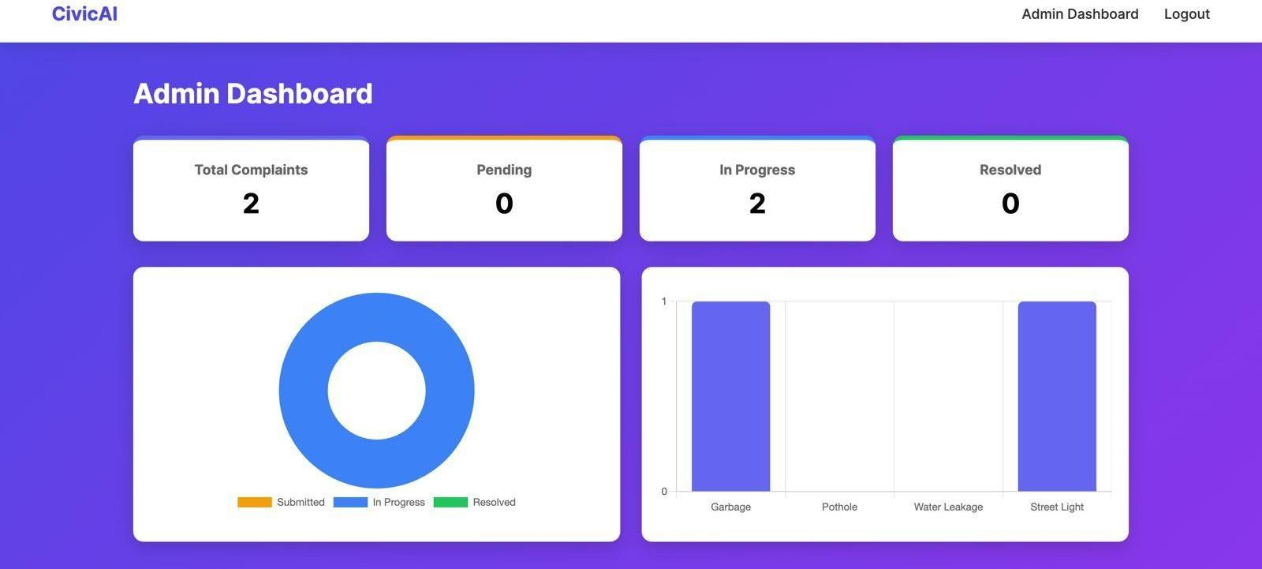
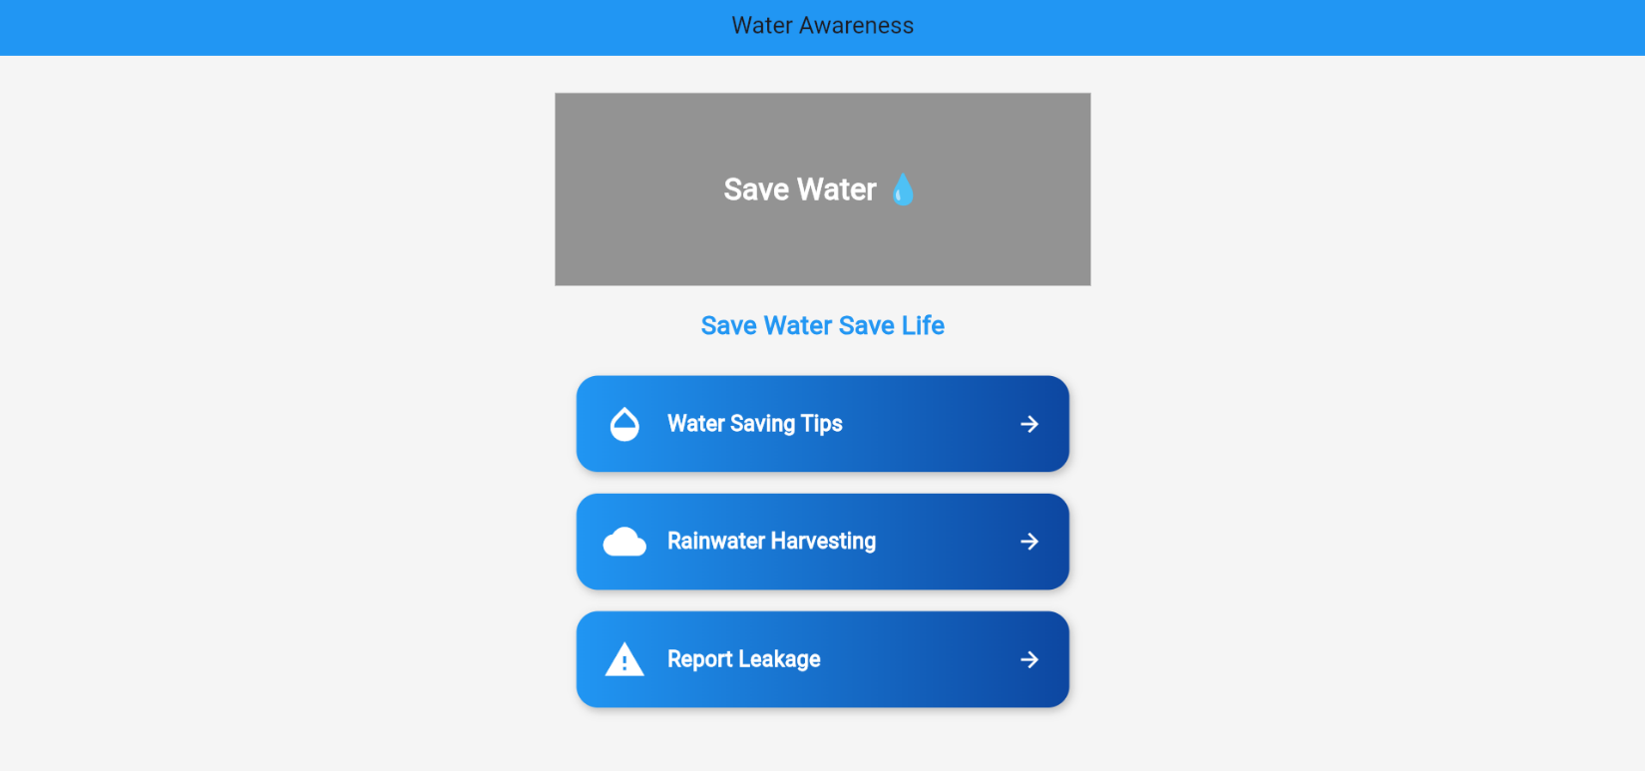

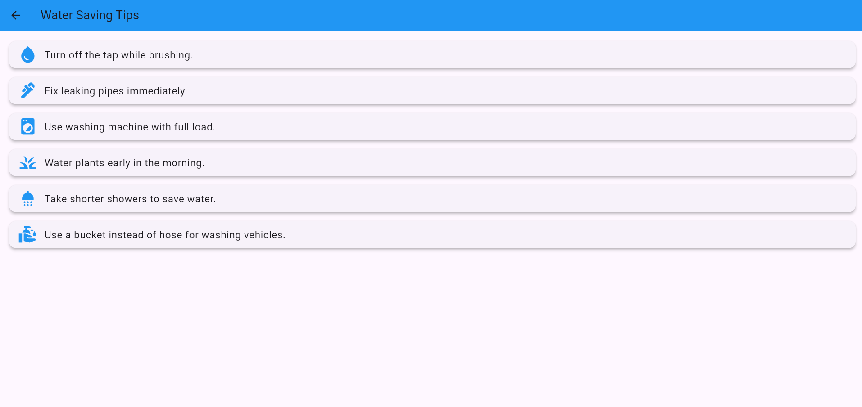

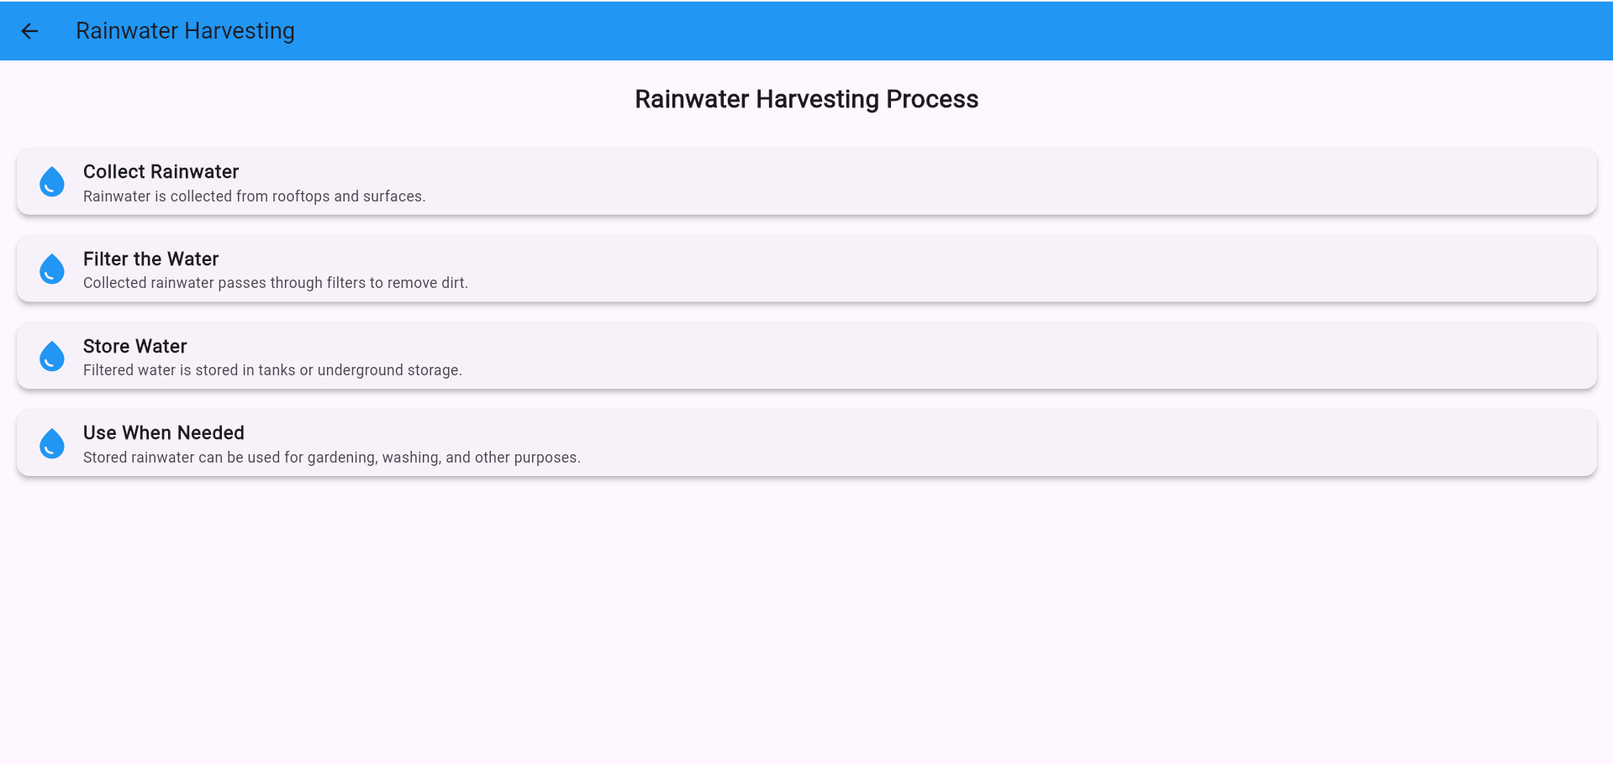

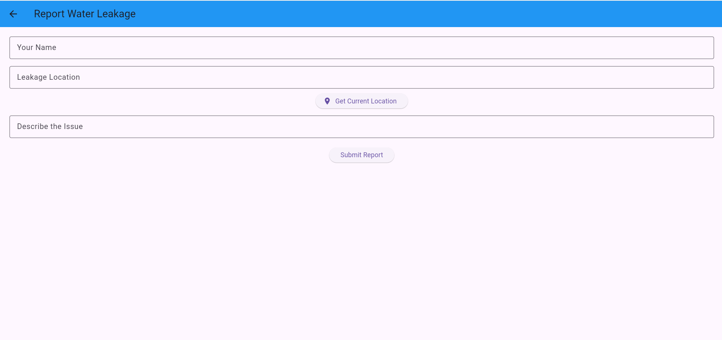

Overall Conclusion:

Our Water Conservation Awareness System acts as a digital platform designed to educate people, especially in rural communities, about the importance of saving water and adopting sustainable usage practices. It helps users understand simple and effective methods such as fixing leakages, reusing water, and practicing rainwater harvesting through easy-to-access content in local languages. By using a user-friendly mobile application with clear visuals and guidance, the system promotes responsible water usage in daily life.

We recognize that there may be challenges in implementing such a system. Some users may have limited digital literacy, and there may be initial hesitation in using mobile applications for learning. However, these challenges can be overcome through awareness programs, simple interface design, and proper user guidance. By educating users and providing accessible content, the system can achieve better reach and acceptance among rural populations.

Ultimately, the goal of this project is to promote sustainable water management and create long-term awareness about water conservation. By leveraging technology, the project encourages behavioral change, reduces water wastage, and supports the preservation of water resources. This initiative contributes to building responsible communities and ensures the availability of water for future generations.

.

CHAPTER 5

RECOMMENDATIONS AND CONCLUSIONS OF THE MINI PROJECT

Recommendations:
To ensure the long-term success and effectiveness of the Water Conservation Awareness System, it is important to focus on improving usability, accessibility, and community engagement. The system should continuously evolve based on user feedback to remain simple, informative, and effective for all users.
One key recommendation is to enhance user interaction with the application. Since the system is designed for rural users with varying levels of digital literacy, the interface should be simple, intuitive, and easy to navigate. Clear instructions, visual guides, and interactive content will help users understand water conservation practices effectively. Feedback can be collected to improve the application based on user needs.
Improving accessibility is also important. The application should work efficiently on low-end devices and in areas with limited internet connectivity. Features such as lightweight design, offline content access, and minimal data usage will increase adoption. Providing multilingual support will further help users understand the content easily.
Promoting awareness and encouraging regular usage is essential for the success of the system. Awareness campaigns, training sessions, and demonstrations should be conducted in rural areas to educate people about the importance of water conservation. Real-life examples and practical demonstrations can motivate users to adopt water-saving habits.
Continuous improvement of the system is necessary. Regular updates should be made to improve content quality, user experience, and performance. Adding features like reminders, tips, and notifications can keep users engaged and encourage consistent water-saving practices.
Future development can include advanced features such as personalized recommendations for water conservation, interactive learning modules, and integration with local environmental data. These enhancements can make the system more impactful and user-friendly.
Community involvement is also important. Local volunteers, students, and organizations can help spread awareness and guide others in using the application. Encouraging participation will increase the reach and effectiveness of the project.
Finally, technical aspects such as system performance, reliability, and data security should be maintained to ensure smooth functioning and build user trust.

Conclusions:
The implementation of the ‘Water Conservation Awareness’ System demonstrates the importance of technology in promoting sustainable practices and environmental responsibility. By providing a simple and accessible platform, the project helps users understand the importance of conserving water and adopting efficient usage methods.

Throughout the project, users were introduced to digital awareness tools that educate them about water conservation. Through demonstrations and practical usage, people learned how to reduce water wastage and adopt better habits. This increased their awareness and encouraged responsible behavior.

The project highlights the importance of a user-friendly design. By keeping the application simple and easy to understand, even users with limited digital knowledge can benefit from it. Continuous feedback helped improve the system and make it more effective.

Another key outcome is increased awareness about sustainable water management. Users understood how small changes in daily activities can make a significant impact on water conservation. This led to positive behavioral changes and better resource management..

The impact of the project is reflected in improved awareness, reduced water wastage, and increased community participation. People became more conscious about their water usage and contributed to conservation efforts.

Despite its success, the project faced challenges such as low digital literacy, limited access to technology, and initial resistance to change. However, these challenges can be addressed through continuous awareness programs, training, and system improvements.

Looking ahead, the project has strong potential for future development. Enhancements such as advanced learning features, wider language support, and integration with environmental initiatives can make the system more effective. With continuous improvement and community support, this project can play a vital role in promoting sustainable water usage and ensuring water availability for future generations.

Student Self-Evaluation for the Community Service Project

Student Name: Devarakonda Anand

Registration No: 22BQ1A6114

Period of CSP : 8 Weeks From 04-06-2025 To:30-10-2025 Date of Valuation:
Please rate your performance in the following areas:

Rating Scale: Letter grade of CGPA calculation to be provided
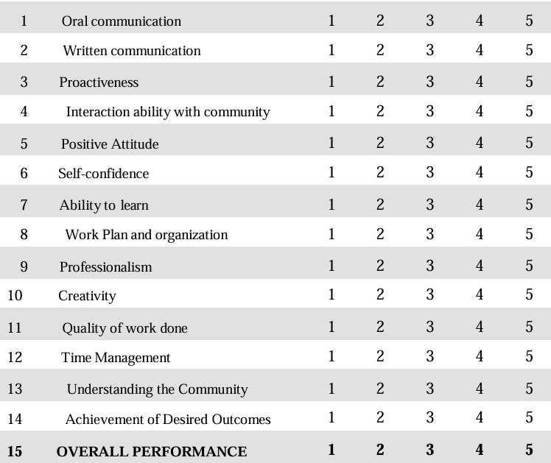

Date: Signature of the Student

Evaluation by the Person in-charge in the Community / Habitation

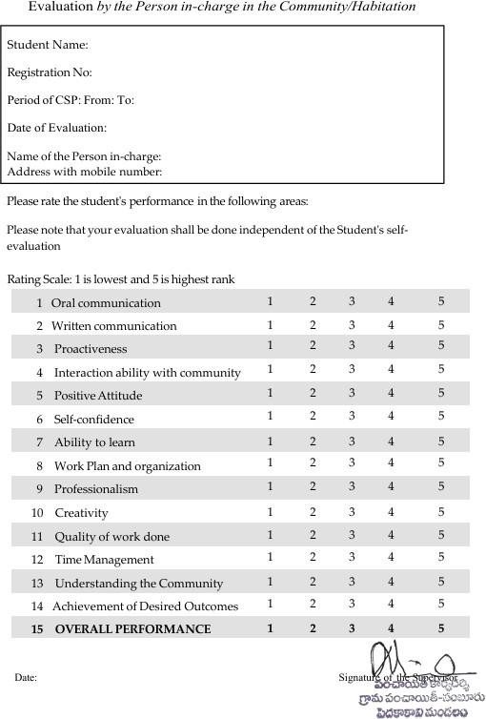

PHOTOS & VIDEO LINKS
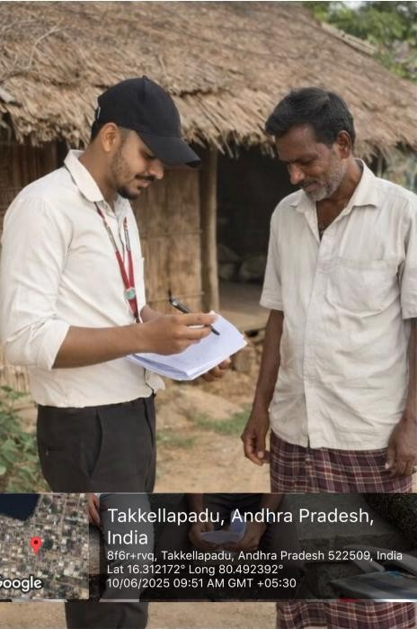
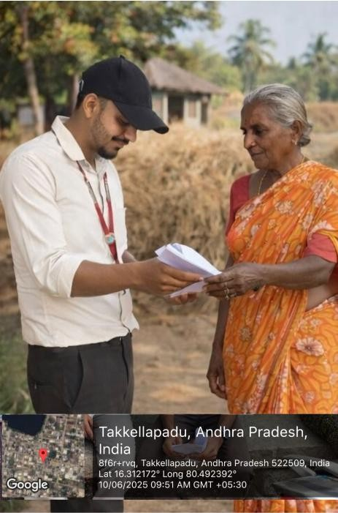

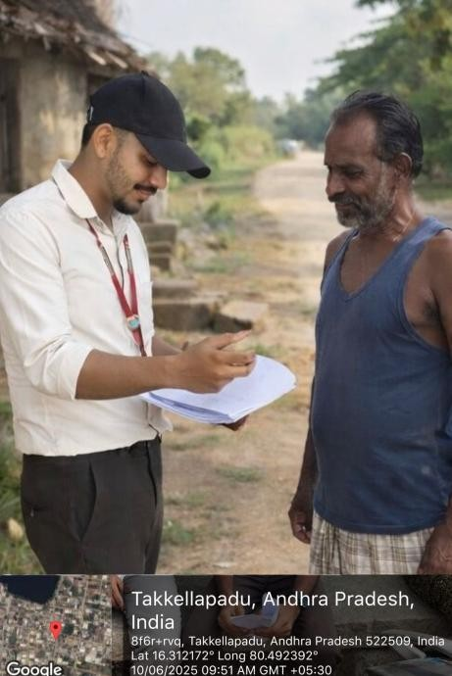
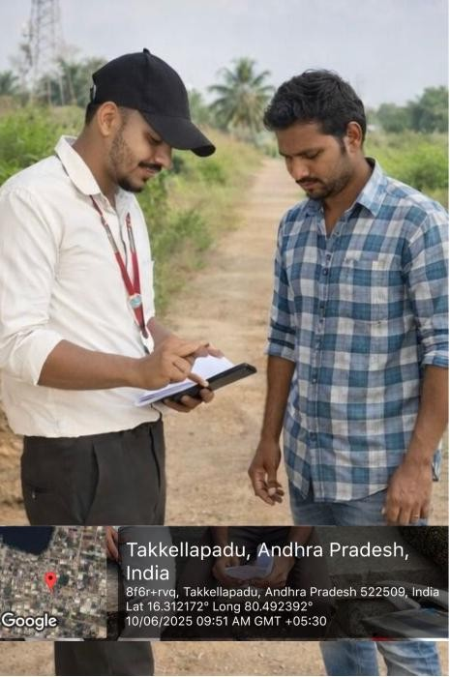

INTERNAL ASSESSMENT STATEMENT

Name Of the Student: Devarakonda Anand Programme of Study: Bachelor of Technology Year of Study: IV-II
Branch: Artificial Intelligence and Machine Learning

Register No/H.T. No: 22BQ1A6114

Name of the College: Vasireddy Venkatadri Institute of Technology

University:

Sl.No | Evaluation Criterion | Maximum Marks | Marks Awarded
1. | Activity Log | 20
2. | Community Service Project Implementation | 30
3. | Mini Project Work | 25
4. | Oral Presentation | 25
 | GRAND TOTAL | 100

Date: Signature of the Faculty Guide

Certified by

Date: Signature of the Head of the Department/Principal
Seal

