**Problem Statement**

To build a Multi-classification methodology to determine whether a person facing which diseases and what required to do.

Our intuitive interface allows users to input their symptoms effortlessly, creating a seamless user experience.

**Architecture:**

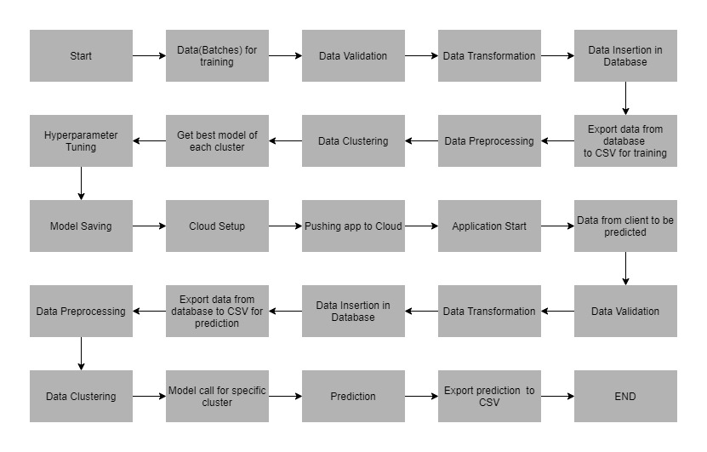

**Data Description**

The patient will send data in multiple sets of files in batches at a given location. The data has been extracted from the csv files.

The data contains 131 rows and 1 target column.

**Features:**

1. itching
2. skin_rash
3. nodal_skin_eruptions
4. continuous_sneezing
5. shivering
6. chills
7. joint_pain
8. stomach_pain
9. acidity
10. ulcers_on_tongue
11. muscle_wasting
12. vomiting
13. burning_micturition
14. spotting_urination
15. fatigue
16. weight_gain
17. anxiety
18. cold_hands_and_feets
19. mood_swings
20. weight_loss
21. restlessness
22. lethargy
23. patches_in_throat
24. irregular_sugar_level
25. cough
26. high_fever
27. sunken_eyes
28. breathlessness
29. sweating
30. dehydration
31. indigestion
32. headache
33. yellowish_skin
34. dark_urine
35. nausea
36. loss_of_appetite
37. pain_behind_the_eyes
38. back_pain
39. constipation
40. abdominal_pain
41. diarrhoea
42. mild_fever
43. yellow_urine
44. yellowing_of_eyes
45. acute_liver_failure
46. fluid_overload
47. swelling_of_stomach
48. swelled_lymph_nodes
49. malaise
50. blurred_and_distorted_vision
51. phlegm
52. throat_irritation
53. redness_of_eyes
54. sinus_pressure
55. runny_nose
56. congestion
57. chest_pain
58. weakness_in_limbs
59. fast_heart_rate
60. pain_during_bowel_movements
61. pain_in_anal_region
62. bloody_stool
63. irritation_in_anus
64. neck_pain
65. dizziness
66. cramps
67. bruising
68. obesity
69. swollen_legs
70. swollen_blood_vessels
71. puffy_face_and_eyes
72. enlarged_thyroid
73. brittle_nails
74. swollen_extremeties
75. excessive_hunger
76. extra_marital_contacts
77. drying_and_tingling_lips
78. slurred_speech
79. knee_pain
80. hip_joint_pain
81. muscle_weakness
82. stiff_neck
83. swelling_joints
84. movement_stiffness
85. spinning_movements
86. loss_of_balance
87. unsteadiness
88. weakness_of_one_body_side
89. loss_of_smell
90. bladder_discomfort
91. foul_smell_of urine
92. continuous_feel_of_urine
93. passage_of_gases
94. internal_itching
95. toxic_look_(typhos)
96. depression
97. irritability
98. muscle_pain
99. altered_sensorium
100. red_spots_over_body
101. belly_pain
102. abnormal_menstruation
103. dischromic _patches
104. watering_from_eyes
105. increased_appetite
106. polyuria
107. family_history
108. mucoid_sputum
109. rusty_sputum
110. lack_of_concentration
111. visual_disturbances
112. receiving_blood_transfusion
113. receiving_unsterile_injections
114. coma': 113, 'stomach_bleeding
115. distention_of_abdomen
116. history_of_alcohol_consumption
117. fluid_overload.1
118. blood_in_sputum
119. prominent_veins_on_calf
120. palpitations
121. painful_walking
122. pus_filled_pimples
123. blackheads
124. scurring
125. skin_peeling
126. silver_like_dusting
127. small_dents_in_nails
128. inflammatory_nails
129. blister
130. red_sore_around_nose
131. yellow_crust_ooze

**Target Label:**

**Prognosis:**

Fungal infection

Allergy

GERD

Chronic cholestasis

Drug Reaction

Peptic ulcer diseae

AIDS

Diabetes

Gastroenteritis

Bronchial Asthma

Hypertension

Migraine

Cervical spondylosis

Paralysis (brain hemorrhage)

Jaundice

Malaria

Chicken pox

Dengue

Typhoid

hepatitis A

Hepatitis B

Hepatitis C

Hepatitis D

Hepatitis E

Alcoholic hepatitis

Tuberculosis

Common Cold

Pneumonia

Dimorphic hemmorhoids(piles)

Heart attack

Varicose veins

Hypothyroidism

Hyperthyroidism

Hypoglycemia

Osteoarthristis

Arthritis

(vertigo) Paroymsal Positional Vertigo

Acne

Urinary tract infection

Psoriasis

Impetigo

**Data Validation**

In this step, we perform different sets of validation on the given set of training files.

1. Name Validation- We validate the name of the files based on the given name in the schema file. We have created a regex pattern as per the name given in the schema file to use for validation. After validating the pattern in the name, we check for the length of date in the file name as well as the length of time in the file name. If all the values are as per requirement, we move such files to "Good_Data_Folder" else we move such files to "Bad_Data_Folder."
2. Number of Columns - We validate the number of columns present in the files, and if it doesn't match with the value given in the schema file, then the file is moved to "Bad_Data_Folder."
3. Name of Columns - The name of the columns is validated and should be the same as given in the schema file. If not, then the file is moved to "Bad_Data_Folder".
4. The datatype of columns - The datatype of columns is given in the schema file. It is validated when we insert the files into Database. If the datatype is wrong, then the file is moved to "Bad_Data_Folder".
5. Null values in columns - If any of the columns in a file have all the values as NULL or missing, we discard such a file and move it to "Bad_Data_Folder".

**Data Insertion in Database**

1) Database Creation and connection - Create a database with the given name passed. If the database has already been created, open a connection to the database.

2) Table creation in the database - Table with name - "Good_Data", is created in the database for inserting the files in the "Good_Data_Folder" based on given column names and datatype in the schema file. If the table is already present, then the new table is not created, and new files are inserted in the already present table as we want training to be done on new as well as old training files.

3) Insertion of files in the table - All the files in the "Good_Data_Folder" are inserted in the above-created table. If any file has invalid data type in any of the columns, the file is not loaded in the table and is moved to "Bad_Data_Folder".

**Model Training**

1) **Data Export from Db** - The data in a stored database is exported as a CSV file to be used for model training.

2) **Data Preprocessing**

1. Check for null values in the columns. If present, impute the null values using the categorical imputer.
2. Scale the numeric values using the standard scaler.
3. Check for correlation.

3) **Clustering -** KMeans algorithm is used to create clusters in the preprocessed data. The optimum number of clusters is selected by plotting the elbow plot, and for the dynamic selection of the number of clusters, we are using "KneeLocator" function. The idea behind clustering is to implement different algorithms

The Kmeans model is trained over preprocessed data, and the model is saved for further use in prediction.

1. **Model Selection –** After the clusters have been created, we find the best model for each cluster. We are using algorithms like:

RandomForestClassifier

GradientBoostingClassifier

KNeighborsClassifier

MultinomialNB.

For each cluster, these algorithms are passed with the best parameters derived from GridSearch. We calculate the accuracy scores for all models and select the model with the best score. Similarly, the model is selected for each cluster. All the models for every cluster are saved for use in prediction.

**Prediction Data Description**

The patient will send the input in multiple sets of information at a given location.

**Data Validation**

In this step, we perform different sets of validation on the given set of training files.

1) Name Validation- We validate the name of the files based on given Name in the schema file. We have created a regex pattern as per the name given in the schema file, to use for validation. After validating the pattern in the name, we check for the length of date in the file name as well as the length of the timestamp in the file name. If all the values are as per requirement, we move such files to "Good_Data_Folder" else we move such files to "Bad_Data_Folder".

2) Number of Columns - We validate the number of columns present in the files, and if it doesn't match with the value given in the schema file, then the file is moved to "Bad_Data_Folder".

3) Name of Columns - The name of the columns is validated and should be same as given in the schema file. If not, then the file is moved to "Bad_Data_Folder".

4) Datatype of columns - The datatype of columns is given in the schema file. This is validated when we insert the files into Database. If the datatype is incorrect, then the file is moved to "Bad_Data_Folder".

5) Null values in columns - If any of the columns in a file has all the values as NULL or missing, we discard such file and move it to "Bad_Data_Folder".

**Data Insertion in Database**

1) Database Creation and connection - Create a database with the given name passed. If the database is already created, open the connection to the database.

2) Table creation in the database - Table with name - "Good_Data", is created in the database for inserting the files in the "Good_Data_Folder" based on given column names and datatype in the schema file. If the table is already present, then a new table is not created, and new files are inserted into the already present table as we want training to be done on new as well old training files.

3) Insertion of files in the table - All the files in the "Good_Data_Folder" are inserted in the above-created table. If any file has invalid data type in any of the columns, the file is not loaded in the table and is moved to "Bad_Data_Folder".

**Prediction**

1) Data Export from Db - The data in the stored database is exported as a CSV file to be used for prediction.

2) Data Preprocessing :

1. Check for null values in the columns. If present, impute the null values using the categorical imputer.
2. Scale the numeric values using the standard scaler.
3. Check for correlation.

3) Clustering - KMeans model created during training is loaded, and clusters for the preprocessed prediction data is predicted.

4) Prediction - Based on the cluster number, the respective model is loaded and is used to predict the data for that cluster.

5) Once the prediction is made for all the clusters, the predictions along with the Wafer names are saved in a CSV file at a given location, and the location is returned to the client.