**Design and Development of Activity Tracking System for Students on Campus**

**Abstract**— The Student Tracking and Visualization System (STVS) is a user-friendly web-based application designed to monitor and analyse student activities in an e-campus. It provides an intuitive interface for administrators, faculty, and students to access the necessary data quickly. STVS is a secure and reliable solution for educational institutions looking to track and analyse student activities. Its versatility and functionality make it an ideal tool for assessing and monitoring student progress.

**Keywords**— Student Tracking, Visualization System, web-based application, monitor, analyse, e-campus, administrators, faculty, students, data, user-friendly, secure, reliable, educational institutions, assess, progress.

1. Introduction

* The Student Tracking and Visualization System (STVS) is a web-based application that can be used to monitor and visualize student activities in an e-campus and designed to help universities, colleges, and other educational institutions to monitor and assess the activities of their students.
* It is designed to be used by administrators, faculty, and students to monitor and analyse student activities.
* The system is designed to be intuitive and user-friendly, allowing users to quickly access the data they need.
* STVS is also designed to be secure and reliable, making it an ideal solution for educational institutions looking to track and analyse student activities.

1. literature survey

The table below consists of the research papers for the topic:



* **Face Recognition Based Attendance System**:

This Paper was published on February 2019 by IJEAT. Smart Attendance using Real-Time Face Recognition is a real-world solution which comes with day-to-day activities of handling student attendance system. Face recognition-based attendance system is a process of recognizing the students face for taking attendance by using face biometrics based on high - definition monitor video and other information technology. In my face recognition project, a computer system will be able to find and recognize human faces fast and precisely in images or videos that are being captured through a surveillance camera. Numerous algorithms and techniques have been developed for improving the performance of face recognition but the concept to be implemented here is Deep Learning. It helps in conversion of the frames of the video into images so that the face of the student can

be easily recognized for their attendance so that the attendance database can be easily reflected automatically.

* **IOT based Live Student Tracking System:**

This paper was published on May 2020, by IJRTE Journal. It focused on creating a IOT Based Student Tracking System for ensuring the safety and security of students. The main objective of the application is to build a smart watch for a school student. Now a days teachers and parents are worry about children because of the large amount students are bunking their classes.

The system consists of school unit and bus unit which interact with the user. The school unit consists of a Bluetooth Low Energy device which is like a watch, that is used to send information once the student is out of Bluetooth range and if the watch is removed by the student and the bus unit consists of mobile module where the app is placed. The parents act like an end user, they can get a student exact location in their mobile phones. With this help of mobile application, the parents and teachers can lively track the student’s location.

Methodology:

* Arduino Nano:

The Arduino Nano is one of the basic models of ATMega328. It is very compact and has high specifications and same functionality of Arduino ATMega328.It has the inbuilt functions of the Arduino UNO. Nano has various input and output ports in that USB port is mainly for programming

and monitoring of the device.

* Bluetooth Module:

This module is used in various protocol designs for the Bluetooth connectivity for pairing one device to another like connecting to mobiles, mouse, headset. It has high frequency and bandwidth can work on any place without the network. HC-05 module is a wireless communication used in

master or slave configuration.

* Battery 9V:

9v battery is small size battery which is handy and used in most of the places such as clocks, detectors.9v battery is made up of cells of alkaline and carbon-zinc types. Most of the testing’s are done only by this, it can be adjusted according to the needs. The positive and negative terminals relate to the wired which is on the top of the battery. Thus, the live student tracking system tracks the location of the student thus ensuring safety and security of the student and providing relief to the parents.

* **Real Time Student Tracking System Using RFID Tags and IOT Enabled Device:**

This paper was published on April 2020 by In schools, colleges and institutions there exist a problem of irregularity of students which affects the overall academic performance of students. Currently, in some institutions the attendance is taking by calling in registers which is very time consuming and tedious. So, in this paper we are present the RFID and GSM based attendance monitoring system. The main goal of this project is to automate the process of attendance of the students, using active RFID tags. Each student is assigned with his/her specific RFID tag. The serial number of each tag is associated with each tag is associated with each student’s database. The active RFID readers can detect the tags within a predefine parameter. This project is to simplify attendance recorder system by using radio frequency identification (RFID) technology, within the RFID kit, the system will be developed by using C++ technology and database support.

Methodology:

We are going to show this large-scale automation on small scale with the help of breadboard circuit or Printed Circuit Board (PCB). On PCB we will attach components that are required to provide an example of an automation this component soldered on to PCB will function in such a way to illustrate RFID system. We use digital hardware circuit with RF reader.

* RFID Tag:

RFID tag is a small object that can be attached to product. It has antennas that help to transmit radio signal and frequencies to and from transceivers. There is two type of RFID passive and active. Active RFID depends on an internal power supply continuously to run the tag and its radio frequency. It allows low level signal to be received by the tag.

* RFID Reader:

RFID reader has antenna which produce radio waves the tag responds by sending back its data. The thing which can affect is the distance at which tags can be read. And the where we are placed the tag on the object is have impact on RFID system read range.

In this student tracking system, we focus on two main things. The first aim will be to build reliable system to access student data. And the second is to monitor students’ attendance percentages in each class.

* **FACE DETECTION BASED ATTENDANCE SYSTEM USING ESP32:**

This proposal is mainly projects about the face detection-based attendance system which overcomes from some of the problems which were raised due to the new virus corona breakout. Unlike Biometric attendance system, this face detection-based attendance system does not require any person to be in contact with finger print reader module, which reduces the increase of the corona cases in turn. Same student or employee touches the biometric attendance system to mark their attendance, infecting the biometric machine. This project involves the student, faculty, or employee attendance by face recognition. The face detection and recognition were carried out by using ESP32 cam module which captures the images of the available students in the classroom. Using this image, it recognizes and compares with the images in the database and marks their attendance. ESP8266 is used for faculty attendance and data can be logged in SD card and Google sheets are also available.

* **Design of an IOT System based on Face Recognition Technology using ESP32-CAM:**

This Paper was published on August 2022 by IJCSNS. In this paper, we will present the realization of a facial recognition system using the ESP32-CAM board controlled by an Arduino board. The goal is to monitor a remote location in real time via a camera that is integrated into the ESP32 IOT board. The acquired images will be recorded on a memory card and at the same time transmitted to a pc (a web server). The development of this remote monitoring system is to create an alternative between security, reception, and transmission of information to act accordingly. The simulation results of our proposed application of the facial recognition domain are very efficient and satisfying in real time

1. Methods and Methodology

**Objective 1**

To conduct a literature survey on tracking applications/systems and its method and methodologies.

1.1 To conduct a literature survey on tracking applications/systems, it is necessary to search for available resources like books, journals, articles,

reviews, etc., that provide information on the domain area.

1.2 The resources should be appropriate and contain the latest information about the topic.

1.3 The resources should be evaluated thoroughly and relevant information should be extracted from them.

1.4 The information should be organized into a suitable format that can be used for further analysis.

**Objective 2**

To derive the functional and nonfunctional requirements based on identified survey

2.1 The gathered information from literature survey should be analyzed to identify the functional and non-functional requirements for the tracking application.

2.2 The identified requirements should be documented properly in order to make sure that all the requirements are taken into consideration while designing and developing the application.

**Objective 3**

To design high- and low-level design specification based on requirement analysis

3.1 The requirements should be studied in detail to develop a high- and low-level design specification.

3.2 The design specification should include the details of the user interface, the structure of the application, the databases used and other necessary details.

**Objective 4**

To develop web-based application for visualization of student activities

4.1 Based on the design specifications, a web-based application should be developed.

4.2 The application should be developed using appropriate technologies and tools.

4.3 The application should be tested properly to make sure that it is working as expected.

**Objective 5**

To test the developed application using unit testing and integration testing

5.1 The application should be tested using unit testing and integration testing to make sure that it is functioning properly.

5.2 The application should be tested thoroughly to ensure that all the features are working as expected.

**Objective 6**

To document the report as per the template

6.1 The developed application should be documented properly as per the template.

6.2 The documentation should include the details of the application, its features, the testing results, and other relevant information.

1. DESIGN
2. **Low Level Diagram**

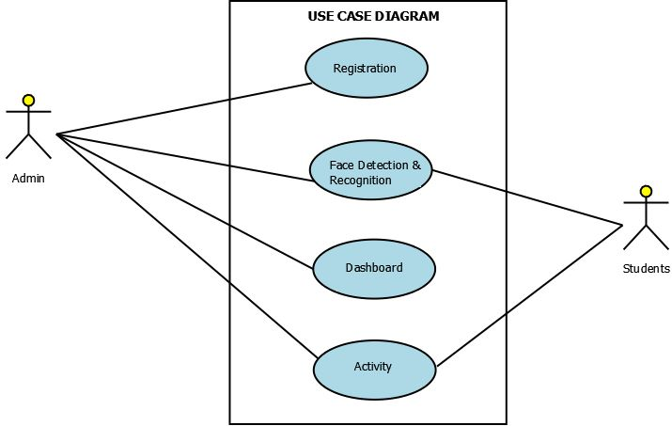

1. **High Level Diagram**

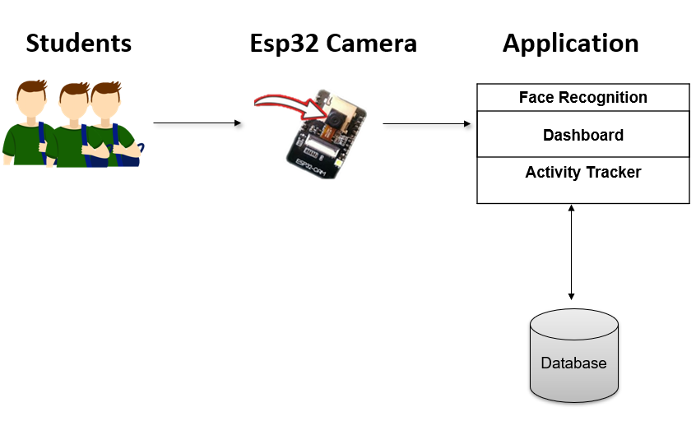

1. **Sequence Diagram**

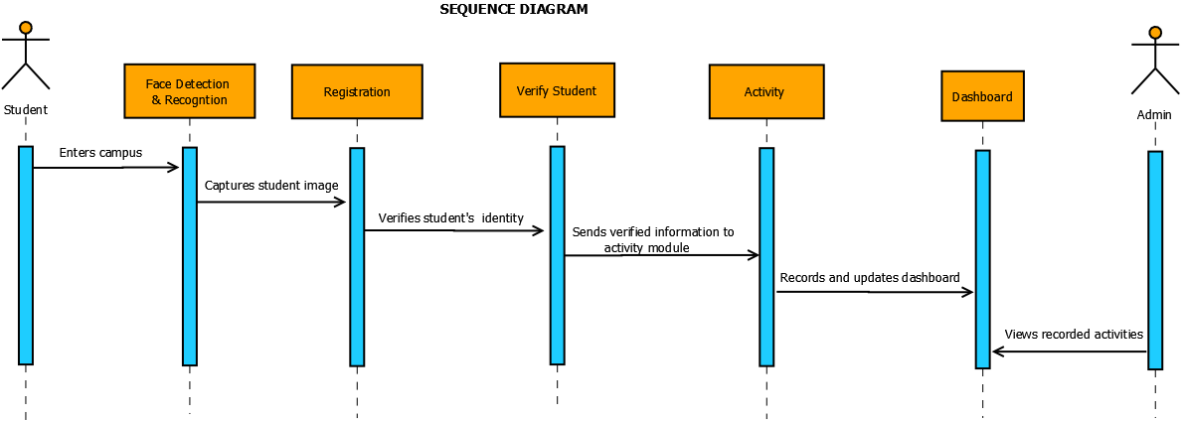

1. RESULTS

**Esp32 Camera Connection with Ftdi**

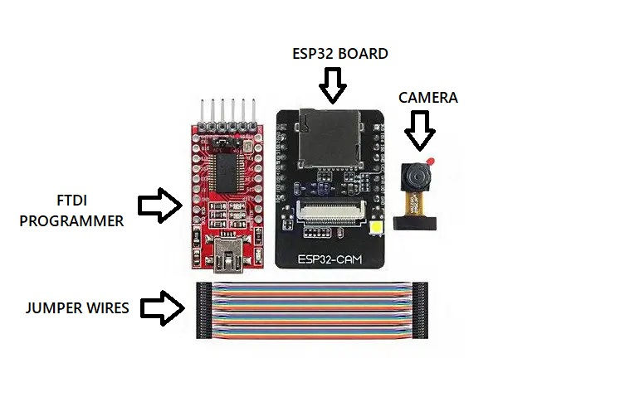

**FIGURE 1**

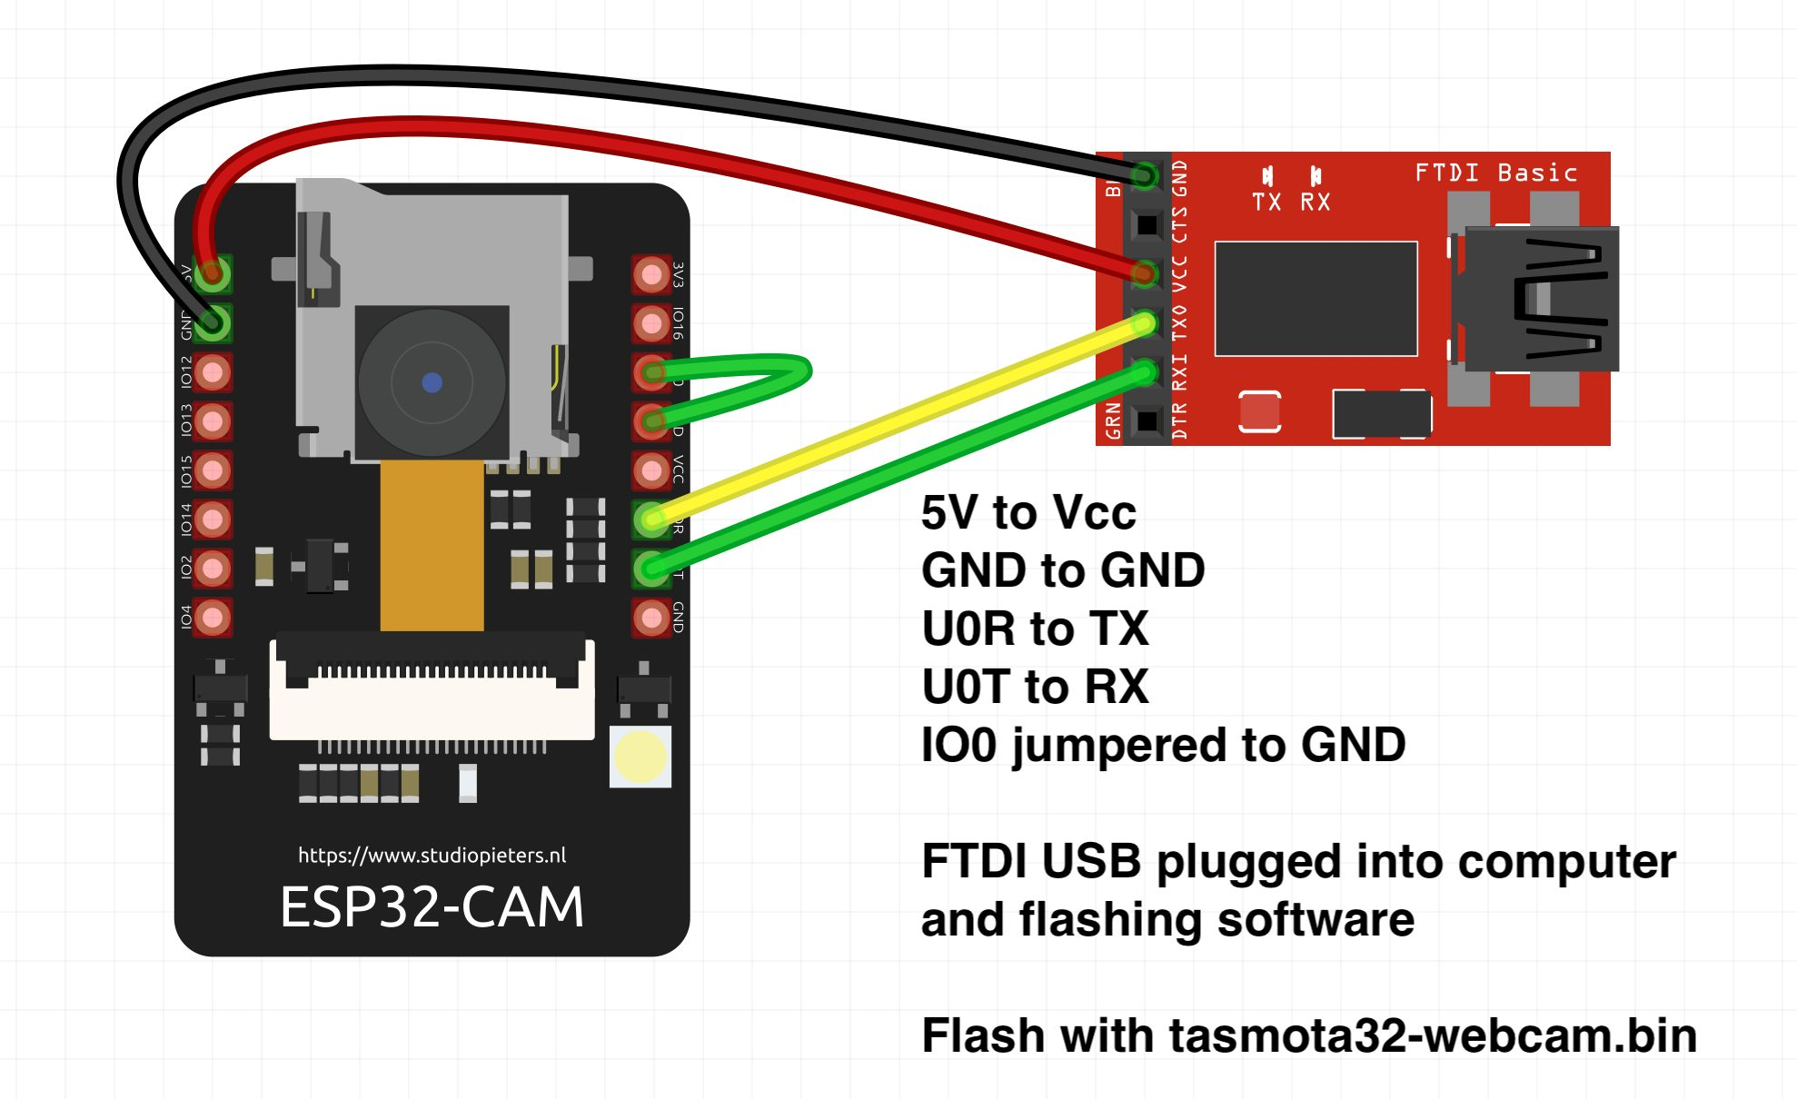

**FIGURE 2**

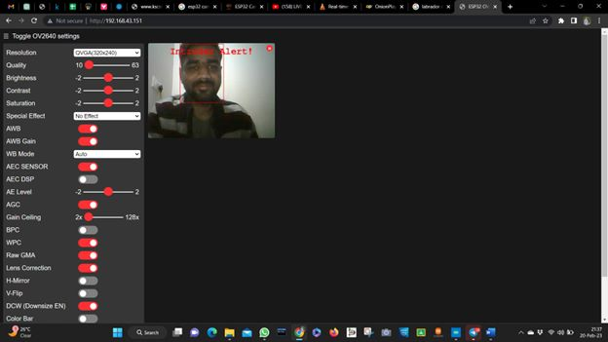

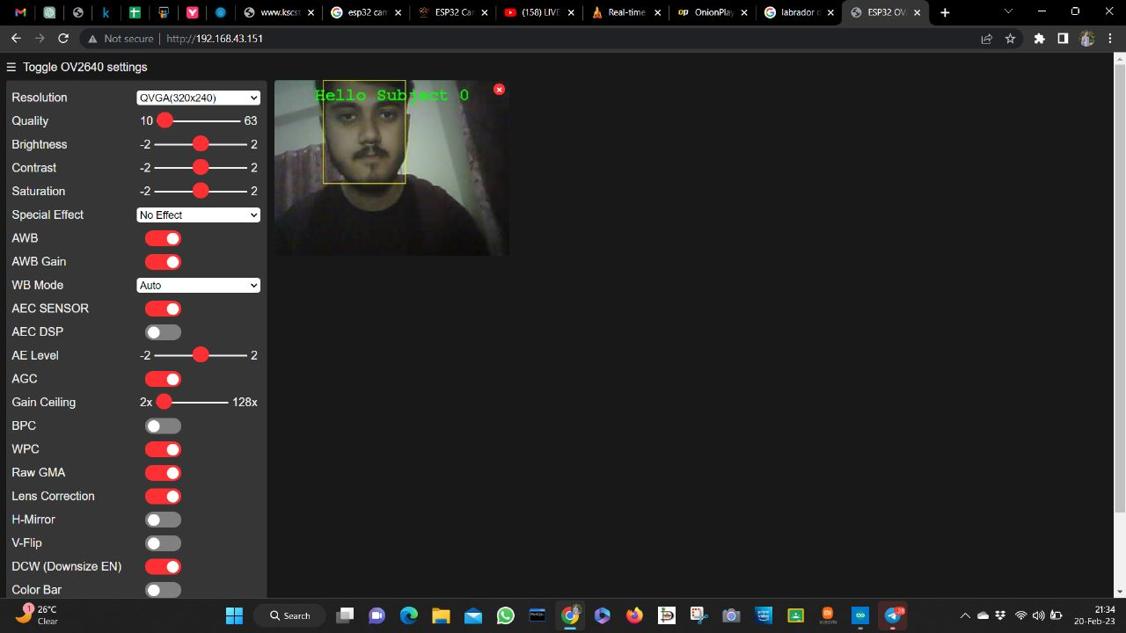

1. Conclusions

STVS is a promising tool for educational institutions to monitor and assess student activities. Our study found that the system can improve student engagement and academic performance. While there was no significant effect on retention, STVS could still be a valuable tool in enhancing student success. Future research could explore the use of STVS in combination with other interventions to improve retention rates.

Acknowledgment

We would like to express our sincere gratitude to all the individuals who contributed to this study. Our thanks go to the educational institution that provided access to the STVS and the student data used in this study. We also want to thank the students who participated in the survey and allowed us to use their data. Finally, we acknowledge the efforts of the research team involved in data collection, analysis, and interpretation. Their contributions were critical to the success of this study.

References

1. "Using Computer Vision for Student Attendance Tracking" by Pratiksha Yadav and Shailendra Mishra, in Proceedings of the 5th International Conference on Computing Communication and Networking Technologies (ICCCNT), 2014. This paper provides a detailed overview of how computer vision techniques can be used for attendance tracking in classrooms.
2. "Design and Implementation of a Web-based Student Attendance Tracking System using Facial Recognition" by Hesham Ahmed and Ahmed Abdellatif, in Proceedings of the 9th International Conference on Computer Engineering & Systems (ICCES), 2014. This paper describes the design and implementation of a web-based attendance tracking system that uses facial recognition technology.
3. "Web-based Dashboard for Data Visualization" by Shilpa Kamble, in Proceedings of the International Conference on Innovations in Information, Embedded and Communication Systems (ICIIECS), 2017. This paper discusses the design and development of a web-based dashboard for visualizing data from various sources.
4. "Introduction to Data Visualization" by Rafael Irizarry, Harvard University. This online course introduces data visualization and covers various techniques and tools for creating visualizations.
5. "Data Visualization Best Practices" by Tableau, a leading data visualization software company. This guide provides best practices and tips for creating effective visualizations.
6. "Designing Data-Driven Interfaces" by Stephen Few, a data visualization expert. This book provides guidance on how to design interfaces that effectively communicate data.
7. "D3.js" by Mike Bostock, a popular JavaScript library for creating dynamic and interactive visualizations on the web.
8. "Google Charts" by Google, a library for creating a wide range of charts and visualizations on the web.