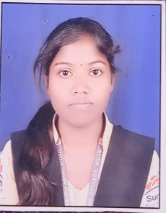

GODAVARI

Analyst/Software Engineer

Base Location : Bangalore

Email ID : godavari.godavari@capgemini.com

Mobile No : 8618154713

Grade : A4



# **Education and certificates**

Master Of Computer

Applications :2019-2021

# **Skills**

Spring Boot

JPA CURD/JPA MONGODB

# **Backend**

Spring Boot

MongoDB

REST-API

# **Database**

No SQL database-MongoDB

MongoDB

REST-API

# **Web Technologies**

HTML5

CSS3

JavaScript/TypeScript

# **Add-ons**

GitHub

Maven

Postman

# **Additional Details**

Excellent Communication Skills

Team Player

* A self-driven learner with Front-End and Back-End knowledge. Passionate about implementing and launching new projects.
* Ready to learn new technologies/Frameworks and implement them to further improve my knowledge.

### A team player with good communication skill always ready to work for the enrichment of knowledge.

* Has working knowledge on Angular and Java Microservice Development using Spring framework on- an intermediate level.

### Also Implemented Eureka Server and Semantic UI in- case study and upskilling day by day.

#### **Tourist Management System**

Completed end to end case study on Matchsapp using java spring Boot and mongo DB for Backend and Angular for UI Interface.

#### **Trained on**

Java-Full stack with Angular which HTMl,CSS3, JavaScript/TypeScript and Angular as web technologies and java, spring boot for backend with MongoDB database support.

Strengths Achivement