# Overall summary

The whole dataset is consisting of the trip data. That is actually compromised of 15 columns that are consisting information about the trip, the very first column explains the trip duration, and then there are many columns but the most important ones are when the trip started and when it is going to end and the gender and the user type are the correlated and the columns with the significant importance. We calculated certain relations, such as the trips by the gender per weekday and the gender per weekday by the hour and we also calculated the relation of the user type and the gender. The overall purpose of creating this analysis is to calculate the relationship between the trips the gender and the days.

# Visualization

## Graph1

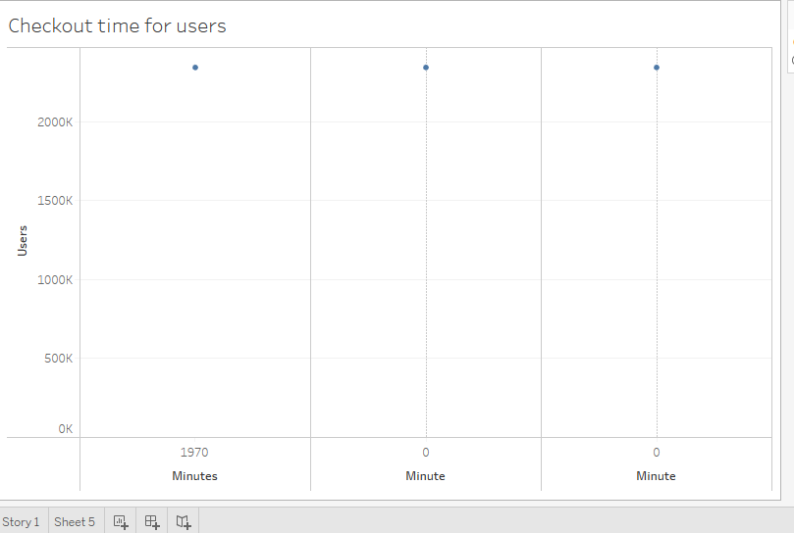

In the graph, we took 4 attributes to visualize the result, one for the row and the three for column. For the row, we placed there the software-generated variable that represents the number of the record in the dataset and then we placed the same attribute by 3 times in the dataset by implementing filler to make sure that we are getting the real statics. In the first 20 minutes the number of bikes increases and it increases above the 140k at the 10th minute and it start gradually coming down and at the sixth minute the number of bikes were almost zero.

## Graph2

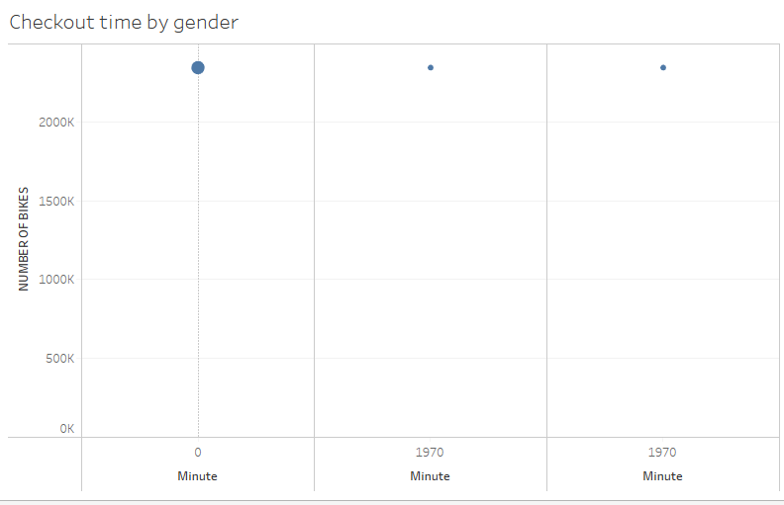

In the graph, we took 5 attributes to visualize the result, one for the row and the ree for column. For th row, we placed there the software-generated variable that represents the number of the record in the dataset and then we placed the same attribute by 3 times in the dataset by implementing filler to make sure that we are getting the real statics. And we moved the gender to the color to review its impact on the system. In the first 10 minutes, the number of male bikers reaches 100k and it gradually starts coming down and up to the 50th minute it is zero. And in the case of females it reaches to the 30k and it comes down and last tills the 60th minute. The value for the unknown genders increases and only reaches the 10k but it lasts till the 60th of the minute.

## Graph3

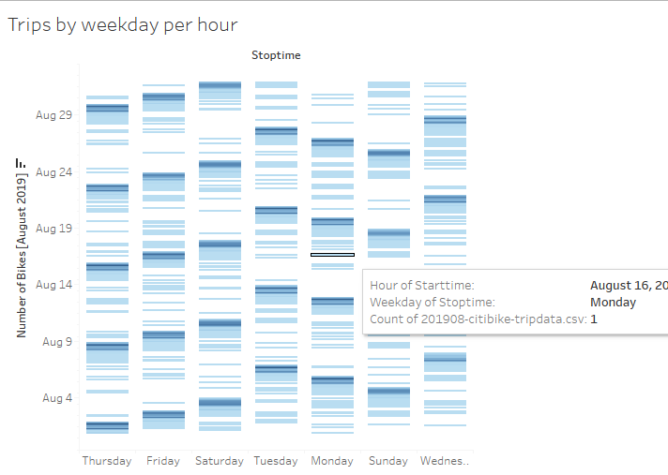

We illustrated this graph with the help of two attributes that are the weekdays and the start time and we created the graph the graph represented that from Monday to Friday from 6 AM to 9 AM that there were the maximum number of bikes were viewed and in the days of weekend of Saturday Sunday there were the maximum number of bikes were seen from the time of 9AM to the 5PM.

## Diagram 4

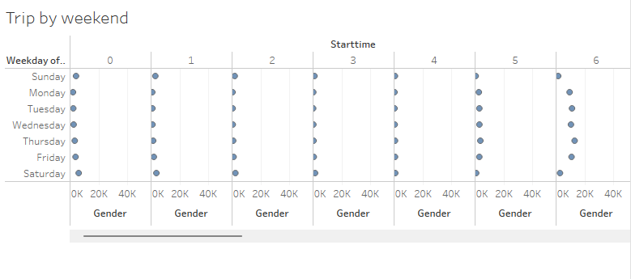

When we illustrated the graph we got the following results, the first thing that we analyzed from the diagram is that from Monday to Friday and in the time between 6 AM and 9 AM the visits of the males were quite high while the visits for the females were low. And then on the same days from Monday to Friday the time frame from 5pm to7pm that there was highest number of male were found but against the number of females were quite low. For the weekends we just reviewed the data and we got to know that there were the higher number of male visiter from 9AM to 5PM.

## Diagram 5

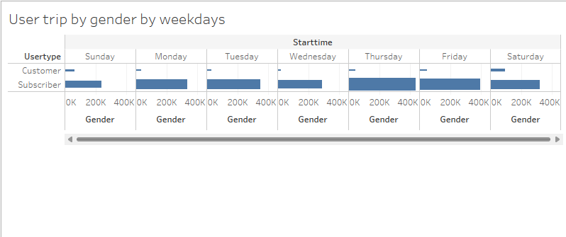

When we illustrated this graph we put the user type to the row and the weekdays and the gender to the columns we extracted the following results there was the users who were the subscriber and the male showed us with the maximum number of trips.

# Detailed Summary

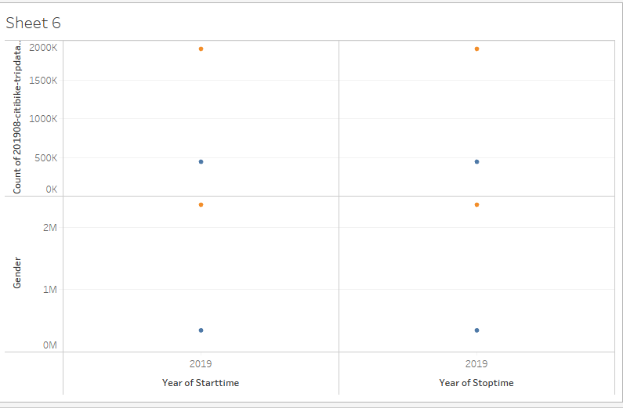

In order to analyses our data and correctly explain the relation and features correctly we converted the column of trip duration to the date time format. And while analyzing the features we put the number of bikers on 1 side and all the other features on the other side. We were actually calculating the relation of the number of bikes with the several other attributes and we checked the contribution of different parameters. And we got this that the number of bikers were maximum in the weekdays in the morning from 6 Am to the 9 AM and in the evening the number of bikers were maximum from 5pm to 9pm and the number of bikers were highest for the gender male. The final result of our analysis was that there are two time frames from Monday to Friday and the male gender is dominated one.

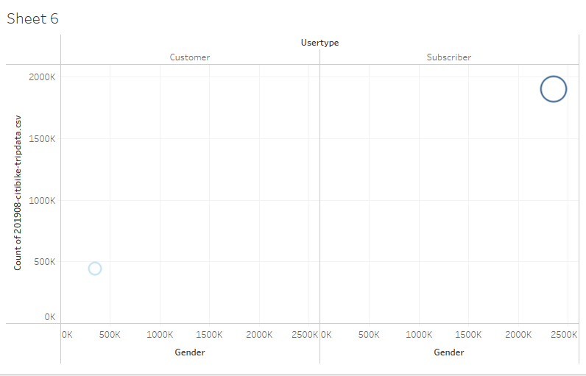

[Tableau Link] https://public.tableau.com/views/Book3_16590355902330/Sheet6?:language=en-US&publish=yes&:display_count=n&:origin=viz_share_link