Stock Trader Terraform Scripts - Beginner’s Guide
Document Version: 1.0
Last Updated: October 2025
For: Newcomers who want to understand what the Terraform scripts do
Focus: Understanding and using the automation scripts
Author: Anand Mohan Singh

Document Overview
This guide is written for someone who is new to this repository and wants to understand how the Terraform scripts work. If you’ve never used this before, start with the “5-Minute Quick Start” section. If you want to understand what’s happening under the hood, read the “Module-by-Module Deep Dive” section.
Time to read: 45-60 minutes
Time to deploy: 20-25 minutes
Difficulty: Beginner to Intermediate

Table of Contents
Stock Trader Terraform Scripts - Beginner’s Guide 1
Document Overview 1
Official Repository Links 5
What This Guide Covers 5
What This Guide Does NOT Cover 5
The Problem We’re Solving 6
Before vs After: The Transformation 6
The Manual Nightmare (Before) 7
The Automated Solution (After) 7
The 5-Minute Quick Start 8
Prerequisites 8
Run the Deployment 8
Command Reference 9
Verify It Worked 10
Access the Application 11
Understanding the File Structure 12
Top-Level Files (azure/) 12
The main.tf File - The Orchestrator 14
The Modules Directory 15
The Automation Scripts Explained 16
The Makefile - Your Command Center 16
The precheck.sh Script - Your Safety Net 16
The postcheck.sh Script - Your Verification Tool 19
The make app-url Command - Get Your Application URL 25
Why These Scripts Matter 25
How the Scripts Work Together 26
The Dependency Flow 26
How Variables Flow 28
How Outputs Work 29
Module-by-Module Deep Dive 30
Module 1: Network (modules/network/) 30
Module 2: AKS (modules/aks/) 31
Module 3: PostgreSQL (modules/postgres/) 34
Module 4: Redis (modules/redis/) 35
Module 5: Key Vault (modules/key_vault/) 35
Module 6: User Assigned Identity (modules/uai/) 36
Module 7: K8s Bootstrap (modules/k8s_bootstrap/) 37
Module 8: External Secrets (modules/external_secrets/) 38
Module 9: PostgreSQL Init (modules/postgres_init/) 40
Module 10: Apply CR (modules/apply_cr/) 42
How Template Files (.tmpl) Get Their Variables 45
Module 11: Function App (modules/function_app/) 48
The Automation Magic 50
The Complete Execution Flow 50
How Secrets Flow Automatically 52
How DDL Execution Works 53
How Kubernetes Manifests Get Applied 54
How Dependencies Ensure Correct Order 55
Configuration Guide 56
The terraform.tfvars File 56
Absolute Minimum Configuration 56
Important Naming Rules 59
Recommended Values 59
What Happens If You Change Values? 59
Environment-Specific Configurations 60
What Happens During Make Apply 61
Phase 0: Precheck (bash precheck.sh) 61
Phase 1: Planning (make plan) 61
Phase 2: Application (make apply) 62
Phase 3: Background (Stock Trader Operator) 65
Phase 4: Verification (make postcheck) 65
Complete Deployment Flow Summary 66
Troubleshooting Your Deployment 66
Common Issues When Running Terraform 66
Viewing Terraform State 70
Debugging Module Execution 70
When to Destroy and Recreate 70
Modifying the Scripts 71
Common Modifications 71
Best Practices for Modifications 74
Summary: What You’ve Learned 75
What to Do Next 75
Quick Reference 77
Essential Commands 77
Essential Files 77
Module Documentation 78
Getting Help 78
Final Thoughts 78

Official Repository Links
- Main Stock Trader Organization: https://github.com/IBMStockTrader
- Terraform Setup Repository: https://github.com/IBMStockTrader/stocktrader-setup

What This Guide Covers
This guide explains exactly what our Terraform scripts do to set up Stock Trader on Azure. By the end, you’ll understand:
Topic | What You’ll Learn
Deployment Process | What happens when you run make apply
Module Architecture | How our modules work together
Automation Magic | DDL execution, YAML application, secret wiring
Validation Scripts | How precheck and postcheck scripts validate your deployment
Customization | How to read and modify the scripts for your needs

What This Guide Does NOT Cover
Topic | Where to Learn
Basic Terraform Syntax | terraform.io
General Azure Concepts | docs.microsoft.com
Stock Trader Application | Covered in separate video by John Alcorn

The Problem We’re Solving
The IBM Stock Trader application is a cloud-native microservices demonstration that shows how to build modern applications using Kubernetes, Istio, and various Azure services. Originally created at IBM and now maintained by Kyndryl (by the ex-IBMers that created it), it serves as an excellent example of cloud-native architecture.
The application demonstrates how to build a cloud-native application out of a set of containerized microservices that run in Kubernetes, with each microservice in its own repository under the IBMStockTrader organization.

Before vs After: The Transformation
Aspect | Before (Manual) | After (Terraform)
Time | 2-3 hours per environment | 15-20 minutes total
Azure Resources | Manual clicking through 15+ Portal screens | Single make apply command
Database Setup | Manual DDL script execution | Automated via temporary pods
Kubernetes Deployment | Manual kubectl apply of 10+ YAML files | Automated via Custom Resources
Secret Management | Manual copy/paste from Azure to Kubernetes | Automatic sync via External Secrets
Configuration | Copy/paste connection strings, firewall rules | Automated via Terraform variables
Error Rate | High (forgot steps, wrong subnets, typos) | Low (validated by precheck/postcheck)
Consistency | Each environment different | Identical every time
Reproducibility | Difficult to recreate | One command deployment

The Manual Nightmare (Before)
What you had to do manually:
- Azure Portal clicking: Create AKS (15 minutes of clicking), PostgreSQL (10 minutes), Redis (5 minutes), Key Vault (5 minutes)
- Manual configuration: Copy/paste connection strings, set up firewall rules, configure VNets
- Database setup: Manually run DDL scripts to create tables
- Kubernetes setup: Manually kubectl apply 10+ YAML files in the right order
- Secret management: Manually create secrets, copy values from Azure to Kubernetes
- Easy to mess up: Forget a step? Wrong subnet? Mistyped password? Start over
Result: Inconsistent environments, configuration drift, and lots of frustration.

The Automated Solution (After)
What you do now:
bash precheck.sh # Validates your environment
make init # Initialize Terraform
make plan # Show what will be created
make apply # Deploy everything
make postcheck # Verify deployment
make app-url # Get the application URL
What you get automatically:
- AKS cluster running with CNI overlay networking
- PostgreSQL with tables created
- Redis cache ready
- Secrets synced from Key Vault to Kubernetes
- Stock Trader application deployed and running
- Istio Gateway configured for external access
How? Let’s dive into the scripts.

The 5-Minute Quick Start
Before we understand how it works, let’s see it in action. This guide covers the Terraform automation scripts from the IBM Stock Trader organization.

Prerequisites
# 1. Tools installed
terraform --version # Should show 1.0+
az --version # Should show Azure CLI
operator-sdk version # Should show operator SDK
psql --version # PostgreSQL client
# 2. Logged into Azure
az login
az account set --subscription "your-subscription-id"
# 3. Resource group exists (create if needed)
az group create --name stocktrader-rg --location eastus

Run the Deployment
Step | Command | Purpose | Time
1 | cp terraform.tfvars.example terraform.tfvars | Copy configuration template | 30 seconds
2 | Edit terraform.tfvars with your values | Configure your deployment | 2-3 minutes
3 | bash precheck.sh | Validate environment | 30 seconds
4 | make init | Initialize Terraform | 1 minute
5 | make plan | Review deployment plan | 30 seconds
6 | make apply | Deploy everything | 15-20 minutes
7 | make postcheck | Verify deployment | 2 minutes
8 | make app-url | Get application URL | Instant
Complete deployment sequence:
# Navigate to the azure directory
cd stocktrader-setup/azure
# Step 1: Copy and edit configuration
cp terraform.tfvars.example terraform.tfvars
# Edit terraform.tfvars with your values
# Step 2: Validate your environment (IMPORTANT!)
bash precheck.sh
# Step 3: Initialize Terraform
make init
# Step 4: Review what will be created
make plan
# Step 5: Deploy everything
make apply
# Step 6: Verify the deployment
make postcheck
# Step 7: Get the application URL
make app-url

Command Reference
Command | What It Does | When to Use
precheck.sh | Validates all prerequisites are installed and configured correctly | Before every deployment
make init | Downloads Terraform providers and initializes the backend | First time or after changes
make plan | Shows what resources will be created (saves plan to plan.tfplan) | Before applying changes
make apply | Applies the saved plan (no additional confirmation needed) | To deploy or update
make postcheck | Comprehensive validation of the deployment | After deployment
make app-url | Displays the Stock Trader application URL | To access the application
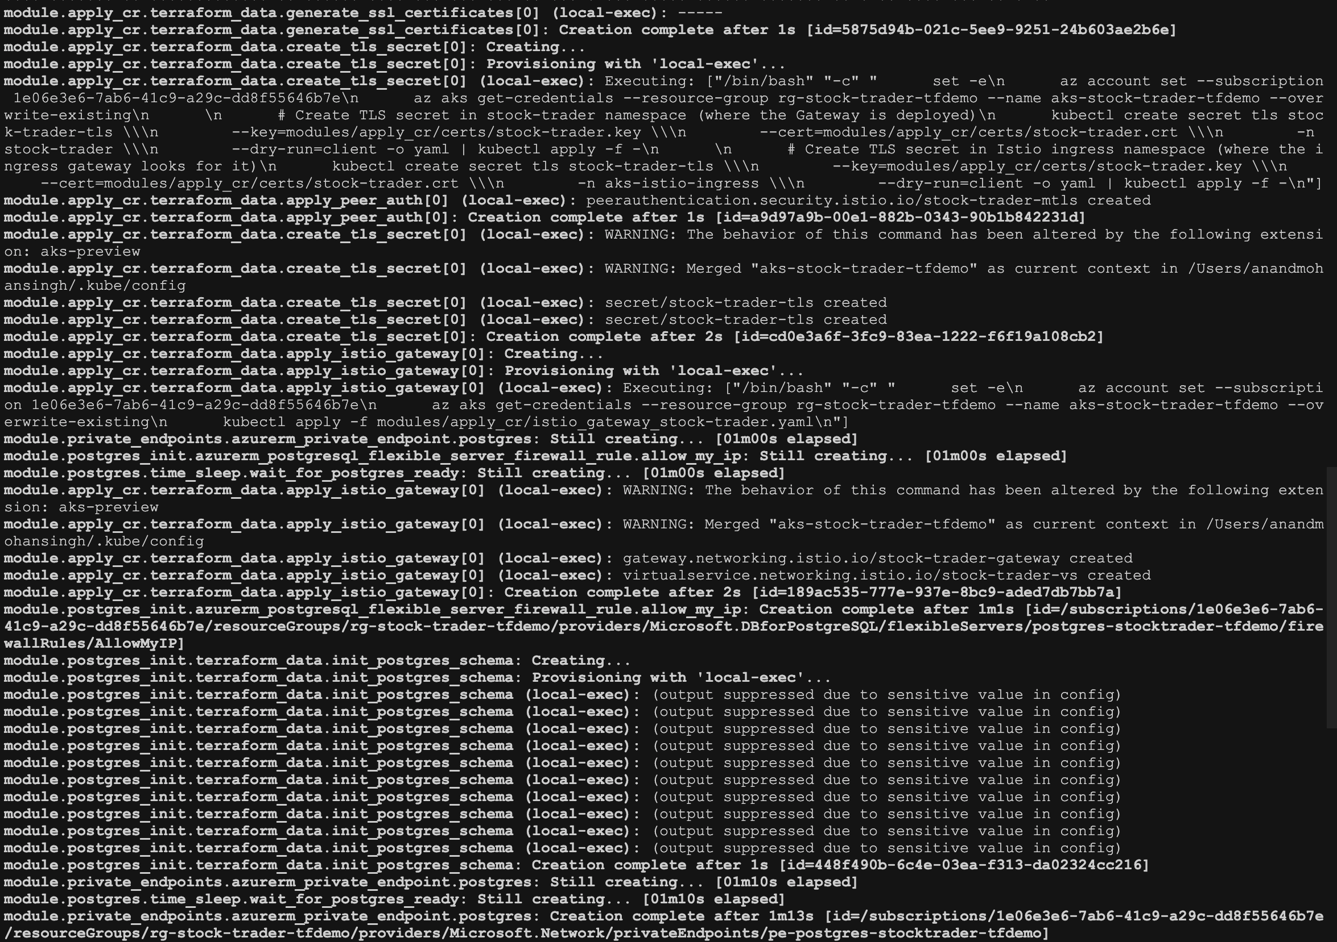
Figure 1: Deployment in progress

Verify It Worked
The postcheck script automatically verifies everything, but you can also check manually:
# Get Kubernetes access
az aks get-credentials --resource-group stocktrader-rg --name stocktrader-aks
# Check pods are running (should show 2/2 with Istio sidecars)
kubectl get pods -n stock-trader
# Expected: All pods showing "2/2 Running" status
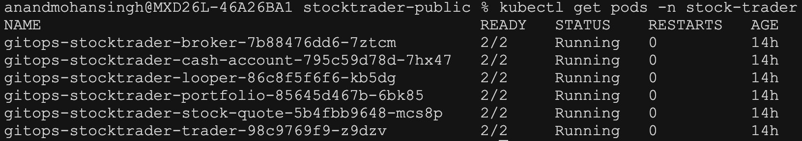
Figure 2: Stock Trader pods running with Istio sidecars

Access the Application
After postcheck passes, get the application URL:
make app-url
This will output something like:
https://20.102.45.67/trader
Open this URL in your browser.
Default Login Credentials: - Username: stock - Password: trader
These are the default credentials built into the Stock Trader application.
What you’ll see: - Stock Trader web interface - Portfolio view with sample data - Real-time stock quotes - Trading functionality
If you can log in and see the interface, congratulations - your deployment worked!

Understanding the File Structure
The Terraform scripts are organized in the stocktrader-setup repository under the azure/ directory. This repository contains the infrastructure-as-code for provisioning and configuring the Stock Trader application across multiple cloud providers, with the initial implementation targeting Microsoft Azure.
Let’s look at what files exist and what they do:

Top-Level Files (azure/)
File | Purpose | When You Use It
main.tf | The orchestrator - calls all modules | Read to understand the flow
variables.tf | Defines what you can configure | Reference for available options
terraform.tfvars.example | Example configuration | Copy to create your config
terraform.tfvars | Your actual configuration | Edit with your values
outputs.tf | What info to display after deployment | See results after apply
provider.tf | Configures Azure and Kubernetes providers | Rarely need to modify
versions.tf | Locks provider versions | Ensures consistency
tags.tf | Common Azure tags | Applied to all resources
Makefile | Make commands for easier deployment | Use instead of raw terraform
precheck.sh | Validates prerequisites before deployment | Run before every deployment
postcheck.sh | Verifies deployment after completion | Run after deployment
modules/ | The actual work happens here | Contains all module code

File structure overview:
azure/
├── main.tf ← The orchestrator - calls all modules
├── variables.tf ← Defines what you can configure
├── terraform.tfvars.example ← Example configuration
├── outputs.tf ← What info to display after deployment
├── provider.tf ← Configures Azure and Kubernetes providers
├── versions.tf ← Locks provider versions
├── tags.tf ← Common Azure tags
├── Makefile ← Make commands for easier deployment
├── precheck.sh ← Validates prerequisites before deployment
├── postcheck.sh ← Verifies deployment after completion
└── modules/ ← The actual work happens here
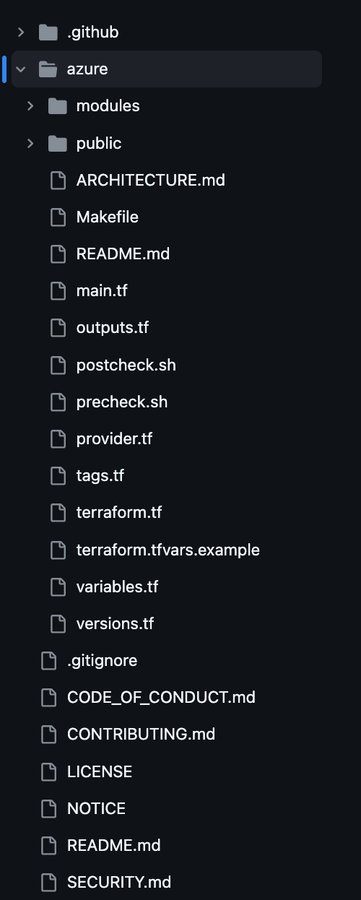
Figure 3: Terraform project structure

The main.tf File - The Orchestrator
This is the most important file. Let’s look at its structure:
# azure/main.tf (simplified)
# 1. Create resource group (or use existing)
resource "azurerm_resource_group" "main" {
name = var.resource_group_name
location = var.location
}
# 2. Set up networking
module "network" {
source = "./modules/network"
# ... passes variables
}
# 3. Create AKS cluster
module "aks" {
source = "./modules/aks"
# ... depends on network module
}
# 4. Create databases
module "postgres" {
source = "./modules/postgres"
# ... depends on network module
}
module "redis" {
source = "./modules/redis"
# ... depends on network module
}
# 5. Create Key Vault and identity
module "key_vault" {
source = "./modules/key_vault"
# ... stores secrets
}
module "uai" {
source = "./modules/uai"
# ... creates managed identity
}
# 6. Bootstrap Kubernetes
module "k8s_bootstrap" {
source = "./modules/k8s_bootstrap"
# ... depends on AKS
}
# 7. Sync secrets
module "external_secrets" {
source = "./modules/external_secrets"
# ... depends on key_vault and k8s_bootstrap
}
# 8. Initialize database
module "postgres_init" {
source = "./modules/postgres_init"
# ... runs DDL scripts
}
# 9. Deploy Stock Trader
module "apply_cr" {
source = "./modules/apply_cr"
# ... applies Kubernetes manifests
}
# 10. Create Azure Function
module "function_app" {
source = "./modules/function_app"
# ... deploys stock quote function
}
Key insight: Each module block is calling code in the modules/ directory. The order matters because of dependencies.

The Modules Directory
Each module is a self-contained Terraform package:
modules/aks/
├── main.tf ← Creates the AKS cluster
├── variables.tf ← Inputs this module needs
├── outputs.tf ← Values this module exposes
└── README.md ← Documentation
This pattern repeats for all modules.

The Automation Scripts Explained
Before diving into the Terraform modules, let’s understand the helper scripts that make deployment easier and safer.

The Makefile - Your Command Center
The Makefile provides simple commands instead of remembering complex Terraform flags.
Key Commands:
make init # terraform init
make plan # terraform plan -out=plan.tfplan
make apply # terraform apply plan.tfplan
make destroy # terraform plan -destroy + apply
make precheck # bash precheck.sh
make postcheck # bash postcheck.sh
make app-url # Get application URL
Why use Make instead of raw Terraform commands?
- Saved plans: make plan saves to plan.tfplan, then make apply uses that exact plan (no surprises)
- No confirmations: Since you already reviewed the plan, apply doesn’t ask again
- Consistency: Everyone on the team uses the same commands
- Fewer mistakes: You can’t accidentally skip terraform plan

The precheck.sh Script - Your Safety Net
This script runs BEFORE deployment to catch problems early.
What precheck.sh validates:
bash precheck.sh
Checks performed:
- Tool Installation
  - Azure CLI (az) installed and working
  - Terraform installed (version 1.0+)
  - Operator SDK installed
  - PostgreSQL client (psql) installed
  - OpenSSL installed
  - Azure Functions Core Tools
- Azure Login
  - You’re logged into Azure
  - Your session hasn’t expired
  - You have access to the subscription
- Azure Permissions
  - You can create resources in the subscription
  - You have Contributor role (or equivalent)
- Resource Naming
  - Checks if resource names in terraform.tfvars already exist
  - Prevents naming collisions (AKS cluster names must be unique)
  - Validates naming conventions
- Configuration File
  - terraform.tfvars exists and is readable
  - Required variables are set
  - No obviously wrong values (like “CHANGEME”)
Sample output:
🔍 Terraform Azure Deployment Precheck
==================================================
📋 Checking Azure CLI...
✅ Azure CLI version: 2.59.0
🔑 Checking Azure login status...
✅ Logged in as: your.email@company.com
✅ Subscription ID: 12345678-1234-1234-1234-123456789012
📦 Checking Operator SDK...
✅ Operator SDK version: 1.31.0
🏗️ Checking Terraform...
✅ Terraform version: 1.7.0
📋 Checking terraform.tfvars...
✅ terraform.tfvars file exists
✅ All required variables are set
🔍 Checking resource name availability...
✅ AKS cluster name 'stocktrader-aks' is available
✅ PostgreSQL server name 'stocktrader-postgres' is available
✅ Redis cache name 'stocktrader-redis' is available
==================================================
✅ All prechecks passed! You're ready to deploy.
If something’s wrong:
❌ Terraform is not installed. Please install Terraform version 1.0.0 or later:
https://www.terraform.io/downloads.html
The script stops and tells you exactly what to fix.
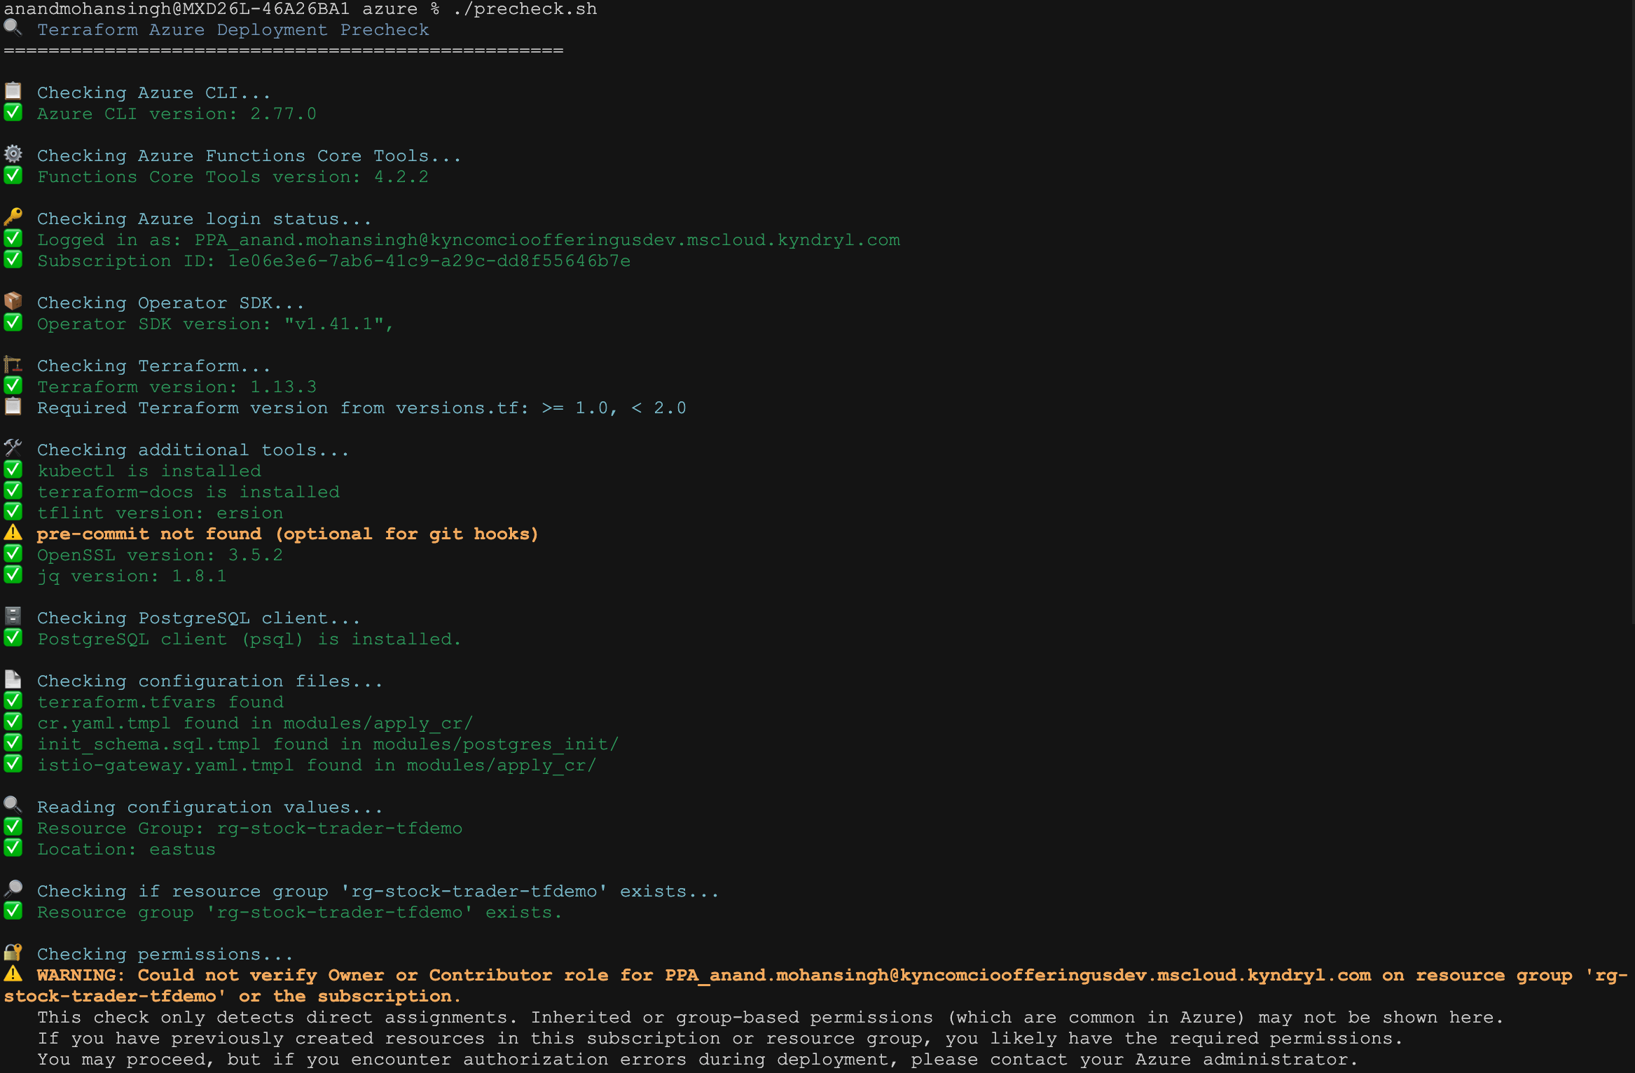
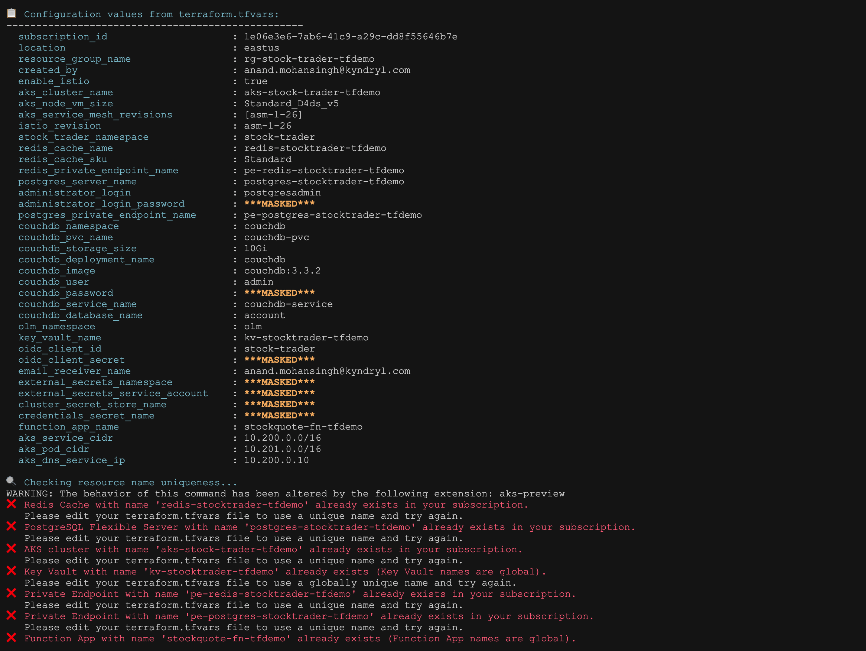
Figure 4: precheck.sh validating environment

The postcheck.sh Script - Your Verification Tool
This script runs AFTER deployment to verify everything works. It’s comprehensive - it checks over 30 different things.
What postcheck.sh validates:
make postcheck
Checks performed (in order):
- Azure CLI and Login
  - Azure CLI is installed
  - You’re logged into Azure
  - Session is valid
- Function App Deployment
  - Function App exists in resource group
  - Can retrieve function key
  - Function endpoint responds to test calls (curl with symbol=AAPL)
  - Returns HTTP 200 OK
- Tool Availability
  - kubectl is installed
  - psql (PostgreSQL client) is available
- Azure Resources
  - Resource group exists
  - AKS cluster is running
  - PostgreSQL server is accessible
  - Redis cache is running
  - Key Vault exists and has secrets
- Kubernetes Cluster
  - Can connect to AKS
  - All nodes are Ready
  - CNI overlay is configured correctly (checks pod CIDR)
  - System pods are running
- Istio Service Mesh (if enabled)
  - Istio control plane pods are running
  - Ingress gateway exists
  - Ingress gateway has external IP
  - mTLS configuration is applied
  - Sidecar injection is working (checks pod containers)
- External Secrets Operator
  - Operator pods are running
  - SecretStore is configured
  - ExternalSecrets are created
  - Secrets are synced to Kubernetes
- Stock Trader Application
  - All microservice pods are running
  - Pods show 2/2 Ready (app + Istio sidecar)
  - Operator is running
  - Custom Resource is applied
- CouchDB (if enabled)
  - CouchDB pods are running
  - Service is accessible
- Istio Gateway and Application URL
  - Gateway resource exists
  - VirtualService is configured
  - External IP is assigned
  - Can reach the application
- PostgreSQL Database and Tables
  - Can connect to PostgreSQL from within AKS
  - Database “stocktrader” exists
  - Required tables exist: Portfolio, Stock, cashaccount
  - Tables have correct schema
- Redis Configuration
  - Can connect to Redis from within AKS
  - Authentication works
  - Can set and get test values
- Application External Secret
  - Application secret is synced
  - Contains required keys
- Network Connectivity
  - Private endpoints (if enabled)
  - DNS resolution
  - Network policies
Sample output:
🔍 Terraform Azure Deployment Postcheck
==================================================
📋 Reading configuration values...
✅ Configuration values loaded
🔑 Checking Azure CLI and login...
✅ Azure CLI and login verified
🔍 Checking Azure Resources...
✅ Resource group 'stocktrader-rg' exists
✅ AKS cluster 'stocktrader-aks' is running
✅ PostgreSQL server 'stocktrader-postgres' is accessible
✅ Redis cache 'stocktrader-redis' is running
✅ Key Vault 'stocktrader-kv' has 8 secrets
☸️ Checking Kubernetes Cluster...
✅ Can connect to AKS cluster
✅ 3/3 nodes are Ready
✅ CNI overlay is configured (pod CIDR: 10.201.0.0/16)
✅ All system pods are running
🌐 Checking Istio Service Mesh...
✅ Istio control plane is healthy
✅ Ingress gateway has external IP: 20.102.45.67
✅ Sidecar injection is working
📦 Checking Stock Trader Application...
✅ All application pods are running (2/2):
- trader-7d4b8c9f6-abc123 (2/2 Running)
- broker-8e5c9d0a7-def456 (2/2 Running)
- portfolio-9f6d0e1b8-ghi789 (2/2 Running)
✅ Istio Gateway is configured
✅ VirtualService routes are set up
🗄️ Checking Database...
✅ Connected to PostgreSQL
✅ Tables exist: portfolio, stock, account_profile
🔐 Checking Secrets...
✅ External Secrets Operator is running
✅ Secrets synced: postgres-credentials, redis-credentials
⚡ Checking Function App...
✅ Function App deployed
✅ Function endpoint responds: HTTP 200 OK
==================================================
All checks passed! Your deployment is healthy.
Application URL: https://20.102.45.67/trader
Default login: stock / trader
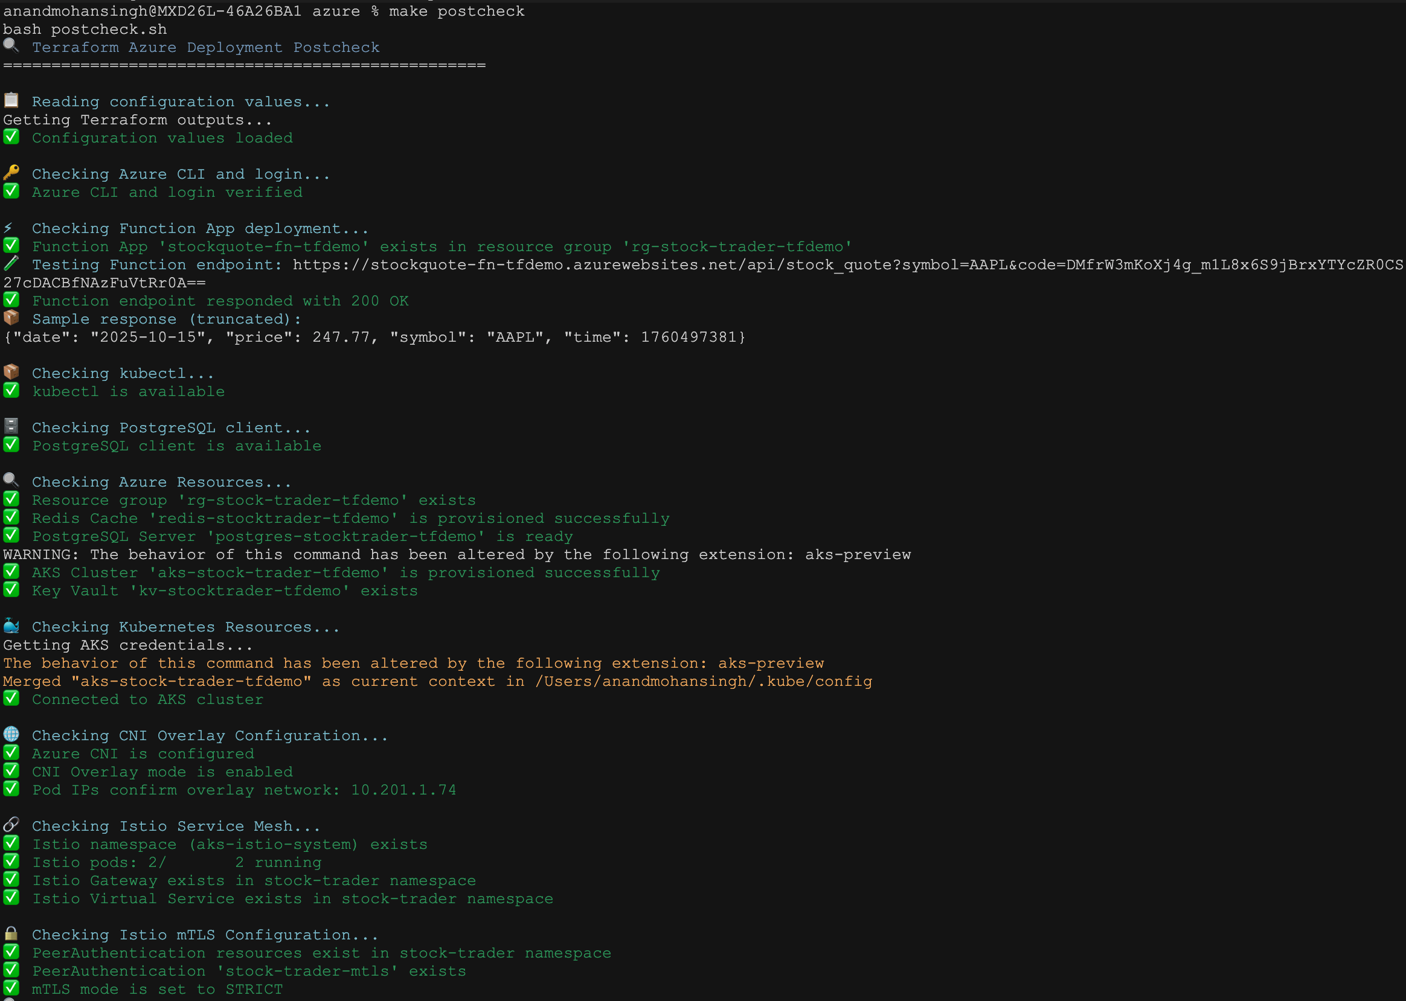
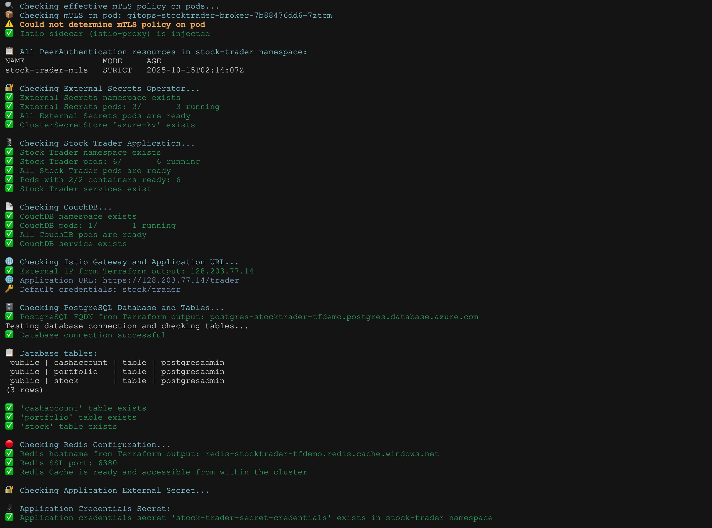
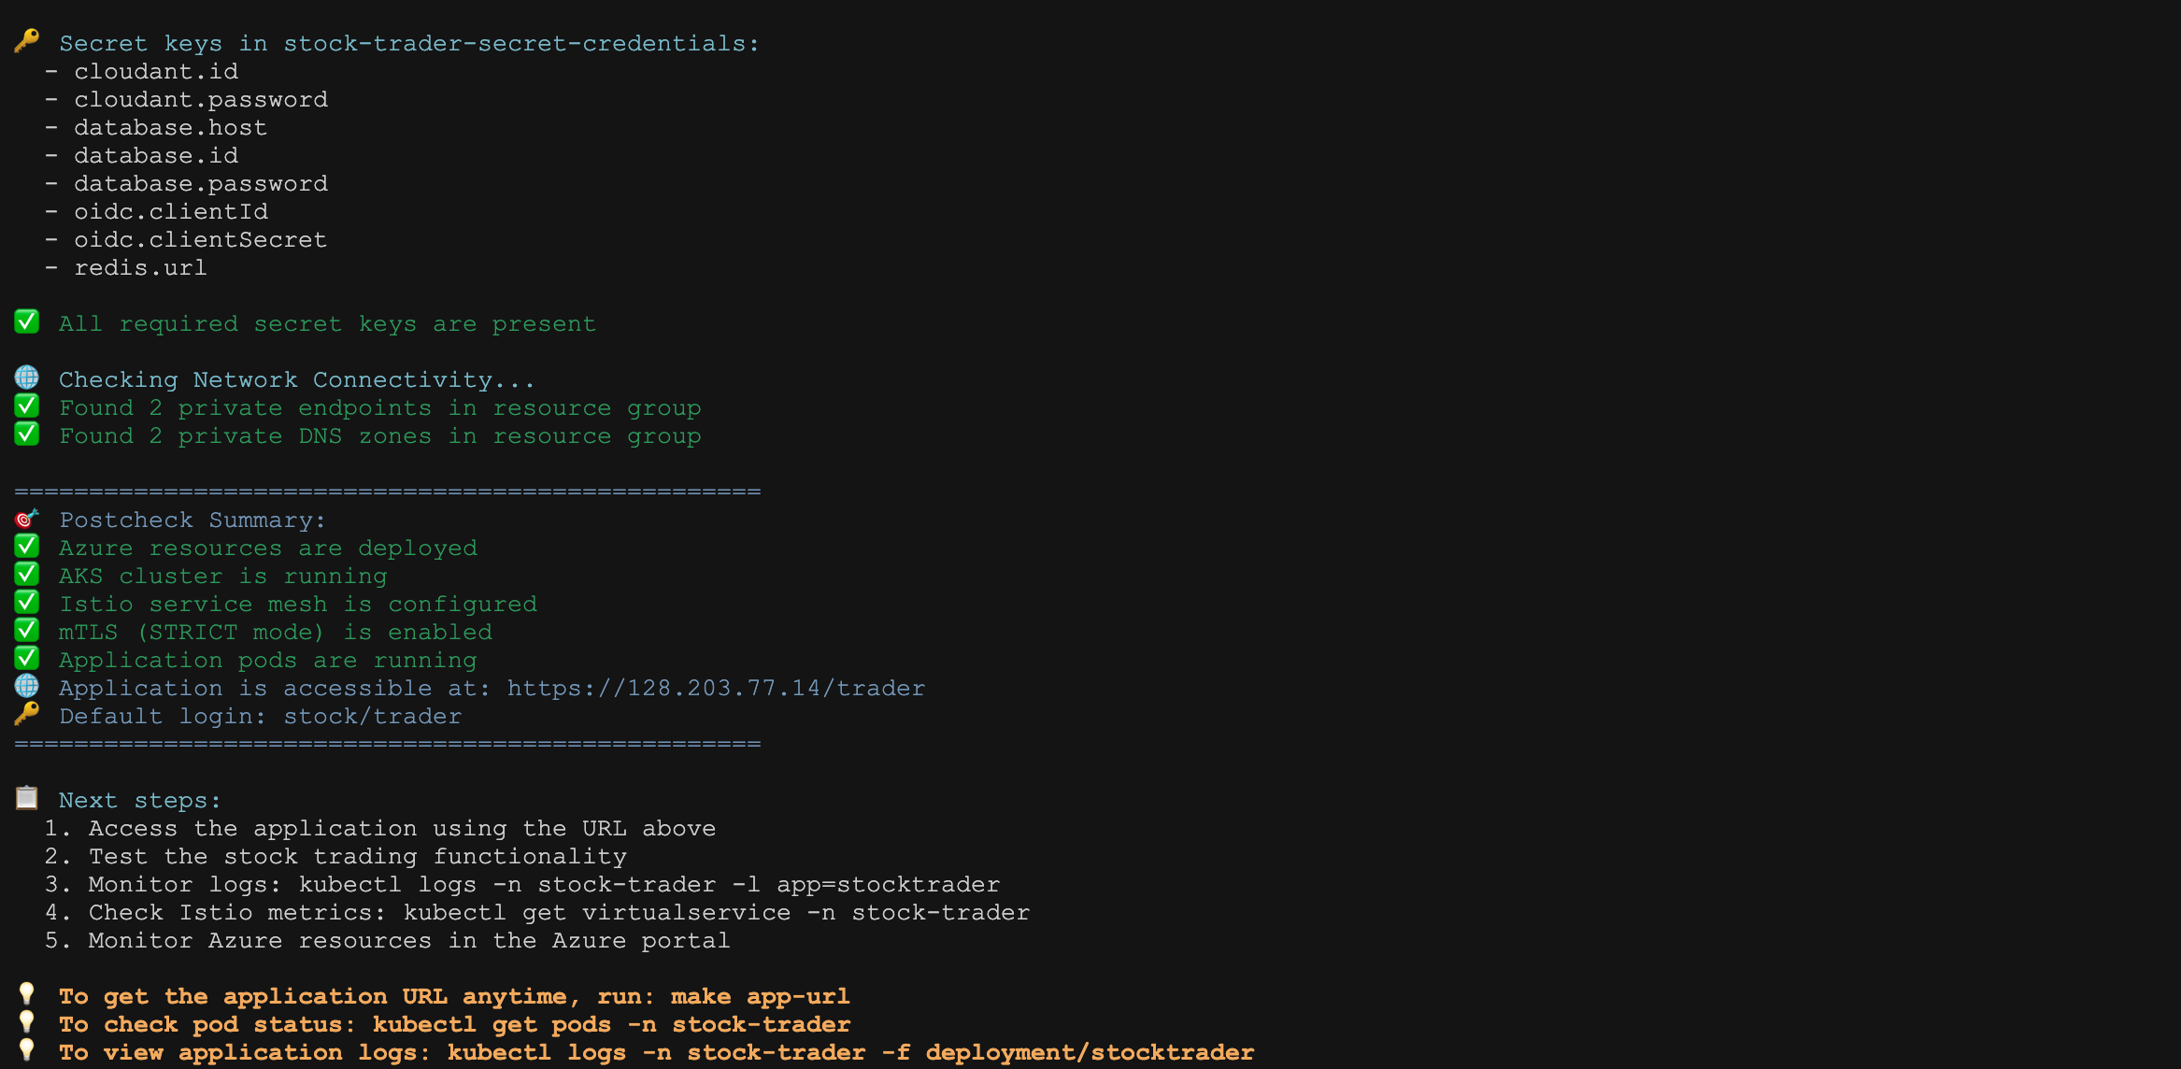
Figure 6: postcheck.sh verifying all components

The make app-url Command - Get Your Application URL
After deployment, you need the URL to access Stock Trader.
make app-url
What it does:
- Checks if Istio is enabled in your terraform.tfvars
- If Istio is enabled: Gets the Istio ingress gateway external IP
- If Istio is disabled: Gets the LoadBalancer service IP
- Prints the complete URL with /trader path
Output:
https://20.102.45.67/trader
You can then open this URL in your browser.

Why These Scripts Matter
Without precheck: - You run terraform apply - 10 minutes later it fails because you forgot to install operator-sdk - Wasted time
Without postcheck: - Terraform says “Apply complete!” - You open the app URL… 404 error - Spend an hour debugging - Turns out External Secrets Operator didn’t sync
With our scripts: - precheck catches problems in 30 seconds - postcheck confirms everything works in 2 minutes - You know immediately if something’s wrong

How the Scripts Work Together

The Dependency Flow
Here’s how modules depend on each other:
Phase | Modules | Dependencies | Purpose
1 | network | None | Creates VNet and subnets
2 | aks, postgres, redis, key_vault | network | Core infrastructure (parallel)
3 | uai | key_vault | Creates managed identity
4 | k8s_bootstrap | aks | Prepares Kubernetes
5 | external_secrets | key_vault + k8s_bootstrap | Syncs secrets to K8s
6 | postgres_init | postgres + k8s_bootstrap | Creates database tables
7 | apply_cr | Everything above | Deploys Stock Trader
8 | function_app | None | Deploys Azure Function
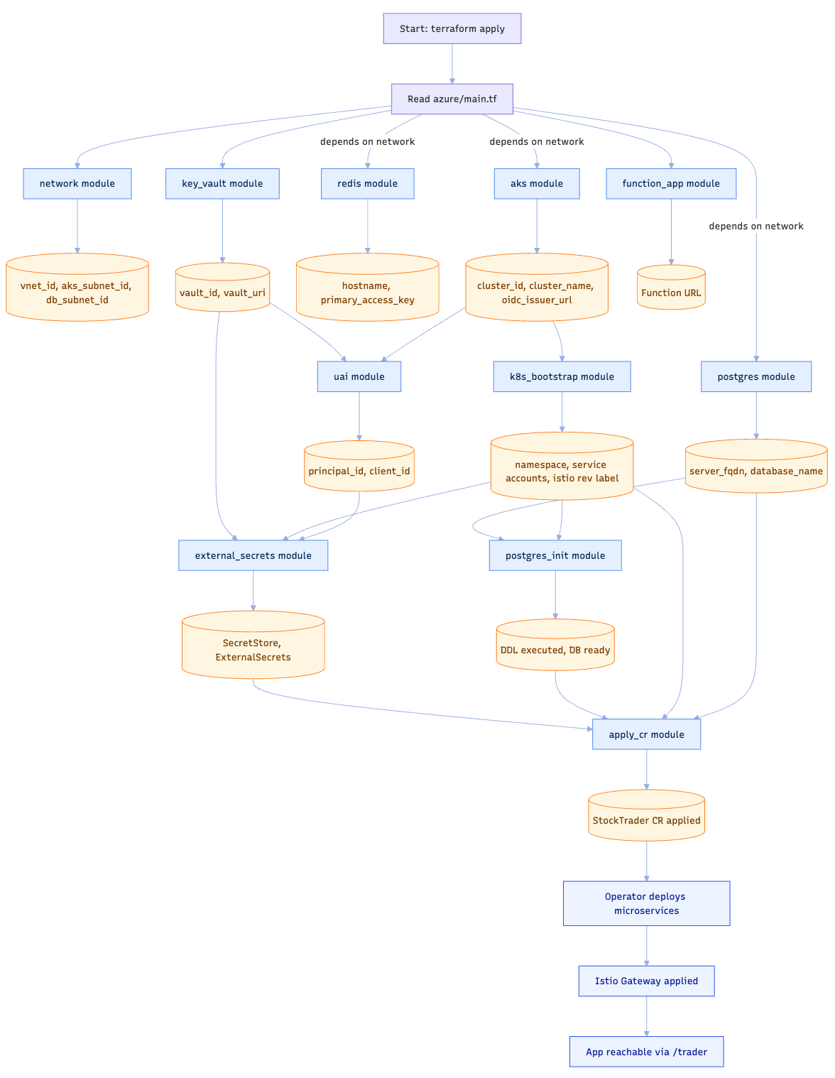
Figure 4: Module dependencies and execution order
Execution flow:
1. network module
↓
2. aks, postgres, redis, key_vault (parallel)
↓
3. uai (needs key_vault)
↓
4. k8s_bootstrap (needs aks)
↓
5. external_secrets (needs key_vault + k8s_bootstrap)
↓
6. postgres_init (needs postgres + k8s_bootstrap)
↓
7. apply_cr (needs everything above)
↓
8. function_app (independent)
Terraform automatically figures out this order by analyzing dependencies.

How Variables Flow
Let’s trace a variable from your terraform.tfvars to a module:
You set in terraform.tfvars:
postgres_admin_password = "MySecurePass123!"
↓
Declared in variables.tf:
variable "postgres_admin_password" { ... }
↓
Passed to postgres module in main.tf:
module "postgres" {
admin_password = var.postgres_admin_password
}
↓
Used in modules/postgres/main.tf:
resource "azurerm_postgresql_server" "main" {
administrator_login_password = var.admin_password
}
↓
Also stored in Key Vault:
module "key_vault" {
secrets = {
postgres-password = var.postgres_admin_password
}
}
↓
Synced to Kubernetes by external_secrets module:
Creates K8s secret "postgres-credentials"
↓
Used by Stock Trader pods:
env:
- name: DB_PASSWORD
valueFrom:
secretKeyRef:
name: postgres-credentials
key: postgres-password
This is the power of Infrastructure as Code: One value, automatically propagated everywhere it’s needed.

How Outputs Work
After terraform apply, you see output values. Let’s see how that works:
# In modules/aks/outputs.tf
output "cluster_name" {
value = azurerm_kubernetes_cluster.main.name
}
# In azure/main.tf
module "aks" {
source = "./modules/aks"
# ...
}
# In azure/outputs.tf
output "aks_cluster_name" {
description = "Name of the AKS cluster"
value = module.aks.cluster_name # ← References module output
}
When you run terraform output, you get:
aks_cluster_name = "stocktrader-aks"
postgres_fqdn = "stocktrader-postgres.postgres.database.azure.com"
redis_hostname = "stocktrader-redis.redis.cache.windows.net"

Module-by-Module Deep Dive
Let’s understand what each module actually does in our scripts.

Module 1: Network (modules/network/)
What it does: Creates the virtual network foundation.
Key file: modules/network/main.tf
# Creates a VNet
resource "azurerm_virtual_network" "main" {
name = "${var.name_prefix}-vnet"
address_space = [var.vnet_cidr] # Default: "10.0.0.0/16"
location = var.location
resource_group_name = var.resource_group_name
}
# Creates subnets for different purposes
resource "azurerm_subnet" "aks" {
name = "aks-subnet"
address_prefixes = [var.aks_subnet_cidr] # Default: "10.0.1.0/24"
virtual_network_name = azurerm_virtual_network.main.name
}
resource "azurerm_subnet" "database" {
name = "database-subnet"
address_prefixes = [var.db_subnet_cidr] # Default: "10.0.2.0/24"
virtual_network_name = azurerm_virtual_network.main.name
}
# Network Security Groups
resource "azurerm_network_security_group" "aks" {
name = "${var.name_prefix}-aks-nsg"
location = var.location
resource_group_name = var.resource_group_name
# Allow HTTPS inbound
security_rule {
name = "AllowHTTPS"
priority = 100
direction = "Inbound"
access = "Allow"
protocol = "Tcp"
source_port_range = "*"
destination_port_range = "443"
source_address_prefix = "*"
destination_address_prefix = "*"
}
}
What you get: A VNet with isolated subnets for AKS and databases, with basic security rules.
Important outputs (used by other modules): - vnet_id: The VNet ID - aks_subnet_id: Where AKS nodes will live - db_subnet_id: Where database private endpoints connect

Module 2: AKS (modules/aks/)
What it does: Creates the Kubernetes cluster where Stock Trader runs.
Key file: modules/aks/main.tf
resource "azurerm_kubernetes_cluster" "main" {
name = var.cluster_name # From your tfvars
location = var.location
resource_group_name = var.resource_group_name
dns_prefix = var.cluster_name
# Default node pool (system pods)
default_node_pool {
name = "system"
node_count = 1
vm_size = "Standard_D2s_v3"
vnet_subnet_id = var.aks_subnet_id # From network module
type = "VirtualMachineScaleSets"
enable_auto_scaling = false
}
# Identity for the cluster
identity {
type = "SystemAssigned"
}
# Network profile with CNI overlay
network_profile {
network_plugin = "azure"
network_policy = "azure"
load_balancer_sku = "standard"
# CNI overlay saves IP addresses
network_plugin_mode = "overlay"
pod_cidr = "10.244.0.0/16"
service_cidr = "10.245.0.0/16"
}
# Enable features
oidc_issuer_enabled = true # For workload identity
workload_identity_enabled = true
}
# User node pool (for application pods)
resource "azurerm_kubernetes_cluster_node_pool" "user" {
name = "user"
kubernetes_cluster_id = azurerm_kubernetes_cluster.main.id
vm_size = var.vm_size # From your tfvars
node_count = var.node_count # From your tfvars
vnet_subnet_id = var.aks_subnet_id
}
What you get: - A Kubernetes cluster with system pool (1 node) and user pool (configurable nodes) - CNI overlay networking (saves ~90% of IP addresses) - Workload identity enabled (for secure Azure access)
Why CNI Overlay matters:
Aspect | Without Overlay | With CNI Overlay
VNet Address Space | 10.20.0.0/16 (65,536 IPs) | 172.16.0.0/26 (64 IPs)
Node IPs | 10.20.1.0/24 (256 IPs) | 172.16.0.0/27 (32 IPs)
Pod IPs | 10.20.2.0/24 (256 IPs) | 10.201.0.0/16 (65,536 IPs)
Service IPs | 10.20.3.0/24 (256 IPs) | 10.200.0.0/16 (65,536 IPs)
Total Application IPs | 256 pods + 256 services = 512 | 65,536 pods + 65,536 services = 131,072
Efficiency | 2% of VNet IPs used for apps | 99.9% of overlay IPs available for apps
Scalability | Limited by VNet size | Massive scale independent of VNet
Network Isolation | Pods share VNet addressing | Pods isolated in overlay networks
The Problem (Without Overlay):
- VNet: 10.20.0.0/16 (65,536 total IPs)
- Nodes: 10.20.1.0/24 (256 IPs)
- for servers - Pods: 10.20.2.0/24 (256 IPs) - for applications
- Services: 10.20.3.0/24 (256 IPs) - for internal services
- Total Used: ~1,280 IPs out of 65,536 available - Efficiency: Only 2% of IPs actually used for applications!
The Solution (With CNI Overlay):
- VNet: 172.16.0.0/26 (64 IPs) - Infrastructure only
- Nodes: 172.16.0.0/27 (32 IPs) - for servers
- Services: 172.16.0.32/28 (16 IPs) - for Azure services
- Overlay Networks:
- Pod Network: 10.201.0.0/16 (65,536 IPs) - for applications
- Service Network: 10.200.0.0/16 (65,536 IPs) - for internal services
- Total Capacity: 131,072 IPs for applications - Efficiency: 99.9% of overlay IPs available for applications!
Why this matters: CNI overlay decouples pod networking from VNet addressing, giving you massive scale without consuming your Azure network address space.
Important outputs: - cluster_name: Used by kubectl and other modules - cluster_id: Used by other modules to reference the cluster - oidc_issuer_url: Used for workload identity
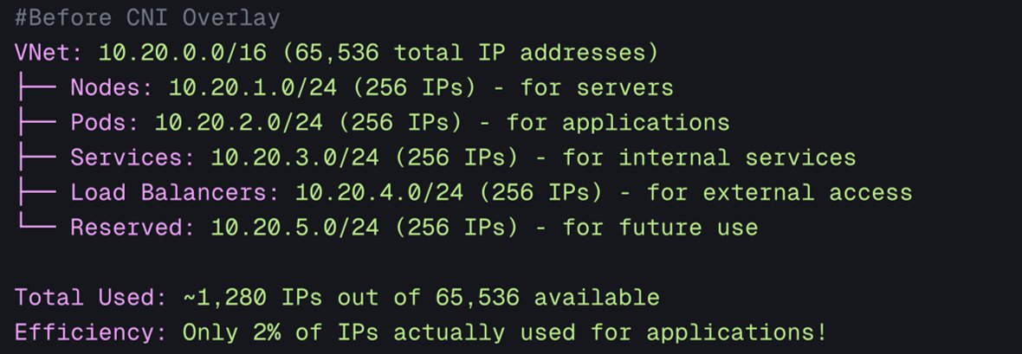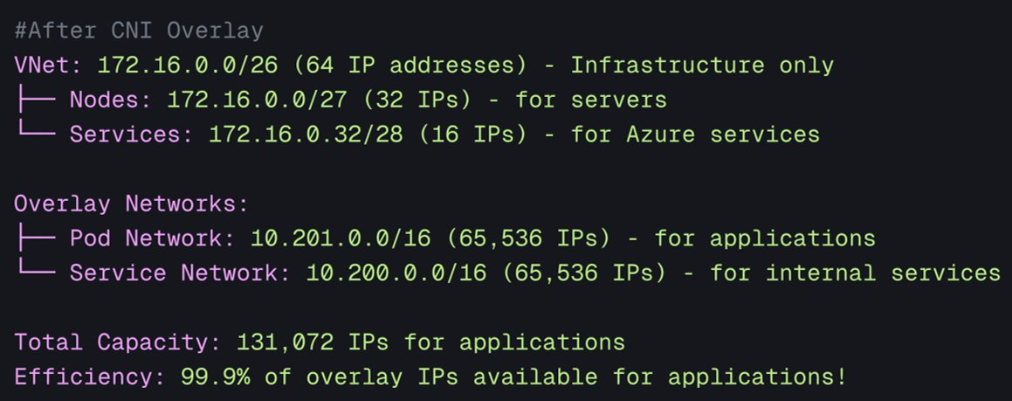
Figure 5: AKS CNI Overlay networking efficiency

Module 3: PostgreSQL (modules/postgres/)
What it does: Creates the primary database for Stock Trader.
Key file: modules/postgres/main.tf
resource "azurerm_postgresql_flexible_server" "main" {
name = var.server_name # "stocktrader-postgres"
resource_group_name = var.resource_group_name
location = var.location
# Admin credentials
administrator_login = var.admin_username
administrator_password = var.admin_password # From your tfvars
# SKU configuration
sku_name = var.sku_name # "GP_Standard_D2s_v3"
storage_mb = var.storage_mb # 32768 (32 GB)
# Version
version = "13"
# Backup settings
backup_retention_days = 7
geo_redundant_backup_enabled = false
# Network
delegated_subnet_id = var.db_subnet_id # From network module
private_dns_zone_id = azurerm_private_dns_zone.postgres.id
}
# Create the database
resource "azurerm_postgresql_flexible_server_database" "stocktrader" {
name = "stocktrader"
server_id = azurerm_postgresql_flexible_server.main.id
charset = "UTF8"
collation = "en_US.utf8"
}
# Firewall rule to allow AKS (if not using private endpoint)
resource "azurerm_postgresql_flexible_server_firewall_rule" "aks" {
name = "allow-aks"
server_id = azurerm_postgresql_flexible_server.main.id
start_ip_address = "10.0.1.0"
end_ip_address = "10.0.1.255"
}
What you get: PostgreSQL server with a “stocktrader” database, accessible from AKS.
Important outputs: - server_fqdn: stocktrader-postgres.postgres.database.azure.com - database_name: stocktrader - admin_username: For DDL execution - admin_password: For DDL execution

Module 4: Redis (modules/redis/)
What it does: Creates Redis cache for performance.
Key file: modules/redis/main.tf
resource "azurerm_redis_cache" "main" {
name = var.cache_name # "stocktrader-redis"
location = var.location
resource_group_name = var.resource_group_name
capacity = var.capacity # 1 (1 GB)
family = "C"
sku_name = var.sku_name # "Standard"
enable_non_ssl_port = false
minimum_tls_version = "1.2"
redis_configuration {
maxmemory_policy = "allkeys-lru"
}
}
What you get: 1GB Redis cache with SSL enforced.
Important outputs: - hostname: stocktrader-redis.redis.cache.windows.net - ssl_port: 6380 - primary_access_key: For authentication

Module 5: Key Vault (modules/key_vault/)
What it does: Securely stores all secrets.
Key file: modules/key_vault/main.tf
resource "azurerm_key_vault" "main" {
name = var.vault_name # "stocktrader-kv"
location = var.location
resource_group_name = var.resource_group_name
tenant_id = data.azurerm_client_config.current.tenant_id
sku_name = "standard"
# Enable for private endpoint
public_network_access_enabled = !var.enable_private_endpoint
}
# Store PostgreSQL password
resource "azurerm_key_vault_secret" "postgres_password" {
name = "postgres-password"
value = var.postgres_admin_password
key_vault_id = azurerm_key_vault.main.id
}
# Store Redis key
resource "azurerm_key_vault_secret" "redis_key" {
name = "redis-primary-key"
value = var.redis_primary_access_key
key_vault_id = azurerm_key_vault.main.id
}
# Store other secrets...
What you get: Key Vault with all secrets stored securely.
Important outputs: - vault_uri: https://stocktrader-kv.vault.azure.net/ - vault_id: Used by other modules

Module 6: User Assigned Identity (modules/uai/)
What it does: Creates a managed identity for secure access.
Key file: modules/uai/main.tf
resource "azurerm_user_assigned_identity" "main" {
name = var.identity_name # "stocktrader-identity"
location = var.location
resource_group_name = var.resource_group_name
}
# Give it permission to read Key Vault secrets
resource "azurerm_role_assignment" "keyvault_secrets_user" {
scope = var.key_vault_id
role_definition_name = "Key Vault Secrets User"
principal_id = azurerm_user_assigned_identity.main.principal_id
}
# Federated credential for Kubernetes service account
resource "azurerm_federated_identity_credential" "external_secrets" {
name = "external-secrets-sa"
resource_group_name = var.resource_group_name
parent_id = azurerm_user_assigned_identity.main.id
audience = ["api://AzureADTokenExchange"]
issuer = var.oidc_issuer_url # From AKS module
subject = "system:serviceaccount:external-secrets-system:external-secrets"
}
What you get: An identity that External Secrets Operator uses to read Key Vault.
Important outputs: - client_id: Used by External Secrets - principal_id: For role assignments

Module 7: K8s Bootstrap (modules/k8s_bootstrap/)
What it does: Prepares Kubernetes for Stock Trader.
Key file: modules/k8s_bootstrap/main.tf
provider "kubernetes" {
host = var.cluster_endpoint
cluster_ca_certificate = base64decode(var.cluster_ca_certificate)
exec {
api_version = "client.authentication.k8s.io/v1beta1"
command = "az"
args = [
"aks",
"get-credentials",
"--resource-group", var.resource_group_name,
"--name", var.cluster_name,
"--format", "exec"
]
}
}
# Create namespace for Stock Trader
resource "kubernetes_namespace" "stocktrader" {
metadata {
name = var.namespace # Default: "stock-trader"
labels = {
"istio.io/rev" = var.istio_revision # e.g., "asm-1-24"
}
}
}
# Create service account
resource "kubernetes_service_account" "stocktrader" {
metadata {
name = "stocktrader-sa"
namespace = kubernetes_namespace.stocktrader.metadata[0].name
}
}
What you get: - stock-trader namespace ready - Istio sidecar injection enabled via revision label - Service accounts created
Important note: The namespace uses the Istio revision label (istio.io/rev=asm-1-24) instead of istio-injection=enabled. This is the modern approach for AKS with Istio add-on.
Important outputs: - namespace_name: stock-trader

Module 8: External Secrets (modules/external_secrets/)
What it does: Syncs secrets from Key Vault to Kubernetes.
Key file: modules/external_secrets/main.tf
# Install External Secrets Operator via Helm
resource "helm_release" "external_secrets" {
name = "external-secrets"
repository = "https://charts.external-secrets.io"
chart = "external-secrets"
namespace = "external-secrets-system"
create_namespace = true
version = var.operator_version # "0.9.0"
}
# Configure SecretStore to connect to Key Vault
resource "kubectl_manifest" "secret_store" {
yaml_body = <<-YAML
apiVersion: external-secrets.io/v1beta1
kind: SecretStore
metadata:
name: azure-secret-store
namespace: stocktrader
spec:
provider:
azurekv:
vaultUrl: "${var.vault_url}"
authType: WorkloadIdentity
serviceAccountRef:
name: external-secrets
YAML
depends_on = [helm_release.external_secrets]
}
# Create ExternalSecret for PostgreSQL
resource "kubectl_manifest" "postgres_secret" {
yaml_body = <<-YAML
apiVersion: external-secrets.io/v1beta1
kind: ExternalSecret
metadata:
name: postgres-credentials
namespace: stocktrader
spec:
refreshInterval: 1h
secretStoreRef:
name: azure-secret-store
kind: SecretStore
target:
name: postgres-credentials
creationPolicy: Owner
data:
- secretKey: username
remoteRef:
key: postgres-username
- secretKey: password
remoteRef:
key: postgres-password
- secretKey: host
remoteRef:
key: postgres-host
- secretKey: database
remoteRef:
key: postgres-database
YAML
depends_on = [kubectl_manifest.secret_store]
}
# Similar ExternalSecrets for Redis, etc.
What you get: - External Secrets Operator running - Automatic sync from Key Vault to Kubernetes secrets - Secrets refresh every hour
The magic: Stock Trader pods can now use secrets like:
env:
- name: DB_PASSWORD
valueFrom:
secretKeyRef:
name: postgres-credentials
key: password
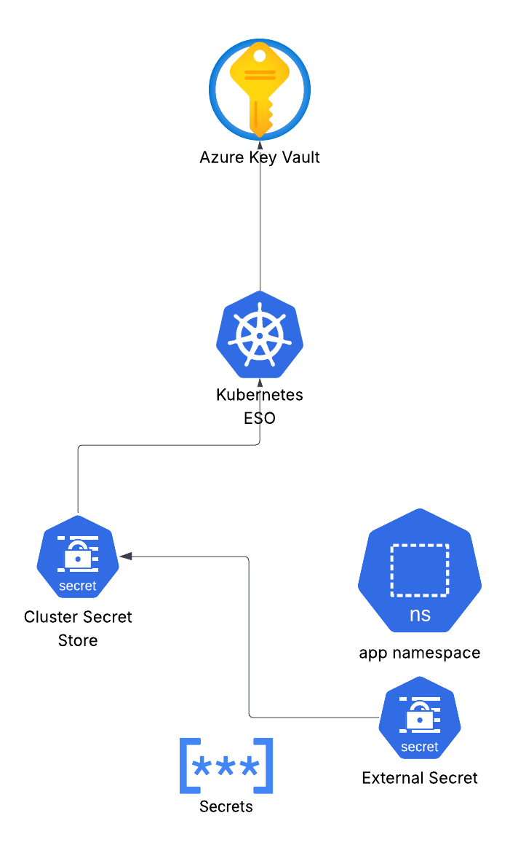
Figure 7: How secrets flow from Key Vault to pods

Module 9: PostgreSQL Init (modules/postgres_init/)
What it does: Runs DDL scripts to create database tables.
This is where automation shines!
Key files: 1. modules/postgres_init/init_schema.sql.tmpl - The DDL template 2. modules/postgres_init/main.tf - Executes it
init_schema.sql.tmpl:
CREATE TABLE IF NOT EXISTS Portfolio(
owner VARCHAR(32) NOT NULL,
total DOUBLE PRECISION,
accountID VARCHAR(64),
PRIMARY KEY(owner)
);
CREATE TABLE IF NOT EXISTS Stock(
owner VARCHAR(32) NOT NULL,
symbol VARCHAR(8) NOT NULL,
shares INTEGER,
price DOUBLE PRECISION,
total DOUBLE PRECISION,
dateQuoted VARCHAR(10),
commission DOUBLE PRECISION,
FOREIGN KEY (owner) REFERENCES Portfolio(owner) ON DELETE CASCADE,
PRIMARY KEY(owner, symbol)
);
CREATE TABLE IF NOT EXISTS cashaccount(
owner VARCHAR(32) NOT NULL,
balance DOUBLE PRECISION,
currency VARCHAR(8),
PRIMARY KEY(owner)
);
-- Add currency constraint
DO $$
BEGIN
IF NOT EXISTS (SELECT 1 FROM pg_constraint WHERE conname = 'allowed_currencies') THEN
ALTER TABLE cashaccount ADD CONSTRAINT allowed_currencies
CHECK (currency IN ('AUD', 'BGN', 'BRL', 'CAD', 'CHF', 'CNY', 'CZK', 'DKK',
'EUR', 'GBP', 'HKD', 'HUF', 'IDR', 'ILS', 'INR', 'ISK',
'JPY', 'KRW', 'MXN', 'MYR', 'NOK', 'NZD', 'PHP', 'PLN',
'RON', 'SEK', 'SGD', 'THB', 'TRY', 'USD', 'ZAR'));
END IF;
END$$;
main.tf:
# Render the template with variables
data "template_file" "init_schema" {
template = file("${path.module}/init_schema.sql.tmpl")
vars = {
database_name = var.database_name
}
}
# Use null_resource to execute psql
resource "null_resource" "run_ddl" {
# Re-run if SQL content changes
triggers = {
sql_hash = md5(data.template_file.init_schema.rendered)
}
provisioner "local-exec" {
command = <<-EOT
kubectl run psql-client --rm -i --restart=Never \
--image=postgres:13 \
--namespace=stocktrader \
--env="PGPASSWORD=${var.admin_password}" \
-- psql -h ${var.server_fqdn} \
-U ${var.admin_username} \
-d ${var.database_name} \
-c "${data.template_file.init_schema.rendered}"
EOT
}
depends_on = [
var.aks_cluster_id,
var.postgres_server_id
]
}
What happens:
- Terraform reads init_schema.sql.tmpl
- Runs a temporary PostgreSQL pod in Kubernetes
- Executes the DDL against Azure PostgreSQL
- Tables are created automatically
You don’t have to manually run SQL!

Module 10: Apply CR (modules/apply_cr/)
What it does: Deploys Stock Trader to Kubernetes.
This is the final piece that brings everything together!
Key files: 1. cr.yaml.tmpl - Stock Trader Custom Resource template 2. istio-gateway.yaml.tmpl - Istio Gateway configuration 3. peer-auth.yaml.tmpl - mTLS configuration 4. main.tf - Applies them
cr.yaml.tmpl (simplified):
apiVersion: stocktrader.ibm.com/v1
kind: StockTrader
metadata:
name: stocktrader
namespace: stocktrader
spec:
# Microservice configurations
trader:
enabled: true
replicas: ${trader_replicas}
image: quay.io/ibmstocktrader/trader:latest
broker:
enabled: true
replicas: ${broker_replicas}
image: quay.io/ibmstocktrader/broker:latest
portfolio:
enabled: true
replicas: ${portfolio_replicas}
image: quay.io/ibmstocktrader/portfolio:latest
database:
host: ${postgres_host}
name: ${postgres_database}
secretRef: postgres-credentials
# ... other microservices
# External services
stockQuote:
url: ${stock_quote_api_connect}
istio-gateway.yaml.tmpl:
apiVersion: networking.istio.io/v1beta1
kind: Gateway
metadata:
name: stock-trader-gateway
namespace: stocktrader
spec:
selector:
istio: ingressgateway
servers:
- port:
number: 443
name: https
protocol: HTTPS
hosts:
- "${domain_name}"
tls:
mode: SIMPLE
credentialName: stock-trader-tls
---
apiVersion: networking.istio.io/v1beta1
kind: VirtualService
metadata:
name: stock-trader
namespace: stocktrader
spec:
hosts:
- "${domain_name}"
gateways:
- stock-trader-gateway
http:
- match:
- uri:
prefix: /trader
route:
- destination:
host: trader
port:
number: 8080
peer-auth.yaml.tmpl:
apiVersion: security.istio.io/v1beta1
kind: PeerAuthentication
metadata:
name: stock-trader-mtls
namespace: stocktrader
spec:
mtls:
mode: STRICT
main.tf:
# Render CR template
data "template_file" "stock_trader_cr" {
template = file("${path.module}/cr.yaml.tmpl")
vars = {
trader_replicas = var.trader_replicas
broker_replicas = var.broker_replicas
portfolio_replicas = var.portfolio_replicas
postgres_host = var.postgres_host
postgres_database = var.postgres_database
stock_quote_api_connect = var.stock_quote_url
# ... other variables
}
}
# Apply Stock Trader CR
resource "kubectl_manifest" "stock_trader" {
yaml_body = data.template_file.stock_trader_cr.rendered
depends_on = [
var.k8s_bootstrap_complete,
var.external_secrets_complete
]
}
# Apply Istio Gateway
resource "kubectl_manifest" "istio_gateway" {
yaml_body = data.template_file.istio_gateway.rendered
}
# Apply mTLS
resource "kubectl_manifest" "peer_auth" {
yaml_body = data.template_file.peer_auth.rendered
}
What happens:
- Templates are filled with actual values (database URLs, etc.)
- kubectl apply is executed for each manifest
- Stock Trader operator sees the CR and deploys all microservices
- Istio Gateway exposes the app externally
- mTLS is enforced between services
You don’t have to manually kubectl apply!

How Template Files (.tmpl) Get Their Variables
Variables used inside .tmpl files come from two places:
- From the root (azure/terraform.tfvars) → passed down via azure/main.tf into module inputs
- From within a module → declared in that module’s variables.tf and optionally normalized via locals {}
At render time, the module builds a simple key/value map and renders the template with those values.

End-to-end flow (root → module → template)
# azure/terraform.tfvars (you set these)
stock_trader_namespace = "stock-trader"
trader_replicas = 1
portfolio_replicas = 1
stock_quote_url = "https://<function-url>/api/stock_quote"
# azure/main.tf (root passes values/outputs to modules)
module "apply_cr" {
source = "./modules/apply_cr"
namespace = var.stock_trader_namespace
trader_replicas = var.trader_replicas
broker_replicas = 1
portfolio_replicas = var.portfolio_replicas
# outputs from other modules
postgres_host = module.postgres.server_fqdn
postgres_database = module.postgres.database_name
stock_quote_url = module.function_app.function_url
}
Inside modules/apply_cr, inputs are defined and then provided to the template renderer.
# modules/apply_cr/variables.tf
variable "namespace" { type = string }
variable "trader_replicas" { type = number }
variable "broker_replicas" { type = number }
variable "portfolio_replicas" { type = number }
variable "postgres_host" { type = string }
variable "postgres_database" { type = string }
variable "stock_quote_url" { type = string }
# modules/apply_cr/main.tf (locals + render)
locals {
ns = var.namespace != "" ? var.namespace : "stock-trader"
}
# Legacy data source (works):
data "template_file" "stock_trader_cr" {
template = file("${path.module}/cr.yaml.tmpl")
vars = {
namespace = local.ns
trader_replicas = var.trader_replicas
broker_replicas = var.broker_replicas
portfolio_replicas = var.portfolio_replicas
postgres_host = var.postgres_host
postgres_database = var.postgres_database
stock_quote_api_connect = var.stock_quote_url
}
}
# Modern function (preferred in newer Terraform):
# locals {
# cr_yaml = templatefile("${path.module}/cr.yaml.tmpl", {
# namespace = local.ns
# trader_replicas = var.trader_replicas
# broker_replicas = var.broker_replicas
# portfolio_replicas = var.portfolio_replicas
# postgres_host = var.postgres_host
# postgres_database = var.postgres_database
# stock_quote_api_connect = var.stock_quote_url
# })
# }
resource "kubectl_manifest" "stock_trader" {
yaml_body = data.template_file.stock_trader_cr.rendered
# yaml_body = local.cr_yaml # if using templatefile()
}
The same pattern is used in postgres_init:
# modules/postgres_init/main.tf (simplified)
data "template_file" "init_schema" {
template = file("${path.module}/init_schema.sql.tmpl")
vars = {
database_name = var.database_name
}
}
resource "null_resource" "run_ddl" {
provisioner "local-exec" {
command = <<-EOT
kubectl run psql-client --rm -i --restart=Never \
--image=postgres:13 \
--namespace=${var.namespace} \
--env="PGPASSWORD=${var.admin_password}" \
-- psql -h ${var.server_fqdn} -U ${var.admin_username} -d ${var.database_name} -c "${data.template_file.init_schema.rendered}"
EOT
}
}
Key takeaways: - Values originate in terraform.tfvars and from other module outputs (Postgres FQDN, Function URL). - Modules declare inputs in variables.tf, may derive defaults in locals {}. - Templates are rendered by passing a flat map of key/values into template_file/templatefile(). - Placeholders like ${postgres_host} in .tmpl map 1:1 to keys in that vars map.
This section complements the video overview with the exact wiring for how template variables are populated.

Module 11: Function App (modules/function_app/)
What it does: Deploys Azure Function for stock quotes.
Key files: 1. app/stock_quote/__init__.py - Python function code 2. main.tf - Deploys to Azure
app/stock_quote/__init__.py:
import azure.functions as func
import requests
def main(req: func.HttpRequest) -> func.HttpResponse:
symbol = req.params.get('symbol')
if not symbol:
return func.HttpResponse(
"Please pass a symbol on the query string",
status_code=400
)
# Call external API (e.g., Yahoo Finance)
url = f"https://query1.finance.yahoo.com/v8/finance/chart/{symbol}"
response = requests.get(url)
if response.status_code == 200:
data = response.json()
# Parse and return stock data
return func.HttpResponse(
json.dumps(data),
mimetype="application/json"
)
else:
return func.HttpResponse(
"Error fetching stock data",
status_code=500
)
main.tf:
resource "azurerm_storage_account" "function" {
name = "${var.name_prefix}funcsa"
resource_group_name = var.resource_group_name
location = var.location
account_tier = "Standard"
account_replication_type = "LRS"
}
resource "azurerm_service_plan" "function" {
name = "${var.name_prefix}-function-plan"
location = var.location
resource_group_name = var.resource_group_name
os_type = "Linux"
sku_name = "Y1" # Consumption plan
}
resource "azurerm_linux_function_app" "stock_quote" {
name = "${var.name_prefix}-stock-quote"
location = var.location
resource_group_name = var.resource_group_name
service_plan_id = azurerm_service_plan.function.id
storage_account_name = azurerm_storage_account.function.name
storage_account_access_key = azurerm_storage_account.function.primary_access_key
site_config {
application_stack {
python_version = "3.9"
}
}
app_settings = {
"FUNCTIONS_WORKER_RUNTIME" = "python"
}
}
# Deploy function code
resource "null_resource" "deploy_function" {
provisioner "local-exec" {
command = <<-EOT
cd ${path.module}/app
zip -r function.zip .
az functionapp deployment source config-zip \
--resource-group ${var.resource_group_name} \
--name ${azurerm_linux_function_app.stock_quote.name} \
--src function.zip
EOT
}
depends_on = [azurerm_linux_function_app.stock_quote]
}
What you get: Azure Function at https://stocktrader-stock-quote.azurewebsites.net/api/stock_quote?symbol=AAPL

The Automation Magic
Now let’s understand the automation flow - what makes this “one command deployment” possible.

The Complete Execution Flow
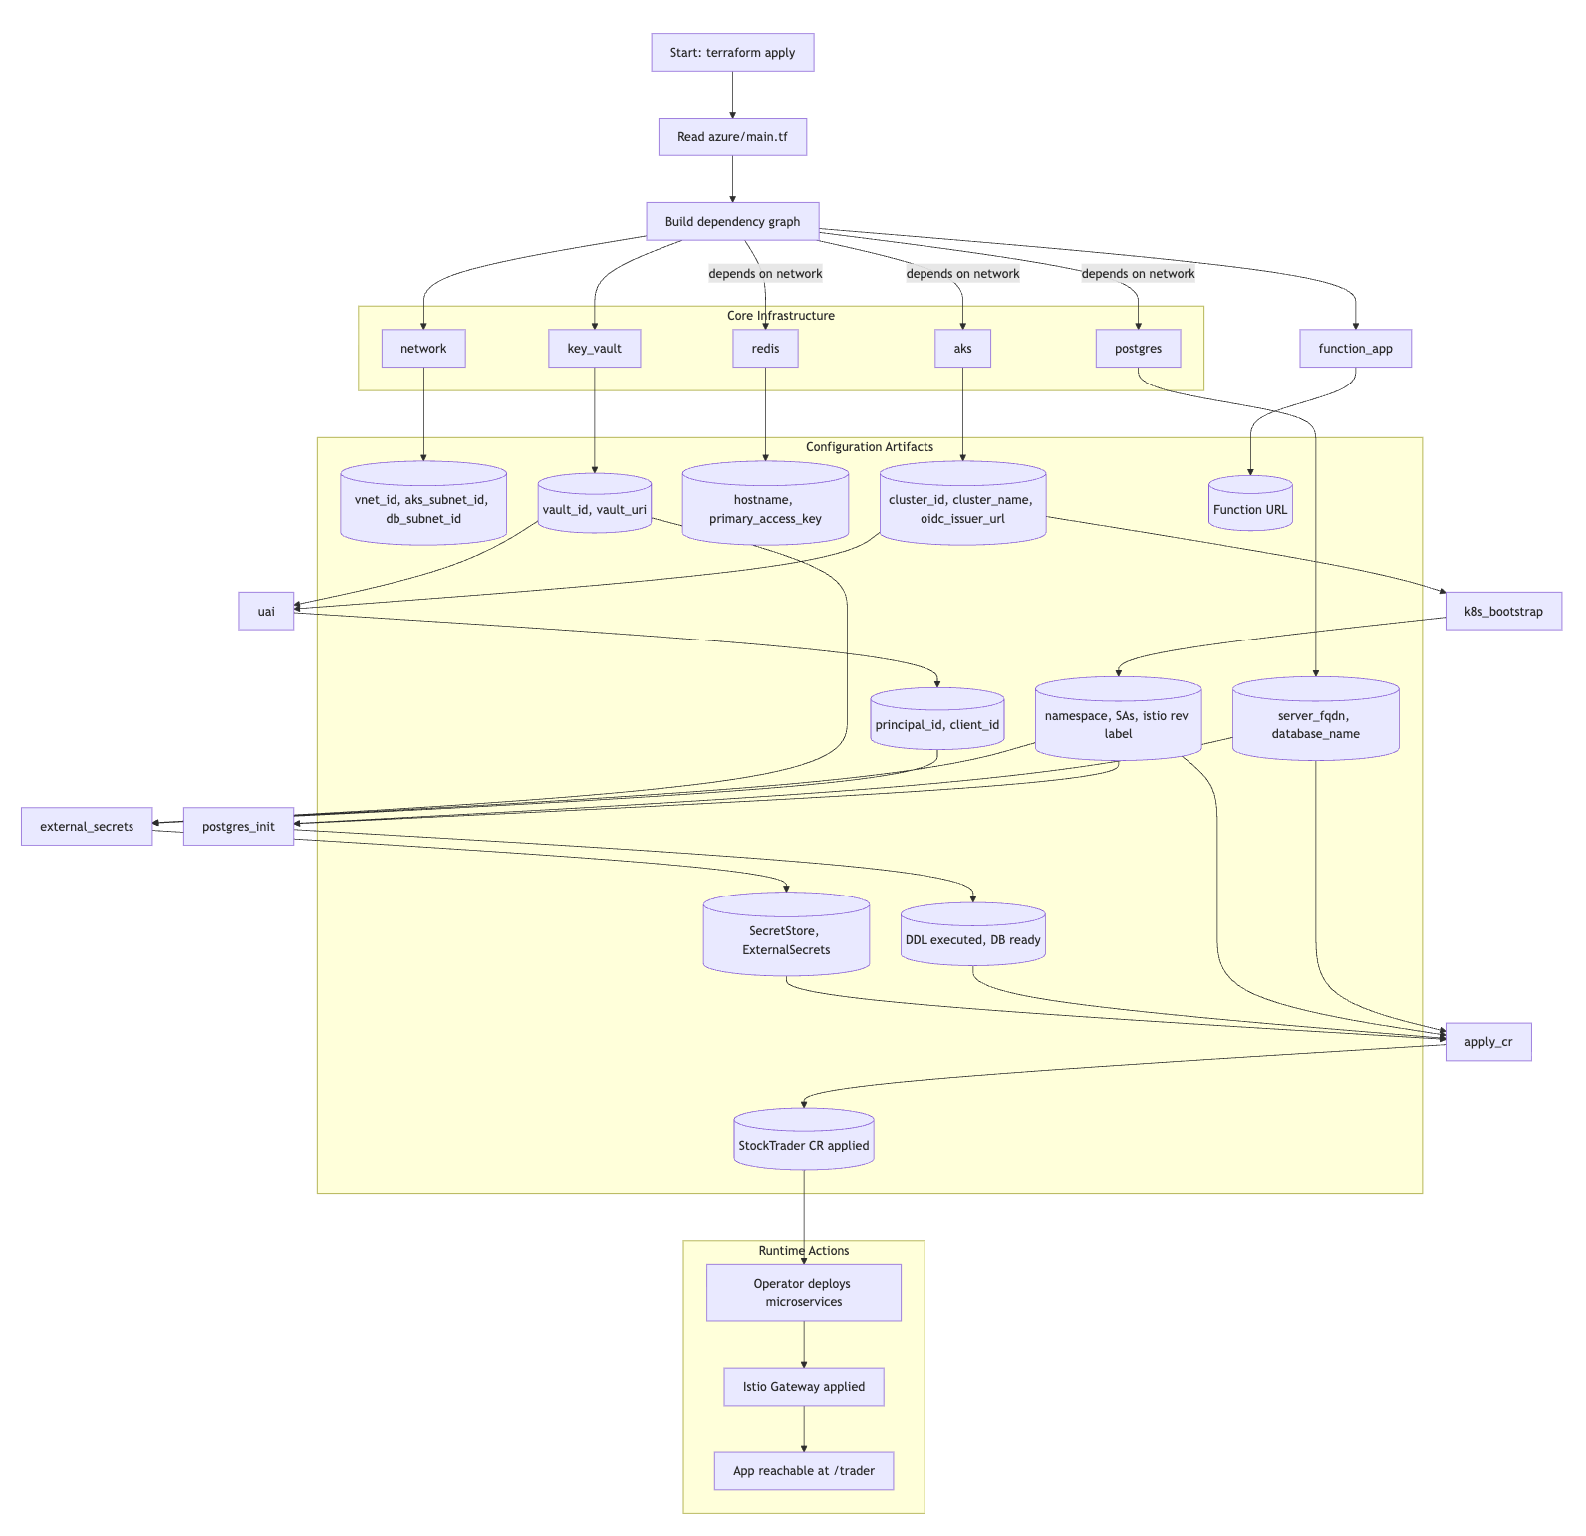
Figure 8: Complete Terraform execution flow

User runs: terraform apply
↓
1. Terraform reads main.tf
↓
2. Builds dependency graph
├─ network (no dependencies)
├─ aks (depends on network)
├─ postgres (depends on network)
├─ redis (depends on network)
├─ key_vault (no dependencies)
├─ uai (depends on key_vault)
├─ k8s_bootstrap (depends on aks)
├─ external_secrets (depends on k8s_bootstrap, key_vault, uai)
├─ postgres_init (depends on postgres, k8s_bootstrap)
├─ apply_cr (depends on everything above)
└─ function_app (independent)
↓
3. Executes in order:
├─ Creates VNet and subnets (2 min)
├─ Creates AKS cluster (8-12 min)
├─ Creates PostgreSQL server (5-8 min)
├─ Creates Redis cache (3-5 min)
├─ Creates Key Vault and stores secrets (1 min)
├─ Creates managed identity (1 min)
├─ Bootstraps Kubernetes namespace (30 sec)
├─ Installs External Secrets Operator (1 min)
├─ Waits for secrets to sync (30 sec)
├─ Runs DDL scripts via psql pod (1 min)
├─ Applies Stock Trader CR (30 sec)
├─ Operator deploys all microservices (2-3 min)
├─ Applies Istio Gateway (30 sec)
└─ Deploys Azure Function (2 min)
↓
4. Total time: 15-20 minutes
↓
5. Stock Trader is running!

How Secrets Flow Automatically
This is one of the most powerful automations:
1. postgres_admin_password in terraform.tfvars
↓
2. Terraform passes to key_vault module
↓
3. key_vault module stores in Azure Key Vault
secret name: "postgres-password"
secret value: "YourSecurePass123!"
↓
4. uai module creates identity with Key Vault access
↓
5. external_secrets module creates:
- SecretStore (connects to Key Vault)
- ExternalSecret (defines what to sync)
↓
6. External Secrets Operator runs in Kubernetes
- Authenticates with workload identity
- Reads from Key Vault
- Creates Kubernetes secret "postgres-credentials"
↓
7. Stock Trader pods mount the secret:
env:
- name: DB_PASSWORD
valueFrom:
secretKeyRef:
name: postgres-credentials
key: password
↓
8. Pods can connect to database!
You never had to: - Manually copy the password - Run kubectl create secret - Update pod specs
It all happened automatically!

How DDL Execution Works
This automation saves you from manually running SQL:
1. postgres module creates database
↓
2. postgres_init module:
a. Reads init_schema.sql.tmpl
b. Fills in database_name variable
c. Creates temporary psql pod in Kubernetes
d. Executes SQL against Azure PostgreSQL
e. Deletes temporary pod
↓
3. Tables exist and are ready!
The key code that does this:
provisioner "local-exec" {
command = <<-EOT
kubectl run psql-client --rm -i --restart=Never \
--image=postgres:13 \
--namespace=stocktrader \
--env="PGPASSWORD=${var.admin_password}" \
-- psql -h ${var.server_fqdn} \
-U ${var.admin_username} \
-d ${var.database_name} \
-f /dev/stdin
EOT
stdin = data.template_file.init_schema.rendered
}
What this does: - Spins up a PostgreSQL client pod - Passes SQL via stdin - Executes it - Pod auto-deletes (–rm flag)

How Kubernetes Manifests Get Applied
The apply_cr module uses Terraform’s kubectl_manifest resource:
resource "kubectl_manifest" "stock_trader" {
yaml_body = <<-YAML
apiVersion: stocktrader.ibm.com/v1
kind: StockTrader
metadata:
name: stocktrader
spec:
# ... configuration
YAML
}
This is equivalent to:
kubectl apply -f stock-trader-cr.yaml
But it happens automatically during terraform apply!

How Dependencies Ensure Correct Order
Terraform uses depends_on to enforce order:
module "postgres_init" {
source = "./modules/postgres_init"
# ...
depends_on = [
module.postgres, # Wait for database to exist
module.k8s_bootstrap # Wait for Kubernetes namespace
]
}
module "apply_cr" {
source = "./modules/apply_cr"
# ...
depends_on = [
module.k8s_bootstrap, # Namespace must exist
module.external_secrets, # Secrets must be synced
module.postgres_init # Tables must be created
]
}
Terraform won’t deploy Stock Trader until: - Namespace exists ✓ - Secrets are synced ✓ - Database tables are created ✓

Configuration Guide

The terraform.tfvars File
This is where YOU configure the deployment. Copy the example file first:
cp terraform.tfvars.example terraform.tfvars
Then edit terraform.tfvars with your values.

Absolute Minimum Configuration
These are the only values you MUST set to get started:
Category | Variable | Example Value | Notes
Core Infrastructure | subscription_id | "12345678-1234-1234-1234-123456789012" | Get from: az account show
 | location | "eastus" | Your Azure region
 | resource_group_name | "stocktrader-rg" | Must already exist
 | created_by | "your.email@company.com" | For tracking
AKS Configuration | aks_cluster_name | "aks-stocktrader-dev" | Must be unique
 | aks_node_vm_size | "Standard_D4ds_v5" | Node VM size
Istio Configuration | enable_istio | true | Enable Istio mesh
 | aks_service_mesh_revisions | ["asm-1-26"] | Istio version
 | istio_revision | "asm-1-26" | Must match above
Database Configuration | postgres_server_name | "pgflex-stocktrader-dev" | Must be globally unique
 | administrator_login | "pgadmin" | PostgreSQL username
 | administrator_login_password | "YourSecurePassword123!" | STRONG password!
Redis Configuration | redis_cache_name | "redis-stocktrader-dev" | Must be globally unique
 | redis_cache_sku | "Standard" | Basic, Standard, or Premium
Namespace | stock_trader_namespace | "stock-trader" | Kubernetes namespace
Key Vault | key_vault_name | "kv-stocktrader-dev" | Must be globally unique
OIDC Authentication | oidc_client_id | "stock-trader" | Client identifier
 | oidc_client_secret | "generate-with-openssl-rand" | Generate: openssl rand -base64 32
Complete configuration example:
# Core Infrastructure
subscription_id = "12345678-1234-1234-1234-123456789012" # Get from: az account show
location = "eastus" # Your Azure region
resource_group_name = "stocktrader-rg" # Must already exist
created_by = "your.email@company.com" # For tracking
# AKS Configuration
aks_cluster_name = "aks-stocktrader-dev" # Must be unique
aks_node_vm_size = "Standard_D4ds_v5" # Node VM size
# Istio Configuration
enable_istio = true # Enable Istio mesh
aks_service_mesh_revisions = ["asm-1-26"] # Istio version
istio_revision = "asm-1-26" # Must match above
# Database Configuration
postgres_server_name = "pgflex-stocktrader-dev" # Must be globally unique
administrator_login = "pgadmin" # PostgreSQL username
administrator_login_password = "YourSecurePassword123!" # STRONG password!
# Redis Configuration
redis_cache_name = "redis-stocktrader-dev" # Must be globally unique
redis_cache_sku = "Standard" # Basic, Standard, or Premium
# Namespace
stock_trader_namespace = "stock-trader" # Kubernetes namespace
# Key Vault
key_vault_name = "kv-stocktrader-dev" # Must be globally unique
# OIDC (for authentication)
oidc_client_id = "stock-trader"
oidc_client_secret = "generate-with-openssl-rand" # Generate: openssl rand -base64 32

Important Naming Rules
Some Azure resources must have globally unique names across ALL Azure subscriptions:
- postgres_server_name - PostgreSQL server (must be unique)
- redis_cache_name - Redis cache (must be unique)
- key_vault_name - Key Vault (must be unique)
- aks_cluster_name - AKS cluster (must be unique in region)
The precheck.sh script will tell you if any names are already taken.

Recommended Values
# Network Configuration (defaults are fine)
aks_service_cidr = "10.200.0.0/16" # Kubernetes services
aks_pod_cidr = "10.201.0.0/16" # Pod overlay network
aks_dns_service_ip = "10.200.0.10" # DNS service IP
# CouchDB (optional)
couchdb_enabled = false # Set true if needed
couchdb_namespace = "stock-trader" # Where to deploy CouchDB
# External Secrets
external_secrets_namespace = "external-secrets" # Namespace for operator

What Happens If You Change Values?
Changing node_count from 3 to 5:
node_count = 5
make plan
make apply
Result: Terraform adds 2 more nodes to the existing cluster (no downtime).
Changing postgres_admin_password:
postgres_admin_password = "NewPassword456!@#"
make plan
make apply
Result: - Password updated in Key Vault - External Secrets syncs new password to Kubernetes - Pods need restart to pick up new password
Changing trader_replicas from 1 to 3:
trader_replicas = 3
make plan
make apply
Result: Stock Trader CR updated, operator scales trader to 3 pods.

Environment-Specific Configurations
Development:
# dev.tfvars
environment = "dev"
node_count = 1
vm_size = "Standard_B2s"
postgres_sku = "B_Standard_B1ms"
redis_sku = "Basic"
enable_private_endpoints = false
enable_monitoring = false
Cost: ~$80/month
Production:
# prod.tfvars
environment = "prod"
node_count = 5
vm_size = "Standard_D4s_v3"
postgres_sku = "GP_Standard_D4s_v3"
redis_sku = "Premium"
redis_capacity = 2
enable_private_endpoints = true
enable_monitoring = true
backup_retention_days = 30
Cost: ~$600/month
Usage:
For different environments, copy terraform.tfvars.example to environment-specific files:
# Create environment-specific configs
cp terraform.tfvars.example dev.tfvars
cp terraform.tfvars.example prod.tfvars
# Edit each with environment-specific values
# Then deploy with:
terraform plan -var-file="dev.tfvars" -out=dev.tfplan
terraform apply dev.tfplan
# Or for production:
terraform plan -var-file="prod.tfvars" -out=prod.tfplan
terraform apply prod.tfplan

What Happens During Make Apply
Let’s trace through exactly what happens when you run make apply.

Phase 0: Precheck (bash precheck.sh)
Before anything else, you should run:
$ bash precheck.sh
This validates your environment and catches issues early. See the “Automation Scripts Explained” section for details.

Phase 1: Planning (make plan)
$ make plan
This runs terraform plan -out=plan.tfplan
What Terraform does:
- Read configuration files:
  - main.tf, variables.tf, terraform.tfvars
  - All module files
- Build dependency graph:
- network
├─> aks
├─> postgres
└─> redis
key_vault
└─> uai
aks
└─> k8s_bootstrap
key_vault + k8s_bootstrap + uai
└─> external_secrets
postgres + k8s_bootstrap
└─> postgres_init
external_secrets + postgres_init
└─> apply_cr
- Compare with current state:
  - Reads terraform.tfstate
  - Figures out what’s new, changed, or deleted
- Show plan:
- Plan: 45 to add, 0 to change, 0 to destroy.
Changes to Outputs:
+ aks_cluster_name = "stocktrader-aks"
+ postgres_server_fqdn = "stocktrader-postgres.postgres.database.azure.com"
+ redis_hostname = "stocktrader-redis.redis.cache.windows.net"
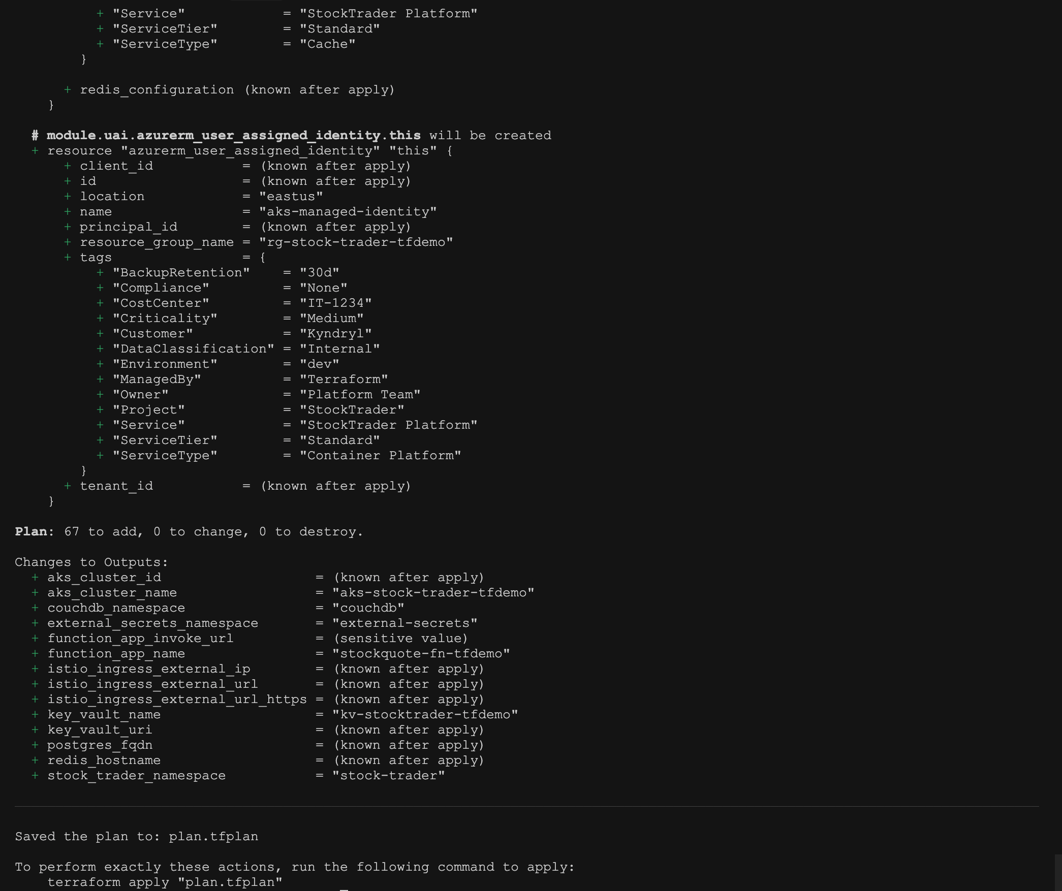
Figure 9: Terraform plan showing resources to create

Phase 2: Application (make apply)
$ make apply
This runs terraform apply plan.tfplan
No confirmation needed because you already reviewed the plan in the previous step.
Terraform executes in phases:
Phase 2.1: Network (2-3 minutes)
module.network.azurerm_virtual_network.main: Creating...
module.network.azurerm_virtual_network.main: Creation complete after 5s
module.network.azurerm_subnet.aks: Creating...
module.network.azurerm_subnet.database: Creating...
module.network.azurerm_subnet.aks: Creation complete after 8s
module.network.azurerm_subnet.database: Creation complete after 8s
module.network.azurerm_network_security_group.aks: Creating...
module.network.azurerm_network_security_group.aks: Creation complete after 3s
Phase 2.2: Core Services (parallel, 8-12 minutes)
module.aks.azurerm_kubernetes_cluster.main: Creating...
module.postgres.azurerm_postgresql_flexible_server.main: Creating...
module.redis.azurerm_redis_cache.main: Creating...
module.key_vault.azurerm_key_vault.main: Creating...
[8 minutes later...]
module.aks.azurerm_kubernetes_cluster.main: Still creating... [8m30s elapsed]
module.postgres.azurerm_postgresql_flexible_server.main: Still creating... [8m30s elapsed]
module.redis.azurerm_redis_cache.main: Still creating... [5m30s elapsed]
module.redis.azurerm_redis_cache.main: Creation complete after 6m12s
module.postgres.azurerm_postgresql_flexible_server.main: Creation complete after 9m23s
module.aks.azurerm_kubernetes_cluster.main: Creation complete after 11m45s
module.key_vault.azurerm_key_vault.main: Creation complete after 2m15s
Phase 2.3: Kubernetes Bootstrap (1-2 minutes)
module.k8s_bootstrap.kubernetes_namespace.stocktrader: Creating...
module.k8s_bootstrap.kubernetes_namespace.stocktrader: Creation complete after 2s
module.k8s_bootstrap.kubernetes_service_account.stocktrader: Creating...
module.k8s_bootstrap.kubernetes_service_account.stocktrader: Creation complete after 1s
Phase 2.4: External Secrets (1-2 minutes)
module.external_secrets.helm_release.external_secrets: Creating...
module.external_secrets.helm_release.external_secrets: Still creating... [30s elapsed]
module.external_secrets.helm_release.external_secrets: Creation complete after 45s
module.external_secrets.kubectl_manifest.secret_store: Creating...
module.external_secrets.kubectl_manifest.secret_store: Creation complete after 3s
module.external_secrets.kubectl_manifest.postgres_secret: Creating...
module.external_secrets.kubectl_manifest.postgres_secret: Creation complete after 2s
Phase 2.5: Database Init (1 minute)
module.postgres_init.null_resource.run_ddl: Creating...
module.postgres_init.null_resource.run_ddl: Provisioning with 'local-exec'...
module.postgres_init.null_resource.run_ddl: (local-exec): pod "psql-client" created
module.postgres_init.null_resource.run_ddl: (local-exec): CREATE TABLE portfolio
module.postgres_init.null_resource.run_ddl: (local-exec): CREATE TABLE stock
module.postgres_init.null_resource.run_ddl: (local-exec): pod "psql-client" deleted
module.postgres_init.null_resource.run_ddl: Creation complete after 45s
Phase 2.6: Apply Stock Trader (30 seconds)
module.apply_cr.kubectl_manifest.stock_trader: Creating...
module.apply_cr.kubectl_manifest.stock_trader: Creation complete after 5s
module.apply_cr.kubectl_manifest.istio_gateway: Creating...
module.apply_cr.kubectl_manifest.istio_gateway: Creation complete after 3s
module.apply_cr.kubectl_manifest.peer_auth: Creating...
module.apply_cr.kubectl_manifest.peer_auth: Creation complete after 2s
Phase 2.7: Function App (2 minutes)
module.function_app.azurerm_linux_function_app.stock_quote: Creating...
module.function_app.azurerm_linux_function_app.stock_quote: Creation complete after 1m30s
module.function_app.null_resource.deploy_function: Creating...
module.function_app.null_resource.deploy_function: Provisioning with 'local-exec'...
module.function_app.null_resource.deploy_function: (local-exec): Deploying function code...
module.function_app.null_resource.deploy_function: Creation complete after 25s
Phase 2.8: Complete
Apply complete! Resources: 45 added, 0 changed, 0 destroyed.
Outputs:
aks_cluster_name = "stocktrader-aks"
aks_cluster_endpoint = "https://stocktrader-aks-dns-12345678.hcp.eastus.azmk8s.io:443"
postgres_server_fqdn = "stocktrader-postgres.postgres.database.azure.com"
redis_hostname = "stocktrader-redis.redis.cache.windows.net"
key_vault_uri = "https://stocktrader-kv.vault.azure.net/"
function_url = "https://stocktrader-stock-quote.azurewebsites.net/api/stock_quote"
Total time: 15-20 minutes

Phase 3: Background (Stock Trader Operator)
After make apply completes, the Stock Trader operator (which was installed during k8s_bootstrap) sees the CR and deploys the microservices:
$ kubectl get pods -n stocktrader -w
NAME READY STATUS RESTARTS AGE
trader-7d4b8c9f6-abc123 0/2 ContainerCreating 0 10s
broker-8e5c9d0a7-def456 0/2 ContainerCreating 0 10s
portfolio-9f6d0e1b8-ghi789 0/2 ContainerCreating 0 10s
[1 minute later...]
trader-7d4b8c9f6-abc123 2/2 Running 0 1m
broker-8e5c9d0a7-def456 2/2 Running 0 1m
portfolio-9f6d0e1b8-ghi789 2/2 Running 0 1m
trade-history-abc-def 2/2 Running 0 1m
cash-account-ghi-jkl 2/2 Running 0 1m
All pods have 2/2 containers because: - Container 1: The microservice itself - Container 2: Istio sidecar (auto-injected because namespace has istio-injection=enabled label)
After 2-3 minutes, everything is running.

Phase 4: Verification (make postcheck)
Now run the verification script:
$ make postcheck
This runs comprehensive checks on every component (see “Automation Scripts Explained” section for details).
If all checks pass, you’re done. If anything fails, the script tells you exactly what’s wrong.

Complete Deployment Flow Summary
Phase | Command | What It Does | Time | Status
0 | bash precheck.sh | Validates environment | 30 seconds | Manual
1 | make init | Initializes Terraform | 1 minute | Manual
2 | make plan | Shows deployment plan | 30 seconds | Manual
3 | make apply | Deploys infrastructure | 15-20 minutes | Automated
4 | [Background] | Operator deploys apps | 2-3 minutes | Automated
5 | make postcheck | Verifies deployment | 2 minutes | Manual
6 | make app-url | Get application URL | Instant | Manual
Total Time: 20-25 minutes
Deployment sequence:
1. bash precheck.sh → Validates environment (30 seconds)
2. make init → Initializes Terraform (1 minute)
3. make plan → Shows deployment plan (30 seconds)
4. make apply → Deploys everything (15-20 minutes)
5. [Operator deploys apps in background] (2-3 minutes)
6. make postcheck → Verifies deployment (2 minutes)
7. make app-url → Get application URL (instant)
─────────────────────────────────────────────────
Total: ~20-25 minutes

Troubleshooting Your Deployment

Common Issues When Running Terraform
Issue | Error Message | Cause | Solution
Insufficient Permissions | Error: Error creating AKS cluster: authorization failed | Azure account doesn’t have Contributor role | Grant Contributor role or ask admin
Resource Group Not Found | Error: Error creating Resource Group: resource group "stocktrader-rg" not found | Resource group doesn’t exist | Create resource group first
Quota Exceeded | Error: Error creating AKS cluster: quota exceeded for StandardDSv3Family | Not enough quota for VM size | Use smaller VM or request quota increase
Pods Stuck in Pending | 0/3 nodes are available: insufficient cpu | Not enough resources on nodes | Increase node count
Image Pull Back Off | Failed to pull image | Can’t pull container image | Check image exists and network access
Secrets Not Syncing | No resources found in stocktrader namespace | External Secrets Operator not working | Check workload identity permissions
Database Connection Fails | Error: connection refused to postgres:5432 | Database not accessible from AKS | Check firewall rules and network

Issue 1: “Error: Insufficient permissions”
Error: Error creating AKS cluster: authorization failed
Cause: Your Azure account doesn’t have Contributor role.
Solution:
# Check your roles
az role assignment list --assignee $(az account show --query user.name -o tsv)
# Ask your admin to grant Contributor role:
az role assignment create \
--assignee your-email@company.com \
--role Contributor \
--scope /subscriptions/YOUR-SUBSCRIPTION-ID

Issue 2: “Error: Resource group not found”
Error: Error creating Resource Group: resource group "stocktrader-rg" not found
Cause: Resource group doesn’t exist.
Solution:
# Create it
az group create --name stocktrader-rg --location eastus

Issue 3: “Error: Quota exceeded”
Error: Error creating AKS cluster: quota exceeded for StandardDSv3Family
Cause: Azure subscription doesn’t have enough quota for the VM size.
Solution: 1. Option A: Use smaller VM size in terraform.tfvars: hcl vm_size = "Standard_B2s"
- Option B: Request quota increase:
  - Go to Azure Portal → Subscriptions → Usage + quotas
  - Search for “StandardDSv3Family”
  - Click “Request Increase”

Issue 4: Pods stuck in “Pending”
$ kubectl get pods -n stocktrader
NAME READY STATUS RESTARTS AGE
trader-7d4b8c9f6-abc123 0/2 Pending 0 5m
Cause: Not enough resources on nodes.
Diagnosis:
kubectl describe pod trader-7d4b8c9f6-abc123 -n stocktrader
# Look for: "0/3 nodes are available: insufficient cpu"
Solution:
# In terraform.tfvars, increase node count
node_count = 5
make plan
make apply

Issue 5: Pods stuck in “ImagePullBackOff”
$ kubectl get pods -n stocktrader
NAME READY STATUS RESTARTS AGE
trader-7d4b8c9f6-abc123 0/2 ImagePullBackOff 0 2m
Cause: Can’t pull container image (network issue or image doesn’t exist).
Diagnosis:
kubectl describe pod trader-7d4b8c9f6-abc123 -n stocktrader
# Look for: "Failed to pull image"
Solution:
# Verify image exists
docker pull quay.io/ibmstocktrader/trader:latest
# Check if AKS can reach quay.io
kubectl run curl-test --rm -it --image=curlimages/curl -- curl https://quay.io

Issue 6: Secrets not syncing
$ kubectl get secrets -n stocktrader
No resources found in stocktrader namespace.
Cause: External Secrets Operator not working.
Diagnosis:
# Check operator is running
kubectl get pods -n external-secrets-system
# Check logs
kubectl logs -n external-secrets-system deployment/external-secrets
# Check SecretStore
kubectl get secretstore -n stocktrader
# Check ExternalSecret status
kubectl describe externalsecret postgres-credentials -n stocktrader
Solution:
# Usually a workload identity issue
# Check UAI has Key Vault permissions:
az role assignment list --scope /subscriptions/.../resourceGroups/stocktrader-rg/providers/Microsoft.KeyVault/vaults/stocktrader-kv

Issue 7: Database connection fails
$ kubectl logs trader-7d4b8c9f6-abc123 -n stocktrader
Error: connection refused to postgres:5432
Cause: Database not accessible from AKS.
Diagnosis:
# Test connection from within cluster
kubectl run postgres-test --rm -it --image=postgres:13 -- \
psql -h stocktrader-postgres.postgres.database.azure.com -U postgres -d stocktrader
# Check firewall rules
az postgres flexible-server firewall-rule list \
--resource-group stocktrader-rg \
--name stocktrader-postgres
Solution: Add AKS subnet to PostgreSQL firewall in modules/postgres/main.tf.

Viewing Terraform State
See what Terraform created:
# List all resources
terraform state list
# Show details of a resource
terraform state show module.aks.azurerm_kubernetes_cluster.main
# See outputs
terraform output

Debugging Module Execution
See what a module is doing:
# Enable debug logging
export TF_LOG=DEBUG
terraform apply
# Save debug log to file
export TF_LOG_PATH=terraform-debug.log
terraform apply

When to Destroy and Recreate
Sometimes it’s easier to start fresh:
# Destroy everything
make destroy
# Clean state (if needed)
rm -rf .terraform terraform.tfstate*
# Start fresh
make init
make plan
make apply

Modifying the Scripts

Common Modifications

1. Add a New Secret to Key Vault
File: modules/key_vault/main.tf
Add:
resource "azurerm_key_vault_secret" "my_new_secret" {
name = "my-secret-name"
value = var.my_secret_value
key_vault_id = azurerm_key_vault.main.id
}
File: modules/key_vault/variables.tf
Add:
variable "my_secret_value" {
description = "My new secret"
type = string
sensitive = true
}
File: azure/main.tf
Pass to module:
module "key_vault" {
source = "./modules/key_vault"
# ... existing variables
my_secret_value = var.my_secret_value
}
File: azure/variables.tf
Add:
variable "my_secret_value" {
description = "My new secret"
type = string
sensitive = true
}
File: terraform.tfvars
Set:
my_secret_value = "secret-value-here"

2. Change Number of Replicas for a Microservice
File: terraform.tfvars
Change:
trader_replicas = 3 # Was 1
Run:
terraform apply
What happens: apply_cr module updates the CR, operator scales trader to 3 pods.

3. Add a New Node Pool to AKS
File: modules/aks/main.tf
Add after existing user pool:
resource "azurerm_kubernetes_cluster_node_pool" "gpu" {
name = "gpu"
kubernetes_cluster_id = azurerm_kubernetes_cluster.main.id
vm_size = "Standard_NC6"
node_count = 1
vnet_subnet_id = var.aks_subnet_id
node_labels = {
"workload" = "gpu"
}
node_taints = [
"gpu=true:NoSchedule"
]
}
Run:
terraform apply

4. Enable Private Endpoint for PostgreSQL
File: terraform.tfvars
Set:
enable_private_endpoints = true
File: modules/postgres/main.tf (if not already there)
Add:
resource "azurerm_private_endpoint" "postgres" {
count = var.enable_private_endpoint ? 1 : 0
name = "${var.server_name}-pe"
location = var.location
resource_group_name = var.resource_group_name
subnet_id = var.db_subnet_id
private_service_connection {
name = "${var.server_name}-psc"
private_connection_resource_id = azurerm_postgresql_flexible_server.main.id
is_manual_connection = false
subresource_names = ["postgresqlServer"]
}
}
Run:
terraform apply

5. Add a New Environment Variable to Stock Trader
File: modules/apply_cr/cr.yaml.tmpl
Add to trader section:
spec:
trader:
enabled: true
replicas: ${trader_replicas}
env:
- name: MY_NEW_ENV_VAR
value: "${my_env_var_value}"
File: modules/apply_cr/variables.tf
Add:
variable "my_env_var_value" {
description = "My new environment variable"
type = string
}
File: azure/main.tf
Pass to module:
module "apply_cr" {
source = "./modules/apply_cr"
# ... existing variables
my_env_var_value = var.my_env_var_value
}
File: terraform.tfvars
Set:
my_env_var_value = "my-value"
Run:
make plan
make apply

Best Practices for Modifications
- Always run precheck first: Catch issues early with bash precheck.sh
- Test in dev before prod: Use separate tfvars files for different environments
- Use make plan before apply: Always review what will change
- Keep modules independent: Don’t create tight coupling between modules
- Document your changes: Update module READMEs when you modify them
- Version control: Commit before and after changes
- Use variables for everything: Don’t hardcode values in the code
- Follow the existing pattern: Match the style of existing code
- Run postcheck after changes: Verify your modifications didn’t break anything

Summary: What You’ve Learned
You now understand:
The problem: Manual setup was error-prone and time-consuming
The solution: Terraform automates everything with Make commands and validation scripts
The structure: main.tf orchestrates modules, each in modules/ directory
The validation: precheck.sh validates before deployment, postcheck.sh verifies after
The flow: Dependencies ensure correct execution order
The automation magic: - Secrets auto-sync from Key Vault to Kubernetes - DDL scripts auto-execute via temporary pods - Kubernetes manifests auto-apply - Stock Trader auto-deploys via operator
The configuration: terraform.tfvars controls everything
The execution: make apply runs through phases in 15-20 minutes
The troubleshooting: Common issues and how to fix them
The modifications: How to customize for your needs

What to Do Next
For first-time users:
- Follow the 5-minute quick start to deploy your first environment
- Run make postcheck to verify everything works
- Access the application at the URL from make app-url
- Try creating a portfolio and making some trades
To understand the scripts:
- Read through azure/main.tf to see how modules are orchestrated
- Pick a module (start with modules/aks or modules/postgres) and read its main.tf
- Look at the template files in modules/apply_cr/ to see how Kubernetes manifests are generated
To customize for your needs:
- Experiment with different values in terraform.tfvars
- Try enabling/disabling optional modules (like CouchDB or monitoring)
- Modify replica counts and see how the application scales
- Add your own secrets or environment variables
To contribute:
- Find something that could be improved
- Make changes and test them thoroughly
- Run make precheck and make postcheck to validate
- Submit a pull request with your improvements

Quick Reference

Essential Commands
# Validate environment before deployment
bash precheck.sh
# Initialize (first time only)
make init
# See what will change
make plan
# Apply changes
make apply
# Verify deployment
make postcheck
# Get application URL
make app-url
# Destroy everything
make destroy
# See outputs
terraform output
# See what Terraform created
terraform state list
# Check specific resource
terraform state show module.aks.azurerm_kubernetes_cluster.main

Essential Files
azure/
├── Makefile ← Make commands
├── precheck.sh ← Pre-deployment validation
├── postcheck.sh ← Post-deployment verification
├── main.tf ← The orchestrator - calls all modules
├── variables.tf ← See what's configurable
├── terraform.tfvars ← YOUR configuration
├── outputs.tf ← What you get after apply
└── modules/
├── aks/ ← Kubernetes cluster
├── postgres/ ← Database
├── postgres_init/ ← DDL automation
├── external_secrets/← Secret sync automation
└── apply_cr/ ← App deployment automation

Module Documentation
Each module has its own README:
cat modules/aks/README.md
cat modules/postgres/README.md
# etc.

Getting Help
- Issues with infrastructure: Open issue on this repo
- Issues with Stock Trader app: IBMStockTrader GitHub

Final Thoughts
Understanding these scripts gives you the power to provision complex infrastructure with a single command. That’s the magic of Infrastructure as Code.
The key takeaway: This isn’t just about creating Azure resources. Our Terraform scripts also handle the application bootstrap - running DDL scripts, syncing secrets, applying Kubernetes manifests, and deploying the Stock Trader application. All automatically.
You went from 2-3 hours of manual, error-prone work to 20 minutes of automated, consistent deployment.

