BlueWings Airlines
Database Design
Data model, entity design & production schema mapping — 22North Product Engineering Challenge 2026

1. MVP Storage Approach
For the 48-hour build, all data is held in-memory inside the Node.js process (server/data/store.js) rather than in a real database. This was a deliberate trade-off: it removes a moving part (no DB server to provision, seed, or keep alive during grading) while still modelling the data with the same shape a production schema would use, so the migration path is additive rather than a rewrite.
Every entity below is implemented as a plain JavaScript object/array today, but is designed 1:1 against the relational schema in §3, so swapping the storage layer (see §4) does not change the shape of the data the rest of the application depends on.

2. Entity-Relationship Diagram
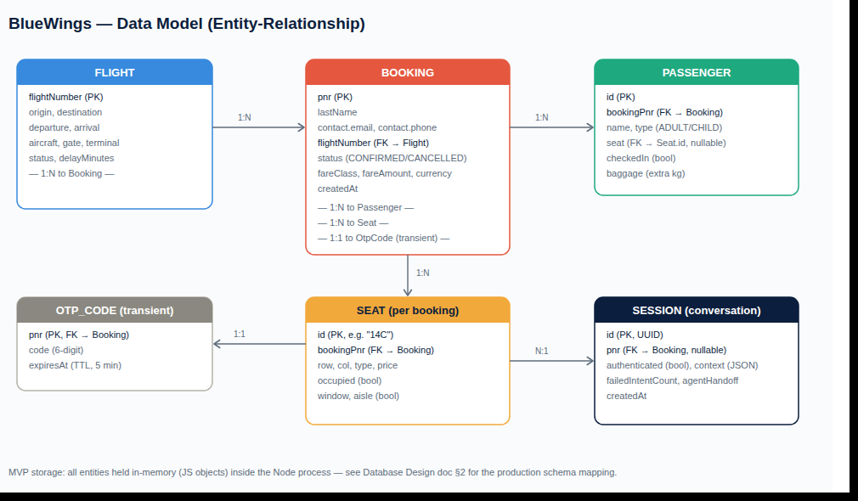

3. Entity Reference

3.1 Flight
Represents a scheduled flight. In production this is owned by the airline's schedule/inventory system, not by BlueWings' own database — we would cache it, not own it.
Field | Type | Notes
flightNumber | string (PK) | e.g. "BW101"
origin / destination | object { code, city } | IATA airport code + city name
departure / arrival | ISO 8601 datetime
aircraft | string | e.g. "A320neo"
status | enum: ON_TIME, DELAYED
delayMinutes | integer, nullable | present only when status = DELAYED
gate, terminal | string

3.2 Booking
The passenger-facing reservation (PNR). The primary aggregate the conversational engine authenticates against.
Field | Type | Notes
pnr | string (PK) | 6-character alphanumeric booking reference
lastName | string | used with pnr for passenger authentication
contact | object { email, phone } | used for OTP / refund correspondence
flightNumber | string (FK → Flight)
status | enum: CONFIRMED, CANCELLED
fareClass | string | e.g. "ECONOMY SAVER", "ECONOMY FLEX"
fareAmount, currency | number, string
createdAt | ISO 8601 datetime

3.3 Passenger
One row per traveller on a booking. A booking has one or more passengers.
Field | Type | Notes
id | string (PK) | unique within a booking, e.g. "p1"
bookingPnr | string (FK → Booking)
name | string
type | enum: ADULT, CHILD
seat | string, nullable (FK → Seat.id) | null until a seat is chosen
checkedIn | boolean
baggage | integer | extra kg purchased, beyond the free allowance

3.4 Seat
The seat inventory for a booking's flight. Modelled per-booking in the MVP for simplicity; in production this is shared inventory per flight, not duplicated per booking (see §4).
Field | Type | Notes
id | string (PK) | e.g. "14C" — row + column
bookingPnr | string (FK → Booking) | MVP-only; production keys this by flightNumber instead
row, col | integer, string
type | enum: standard, extra-legroom, exit-row
price | number | seat-selection upsell price
occupied | boolean
window, aisle | boolean | derived from column, used for preference matching

3.5 OtpCode (transient)
Short-lived step-up authentication code, generated before a cancellation and verified before the cancellation is committed.
Field | Type | Notes
pnr | string (PK, FK → Booking) | one active OTP per PNR at a time
code | string | 6-digit numeric
expiresAt | epoch ms | 5-minute TTL from generation

3.6 Session (conversation state)
Not airline data — this is the chat layer's own state, one row per active conversation.
Field | Type | Notes
id | string (PK, UUID) | the sessionId returned by POST /api/session
authenticated | boolean
pnr | string, nullable (FK → Booking) | bound once the passenger authenticates
context | JSON object | in-flight dialogue state, e.g. which sub-flow is active
failedIntentCount | integer | drives the agent-escalation rule
agentHandoff | boolean
createdAt | ISO 8601 datetime

4. Production Schema Mapping
None of the entities above need to change shape to move to a real database — only where they live changes. The intended production mapping:
MVP entity | Production store | Why
Flight | Not owned by us — cached read from the airline schedule/inventory service (PSS) | Flight data is a system of record elsewhere; we only cache/display it
Booking, Passenger | PSS (Passenger Service System) — the airline's existing booking database | BlueWings already owns this system; the chat layer reads/writes through its API rather than owning a duplicate copy
Seat | DCS (Departure Control System) seat inventory, keyed by flightNumber (not bookingPnr) | Real seat inventory is shared across all bookings on a flight and must avoid double-allocation under concurrent check-ins
OtpCode | Redis (or equivalent), with native TTL | Short-lived, high-write, no durability requirement beyond the TTL window — a cache is a better fit than a relational table
Session | Redis (hot path) or Postgres (if audit history of conversations is required) | Needs to be shared across multiple stateless server instances once the conversation gateway is horizontally scaled

Consistency & concurrency notes for production
- Seat selection must be a compare-and-set / row-lock operation against DCS inventory, not a read-then-write from the application layer, to prevent two passengers being assigned the same seat under concurrent check-ins.
- Cancellation must be idempotent (safe to retry) since refund processing is a financial operation — the MVP already guards against double-cancellation (ALREADY_CANCELLED), and production would add an idempotency key on the refund call to the payment gateway.
- OTP verification should be rate-limited per PNR in production to prevent brute-forcing a 6-digit code; out of scope for this MVP but noted as a security follow-up.

5. Indexing (production)
- Booking: primary key on pnr; secondary index on (lastName, pnr) for the authentication lookup, and on contact.phone for OTP delivery lookups.
- Passenger: index on bookingPnr for "all passengers on this booking" queries (used by check-in and baggage flows).
- Seat: composite index on (flightNumber, occupied) for "available seats on this flight" queries once seats are keyed by flight rather than by booking.
- Session: TTL index (or Redis native TTL) to expire abandoned conversations automatically.

