BlueWings Airlines
Conversational Booking & Servicing MVP
Solution Document — Architecture, API Design & Assumptions
22North Product Engineering Challenge 2026
Challenge 2 · Conversational Booking & Servicing

1. Executive Summary
BlueWings wants passengers to complete common booking and servicing tasks over WhatsApp and a Progressive Web App instead of calling the contact centre. This MVP delivers a conversational assistant that authenticates a passenger with their PNR and last name, then lets them check flight status, check in and choose a seat, add baggage, and cancel a booking with a simulated refund — all inside a chat interface, with a clear handoff to a live agent when the bot cannot help.
The system is built as three layers: a chat-first client (React PWA, styled to mirror a WhatsApp-like experience and installable to a phone home screen), a conversational engine (intent recognition + dialogue state machine + session/auth handling), and a booking service layer that talks to airline systems — mocked for this MVP, but designed so those mocks are swappable for real PSS/DCS/payment APIs without changing the conversation layer.
The build prioritises depth over breadth: five journeys, done well, with real authentication logic, real step-up verification (OTP) before a destructive action like cancellation, and a deliberate, non-generic escalation policy — rather than a longer feature list implemented shallowly.

2. Journeys Supported & Prioritisation
Airline contact-centre volume is dominated by a small set of repeat reasons. We chose journeys that (a) are high-frequency, (b) are simple enough to fully automate in 48 hours, and (c) showcase distinct product patterns (retrieval, stateful multi-step flow, payment-adjacent flow, and a destructive/high-risk flow requiring step-up auth).
Journey | Why included | Complexity
Retrieve booking (PNR + last name) | Entry point for every other journey; establishes identity. | Low
Flight status | Highest-frequency query in the days before travel. | Low
Check-in + seat selection | High-value self-serve journey; replaces a common call reason and a manual airport queue. | Medium
Add baggage | Common ancillary revenue journey; simulated payment shows the pattern. | Low
Cancel booking + refund | High-risk / high-emotion journey; demonstrates step-up authentication (OTP) before an irreversible action. | Medium
Agent handoff | Not a servicing journey itself, but the safety net every journey above needs. | Low

Explicitly out of scope for this MVP
- New bookings / fare search — search + pricing + seat inventory across multiple flights is materially more complex than servicing an existing PNR, and contact-centre volume for airlines skews toward servicing, not new sales.
- Group bookings, special assistance (wheelchair, unaccompanied minor), and multi-city itineraries — these carry higher regulatory/safety weight and are better handled by a human agent; the bot recognises the topic and hands off rather than guessing.
- Loyalty/miles redemption and multi-currency payments — deferred; the payment step is simulated for all journeys in this MVP.

3. Authentication Design

Primary authentication: PNR + last name
This mirrors the pattern passengers already know from airline "Manage my booking" pages, so there is no new credential to remember and no account creation step — critical for a channel like WhatsApp where friction kills adoption. The bot accepts the PNR and last name in a single free-text message (e.g. "BW7X9K Sharma") to keep the exchange to one turn.

Step-up authentication: OTP before irreversible actions
Booking retrieval alone is treated as low-risk (read-only). Before an irreversible, financially consequential action — cancellation — the bot requires a 6-digit OTP sent to the passenger's registered mobile number. This two-tier model (low friction for reads, step-up for writes/refunds) is the same pattern banks use for balance checks vs. money transfers, and it keeps the common-case journeys (status, check-in) to a single authentication step.

Channel-level identity (production direction, not built in this MVP)
In production, WhatsApp's verified phone number can pre-fill trust: if the inbound WhatsApp number matches the phone number on file for a PNR, the last-name step could be skipped entirely. We did not build this because the MVP has no real WhatsApp Business API connection (see Assumptions), but the session model already separates "channel identity" from "PNR identity" so this upgrade is additive, not a rearchitecture.

4. When an Agent Gets Involved
Automation should fail safely, not silently. The bot escalates to a human agent in three situations:
- Explicit request — the passenger types "agent", "talk to a human", etc. at any point.
- Repeated misunderstanding — two consecutive messages the bot cannot classify into a known intent or cannot match to a valid PNR trigger an automatic handoff, rather than a third guess.
- Out-of-scope topics — group bookings, special assistance, and anything not covered by the five journeys above route to an agent instead of a best-effort (and likely wrong) bot answer.
On handoff, the full conversation transcript and the authenticated PNR (if any) are attached to the agent session, so the passenger is never asked to repeat what they already told the bot. In this MVP the handoff is simulated (a banner + a canned "connecting you" message); in production this would open a ticket in the contact-centre CRM (e.g. via a webhook) with the transcript as ticket context.

5. Architecture
The system is a single conversational gateway in front of a booking service layer, so the same dialogue logic serves every channel (WhatsApp, PWA, website widget) and the same booking API serves both the bot and a human agent's desktop tool.
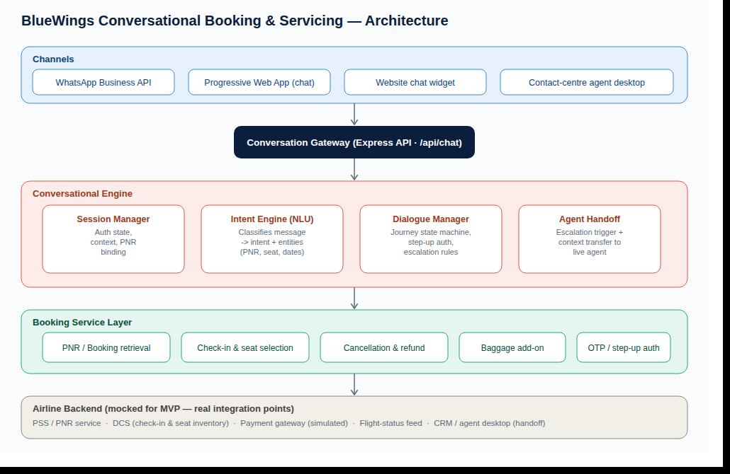

Layer responsibilities
- Channels — WhatsApp Business API, the PWA chat client, a website embed, and the agent desktop all speak the same conversation contract.
- Conversation Gateway — a single REST endpoint (/api/chat) that channels call; keeps channel adapters thin.
- Conversational Engine — session manager (auth + context), intent engine (rule-based NLU for MVP; swappable for an LLM/NLU service), dialogue manager (journey state machine, step-up auth, escalation rules), and the agent-handoff module.
- Booking Service Layer — journey-specific business logic (retrieval, check-in, cancellation, baggage, OTP) sitting between the dialogue manager and the airline backend.
- Airline Backend — mocked in-memory for this MVP (see Assumptions) behind the same service interface a real PSS/DCS/payment integration would implement, so swapping in real systems does not touch the conversational layer.

Why this shape
Two properties matter for a 48-hour MVP that still has to look production-directed: channel independence (WhatsApp today, a website widget or IVR fallback tomorrow, without touching the dialogue logic) and backend swappability (the booking service layer is the seam where mocked data is replaced by real PSS/DCS calls — nothing above that layer needs to change).

6. Customer Journey
A first-time passenger moves through six stages: open the chat, authenticate once with PNR + last name, land on a personalised menu, complete a self-serve journey (with a confirmation rendered as a ticket-style card rather than plain text), and return to the menu or end the chat with the session still authenticated for follow-up questions.
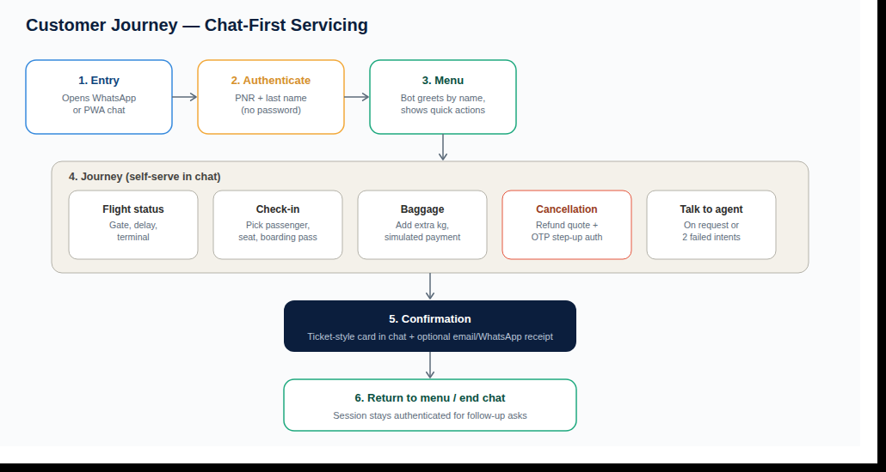

7. API Design
Two API surfaces: a conversational API (session + chat) that channels call, and a REST booking API that mirrors what a real airline PSS/DCS integration exposes. The dialogue manager calls the booking service layer directly in this MVP for simplicity; the REST endpoints below are documented separately because they are the contract a real backend team would implement, and because the agent desktop / other channels would call them directly for non-conversational needs.

7.1 Conversational API
Endpoint | Method | Purpose
/api/session | POST | Create a new chat session. Returns a sessionId used on every subsequent call.
/api/chat | POST | Send a passenger message; returns the bot reply, optional quick-reply buttons, and an optional structured widget payload (flight status, seat map, boarding pass, cancellation receipt).
/api/session/:id | GET | Inspect session state (debug / agent handoff context).

7.2 Booking REST API
Endpoint | Method | Purpose
/api/v1/bookings/:pnr?lastName= | GET | Retrieve a booking summary (passengers, fare, flight).
/api/v1/flights/:flightNumber/status | GET | Real-time flight status: on-time/delayed, gate, terminal.
/api/v1/bookings/:pnr/seatmap | GET | Seat map with occupancy and pricing for the booking's flight.
/api/v1/bookings/:pnr/passengers/:paxId/seat | POST | Assign a seat to a passenger. Body: { seatId }.
/api/v1/bookings/:pnr/passengers/:paxId/checkin | POST | Check in a passenger (requires a seat already assigned); returns a boarding pass.
/api/v1/bookings/:pnr/otp | POST | Trigger an OTP to the registered mobile number for step-up auth.
/api/v1/bookings/:pnr/cancel | POST | Cancel a booking. Body: { otp }. Returns refund breakdown and reference.
/api/v1/bookings/:pnr/passengers/:paxId/baggage | POST | Add extra baggage. Body: { extraKg }. Simulated payment.

7.3 Sample: cancellation flow
POST /api/v1/bookings/BW4M2P/otp
→ { "sent": true }
POST /api/v1/bookings/BW4M2P/cancel Body: { "otp": "846085" }
→ { "pnr": "BW4M2P", "status": "CANCELLED", "refund": { "refundAmount": 58200, "cancellationFee": 0 }, "refundReference": "RF-BW4M2P-351289" }

8. Key Assumptions
- Booking data is mocked in-memory (three demo PNRs, three flights) standing in for real PSS/DCS APIs, per the challenge constraint that "booking data available via APIs" — the service layer is written so a real API client is a drop-in replacement.
- Payments are simulated for baggage add-ons and refunds, per the challenge constraint. No real payment gateway (Stripe/Razorpay) is integrated; the checkout step always succeeds.
- OTP delivery is simulated: the demo code is echoed in the chat response for evaluator convenience rather than sent via SMS/WhatsApp OTP, since there is no CPaaS provider connected in this environment.
- WhatsApp Business API is represented by a WhatsApp-styled PWA chat client rather than a live Meta Business API connection, since that requires business verification, a registered phone number, and template-message approval that cannot be completed in a 48-hour build window. The conversational engine behind it is channel-agnostic, so a real WhatsApp webhook can be pointed at the same /api/chat contract.
- Intent recognition is rule/pattern-based (regex) rather than an LLM or trained NLU model, to keep the MVP deterministic, dependency-free, and fast to demo. The intent engine is an isolated module so it can be swapped for an LLM-based classifier without touching the dialogue manager.
- Session state is held in server memory (no database), acceptable for a demo; production would move session and booking state to Redis/Postgres for durability and horizontal scaling.
- One passenger per browser/WhatsApp session is assumed for authentication; the underlying data model already supports multiple passengers per PNR (used in check-in).
- Fare rules are simplified: a flat 30% cancellation fee for "SAVER" fares and a full refund for "FLEX" fares, illustrative of a real fare-rules engine rather than a full implementation.

9. Trade-offs
- Rule-based NLU over LLM-based NLU — faster, deterministic, and free to run for a demo, at the cost of natural-language flexibility. A production system would likely use an LLM for intent + entity extraction with the same dialogue-manager state machine underneath.
- Single combined Express server (API + static PWA) over separate deployments — simpler to run and demo in 48 hours; production would split the conversation gateway, booking service, and static hosting (CDN) into independently scalable services.
- In-memory data over a real database — appropriate for a stateless demo; not durable across restarts, and not safe for concurrent multi-instance deployment as-is.

10. Future Enhancements
- Real WhatsApp Business API integration (webhook + template messages) using the same /api/chat contract.
- LLM-based intent & entity extraction with graceful fallback to the current rule-based engine.
- New-booking / fare-search journey, loyalty and multi-currency support.
- Persistent session + booking store (Redis/Postgres) and horizontal scaling of the conversation gateway.
- Real OTP delivery via SMS/WhatsApp OTP through a CPaaS provider, and a real payment gateway integration.
- Proactive, push-first messages (e.g. "Your flight BW202 is delayed 40 minutes") rather than purely reactive chat.

