Task Documentation

Functionalities which are working:

1. Show all when page loads
2. Search
3. Filter option
4. Mobile/tablet view
5. Responsive (max width 950px – then images width becomes auto)

Not implemented:

1. Pagination

**Screenshots in next page**

Main Page:

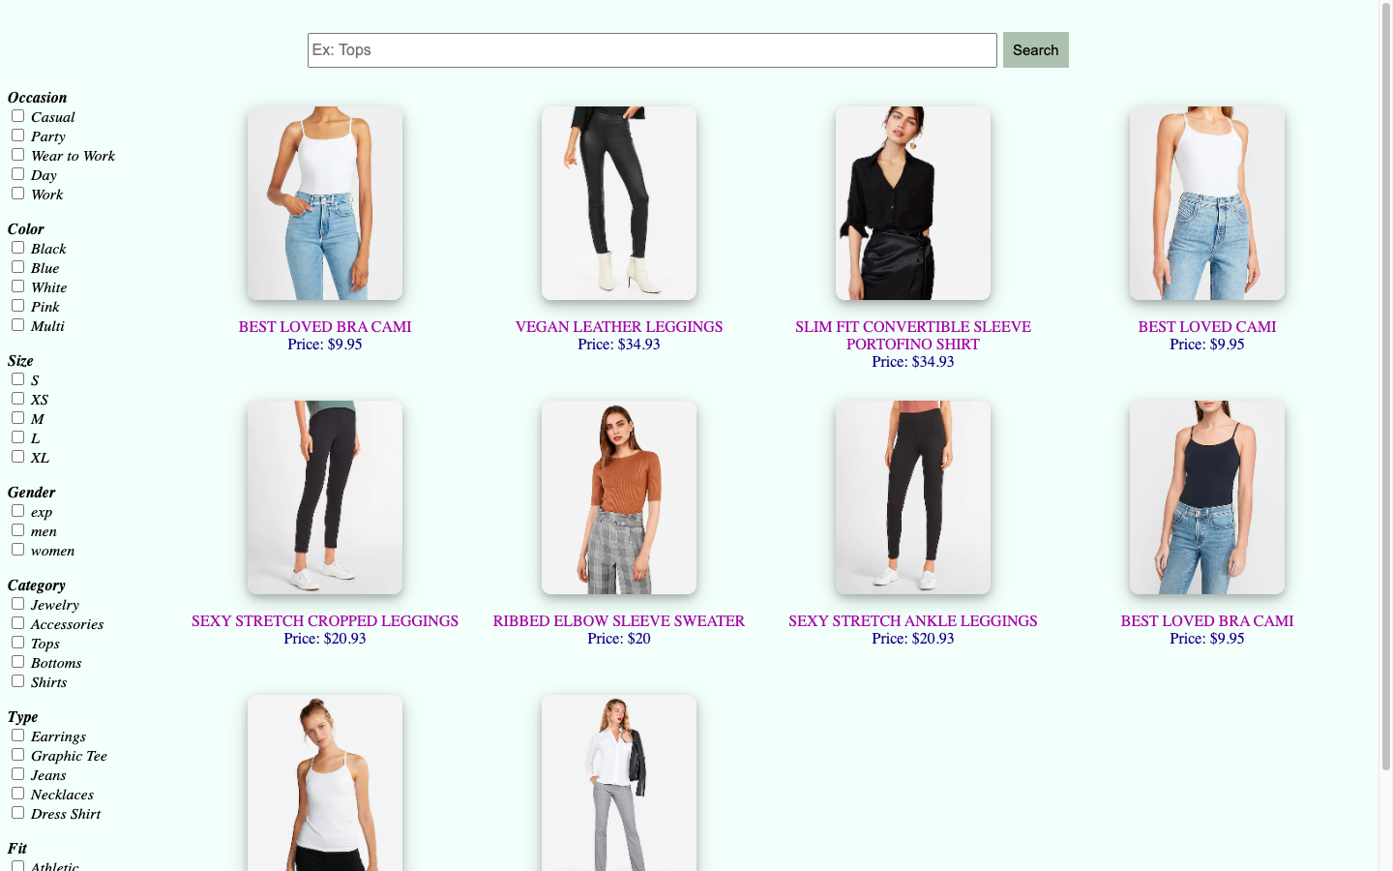

After adding filters:

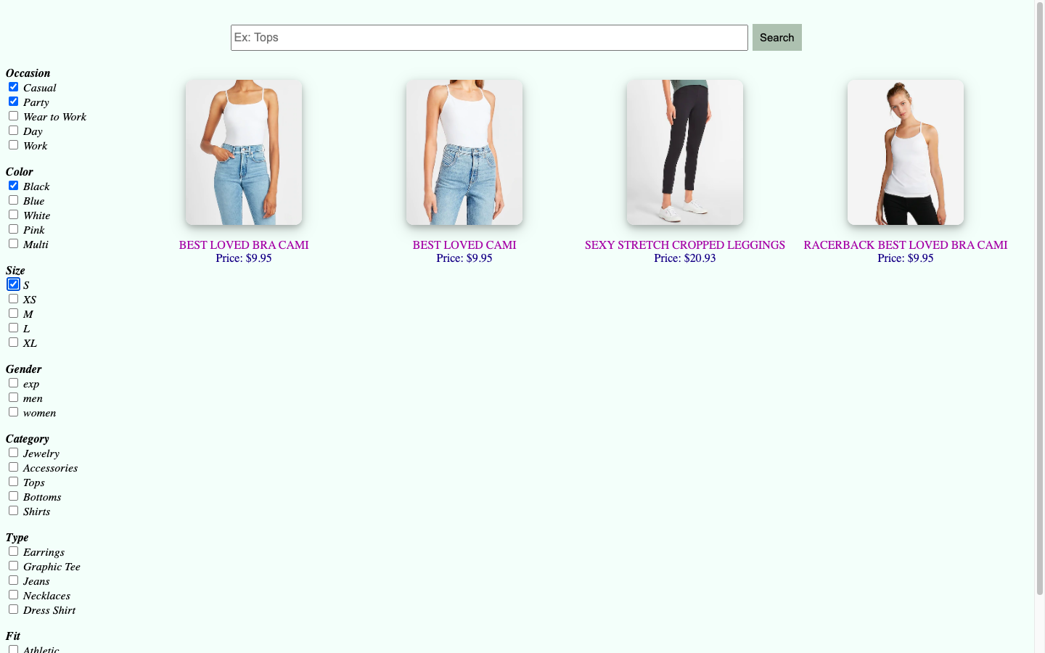

Search for “Express”:

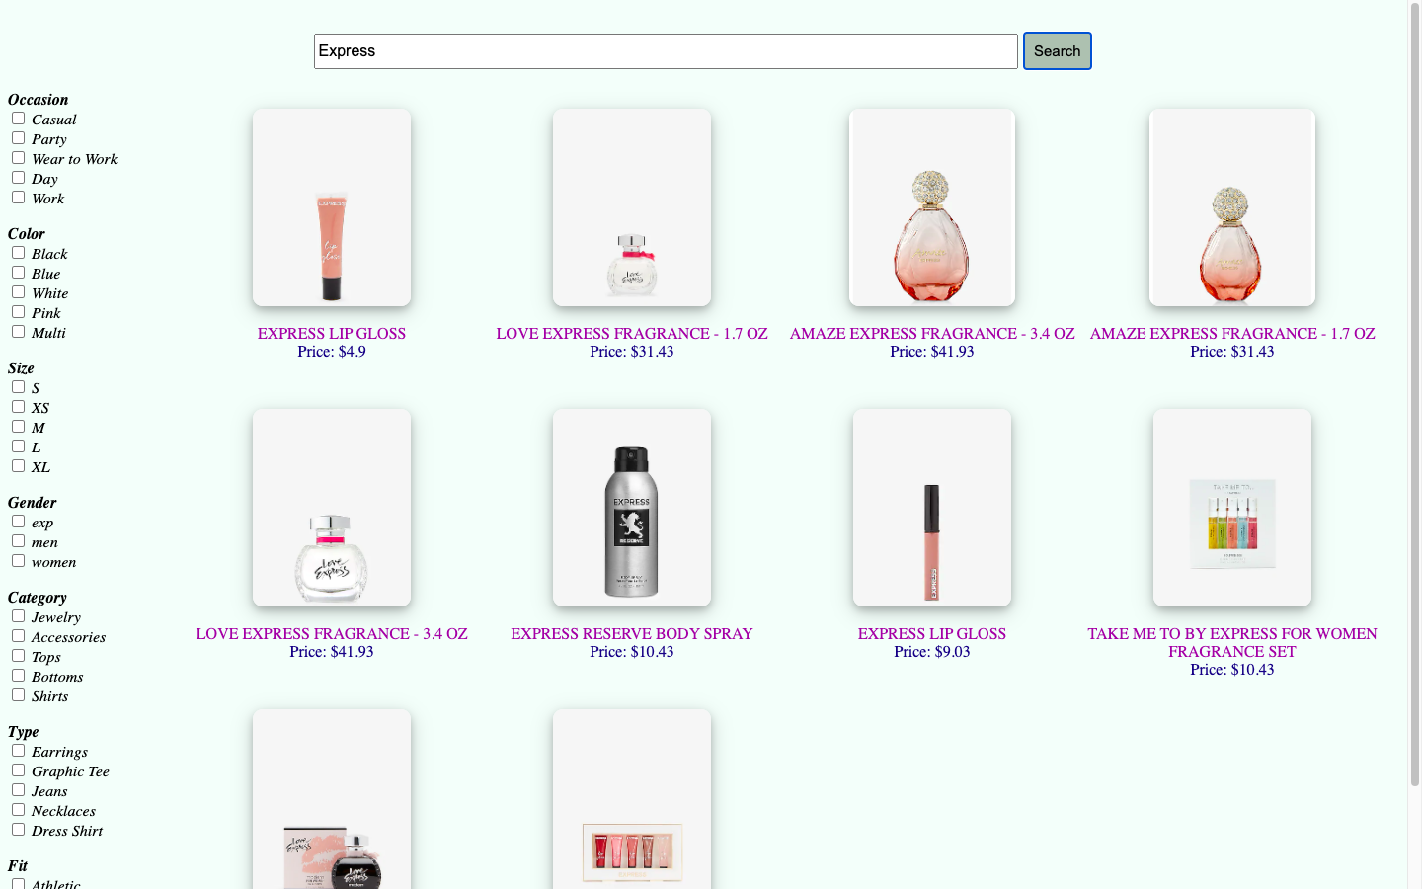

Responsive view (when size decreased < 950px):

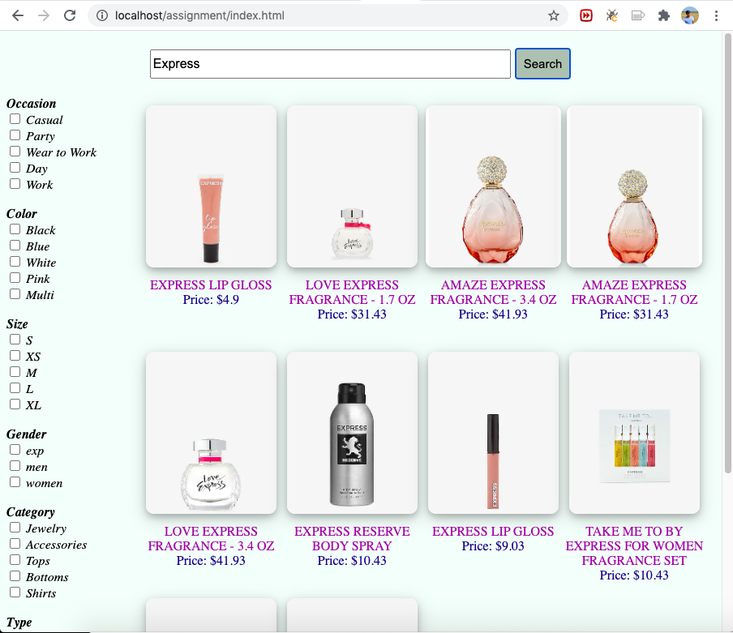

Mobile View:

