Multiple Regression

In our previous example, we only used degree days (a proxy for weather) to predict our kilowatt hour electrical use. However other factors affect electrical use. For example:

number of TV’s,

how often someone is at home,

how late someone stays up,

etc.

Multiple Regression is a generalization of simple regression where we use more than one variable to predict y.

Most of the ideas are the same as in simple linear regression, however there are a few differences.

To begin with it is much more difficult to see relationships between y and x.

Consider the following data which is in the EXCEL file “perfect.xls”.

Data Point | x1 | x2 | y
1 | 9 | 7 | 62
2 | 10 | 12 | 90
3 | 11 | 17 | 118
4 | 3 | 16 | 89
5 | 14 | 4 | 62
6 | 16 | 2 | 58
7 | 4 | 15 | 87
8 | 2 | 6 | 36
9 | 20 | 10 | 110
10 | 18 | 13 | 119
11 | 7 | 19 | 116
12 | 12 | 9 | 81
13 | 5 | 20 | 115
14 | 17 | 5 | 76
15 | 6 | 11 | 73
16 | 8 | 3 | 39
17 | 15 | 1 | 50
18 | 19 | 18 | 147
19 | 13 | 8 | 79
20 | 1 | 14 | 73

There is no variability in this data with the y values following the equation:

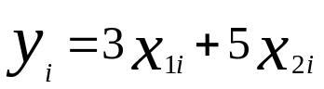
When one plots y vs. x₂ you get the following graph:

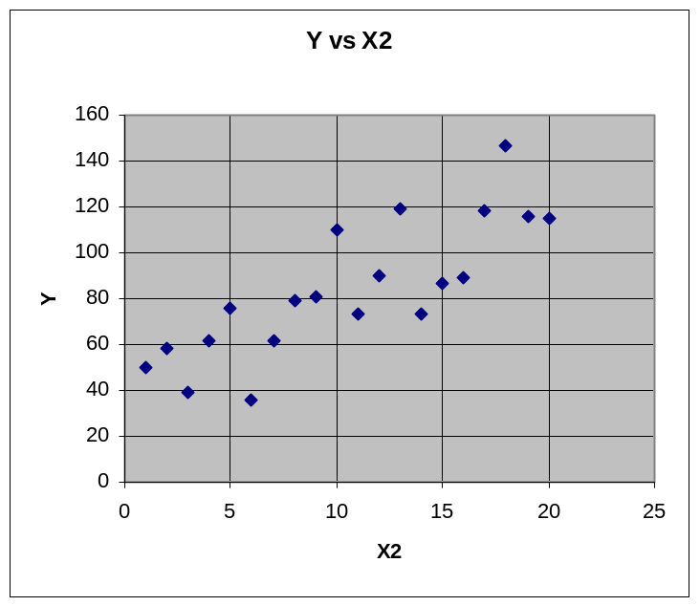

Although the linear relationship is apparent, it looks like there is variability in the data.

Now look at the plot of y vs. x₁:

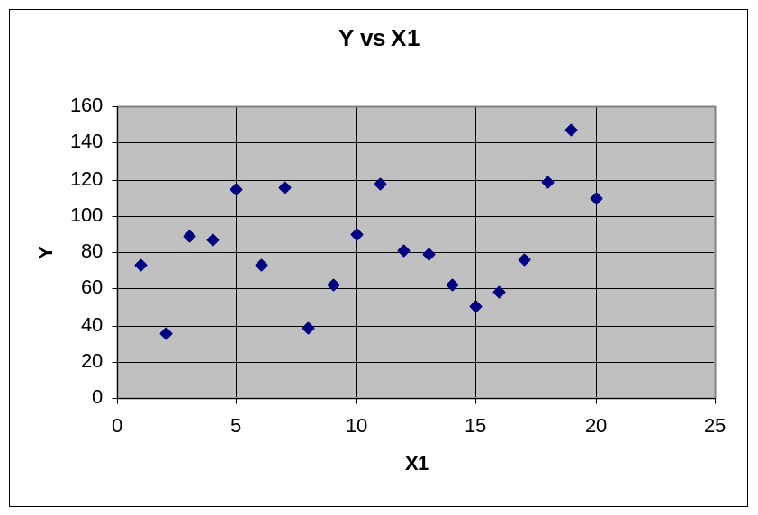

It is not clear that there is any relationship.

Accordingly rather than looking for a clear relationship, the key in multiple regression is to make sure that the plots of y vs. the various x_{i}’s do not show any evidence of curvature.

If curvature is detected, one must be careful in transforming the x and y values. It is possible that one transform which makes the relationship between and y and an x linear, makes a relation between y and some other x even more curved.

In Economics, for example it is standard to take the logarithm of most variables before doing a regression analysis.

The Multiple Regression Model

The formal model for multiple regression is:
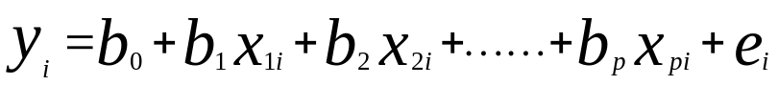

where the assumption on the error terms are exactly as in simple linear regression.

In order to estimate the coefficients and s_{e}, one follows a process very similar to that followed in the case of only one predictor value.

To illustrate, open the EXCEL file “smsarate.xls” in the MBA Part 1 folder.

Then click on the tab at the bottom of the worksheet labeled “Raw Data”.

This data was collected to study possible variables that might affect serious crime.

Your screen should look like that below:

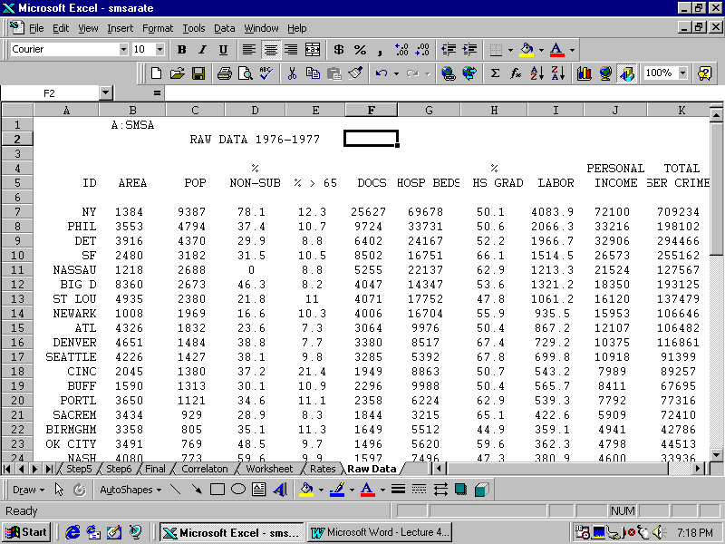

Now click on the tab at the bottom of the worksheet labeled “rates”. Your screen should look like:

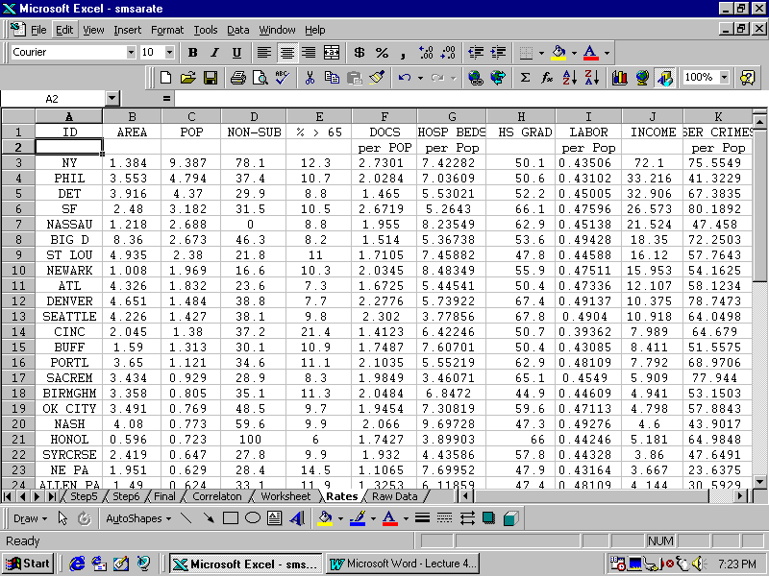

First plot the Crime Rate versus Area.

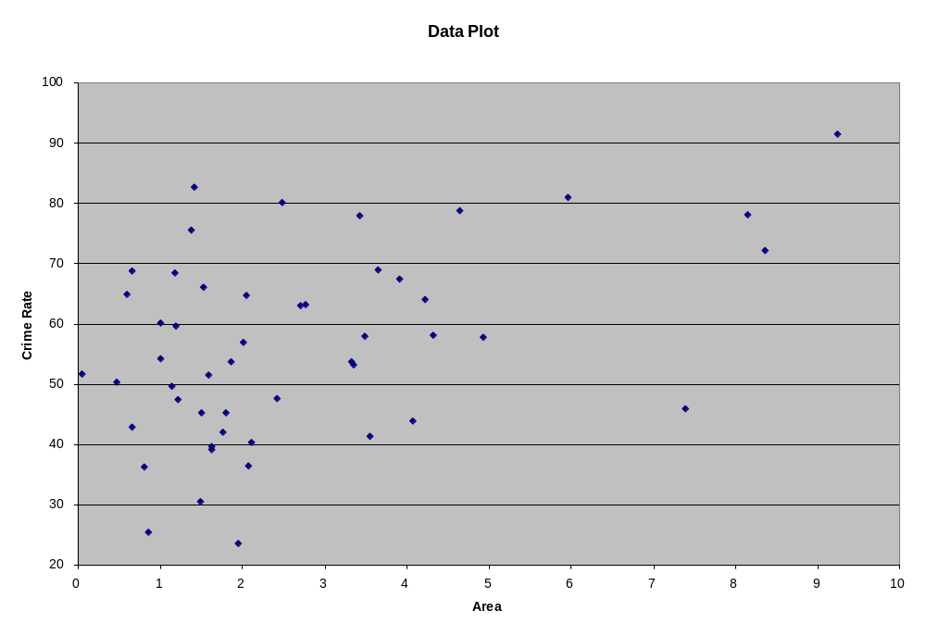

It is clear that there is no curvature in this data.

Next plot the crime rate versus Population

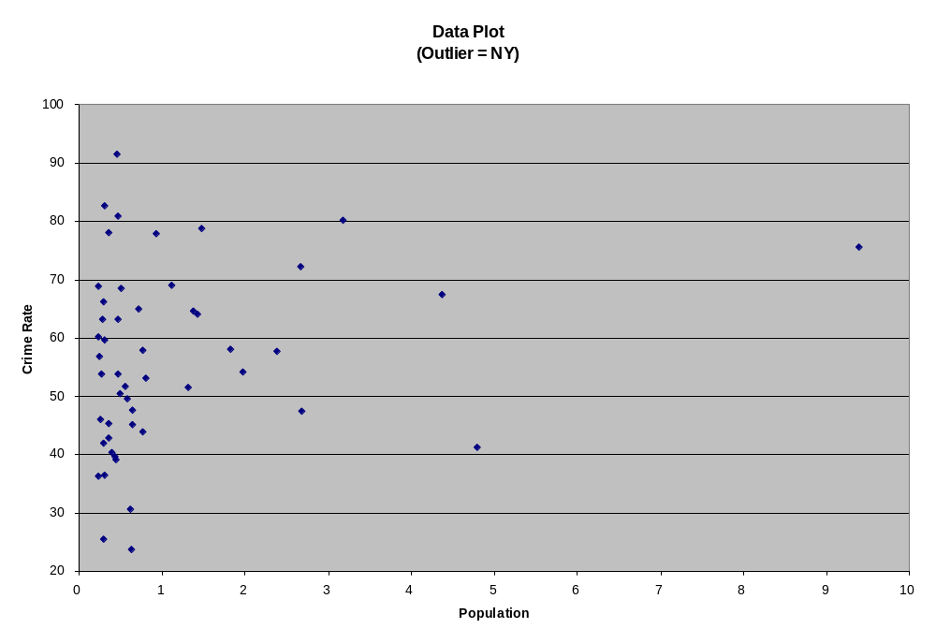

Again we see no curvature. Notice that one of the points (New York) seems far away from the other data. This is an outlier.

Next plot the crime rate versus the % Non-Suburban.

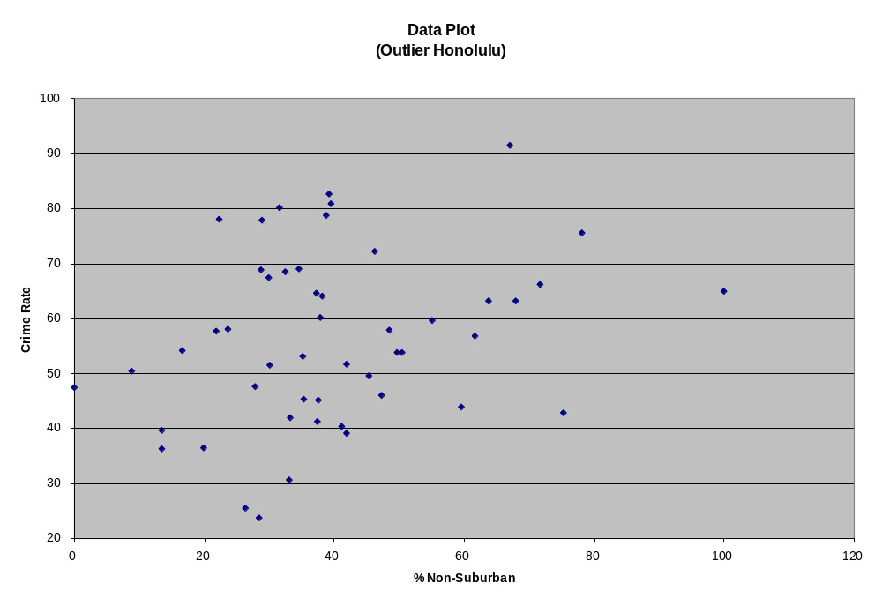

Again the graph shows no evidence of curvature but it also shows an outlier. In this case it is Honolulu.

Now, plot the crime rate versus the % over 65.

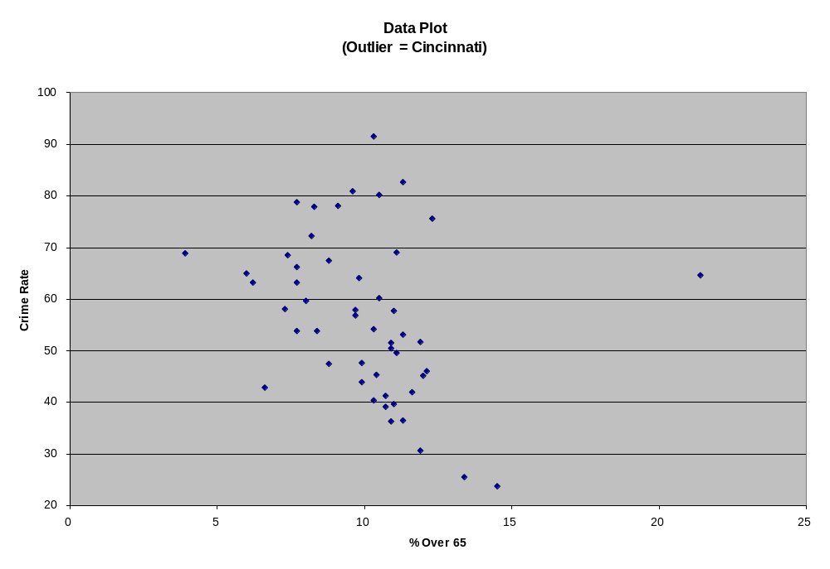

This graph, again, does not show curvature. In fact except for the outlier point (Cincinnati) is shows a strong negative linear relationship.

Now plot the Crime rates versus the numbers of Doctors divided by the population.

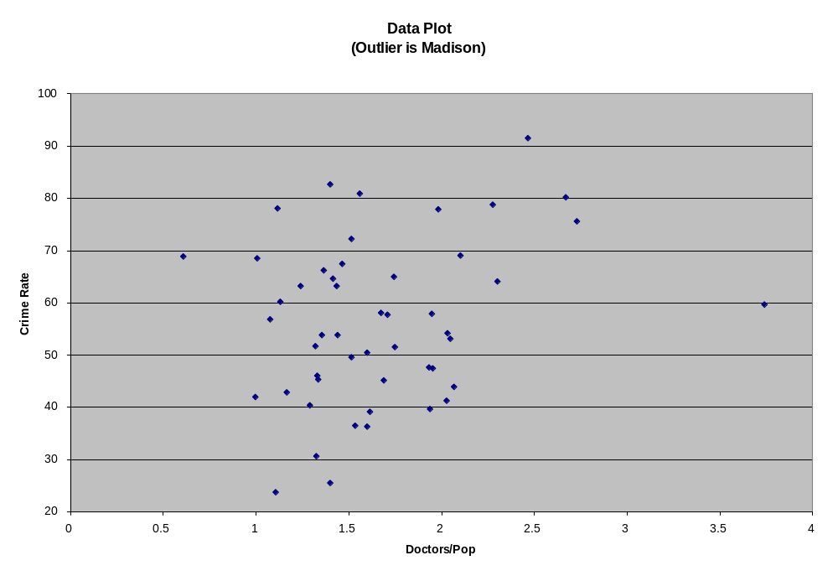

Again there is no evidence of curvature. Note that in this plot Madison is an outlier.

Now plot the Crime rate versus the number of hospital beds per population.

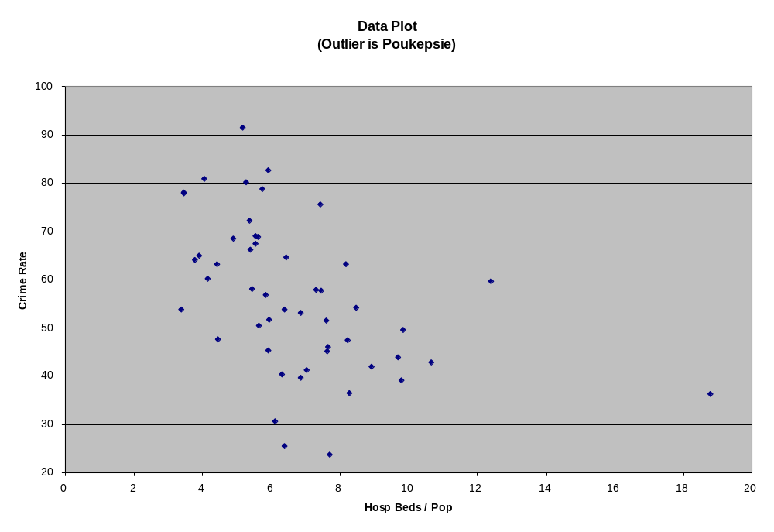

There is no evidence of curvature. Indeed, except for the outlier (Poukepsie) there seems to be a very strong negative linear relationship.

Now plot the crime rate versus the percentage of HS Grads.

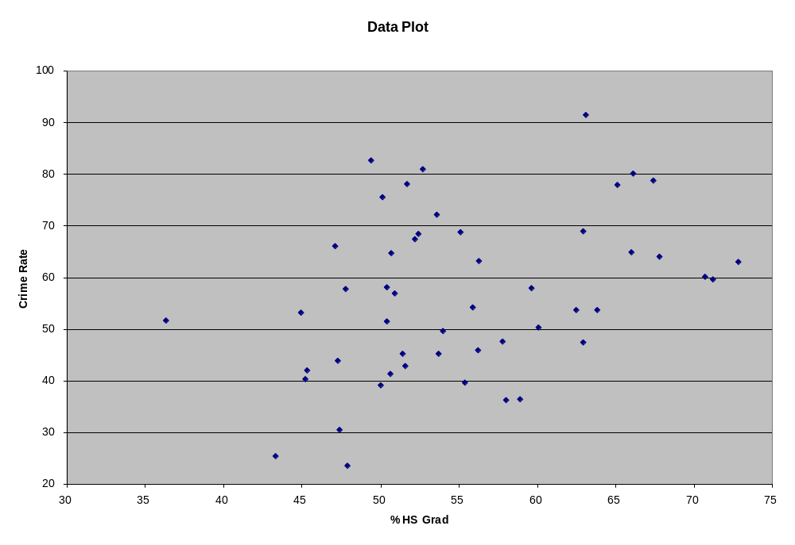

Again there is no evidence of curvature and there is a hint of a positive linear relationship.

Now plot the crime rate versus the % of the population in the labor force.

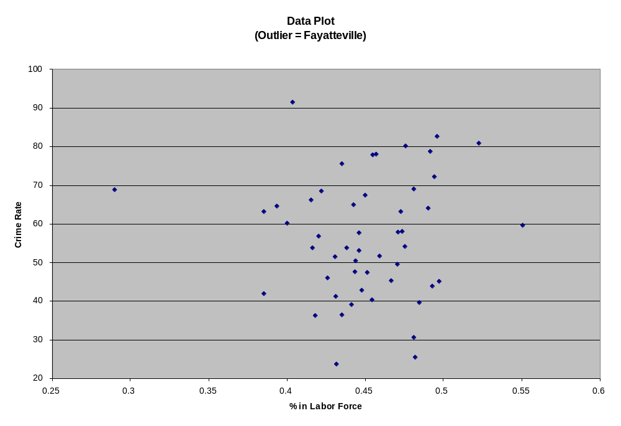

There appears to be no evidence of curvature. The plot does show one outlier, Fayatteville.

Finally, plot the crime rate versus the Per Capita Income.

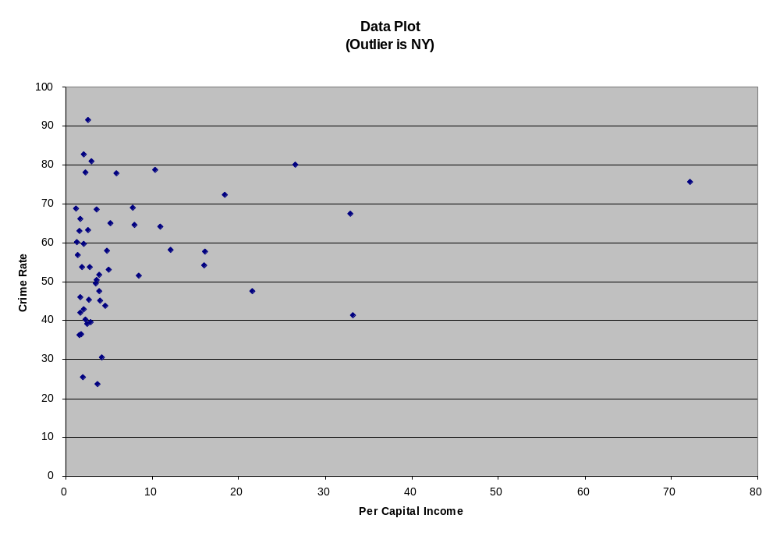

As before, there is no evidence of curvature and New York City appears as an outlier.

To perform the actual regression analysis, go to the tab at the bottom of the worksheet and click on “Worksheet”.

Then open the Data Analysis ToolPak, and select “Regression”.

Highlight the “Serious Crime Rate” column as the y variable, and then highlight all the other columns except “ID” as the x variable range. Then click on labels. The result should look like the following:

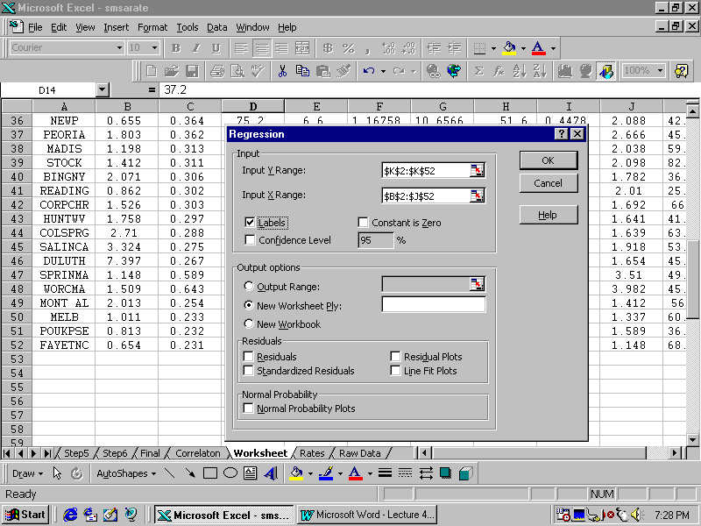
Click “OK” and get the following results:

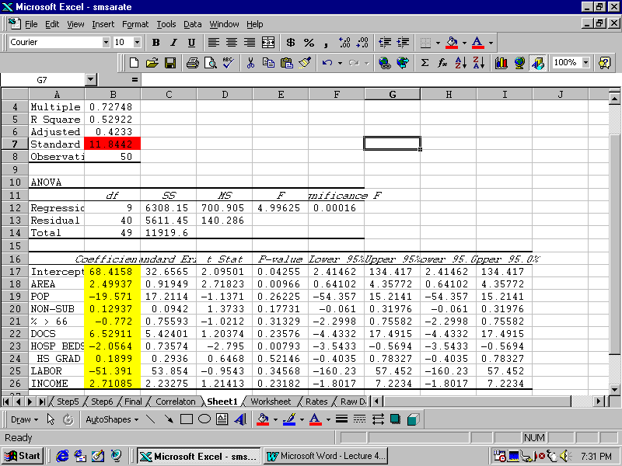
Notice that R² is .52922 indicating that collectively, the x’s explain approximately 52.9% of the variability in y, the serious crime rate. I have highlighted the values of the coefficients in yellow and the value of s_{e}=11.8442, in red.

Even though we have more variables, this regression fit is not as good as in our previous example.

Is this good enough? One way of answering this question is to ask the probability of getting and R-squared value this big in a sample if there really was no predictive value, using these x’s, for y in the population. In other words if R-Squared in the population is zero, what is the probability of observing this large a value in the sample?

This question is answered by examining the last entry in the first row of the ANOVA table labeled “Significance F”. For this data the value is .0001598.

This means that there are about 16 chances in 100,000 that we would get an R-Squared value as high as .52922 in the sample when there is no relationship between y and the x’s in the population.

This does not mean that the estimated relationship is important or useful. It just means that it is unlikely to be 0 in the population.

Most users of statistics usually use a cut off value of .05 to determine if variables are zero or not. (We will study this concept much more in the Third Part of the course, later in the semester). In most computer programs, this value is called the p-value.

You will notice that in the table to the right of the coefficients is another column labeled “p-values”. It is shown below highlighted in green:

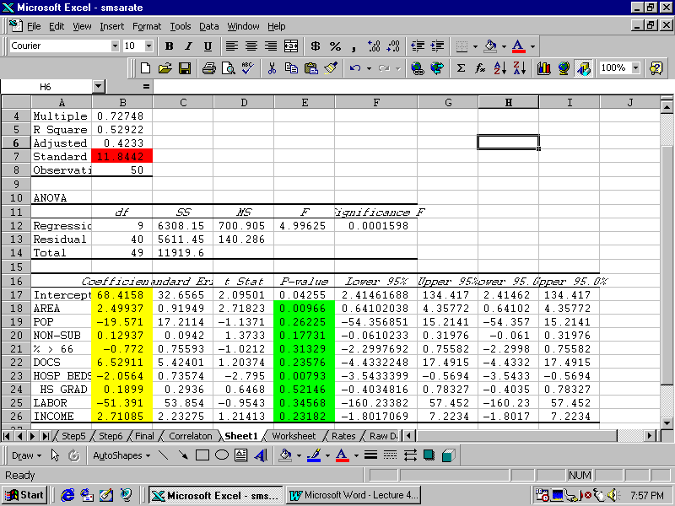
These can be interpreted as measures of the probability that the observed value of the coefficient could occur in the sample if the value of that coefficient in the population were zero.

For example the coefficient of the x-variable AREA is 2.49937. The chances that it would be that big in magnitude (or bigger) in the sample, when in fact it is zero in the population, is given by the p-value as .00966 or about one chance in 100. Since this is less than our .05 threshold, it is likely that this is an important predictor of x.

On the other hand, the coefficient of HS Grad (.1899) has a p-value of .52146 which is much above our minimum threshold of .05. One is tempted to think that it is unimportant. However this may or may not be the case.
To illustrate the problem, open the EXCEL file “colin.xls”. You will see the results shown below:

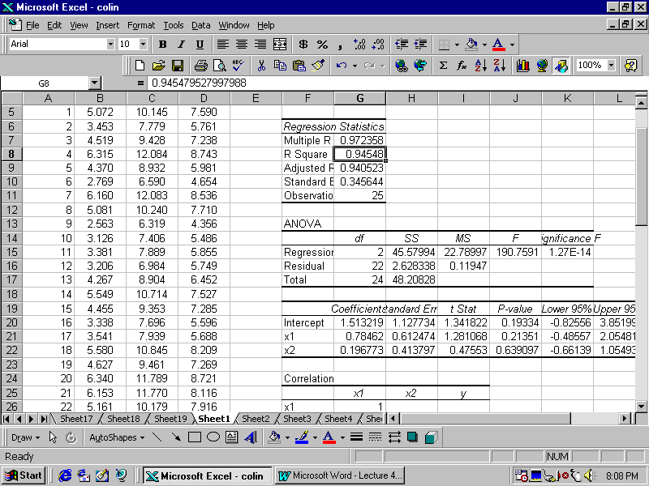

Notice that even though R-squared = .94548 is exceedingly high (indicating that the x’s explain 94.5% of the variability in y), the p-values for both of the coefficients are greater than .05.
Look at the plot of y vs. x1, given below:

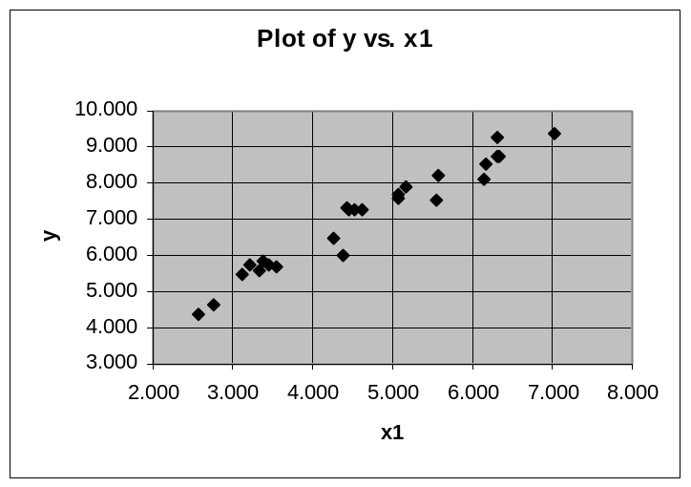
This clearly shows a strong relationship between y and x1.

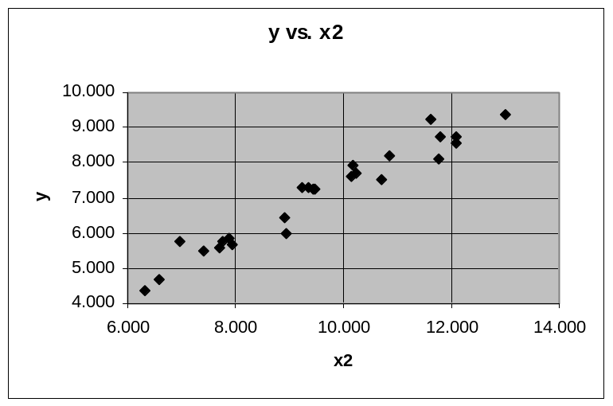 Look at the plot of y vs. x2 given below:

This also shows a strong linear relationship.

To understand this apparent inconsistency, look at the plot of x2 vs. x1 given below:
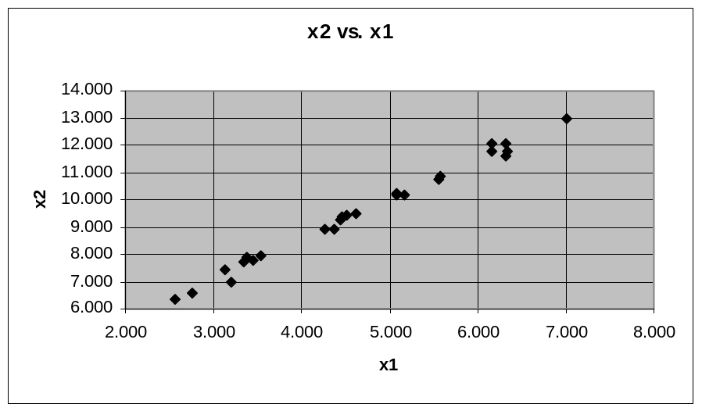

Clearly x2 and x1 are themselves highly linearly related (also called collinear).

This means that the information in x2 and x1 are almost identical. Accordingly, the high p-values for x1 and x2 are telling us:

You don’t need x1 if you already have x2;

and you don’t need x2 if you already have x1.

In other words we need one of the two variables but not both.

To avoid this problem one needs to change variables one-step at a time.

For example if I drop x2 (with the higher p-value of .639097), and rerun the regression only on x1, I get the following results:

SUMMARY OUTPUT
Regression Statistics
Multiple R | 0.97207
R Square | 0.944919
Adjusted R Square | 0.942524
Standard Error | 0.33978
Observation | 25
ANOVA
 | df | SS | MS | F | Significance F
Regression | 1 | 45.55293 | 45.55293 | 394.5679 | 5.61E-16
Residual | 23 | 2.655354 | 0.11545
Total | 24 | 48.20828
 | Coefficients | Standard Error | t Stat | P-value
Intercept | 2.034331 | 0.261731 | 7.772592 | 7.01E-08
x1 | 1.074692 | 0.054103 | 19.86373 | 5.61E-16

As can be seen, the value of R-Squared has dropped from .94548 to the slightly smaller value of .94492. The p-value on the coefficient of x1 is now only about 6 chances in ten quadrillion!!!! This result clearly indicates that it is very unlikely that the coefficient of x1 in the population is zero.

We will be relatively safe in assessing the importance of variables, if we look at them one at a time.

We will use a step-wise regression method called Backward Elimination, to attempt to find out which, if any variables are potentially important. The process works like this:

1) Regress y on your entire x’s and examine the resulting regression coefficient p-values.

2) If all of the regression coefficient p-values are less than .05, stop

3) If some of the p-values are greater than .05, find the variable with the highest p-value greater than .05.

4) Eliminate this x variable and repeat the regression analysis on the remaining x’s.

5) Repeat steps 1) through 4) until you stop at step 2) or run out of variables.

This is not the only step-wise procedure possible. Others are

Forward Selection

True Step-Wise Regression
Returning to our example:

 | Coefficients | Standard Error | t Stat | P-value
Intercept | 68.4158 | 32.6565 | 2.10 | 0.04255
AREA | 2.4994 | 0.9195 | 2.72 | 0.00966
POP | -19.5714 | 17.2114 | -1.14 | 0.26225
NON-SUB | 0.1294 | 0.0942 | 1.37 | 0.17731
% > 65 | -0.7720 | 0.7559 | -1.02 | 0.31329
DOCS | 6.5291 | 5.4240 | 1.20 | 0.23576
HOSP BEDS | -2.0564 | 0.7357 | -2.79 | 0.00793
HS GRAD | 0.1899 | 0.2936 | 0.65 | 0.52146 | <<<<drop
LABOR | -51.3909 | 53.8540 | -0.95 | 0.34568
INCOME | 2.7108 | 2.2328 | 1.21 | 0.23182

We would drop the variable “HS Grad”. This is done by completely deleting the column in the data set.

Then repeat the regression without “HS Grad” to get the following results:

 | Coefficients | Standard Error | t Stat | P-value
Intercept | 84.3142 | 21.3471 | 3.95 | 0.0003
AREA | 2.5467 | 0.9100 | 2.80 | 0.00779
POP | -22.4728 | 16.4982 | -1.36 | 0.18059
NON-SUB | 0.1256 | 0.0934 | 1.35 | 0.18574
% > 65 | -0.9413 | 0.7041 | -1.34 | 0.18863
DOCS | 8.5791 | 4.3703 | 1.96 | 0.05645
HOSP BEDS | -2.1668 | 0.7105 | -3.05 | 0.00401
LABOR | -64.2022 | 49.7227 | -1.29 | 0.20387 | <<<drop
INCOME | 3.0503 | 2.1547 | 1.42 | 0.16444

Now drop both “HS Grad” and “Labor” and rerun the regression on the remaining variables to yield the results:

 | Coefficients | Standard Error | t Stat | P-value
Intercept | 60.4448 | 10.7597 | 5.62 | 1.4E-06
AREA | 2.42243 | 0.9121 | 2.66 | 0.01113
POP | -20.96 | 16.5868 | -1.26 | 0.21331 | <<<drop
NON-SUB | 0.13496 | 0.09382 | 1.44 | 0.15768
% > 65 | -1.0191 | 0.70707 | -1.44 | 0.15692
DOCS | 5.57914 | 3.73077 | 1.50 | 0.14228
HOSP BEDS | -2.1321 | 0.71566 | -2.98 | 0.00479
INCOME | 2.89778 | 2.16852 | 1.34 | 0.18865

Now drop “Area” in addition to “HS Grad” and “Labor” to get the results below:

 | Coefficients | Standard Error | t Stat | P-value
Intercept | 61.488 | 10.8022 | 5.69 | 1E-06
AREA | 2.01851 | 0.86017 | 2.35 | 0.02362
NON-SUB | 0.11584 | 0.09323 | 1.24 | 0.22078
% > 65 | -1.2265 | 0.6925 | -1.77 | 0.08362
DOCS | 6.5879 | 3.66957 | 1.80 | 0.07964
HOSP BEDS | -2.244 | 0.71507 | -3.14 | 0.00307
INCOME | 0.16456 | 0.15703 | 1.05 | 0.30049

Now drop the variable “Income” in addition to the previous variables to obtain:

 | Coefficients | Standard Error | t Stat | P-value
Intercept | 59.8636 | 10.7023 | 5.59 | 1.3E-06
AREA | 1.98509 | 0.86054 | 2.31 | 0.02583
NON-SUB | 0.11965 | 0.09326 | 1.28 | 0.20622
% > 65 | -1.1422 | 0.68858 | -1.66 | 0.10427
DOCS | 8.20301 | 3.33398 | 2.46 | 0.01787
HOSP BEDS | -2.3417 | 0.70975 | -3.30 | 0.00193

Finally, drop the variable “Non-Sub” in addition to the previous variables to obtain the final result:

 | Coefficients | Standard Error | t Stat | P-value
Intercept | 66.5508 | 9.41409 | 7.07 | 8E-09
AREA | 1.98874 | 0.86669 | 2.29 | 0.02647
% > 65 | -1.3687 | 0.67033 | -2.04 | 0.04706
DOCS | 8.67906 | 3.33696 | 2.60 | 0.01254
HOSP BEDS | -2.4076 | 0.71295 | -3.38 | 0.00152

All of the “p-values” are now less than .05 so we stop.

This indicates that the final model is:

Predicted Serious Crime = 66.55 + 1.99*Area – 1.37* (% > 66)

+ 8.68*Docs –2.41 *(Hosp Beds)

+/- 2*(12.03)

Let us assess this model:
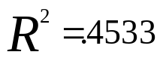

compared to the initial value of .5292.

Now consider the variables selected by the process and their signs:

Area

%>65

Docs

Hosp Beds

Finally, we need to check the residuals to see any pattern remains.

Rerun the last analysis but this time check the boxes “Residuals” and “Residual Plots”.

You will see the following four Residual Plots:

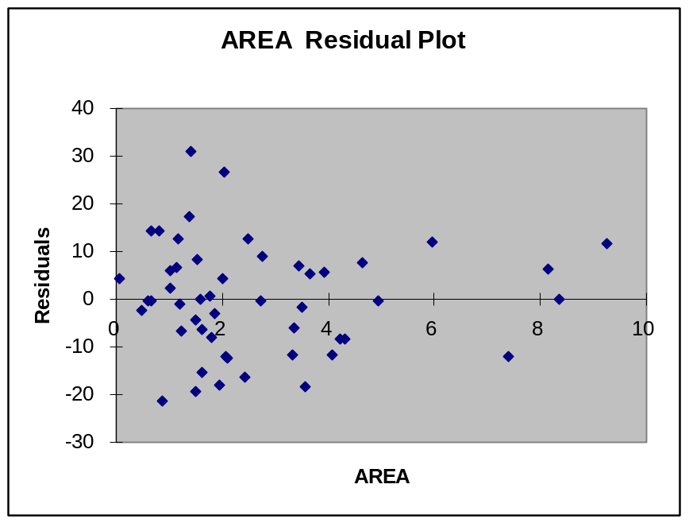
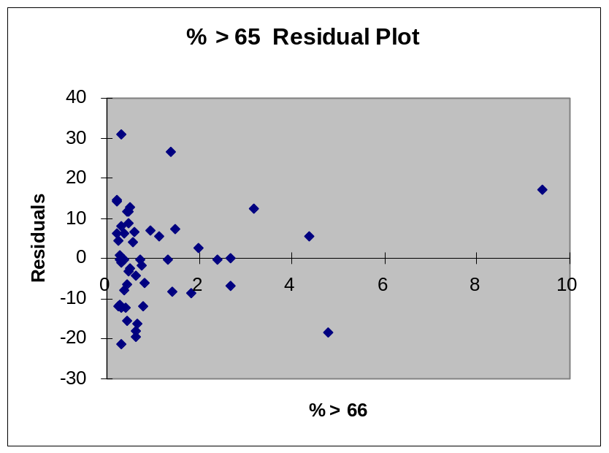

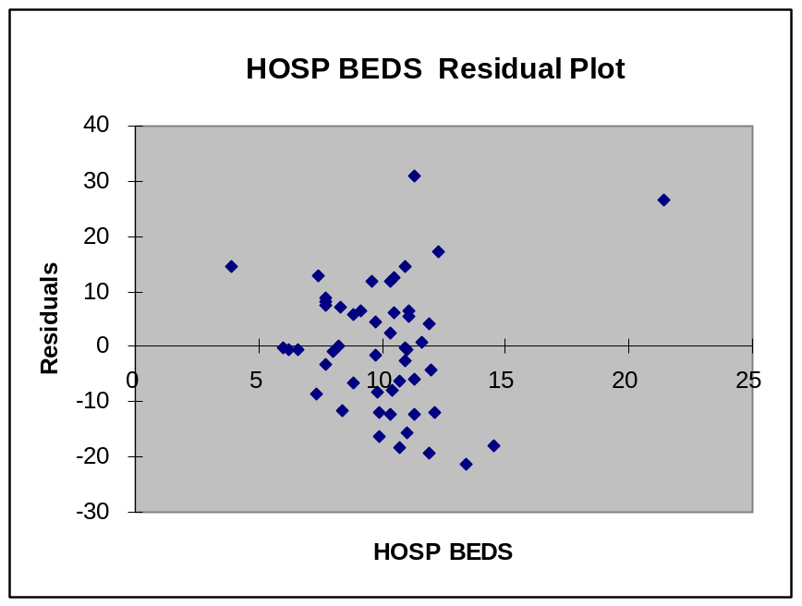
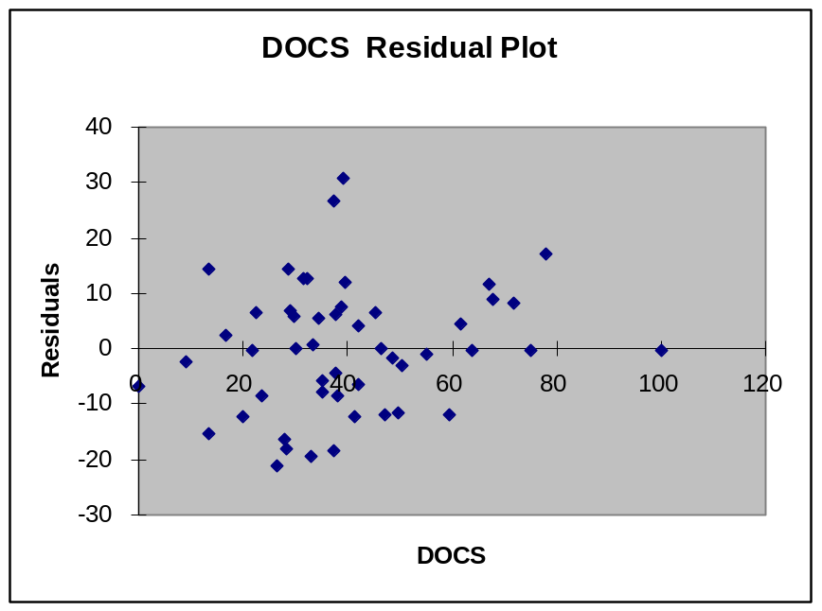

As can be seen, all of these plots look random. Accordingly there does not seem to be any further information in the x variables that can be used to predict y.

One final residual plot is needed which is not automatically provided by EXCEL. Here you need to find the list of predicted and residual values towards the bottom of the regression output spread sheet and do an xy plot of this data. The result looks like:

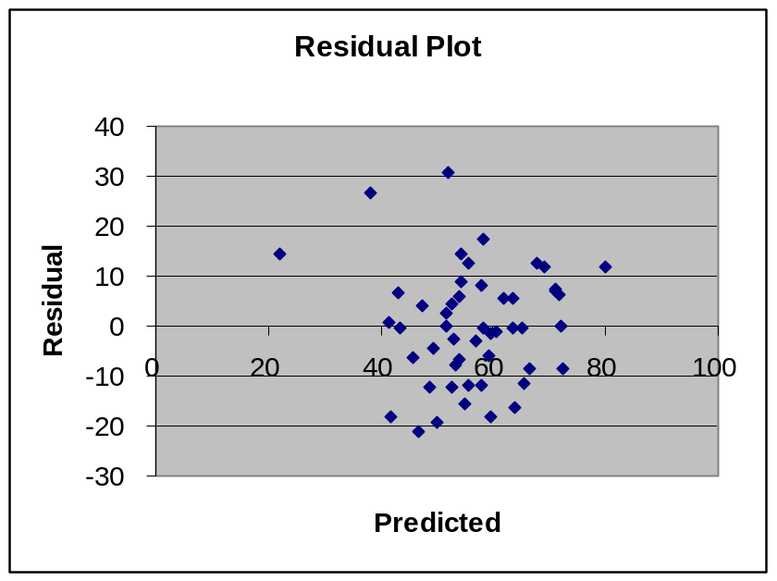

Again no pattern is apparent.

Summary

Even though only 45.33% of the variability is explained, the amount explained is not zero (p-value = .000014).

What explains the other 54.67%?

The range of +/- 2*(12.03) = +/- 24 crimes per person is high.

Interpretation of the variables is not clear.

No further information in these variables is useful for prediction.

