2. Perform the below given activities:

a. Create classification model using different random forest models

ans:-

#Random Forest in R example IRIS data

#Split iris data to Training data and testing data

#2. Perform the below given activities:

# a.Create classification model using different random forest models

#Random Forest in R example IRIS data

#Split iris data to Training data and testing data

ind <- sample(2,nrow(iris),replace=TRUE,prob=c(0.7,0.3))

trainData <- iris[ind==1,]

testData <- iris[ind==2,]

#Load Library Random FOrest

library(randomForest)

#Generate Random Forest learning treee

iris_rf <- randomForest(Species~.,data=trainData,ntree=100,proximity=TRUE)

table(predict(iris_rf),trainData$Species)

# Try to print Random Forest model and see the importance features

print(iris_rf)

plot(iris_rf)

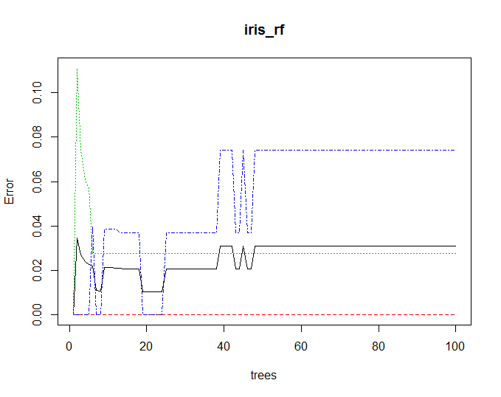

importance(iris_rf)

varImpPlot(iris_rf)

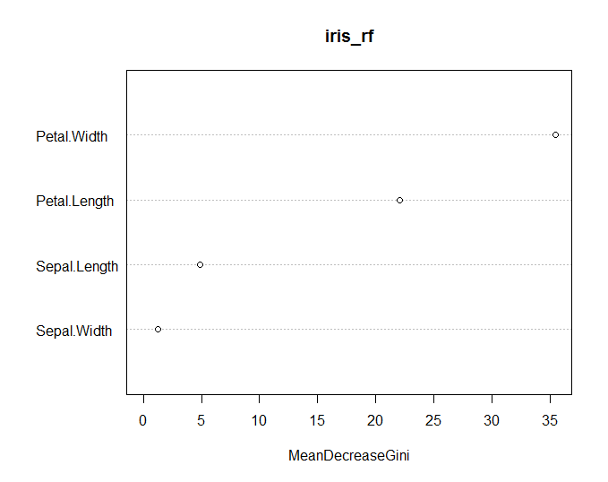

#Try to build random forest for testing data

irisPred<-predict(iris_rf,newdata=testData)

table(irisPred, testData$Species)

# Try to see the margin, positive or negative, if positif it means correct classification

plot(margin(iris_rf,testData$Species))

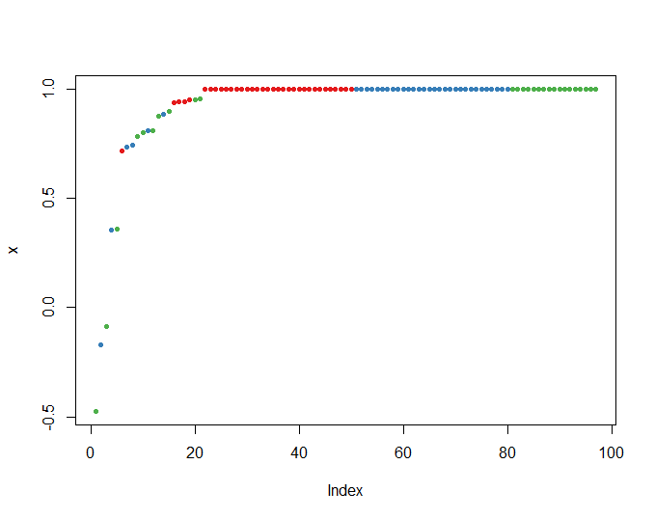

# b. Verify model goodness of fit

#c. Apply all the model validation techniques

Ans:-

table(irisPred, testData$Species)

irisPred setosa versicolor virginica

setosa 16 0 0

versicolor 0 13 3

virginica 0 1 20

Accuracy=(16+13+20)/(16+13+3+1+20)

0.9245283 =92%(approx)

d. Make conclusions

e. Plot importance of variables