1. Create classification model using different classifiers

Ans:-

# svm model

library(MASS)

library(e1071)

data = cats

set.seed(7267166)

trainIndex=createDataPartition(data$Sex, p=0.7)$Resample1

train=data[trainIndex, ]

test=data[-trainIndex, ]

data = cats

head(cats, n=2)

m1 <- svm(Sex~., data = train)

summary(m1)

pred<- predict(m1, test, type = "response")

pred

1. Verify model goodness of fit
2. Apply all the model validation techniques.

Ans:-

TAB<-table(test$Sex, pred)

TAB

pred

F M

F 12 2

M 6 23

#model validation (acuracy)

(12+23)/(12+2+6+23)*100

# 81.39535%

plot(m1, cats)

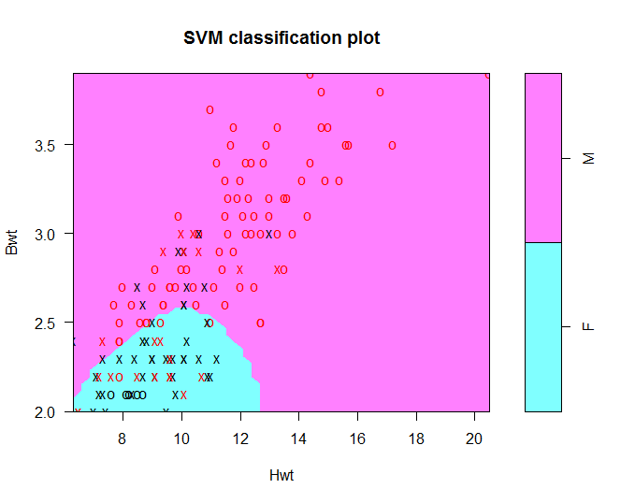

1. Create classification model using different classifiers

Ans:-

# Naive Bayes classifier

# load the libraries

library(caret)

library(klaR)

# load the iris dataset

data(iris)

# define an 80%/20% train/test split of the dataset

split=0.80

trainIndex <- createDataPartition(iris$Species, p=split, list=FALSE)

data_train <- iris[ trainIndex,]

data_test <- iris[-trainIndex,]

# train a naive bayes model

model <- NaiveBayes(Species~., data=data_train)

# make predictions

x_test <- data_test[,1:4]

y_test <- data_test[,5]

predictions <- predict(model, x_test)

print(predictions)

1. Verify model goodness of fit
2. Apply all the model validation techniques.

Ans:-

#model validation (acuracy)

TAB<-table(data_test$Species, predictions$class)

TAB

setosa versicolor virginica

setosa 10 0 0

versicolor 0 8 2

virginica 0 1 9

#acuracy

(10+8+9)/(10+8+2+1+9)*100

# 90%