Utilization of Solar Thermal Energy for
Hostel Cooking



Group 05
Aayush M Anand(21d170001),Brahadish Balaji(23m1341)
Prasad Madhukar Pawar(23d0640), Vishnu TS(22n0413)

Contents
1 Introduction 1
2 Plant configuration 2
2.1 System Description 2
2.2 Scheffler Dish 3
2.3 Other Components 4
2.4 Applications 4
3 Plant model 4
3.1 Radiation model 4
3.1.1 Assumptions 5
3.1.2 Equations Used 5
3.1.3 Step-by-Step Calculations 5
3.2 Performance Analysis Model 7
3.2.1 Optical Efficiency 7
3.2.2 Thermal Efficiency 7
3.3 Load Calculations 8
4 Performance Analysis Model 10
4.1 Sustainability Analysis 10
4.2 Cost Analysis 10
4.2.1 Net Present Value of the project 11
4.2.2 Benefit-cost ratio 11
4.2.3 The internal rate of return (IRR)- 11
5 Results and Discussions 11
6 Limitations 12
7 Conclusions 12

List of Figures
Figure 1: Schematic of the System 5
Figure 2 : Schematic of Scheffler Dish Operation 6
Figure 3:Output vs Demand Curve 13
Figure 4: Number of Cylinders Saved 14

List of Tables

Table 1: System Characteristics 5
Table 2: DNI Calculations 9
Table 3: Moisture content and Specific Heat of Various Dishes 11
Table 4 : Load Calculations for Dishes 12

Abstract

The course project investigates the feasibility of implementing solar thermal energy for cooking in Hostel-17 of IIT Bombay, accommodating approximately 1300 students. Utilizing Scheffler dish solar collectors, the study assesses energy requirements, analyzing solar irradiance in the geographical location (19.15˚ N, 72.95˚ E) using weather data. It develops a solar radiation model to determine solar radiation on a tilted surface, aiding in system sizing. The report comprehensively analyzes the solar energy system, including load calculations, average Direct Normal Irradiance (DNI) determination, and collector-receiver system characterization. It aims to determine the number of Scheffler dishes needed and outlines system components with detailed specifications and supplier information. This investigation seeks to evaluate energy savings potential while ensuring continuous cooking capabilities during periods of low solar availability and off-sun hours.

Keywords: Scheffler dish, Radiation Model, Load Calculations, Direct Normal Irradiance.

Introduction

Our hostel in IIT Bombay is a residence to 1300 students consuming over 5900 MJ per day only for cooking consuming 9 LPG cylinders of 14.2 kg. This study assesses an alternative to solar thermal cooking usingaScheffler dish concentrator. Scheffler collectors use a large, flat, fixed mirror to reflect sunlight on to a fixed focal line or point. Unlike the parabolic shape, the mirror in Scheffler collectors is flat, and it is inclined at a specific angle to concentrate sunlight, which is mainly used for cooking. We will be using a mechanical tracking system to keep the mirror oriented towards the sun, ensuring continuous concentration of sunlight on the fixed focal line. Scheffler collectors are generally simpler in design and may be more cost-effective compared to parabolic dishes. we develop a solar radiation model to help determine the value of solar radiation on a tilted surface by considering the region's annual weather pattern, which in our case is Hostel 17, IIT Bombay ( 19.15˚ N,72.95˚ E).
A brief introduction of the application and the chosen system along with a schematic and a reason for selecting the application. The schematic should include stream numbers which should then be used for all the further equations and explanations.

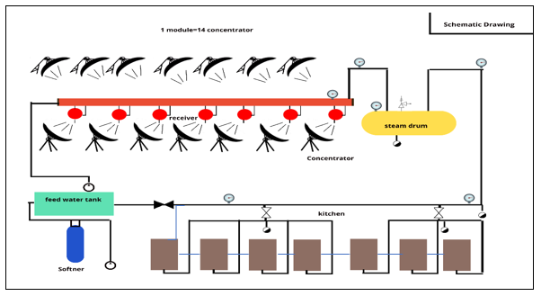
Figure 1: Schematic of the System

Plant configuration

System Description

System Characteristics
Heat Transfer Medium | Water
Temperature | 150 – 200 ˚C
Pressure | 3 – 7 bar
Energy per Day | 5900 MJ
Table 1: System Characteristics

Scheffler Dish

Scheffler dish is a small lateral section of a paraboloid, which concentrates the sun’s radiation over a fixed focus, with automatic single-axis tracking.

Working Principle
The Scheffler dish is made of several flat-shaped mirrors or reflective films that are mounted on a structural frame. The dish rotates about a north-south axis parallel to the earth’s axis to track the sun’s movement. The axis of rotation passes through the center of gravity of the reflector and that’s how the reflector always maintains its gravitational equilibrium. The Scheffler reflector also performs a change in inclination angle while staying directed to the sun, in order to obtain a sharp focal point. Focus is fixed at the distance of the focal length of the paraboloid along the axis of the paraboloid. The receiver at a fixed location captures the concentrated heat and transfers it to water/thermic fluid to generate hot water/hot thermic fluid or high pressure steam.

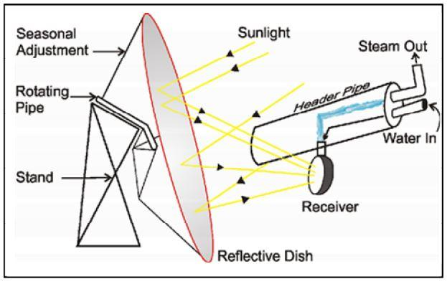
Figure 2 : Schematic of Scheffler Dish Operation

Subsystem
The receiving subsystem collects solar radiation in the solar field from parabola-shaped reflecting collectors and transfers it to working fluids such as water. The tracking subsystem acts as a support to the receiving subsystem. It maximizes the solar energy captured by moving solar collectors towards the sun for a complete day. The circulation subsystem carries fluid and transfers the heat received by it to the end-use application.

Components

- Collector - The collector of Scheffler Dish is an assembly of flat-shaped solar-grade glass mirrors or Aluminium mirror reflectors arranged on a structural steel framework. The mirrors are arranged to give a paraboloidal shape and reflect the incident solar radiation to a common point, i.e. the receiver.

- Receiver - The receiver of the Scheffler dish is placed at the focus of the dish so as to capture the incident solar radiation and transfer it to the thermal medium used in the system. The critical component is generally a dome-type absorber fixed onto the structural steel frame. The receiver works on the thermo siphon principle in which cold water sinks down from the header and hot water/steam moves up to the header.

- Header Pipe –
- Storage tank contains water in the lower half and steam in the upper half
- Works as a buffer system, i.e. it collects and stores steam generated by the Scheffler system, which can be utilized as per the requirement

- Dish and Receiver Support
- Tracking System

Other Components

- Piping and Insulation
- Pumps
- Instrumentation and Safety mechanisms
- Heat Storage System

Applications

Application Type - Residential.

Food consumption pattern over a day and its breakdown:

Energy Calculations per day:

Gas cylinders (14.2kg) - 9 Nos.
LPG has a calorific value of 46.1 MJ/kg.

14.2 cylinder has an energy content of 654.6 MJ of heat.
We have a total of 9 Cylinders which corresponds to total energy used per day = 5900MJ

Plant model

Radiation model

Assumptions

- Calculations are valid for the northern hemisphere
- Sun rays collimate perfectly and parallelly on the mirrors in the solar field
- The system incorporates a precise tracking scheme to follow the sun’s movement
- Only beam normal solar radiation is taken into consideration
- Solar radiation values at the middle of the hour are assumed to remain constant throghout the hour
- The mirrors are assumed to be facing south($γ=0$)

Equations Used

(1) I_{g} = I_{b} + I_{d}
(2) δ = 23. 45 × [$sinsin (360 × \frac{284+n}{365}$)]
(3) B = $360 × \frac{(n-1)}{365}$
(4) 𝐸 = 229. 18 × [0. 000075 + 0. 001868 𝑐𝑜𝑠 𝐵 − 0. 03207 𝑠𝑖𝑛 𝐵 − 0. 014615 𝑐𝑜𝑠 2𝐵 − 0. 04089 𝑠𝑖𝑛 2𝐵] (in mins).
(5) LAT = Standard clock time ± (Standard time longitude - longitude of location)/15 + E/60
(6) ω = (𝐿𝐴𝑇 − 12) × 15
(7) 𝑐𝑜𝑠 θ = 𝑠𝑖𝑛 β 𝑐𝑜𝑠 γ [ 𝑠 δ 𝑐𝑜𝑠 ω 𝑠𝑖𝑛 ϕ − 𝑠𝑖𝑛 δ 𝑐𝑜𝑠 ϕ ] + 𝑠𝑖𝑛 β 𝑠𝑖𝑛 γ 𝑐𝑜𝑠 δ 𝑠𝑖𝑛 ω + 𝑐𝑜𝑠 β [ 𝑐𝑜𝑠 δ 𝑐𝑜𝑠 ω 𝑐𝑜𝑠 ϕ + 𝑠𝑖𝑛 δ 𝑠𝑖𝑛 ϕ ]
(8) 𝑐𝑜𝑠$θ_{z}$ = 𝑐𝑜𝑠 ϕ 𝑐𝑜𝑠 δ 𝑐𝑜𝑠 ω + 𝑠𝑖𝑛 ϕ 𝑠𝑖𝑛 δ
(9) 𝑟_{b} = $\frac{coscos θ }{coscos z }$
(10) 𝑟_{d} = $\frac{(1+ cos β) }{2}$
(11) 𝑟_{r} = $\frac{ ρ(1- cos β) }{2}$
(12) I_{T} = I_{b} r_{b} + I_{d} r_{d} + I_{g} r_{r}
(13) I_{bn} = $\frac{I_{b}}{coscos θ }$
(14) Radiation on a tilted surface is given by(HDKR model)

$I_{t}=$ ($I_{b}+A_{i}I_{d})r_{b}+ I_{d}(1-A_{i})r_{d}[1+ \sqrt{\frac{I_{b}}{I_{g}} }. \frac{β}{2}] + I_{g}r_{r}$
Where A_{i} is the Anisotropic Index, A_{i} = $\frac{I_{b}}{I_{o}}$
I₀ = I_{sc} * cos($coscos θ_{z}$)

(15) I_{sc} = 1367 Wm⁻²

(16) I₀ = I`_{sc} $×$ $coscos θ_{z}$

Step-by-Step Calculations

We have written a Python code to help us in step-by-step calculation and obtain the necessary parameters

Step 1: First we enter the necessary parameters such as n, L, L_{STD}, $∅$, IST
Step 2: Error in Local Apparent Time(LAT) is calculated using equations (3) and (4) for each day of the year
Step 3: LAT is found for every hour using equation (5)
Step 4: Hour angle is calculated using LAT and equation (6)
Step 5: Declination angle(δ) is calculated using equation (2)
Step 6: Zenith angle($θ_{z}$) is calculated using equation (8)
Step 7: We have chosen model 2, therefore using values of I_{g} and I_{bn} and using equation (13) and (1) we get value of I_{d}
Step 8: We calculate the values of r_{b} and r_{d} using the equation (9) and (10)
Step 9: By entering the value of $ρ$ we get the value of r_{r} using equation (11)
Step 10: After entering the anisotropic index we obtain the value of I_{t} using equation (14)

Link to Code: https://onlinegdb.com/kskOmoOB8

Determining Solar Radiation value for Sizing the system

- Hourly averages are calculated at the mid of every hour given in the weather file
- Monthly average of every hour is calculated for every month of the year
- The total daily average energy for a month is obtained by summing the average energy values calculated for each hour throughout the month
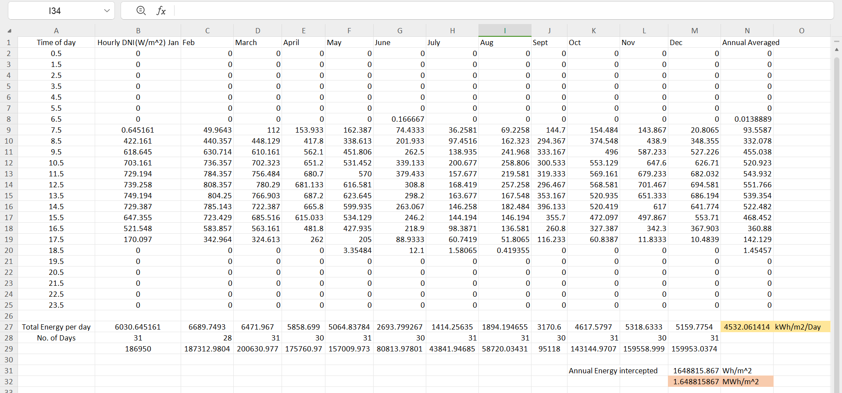
- The daily solar radiation value in kWh/m2 is determined by averaging the monthly average energy per day over a one-year period
Table 2: DNI Calculations

Methodology: Data for DNI values was obtained from the weather file specific to the IITB Hostel 17 location. The analysis covered a monthly time scale to capture seasonal variations and a yearly time scale for a comprehensive overview. The DNI values were calculated and averaged to provide insights into the solar energy potential at the location.

SAM is used to evaluate the solar potential at a specific location, a comprehensive tool for renewable energy system analysis. SAM provides a platform for modelling and simulating the performance of solar photovoltaic systems under varying conditions.

Performance Analysis Model

Optical Efficiency

η_{opt,rec}= ρ × ƞ_{cos} × Absorptivity of receiver

ρ = Reflectivity of the mirror
ƞ_{cos} = Cosine efficiency

Concentration Ratio - $\frac{11.65}{0.1294}$ = 90.3091
η_{optical} = $cos θ$ × reflectivity of the collector x absorptivity of the receiver.
$cos θ$ is calculated for May 17 at 12.30 p.m.
N = 137 | β = ɸ = 19.07600˚ | δ = 19.2636250 ˚ | ω = -1.1445660 ˚ | $γ=0$ ˚

On substitution,
$cos θ= = 0.943822$
Reflectivity of collector = 0.9 | Absorptivity of receiver = 0.7
η_{optical} = 0.943822 × 0.92 ×0.7 = 0.607821

Thermal Efficiency

Heat loss at the receiver end = Loss due to convection + Loss due to radiation
The aperture area of receiver(A_{r}) = 0.1294 m²
Convective Heat Transfer Coefficient(h) =25 W/(m² ⋅K)
T_{r}=473 K : T_{a}=301 K
T_{sky} = 0.00553 × (T_{a}^{1.5}) +10 = 298K (Swinbank’s equation)
q_{loss} = {h ×A_{r} × (T_{r} -T_{a})} + {σ × ε × A_{r} × (T_{r}⁴ - T_{sky}⁴)}
q_{loss} = {25 × A_{r} × (473 – 301)} + {5.67 × 10⁻⁸ × 0.2 × A_{r} × (473⁴ – 298⁴)}
q_{loss} = 4778.1 × 0.1294
q_{loss} = 618.29 W
Aperture area of reflector(A_{ref}) = 11.65 m²

Energy absorbed by a receiver: Average DNI ×A_{ref} × optical efficiency = 665 × 11.65 × 0.6078 = 4708.9 W

Heat loss due to convection and radiation = 618.29 W.
η_{the-rcv} = (Energy absorbed-Heat loss)/Energy absorbed
=(4708.9-618.29)/4708.9
η_{the-rcv} = 0.8687

Overall thermal Efficiency = η_{optical} × η_{rcv}
=0.607 × 0.868
η_{overall} = 0.528.

Load Calculations

Load Calculations comprise of foods which can be cooked by steam replacing conventional LPG cylinders.

Food | Moisture content  (wet basis) | Specific heat(b)  (kJ/kgº C)
Rice | 10.5 - 13.5 | 1.76 - 1.84
Milk | 87.5 | 3.85
Carrots | 86 - 90 | 3.81 - 3.93
Onions | 80-90 | 3.60 - 3.89
Potatoes | 75 | 3.51
Table 3: Moisture content and Specific Heat of Various Dishes
The energy required for the chemical reactions in rice during cooking is estimated to be about 170 kJ/kg.

For cooking 20 kg of rice, 28 litres of water required for three cooking pots used for cooking rice.

Heat required by each pot for cooking rice
Q= {(MC_{p}) _{w} + (MC_{p}) _{f} }(T_{c} - T_{a}) + M_{f} K_{f}

The initial temperature of food = T_{a}
Cooking Temperature = T_{c}
Mass of food=M_{f}
Mass of water=M_{w}
K_{f}=Energy required for Chemical reaction of rice and water

For rice cooking - 20 litres of water and 28 kg of rice are taken.
T_{a} =25℃
T_{c} =120℃
M_{f} = 20kg
M_{w} = 28 litre
C_{pf} = 1.8 KJ/Kg ℃
K_{fi} = Energy required for the chemical reaction of rice and water
Q = {(MC_{p}) _{w} + (MC_{p}) _{f} } × (T_{c} - T_{a}) + M_{f} K_{f} =17.97 MJ

The energy required for 140kg (345kg cooked rice) rice for lunch = 125.79 MJ
The energy required for 100kg (230kg cooked rice) rice for Dinner = 89.85 MJ

Consider the water uptake ratio = 2.3

For milk heating
V=150 litre
S=1.035
C_{p} = 3.85 KJ/Kg ℃
T_{c}=95℃

Q = MC_{p}× (T_{c} - T_{a}) = 41.84 MJ
The energy required for 150-litre milk (morning)= 41.84 MJ
The energy required for 150-litre milk (Evening)= 41.84 MJ

For water heating
V=100 litre
S=1.035
C_{p} = 3.85 KJ/Kg ℃
T_{c}=100℃
Q = MC_{p}× (T_{c} - T_{a}) = 31.40 MJ

The energy required for 25-litre water, used in all 4 meals = 7.85 MJ
From data collected –
LPG Cylinder required for vegetable curry=1.5 /day
The total energy required for curry & Dal =654.6×1.5×0.6=589.14MJ
As gas stove has thermal efficiency of 60%
For Afternoon = 294.57MJ
For Night = 294.57MJ

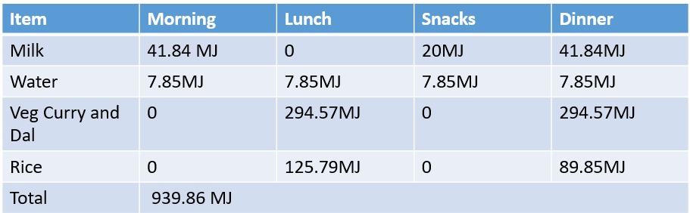
Table 4 : Load Calculations for Dishes

Load requirement for a Day.
Hence, designing our system for maximum load.
Considering the factor of safety=1.1
Total heat load required in the morning hours:
Load requirement=1.1×939.86 MJ=1033.846 MJ
Cooking efficiency of the cooking pot =0.72

ɳ=Cooking load/(mh)st
(mh)steam=1435.89 MJ

No. Of Collectors Needed :
Heat needed = 1435.89 x 10⁶ J.
Heat from one Scheffler dish = 665 x 11.65 x 3600 x 7 x 0.8626 x 0.6078
No of Scheffler = 1435.89 x 10⁶ / 665 x 11.65 x 3600 x 7 x 0.8626 x 0.6078 = 14.02 = 14 dishes.

Performance Analysis Model

Sustainability Analysis

- LPG cylinder - 14.2 kg propane (C₃H₈).
- C₃H₈ + 5O₂ ------------------> 3CO₂ + 4H₂O + Heat
- LPG equivalent of steam produced to achieve cooking
- = 1436 MJ / 655 MJ =2.2 Cylinders.
- Cylinders Saved by incorporating Scheffler based Cooking = 2.2/0.6
=3.67 cylinders per day i.e 52.06 Kg of LPG saved per day
CO₂ calculations
- C₃H₈ + 5O₂ ------------------> 3CO₂ + 4H₂O + Heat
- 44 gm of propane has 36 gm of C
- In a cylinder of 14.2 kg propane we have 11.61 Kg of C.
- C + O₂ CO₂
- 1 mole of C produce one mole of CO₂ i.e 12 gm of C gives 44gm of CO₂
- Thus 11.61 kg of C gives 42.6kg of CO_{2.} CO₂ saved per cylinder = 42.6kg
Per year CO2 savings = 42.6 x 975 = 41535 kg - 41.5 tonnes.

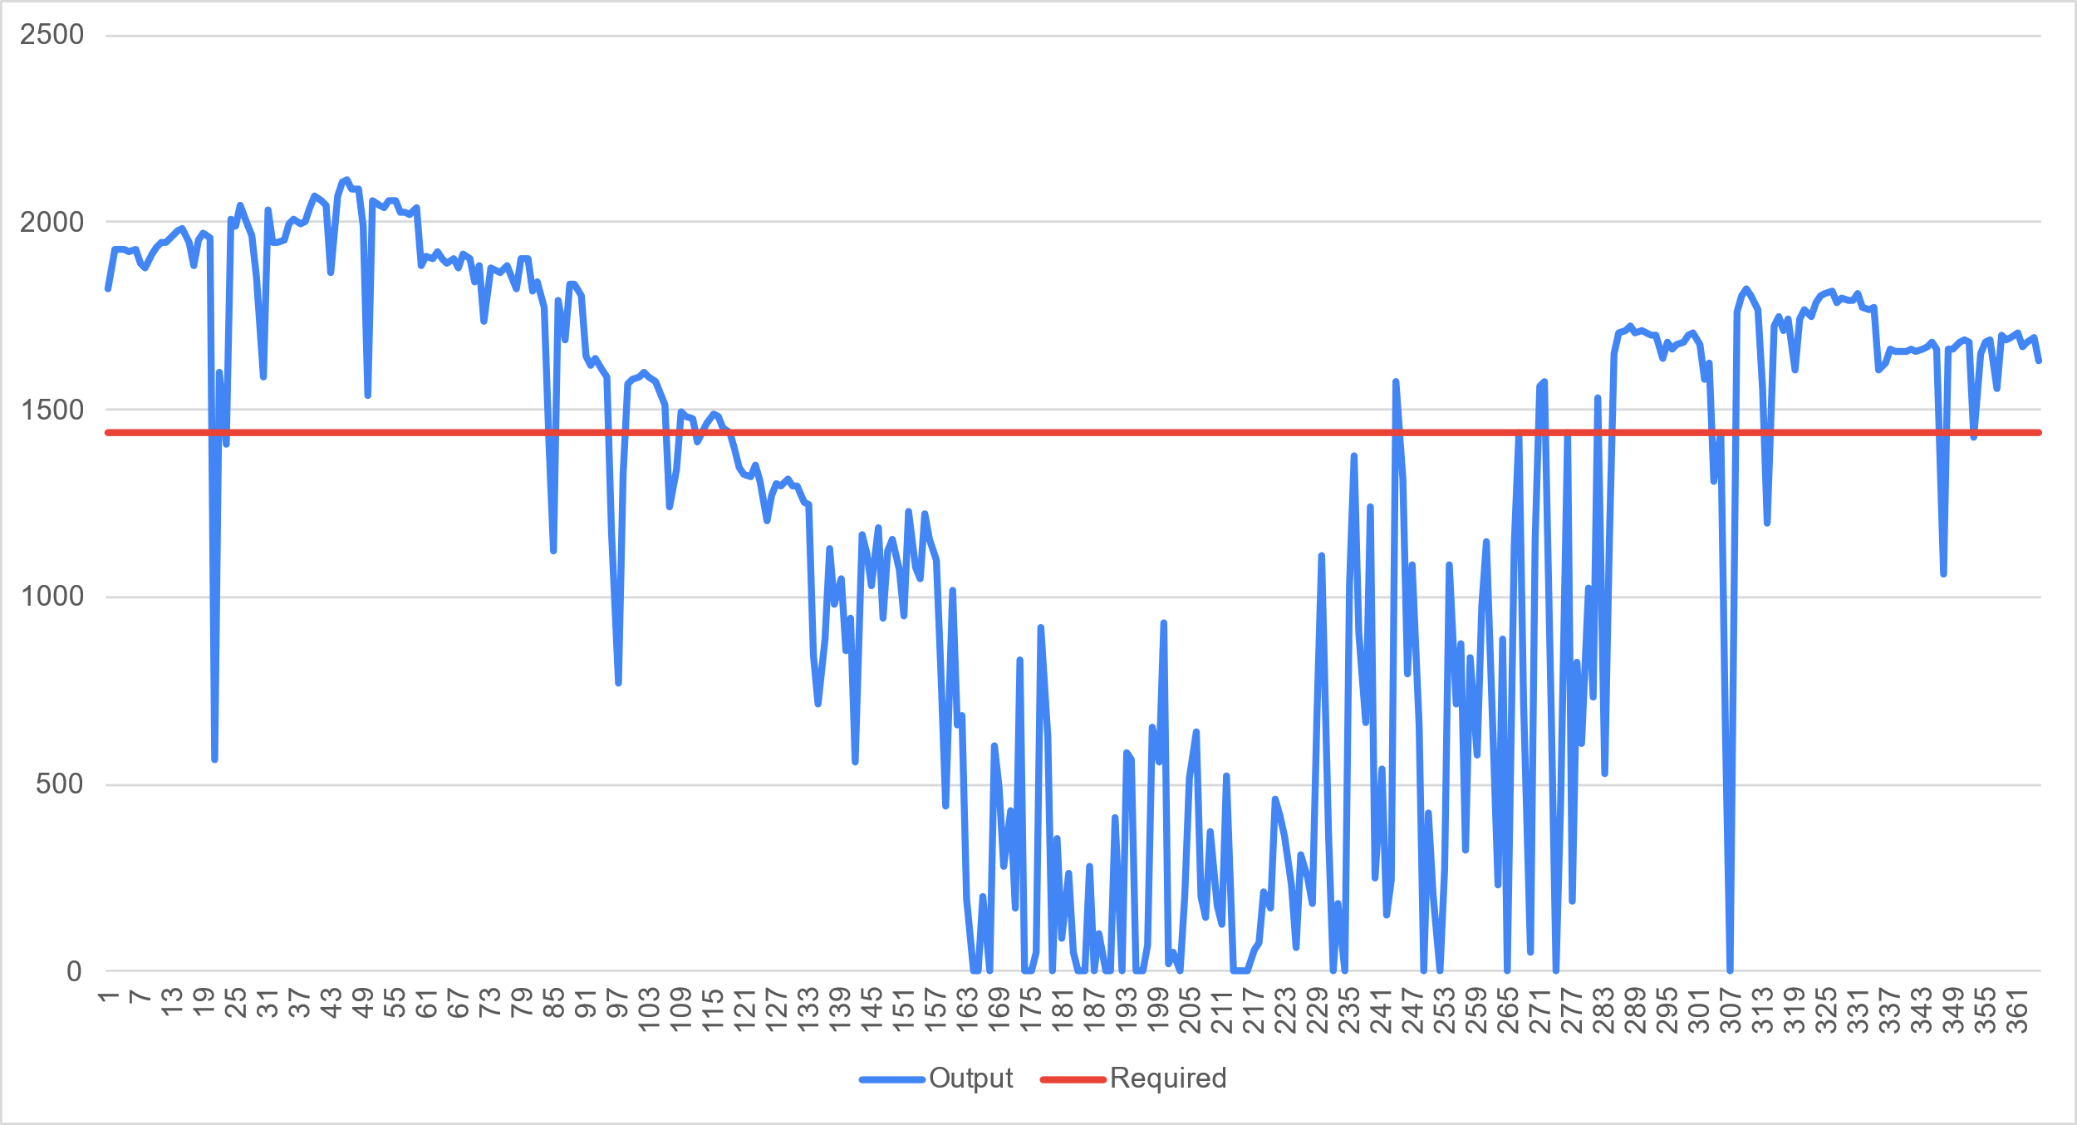
Figure 3:Output vs Demand Curve
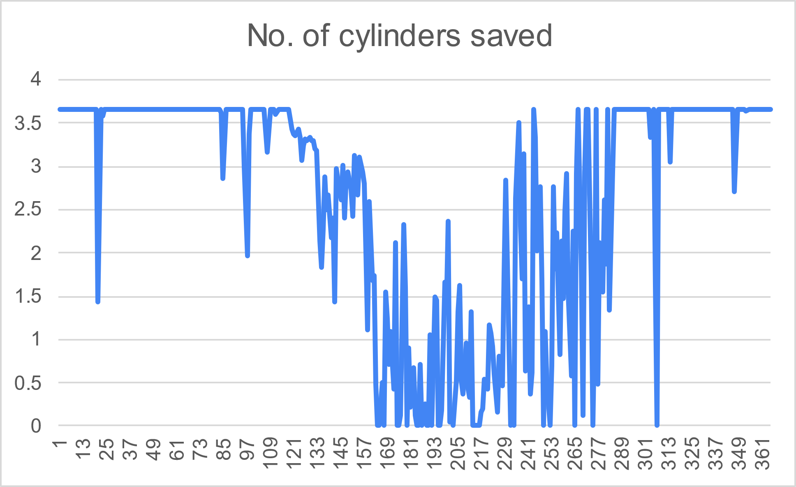

Figure 4: Number of Cylinders Saved

Cost Analysis

As per govt of India single axis tracking based Scheffler system costs 25000 per m^{2 .}
Cost of one Scheffler dish of 16m2 = 16 x 25000= 400000 Rs

- Cost of retrofitting existing kitchen and adding suitable accessories = 30% of capital cost = 120000 per dish[11]
- Total cost of system of 14 dishes = 56 lakh Rs

Fuel saving cost per yr
- Cost of LPG cylinder= 1345 Rs
- Fuel saving cost per yr = 1311631.57 Rs
- SPP =Capital Investment/ Annual Savings = 4.269 yrs
- ROI = (1/SPP)x100 =23.42%
- Expected life of Scheffler dish = 15 yrs
- Annual cost of O&M = 2% of capital cost =112000 Rs
- Discount rate = 10%
- Salvage value = 5% of capital cost =280000 Rs

Net Present Value of the project
Net Present Value of the project
=∑NPV of fuel saving + NPV Salvage – NPV O&M- Capital Cost
- NPV of fuel saving= 9976370 Rs
- NPV of O&M = 851881 Rs
- NPV of Salvage=67029.77 Rs
- NPV of Project= 9679287.61+ 62739.86 -797360.5 -5241600
=3591518 Rs
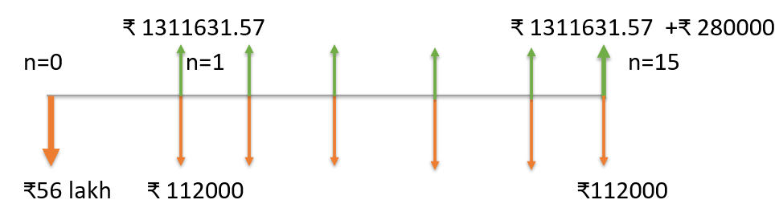

Benefit-cost ratio
The benefit-cost ratio is a measure of financial efficiency. For financial viability of the project, monetary worth of all the benefits must outweigh all the cost associated with it, i.e. B/C must be greater than one
Benefit to Cost Ratio =
(NPV fuel saving + NPV salvage value)/(Capital cost + NPV O&M)
B/C=1.556

The internal rate of return (IRR)-
The internal rate of return (IRR) is essentially the value of the discount rate at which the net present value (NPV) of an investment is zero. Thus, it represents the breakeven value of the discount rate and can be used to assess the financial feasibility of a project if the cost of financing the project is known. The higher the value of IRR for a project, the more attractive it is likely to be for the investors.

IRR = Discount rate at which NPV is zero(taking n=15), on solving
IRR=20.116%

Results and Discussions
The implementation of 14 Scheffler dish collectors for canteen cooking yielded promising outcomes. Economic analysis revealed a positive Net Present Value (NPV), a Benefit-to-Cost ratio (B/C) of 1.556, and an Internal Rate of Return (IRR) of 20.116. Additionally, the system facilitated a reduction of 41.5 tonnes of CO2 emissions, attributable to the displacement of LPG gas burning.
The overall thermal efficiency of the system, at 52.8%, indicates the effectiveness of converting solar energy into usable heat for cooking purposes. Additionally, the optical efficiency of 0.607 underscores the system's ability to capture and concentrate sunlight onto the cooking surface efficiently.

Limitations-

Limitation: Absence of Thermal Storage System

The project lacks a thermal storage system, which could limit its ability to provide consistent cooking capabilities during periods of low solar radiation or at night. Without thermal storage, the Scheffler dish collectors may only be able to operate when sufficient sunlight is available, potentially restricting cooking activities to daylight hours and limiting the system's overall usability and reliability. Introducing thermal storage would enhance the project's capacity to store excess solar energy generated during peak sunlight hours and utilize it for cooking during periods of low solar availability, thereby extending the cooking time window and improving system resilience.

Conclusions
The canteen cooking project demonstrates significant promise in terms of economic feasibility and environmental sustainability. The positive Net Present Value (NPV), favorable Benefit-to-Cost ratio (B/C), and substantial Internal Rate of Return (IRR) indicate that the investment in solar cooking technology is economically justified, with projected returns exceeding initial costs. Additionally, the mitigation of 41.5 tonnes of CO2 emissions highlights the environmental benefits of transitioning from LPG gas burning to solar energy. With an overall thermal efficiency of 52.8% and an optical efficiency of 0.607, the Scheffler dish collectors prove to be effective in harnessing solar energy for cooking applications. Overall, this study underscores the potential of solar Scheffler dish collectors as a viable and eco-friendly solution for meeting cooking needs in canteens and similar settings, offering both economic and environmental advantages.

Nomenclature
Abbreviations
LAT Local Apparent Time
IST Indian Standard Time
DNI Direct Normal Irradiance
NPV Net Present Value

Symbols
I_{g} Global Radiation
I_{b} Beam Radiation
I_{d} Diffused Radiation
I_{T} Radiation on tilt surface
I_{bn} Beam Normal Radiation
$θ$ Angle of Incidence
$θ_{z}$ Zenith Angle
$δ$ Declination Angle
$∅$ Latitude
$γ$ Surface Azimuthal Angle
$ρ$ Albedo constant
A_{i} Anisotropic Index

References

- System Advisor Model Version 2022.11.29 (SAM 2022.11.21). National Renewable Energy Laboratory. Golden, CO. Accessed July 26, 2023. https://https://sam.nrel.
- Scheffler Dish. (n.d.). https://trlindia.com/wp-content/uploads/2020/12/TRL-Parabolic-dish-based-Solar-System-Operations-Maintenance-Manual-1.pdf
- Final-booklet-2-scheffler-dish.PDF. (n.d.-a). https://www.itpower.co.in/wp-content/uploads/2016/01/Final-Booklet-2-Scheffler-Dish.pdf
- Net zero emissions target (no date) Press Information Bureau. Available at: https://pib.gov.in/PressReleaseIframePage.aspx?PRID=1945472 (Accessed: 31 March 2024).
- Service, T.N. (no date) A peep into piped comfort, Tribuneindia News Service. Available at: https://www.tribuneindia.com/news/archive/features/a-peep-into-piped-comfort-660183 (Accessed: 31 March 2024).
- Jatinra Khan (2021) ‘Comparative evaluation of parabolic collector and Scheffler Reflector for solar cooking’, International Journal of Science and Society, 3(1), pp. 56–61. doi:10.54783/ijsoc.v3i1.267.
- Home: Food and Agriculture organization of the United Nations (no date) FAOHome. Available at: https://www.fao.org/home/en (Accessed: 31 March 2024).
- Lather, R.S. (2020) ‘Performance analysis of an LPG cooking stove for improvements and future usability perspective’, Lecture Notes in Mechanical Engineering, pp. 633–643. doi:10.1007/978-981-15-5996-9_50.
- Author links open overlay panelMohammad Malekan 1 et al. (2021) Parabolic Trough Solar Collectors, Design and Performance Optimization of Renewable Energy Systems. Available at: https://www.sciencedirect.com/science/article/abs/pii/B9780128216026000079 (Accessed: 31 March 2024).
- Thirunavukkarasu, V. and Cheralathan, M. (2018) ‘Experimental study on heat losses from external type receiver of a solar parabolic dish collector’, IOP Conference Series: Materials Science and Engineering, 402, p. 012196. doi:10.1088/1757-899x/402/1/012196.

[11] S. Indora and T. C. Kandpal, “Financial appraisal of using Scheffler dish for steam based institutional solar cooking in India,” Renew. Energy, vol. 135, pp. 1400–1411, 2019, doi: 10.1016/j.renene.2018.09.067.

