**MINI PROJECT**

**REPORT**

**Team Members:-**

4413: Anandamayee Modak

4414: Pranjal More

4430: Sharvari Phadke

---------------------------------------------------------------------------------------------------------

* **Title :**

Women/Senior Citizen Safety Device with GPS Tracking ,SMS alerts and buzzer alert.System for ensuring safety of females and senior citizens in emergency and unsafe circumstances .

* **Introduction :**

The safety of women on the streets is an issue even in the 21 st century. Catcalling, stalking and harassment are threats to safety faced by women on the daily. At times, this can lead to serious threat to life, murders, or rapes. Women are mostly targeted when seen to be walking alone in secluded areas, areas without CCTV cameras, parking lots (where the perpetrator may hide in the victim’s car until she is buckled in and then make a move), or at night when help is hard to come by. The attacker can also choose to follow the victim home and attack just as the victim is about to enter. In such situations, the victim often does not have time to scream, let alone call the police for help. Many times with the attacker in front of you you cannot take out your phone and make a call. Threat to life, or the fear instilled by any weapons the perpetrator could display, may make the victim freeze and unable to react. In some instances (having the intuition of being watched or followed), the victim may not be sure if the threat is real till it is too late .This leads to the need for a hidden device that ensures the safety of the victim by discreetly and quickly sending an emergency alert in cases of danger. The device has 2 buttons :panic button and buzzer button.A device, which on just pressing the panic button the will send sms alert to the user’s favourite contacts along with the user’s current location. On pressing the buzzer button a buzzer will be activated which can alert any passerby. The 2 buttons prove to be helpful as depending on the situation the victim can decide whether to alert using buzzer or not.

At times senior citizens when alone at home might suffer seizures, sudden attacks, might faint when in bathroom and may not be able to call and ask for help or pick up their phone if someone calls ,as either their phone is not with them or they are unable to reach the phone in that condition. In such situation these safety devices help as just on the click of the panic button their near and dear ones will be notified immediately and reach out. On pressing the buzzer button if anyone else is at home they can be alerted using the buzzer.

Women/Senior Citizen safety device is a project which sends sms alerts along with GPS location to the user’s favourite contacts and nearby police station or ambulance according to the use case, on pressing the panic button and also alarms passerby using a buzzer, using the buzzer button. This enables the users to get help in required time.Using this information, the police or friend can reach the location and will be able to prevent any unforeseen situation that a potential victim might get into using the information. Speaking of another use case family members can reach home and get the required medical help for the patient in time. For this, we are using an Arduino Uno which is connected to 2 push buttons, buzzer and Bluetooth module. It is connected to the user’s mobile phone which has the safety app, using Bluetooth. On pressing the panic button ,the mobile sends sms alerts to the favourite contacts via the app and on pressing the buzzer button the buzzer on the device activates.

* **Need of Concept :**

Considering the use case of women safety ,the perpetrator will always be on the lookout for any items of self-defence the victim may be carrying. Offenders always go for targets that look weaker/ smaller than them. If the victim is carrying weapons in self-defence , they are likely to be disarmed and have their own weapons used against them. So, it is more efficient to have an alarm system hidden into everyday items of use, such as jewellery, belts, earrings, etc which send an alarm along with the victim’s GPS location once activated. Such devices should be fast and easy to trigger, considering the target does not have a lot of time or opportunity to call for help if the attacker is right in front of them.Having 2 separate buttons helps as depending on situation and use case whether to activate the buzzer or not can be decided.

These wearable safety devices can also provide family members and caregivers with peace of mind .Speaking of this we come to the second use case which is, they will be able to help seniors alone at home in time in case of emergency situations. Many times a situation arises when a senior is alone at home and might suffer sudden attacks, faint or experience discomfort and may not be able to call and ask for help or pick up their phone if someone calls ,as either their phone is not with them or they are unable to reach the phone in that condition. In such situations having the device helps and medical assistance can be provided immediately. Buzzer alert helps in alerting if anyone else is at home. The device being a less complex one makes it user friendly. Thereby, independent seniors still have the freedom and flexibility to do whatever they like with an extra layer of protection in case of an emergency.

* **System Requirements for the project implementation :**
* **Arduino Uno -**The Arduino UNO is a standard board of Arduino. Here UNO means 'one' in Italian. It was named as UNO to label the first release of Arduino Software. It was also the first USB board released by Arduino. It is considered as the powerful board used in various projects. Arduino.cc developed the Arduino UNO board. Arduino UNO is based on an ATmega328P microcontroller. It is easy to use compared to other boards, such as the Arduino Mega board, etc. The board consists of digital and analog Input/Output pins (I/O), shields, and other circuits. The Arduino UNO includes 6 analog pin inputs, 14 digital pins, a USB connector, a power jack, and an ICSP (In-Circuit Serial Programming) header. It is programmed based on IDE, which stands for Integrated Development Environment. It can run on both online and offline platforms.
* **Bluetooth module (HC05) -** Designed to replace cable connections HC-05 uses serial communication to communicate with the electronics. Usually, it is used to connect small devices like mobile phones using a short-range wireless connection to exchange files. It uses the 2.45GHz frequency band.
* **Push button -** A push button switch controls an action in a machine or other type of process. They are common features within the home and workplace, and are also referred to as pushbutton switches or push switches.
* **Resistor -** The resistor is a passive electrical component that creates resistance in the flow of electric current. In almost all electrical networks and electronic circuits they can be found.
* **Buzzer -** An audio signaling device like a beeper or buzzer may be electromechanical or [piezoelectric](https://www.elprocus.com/what-is-a-piezoelectric-material-working/) or mechanical type. The main function of this is to convert the signal from audio to sound.
* **Android Studio -** Android Studio provides a unified environment where you can build apps for Android phones, tablets, Android Wear, Android TV, and Android Auto.
* **Arduino IDE -** The Arduino Integrated Development Environment - or Arduino Software (IDE) - contains a text editor for writing code, a message area, a text console, a toolbar with buttons for common functions and a series of menus. It connects to the Arduino hardware to upload programs and communicate with them.
* **Design Methodologies (Step 1 to Step 6 and Step 9 and 10)**

**Step 1:- Purpose and requirements**

* **Purpose :** Women/Senior Citizen safety device which allows sending sms alerts along with GPS location to the user’s favourite contacts and nearby police station or ambulance according to the use case and also alarms passerby using a buzzer. This enables the users to get help in required time in emergency situations
* **Behaviour :** Device connected using Bluetooth to mobile device. On pressing the button on the device alerts are sent via the app and buzzer on the device goes off.
* **System Management Requirement :** System should provide remote monitoring and control functions and be always connected with user’s mobile phone via Bluetooth.
* **Data Analysis Requirement :** System should perform local analysis of data
* **Application Deployment Requirement :** Application should be deployed locally on the device and should be accessible remotely
* **Security Requirement :** System should have basic user authentication capability

**Step 2:- Process Specification**

*Panic Button on device*

*Buzzer Button on device*

*Panic button pressed*

*Buzzer button pressed*

*pressed*

*released*

*Buzzer rings*

*Buzzer stops ringing*

*pressed*

*released*

*Alerts sent to favourite contacts*

*Alerts not sent to favourite contacts*

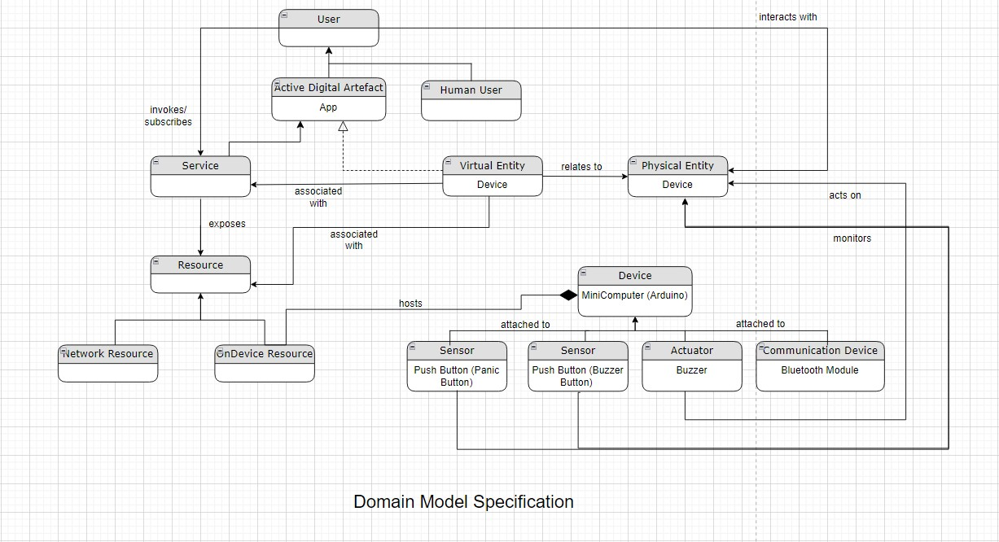**Step 3:- Domain Model Specification**

**Step 4:- Information Model**

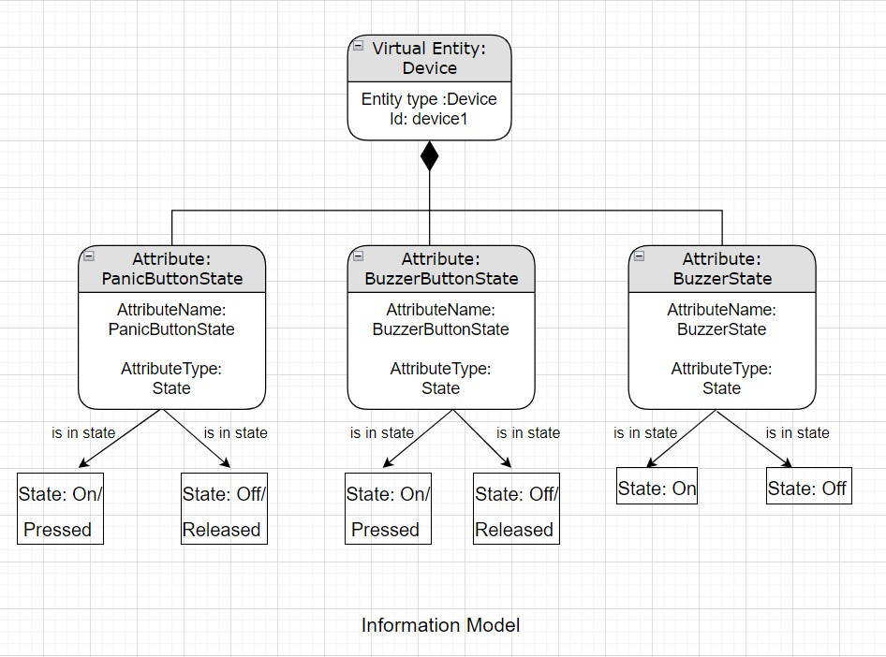

**Step 5: - Service Specifications**

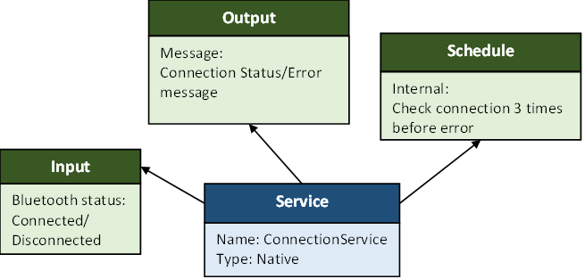

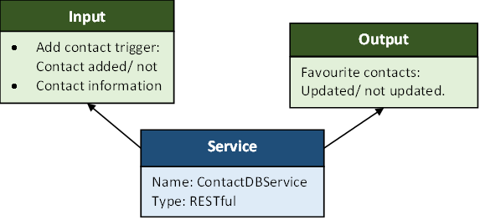

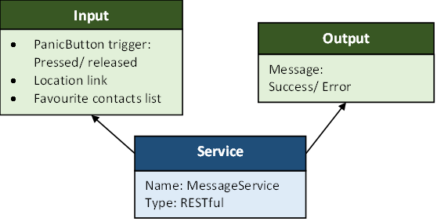

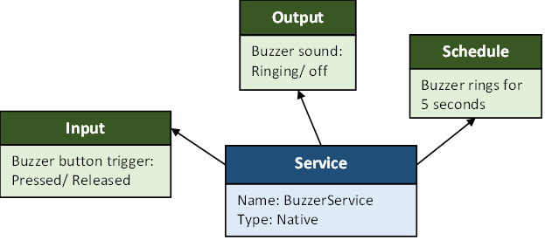

**Step 6: - IoT Level Specification: Level 1**

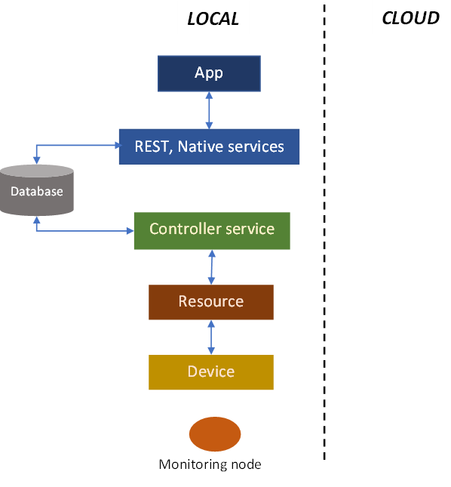

**Step 9: - Device and Component Integration**

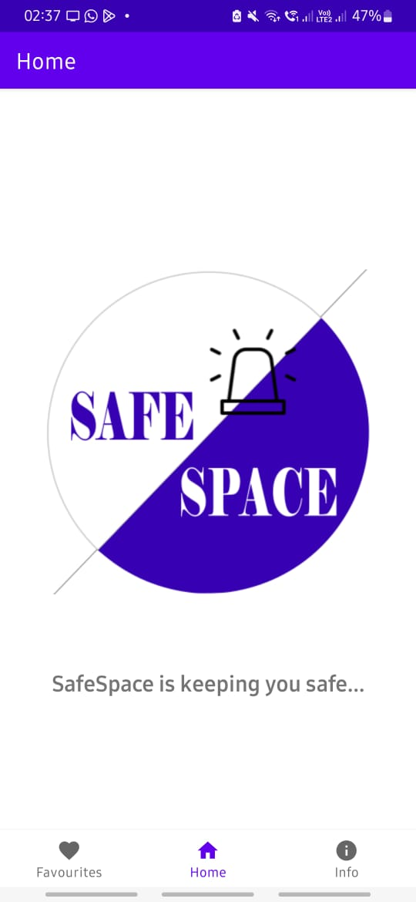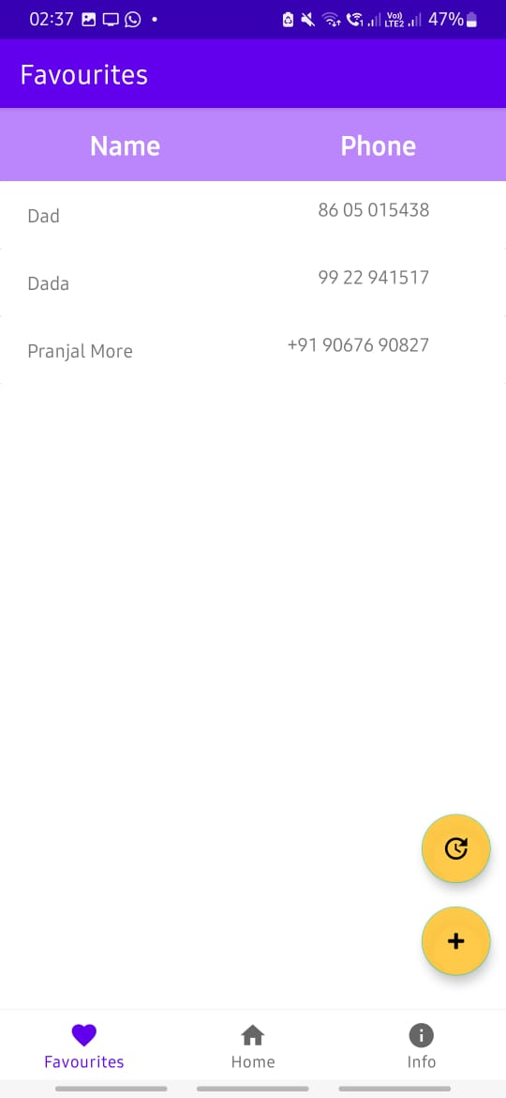

*Fig 2:*

*Adding contacts to alert in case of emergency*

*Fig 1:*

*Home page of client application*

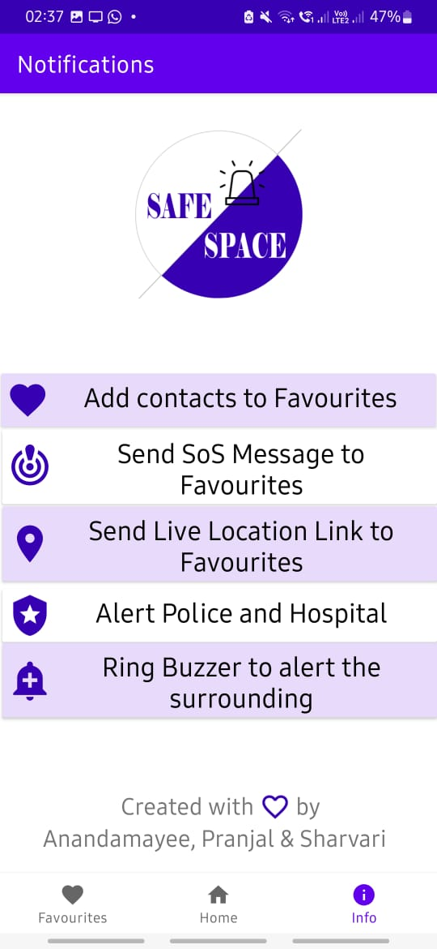

*Fig 3:*

*Features information for the client*

**Step 10: - Application Development**

* **Future Scope :**
* Making the device more compact
* Push notification on receiver’s mobile phone on receiving an alert
* Cloud analysis for trigger incidents in various location in case of women safety.