**TestSG Framework:**

TestSG is a hybrid framework – Keyword driven and Data driven

Main components of this framework are:

* **Test Configuration**
  + Config.xml
  + Constants.java
* **Object Repository**
  + OR.xml
* **Libraries**
  + Logger (Log4j)
  + Report (ExtentReports)
* **Test Input**
  + Test Suite/ Cases.xls
  + Test Data.xls
* **Automation scripts**
  + DriverScript.java
  + Keywords.java
* **Test Output**
  + Reports (Excel & HTML)
  + Logs

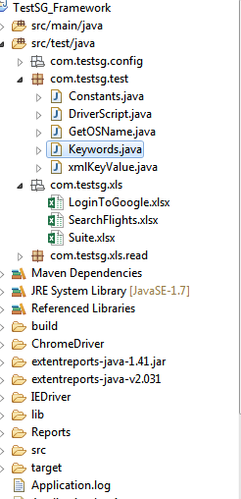

In **TestSG** framework, all the operations and instructions are written in the external files like excel and xml and passed to the script for execution.

Configuration files – config.xml and OR.xml are the main inputs for the script.

‘Config.xml’ – It is used to configure the test environment parameters like browserType, AUT urls etc

Config parameter is ‘key’ element and its value in value.

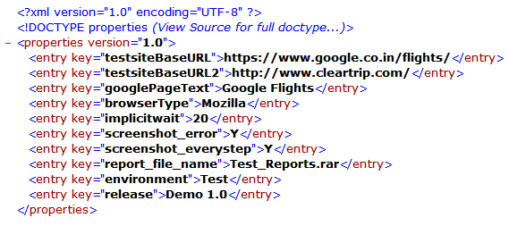

‘OR.xml’ – It is used to define the application object identifiers.

Object name is defined ‘key’ element and its identifier in its value.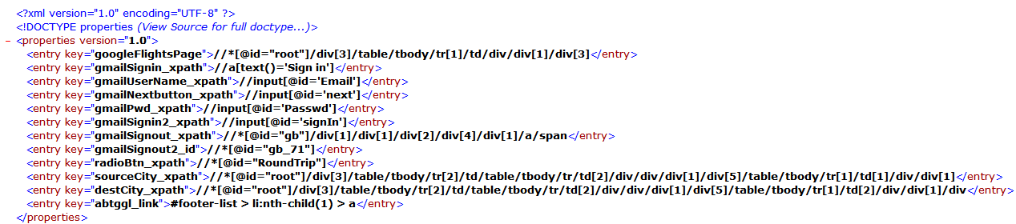‘Constants.java’ – This class holds any constants that are being used in the test scripts.

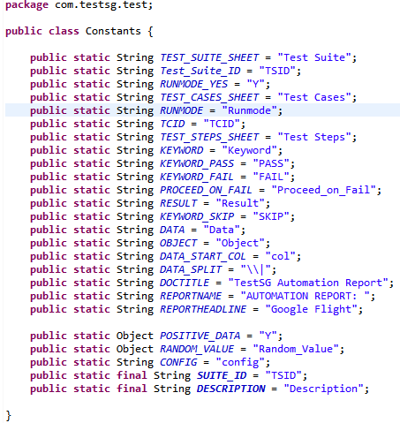

**Framework architecture:**

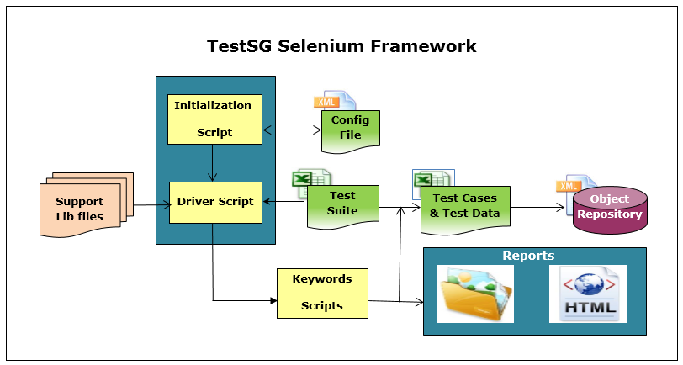

Step wise flow of TestSG Framework flow is detailed below:

* The driver script (DriverScript.java) reads config file from ‘config.xml’ using ‘xmlKeyValue.java’.
* Using ‘Xls_Reader.java’, driver script will read the ‘Suite.xls’ and corresponding test cases if the test cases is enabled to run(Run_mode = ‘Y’).

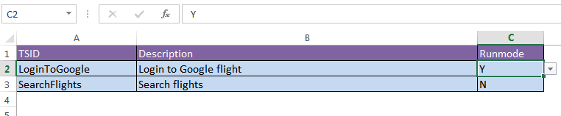

* Test cases which are enabled to run are executed step by step.

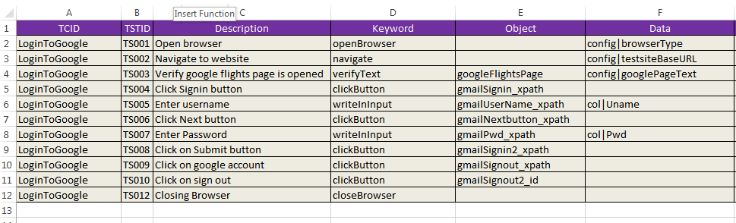

* Test cases which are enabled to run are executed step by step.
* Each keyword of the test step is passed on to ‘Kewords.java’ to perform the operation on UI.

For example, we need to click a button 'Signin' in gmail. Correspondingly, excel will have a keyword 'clickButton'. Now the AUT can have hundreds of button on a page, to identify a Signin button, in excel we will input Object Name as ‘gmailSignin_xpath’.

If Keyword requires data to perform operation then it can be either passed from ‘config.xml’ or testdata sheet in testcases.xls

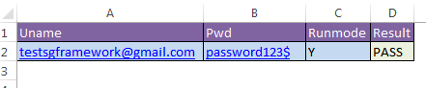

Methods that are invoked to execute through Keywords

ject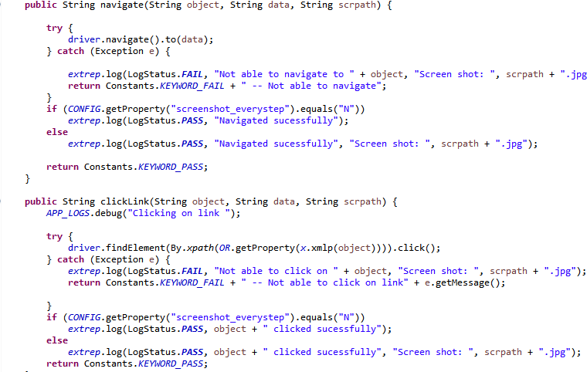

Action is performed on the object using the given locator and its status will be logged to log file ‘Application.log’, Test case excel, and invokes ExtentReport library to report in html format.

Sample Report:

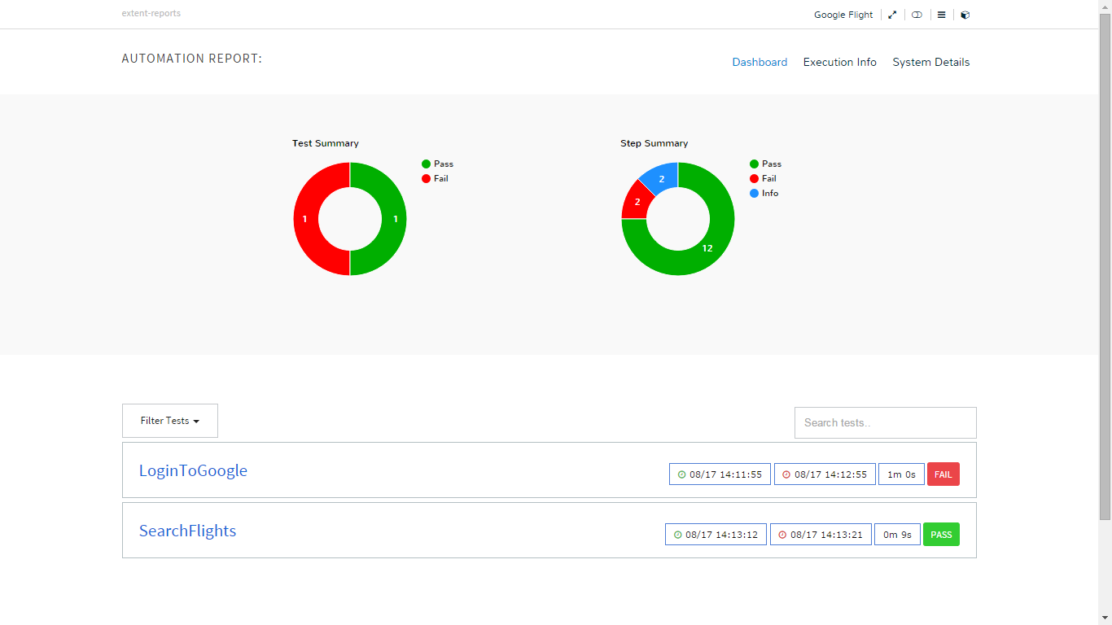

Executor Guidelines:

1. Configure config.xml with test environment values
2. Define the object names and locators in OR.xml
3. Provide test cases to execute in Suite.xls
4. Create test cases excel sheet and provide test steps by selecting appropriate action Keywords
5. Provide object defined in OR.xml and data(if required)
6. Run ‘DriverScript.java’ as java application
7. After completion check reports in Reports folder along with screen shots

**Important Links:**

[Official Website](<http://selenium-grid.seleniumhq.org>)

[Selenium Documentation](<http://seleniumhq.org/docs/>)

[Selenium WebDriver](<http://seleniumhq.org/projects/webdriver/>)

[Selenium Download Page](<http://seleniumhq.org/download/>)

[Selenium Support Page](<http://seleniumhq.org/support/>)

[Platforms Supports](<http://seleniumhq.org/about/platforms.html>)

[Language Supports](<http://seleniumhq.org/about/platforms.html#programming-languages>)

[Testing Frameworks](<http://seleniumhq.org/about/platforms.html#testing-frameworks>)

[Test Design Considerations](<http://seleniumhq.org/docs/06_test_design_considerations.html>)

[UI Mapping](<http://seleniumhq.org/docs/06_test_design_considerations.html#ui-mapping>)

[Data Driven Testing](<http://seleniumhq.org/docs/06_test_design_considerations.html#data-driven-testing>)

[Database Validation](<http://seleniumhq.org/docs/06_test_design_considerations.html#database-validation>)

[Java Documentation](<http://selenium.googlecode.com/svn/trunk/docs/api/java/index.html>)

[Extent Reports](<http://relevantcodes.com/extentreports-for-selenium>)

[Extent Reports documentation](<http://extentreports.relevantcodes.com/1x/docs.html>)